A
PROJECT REPORT ON
Design and Engineering Analysis of an Autonomous Solar Panel Cleaning Robot


DEPARTMENT OF MECHANICAL ENGINEERING
COURSE NAME: DESIGN OF MACHINE ELEMENTS
(GROUP - 10)

S.NO | Name | Roll Number
1 | Ch. Prajay Verma | 230003018
2 | B. Samith Lal | 230003013
3 | B. Santhosh | 230003014
4 | M. Naveen | 230003042
5 | R. Manthru Naik | 230003055
6 | R. Yogendhra Babu | 230003056
7 | S. Manjunatha | 230003067
8 | S. Praveen | 230003063
9 | Y. Akshay | 230003087

Prof. Krishna Mohan Kumar

ABSTRACT

The accumulation of dust and dirt on solar panels significantly reduces their efficiency and power generation capability. Traditional manual cleaning methods are time-consuming, labor-intensive, and less effective for large-scale solar installations. This project presents the design and engineering analysis of an autonomous solar panel cleaning robot developed to automate the cleaning process and improve overall solar panel performance.

The robot consists of a motorized cleaning mechanism, drive system, control unit, and a supporting mechanical structure that enables smooth movement across the solar panel surface. The system is designed to remove dust efficiently while reducing human effort, maintenance cost, and cleaning time. To ensure proper performance and structural reliability, engineering analyses such as Center of Mass (COM) analysis, static analysis, dynamic analysis, and stress analysis are performed to evaluate the robot’s stability, strength, and operational behavior. In addition, CAD modeling and simulation techniques are used to optimize the mechanical design and improve system efficiency.

The proposed robotic system provides a low-cost, efficient, and reliable solution for solar panel maintenance in residential, commercial, and industrial applications. This project contributes toward enhancing renewable energy efficiency through the integration of automation, robotics, and intelligent mechanical design.

Introduction
The increasing use of solar energy systems has created a growing need for efficient maintenance of solar panels. The accumulation of dust, dirt, and other particles on solar panel surfaces reduces their efficiency and power output significantly. Regular cleaning is therefore essential to maintain maximum energy generation and improve panel performance.
Traditional manual cleaning methods require considerable time, labor, and maintenance cost, especially in large solar power plants. To overcome these limitations, this project presents the design and engineering analysis of an autonomous solar panel cleaning robot capable of cleaning solar panels efficiently with minimal human intervention.
The robot is designed with a motorized cleaning mechanism, drive motors, control unit, and supporting mechanical structure for smooth movement across the panel surface. The system aims to improve cleaning efficiency, reduce operational cost, and enhance the overall performance of solar panels.
To ensure proper stability and structural reliability, engineering analyses such as Center of Mass (COM) analysis, static analysis, dynamic analysis, and stress analysis are performed. CAD modeling and simulation techniques are also used to evaluate the mechanical performance of the robot under working conditions.
The project provides a low-cost, reliable, and automated solution for solar panel maintenance by combining concepts of robotics, automation, and renewable energy technology.

Key Contributions:

- Design and development of an autonomous solar panel cleaning robot..

- Integration of a motorized cleaning and drive mechanism for efficient cleaning operation.

- Performance evaluation using COM, static, dynamic, and stress analysis.

- Development of a cost-effective and automated cleaning solution for solar panel maintenance.

2. COMPONENTS USED

S.No | Component | Image | Quantity | Property
1 | Arduino Uno R3 | 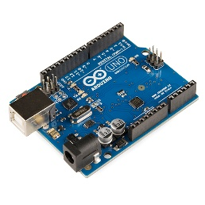 | 1 | ATmega328P microcontroller, 5V operating voltage
2 | IR Obstacle Sensors | 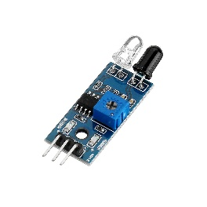 | 4 | Infrared detection, obstacle sensing module
3 | L298N Motor Driver | 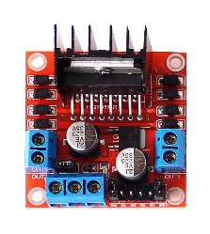 | 1 | Dual H-Bridge motor control module
4 | 2-Channel Relay | 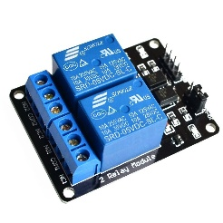 | 1 | Electromagnetic switching module, 5V relay
5 | 18650 Batteries | 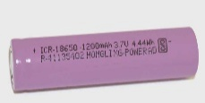 | 4 | Rechargeable Li-ion battery, 3.7V
7 | LM2596 Buck Converter | 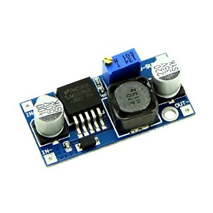 | 1 | DC-DC step-down voltage regulator
8 | 12V Water Pump | 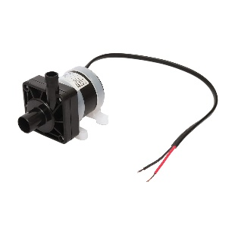 | 1 | Compact DC water circulation pump
9 | BO Motors & Wheels | 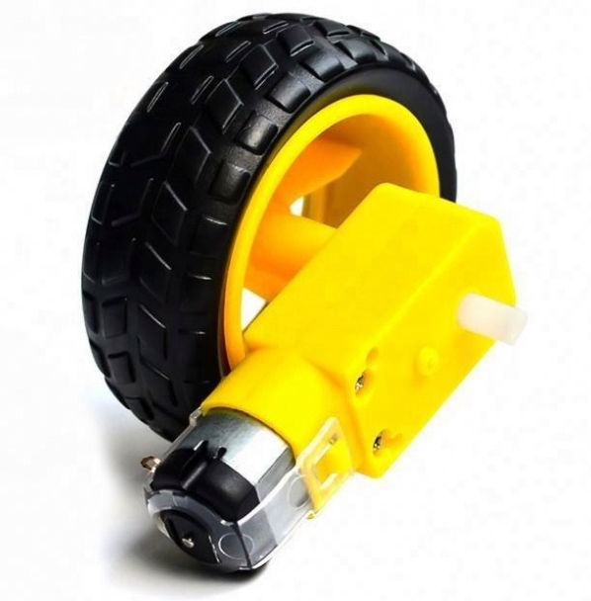 | 4 | High torque geared motor with wheel assembly
11 | Jumper Wires (60pk) | 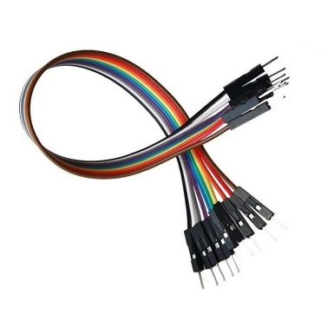 | 1 | Electrical connection wires for circuit interfacing

2.1 Component Selection and Integration

The above table presents the major components used in the development of the autonomous solar panel cleaning robot along with their specifications and functions. Each component is selected to ensure efficient operation, reliable control, stable power management, and effective cleaning performance of the robotic system.

The Arduino Uno R3 acts as the main controller, while the IR sensors are used for obstacle and edge detection. The L298N motor driver controls the movement of the motors, and the relay module is used for switching operations. The system is powered using 18650 Li-ion batteries, and the LM2596 buck converter provides a stable voltage supply to the electronic components.

The integration of these components enables the robot to perform autonomous cleaning operations efficiently with reduced human effort and improved system reliability.

3. Design

3.1 Body Design

The chassis forms the main structural body of the autonomous solar panel cleaning robot and provides support for all mechanical and electronic components. The body is designed to ensure proper stability, lightweight construction, and efficient load distribution during operation on the solar panel surface.

The chassis is developed using CAD modeling techniques with suitable dimensions for mounting motors, batteries, cleaning mechanisms, and control units. The lightweight structure improves mobility and overall system performance.

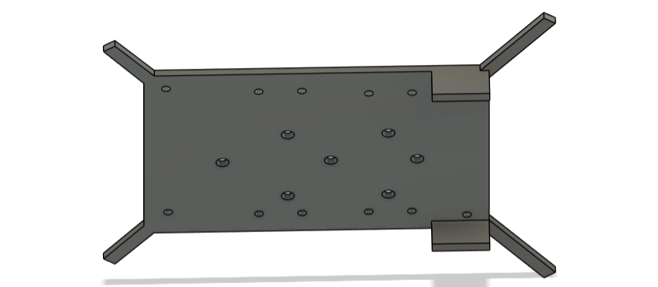

Fig: Robot chassis

3.2 Physical and Structural Properties of Robot Chassis
Area | 43200 mm^2
Density | 1.24 g / cm^3
Mass | 294g
Bounding Box | Length: 240.00mm  Width: 180.00 mm  Thickness: 3.00mm

4. ANALYSIS

1. SYSTEM PARAMETERS & CONSTANTS

Parameter | Symbol | Value
Total Mass | m | 0.7 kg
Gravity Acceleration | g | 9.81 m/s²
Inclination Angle | θ | 21°
Center of Gravity Height | h | 111 mm (0.111 m)
Center of Mass | X,Y | 121 mm ,90 mm
Track Width (Wheelbase) | w | 180 mm (0.180 m)
Wheel Radius | r | 65 mm (0.065 m)
Motor Efficiency | η | 60% (0.60)
Rolling Resistance Coeff | Crr | 0.02
Brush Drag Force | Fbrush | 0.50 N
Brush Reaction Torque | τb | 0.05 Nm (estimated)

2. INCLINATION PLANE FORCE ANALYSIS

When the robot operates on the solar panel surface inclined at an angle of 21°, the gravitational force acting on the robot is resolved into perpendicular and parallel components relative to the inclined plane. This analysis is important to evaluate the robot’s stability, traction, and movement capability on the solar panel surface.

2.1 Total Weight of the Robot
The total gravitational force acting on the robot is calculated using:

Where:

$m=0.7 kg$

$g=9.81 m/s^{2}$

Calculation:

$$W=0.7×9.81=6.867 N$$

Result:

Total Weight (W) = 6.867 N

2.2 Normal Force (N)
The normal force acts perpendicular to the solar panel surface and is responsible for maintaining wheel traction and controlling rolling resistance.

Where:

$W=6.867 N$

$θ={21}^{∘}$

Calculation:

$$N=6.867×cos⁡({21}^{∘}) \\ N=6.867×0.9336 \\ N=6.41 N$$

Result:

Normal Force (N) = 6.41 N

2.3 Downslope Force (Fd)
The downslope force acts parallel to the inclined surface and tends to pull the robot downward along the panel.
Calculation:
$$F_{d}=6.867×sin⁡({21}^{∘}) \\ F_{d}=6.867×0.3584 \\ F_{d}=2.46 N$$
Result:
Downslope Force (Fd) = 2.46 N

3. STATIC TIPPING ANALYSIS

Static tipping analysis is performed to ensure that the robot remains stable while stationary on the inclined solar panel. The robot is considered stable when the restoring moment is greater than the overturning moment.

3.1 Restoring Moment (Mr)

The restoring moment helps prevent the robot from tipping over.

$$M_{r}=N\left(\frac{w}{2}\right)$$

Where:

$N=6.41 N$

$w=0.180 m$

Calculation:

$$M_{r}=6.41×0.090 \\ M_{r}=0.577 Nm$$

Result:

Restoring Moment (Mr) = 0.577 Nm

3.2 Static Overturning Moment

The overturning moment is caused by the downslope force acting through the center of mass height.

$$M_{o,stat}=F_{d}h$$

Calculation:

$$M_{o,stat}=2.46×0.111 \\ M_{o,stat}=0.273 Nm$$

Result:

Static Overturning Moment = 0.273 Nm

3.3 Static Factor of Safety

The static factor of safety indicates whether the robot can safely resist tipping under stationary conditions.

$$FoS_{stat}=\frac{M_{r}}{M_{o,stat}}$$

Calculation:

$$FoS_{stat}=\frac{0.577}{0.273} \\ FoS_{stat}=2.11$$

Result:

Static Factor of Safety = 2.11 (Safe Condition)

4. DYNAMIC FORCE AND ACCELERATION ANALYSIS

Dynamic analysis is performed to evaluate the robot’s movement capability, acceleration, and driving performance while cleaning the solar panel surface.
4.1 Available Drive Force

The robot uses four DC motors, each having a safe continuous torque of 0.3 kg-cm (0.0294 Nm).

Total torque:

$$τ_{total}=4×0.0294 \\ τ_{total}=0.1176 Nm$$

Considering gear efficiency:

$$τ_{eff}=0.1176×0.60 \\ τ_{eff}=0.0706 Nm$$

Drive force:

$$F_{drive}=\frac{τ_{eff}}{r}$$

Calculation:

$$F_{drive}=\frac{0.0706}{0.065} \\ F_{drive}=1.086 N$$

Result:

Available Drive Force = 1.086 N

4.2 Total Resistance Force

The total resistance consists of rolling resistance and brush drag force.

$$F_{rr}=0.02×6.41 \\ F_{rr}=0.128 N \\ F_{res}=0.128+0.50 \\ F_{res}=0.628 N$$

Result:

Total Resistance Force = 0.628 N

4.3 Net Force and Acceleration
The net driving force available for acceleration is:
$$F_{net}=F_{drive}-F_{res}$$
Calculation:
$$F_{net}=1.086-0.628 \\ F_{net}=0.458 N$$
Acceleration:
$$a=\frac{F_{net}}{m}$$
Calculation:
$$a=\frac{0.458}{0.7} \\ a=0.654 m/s^{2}$$
Result:
Acceleration = 0.654 m/s²

5. DYNAMIC TIPPING ANALYSIS

Dynamic tipping analysis evaluates the robot’s stability during motion and acceleration.
  - Inertial Moment
The inertial moment is generated due to the acceleration of the robot and acts about the tipping point of the robot.
Formula:
$$M_{i}=mah$$
Where:
- $m=0.7 kg$
- $a=0.654 m/s^{2}$
- $h=0.111 m$

Calculation:
$$M_{i}=0.7×0.654×0.111 \\ M_{i}=0.051 Nm$$
Result:
Inertial Moment (Mi) = 0.051 Nm
  - Dynamic Overturning Moment
The total dynamic overturning moment is obtained by adding the static overturning moment, inertial moment, and brush torque acting on the robot during operation.
Formula:
$$M_{o,dyn}=M_{o,stat}+M_{i}+τ_{b}$$
Where:
- $M_{o,stat}=0.273 Nm$
- $M_{i}=0.051 Nm$
- $τ_{b}=0.050 Nm$ =(0.5N x 100mm)

Calculation:
$$M_{o,dyn}=0.273+0.051+0.050 \\ M_{o,dyn}=0.374 Nm$$
Result:
Dynamic Overturning Moment = 0.374 Nm

  - Dynamic Factor of Safety
The dynamic factor of safety is calculated to determine whether the robot remains stable during motion. A factor of safety greater than 1 indicates stable operation.
Formula:
$$FoS_{dyn}=\frac{M_{r}}{M_{o,dyn}}$$
Where:
- $M_{r}=0.577 Nm$
- $M_{o,dyn}=0.374 Nm$

Calculation:
$$FoS_{dyn}=\frac{0.577}{0.374} \\ FoS_{dyn}=1.54$$
Result:
Dynamic Factor of Safety = 1.54

6. TRACTION FAILURE ANALYSIS

Traction analysis is performed to ensure that the robot does not slip while moving on the inclined solar panel surface.

The minimum coefficient of friction required is calculated using:

$$μ_{min}=\frac{\sqrt{F_{drive}^{2}+F_{d}^{2}}}{N} (F_{d}=mgsinθ)$$

Calculation:

$$μ_{min}=\frac{\sqrt{{1.086}^{2}+{2.46}^{2}}}{6.41} \\ μ_{min}=\frac{\sqrt{1.179+6.051}}{6.41} \\ μ_{min}=\frac{2.688}{6.41} \\ μ_{min}=0.42$$

Result:

Minimum Coefficient of Friction = 0.42

CONCLUSION:

The traction failure analysis indicates that the robot requires a minimum coefficient of friction of 0.42 to safely operate on the 21° inclined solar panel surface without slipping. Since standard rubber wheels typically provide a friction coefficient of approximately 0.60, the robot possesses sufficient traction for stable movement during cleaning operations.

The analysis confirms that the designed robotic system can maintain proper grip, balance, and directional stability while moving across the solar panel surface. This improves operational safety, enhances cleaning efficiency, and ensures reliable performance under inclined working conditions.

4. STRUCTURAL AND DYNAMIC ANALYSIS

4.1 Project Parameters

The following parameters are used as the foundational inputs for the structural, dynamic, and stress analysis of the autonomous solar panel cleaning robot.

Parameter | Value
Total mass of robot (m) | 0.7 kg
Acceleration (a) | 3.08 m/s²
Solar panel inclination (θ) | 21°
CG height from ground (h) | 116.7 mm (0.1167 m)
Wheel radius (r) | 65 mm
Main chassis dimensions | 245 mm x 180 mm
Chassis thickness (t) | 3 mm
Track width | 180 mm

4.2 Force Analysis on Inclined Solar Panel

When the robot operates on a 21° inclined solar panel, the gravitational force acting on the robot is resolved into two perpendicular components relative to the inclined surface. One component acts perpendicular to the surface as the normal force, while the other acts parallel to the surface and tends to pull the robot downward.

Weight of Robot

$$W=mg \\ W=0.7×9.81 \\ W=6.867 N$$

Parallel Force Component

$$F_{p}=Wsin⁡({21}^{∘}) \\ F_{p}=2.46 N$$

Normal Reaction Force

$$N=Wcos⁡({21}^{∘}) \\ N=6.41 N$$

The force analysis confirms that the robot experiences sufficient normal reaction for maintaining traction and stable movement on the inclined solar panel surface

4.3 Dynamic Force Due to Acceleration

During motion, the acceleration of the robot generates an additional inertial force according to Newton’s Second Law of Motion. This dynamic force contributes to bending stresses in the chassis and supporting arms.

Dynamic Force

$$F_{d}=ma \\ F_{d}=0.7×3.08 \\ F_{d}=2.156 N$$

This force acts on the structural members during acceleration and cleaning operations.

4.4 Overturning Moment Due to Center of Gravity

The center of gravity of the robot is positioned above the wheelbase, creating an overturning moment when the robot operates on the inclined panel surface.

Overturning Moment

$$M=W×h \\ M=6.867×0.1167 \\ M=0.801 Nm$$

This moment tends to rotate the robot about the downhill wheels and is considered in the stability analysis.

4.5 Stress Concentration Theory

Stress concentration occurs in regions where there are sudden geometric changes such as holes, slots, sharp corners, or fillets. These discontinuities cause localized increases in stress compared to the nominal stress in smooth sections.

The stress concentration factor is expressed as:

$$K_{t}=\frac{σ_{max}}{σ_{nom}}$$

Where:

$K_{t}$= Stress Concentration Factor

$σ_{max}$= Maximum localized stress

$σ_{nom}$= Nominal stress

4.6 Front Arm Root Stress Analysis

The front support arms holding the cleaning mechanism behave as cantilever beams. The highest bending stress occurs at the root section where the arm connects to the main chassis.

Dimensions

Length = 90 mm

Width = 20 mm

Thickness = 3 mm

Fillet Radius = 1 mm

Bending Moment

$$M=F_{d}×L \\ M=2.156×0.09 \\ M=0.194 Nm$$

Moment of Inertia

$$I=\frac{bt^{3}}{12} \\ I=\frac{20×3^{3}}{12} \\ I=45 mm^{4}$$

Nominal Bending Stress

$$σ_{nom}=\frac{My}{I} \\ σ_{nom}=\frac{194×1.5}{45} \\ σ_{nom}=6.47 MPa$$

Maximum Localized Stress

For $K_{t}≈3.0$:

$$σ_{max}=3.0×6.47 \\ σ_{max}=19.41 MPa$$

The front arm root is identified as the most critical stress region in the chassis structure.

4.7 Rear Arm Root Stress Analysis

The rear arms are shorter than the front arms, resulting in a lower bending moment andreduced stress levels.

Rear Arm Length

$$L=70 mm$$

Bending Moment

$$M=2.156×0.07 \\ M=0.151 Nm$$

Nominal Stress

$$σ_{nom}=\frac{151×1.5}{45} \\ σ_{nom}=5.03 MPa$$

Maximum Stress

$$σ_{max}=3.0×5.03 \\ σ_{max}=15.09 MPa$$

The rear arm section is structurally safer compared to the front arm section

4.8 Stress at Mounting Holes

Mounting holes reduce the effective cross-sectional area and create localized stress concentration regions.

Net Area

$$A=(20-8)×3 \\ A=36 mm^{2}$$

Nominal Stress

$$σ_{nom}=\frac{F}{A} \\ σ_{nom}=\frac{2}{36} \\ σ_{nom}=0.055 MPa$$

Maximum Stress

For $K_{t}≈2.5$:

$$σ_{max}=2.5×0.055 \\ σ_{max}=0.138 MPa$$

4.9 Motor Slot Stress Analysis

Motor mounting slots are subjected to dynamic impact loading due to wheel movement and vibrations during operation.

Dynamic Load

$$F=1.5×\left(\frac{6.867}{4}\right) \\ F=2.58 N$$

Area

$$A=5×3 \\ A=15 mm^{2}$$

Nominal Stress

$$σ_{nom}=\frac{2.58}{15} \\ σ_{nom}=0.172 MPa$$

Maximum Stress

For $K_{t}≈2.7$:

$$σ_{max}=2.7×0.172 \\ σ_{max}=0.464 MPa$$

The motor slot stresses remain within safe structural limits.

5. FATIGUE STRESS ANALYSIS

The chassis of the solar panel cleaning robot is made of PLA (Polylactic Acid) material. PLA is a lightweight thermoplastic material commonly used in 3D printing applications due to its good strength, ease of fabrication, and cost-effectiveness.

Material Properties

From the material properties of PLA:

Ultimate Tensile Strength, $S_{ut}=58 MPa$

Endurance Limit at $2×{10}^{6}$cycles, $S_{e}^{'}=6.2 MPa$

Fatigue Strength at ${10}^{3}$cycles:

$$S_{m}=0.9×S_{ut} \\ S_{m}=0.9×58 \\ S_{m}=52.2 MPa$$

Corrected Endurance Limit

The corrected endurance limit is calculated using various correction factors:

$$S_{e}=C_{load}×C_{size}×C_{surf}×C_{temp}×C_{reliability}×S_{e}^{'}$$

Where:

$C_{load}=1$(Bending load)

$C_{temp}=1$

$C_{surf}=1$

Reliability factor at 99.9%:

$$C_{reliability}=0.753$$

Size Factor Calculation

For bending of a non-rotating rectangular section:

$$A_{95}=0.05×b×h$$

Where:

$b=180 mm$

$h=240 mm$

Calculation:

$$A_{95}=0.05×180×240 \\ A_{95}=2160 mm^{2}$$

Equivalent diameter:

$$A_{95}=0.0766d^{2}$$

Solving:

$$d_{eq}=167 mm$$

For:

$$8mm<d<250mm$$

Size factor:

$$C_{size}=1.189(d)^{-0.097} \\ C_{size}=1.189(167)^{-0.097} \\ C_{size}=0.723$$

Corrected Endurance Limit Calculation

$$S_{e}=(1)(0.723)(1)(1)(0.753)(6.2) \\ S_{e}=3.375 MPa$$

Result:

Corrected Endurance Limit = 3.375 MPa

S-N Curve Equation

The fatigue behavior of the material is represented using the S-N curve equation:

$$S=aN^{b}$$

Taking logarithm on both sides:

$$log⁡S=log⁡a+blog⁡N$$

Using fatigue strength values:

$$log⁡S_{m}=log⁡a+blog⁡({10}^{3})$$

$log⁡S_{e}=log⁡a+blog⁡(2×{10}^{6})$

These equations are used to determine the fatigue life and endurance characteristics of the PLA chassis material under cyclic loading conditions.

Fatigue Life Calculations

Using the fatigue equations obtained from the S-N curve analysis:

$$log⁡(52.2 MPa)=log⁡a+blog⁡({10}^{3})$$

$$log⁡(3.375 MPa)=log⁡a+blog⁡(2×{10}^{6})$$

Subtracting equation (2) from equation (1):

$$log⁡\left(\frac{52.2}{3.375}\right)=blog⁡\left(\frac{{10}^{3}}{2×{10}^{6}}\right)$$

Solving the above equation:

$$b=-0.3603$$

Determination of Constant $a$

Using:

$$S_{m}=a({10}^{3})^{b}$$

Substituting values:

$$52.2=a({10}^{3})^{-0.3603}$$

Rearranging:

$$a=\frac{52.2}{{\left({10}^{3}\right)}^{-0.3603}} \\ a=628.88 MPa$$

Result:

$a=628.88 MPa$

$b=-0.3603$

Final S-N Curve Equation

The fatigue strength equation for the PLA chassis material becomes:

$$S=628.88(N)^{-0.3603} MPa$$

Where:

$S$= Fatigue strength

$N$= Number of cycles

Fatigue Life Estimation

For a fully reversed loading condition:

$$σ_{max}=+19.41 MPa \\ σ_{min}=-19.41 MPa$$

The alternating stress is calculated as:

$$σ_{a}=\frac{σ_{max}-σ_{min}}{2} \\ σ_{a}=\frac{19.41-(-19.41)}{2} \\ σ_{a}=19.41 MPa$$

Substituting into the S-N equation:

$$19.41=628.88(N)^{-0.3603}$$

Solving for number of cycles:

$$N≈15570 cycles$$

4.10 Fatigue Failure Discussion and Conclusion

The chassis material, PLA plastic, has an approximate Ultimate Tensile Strength (UTS) of 58 MPa. The maximum calculated stress of 19.41 MPa provides a factor of safety close to 3, indicating that the structure is statically safe.

However, repeated cyclic loading due to wheel vibrations and cleaning brush rotation can initiate fatigue cracks in highly stressed regions, particularly at the front arm roots.

Engineering Recommendations:

Increase the fillet radius from 1 mm to 3–5 mm to reduce stress concentration.

Add triangular support ribs (gussets) near the arm roots to improve structural rigidity and distribute the load more effectively.

Use stronger or reinforced materials for improved fatigue resistance and long-term durability.

APPLICATIONS

The proposed autonomous solar panel cleaning robot can be used in various sectors for efficient and automated maintenance of solar panels. The system helps in improving solar panel efficiency, reducing manual labor, and minimizing maintenance cost.

Industrial Solar Power Plants:
Used in large-scale solar farms for automated and continuous cleaning operations.

Smart Cities and Smart Energy Systems:
Can be integrated into smart renewable energy management systems for efficient solar maintenance.

Agricultural Solar Systems:
Used in solar-powered irrigation and agricultural energy systems to improve energy output.

Educational and Research Institutions:
Can be used for robotics, automation, and renewable energy research applications.

Industrial Automation Applications:
The robotic cleaning mechanism can be further adapted for automated surface cleaning and maintenance systems in industries.

FUTURE SCOPE

The proposed autonomous solar panel cleaning robot can be further enhanced by integrating advanced technologies and intelligent automation systems to improve its efficiency, reliability, and operational performance. Future developments can focus on making the system more autonomous, energy-efficient, and suitable for large-scale industrial applications.

Integration of Artificial Intelligence (AI) for intelligent and automated cleaning operations.

Implementation of IoT-based monitoring systems for remote control and real-time performance monitoring.

Development of an automatic dust detection mechanism to initiate cleaning only when required.

Improvement of the cleaning mechanism using water-efficient and self-adjustable brushes.

Integration of a solar-powered charging system for sustainable and energy-efficient operation.

Enhancement of robot stability through advanced Center of Mass (COM) and structural optimization techniques.

