Cryptography Assignment Report — Module 7

Upgradeable ERC20 Token via UUPS Proxy Pattern

Results
# | Component | Address / Result
1 | Implementation V1 | 0x774F61b0fACFF6B7229f08099EB54312bae6A6af
2 | Implementation V2 | 0x430F3Ed7215efabC0dAD77360cE51a199e41cE99
3 | Proxy (token address) | 0x10ecF34D877c9f62FA823d531a65aE0282b0a46d
4 | Owner / Deployer | 0xeD7cd2DA67afAb2c2B0eCE8892B201aEa0d632d3
5 | Recipient (Account 2) | 0x6cA45741a98Ab6b518C160FeeE24b1425be3e8d2
6 | Initial supply minted via proxy | 1,000,000 MTK
7 | version() through proxy after upgrade | "V2"
8 | Balances preserved across upgrade | Yes (999,900 / 600 MTK)
Network: Ethereum Sepolia Testnet

Step 1: Designing the V1 Implementation Contract
Task: Create an initial ERC20 implementation contract that will serve as the logic contract behind a proxy.
Solution:
Smart contracts on Ethereum are immutable once deployed — their bytecode cannot be modified. The proxy pattern solves this by separating state storage (kept in the proxy contract) from logic (kept in a separate implementation contract). The proxy uses delegatecall to execute the implementation's code in the context of its own storage. To upgrade the system, only the implementation address stored in the proxy needs to be replaced.
Two major requirements follow from this design:
- The implementation must not use a constructor for state setup, because a constructor runs only once — at deployment of the implementation itself — and never inside the proxy's storage context. Instead, state is initialized via an initialize() function guarded by the initializer modifier (from OpenZeppelin's Initializable), which can be called exactly once after proxy deployment.
- The implementation contract must be protected from direct initialization. If left uninitialized, an attacker could call initialize() on the logic contract directly and take ownership of it. The standard defense is calling _disableInitializers() inside the implementation's constructor, which permanently locks initialization on the logic contract itself. State in the proxy is not affected.
The UUPS pattern was chosen over the Transparent Proxy pattern: UUPS places the upgrade logic inside the implementation (via UUPSUpgradeable), resulting in a lighter proxy and lower gas costs for user calls, at the price of slightly more responsibility in the implementation contract.
Algorithm:
- Inherit from ERC20Upgradeable, OwnableUpgradeable, and UUPSUpgradeable
- Replace the constructor with an initialize() function marked initializer
- Inside the real constructor, call _disableInitializers()
- Override _authorizeUpgrade(address) with an onlyOwner modifier to restrict who can perform upgrades
- Implement a mint(address, uint256) function restricted to the owner
Implementation:
solidity
contract MyTokenV1 is Initializable, ERC20Upgradeable, OwnableUpgradeable, UUPSUpgradeable {
/// @custom:oz-upgrades-unsafe-allow constructor
constructor() {
_disableInitializers();
}

function initialize(uint256 initialSupply) public initializer {
__ERC20_init("MyToken", "MTK");
__Ownable_init(msg.sender);
_mint(msg.sender, initialSupply);
}

function mint(address to, uint256 amount) public onlyOwner {
_mint(to, amount);
}

function _authorizeUpgrade(address newImplementation) internal override onlyOwner {}
}
Result: V1 contract compiled successfully and deployed to Sepolia at 0x774F61b0fACFF6B7229f08099EB54312bae6A6af.

Step 2: Implementing the Proxy Contract
Task: Implement a proxy contract that delegates calls to the V1 implementation and follows the ERC-1967 storage layout standard.
Solution:
A UUPS-compatible proxy must store the implementation address at the deterministic slot defined by ERC-1967 (keccak256("eip1967.proxy.implementation") - 1). This placement ensures there are no collisions between the proxy's bookkeeping and the implementation's state variables.
OpenZeppelin provides a ready-to-use ERC1967Proxy contract that handles slot placement, the delegatecall fallback, and an optional initialization call made atomically with deployment. A minimal wrapper is enough for this assignment — it only needs to pass the implementation address and initialization calldata to the parent constructor.
Algorithm:
- Inherit from OpenZeppelin's ERC1967Proxy
- In the constructor, accept the implementation address and initialization calldata
- Forward them to the parent constructor, which performs the initial delegatecall to initialize() inside the proxy's storage
Implementation:
solidity
contract MyTokenProxy is ERC1967Proxy {
constructor(address implementation, bytes memory data)
payable
ERC1967Proxy(implementation, data)
{}
}
Result: Proxy contract compiled and ready for deployment. All subsequent token interactions use the proxy address, not the implementation address.

Step 3: Deploying V1 and the Proxy
Task: Deploy V1 as the logic contract and the proxy pointing to it, initializing the token supply during deployment.
Solution:
The deployment is split into two transactions:
- Deploy the V1 implementation. At this stage, no token state exists yet — this contract only holds the code.
- Deploy the proxy with encoded initialize(1_000_000 ether) calldata. During proxy construction, ERC1967Proxy performs a delegatecall to initialize(), which runs in the proxy's storage context. As a result, the initial supply is minted to the deployer's balance at the proxy address.
After deployment, all user interactions happen through the proxy. The implementation contract on its own has no state and is never accessed directly.
Algorithm:
- Deploy MyTokenV1 (the logic contract)
- Encode the initialize(1_000_000 ether) call into calldata
- Deploy MyTokenProxy with the V1 address and the calldata
- Connect to the proxy using the V1 ABI and verify name, symbol, and balanceOf(deployer)
Implementation (scripts/deploy-proxy.js):
javascript
const Impl = await ethers.getContractFactory("MyTokenV1");
const impl = await Impl.deploy();
await impl.waitForDeployment();

const initData = Impl.interface.encodeFunctionData("initialize", [initialSupply]);

const Proxy = await ethers.getContractFactory("MyTokenProxy");
const proxy = await Proxy.deploy(await impl.getAddress(), initData);
await proxy.waitForDeployment();
Result:
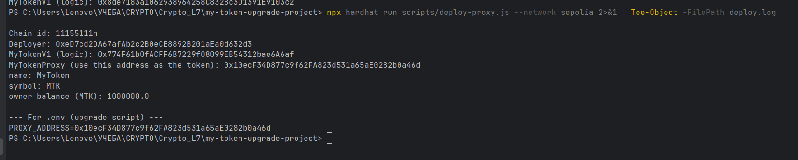SCREENSHOT: 01_deploy
Figure 1. Console output of the deployment script, showing the V1 logic address, the proxy address, and the initial balance of the deployer (1,000,000 MTK) read through the proxy.
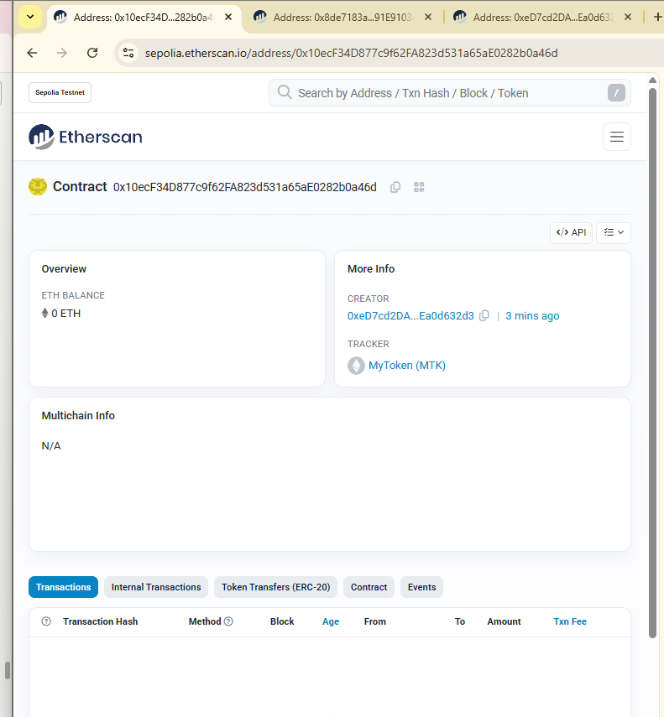SCREENSHOT: 02_etherscan_proxy
Figure 2. Proxy contract on Sepolia Etherscan, recognized as ERC-20 token MyToken (MTK). This confirms that standard ERC20 function calls delegated to V1 return correct values when queried through the proxy address.

Step 4: Interacting with V1 Through the Proxy
Task: Use the proxy address to mint and transfer tokens, verifying that the proxy correctly delegates calls to V1.
Solution:
Two operations demonstrate correct behavior of the proxy + V1 pair:
- mint(recipient, 500 MTK) — exercises the custom mint function restricted to the owner, defined in V1.
- transfer(recipient, 100 MTK) — exercises the standard ERC20 functionality inherited from ERC20Upgradeable.
Both calls go to the proxy address but are executed by V1's code in the proxy's storage context. If the proxy setup is correct, balances are updated in the proxy's state and remain tied to the proxy, not to V1.
Algorithm:
- Connect to the proxy using the V1 ABI
- Read balances of Owner and Recipient before the operations
- Send mint(recipient, 500 ether) from the owner
- Send transfer(recipient, 100 ether) from the owner
- Read balances after and confirm the expected results
Implementation (scripts/interact.js):
javascript
const token = await ethers.getContractAt("MyTokenV1", proxyAddress);

const mintTx = await token.mint(recipient, ethers.parseEther("500"));
await mintTx.wait();

const transferTx = await token.transfer(recipient, ethers.parseEther("100"));
await transferTx.wait();
Result: Owner balance changed from 1,000,000 MTK to 999,900 MTK. Recipient balance changed from 0 MTK to 600 MTK (500 minted + 100 transferred).
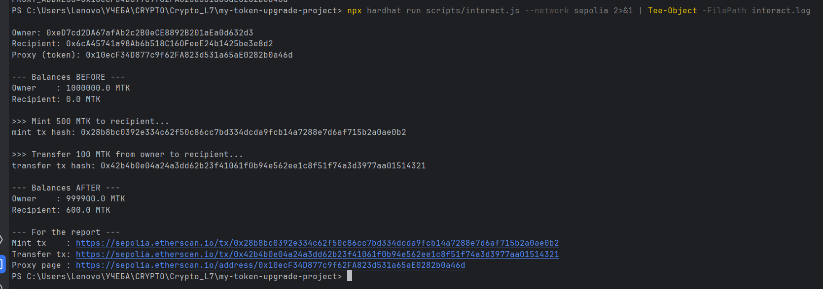SCREENSHOT: 03_mint_transfer
Figure 3. Console output of interact.js, showing balances before and after both operations.
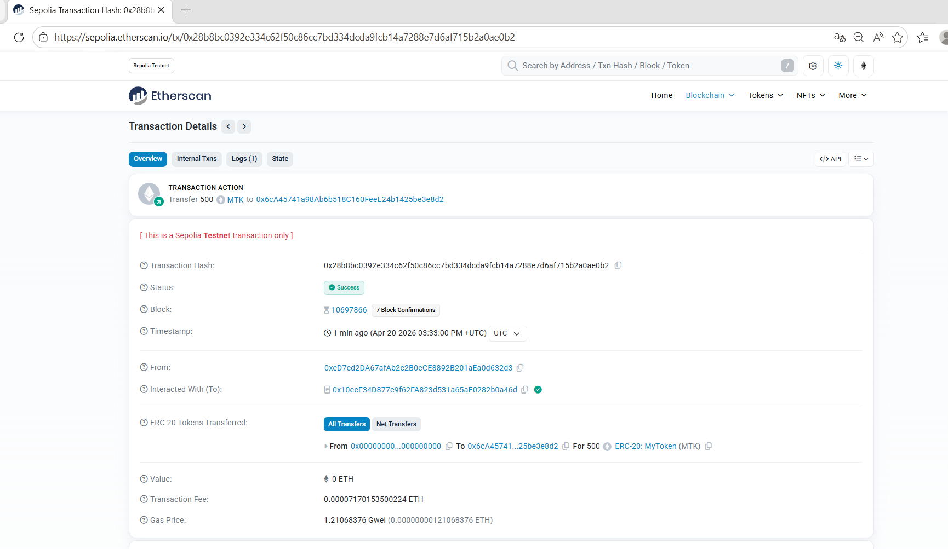 SCREENSHOT: 04_mint_tx
Figure 4. Mint transaction on Etherscan. The transfer is shown from the zero address 0x000...000 to the Recipient, which is the canonical on-chain representation of ERC20 minting. "Interacted With" points to the proxy.
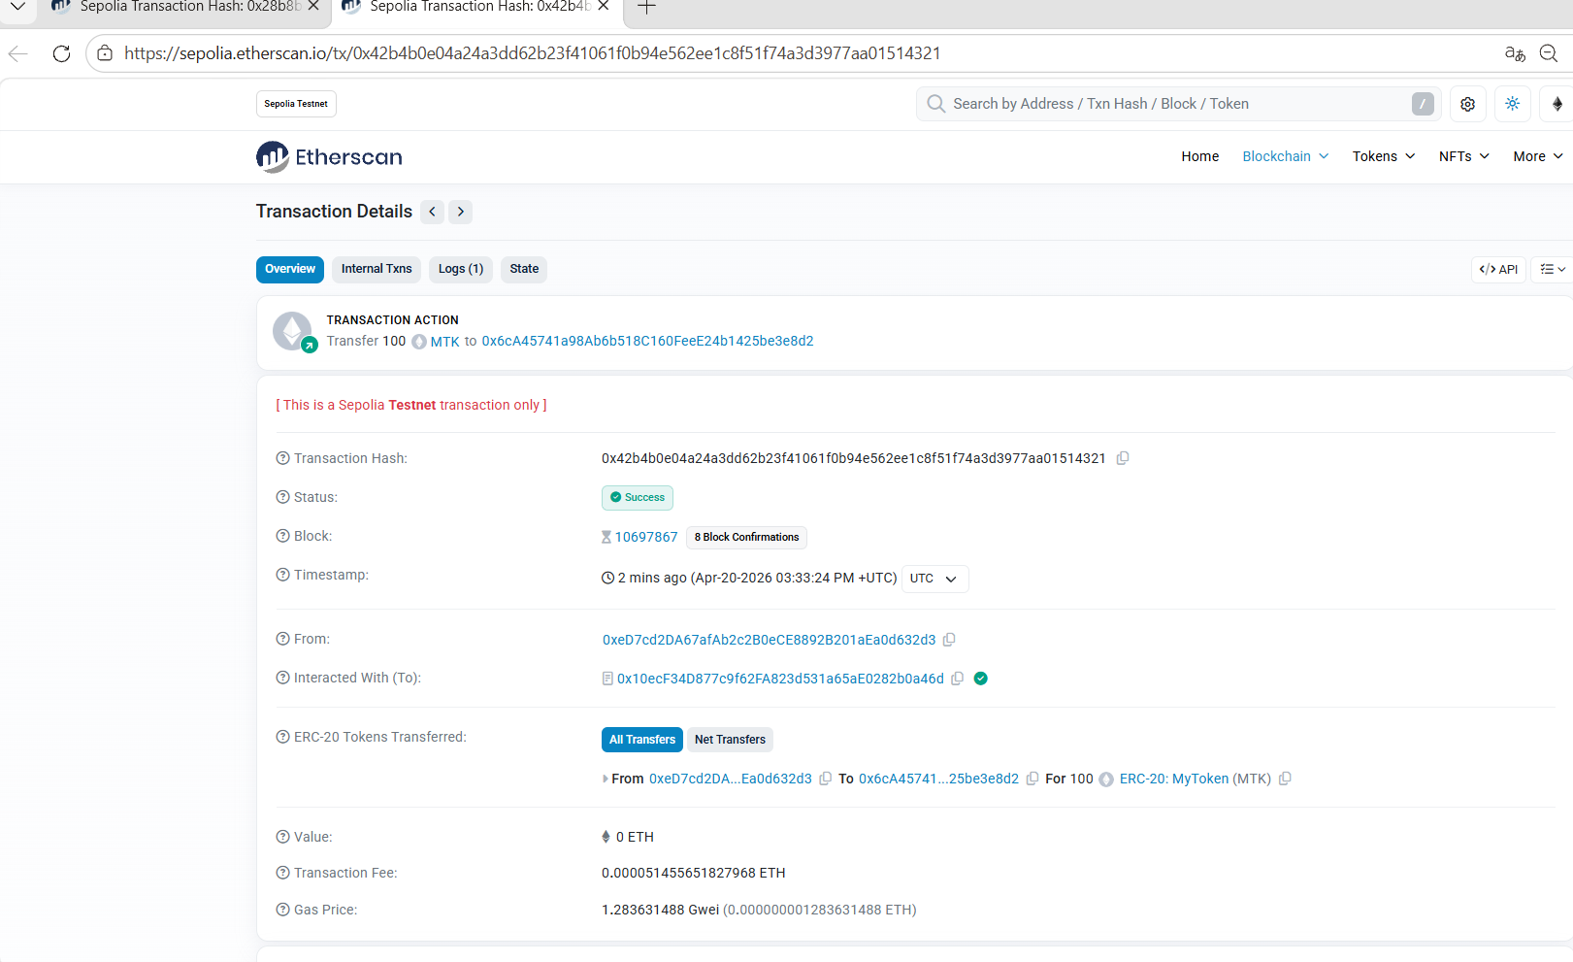SCREENSHOT: 05_transfer_tx
Figure 5. Transfer transaction on Etherscan: 100 MTK sent from Owner to Recipient through the proxy.
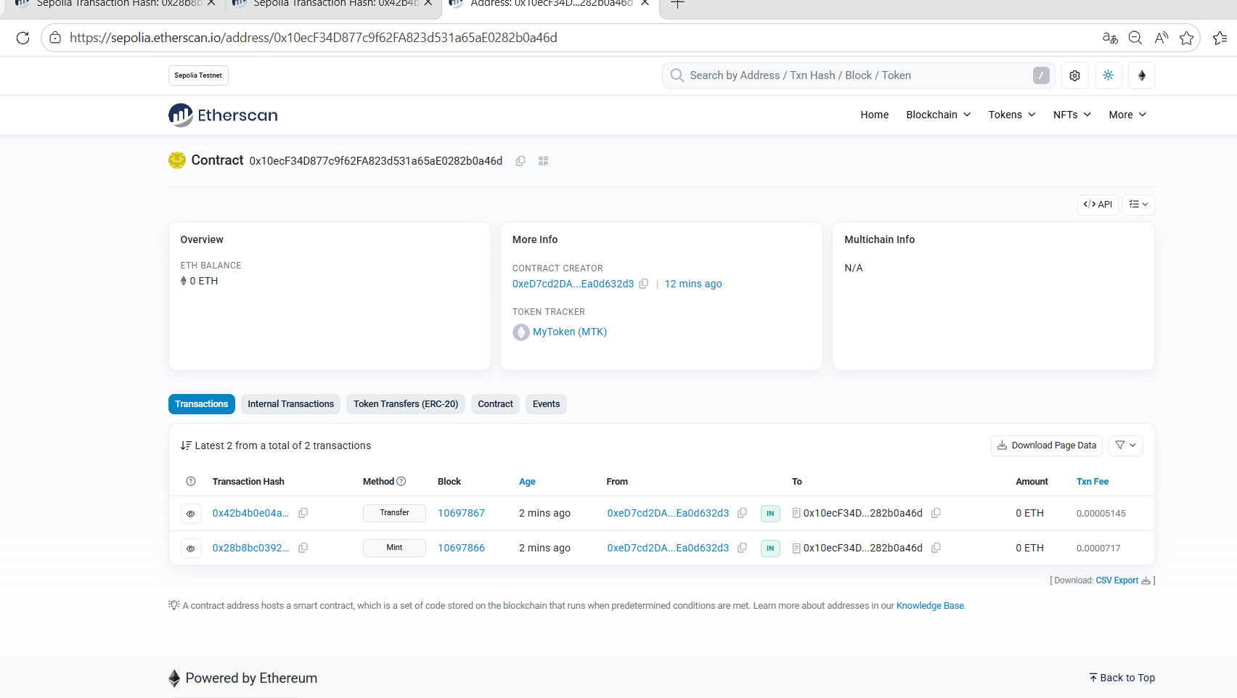SCREENSHOT: 06_proxy_transactions
Figure 6. Proxy transaction history after the interaction phase, showing both Mint and Transfer operations.

Step 5: Designing the V2 Implementation Contract
Task: Create an upgraded implementation (V2) that adds a new version() function while keeping the storage layout compatible with V1.
Solution:
The most critical constraint of any proxy upgrade is storage layout compatibility. Because the proxy keeps all state, the new implementation must declare storage variables in exactly the same order and types as the old one. Reordering, changing types, or inserting a variable in the middle would cause V2 to read or write to the wrong storage slot, corrupting existing balances and ownership data.
The simplest way to guarantee compatibility is to make V2 inherit directly from V1 and only append new functionality. Because V2 does not introduce any new storage variables in this assignment, inheritance is sufficient and no reinitialization is needed.
Algorithm:
- Inherit from MyTokenV1 in a new contract
- Add version() as a public pure function returning the string "V2"
- Do not declare any new state variables (would shift storage layout)
- Do not override initialize() (existing state must remain)
Implementation:
solidity
contract MyTokenV2 is MyTokenV1 {
function version() public pure returns (string memory) {
return "V2";
}
}
Result: V2 contract compiled successfully, maintaining full storage layout compatibility with V1.

Step 6: Upgrading the Proxy to V2
Task: Change the implementation address stored in the proxy from V1 to V2.
Solution:
In the UUPS pattern, the upgrade function (upgradeToAndCall) is defined on the implementation side, in UUPSUpgradeable. It is called through the proxy: the call is delegated to V1, which updates the ERC-1967 implementation slot in the proxy's storage to point to V2. From the next block onward, every call through the proxy will be delegated to V2 instead of V1.
Access to upgradeToAndCall is restricted by _authorizeUpgrade, which was overridden with onlyOwner in V1. Since V2 introduces no new storage and requires no reinitialization, the data argument of upgradeToAndCall is empty ("0x").
Algorithm:
- Deploy the V2 implementation contract
- Obtain a V1-typed interface bound to the proxy address (so the upgradeToAndCall selector is callable)
- Send upgradeToAndCall(v2Address, "0x") from the owner account
- Call version() through the proxy to confirm the upgrade is live
Implementation (scripts/upgrade-proxy.js):
javascript
const V2Factory = await ethers.getContractFactory("MyTokenV2");
const v2impl = await V2Factory.deploy();
await v2impl.waitForDeployment();

const v1AtProxy = await ethers.getContractAt("MyTokenV1", proxyAddress);
const tx = await v1AtProxy.upgradeToAndCall(await v2impl.getAddress(), "0x");
await tx.wait();
Result: V2 deployed at 0x430F3Ed7215efabC0dAD77360cE51a199e41cE99. Upgrade transaction hash: 0x30eb31ad2dab7cab72e81b08aa47aef05fac52d88b520d1c74ed33b73bda4e6d. Calling version() through the proxy returned "V2".
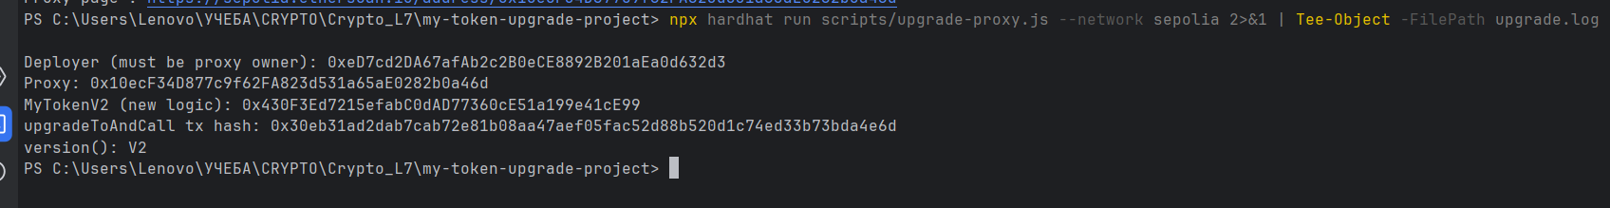SCREENSHOT: 07_upgrade
Figure 7. Console output of the upgrade script: V2 deployment, the upgrade transaction hash, and immediate confirmation that version() via proxy returns "V2".
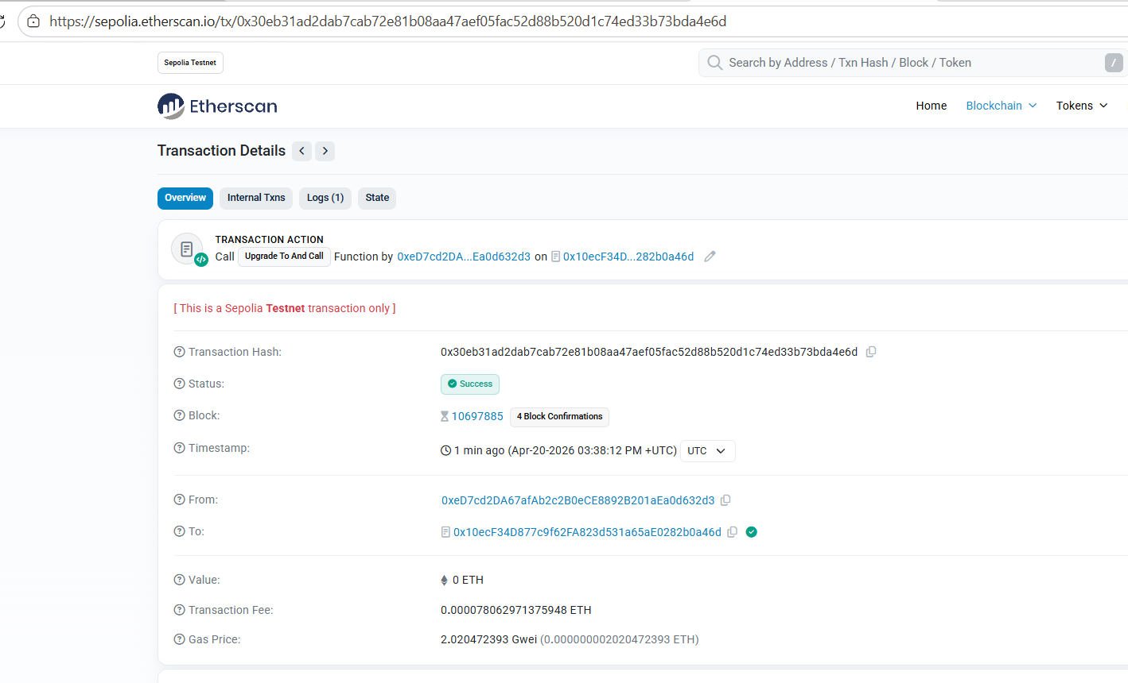SCREENSHOT: 8_upgrade_tx
Figure 8. Upgrade transaction on Etherscan. Status: Success. "Interacted With" is the proxy address. The Upgraded(address) event in the logs references the new V2 implementation address.
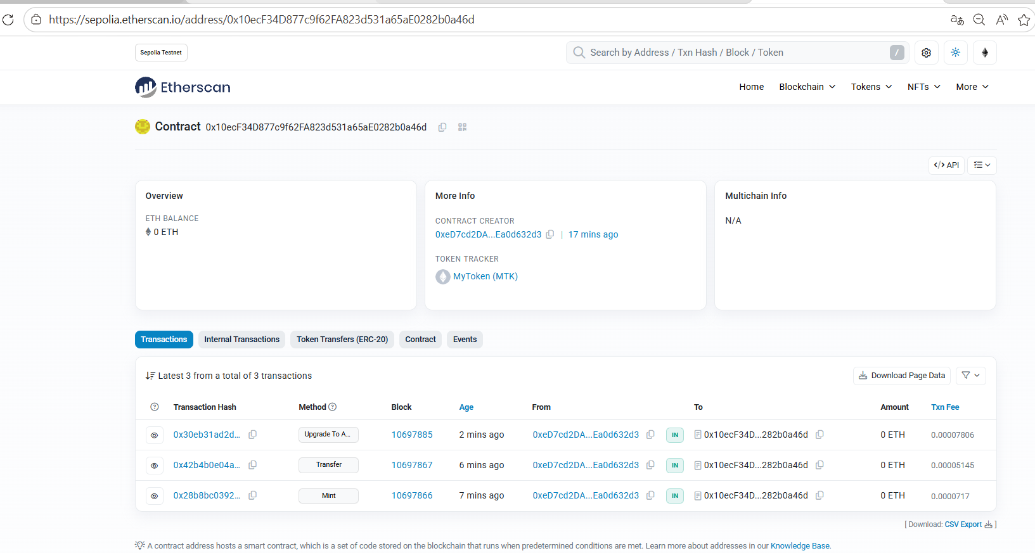SCREENSHOT: 9_proxy_all_txs
Figure 9. Proxy transaction history after the upgrade — four on-chain actions visible: contract creation, Mint, Transfer, and upgradeToAndCall.
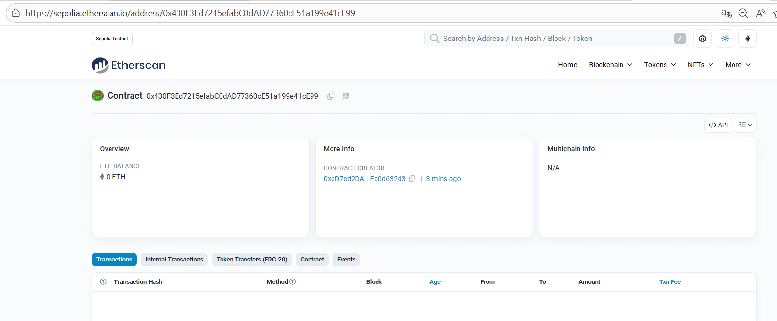SCREENSHOT: 10_v2_implementation
Figure 10. Newly deployed V2 implementation contract on Etherscan.

Step 7: Post-Upgrade Validation
Task: Confirm that (a) balances are preserved across the upgrade, (b) the new version() function is accessible through the proxy, and (c) the existing ERC20 functionality remains operational.
Solution:
The upgrade is considered successful only if the proxy's state is preserved and the new logic is reachable. Three checks are run via a dedicated verification script:
- Read balanceOf(owner), balanceOf(recipient), and totalSupply through the proxy and compare with pre-upgrade values.
- Call version() through the proxy — a function that did not exist in V1. If it returns "V2", the proxy is delegating to V2.
- Execute an additional transfer to demonstrate that ERC20 semantics inherited by V2 from V1 are intact.
Algorithm:
- Connect to the proxy using the V2 ABI
- Call version() and verify the returned string
- Read balances and compare to pre-upgrade values (Owner = 999,900 MTK, Recipient = 600 MTK)
- Execute transfer(recipient, 50 MTK) and re-check balances
Implementation (scripts/verify.js):
javascript
const token = await ethers.getContractAt("MyTokenV2", proxyAddress);

const ver = await token.version(); // "V2"
const ownerBal = await token.balanceOf(owner.address); // 999900 MTK
const recipBal = await token.balanceOf(recipient); // 600 MTK

const tx = await token.transfer(recipient, ethers.parseEther("50"));
await tx.wait();
Result:
- version() through proxy returned "V2" — new logic confirmed live.
- Owner and Recipient balances matched the pre-upgrade values exactly — storage fully preserved.
- Post-upgrade transfer of 50 MTK succeeded, updating final balances to 999,850 MTK (Owner) and 650 MTK (Recipient).
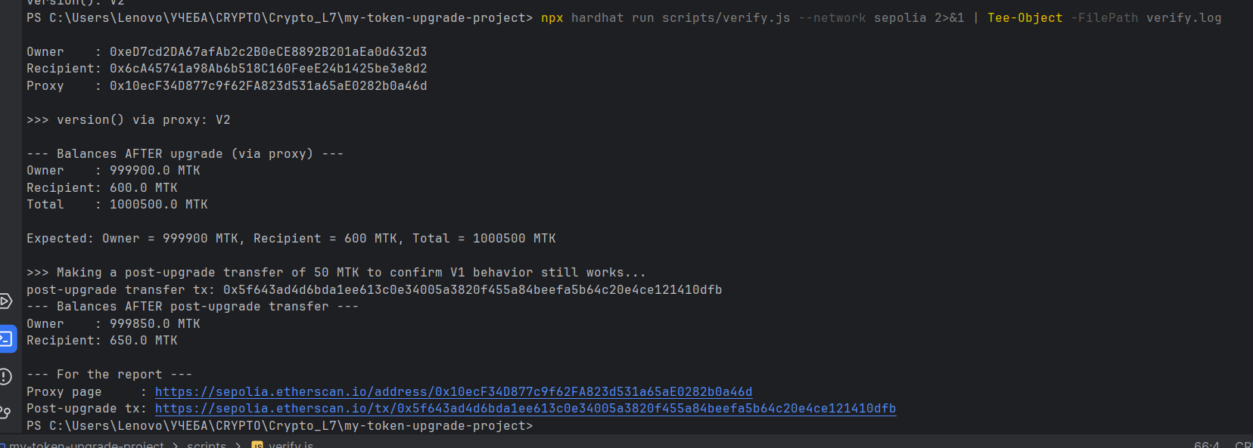SCREENSHOT: 11_verify
Figure 11. Output of verify.js, showing version() via proxy: V2, preserved balances (999,900 / 600 / total 1,000,500 MTK), and the successful post-upgrade transfer.
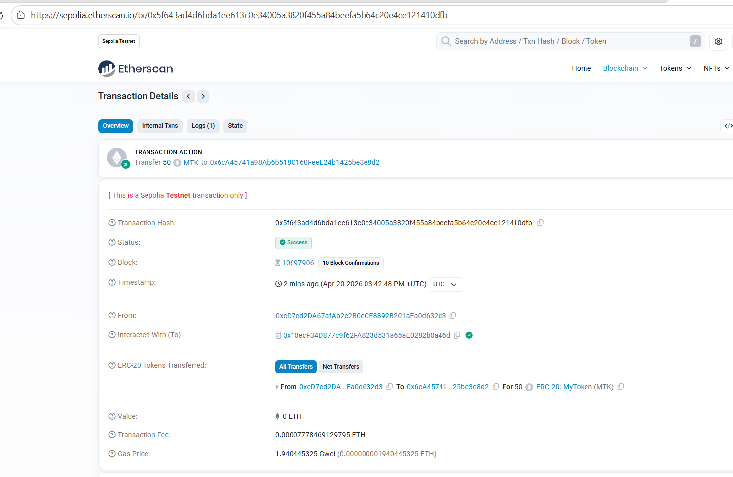SCREENSHOT: 12_post_upgrade_transfer
Figure 12. Post-upgrade transfer transaction on Etherscan, confirming that ERC20 functionality inherited from V1 continues to work after the upgrade.

Project Structure
my-token-upgrade-project/
├── contracts/
│ ├── MyTokenV1.sol — initial implementation (ERC20 + Ownable + UUPS)
│ ├── MyTokenV2.sol — upgraded implementation, inherits V1, adds version()
│ └── MyTokenProxy.sol — ERC1967-based UUPS proxy
├── scripts/
│ ├── deploy-proxy.js — deploys V1 and proxy, initializes supply
│ ├── interact.js — mints and transfers tokens through the proxy
│ ├── upgrade-proxy.js — deploys V2 and performs upgradeToAndCall
│ └── verify.js — validates balances and version() after upgrade
└── hardhat.config.ts — Sepolia network configuration

Conclusions
The following concepts of upgradeable smart contract design were practically applied during the assignment:
- The proxy pattern separates storage from logic, allowing contract behavior to evolve while keeping the same user-facing address and preserving all state.
- The UUPS pattern places upgrade authorization inside the implementation, producing a minimal proxy and shifting responsibility (and flexibility) to the logic contract.
- The initializer mechanism replaces constructors in upgradeable contracts, because constructor state never reaches the proxy's storage.
- Calling _disableInitializers() in the implementation's own constructor prevents direct takeover of the logic contract.
- Storage layout compatibility is the core safety invariant of upgrades: new implementations may only append state variables, never reorder or retype existing ones.
- delegatecall executes the implementation's code in the proxy's storage context, which is what makes all the above work as a coherent system.

