
PUNDRA UNIVERSITY OF
SCIENCE & TECHNOLOGY

PROJECT REPORT
CleanCity Simulator
Smart City Waste Management Simulation using C++ and OpenGL
Course Title | : Computer Graphics Sessional
Course Code | : CSE 4202
Submission Date | : 14 Nov 2026

  SUBMITTED BY
  Name | Md. Samiual Mia
  ID | 0322410105101001
  Program | BSc in CSE
  Semester | 6th
  Batch | 24th
  SUBMITTED TO
  Name | Radha Rani Paul
  Designation | Lecturer
  Department | CSE
  Signature

CleanCity Simulator
Smart City Waste Management Simulation
Md. Samiual Mia

1. Project Name
CleanCity Simulator (executable: CleanCitySimulator.exe)
Subtitle: Smart City Waste Management and Cleanliness Monitoring Simulation

2. Project Description

CleanCity Simulator is a 2D software-based simulation that demonstrates how a smart city manages waste collection and recycling. The project is developed in C++ using OpenGL and FreeGLUT. It is entirely software-based, meaning no physical hardware, sensors, GPS, or real-world data are required. All activities take place within the simulation.

The city includes roads, buildings, a lake, a park, and a Collection Center. It has twelve smart dustbins (DB-01 to DB-12) that gradually fill up over time. Three garbage trucks operate from the Collection Center, follow the shortest available routes to selected dustbins, collect the waste, and return to the recycling facility to unload it. A dashboard also displays real-time statistics, providing an overview of waste collection and recycling activities across the city.

Main features
- Interactive city map. A 5 x 4 road grid with buildings, trees, traffic lights, clouds and a lake. Clicking a dustbin shows its details.
- Shortest-path routing. Dijkstra’s algorithm finds the shortest route on the road graph, and the truck follows exactly that route.
- Garbage truck simulation. Trucks move through the states Idle, To Bin, Collecting, Returning and Unloading, with animated wheels.
- Traffic mode. Congested roads cost 2.5 times more, so routes change when traffic is switched on.
- Day / night cycle. A smooth blend between day and night scenes.
- Recycling center. Waste is recycled at a different rate for each category: Organic 85%, Plastic 60%, Paper 80%, Metal 95%, Glass 90%.
- Dashboard and statistics. Live counters, zone cleanliness, bin levels and a one-click PDF report.
- Auto dispatch. Trucks are sent automatically to bins that need service.

Computer Graphics concepts used
- Rendering. A matrix stack renderer, time-based animation (dt), mouse picking, alpha blending and gradients.

3. Tools
Item | Used in this project
Language | C++ (C++11)
Graphics library | OpenGL (legacy fixed pipeline)
Window and input | FreeGLUT (freeglut.dll on Windows)
Compiler | MinGW-w64 g++ (GCC); also builds with Clang and MSVC
Build system | CMake, Makefile and build_windows.bat
Algorithm | Dijkstra’s shortest path (priority queue)
Version control | Git and GitHub
Platform | Windows (also builds on Linux and macOS)

4. Source Code
The project has 33 source and header files (about 3,700 lines). The key files are listed below. The complete source code is available in the project folder and on GitHub: github.com/samiual67/CleanCity-Simulator

Project structure
File | Purpose
main.cpp | GLUT setup and the main loop (about 60 FPS timer)
Application.cpp | Screens, buttons and input handling
Simulation.cpp | Simulation state and commands
CityLayout.cpp / CityMap.cpp | Road graph and city drawing
WasteManager.cpp / Dustbin.cpp | Dustbins, levels and sample data
GarbageTruck.cpp | Truck state machine and movement
RoutePlanner.cpp | Dijkstra shortest path
RecyclingCenter.cpp | Recycling processing
Dashboard.cpp / Statistics.cpp / PdfReport.cpp | Dashboard, statistics and PDF report
Gfx.cpp / Objects.cpp / UIComponents.cpp | Drawing helpers, objects and buttons
src/main.cpp
#include "GLInclude.h"
#include <cstdlib>
#include "Application.h"
static Application app;
static int lastTime = 0;
static void display() {
app.render();
glutSwapBuffers();
}
static void reshape(int w, int h) {
app.setWindowSize(w, h);
}
static void timer(int) {
int now = glutGet(GLUT_ELAPSED_TIME);
float dt = (now - lastTime) / 1000.0f;
lastTime = now;
if (dt > 0.05f) dt = 0.05f; // avoid huge jumps (window drag, breakpoints)
app.update(dt);
if (app.wantsExit) std::exit(0);
glutPostRedisplay();
glutTimerFunc(16, timer, 0); // ~60 FPS
}

static void mouse(int b, int s, int x, int y) { app.onMouse(b, s, x, y); }
static void motion(int x, int y) { app.onMotion(x, y); }
static void passive(int x, int y) { app.onPassiveMotion(x, y); }
static void keyboard(unsigned char k, int, int) { app.onKey(k); }
static void special(int k, int, int) { app.onSpecial(k); }
static void wheel(int, int dir, int x, int y) { app.onWheel(dir, x, y); }

int main(int argc, char** argv) {
glutInit(&argc, argv);
glutInitDisplayMode(GLUT_DOUBLE | GLUT_RGB);
glutInitWindowSize(WIN_W, WIN_H);
glutInitWindowPosition(60, 40);
glutCreateWindow("CleanCity Simulator - Smart City Waste Management Simulation");

app.init();
app.setWindowSize(WIN_W, WIN_H);

glutDisplayFunc(display);
glutReshapeFunc(reshape);
glutMouseFunc(mouse);
glutMotionFunc(motion);
glutPassiveMotionFunc(passive);
glutKeyboardFunc(keyboard);
glutSpecialFunc(special);
glutMouseWheelFunc(wheel);
lastTime = glutGet(GLUT_ELAPSED_TIME);
glutTimerFunc(16, timer, 0);
glutMainLoop();
return 0;
}
include/RoutePlanner.h
// RoutePlanner.h - road graph + Dijkstra's shortest path algorithm
#pragma once
#include "Common.h"
struct RoadEdge {
int a, b;
float length; // euclidean length (simulation units)
float factor; // congestion multiplier (1 = free road)
float weight() const { return length * factor; }
};

class RoutePlanner {
public:
int addNode(Vec2 p);
int addEdge(int a, int b);
void setEdgeFactor(int e, float f) { edges_[e].factor = f; }
void clear() { nodes_.clear(); edges_.clear(); adj_.clear(); }

// Dijkstra: returns node ids from s to t (empty if unreachable).
// cost = sum of edge weights, dist = pure geometric length, visited = nodes settled.
std::vector<int> shortestPath(int s, int t, float* cost = 0, float* dist = 0, int* visited = 0) const;

int nearestNode(const Vec2& p) const;
std::vector<int> neighbors(int n) const;
int findEdge(int a, int b) const;

const std::vector<Vec2>& nodes() const { return nodes_; }
const std::vector<RoadEdge>& edges() const { return edges_; }

private:
std::vector<Vec2> nodes_;
std::vector<RoadEdge> edges_;
std::vector<std::vector<int>> adj_; // adjacency list of edge indices
};
src/RoutePlanner.cpp
#include "RoutePlanner.h"
#include <queue>
#include <limits>

int RoutePlanner::addNode(Vec2 p) {
nodes_.push_back(p);
adj_.push_back(std::vector<int>());
return (int)nodes_.size() - 1;
}

int RoutePlanner::addEdge(int a, int b) {
RoadEdge e;
e.a = a; e.b = b; e.factor = 1.0f;
e.length = distf(nodes_[a], nodes_[b]);
edges_.push_back(e);
int id = (int)edges_.size() - 1;
adj_[a].push_back(id);
adj_[b].push_back(id);
return id;
}

std::vector<int> RoutePlanner::shortestPath(int s, int t, float* cost, float* dist, int* visited) const {
const float INF = std::numeric_limits<float>::max();
int n = (int)nodes_.size();
std::vector<int> path;
if (s < 0 || t < 0 || s >= n || t >= n) return path;

std::vector<float> d(n, INF);
std::vector<int> prev(n, -1);
std::vector<char> done(n, 0);
typedef std::pair<float, int> QItem;
std::priority_queue<QItem, std::vector<QItem>, std::greater<QItem> > pq;
d[s] = 0;
pq.push(QItem(0.0f, s));
int settled = 0;

while (!pq.empty()) {
QItem top = pq.top(); pq.pop();
int u = top.second;
if (done[u]) continue;
done[u] = 1;
settled++;
if (u == t) break;
for (size_t k = 0; k < adj_[u].size(); k++) {
const RoadEdge& e = edges_[adj_[u][k]];
int v = (e.a == u) ? e.b : e.a;
float nd = d[u] + e.weight();
if (nd < d[v]) {
d[v] = nd;
prev[v] = u;
pq.push(QItem(nd, v));
}
}
}
if (visited) *visited = settled;
if (d[t] == INF) return path;

for (int v = t; v != -1; v = prev[v]) path.push_back(v);
std::reverse(path.begin(), path.end());
if (cost) *cost = d[t];
if (dist) {
float L = 0;
for (size_t i = 1; i < path.size(); i++) L += distf(nodes_[path[i - 1]], nodes_[path[i]]);
*dist = L;
}
return path;
}

int RoutePlanner::nearestNode(const Vec2& p) const {
int best = -1; float bd = 1e30f;
for (size_t i = 0; i < nodes_.size(); i++) {
float d = distf(nodes_[i], p);
if (d < bd) { bd = d; best = (int)i; }
}
return best;
}

std::vector<int> RoutePlanner::neighbors(int n) const {
std::vector<int> r;
for (size_t k = 0; k < adj_[n].size(); k++) {
const RoadEdge& e = edges_[adj_[n][k]];
r.push_back(e.a == n ? e.b : e.a);
}
return r;
}

int RoutePlanner::findEdge(int a, int b) const {
for (size_t k = 0; k < adj_[a].size(); k++) {
const RoadEdge& e = edges_[adj_[a][k]];
if ((e.a == a && e.b == b) || (e.a == b && e.b == a)) return adj_[a][k];
}
return -1;
}
src/GarbageTruck.cpp
#include "GarbageTruck.h"

static const float COLLECT_TIME = 1.8f;
static const float UNLOAD_TIME = 1.2f;

void GarbageTruck::init(int truckId, Vec2 homePos, Color c) {
id = truckId;
home = homePos;
color = c;
mover = Mover();
mover.pos = home;
mover.angle = 0;
mover.speed = 110.0f;
state = T_IDLE;
targetBin = -1;
route.clear();
routeDist = routeCost = 0;
timer = progress = 0;
wheelAngle = 0;
collections = 0;
totalCollected = 0;
for (int i = 0; i < W_COUNT; i++) cargo[i] = 0;
}

std::string GarbageTruck::label() const {
char b[16]; std::snprintf(b, sizeof(b), "TR-%d", id + 1); return b;
}

float GarbageTruck::cargoTotal() const {
float s = 0; for (int i = 0; i < W_COUNT; i++) s += cargo[i]; return s;
}

std::string GarbageTruck::statusText() const {
char b[64];
switch (state) {
case T_IDLE: return "Idle at depot";
case T_TO_BIN: std::snprintf(b, sizeof(b), "En route to DB-%02d", targetBin + 1); return b;
case T_COLLECTING: std::snprintf(b, sizeof(b), "Collecting DB-%02d (%d%%)", targetBin + 1, (int)(progress * 100)); return b;
case T_RETURNING: return "Returning to depot";
default: return "Unloading cargo";
}
}

static std::vector<Vec2> routePoints(const RoutePlanner& rp, const std::vector<int>& r) {
std::vector<Vec2> p;
for (size_t i = 0; i < r.size(); i++) p.push_back(rp.nodes()[r[i]]);
return p;
}

static std::vector<Vec2> lanePath(const std::vector<Vec2>& in) {
std::vector<Vec2> p; // drop repeated points
for (size_t i = 0; i < in.size(); i++)
if (p.empty() || distf(p.back(), in[i]) > 0.001f) p.push_back(in[i]);
std::vector<Vec2> o;
if (p.size() < 2) return o;
std::vector<Vec2> n; // left-hand normal of every road segment
for (size_t i = 0; i + 1 < p.size(); i++) {
Vec2 d = p[i + 1] - p[i];
float len = std::sqrt(d.x * d.x + d.y * d.y);
n.push_back(Vec2(d.y / len, -d.x / len));
}
o.push_back(p.front() + n.front() * LANE_OFFSET);
for (size_t i = 1; i + 1 < p.size(); i++) { // mitre the lane at every junction
Vec2 s = n[i - 1] + n[i];
float den = 1.0f + n[i - 1].x * n[i].x + n[i - 1].y * n[i].y;
o.push_back(den > 0.2f ? p[i] + s * (LANE_OFFSET / den) : p[i] + n[i] * LANE_OFFSET);
}
o.push_back(p.back() + n.back() * LANE_OFFSET);
return o;
}

static std::vector<Vec2> departPath(const std::vector<Vec2>& road, const Vec2& home) {
std::vector<Vec2> o = lanePath(road);
if (o.empty()) return road;
if (o.size() >= 2 && std::fabs(o[0].y - o[1].y) < 0.01f) o[0].x = home.x; // start from this bay, no backtracking
o.insert(o.begin(), Vec2(home.x, o.front().y)); // leave the bay straight onto the road
return o;
}

static std::vector<Vec2> returnPath(const std::vector<Vec2>& road, const Vec2& home) {
std::vector<Vec2> o = lanePath(road);
if (o.size() >= 2 && std::fabs(o[o.size() - 1].y - o[o.size() - 2].y) < 0.01f) o.back().x = home.x; // stop in front of this bay
if (!o.empty()) o.push_back(Vec2(home.x, o.back().y)); // turn into the bay straight
o.push_back(home);
return o;
}

bool GarbageTruck::assign(int binId, const RoutePlanner& rp, WasteManager& wm, int depotNode) {
if (state != T_IDLE || binId < 0 || binId >= (int)wm.bins.size()) return false;
Dustbin& b = wm.bins[binId];
float cost = 0, dist = 0;
std::vector<int> r = rp.shortestPath(depotNode, b.nodeId, &cost, &dist); // Dijkstra
if (r.empty()) return false;
route = r;
routeDist = dist;
routeCost = cost;
mover.setPath(departPath(routePoints(rp, r), home));
state = T_TO_BIN;
targetBin = binId;
b.status = CS_ASSIGNED;
return true;
}

void GarbageTruck::update(float dt, const RoutePlanner& rp, WasteManager& wm, RecyclingCenter& rc, int depotNode) {
bool moving = mover.active;
switch (state) {
case T_IDLE: break;

case T_TO_BIN:
if (mover.update(dt)) {
state = T_COLLECTING;
timer = 0; progress = 0;
wm.bins[targetBin].status = CS_COLLECTING;
}
break;

case T_COLLECTING: {
timer += dt;
progress = clampf(timer / COLLECT_TIME, 0, 1);
if (timer >= COLLECT_TIME) {
Dustbin& b = wm.bins[targetBin];
float amount = b.empty();
b.status = CS_WAITING;
cargo[b.category] += amount;
collections++;
totalCollected += amount;
wm.recordCollection(id, b, amount);
char msg[96];
std::snprintf(msg, sizeof(msg), "%s collected %.0f kg of %s from %s", label().c_str(),
amount, wasteInfo(b.category).name, b.label().c_str());
wm.addLog(msg);
// plan the way back with Dijkstra again
std::vector<int> r = rp.shortestPath(b.nodeId, depotNode, &routeCost, &routeDist);
route = r;
std::vector<Vec2> pts = returnPath(routePoints(rp, r), home);

mover.setPath(pts);
state = T_RETURNING;
}
break;
}

case T_RETURNING:
if (mover.update(dt)) { state = T_UNLOADING; timer = 0; progress = 0; }
break;

case T_UNLOADING:
timer += dt;
progress = clampf(timer / UNLOAD_TIME, 0, 1);
while (mover.angle > 180) mover.angle -= 360; // swing the truck straight in its bay
while (mover.angle < -180) mover.angle += 360;
mover.angle += (0 - mover.angle) * clampf(dt * 8.0f, 0.0f, 1.0f);
if (timer >= UNLOAD_TIME) {
char msg[96];
std::snprintf(msg, sizeof(msg), "%s delivered %.0f kg to the Recycling Facility", label().c_str(), cargoTotal());
wm.addLog(msg);
rc.receive(cargo);
for (int i = 0; i < W_COUNT; i++) cargo[i] = 0;
state = T_IDLE;
targetBin = -1;
route.clear();
mover.angle = 0;
}
break;
}
if (moving) wheelAngle += mover.speed * dt / 4.5f * 180.0f / PI_F;
}

5. Output:
The screenshots below were taken from the running simulator.
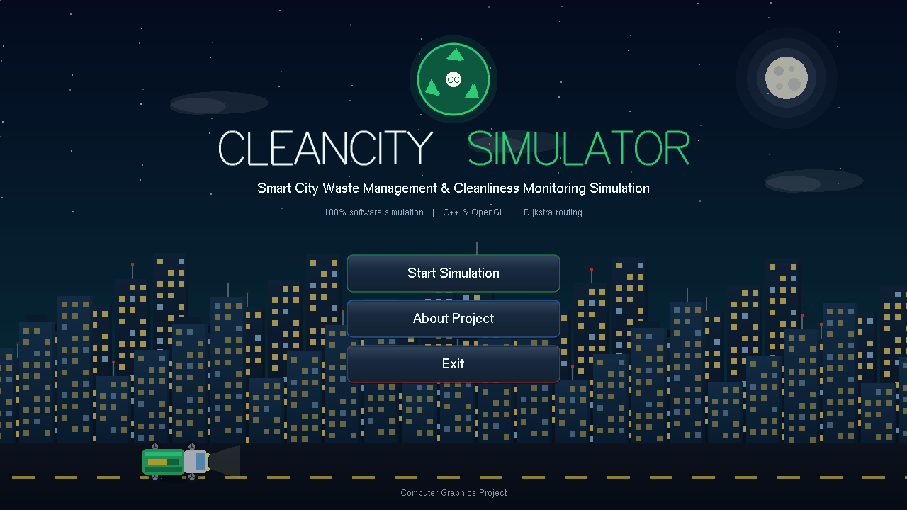
Figure 1: Splash screen

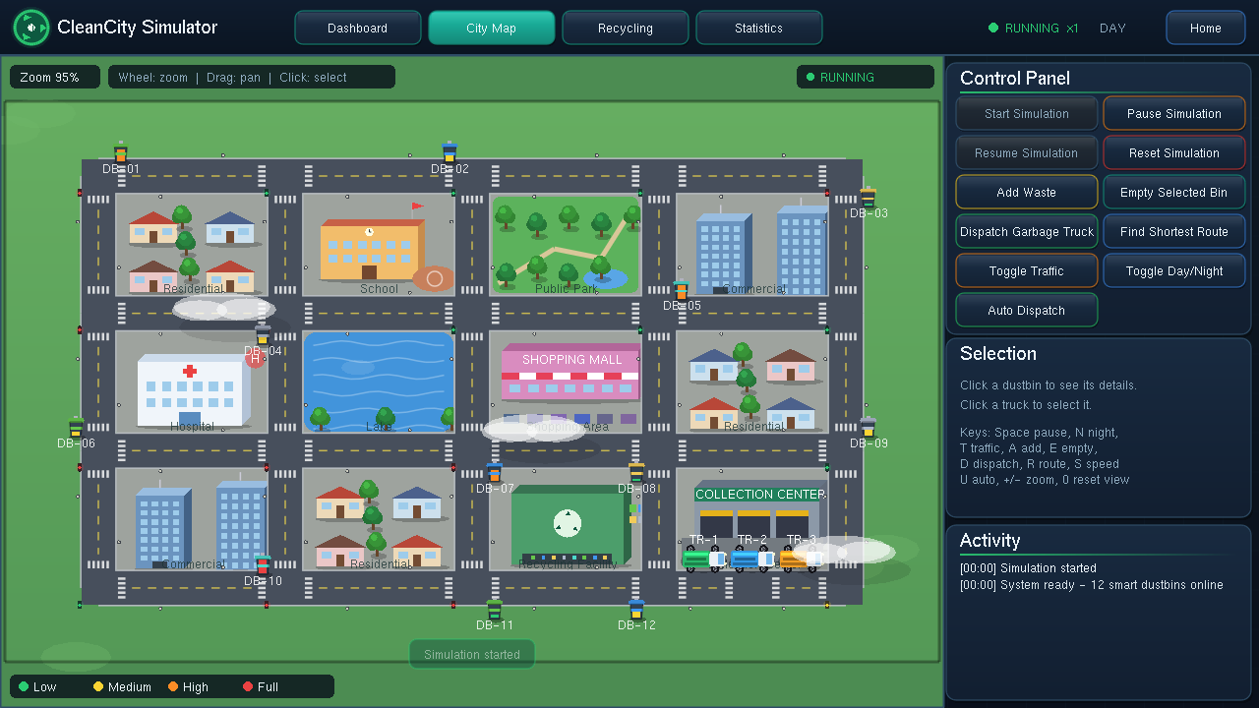
Figure 2: City map with 12 dustbins and 3 trucks at the Collection Center
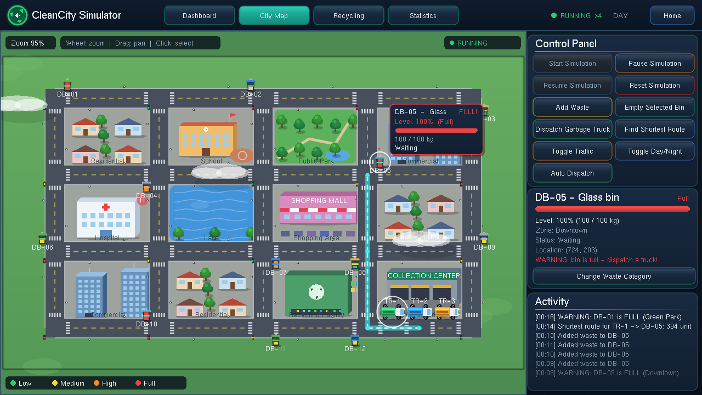
Figure 3: Shortest route from the depot to the selected dustbin (DB-05)

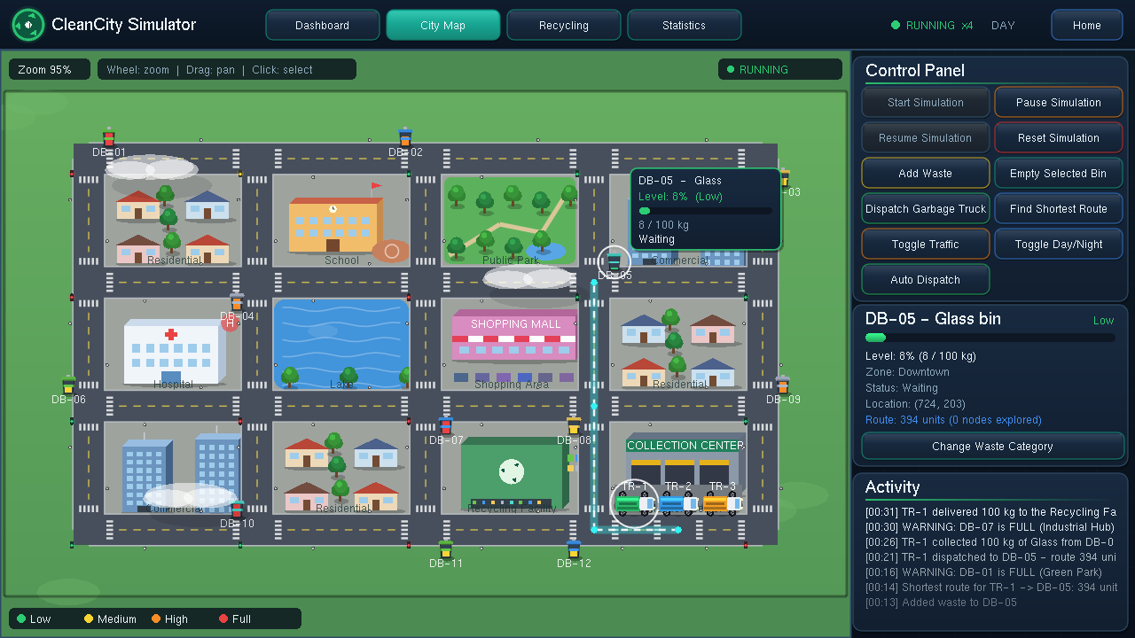
Figure 4: Truck collecting and delivering waste, with the activity log
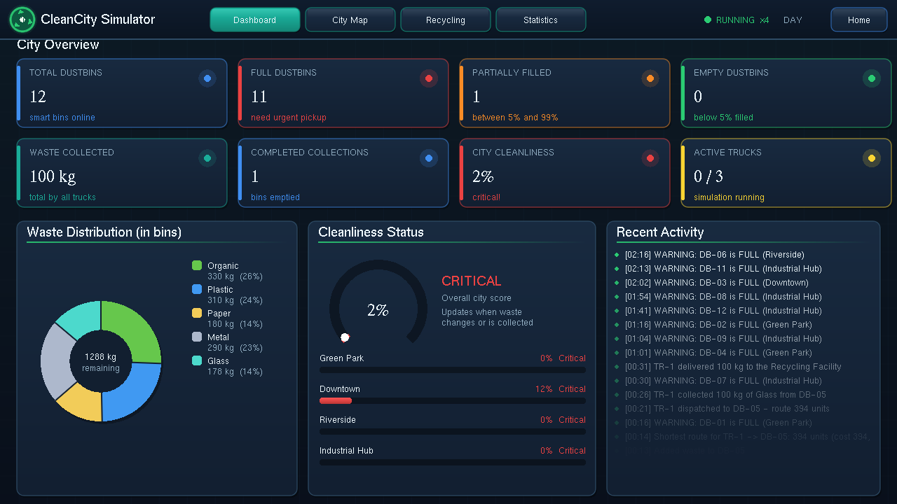
Figure 5: Dashboard with live city statistics

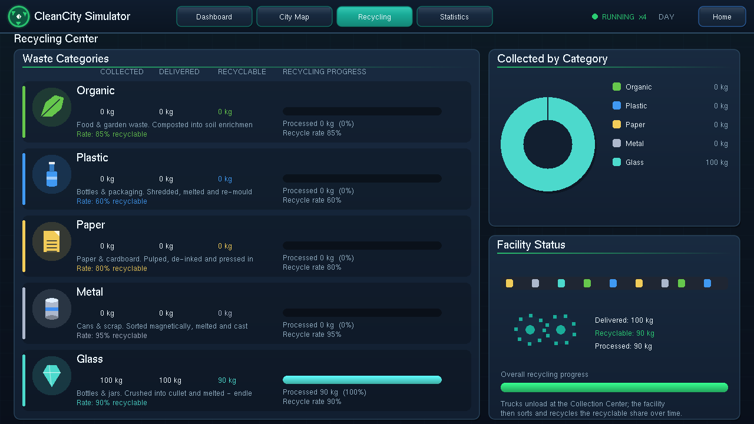
Figure 6: Recycling center with category-wise progress
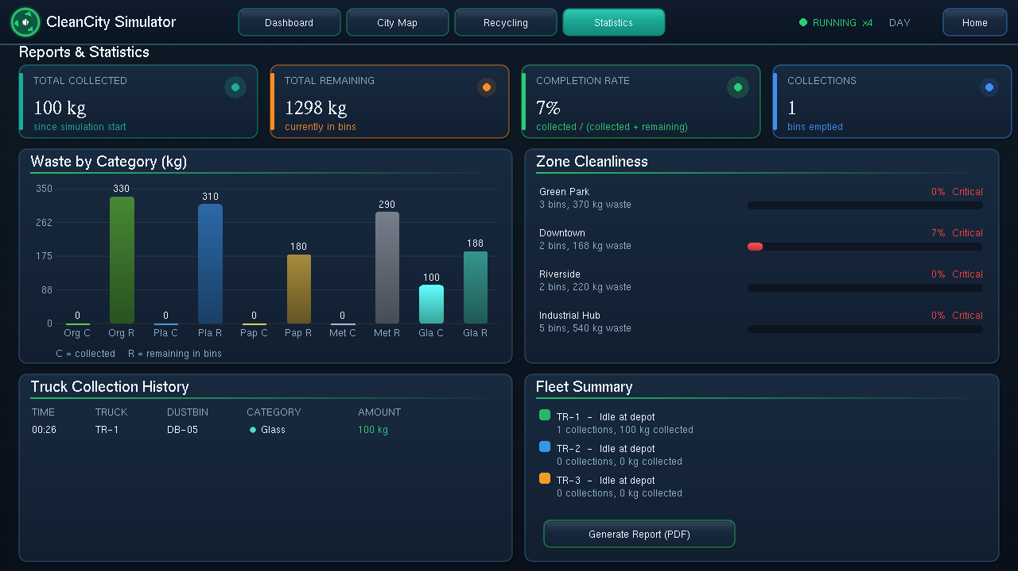
Figure 7: Reports and statistics screen

6. Use / Application
CleanCity Simulator is designed as an educational and demonstration tool. It has several practical uses:
• Computer Graphics education. It provides a practical example of matrix-stack rendering, camera control, animation, and mouse picking within a single working project.
• Algorithm demonstration. It illustrates how Dijkstra’s algorithm finds the shortest path through a weighted road network and how traffic conditions can affect route selection.
• Smart city and waste management planning. It demonstrates how a city could organize its waste collection process by identifying full dustbins, assigning suitable garbage trucks, and selecting efficient routes.
• Environmental awareness. It provides a clear view of the amount of waste collected and recycled in each category, helping users understand the importance of proper waste management and recycling.
• Software design practice. It serves as a complete C++ project with separate logic and rendering components, making it a useful example of object-oriented programming and modular software design.
As the entire system is software-based, it can run on an ordinary computer without requiring any additional hardware. The concepts demonstrated in this project could also be extended in the future by integrating real sensors and GPS data into an actual smart city waste management system.

