LAB # 1
Introduction to Eclipse IDE
OBJECTIVE
Introduction to Eclipse IDE, creating projects, its classes and mapping UML class diagram in to java code.
Lab Task
Write the java code with the help of the given class diagram of Hospital Management System.
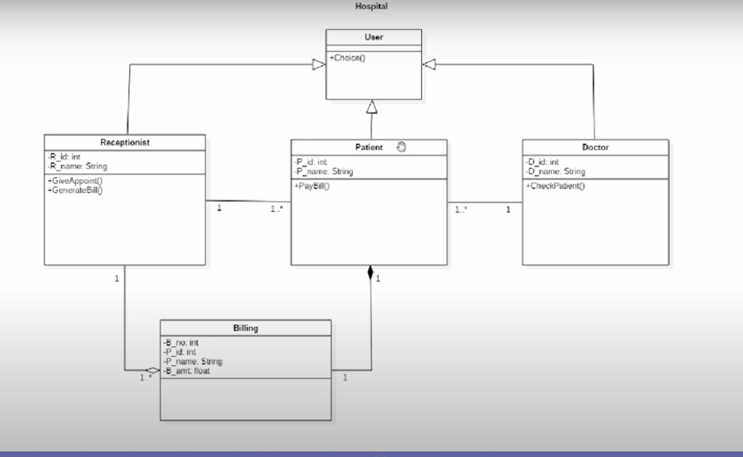

Code:
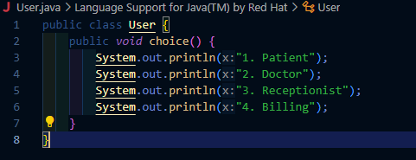
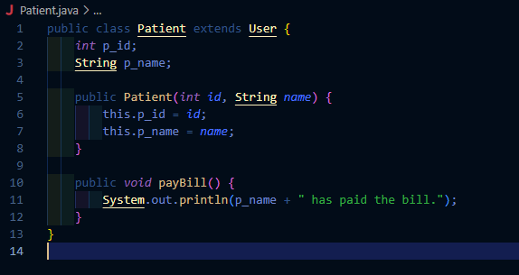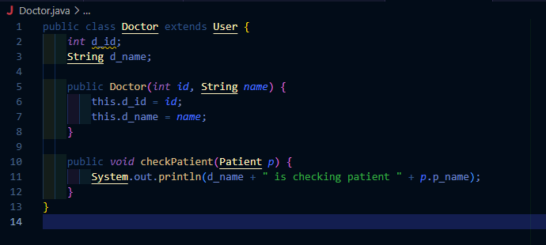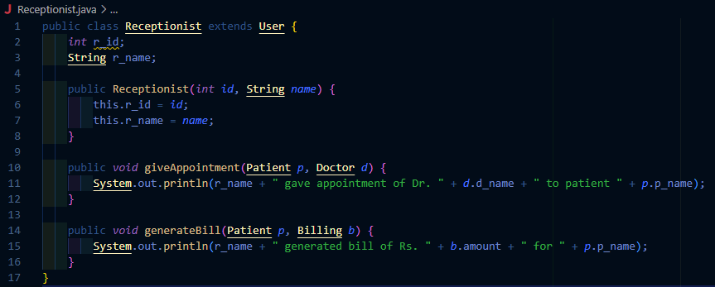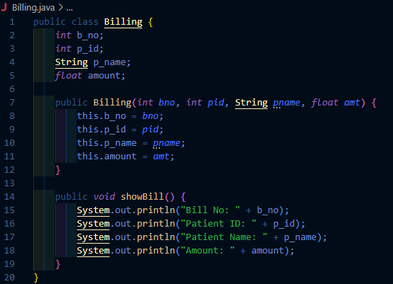
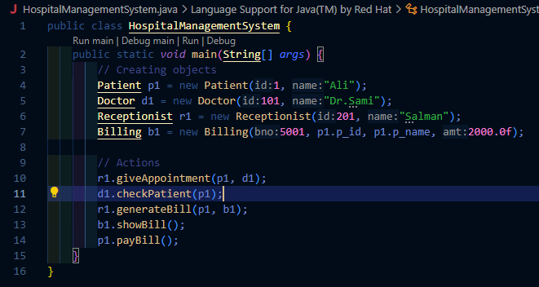
Output:
