LAB # 3
Introduction to Concurrency
OBJECTIVE
Understanding and implementing the concept of concurrency through different mechanisms of multithreading.
Lab Task:
- Implement the following program on eclipse IDE and answer the following questions:
- How many threads are running?
Three threads are running: t1, t2, and t3.
Each one runs the run() method independently.
- How many tasks are running?
Three tasks are running (each thread performs one task → prints "task one").
- If more tasks are added than what will be the impact on number of threads?
If you add more tasks (like t4, t5, etc.),
then more threads will run concurrently.
Each new thread runs separately and executes its own task.
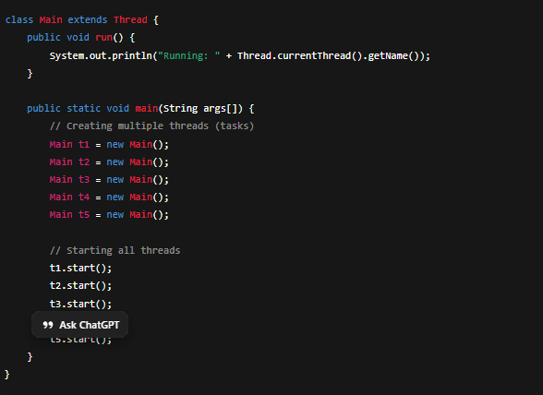

- Explain the flow of program:
class Main extends Thread{
public void run(){
System.out.println("task one");
}
public static void main(String args[]){
Main t1=new Main();
Main t2=new Main();
Main t3=new Main();
t1.start();
t2.start();
t3.start();
}
}

Flow of Program Explanation
- Class Definition:
The class Main extends Thread, meaning each object of this class can work as a separate thread.
- run() Method:
The run() method contains the code that each thread will execute — here it simply prints "task one".
- main() Method Execution:
- The program starts from main().
- Three thread objects are created: t1, t2, and t3.
- Starting Threads:
- When t1.start(), t2.start(), and t3.start() are called, each thread begins execution independently.
- Each thread internally calls its run() method.
- Concurrent Execution:
- All three threads run at the same time, so the output may appear in any order (because threads run concurrently).
- Program End:
- After all threads finish printing "task one", the program ends.

- With the help of threading print two tables concurrently, print one table number of student roll number e.g. 2019-SE-092 and second number should be date of birth e.g. 05-April.
Code:
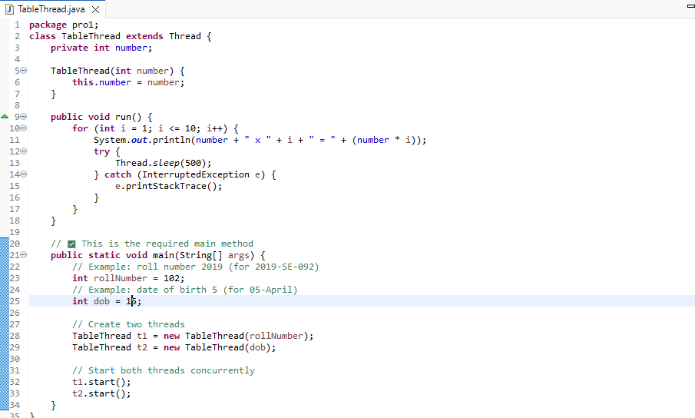
Output:
