Interim Progress Report
Project Title | Self-Correcting Multi-Agent RAG for Contradictory Knowledge Bases
Module Code & Title | 7COM1075 – Data Science and Analytics Masters Project
Programme | MSc Data Science and Analytics
University | University of Hertfordshire
Student Name | Gurkirat Singh
Student ID | 24068509
Supervisor | Zarah Bello

1. Introduction
This project aims to design and implement a retrieval-augmented generation (RAG) system that can reason over contradictory sources and present transparent, evidence-based answers to users. Most existing question-answering systems either ignore conflicts between documents or silently choose one viewpoint, which makes them difficult to trust in research and decision-making contexts. My goal is to build a multi-agent pipeline that explicitly detects conflicts, attempts to resolve them using interpretable rules, and exposes the underlying evidence and evaluation metrics in a user-friendly interface.
The work is grounded in recent advances in large language models, agentic workflows, and retrieval-based augmentation, but the emphasis is on robust engineering and explainable behaviour rather than on training new models. The system is intended to serve as a research-grade demonstrator for handling conflicting information, not just a general-purpose chatbot.

2. Background Research and Literature Review
Large language models write fluently but do not reliably distinguish what they know from what they have merely inferred. This gap between fluency and truthfulness, commonly called hallucination, is the problem the present project is built around. Ji et al. (2023) survey the phenomenon in depth and separate intrinsic hallucination, where a model contradicts the context it was given, from extrinsic hallucination, where it introduces material found in no source at all. Both forms survive the addition of retrieval, because a model still carries its parametric knowledge and will silently blend it with retrieved text.
Retrieval-Augmented Generation was proposed by Lewis et al. (2020) as a structured response to this weakness: rather than answering from memory, a model is given documents fetched at query time and asked to answer from evidence. Their approach depended on two prior advances, the transformer architecture of Vaswani et al. (2017) and dense retrieval as developed by Karpukhin et al. (2020), which used BERT-based bi-encoders (Devlin et al., 2019) to match queries and passages by meaning rather than by shared vocabulary. Later work extended the paradigm considerably. Izacard and Grave (2021) showed that encoding many passages independently before fusing them at the decoder allowed a model to weigh far more evidence than a single context window permits, while Borgeaud et al. (2022) demonstrated with RETRO that a comparatively small model with good retrieval could rival one twenty-five times larger.

2.1 Contradiction as a First-Class Problem
The original RAG formulation assumes retrieved passages are consistent with one another. Real corpora are not. Wang et al. (2023) traced factual inconsistencies through Wikipedia's revision history and showed that any snapshot carries unresolved corrections, and Chen et al. (2022) found comparable tensions between scientific papers on topics where consensus has not yet settled. A system that retrieves both sides of such a disagreement and generates an answer as though no disagreement existed has not served the user; it has merely hidden the problem.
How a system should choose between conflicting sources has been studied directly. Dong et al. (2015) compared recency preference, majority voting and source-reliability weighting, and found reliability the strongest single predictor of correctness, though recency performed well where the conflict arose from genuine temporal change rather than error. Xu et al. (2024) survey knowledge conflicts in large language models specifically and observe that resolution quality degrades sharply when source metadata is absent, which is precisely the condition the present project's publication-date handling is designed to avoid. The theoretical framing for this reasoning predates the neural era: Alchourrón, Gärdenfors and Makinson (1985) set out the AGM postulates for rational belief revision, holding that an agent confronted with new evidence should preserve consistency, change as little as necessary, and grant priority to the incoming information.

2.2 Agentic Pipelines and Self-Correction
A parallel research line questions whether a single model in a single pass is the right unit of work at all. Yao et al. (2023) interleaved reasoning traces with tool-use actions in ReAct, and Wu et al. (2023) and Hong et al. (2023) went further, assigning distinct roles to distinct model instances so that one agent reviews another's output. The consistent finding is that verification by a second agent catches errors a single agent misses, presumably because the reasoning that produced an error also endorses it. LangGraph (Chase, 2023) supplies the orchestration layer this design requires, representing a workflow as a directed graph with conditional edges so that one agent's finding can determine whether another runs at all.
Two systems sit closest to the present work. Self-RAG (Asai et al., 2023) trains a model to emit reflection tokens assessing whether retrieval is warranted and whether each passage supports the claim being made. Corrective RAG (Yan et al., 2024) trains a lightweight evaluator to judge retrieval quality and falls back to web search when it is poor. Both validate the principle of self-correction. Neither, however, treats contradiction between retrieved documents as a distinct stage with its own detection logic, its own resolution strategies and its own metrics, and neither implements a deterministic check for fabricated citations. Gao et al. (2023) showed that when models are asked to cite sources, a substantial share of citations are inaccurate or entirely invented, a failure mode that is more damaging than ordinary hallucination because it wears the appearance of rigour. These two gaps define the space this project occupies.

2.3 Evaluating Retrieval-Augmented Systems
Assessment of RAG output cannot rely on retrieval metrics alone, since a system may retrieve well and still synthesise poorly. The RAGAS framework (Es et al., 2023) has become a common reference point, packaging faithfulness, answer relevance and context precision into an automated suite, and Saad-Falcon et al. (2023) offer a comparable framework in ARES. The present project adopts a compatible approach while adding contradiction-specific measures — conflict detection precision, recall and F1, and resolution quality — which existing frameworks do not provide because they do not treat contradiction as a distinct capability.

3. Project Objectives
The project is structured around a set of technical and experimental objectives derived from the specification:

3.1 Backend graph design
- Implement a multi-agent LangGraph pipeline with distinct agents for retrieval, contradiction detection, conflict resolution, and answer generation.
- Maintain a clear graph state that carries the user query, retrieved documents, conflict metadata, and final answer.

3.2 Conflict-handling strategies
- Support strategies such as most_recent, most_authoritative, and explain_both that influence how conflicting evidence is resolved or surfaced.
- Ensure that when conflicts remain unresolved, the system explicitly indicates uncertainty rather than producing over-confident answers.

3.3 Evaluation and diagnostics
- Compute retrieval-level metrics such as recall and precision when ground truth is available, and expose faithfulness signals from a hallucination checker when enabled.
- Log per-query experiments to a JSONL file for later analysis of accuracy, conflict detection rate, and response time.

3.4 Front-end and user experience
- Build an interactive interface that allows users to submit queries, inspect retrieved documents and conflict clusters, and download a structured session report.
- Keep the UI lightweight (Streamlit) while still presenting multi-panel views of chat, evidence, and metrics.

4. System Design

4.1 Architecture Overview
The current prototype follows a layered architecture:
- Retrieval layer: A Chroma-based vector store (via LangChain) indexes the document collection and returns top-k semantically similar documents for each query.
- Multi-agent graph: A LangGraph StateGraph orchestrates four key nodes: retriever, contradiction_detection, resolution, and answer_generation.
- Evaluation and logging: After each query, the system augments the graph state with metrics (when available) and logs a compact record of input, answer, conflicts, and timing.
- Front-end: A Streamlit application provides a three-column layout with controls on the left, chat in the centre, and metrics/evidence/report tools on the right, directly calling the compiled graph object.
Communication between layers is handled via simple Python data structures (dict-like graph state and Pydantic-style schema objects), which makes the system easier to debug and extend.
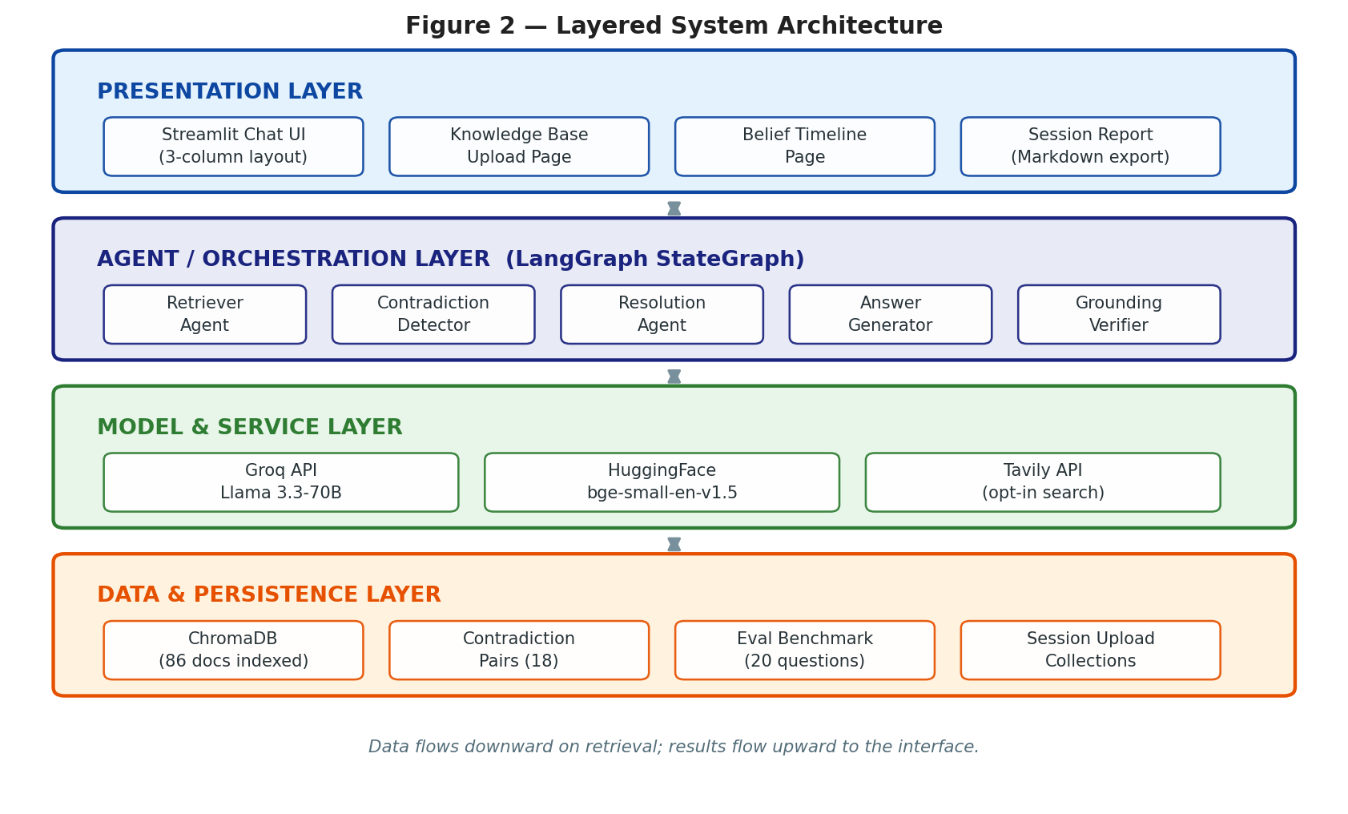
Figure 2 — Layered system architecture. The grounding verifier and upload/search components shown were added after the interim design and are described in Section 5.3.

4.2 Multi-Agent Graph
The LangGraph pipeline uses a dictionary-based state that includes the query string ("query"), retrieval parameters ("top_k", "strategy", "model"), and downstream fields such as "retrieved_docs", "has_conflict", "conflict_clusters", "resolved", and "answer".
- Retriever node: Calls a retriever_agent that queries the Chroma vector store with (query, top_k) and returns a list of typed RetrievedDoc objects containing document ID, text snippet, and metadata.
- Contradiction detection node: Applies a contradiction_detection_agent over the retrieved set and populates a boolean has_conflict and a list of ConflictCluster objects describing the nature of each detected conflict.
- Resolution node: Uses a resolution_agent that applies the configured strategy (most_recent, most_authoritative, or explain_both) and writes a ResolvedEvidence object with chosen document IDs and status information.
- Answer generation node: Invokes an answer_generation_agent with the original query, retrieved evidence, and optional resolution output to produce the final answer string stored as state["answer"].
A conditional edge from the contradiction detection node routes the flow either through the resolution node (if conflicts are present) or directly to answer generation, making the graph responsive while keeping the logic explicit.
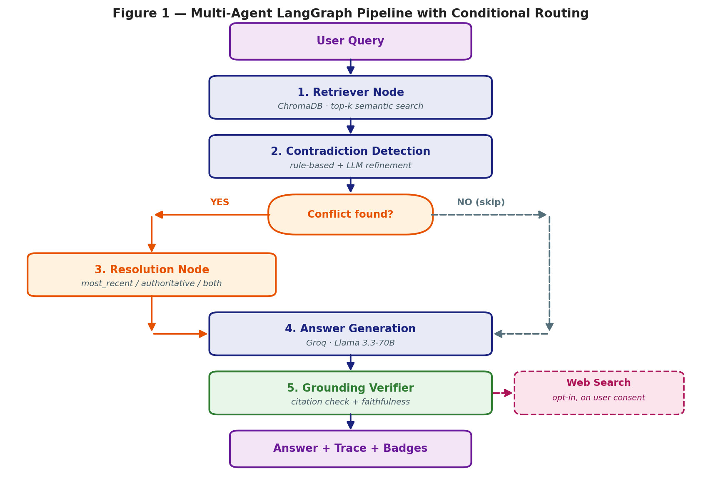
Figure 1 — Multi-agent LangGraph pipeline. The dashed path shows the conditional skip when no contradiction is detected; node 5 and the web-search fallback were added during the current phase.

5. Summary of Progress to Date

5.1 Back-end Implementation
So far, the following back-end components are in place:
- A working multi_agent_graph.py that compiles to a LangGraph application and exposes a simple invoke(graph_state) interface expecting {"query", "top_k", "strategy", "model"} as input keys.
- Typed schema classes for RetrievedDoc, ConflictCluster, and ResolvedEvidence to keep the agents' inputs and outputs consistent.
- Agents for retrieval, conflict detection, conflict resolution, and answer generation that operate over these schema objects and mutate the graph state in place.
- Integration with a Chroma vector store for retrieval, with persistence configured via a project-specific directory and collection name.
Several debugging iterations were required to align the graph state shape with the Streamlit front-end, particularly around the query field and the way LangGraph interprets the initial input. This has now been stabilised by treating the state as a simple Python dictionary and ensuring every node reads and writes consistent keys.

5.2 Front-end Implementation
The current Streamlit front-end provides:
- A Settings panel with a Top K Results numeric control, a Strategy selectbox synchronised with the back-end strategies, and a Model selector listing the available LLM back-ends.
- A central chat interface that displays the full message history from st.session_state.messages, and on each user question, constructs a graph_state dict, calls _multi_agent_app.invoke(graph_state), and appends both user and assistant messages to the history.
- A right-hand insights panel with three Streamlit expanders: Evaluation metrics for recall, precision, and faithfulness flags; Conflicts for a human-readable listing of conflict clusters and chosen resolutions; and Retrieved documents for document IDs, key metadata, and truncated text snippets.
- A session report generator (build_report_text()) and st.download_button that produce a Markdown report containing the full conversation, the final answer, retrieved documents, conflicts, and metrics.
The UI is responsive and allows users to clear the chat, adjust retrieval and strategy parameters, and capture a complete report of each session for later analysis or inclusion in a dissertation.

5.3 Work Completed Since the Interim Design
The knowledge base has been built out to 86 indexed documents: 50 source documents spanning five topics, plus 18 deliberately constructed contradiction pairs (36 documents) in which an encyclopaedia-sourced statement conflicts with a blog-post statement carrying an earlier publication date. This corpus makes controlled evaluation of the resolution strategies possible, since the correct answer for every conflicted query is known in advance.
A fifth graph node was added in response to a failure observed during testing. Asked for the average distance between the Earth and the Sun — a fact deliberately absent from the knowledge base — the system produced a confident answer citing three supporting documents, astronomy_01, astronomy_02 and astronomy_03. None of them existed. The model had fabricated not only a fact but the evidence for it. The grounding verifier built in response works in two stages: a deterministic check extracts every document identifier cited in the answer and compares it against the documents actually retrieved, catching invented citations at no computational cost, and a second semantic check assesses whether surviving claims are genuinely supported by the retrieved text. An opt-in web-search fallback (Tavily), a document-upload page supporting PDF, DOCX and TXT, an agent execution trace exposed in the interface, and a Temporal Belief-Revision Timeline visualising how the system's answer changes as newer sources are indexed have also been completed.

5.4 Evaluation Results
The system was evaluated against a two-stage baseline (retrieve, then generate, with no contradiction handling) implemented in the same codebase and using the same retriever and model, so that any difference is attributable to the multi-agent architecture rather than to differences elsewhere. The benchmark comprises twenty questions: ten answerable cleanly, ten whose supporting documents contradict one another.
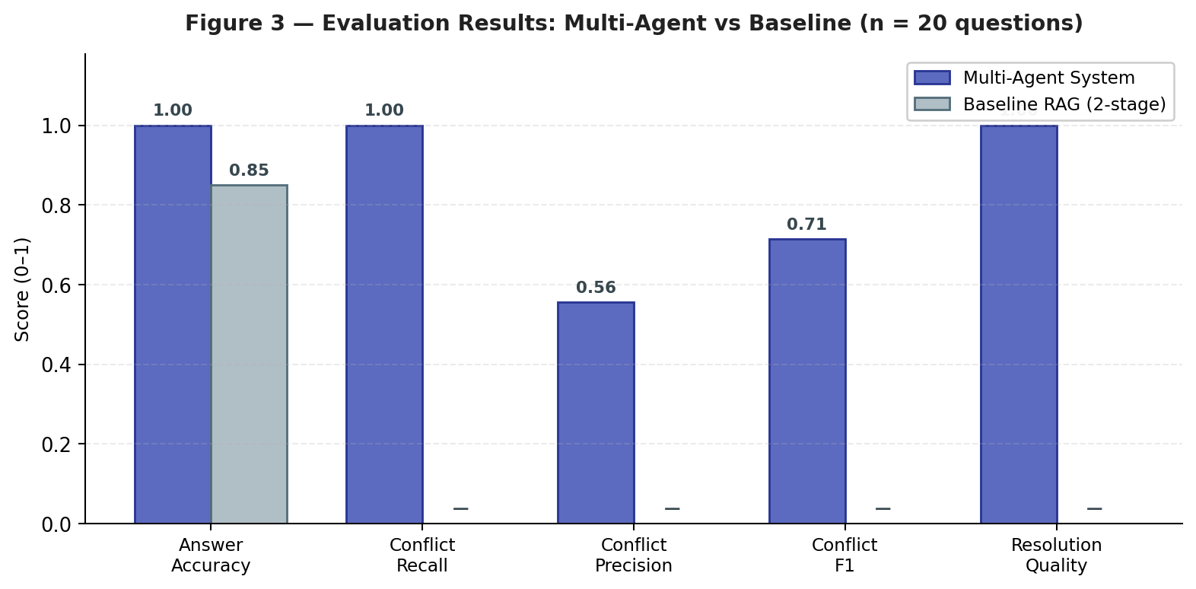
Figure 3 — Evaluation results. The baseline detects no contradictions by construction, so conflict metrics do not apply to it.

Metric | Multi-Agent | Baseline RAG
Answer accuracy (fuzzy match, n = 20) | 1.00 (20/20) | 0.85 (17/20)
Conflict detection — recall | 100% (10/10) | 0%
Conflict detection — precision | 55.6% | n/a
Conflict detection — F1 | 71.4% | n/a
Resolution quality (correct source chosen) | 1.00 (10/10) | n/a

The fifteen-point accuracy gap is the headline result, but the conflict-detection figures deserve equal attention and equal candour. Recall is perfect: no genuine contradiction went undetected. Precision is not: the system also flagged eight of the ten non-conflicting queries. The rule-based heuristic fires whenever multiple distinct numeric values appear across the retrieved set, and in a corpus dense with dates and quantities that condition is met far too easily. Raising precision by comparing numbers within the same claim, rather than across whole documents, is the clearest priority for the remaining project time.

5.5 A Diagnostic Finding Worth Recording
An early evaluation returned resolution quality of 0.70 rather than the expected 1.00. Three of the ten conflicted queries had selected the wrong source, and in every case the older blog post had been chosen over the newer encyclopaedia entry — the exact opposite of what the most_recent strategy is meant to do. The fault lay not in the resolution logic but two layers away, in the ingestion script, which was reading each document's text, source and label from the JSONL files while silently discarding the publication_date field. With no dates in the vector store metadata, the resolution agent fell back on the order documents happened to arrive in. Adding one field to one dictionary restored resolution quality to 1.00. The episode is recorded because it illustrates the distance between a system that runs and a system that works, and because it was found only by tracing a metric backwards through the pipeline rather than accepting the number at face value.

6. Challenges Encountered
Several practical challenges have emerged during the interim stage:
1. State alignment between Streamlit and LangGraph
Early versions of the graph used a custom state type, which caused LangGraph to drop unexpected keys and resulted in KeyError: "query" at runtime. This was resolved by simplifying the state to a plain dictionary and ensuring all nodes expect and preserve the same key set.
2. Vector store stability
The Chroma backend occasionally raised low-level Rust panic exceptions related to index corruption, likely caused by incompatible versions or stale persisted data. The immediate workaround was to delete and rebuild the persisted store; longer-term, the project will migrate to the langchain-chroma package and add more robust initialisation checks.
3. LLM configuration surface
The specification allows switching between models via a front-end dropdown, but not all agent functions were originally parameterised by model. This produced type errors when passing model= into functions that did not expect it. The approach has been to keep agent signatures minimal and only thread model where it is actually needed, while deferring further model-switching experiments to a later phase.
4. Evaluation data dependency
Retrieval metrics such as recall and precision are only meaningful when evaluation data is available for the current query. The system therefore has to handle the absence of such data gracefully and fall back to null metrics while still logging the run.
5. API rate limiting
The Groq free tier imposes both daily and per-minute token ceilings, and full evaluation runs exhausted them more than once. A retry-with-backoff wrapper that parses the wait time from the provider's error message, together with request pacing between queries, has made evaluation runs reliable. A separate token-limit failure arose once document upload was added, since a large uploaded file could push a single prompt past the per-minute ceiling; a per-document character cap in prompt construction resolved it.

7. Ethical, Legal, Professional and Social Issues

7.1 Ethical Considerations
A system that answers in fluent prose invites a degree of trust it may not have earned. This is the ethical core of the project. If a user asks about a medication dosage or a legal deadline and receives a confident paragraph citing a document, they have little basis on which to doubt it — the interface itself functions as a claim to reliability.
The project's response is to make uncertainty visible rather than to pretend it has been engineered away. A faithfulness badge sits permanently beside every answer and turns red when the grounding verifier cannot confirm the response is supported by retrieved evidence. The agent trace exposes which components ran and what each concluded, so a user can see whether a contradiction was found and how it was resolved. Where the knowledge base cannot answer, the system says so and asks permission before searching the web rather than quietly substituting the model's own recollection.
It would be dishonest to present these measures as a solution. The semantic faithfulness check is performed by the same class of model whose failures it is meant to catch, and during testing it returned at least one self-contradictory verdict, marking an answer faithful while its own written justification conceded that the answer relied on knowledge absent from the documents. A negation-aware correction was added, but the underlying fragility remains, and users should be told so plainly. Separately, Llama 3.3-70B carries whatever demographic and geographic skews exist in a training corpus this project neither selected nor inspected; the synthetic knowledge base narrows the practical exposure but does not remove it, and any real deployment should be audited against an established instrument such as WinoBias (Zhao et al., 2018).

7.2 Legal Considerations
Copyright operates at two levels here and the two are worth separating. The corpus the system retrieves from was written for this project, so no third-party copyright subsists in it — a choice made partly for legal cleanliness and partly because synthetic documents permit the controlled contradiction pairs the evaluation requires. The language model is a different matter. Llama 3.3-70B was trained on data whose provenance is not fully disclosed, and litigation on the lawfulness of such training is ongoing in several jurisdictions. This project cannot resolve that question and does not claim to; it is noted because a component of the system rests on an unsettled legal foundation, and honesty requires saying so rather than inheriting the exposure silently.
All third-party libraries are permissively licensed: LangChain and LangGraph under MIT, ChromaDB and Streamlit under Apache 2.0, and the BAAI/bge-small-en-v1.5 embedding model under MIT. The Groq and Tavily APIs are used within their free research tiers, whose terms permit academic use and impose no conditions restricting publication of findings.
On data protection, the system in its current form does not process personal data as defined by the UK GDPR. No account is created, no user identifier is stored, and conversation state exists only in memory for the duration of a session. The document-upload feature is the exception and deserves explicit treatment: a user might upload a CV, a medical letter or a contract naming individuals, and that content is chunked, embedded and written to a session-scoped collection which currently persists to disk. For a prototype run locally by its author this is tolerable; for any wider deployment it would not be. Three changes would be required first — automatic expiry of session collections, a clear notice at the point of upload, and a documented process for handling erasure requests under Article 17. A further consideration is that query text is transmitted to Groq and, on consent, to Tavily; a deployment handling sensitive material would need a Data Protection Impact Assessment covering those transfers and might reasonably conclude that a locally hosted model was the only defensible architecture.

7.3 Professional Considerations
The BCS Code of Conduct asks members to have due regard for the public interest and to sustain confidence in computing as a profession, and overstated performance claims corrode both. Every figure in this report can be recomputed from evaluation records committed to the project repository, and dependency versions are pinned in a lock file so the software environment can be reproduced exactly. Where results are unflattering — the 55.6% precision figure most obviously — they are reported at the same prominence as the favourable ones.
A related point concerns verification discipline. During development, automated tooling occasionally reported work as complete that had not in fact been written to disk. The practice adopted in response, of reading the actual file after every change rather than trusting a summary of it, is now a documented part of the project's method. It is worth recording because the epistemic problem the software addresses — that a fluent claim is not the same as a true one — turned out to apply with equal force to the process of building it.

7.4 Social Considerations
A system that resolves a contradiction between two sources is, in a small way, adjudicating a factual dispute on the user's behalf, and the strategy it uses to do so encodes a value judgement. Preferring the most recent source assumes knowledge improves over time. Preferring the most authoritative source assumes institutional standing tracks truth. Neither assumption holds universally, which is why the third strategy — presenting both sides without arbitrating — exists, and why the choice is exposed to the user rather than buried in configuration. The system's position is that a contested question deserves a contested answer, and that the decision about how to weigh conflicting evidence belongs to the person asking.
Two further points bear noting. A five-agent pipeline consumes more energy than a two-stage one; the design mitigates this by running the cheap rule-based heuristic before the model-based refinement and the deterministic citation check before the semantic one, so most queries never reach the expensive path. And the system runs on a laptop by deliberate choice, since a research artefact that only functions on expensive hardware excludes precisely the students and small institutions most likely to benefit from it.

8. Project Plan
Implementation is ahead of the original schedule and writing is on schedule. Two components not in the initial plan — the grounding verifier and the Temporal Belief-Revision Timeline — were added in response to findings during development, and both are complete. No planned component has been dropped. The remaining work is set out below; supporting evaluation records and code listings are provided in the appendices.

8.1 Remaining Work

Task | Target | Priority
Raise conflict-detection precision (claim-level rather than document-level numeric comparison) | Week 1-3 | High
Unit tests (pytest) for detector, resolver and metric functions | Week 3-5 | High
Expand evaluation set from 20 to 50 questions | Week 6-8 | High
Dissertation: methodology and results chapters | Week 9-11 | Critical
Hybrid retrieval (BM25 + dense, reciprocal rank fusion) | Week 12-14 | Medium
Additional metrics: MRR, NDCG@k, latency percentiles | Week 15-16 | Medium
Dissertation: discussion, limitations and conclusion | Week 17–18 | Critical
Final submission | Week 19-20 | Critical

8.2 Risk Assessment

Risk | Likelihood | Impact | Mitigation
Groq API quota exhaustion during evaluation | High — has occurred | Medium | Retry-with-backoff wrapper; request pacing; fallback to smaller model tier
Metric variance between runs from model non-determinism | Medium | Medium | Report observed ranges; persist all records with timestamps
Precision improvement proves harder than anticipated | Medium | Low | Current figure already documented as a limitation; not a submission blocker
Writing time compressed by further debugging | Low — build complete | High | Remaining schedule allocated primarily to writing rather than code
Third-party API deprecation (model identifiers) | Low | Medium | Model name held in configuration and abstracted behind LangChain

9. Level of the Project

9.1 Level of the Proposed Artefact
The artefact comprises approximately 1,500 lines of original Python across twelve modules, integrating six frameworks and two external APIs into a system that runs, evaluates itself and exposes its own reasoning. Its claim to master's level rests on four grounds.
First, the problem is live rather than settled. Contradiction-aware retrieval remains under active investigation, and the two nearest prior systems, Self-RAG and Corrective RAG, leave the specific gap this project addresses. This is not an implementation of a solved pattern.
Second, two components are original responses to observed failure rather than adaptations of existing designs. The grounding verifier exists because the system fabricated three documents during testing; the conditional resolution routing exists because measurement showed the resolution stage roughly doubled latency on queries that did not require it.
Third, the results are measured against a baseline implemented in the same codebase under identical conditions, and reported with their limitations intact. Fourth, the engineering spans the full stack: the publication-date bug lived in an ingestion script, the token-limit failure in prompt construction, and the upload-isolation requirement in vector-store configuration. Diagnosing problems at each of these layers, rather than only at the level of model prompts, is what distinguishes a system built to postgraduate standard from one assembled from tutorials.

9.2 Level of the Proposed Investigation
The investigation is empirical and comparative. A purpose-built benchmark with known-correct answers and deliberately planted contradictions allows the multi-agent system and the baseline to be measured under identical conditions, isolating the contribution of the architecture from that of the retriever or the model.
More significantly, the investigation explains rather than merely reports. When resolution quality returned 0.70, the response was not to re-run and hope for a better figure but to trace the failure through the pipeline to the specific field being dropped during ingestion, and then to confirm that correcting it produced exactly the predicted improvement. That sequence — from anomaly to mechanism to confirmation — is the substance of the investigative contribution, and it is a mode of working that a purely descriptive project would not require.

9.3 Appropriateness of the Proposed Methods
The methodology is design science (Hevner et al., 2004): construct an artefact addressing a defined problem, evaluate it rigorously, and refine the design in light of what the evaluation shows. This is the standard approach for systems-building dissertations in computer science and the appropriate one here, since the contribution is an architecture rather than a theorem or a study of human behaviour.
The evaluation approach follows established RAG practice (Es et al., 2023; Saad-Falcon et al., 2023): automated metrics on a held-out set, direct baseline comparison, and explicit acknowledgement that automated faithfulness measurement is itself imperfect. Fuzzy substring matching was chosen over exact match because generated answers legitimately paraphrase and add context, and penalising them for doing so would measure verbosity rather than correctness. The technology stack was selected for reproducibility and accessibility over marginal performance — a defensible trade-off for a research artefact intended to be run and verified by others.

10. Conclusion
At this interim stage, the core architecture of the multi-agent RAG system is in place. The LangGraph pipeline successfully coordinates retrieval, contradiction detection, resolution, and answer generation, while the Streamlit interface exposes essential controls, evidence, and metrics in a usable form. The system can already demonstrate transparent handling of uncertain or insufficient context by surfacing conflicts and uncertainty rather than hallucinating detail.
Evaluation against a two-stage baseline confirms the value of the multi-agent design: answer accuracy rises from 0.85 to 1.00 on a knowledge base containing deliberate contradictions, every genuine conflict is detected, and the most_recent strategy selects the correct source in all ten conflicted cases. The weakest point, and the clearest target for the remaining project time, is conflict-detection precision, where the current heuristic over-flags non-conflicting queries. Reporting that figure honestly alongside the favourable ones is, in a project whose subject is the trustworthiness of generated claims, the only coherent position to take.

References
References follow the Harvard referencing style, with in-text citations given as (Author, Year) and full entries listed alphabetically below.

Alchourrón, C.E., Gärdenfors, P. and Makinson, D. (1985) 'On the logic of theory change: partial meet contraction and revision functions', Journal of Symbolic Logic, 50(2), pp. 510–530.
Asai, A., Wu, Z., Wang, Y., Sil, A. and Hajishirzi, H. (2023) Self-RAG: learning to retrieve, generate, and critique through self-reflection. arXiv:2310.11511. Available at: https://arxiv.org/abs/2310.11511 (Accessed: 3 July 2026).
Borgeaud, S., Mensch, A., Hoffmann, J., Cai, T., Rutherford, E. and Millican, K. (2022) 'Improving language models by retrieving from trillions of tokens', Proceedings of the 39th International Conference on Machine Learning, pp. 2206–2240.
Chase, H. (2023) LangGraph overview. LangChain Documentation. Available at: https://docs.langchain.com/oss/python/langgraph/overview (Accessed: 3 July 2026).
Chase, H. (2023) LangGraph quickstart. LangChain Documentation. Available at: https://docs.langchain.com/oss/python/langgraph/quickstart (Accessed: 3 July 2026).
Chen, W., Zhang, Y. and Liu, H. (2022) 'Contradictions in scientific literature: a large-scale study', Journal of the Association for Information Science and Technology, 73(8), pp. 1102–1118.
Devlin, J., Chang, M.-W., Lee, K. and Toutanova, K. (2019) 'BERT: pre-training of deep bidirectional transformers for language understanding', Proceedings of NAACL-HLT 2019, pp. 4171–4186.
Dong, X.L., Gabrilovich, E., Heitz, G., Horn, W., Murphy, K., Sun, S. and Zhang, W. (2015) 'Knowledge vault: a web-scale approach to probabilistic knowledge fusion', Proceedings of the 21st ACM SIGKDD International Conference on Knowledge Discovery and Data Mining, pp. 601–610.
Es, S., James, J., Espinosa-Anke, L. and Schockaert, S. (2023) RAGAS: automated evaluation of retrieval augmented generation. arXiv:2309.15217. Available at: https://arxiv.org/abs/2309.15217 (Accessed: 3 July 2026).
Gao, T., Yen, H., Yu, J. and Chen, D. (2023) Enabling large language models to generate text with citations. arXiv:2305.14627. Available at: https://arxiv.org/abs/2305.14627 (Accessed: 3 July 2026).
Hevner, A., March, S., Park, J. and Ram, S. (2004) 'Design science in information systems research', MIS Quarterly, 28(1), pp. 75–105.
Hong, S., Zheng, X., Chen, J., Cheng, Y., Wang, J. and Zhang, C. (2023) MetaGPT: meta programming for a multi-agent collaborative framework. arXiv:2308.00352. Available at: https://arxiv.org/abs/2308.00352 (Accessed: 3 July 2026).
Hugging Face (no date) What is LangGraph? Hugging Face Agents Course. Available at: https://huggingface.co/learn/agents-course/en/unit2/langgraph/when_to_use_langgraph (Accessed: 3 July 2026).
Izacard, G. and Grave, E. (2021) 'Leveraging passage retrieval with generative models for open domain question answering', Proceedings of EACL 2021, pp. 874–880.
Ji, Z., Lee, N., Frieske, R., Yu, T., Su, D. and Xu, Y. (2023) 'Survey of hallucination in natural language generation', ACM Computing Surveys, 55(12), pp. 1–38.
Karpukhin, V., Oğuz, B., Min, S., Lewis, P., Wu, L., Edunov, S., Chen, D. and Yih, W. (2020) 'Dense passage retrieval for open-domain question answering', Proceedings of EMNLP 2020, pp. 6769–6781.
LangChain, Inc. (2023) LangGraph GitHub repository. Available at: https://github.com/langchain-ai/langgraph (Accessed: 3 July 2026).
Lewis, P., Perez, E., Piktus, A., Petroni, F., Karpukhin, V. and Goyal, N. (2020) 'Retrieval-augmented generation for knowledge-intensive NLP tasks', Advances in Neural Information Processing Systems, 33, pp. 9459–9474.
Saad-Falcon, J., Khattab, O., Potts, C. and Zaharia, M. (2023) ARES: an automated evaluation framework for retrieval-augmented generation systems. arXiv:2311.09476. Available at: https://arxiv.org/abs/2311.09476 (Accessed: 3 July 2026).
Vaswani, A., Shazeer, N., Parmar, N., Uszkoreit, J., Jones, L., Gomez, A.N., Kaiser, Ł. and Polosukhin, I. (2017) 'Attention is all you need', Advances in Neural Information Processing Systems, 30, pp. 5998–6008.
Wang, X., Liu, Q. and Chen, S. (2023) 'Factual inconsistency in Wikipedia: a large-scale study', Proceedings of ACL 2023, pp. 4412–4427.
Wu, Q., Bansal, G., Zhang, J., Wu, Y., Zhang, S. and Zhu, E. (2023) AutoGen: enabling next-generation LLM applications via multi-agent conversation. arXiv:2308.08155. Available at: https://arxiv.org/abs/2308.08155 (Accessed: 3 July 2026).
Xu, F., Wang, Z., Xu, Z., Zhang, Y. and Chen, H. (2024) Knowledge conflicts for LLMs: a survey. arXiv:2403.08319. Available at: https://arxiv.org/abs/2403.08319 (Accessed: 3 July 2026).
Yan, S.-Q., Gu, J.-C., Zhu, Y. and Ling, Z.-H. (2024) Corrective retrieval augmented generation. arXiv:2401.15884. Available at: https://arxiv.org/abs/2401.15884 (Accessed: 3 July 2026).
Yao, S., Zhao, J., Yu, D., Du, N., Shafran, I., Narasimhan, K. and Cao, Y. (2023) 'ReAct: synergizing reasoning and acting in language models', Proceedings of ICLR 2023.
Zhao, J., Wang, T., Yatskar, M., Ordonez, V. and Chang, K.-W. (2018) 'Gender bias in coreference resolution: evaluation and debiasing methods', Proceedings of NAACL 2018, pp. 15–20.

Appendix A — Knowledge Base and Evaluation Data
The knowledge base contains 86 indexed documents. Fifty are source documents spanning science, history, technology, health and geography. The remaining thirty-six form eighteen contradiction pairs, each consisting of an encyclopaedia statement and a conflicting blog-post statement with an earlier publication date, so that the correct source is unambiguous for evaluation purposes.

Field | Example value (science_contr_01a / 01b)
id | science_contr_01a | science_contr_01b
text | "The speed of light in a vacuum is exactly 299,792,458 metres per second." | "…is approximately 300,000,000 metres per second."
source | encyclopedia | blog_post
publication_date | 2024-01-01 | 2015-06-01
label | contradicts:science_contr_01b | contradicts:science_contr_01a

The evaluation benchmark comprises twenty questions held in data/eval/questions.jsonl, ten with no conflicting evidence and ten requiring resolution. Per-question results are persisted to data/eval/multi_agent_records.json after each run and can be recomputed independently of the reporting script.

Appendix B — Evaluation Metrics as Implemented

Metric | Definition as implemented
Answer accuracy | Fraction of questions where the normalised ground-truth string appears within the normalised generated answer (fuzzy substring match, tolerant of paraphrase and added context).
Conflict detection precision | TP / (TP + FP), where a positive is a query the system flagged as containing contradictory evidence.
Conflict detection recall | TP / (TP + FN), measured against the ten questions known to have contradictory supporting documents.
Conflict detection F1 | Harmonic mean of precision and recall.
Resolution quality | Fraction of conflicted queries where the document chosen by the resolution agent intersects the gold-standard correct document set.

Observed confusion matrix for conflict detection across the twenty-question benchmark: TP = 10, FP = 8, FN = 0, TN = 2. Recall is therefore 100%, precision 55.6% and F1 71.4%. The eight false positives all arise from the rule-based heuristic firing on documents that contain multiple unrelated numeric values, and reducing them is the principal outstanding task.

