MARKETING AGENT
System & Workflow Report
How the AI social media agent works, from the dashboard to every n8n node
Item | Detail
Prepared by | Samiullah Waheed
Date | 5 November 2026
Scope | Dashboard, n8n workflow (create and publish), AI models, Supabase data and storage, social publishing
Platforms | LinkedIn, Facebook Page, Instagram Business
Status | Working end to end; see Section 9 for test results and open items

Contents
1. Executive summary 3
What it delivers 3
Status at a glance 3
2. System architecture 4
3. How a post moves through the system 5
3.1 End-to-end journey 5
3.2 Post status lifecycle 6
4. Dashboard 7
5. n8n workflow, part A: create and rewrite 8
6. n8n workflow, part B: publish 10
7. Integrations and data 12
7.1 Interfaces 12
7.2 Data stored in Supabase 12
8. Security and reliability 13
8.1 Security 13
8.2 Reliability 13
9. Test results and open items 14
9.1 What was verified 14
9.2 Open items and risks 14
9.3 Recommended next steps 14
Appendix A. Configuration checklist 15
Dashboard environment variables 15
n8n credentials 15

1. Executive summary
The Marketing Agent turns a one-line topic into ready-to-publish posts for LinkedIn, Facebook and Instagram, each written for its platform, together with one AI-generated image. A person reviews every draft in a web dashboard and nothing is published until it is approved. After approval the agent publishes immediately or at a scheduled time and reports back the link or the reason for any failure.
The dashboard is the control centre. An n8n workflow does the work: Anthropic Claude writes the copy and the image prompt, OpenAI generates the image, and the workflow publishes through the LinkedIn and Meta APIs. Supabase stores posts, settings and images.

What it delivers
- One topic, three tailored posts. Tone, length and hashtags are adapted to each platform; all three share one image.
- Human in the loop. Drafts can be edited, rewritten with instructions, or rejected with a reason before anything goes live.
- Post now or schedule. Leave the time empty to publish as soon as the draft is approved, or pick a date and time.
- Brand safety. Brand voice and banned words are sent with every request; Claude flags claims and statistics to double-check.
- Clear outcomes. Every platform reports its own result. A failure shows the platform's reason, and Try again resends only what failed.
- Live dashboard. Open pages refresh automatically the moment the agent reports a finished draft or a publish result.

Status at a glance
Area | Status | Notes
Draft writing (Claude) | Working | Separate LinkedIn, Facebook and Instagram versions confirmed in test posts
AI image (gpt-image-2) | Working | Generated, converted to JPEG and stored in Supabase for 11 test posts
Facebook Page publishing | Working | Posts with image published on 5 Nov 2026
Instagram publishing | Working | Posts with image published on 5 Nov 2026; Meta token check passed
LinkedIn publishing | Working, rate-limited | Posts published; LinkedIn intermittently replies "too many requests" (Section 9)
Live dashboard refresh | Built | Tested locally; available after the next deployment
Strategy section | Prototype | Insights, Plan and Audiences use illustrative data by design

2. System architecture
Five parts work together. The dashboard never publishes directly: it hands work to n8n through two secured webhooks and receives results through one secured callback. Images live in Supabase Storage at public addresses so that LinkedIn, Facebook and Instagram can fetch them.
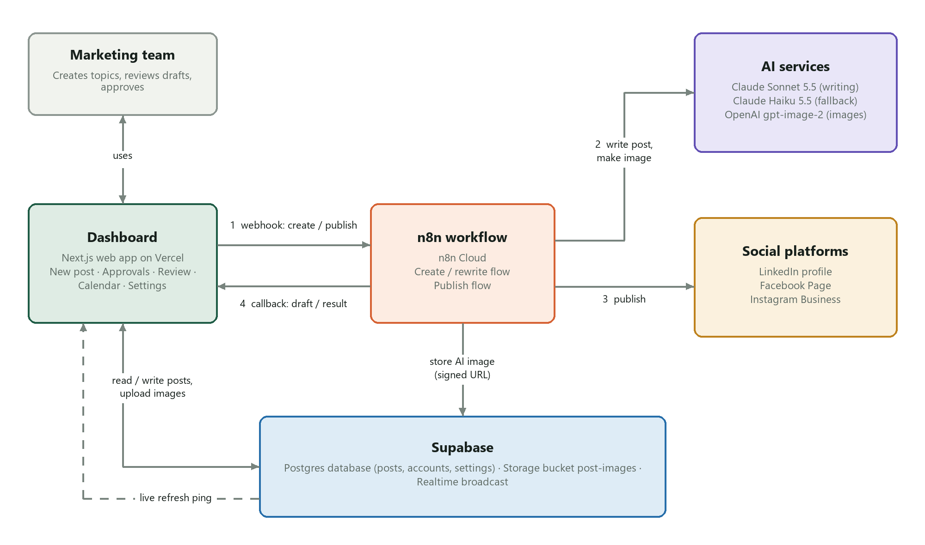
Figure 1. System architecture and the four-step request cycle
Component | Technology | Responsibility
Dashboard | Next.js 16, React 19, hosted on Vercel | Create, review, approve and track posts; secure server actions; receives n8n callbacks; password login
Workflow engine | n8n Cloud | Runs the create/rewrite flow and the publish flow, each started by a webhook
Writing AI | Anthropic Claude Sonnet 5.5, fallback Claude Haiku 5.5 | Platform-specific copy, hashtags, fact-check warnings and the image prompt
Image AI | OpenAI gpt-image-2 (n8n AI credits) | 1024x1024 image, converted to a 1080x1080 JPEG
Database | Supabase Postgres | Posts, connected accounts and settings; atomic merge of publish results
File storage | Supabase Storage, public bucket post-images | Hosts uploaded and AI images at public URLs
Realtime | Supabase Realtime broadcast | Tells open dashboards to refresh when n8n reports back
Social APIs | LinkedIn API, Meta Graph API v23.0 | Publishing to the LinkedIn profile, Facebook Page and Instagram Business account

3. How a post moves through the system

3.1 End-to-end journey
- Create. On New post the user enters the topic, audience and language, chooses an AI image (with an optional description) or uploads one, ticks the platforms, and leaves Post now on or picks a date and time.
- Hand-off. The dashboard saves the post as Processing. An uploaded image goes straight to Supabase Storage; for an AI image the dashboard creates a one-time upload link. It then calls the n8n create webhook.
- Draft. n8n validates the request, Claude writes one version per platform, Claude writes an image prompt, gpt-image-2 renders the image, and n8n converts it to JPEG and uploads it.
- Ready for review. n8n calls the dashboard back with the drafts, the image link and any warnings. The post becomes Waiting approval and open dashboards refresh on their own.
- Review. The reviewer checks each platform tab, edits text or hashtags, swaps the image if needed, then chooses Approve, Rewrite (with instructions) or Reject (with a reason, optionally banning a word for future drafts).
- Publish. Approve sends the post to the n8n publish webhook with the publish time: now for Post now, otherwise the scheduled time.
- Report. n8n waits if the time is in the future, publishes to each platform, and reports each platform's link or error. The post ends as Published or Failed; Try again resends only the platforms that failed.

3.2 Post status lifecycle
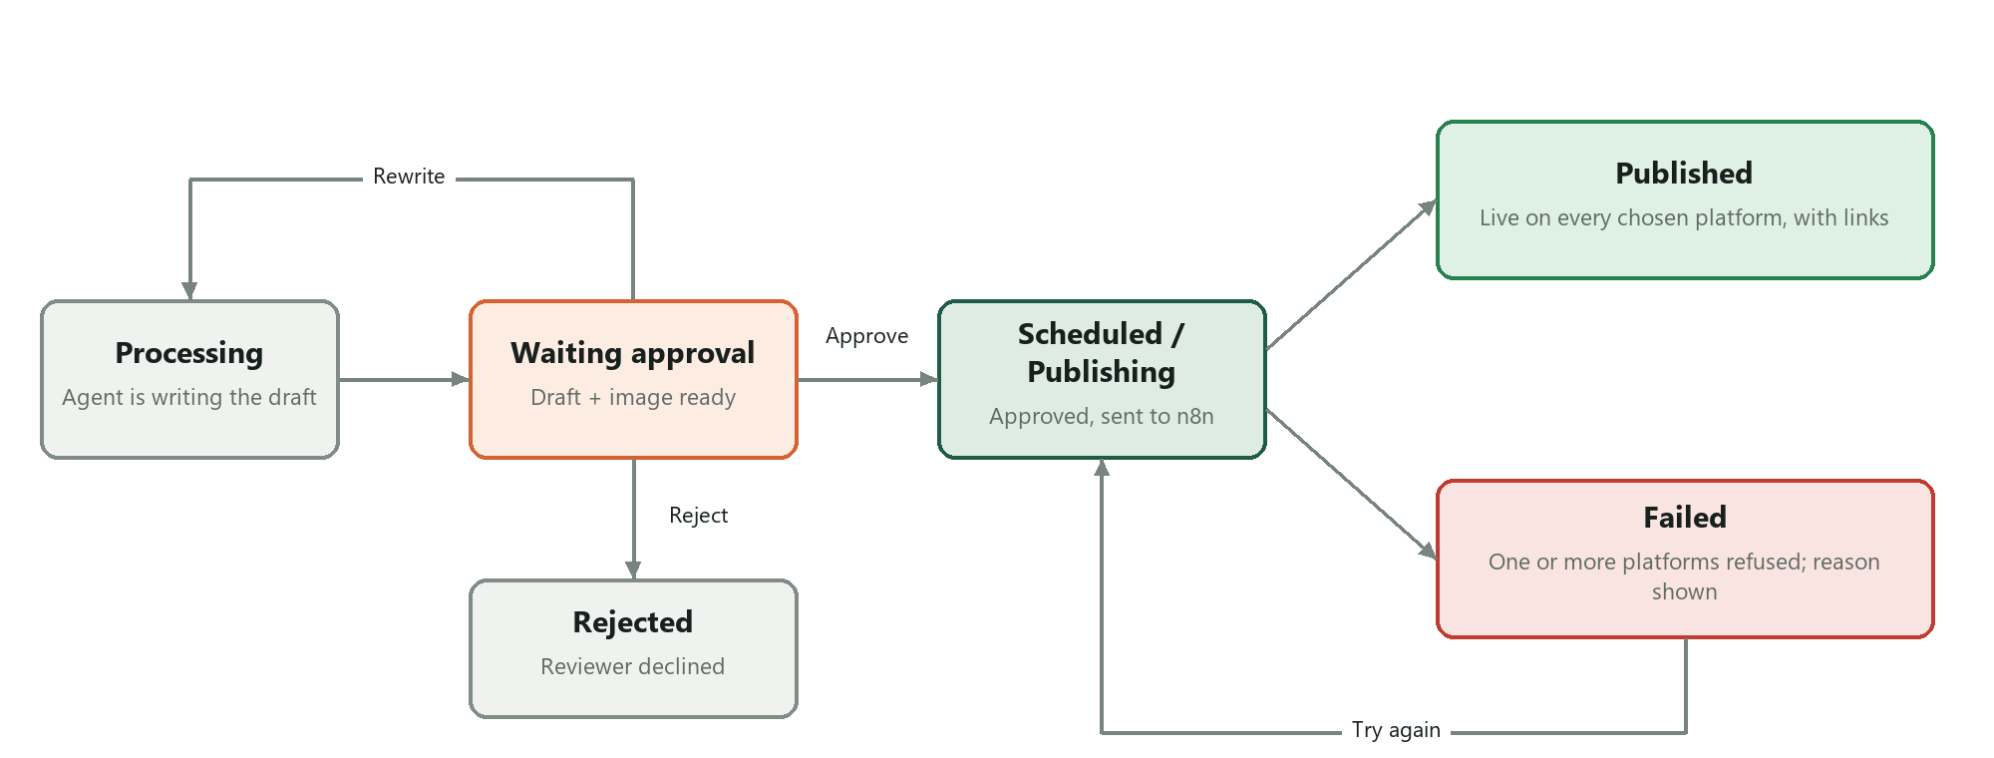
Figure 2. Post status lifecycle
Status | Meaning
Processing | The agent is writing the draft and making the image.
Waiting approval | Drafts and image are ready for a person to review.
Scheduled / Publishing | Approved and handed to n8n. Shown as Publishing for Post now, or Scheduled with the date for timed posts.
Published | Every selected platform accepted the post; links are stored per platform.
Failed | Drafting failed, or at least one platform refused. The reason is shown and Try again is available.
Rejected | The reviewer declined the draft, with a reason and optional note.

4. Dashboard
The dashboard is password protected; every page and internal API requires a signed session. All changes go through server-side actions, so database keys never reach the browser.
Page | What it does
Home | Needs-you alerts (drafts waiting, failed posts, expired logins), posts coming up, monthly counters and recent results.
New post | Topic, audience, language, AI image description or image upload (max 5 MB), platform selection with connection status, and Post now or Schedule.
Approvals | Tabs for Waiting, Scheduled, Failed, Published and Rejected, with search. Failed posts show the platform's reason and a Try again button.
Review | Per-platform preview with character limit and cut-off markers, inline editing of text and hashtags, image change, fact-check warnings, and Approve / Rewrite / Reject.
Rewrite | Free-text instructions plus quick options (Shorter, More professional, Stronger hook and more), choice of platforms, and Keep my hashtags.
Reject | Reason, note, and an option to ban a word so future drafts avoid it.
Published post | Links to the live post on each platform.
Calendar | All posts by date; posts can be moved to another day.
Settings | Connected accounts, brand voice (tone, keywords, sample text, do-nots) and the banned-words list.
Strategy | Insights, Plan and Audiences: prototype screens with illustrative data, not connected to the workflow.

5. n8n workflow, part A: create and rewrite
This flow runs when a post is created, when a reviewer asks for a rewrite, and when a post that failed before any draft existed is retried. It answers the dashboard straight away and then works in the background, reporting back with one callback.
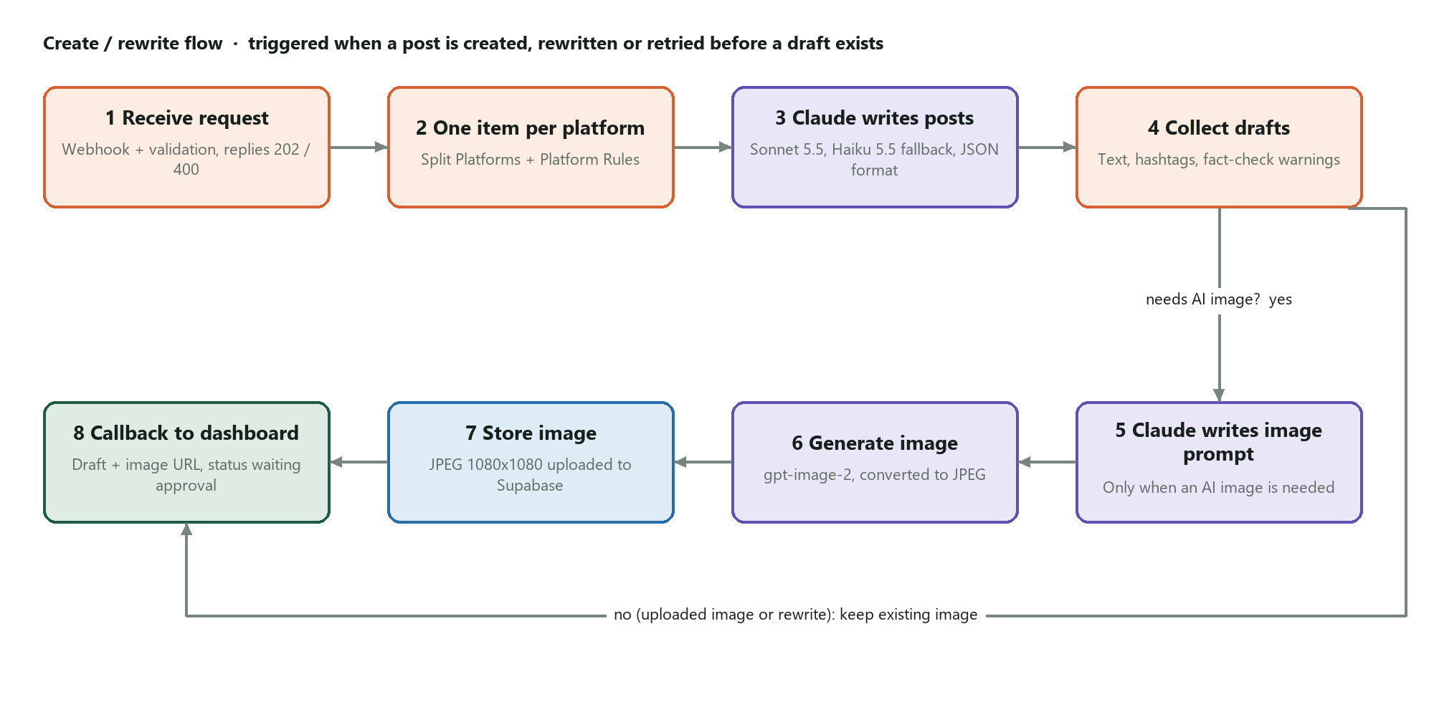
Figure 3. Create / rewrite flow
# | Node | Type | What it does
1 | Create Post Webhook | Webhook | Entry point at /webhook/social-post-create. Accepts only requests carrying the shared API key.
2 | Normalize Request | Code | Validates required fields and platforms, then normalises topic, platforms, brand voice, banned words, image details and rewrite instructions.
3 | Accept Create Request | Respond to Webhook | Replies 202 to the dashboard once the request is valid; the rest runs in the background.
4 | Reject Create Request | Respond to Webhook | Replies 400 with the reason; the dashboard marks the post Failed with that message.
5 | Split Platforms | Split Out | Creates one item per selected platform.
6 | Platform Rules | Code (per item) | Adds limits and style: LinkedIn 3,000 characters, professional; Instagram 2,200, visual; Facebook, conversational.
7 | Write Platform Post | Basic LLM Chain | Prompts Claude with topic, audience, language, brand voice, banned words, style and limit; adds the requested changes on a rewrite.
8 | Claude Sonnet (Post Writer) | Anthropic chat model | Primary writing model (claude-sonnet-5-5).
9 | Claude Haiku (Fallback) | Anthropic chat model | Used automatically if the primary model fails (claude-haiku-5-5).
10 | Post Format | Structured Output Parser | Forces a JSON answer: text, hashtags, suggested hashtags and warnings.
11 | Aggregate Generated Content | Code | Merges the platform drafts, cleans hashtags, keeps the old hashtags when asked, and records any platform that could not be written.
12 | Needs AI Image? | If | Continues to image creation only for AI-image posts that do not already have an image.
13 | Write Image Prompt | Basic LLM Chain | Claude acts as art director: one prompt of up to 90 words, square, no text or logos in the picture.
14 | Claude Sonnet (Image Prompt) | Anthropic chat model | Model for the image prompt.
15 | Generate Image | OpenAI | gpt-image-2 renders a 1024x1024 image using n8n AI credits.
16 | Image Generated? | If | Checks an image file was returned; if not, skips ahead and records a warning.
17 | Image to File | Edit Image | Resizes to 1080x1080 and converts to JPEG, the only format Instagram accepts.
18 | Upload Image to Supabase | HTTP Request (PUT) | Uploads to the one-time signed link from the dashboard, so n8n needs no storage credentials. Retries up to 3 times.
19 | Attach AI Image | Code | Attaches the public image link, or a clear warning such as "AI image could not be created" so the reviewer can upload one.
20 | Keep Existing Image | Code | For uploaded images and rewrites, reuses the post's current image.
21 | Return Generated Content to Dashboard | HTTP Request | Calls back with drafts, image link, warnings and status (Waiting approval or Failed). Retries up to 3 times.

6. n8n workflow, part B: publish
This flow runs when a draft is approved and when a failed post is retried. Each platform is handled independently and set to continue on error, so one refusal never blocks the others and every outcome reaches the dashboard.
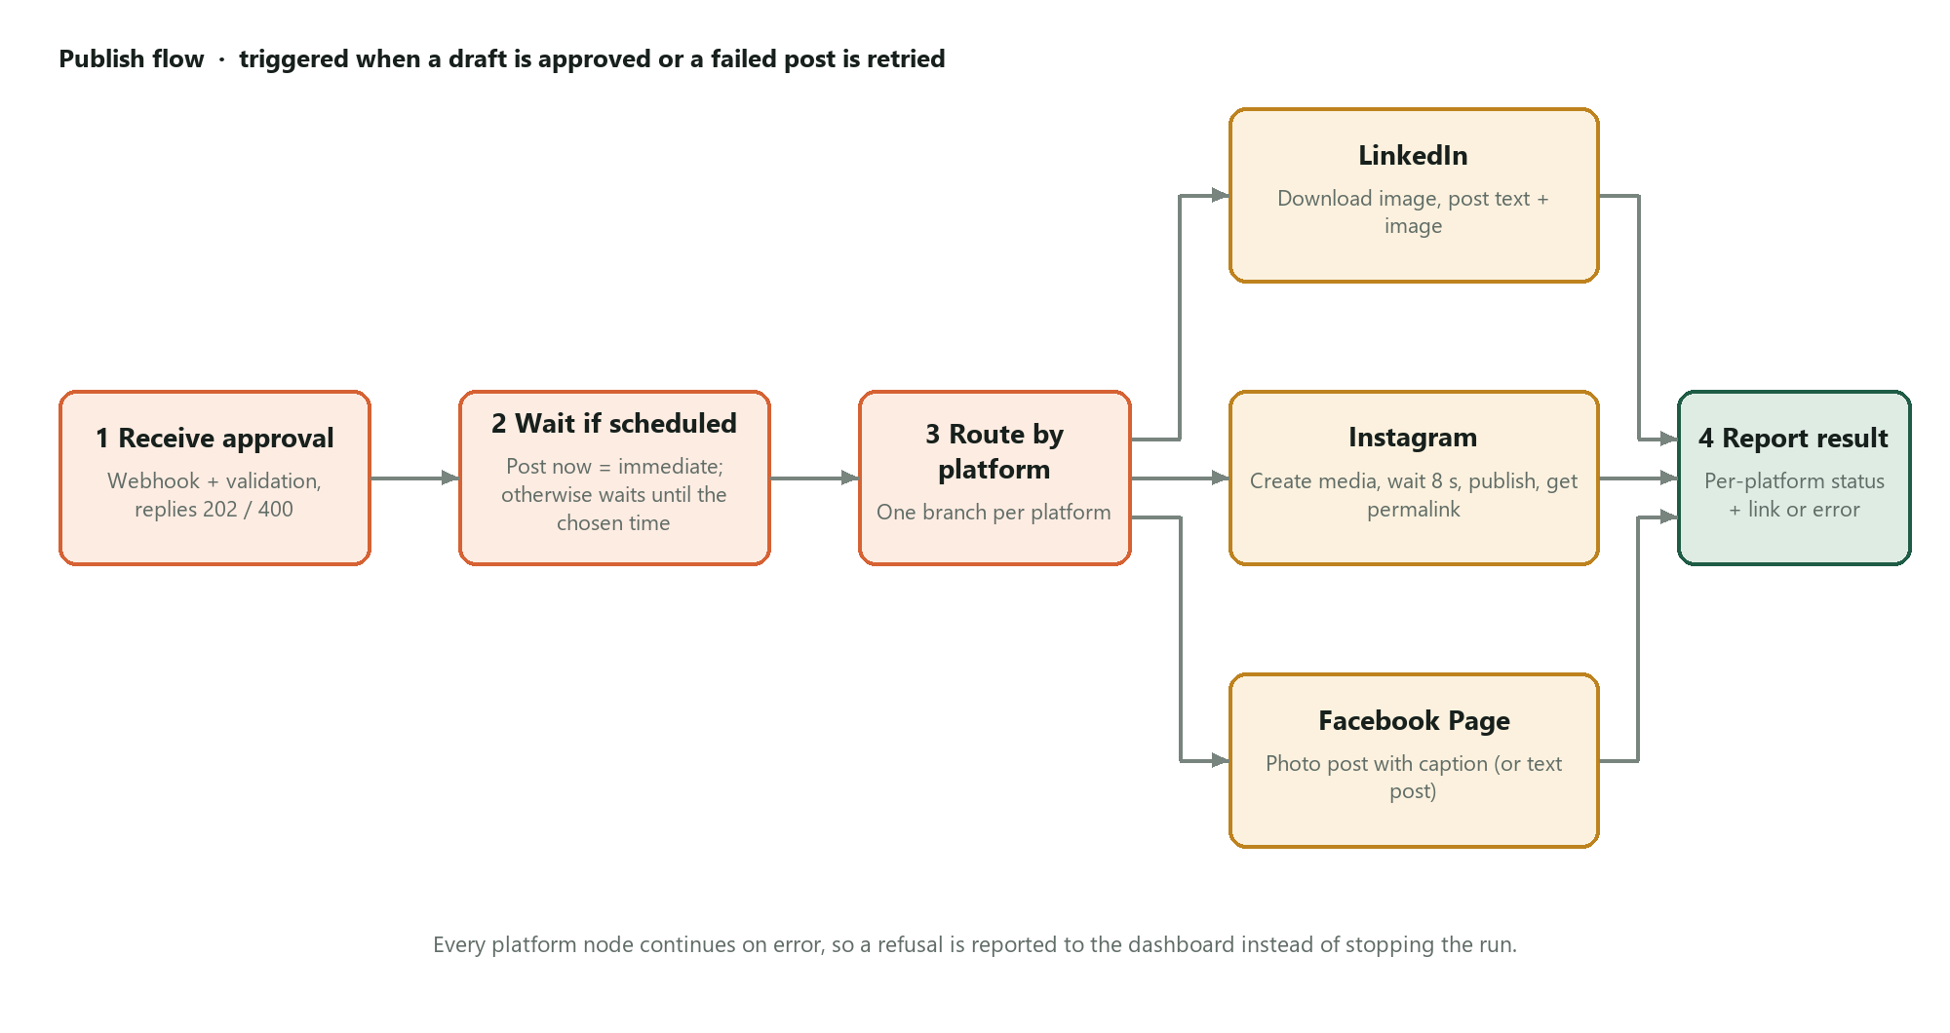
Figure 4. Publish flow
# | Node | Type | What it does
1 | Publish Webhook | Webhook | Entry point at /webhook/social-post-publish, protected by the shared API key.
2 | Normalize Publish Request | Code | Validates the request, holds the Facebook Page and Instagram account IDs, and builds each platform's final caption with hashtags.
3 | Accept Publish Request | Respond to Webhook | Replies 202 once the request is valid.
4 | Reject Publish Request | Respond to Webhook | Replies 400 with the reason.
5 | Split Publish Platforms | Code | Creates one item per platform to publish.
6 | Schedule Required? | If | If the publish time is in the future, waits; otherwise publishes now.
7 | Wait Until Scheduled | Wait | Pauses the run until the scheduled date and time.
8 | Platform Router | Switch | Sends each item to its LinkedIn, Instagram or Facebook branch.
9 | LinkedIn Has Image? | If | Chooses an image post or a text-only post.
10 | Download Image for LinkedIn | HTTP Request | Fetches the image file from Supabase Storage.
11 | Publish LinkedIn (Image) | LinkedIn | Publishes text and image, visible to the public.
12 | Publish LinkedIn | LinkedIn | Publishes a text-only post when there is no image.
13 | Instagram Has Image? | If | Instagram requires an image; posts without one go to the next node.
14 | Instagram Needs Image | Code | Returns a clear error asking for an image, so the dashboard shows why.
15 | Create Instagram Media | Facebook Graph API | Creates the Instagram media container from the image link and caption.
16 | Wait for Instagram Processing | Wait | Gives Instagram 8 seconds to process the image.
17 | Publish Instagram | Facebook Graph API | Publishes the media container.
18 | Get Instagram Permalink | Facebook Graph API | Fetches the public link of the new Instagram post.
19 | Publish Facebook | Facebook Graph API | Publishes a photo post with caption to the Page, or a text post when there is no image.
20 | Normalize Publish Result | Code | Turns each platform's response into Published with a link, or Failed with the platform's own reason.
21 | Return Publish Result to Dashboard | HTTP Request | Reports each platform's result to the dashboard. Retries up to 3 times.

7. Integrations and data

7.1 Interfaces
Interface | Direction | Protection | Purpose
Webhook social-post-create | Dashboard to n8n | x-api-key header | New draft, rewrite, or retry before a draft exists
Webhook social-post-publish | Dashboard to n8n | x-api-key header | Approve, or retry failed platforms
/api/n8n/callback (draft) | n8n to dashboard | Shared secret header | Drafts, image link and warnings; sets Waiting approval or Failed
/api/n8n/callback (publish) | n8n to dashboard | Shared secret header | One result per platform, merged safely even when they arrive together
Signed upload link | n8n to Supabase Storage | One-time token, valid 2 hours | Stores the AI image without storage credentials in n8n
Realtime posts-changed | Dashboard server to browsers | Carries no post data | Tells open dashboards to refresh

7.2 Data stored in Supabase
Item | Contents
posts | Topic, local date and time, publish time, Post now flag, platforms, image mode, prompt and link, audience, language, per-platform drafts, warnings, status, attempts, last error, per-platform results and rejection details.
accounts | Connection status shown on the dashboard for LinkedIn, Instagram and Facebook.
settings | Brand voice, banned words and AI credit display.
post-images bucket | Uploaded images and AI images (JPEG), at public URLs the social platforms can fetch.
apply_publish_results | Database function that merges each platform's result in one step and sets the final Published or Failed status.

8. Security and reliability

8.1 Security
- Login. Dashboard password with a signed session cookie; all pages and internal APIs require it.
- Keys stay on the server. The Supabase service key is used only server-side. Row Level Security is on with no public access; the browser holds only the publishable key, used for the refresh signal.
- Signed traffic. Both webhooks require an API key and the callback requires a shared secret, so outsiders cannot start the workflow or change posts.
- No storage credentials in n8n. AI images are uploaded with one-time signed links created by the dashboard.
- Meta access verified. A read-only check (npm run verify:meta) confirmed the Facebook token is a non-expiring Page token with every required permission, linked to the Instagram Business account, with publishing quota available.

8.2 Reliability
- Claude Haiku takes over automatically if Claude Sonnet fails.
- If image creation fails, the draft still arrives with a clear warning instead of stopping.
- Platforms publish independently; each one reports its own result and reason.
- Callbacks and image uploads retry up to three times.
- Results arriving at the same time are merged safely in the database.
- Try again redrafts a post that never got a draft, and otherwise resends only the platforms that failed.

9. Test results and open items

9.1 What was verified
- Drafts generated with separate LinkedIn, Facebook and Instagram versions.
- AI images generated, converted to JPEG and stored in Supabase; images open from their public links.
- Posts published with images on the Facebook Page and on Instagram (5 November 2026).
- Posts published on LinkedIn (4 and 5 November 2026).
- Meta token check passed every item: valid, Page token, never expires, all permissions, Instagram linked.
- Dashboard pages, callbacks and the live refresh signal tested against a production build.

9.2 Open items and risks
Item | Impact | Action
LinkedIn rate limit | After a few posts LinkedIn replies "too many requests"; those posts fail on LinkedIn only. | Create a dedicated LinkedIn developer app for our own quota; meanwhile retry later.
LinkedIn image posts | Image upload to LinkedIn was added in the latest workflow version. | Verify with the next approved post.
n8n Cloud trial | The workflow stops when the trial ends. | Move to a paid n8n plan.
AI credits | Images use n8n's limited free credits; Claude usage is billed per use. | Use company API keys with spending limits for production.
Instagram format | Instagram requires an image on every post and accepts JPEG only. | AI images are already JPEG; ask users to upload JPEG files.
Test data | The database contains sample and test posts. | Clear before go-live.
Strategy section | Shows illustrative data only. | Connect to real post metrics in a later phase.

9.3 Recommended next steps
- Set up a dedicated LinkedIn developer app and switch the n8n LinkedIn credential to it.
- Choose an n8n paid plan before the trial ends.
- Add company Anthropic and OpenAI API keys with monthly spending limits.
- Deploy the latest dashboard build (live refresh) and remove test data.
- Phase 2: post performance metrics and a real Strategy section; optional approval notifications by email or Slack.

Appendix A. Configuration checklist
Secret values are kept in Vercel, the local environment file and n8n credentials only; they are not included in this report.

Dashboard environment variables
Variable | Purpose
DASHBOARD_PASSWORD | Login password
SESSION_SECRET | Signs the login cookie
SUPABASE_URL | Supabase project address (server)
SUPABASE_SERVICE_ROLE_KEY | Server-only database and storage key
NEXT_PUBLIC_SUPABASE_URL | Project address for the live refresh signal
NEXT_PUBLIC_SUPABASE_PUBLISHABLE_KEY | Public key for the live refresh signal only
N8N_CREATE_POST_WEBHOOK_URL | n8n create webhook (production URL)
N8N_PUBLISH_POST_WEBHOOK_URL | n8n publish webhook (production URL)
N8N_WEBHOOK_API_KEY | Key sent to n8n in the x-api-key header
N8N_CALLBACK_SECRET | Secret n8n sends back on callbacks (same value as the API key)
APP_BASE_URL | Public dashboard address n8n calls back to

n8n credentials
Credential | Used by
Header Auth account | Both webhooks and both callbacks
Anthropic account | Claude Sonnet (Post Writer), Claude Haiku (Fallback), Claude Sonnet (Image Prompt)
n8n AI credits (OpenAI) | Generate Image
LinkedIn account | Publish LinkedIn, Publish LinkedIn (Image)
Facebook Graph account (Page token) | Create Instagram Media, Publish Instagram, Get Instagram Permalink, Publish Facebook

