Title
Determinants of Financial Literacy Among Italian Adults: The Role of Demographic, Educational, and Digital Factors
2. Authors’ details
Group members:
Abdul Sami (939542) a.sami7@campus.unimib.it
Davina David (946851) d.david2@campus.unimib.it

3. Keywords
Financial literacy, financial behaviour, financial attitudes, Italy, digital finance

4. Name of the dataset
Surveys on Financial Literacy and Digital Financial Skills in Italy (Adults) – IACOFI 2023 microdata(Link), file database_eng.dta (Stata format), distributed by the Bank of Italy.

5. Declaration on AI tools
We used AI tools (for instance Perplexity) to:
- help structure the outline of the report and align it with the exam instructions,
- refine the wording of some sections and check the clarity of methodological descriptions.
However, all data loading, cleaning, scoring, analysis, and interpretation of results are carried out by the group, based on our own understanding of the dataset, the OECD/INFE methodology, and the course material.

6. Abstract
This study aims to investigate which demographic, educational, and digital-finance-related factors explain differences in financial literacy among Italian adults. We use the 2023 IACOFI survey microdata from the Bank of Italy, which includes about 5,000 individuals aged 18–79 and measures three dimensions of financial literacy: knowledge, behaviour, and attitudes. We construct a composite financial-literacy score and a digital-finance score, then apply descriptive statistics and multiple linear regression to quantify the contribution of age, gender, region, education, income, and online-banking behaviour. Results show that education and certain digital-finance behaviours are significant predictors of financial literacy, while gender and region play a smaller but detectable role. The study highlights groups at risk of lower financial literacy and provides a reproducible data-science workflow for survey-based financial-literacy analysis.

7. Research question
7a. Statement
Main question:
To what extent do demographic, educational, and digital-finance-related factors explain differences in financial literacy among Italian adults?
Sub-questions:
- RQ1: Does education level influence financial literacy?
- RQ2: Are there demographic differences in financial literacy (age, gender, region)?
- RQ3: Is digital-finance behaviour associated with higher financial literacy?
- RQ4: Which factors are the strongest predictors of financial literacy?
Here, “financial literacy” is treated as a composite score built from three components:
- Knowledge: objective understanding of financial concepts (for instance inflation, interest, risk diversification);
- Behaviour: concrete financial practices (budgeting, saving, careful planning);
- Attitudes: orientation toward saving, monitoring finances, and long-term planning.
“Digital-finance behaviour” refers to the frequency with which respondents use digital tools to manage their finances (for instance checking balances, paying bills, transferring money, and managing financial products online).

7b. Motivation and stakeholders
Understanding financial literacy in Italy is not simply a matter of measuring what people know about finance. It is about identifying who is left behind and why. Italian adults differ substantially in their access to education, their exposure to digital financial tools, and the socioeconomic conditions they navigate daily. These differences do not exist in isolation: a person with low education living in Southern Italy and with limited digital engagement faces a compounding set of disadvantages that a single-question analysis would miss entirely. By asking which demographic, educational, and digital-finance factors jointly explain financial literacy, this study builds a more complete picture of financial vulnerability in the Italian adult population.
This question is relevant for multiple audiences. Policymakers and financial-education authorities such as the Bank of Italy and OECD/INFE need to know not just that financial literacy is unequal, but where the gaps are largest and which factors drive them, in order to design targeted interventions. Financial institutions and educators developing digital-finance tools need to understand whether digital engagement actually accompanies higher literacy or whether it is concentrated among already-advantaged groups. More broadly, this project demonstrates how data-science techniques taught in the course can be applied to real-world survey data to produce policy-relevant insights rather than isolated statistical outputs.

8. The Data
8a. Data description
The dataset is the 2023 IACOFI survey (“Surveys on Financial Literacy and Digital Financial Skills in Italy: Adults”), collected by the Bank of Italy using Computer-Assisted Telephone Interviewing (CATI) on a sample of about 5,000 adults aged 18–79.
Key variables used in our analysis fall into three groups:
- Demographics and socio-economic background
  - Age (qd7), gender (qd1: 1 = male, 0 = female), region (qd2: 1–5 = North-West, North-East, Center, South, Islands), urban or rural environment (qd3), household structure, employment status (qd10), education level (qd9), and income band (qd13).
- Financial literacy components
  - Knowledge: Objective questions on financial concepts, for instance (inflation, simple and compound interest, risk diversification; items qk3, qk4, qk5, qk6, qk10).
  - Behaviour: Indicators of financial planning and day-to-day management (for instance making a plan to manage income and expenses, saving in a deposit account, arranging automatic payments; items qf2_*, qs2_3, qs2_5).
  - Attitudes: Statements on saving, financial-management attention, and long-term-planning orientation (for instance keeping a close watch on finances, striving to achieve long-term goals; items qs1_1, qs1_5, qs1_8).
- Digital-finance behaviour
  - Frequency of online-finance activities (qp9_1 to qp9_6, for instance checking balances, paying bills, buying goods, transferring money, and managing financial products online).
Responses are coded on ordinal scales (for instance 1–5 for “Never” to “Very often”), and missing/refused values are marked with codes such as -99, -98, -97, -999.

8b. Strengths and weaknesses with respect to the goal
Strengths:
- Nationally representative sample of Italian adults, enabling generalization within the population.
- Rich, multi-dimensional measurement of financial literacy (knowledge, behaviour, attitudes) plus digital-finance behaviour, aligned with the OECD/INFE framework.
- Publicly available microdata in standard formats (Stata, CSV), allowing transparent and reproducible analysis.
Weaknesses:
- Cross-sectional design: we observe individuals at a single point in time, so we cannot infer causality (for instance whether higher education causes higher financial literacy, or vice versa).
- Reliance on self-reported behaviour and attitudes, which may be subject to social-desirability bias or misreporting.
- Some variables are coarsely grouped (for instance income bands, age bands), which limits the precision of continuous-scale analyses.
Despite these weaknesses, the data are sufficient to address our research question empirically and to illustrate the limitations in the conclusion.

9. Methodology
9a. Overall logic thread of the study
The overall logic thread follows these steps:
- Load and clean the data in Python, handle missing values, and spot-check data types.
- Define meaningful variables by renaming key columns and recoding ordinal scales when needed.
- Build composite scores for financial-literacy components (knowledge, behaviour, attitudes) and a digital-finance score, following the OECD/INFE approach.
- Inspect distributions and correlations of the composite scores with demographic and digital-finance variables using descriptive statistics and visualizations.
- Fit a regression model that uses demographic, educational, and digital-finance variables to explain variation in the overall financial-literacy score.
- Interpret the model and discuss insights and limitations, especially in light of the survey design and categorical variables.
The goal is to start from a meaningful question, motivate each step, and keep the analysis interpretable for non-technical stakeholders.

9b. Tools used and why
- Python with pandas, numpy, matplotlib, and seaborn:
  - Chosen because Python is widely used in data science, and the libraries support efficient data manipulation, visualization, and reproducibility.
- Linear regression (via sklearn.linear_model.LinearRegression )
  - Chosen because our outcome is an integer-valued financial-literacy score, and linear regression provides interpretable coefficients and a clear way to rank the importance of predictors.
- Descriptive statistics and visualizations (bar plots, boxplots, density plots, correlation heatmaps):
  - Used to explore the data and support the regression findings with intuitive graphics.
All code is implemented in a Jupyter notebook or Python script, and the final code files are attached to the submission or linked in the Appendix.

10. Results
10a. Steps of the study
We began by loading database_eng.dta in Python and cleaning the dataset by replacing invalid codes such as -99, -98, -97, and -999 with missing values. We then restricted the sample to respondents with complete information on the variables used in the analysis. This step ensured that the subsequent construction of scores and statistical models was based on a consistent working sample.
Next, we constructed composite indicators for the main dimensions of financial literacy. The financial knowledge score was based on objective questions concerning inflation, interest, compound interest, and related financial concepts. The financial behaviour score captured respondents’ budgeting, saving, and planning practices. The financial attitude score measured respondents’ orientation toward long-term planning and financial monitoring. These three components were then combined into an overall financial literacy score.
In addition, we built a digital finance score from items measuring online financial activity, such as checking balances, paying bills, transferring money, and managing financial products online. Higher values on this score indicate more frequent use of digital financial tools.
After constructing these measures, we explored the data through descriptive statistics, boxplots, scatter plots, a correlation heatmap, and a histogram of the main score distribution. Finally, we applied K-means clustering to identify broad respondent profiles and used the elbow method to select three clusters. The PCA projection of the clustered data showed three partially overlapping groups, suggesting a gradual transition from lower to higher financial capability rather than sharply separated categories.
To assess the factors associated with financial literacy, we estimated a linear regression model with education, age, gender, region, income, and digital finance behaviour as predictors. The model was used to evaluate which variables were most strongly associated with the overall financial literacy score.

10b. Comments and interpretation
Histogram
The histogram of financial literacy scores shows that most respondents are concentrated around the middle of the distribution, with the largest mass of observations between about 20 and 27. This indicates that financial literacy among Italian adults is generally moderate, rather than very low or very high. At the same time, a smaller group of respondents records very low scores, close to 0–10, which suggests that financial vulnerability is still present in the sample. "This moderate concentration of scores sets the context for understanding how demographic and educational factors distribute across the population."
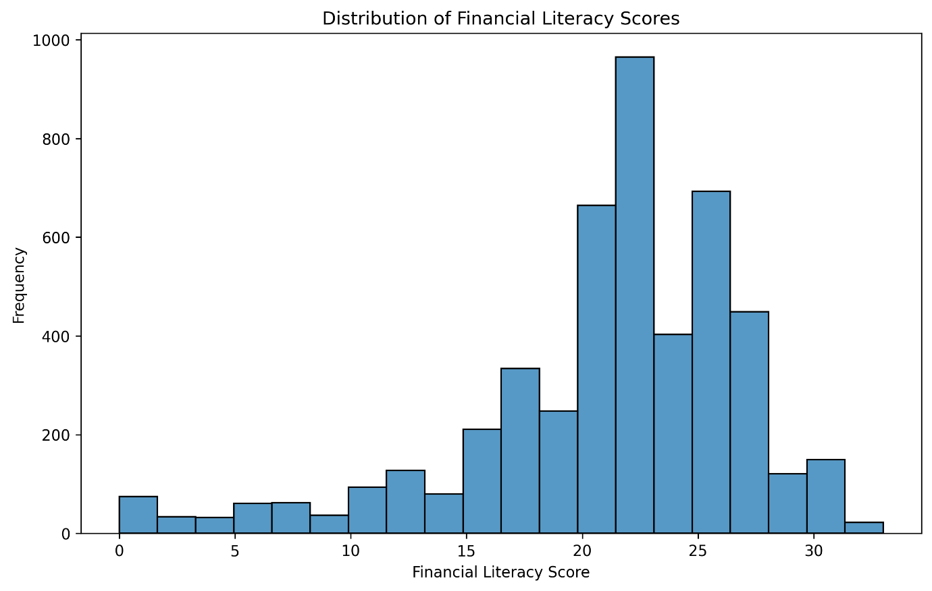
Boxplot by gender
The boxplot by gender shows only a small difference between men and women. Male respondents have a median financial literacy score of about 23, while female respondents have a median of about 22. The interquartile ranges are also very similar, roughly 19–25 for men and 18–25 for women. This means that gender differences exist, but they are limited and the distributions overlap heavily. "While gender alone is not a primary driver, it is worth examining alongside education and age to see whether these factors interact."
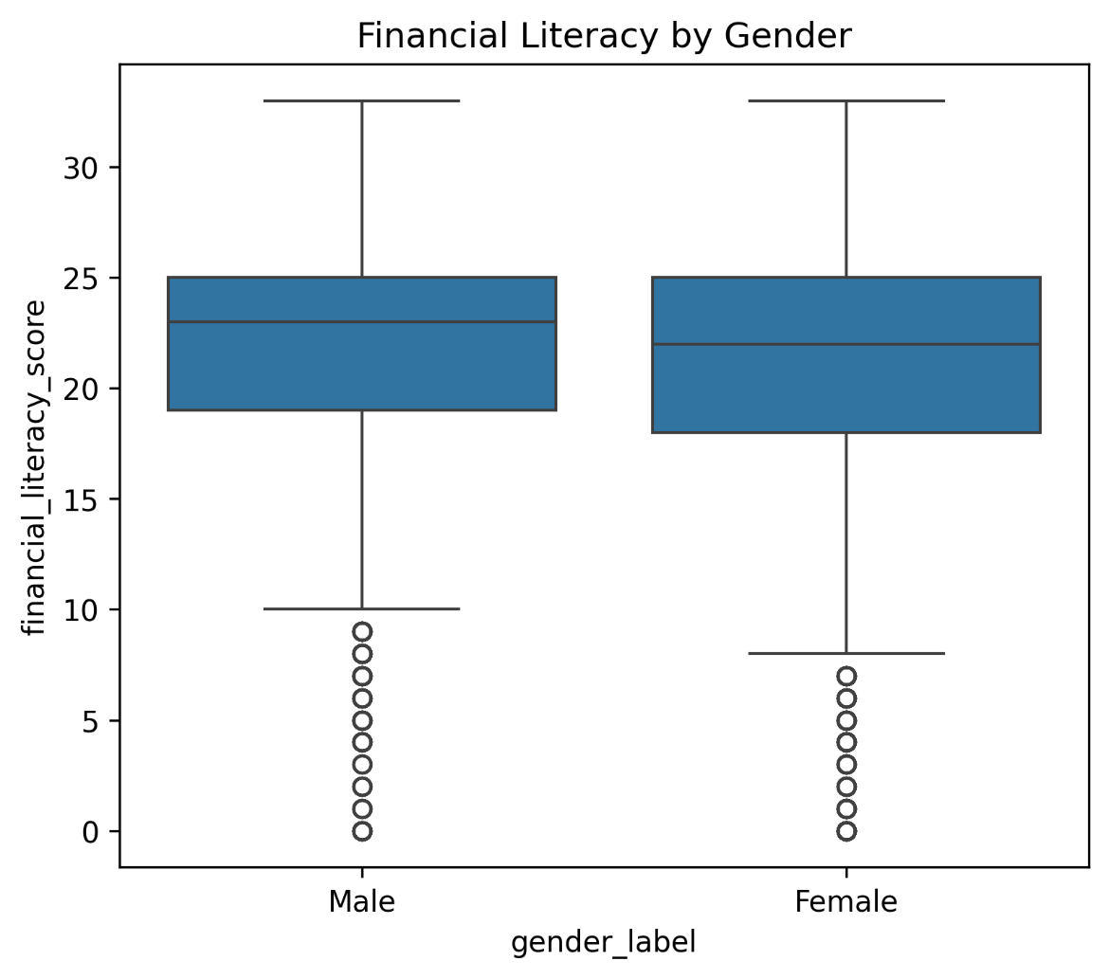
Boxplot by education
The boxplot by education level shows a much stronger pattern. Respondents with master’s degrees and postgraduate education have median scores of around 24, while bachelor’s degree holders score around 23. Respondents with only high school education have a median of about 22, while lower education groups such as primary school and no education show much lower medians, around 18 and 11 respectively. This confirms that education is one of the strongest predictors of financial literacy. "This strong education gradient is the most consistent finding in the dataset and provides the baseline against which other factors should be interpreted."
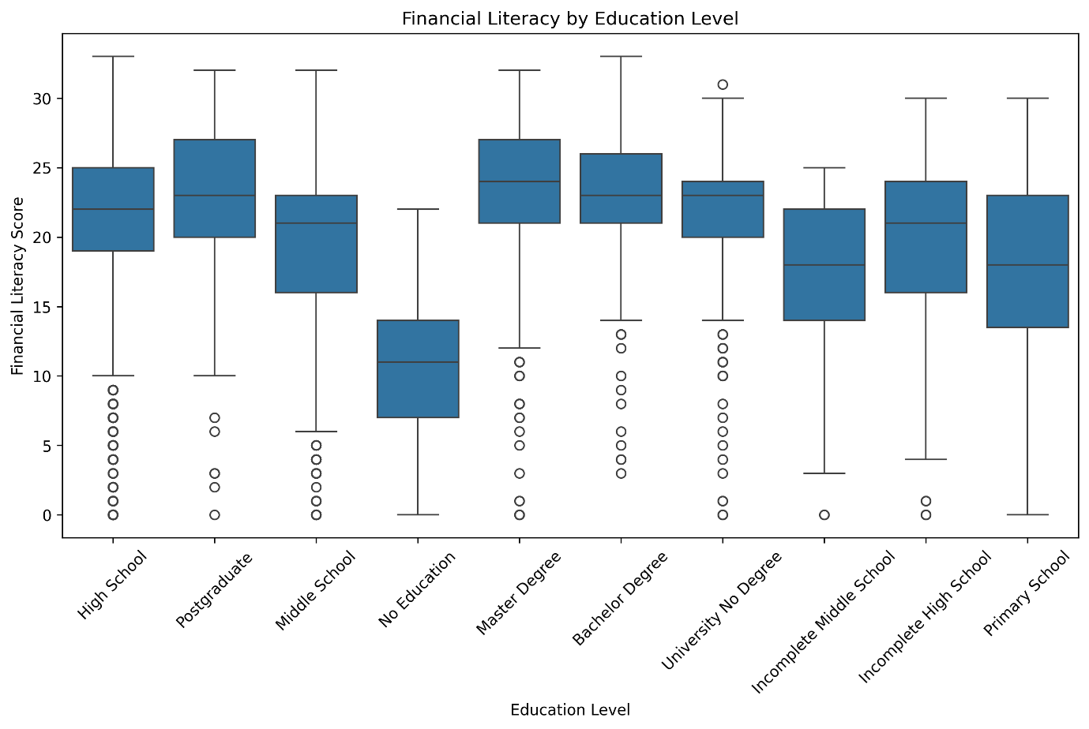
Boxplot by age group
The boxplot by age group suggests that financial literacy is highest among adults aged 30–39 and 40–49, whose median scores are around 23. The 18–29 group has a lower median and a wider spread, while older groups such as 60–69 and 70+ show a slight decline. This pattern suggests that financial literacy tends to rise with age and experience, but may decrease somewhat in later life. "This inverted-U pattern by age complements the education finding, suggesting that both life experience and formal education shape financial capability."
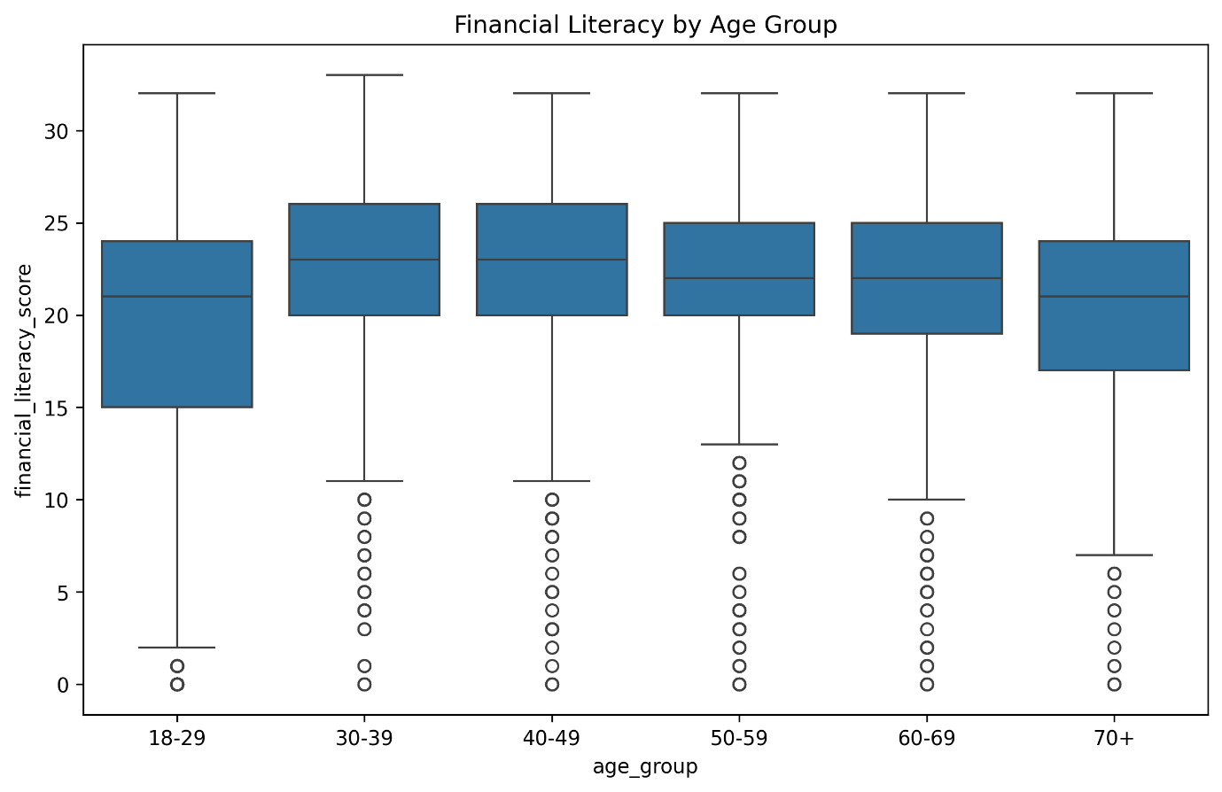
Scatter plot (digital finance vs literacy)
The scatter plot of digital finance score versus financial literacy shows a positive but weak relationship. The correlation is around 0.17, which means that respondents who use digital financial tools more often tend to score slightly higher on financial literacy, but the relationship is not strong. In other words, digital finance use is related to financial literacy, but it explains only a small part of the variation. "This weak but positive relationship suggests that digital finance engagement is part of the financial literacy picture, though it acts more as a complement to education than a substitute for it."
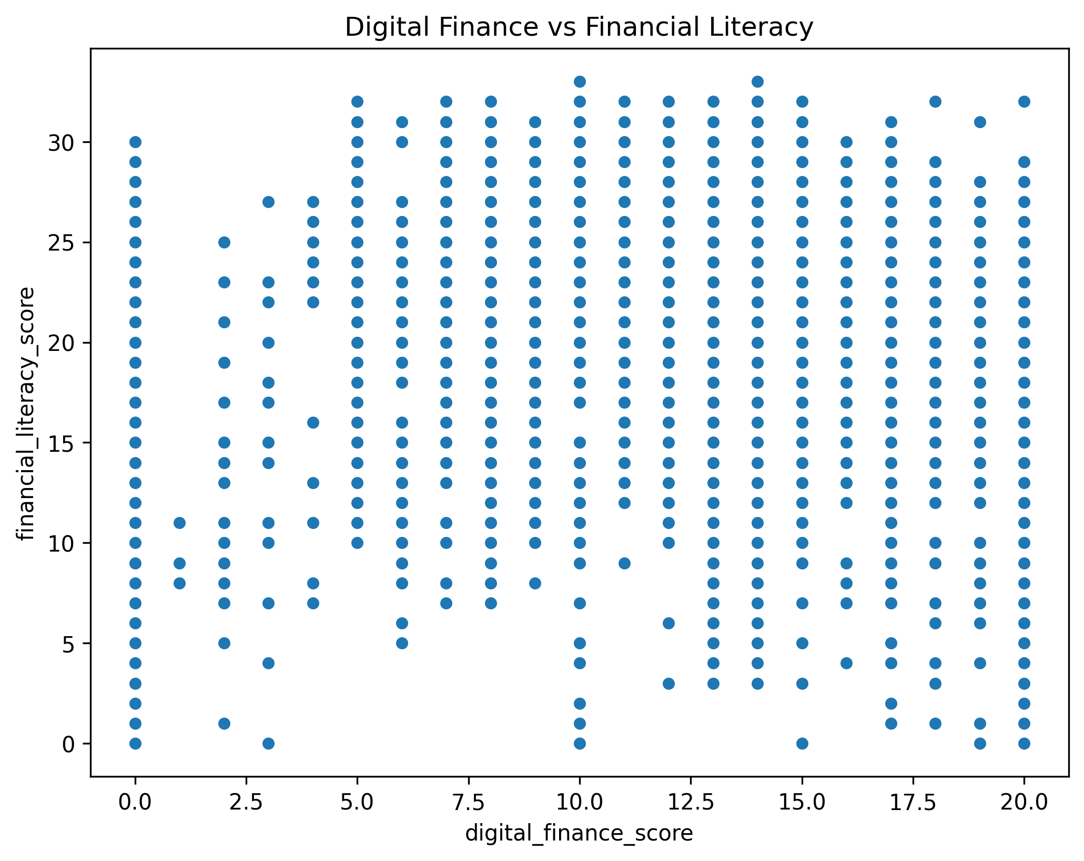

Correlation heatmap
The correlation heatmap highlights the strongest associations in the dataset. Financial literacy is strongly correlated with financial behaviour (0.87) and financial attitudes (0.84), while its relationship with financial knowledge is more moderate at 0.56. The correlation with digital finance score is much weaker at about 0.17, confirming that digital behaviour matters, but less than behaviour and attitudes. The sign of the education correlation depends on the coding scheme used in the dataset, since lower numeric values represent higher educational attainment. • "The heatmap confirms that behaviour and attitudes are the dimensions most tightly linked to overall literacy, while digital finance and knowledge play a supporting role."
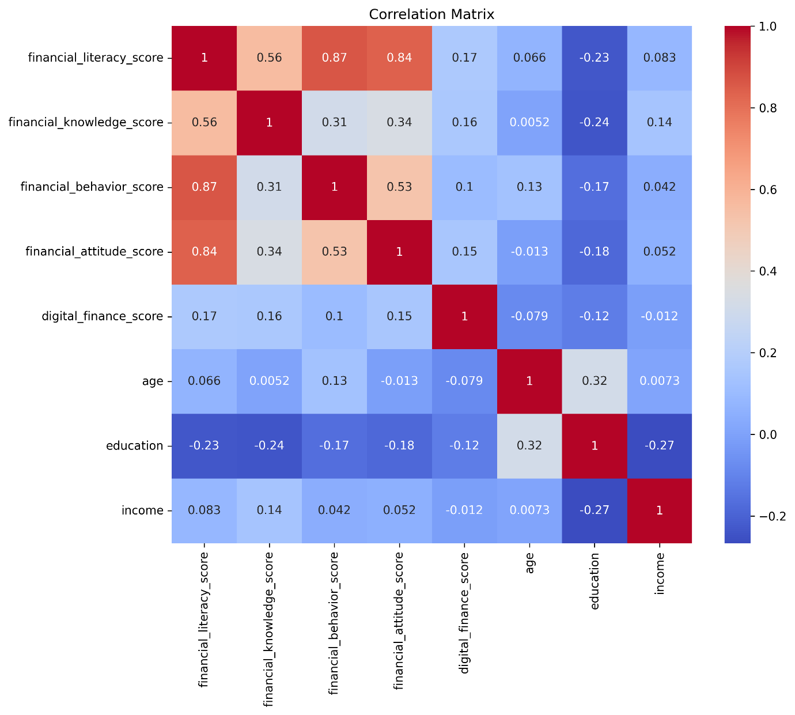
PCA cluster plot
The PCA visualization identified 3 distinct financial-literacy clusters using K-means clustering (K = 3). Cluster 1 (orange) represents respondents with relatively lower financial-literacy and digital-finance scores, while Cluster 2 (blue) includes individuals with higher financial behaviour, attitudes, and digital engagement. Cluster 0 (green) appears to represent respondents with moderate financial-literacy characteristics. Although the clusters are distinguishable, some overlap exists between groups, indicating a gradual transition from lower to higher financial-literacy profiles. Overall, the results demonstrate meaningful variation in financial-literacy patterns among Italian adults. "The gradual transitions between clusters visible in the PCA plot suggest that financial literacy profiles are shaped by combinations of factors rather than a single dominant variable."
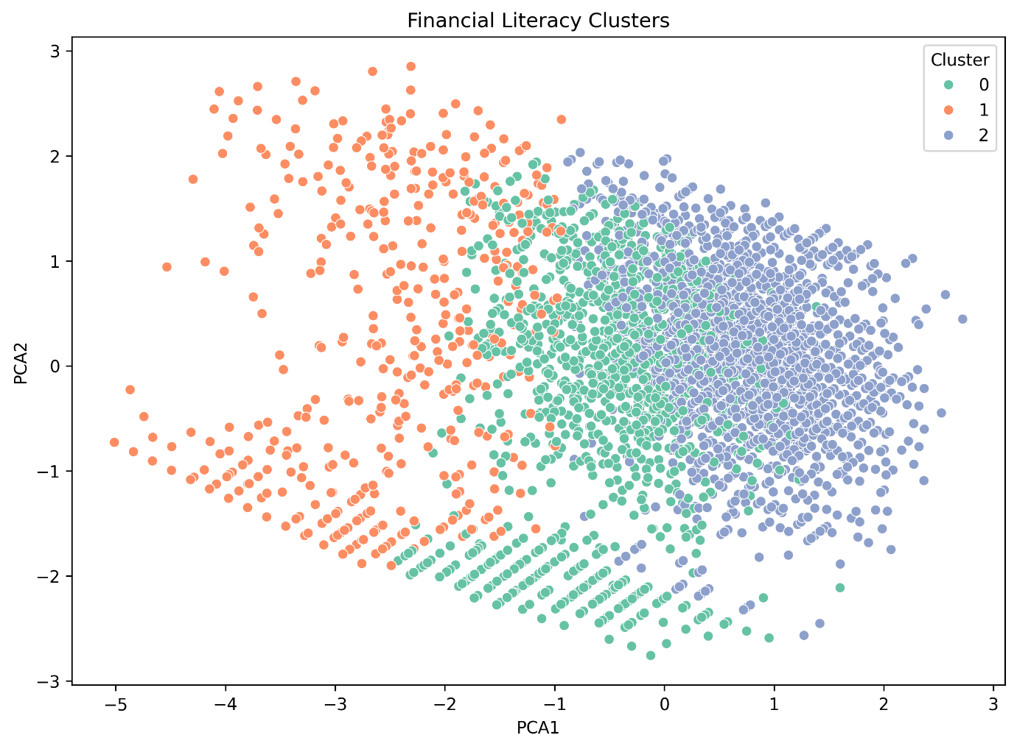

Elbow method plot
The elbow method suggests that 3 clusters is the best choice for K-means clustering. Inertia drops sharply from about 19,500 at K = 1 to around 13,600 at K = 2, and then to nearly 11,400 at K = 3. After that, the improvement becomes smaller, which means that a three-cluster solution gives a good balance between simplicity and fit. The PCA cluster plot confirms this result by showing three broad groups with some overlap, suggesting a gradient from lower to higher financial capability rather than completely separate categories. "The three-cluster solution provides a practical and interpretable segmentation of the Italian adult population for policy purposes, without overfitting to noise in the data."

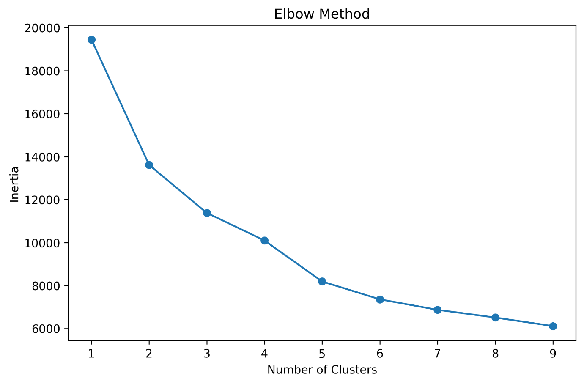
11. Conclusion
Gap between the goal and the results
Our goal was to understand which demographic, educational, and digital-finance factors explain differences in financial literacy among Italian adults, and to do so in a way that produces an integrated interpretation rather than a set of isolated answers. The analysis achieves this. Education emerges as the strongest individual predictor, but its effect is best understood alongside age, regional context, and digital-finance engagement, all of which contribute to a broader profile of financial capability. The regression framework quantifies these contributions in a unified model, and the clustering analysis confirms that Italian adults are distributed along a continuous gradient of financial literacy rather than divided into sharply separate groups. Together, these findings suggest that financial vulnerability in Italy is concentrated among individuals with lower education, limited digital engagement, and specific demographic profiles, and that effective policy interventions will need to address these factors in combination rather than individually.
Strengths and weaknesses of the study
Strengths
- Use of a nationally representative dataset aligned with OECD/INFE standards.
- Transparent construction of financial-literacy and digital-finance scores, with reproducible code.
- Integrated interpretation of results that connects demographic, educational, and digital-finance findings into a coherent narrative.
Weaknesses
- Cross-sectional design limits causal inference.
- Coarse grouping of some variables such as income bands and education levels, combined with self-reported behaviour, reduces precision.
- Limited ability to capture omitted factors such as early-life financial education, cultural attitudes, or past financial shocks.
Directions for further research or improvements
Longitudinal analysis using future IACOFI waves would allow panel-based models to better estimate causal effects. Separate regression models for Northern and Southern regions, or for different age groups, could reveal whether the factors identified here operate differently across subpopulations. Behavioural experiments could test how financial-education interventions affect literacy and digital-finance adoption in practice. Finally, richer income and household variables would support more detailed models of financial resilience and wellbeing.
12. References
- Bank of Italy. Surveys on Financial Literacy and Digital Financial Skills in Italy: Adults – 2023. 2023. Available at: https://www.bancaditalia.it/statistiche/tematiche/indagini-famiglie-imprese/alfabetizzazione/index.html
- OECD/INFE. OECD/INFE 2023 International Survey of Adult Financial Literacy. OECD Publishing, 2023.
- Bank of Italy. Questioni di Economia e Finanza – report on financial literacy and inequality. 2021–2023.
- Bank of Italy. Data description – IACOFI 2023 microdata. 2024.

