JOHNS SANDWICH SHOP.
DATBASE - an organized collection of information stored and accessed electronically mainly from a computer system.
PURPOSE AND BENEFITS.
Developing a database for the business will help in:
- Making data management simple and efficient
- Analyse data in a variety of ways
- Encouraging a disciplined approach to data management
- Turn information into a valuable resource
- improving the quality and consistency of information

Requirements
- Forms to enter information about customer, Order, Sandwich and the shop
- User to open all forms, queries and reports.
- A report that displays all order that still require payment for outstanding orders.
- A report that displays an invoice for a particular customer invoice.
NOTE: 10% discount is given to the customers when they spend over £50

Design requirements
A consistency of styling must be employed in order to create a professional image and to help users interact with the system. Consistency must extend to at least the following:
- Layout Inc. forms, reports and use of logos etc.
- Colours
- Naming of tables and fields

Meeting discussion
- In the meeting I attended with the Sandwich Maker, Clerk, Customer Driver and the Manager we discussed about their roles and the new project which will bring changes to the computer system, staff and the business in general since three new branches will be opened soon due to a popular demand. They have raised issues that can be solved moving forward. The meeting highlighted that a real change was needed.

What do People do in Mia’s Sandwich Shop?
Customer role.
The Customer orders a Sandwich. (Buys a service and product) giving their Name, Address, Postcode, Contact Number and billing information by filling the customer form Uses a menu to evaluate their choices. Passes the information to clerk.
Order clerk.
Takes and process customer order ensure there are supplies in stock. Receives Customers Names, Addresses, postcode, billing information and contact number. Gives information on Price and data related to the transaction. Process the information given and insert it in the order form and Passes information to Manager.
Sandwich Maker role.
Creates and presents sandwich to each Customer gives information if order made will be achievable Receives Information on stock and suppliers to determine what is possible to create and make and gives recommendation to the order clerk. Fills the sandwich form.
Driver Role.
Loads transports and delivers items to customers in a safe, timely manner. He also reviews orders before and after delivery to ensure that orders are complete, the charges are correct, and the customer is satisfied. Takes payments for delivered items and prepares reports and other documents relating to deliveries.
Problems.
- Errors being made when inserting data
- Retrieving Data
- No reporting facilities causing lack of printing invoice and outstanding payments.
- Spreadsheet use not effective
- Communication between order clerk and sandwich maker being inadequate due to sandwiches being made and later cancelled due to change from the customer or wrong order from the clerk which leads to food being wasted causing profit loss.
- Lack of organization
- Delivering food to the wrong addresses since the customers don’t enter the correct address due to the system not having restricted choices to avoid this problem
- Lack of contribution from other staff members causing delays leading to customers complaining since the delays affect the whole business.
- Widespread system problems from all the staff.
- Layout that’s not welcoming to customers and causes crowding of the business.
- Errors being made when counting inventory
- Theft of cash during night-time.
- Staff not having basic knowledge in language and literacy
Recourses
- New up-to-date computers across all the business operation rooms.
- Scanners.
- Multiple contactless card readers.
- Cash wrap/point of sale (POS) to be integrated-to avoid lines and crowding.
- Digital signage equipment.
- Cameras/security.
Limitations of the project.
- Training of staff will be needed in order to enhance communication, cooperation, cash handling and use of the database and computers.
- Low Budget.
- Enlightening and educating customers on how their data will be used.
- New design and layout to be made in all shops to give the customers and staff smooth experience.
- New recruitment process so that the business can progress and be successful.
- Additional resources.

Proposals.
- Unique ids to easily find information.
- Data dictionary to be active.
- Primary keys to be used.
- Training staff
- Create reports, queries and forms.
- 10% discount to be applied on orders above £50
- Changing the interior of the stores

After the discussions, I made an Entity relationship diagram to design and model the database. This is the basic first step to build a database. Microsoft Access is used to design, implement and maintain the database It contains different table including.
- Customer Table this table has information about unique Id that gets generated when customer name, surname, address, postcode, Sex, DOB, Time ordered, Order payment. This data is used to Identify and categorize the customer age and contact information for deliveries.
- Order table has a unique id that contains information that classifies the order, who made it both customer and staff, time and date the order was made and the delivery id and most importantly the mode payment.
- Staff table-Includes all necessary contact information on staff, date of employment, position and qualification and comes with the unique id which instantly identifies the staff.
- Delivery table has information on the customer and staff delivery, time and date ordered and contact details of customer and staff helping the delivery to be delivered in a simple and easy way.
- Sandwich table holds information of the sandwich name, type, Description which says the ingredients and how it was made and price.
- Branch Table has information on the branch's location, address and contact details. Each branch also has a unique id which gives all the information needed.

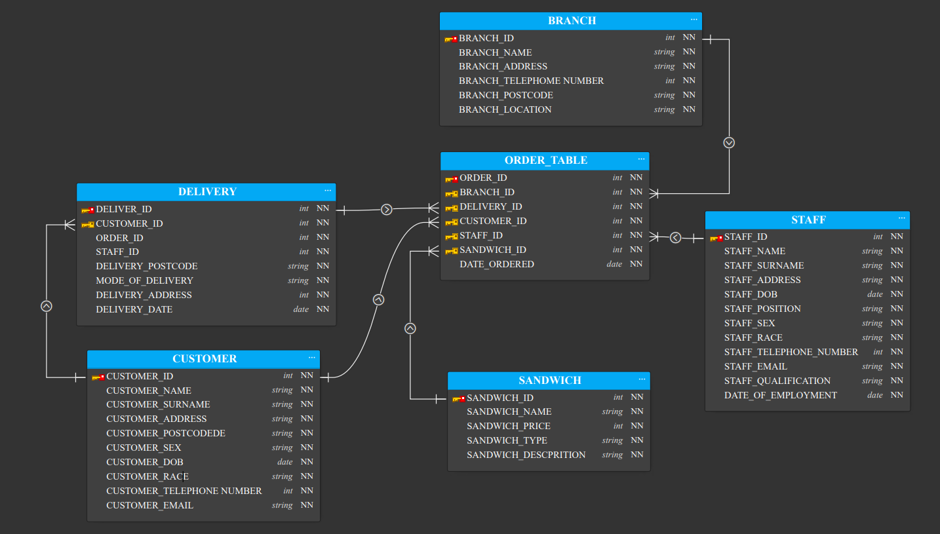
Normalised 3rd order form entity relationship diagram.
Forms
- Customer Form will be used to insert customer information by the customer when ordering and staff uses it to confirm if it has the data.
- Staff Form will be used to put in the detail of staff and filled when they come to work and leave this will be overseen and filled by the manager.
- Order form will be filled by the customer and staff so that the order can take place and it has information on contact details and if the payment is paid or not.
- Delivery form is to be filled by the staff and signed by the customer to confirm if the order has been delivered.
- Sandwich form will be filled by the order clerk and sandwich maker detailing the inventory, sandwich description and price.
Report
Reports will offer the shops a way to view, format, and summarize the information in the database. The tool used will be report wizard which displays a multiple-step wizard that lets you specify fields, grouping or sorting levels and layout options. The Aim is to display all order that still require payment for outstanding orders. Also, a report that displays an invoice for a particular customer invoice.
Query
Select query will be suitable to review data from a certain field in a table, or maybe just see the data based on certain criteria. This will apply to categorically view customer payment if it is paid or outstanding and show the discount available.

DATA DICTIONARY.
Data dictionaries are used to provide detailed information about the contents of a database for example metadata and also restricts what information the customers and staff can insert to avoid mistakes I propose that it should be active so that it can be maintained as new customers join the and the information increases However, for this to take place we need a skilled database worker who will also provide training for staff on how to use and utilise the database.

BACKEND DATA

PERFORMING DDL
(1)CUSTOMER_TABLE
CREATE TABLE CUSTOMER(CUSTOMER_ID INT, CUSTOMER_NAME VARCHAR2(100),CUSTOMER_SURNAME VARCHAR2(100) ,CUSTOMER_ADDRESS VARCHAR2(100), CUSTOMER_POSTCODE VARCHAR2(100) ,CUSTOMER_SEX VARCHAR2(100), CUSTOMER_DOB DATE,CUSTOMER_RACE VARCHAR2(100), CUSTOMER_TELEPHONE INT, CUSTOMER_EMAIL VARCHAR2(100),CONSTRAINT CUSTOMER_ID_PK PRIMARY KEY(CUSTOMER_ID));

(2)SANDWICH_TABLE
CREATE TABLE SANDWICH(SANDWICH_ID INT,SANDWICH_NAME VARCHAR2(100),SANDWICH_PRICE INT,SANDWICH_TYPE VARCHAR2(100),SANDWICH_DESCPITION VARCHAR2(100),CONSTRAINT SANDWICH_ID_PK PRIMARY KEY(SANDWICH_ID));

(3)STAFF_TABLE
CREATE TABLE STAFF (STAFF_ID INT, STAFF_NAME VARCHAR2(100), STAFF_SURNAME VARCHAR2(100),STAFF_ADDRESS VARCHAR2(100),STAFF_DOB DATE,STAFF_POSITION VARCHAR2(100),STAFF_SEX VARCHAR2(10),STAFF_TELEPHONE_NUMBER INT,STAFF_EMAIL VARCHAR2(100), STAFF_QUALIFICATION VARCHAR2(100),DATE_OF_EMPLOYMENT DATE,CONSTRAINT STAFF_ID_PK PRIMARY KEY(STAFF_ID));

(4)BRANCH_TABLE
CREATE TABLE BRANCH(BRANCH_ID INT,BRANCH_NAME VARCHAR2(100),BRANCH_ADDRESS VARCHAR2(100),BRANCH_TELEPHONE_NUMBER INT,BRANCH_POSTCODE VARCHAR2(100) , BRANCH_LOCATION VARCHAR2(100), CONSTRAINT BRANCH_ID_PK PRIMARY KEY(BRANCH_ID));

(5)DELIVERY_TABLE
CREATE TABLE DELIVERY(DELIVERY_ID INT,CUSTOMER_ID INT,ORDER_ID INT,STAFF_ID INT,DELIVERY_POSTCODE VARCHAR2(100),MODE_OF_DELIVERY VARCHAR2(100),DELIVERY_ADDRESS VARCHAR2(100),DELIVERY_DATE DATE,CONSTRAINT DELIVERY_ID_PK PRIMARY KEY(DELIVERY_ID),CONSTRAINT DELIVERY_CUSTOMER_fk FOREIGN KEY (CUSTOMER_ID) REFERENCES DELIVERY(DELIVERY_ID));
(6)ORDER_TABLE
CREATE TABLE ORDER_TABLE(ORDER_ID INT,BRANCH_ID INT,DELIVERY_ID INT ,CUSTOMER_ID INT,STAFF_ID INT,SANDWICH_ID INT ,DATE_ORDERED DATE,CONSTRAINT ORDER_ID_Pk PRIMARY KEY(ORDER_ID)
,CONSTRAINT ORDER_TABLE_BRANCH_fk FOREIGN KEY (BRANCH_ID) REFERENCES ORDER_TABLE(ORDER_ID)
,CONSTRAINT ORDER_TABLE_DELIVERY_fk FOREIGN KEY (DELIVERY_ID) REFERENCES ORDER_TABLE(ORDER_ID)
,CONSTRAINT ORDER_TABLE_CUSTOMER_fk FOREIGN KEY (CUSTOMER_ID) REFERENCES ORDER_TABLE(ORDER_ID)
,CONSTRAINT ORDER_TABLE_STAFF_fk FOREIGN KEY (STAFF_ID) REFERENCES ORDER_TABLE(ORDER_ID)
,CONSTRAINT ORDER_TABLE_SANDWICH_fk FOREIGN KEY (SANDWICH_ID) REFERENCES ORDER_TABLE(ORDER_ID));

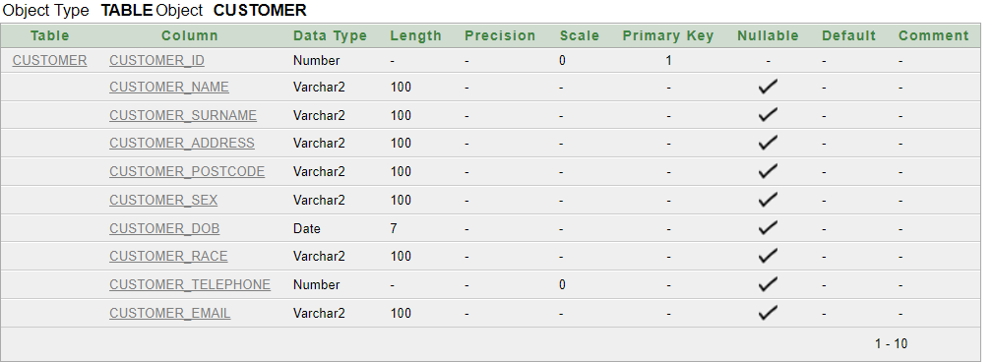
OUTPUT OF ALL DDL PERFORMIED TABLE

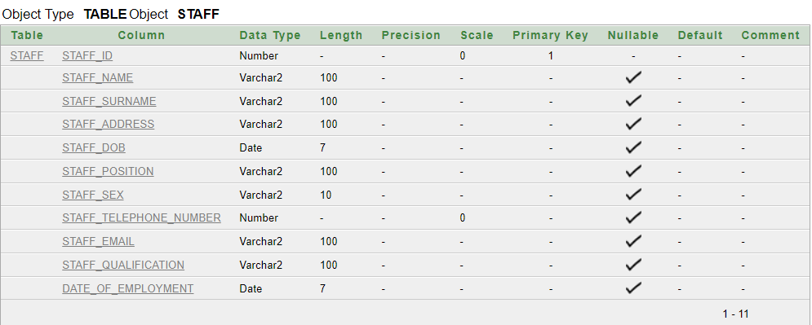

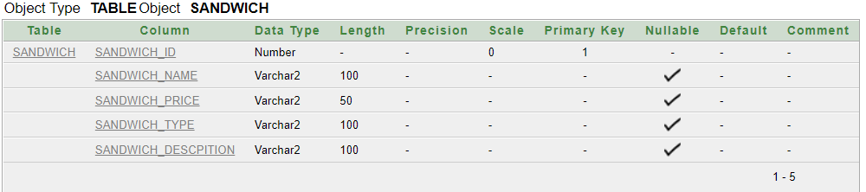

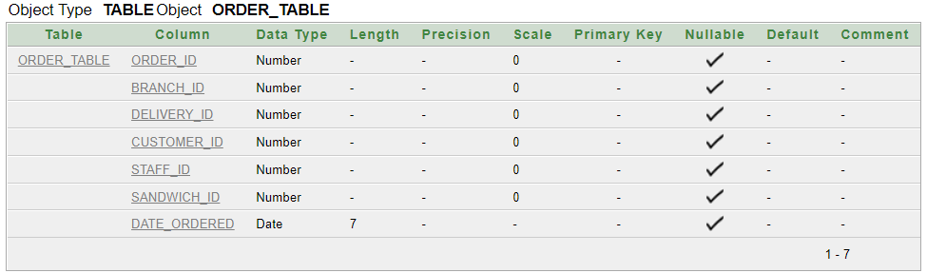
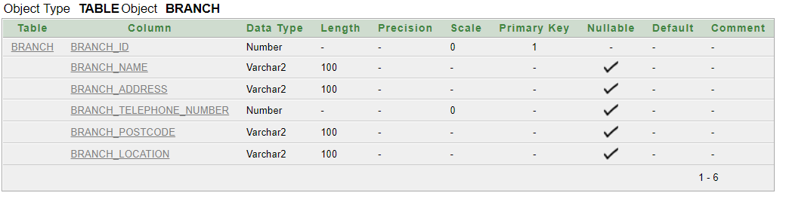
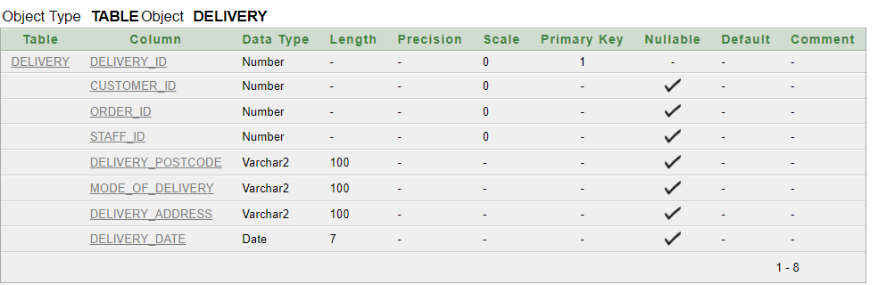

PERFORMING DML
1)CUSTOMERS_TABLE
INSERT INTO CUSTOMER(CUSTOMER_ID ,CUSTOMER_NAME ,CUSTOMER_SURNAME,CUSTOMER_ADDRESS,CUSTOMER_POSTCODE,CUSTOMER_SEX,CUSTOMER_DOB,CUSTOMER_TELEPHONE,CUSTOMER_EMAIL)
VALUES(966023,'James','Wilson','20 Manchester st Centre 123','WW2 6AQ','M',to_date('02/04/1998','dd/mm/yyyy'),720086557,'JamesCharles1@gmail.com');
VALUES(966024,'Adam','Dorothy','52 Merlin Rd Marchington','MA1 0NG','M',to_date('15/06/1990','dd/mm/yyyy'),720497255,'AdamDorothy@gmail.com');
VALUES(966025,'Alder','Briony','80 Winchester Street Lunsly Harchester','LU3 2QN','M',to_date('22/06/1999','dd/mm/yyyy'),720865864,'AlderBriony@gmail.com');
VALUES(966026,'Cairns','Ian','35 Exeter Dell','HA1 6TM','F',to_date('02/04/1997','dd/mm/yyyy'),720675557,'CairnsIan@gmail.com');
VALUES(966027,'Featherstone','Joanne','76 Tongham Park Pearsbridge','PE8 3RU','M',to_date('08/03/2000','dd/mm/yyyy'),720045264,'Featherstone@gmail.com');
VALUES(966028,'Joseph','Keith','10 Peabody Street Tameford','TA3 1NN','F',to_date('09/10/1996','dd/mm/yyyy'),7203456452,'JosephKeith@gmail.com');
VALUES(966029,'Jenkins','Stephen','88 Bliss Grove Cutteringham','CU2 3BY','F',to_date('03/01/1998','dd/mm/yyyy'),720084643,'JenkinsStephen@gmail.com');
VALUES(966030,'Renne','Stephen','97 Newport Rd Cuttingham','CU4 7AQ','F',to_date('12/11/2001','dd/mm/yyyy'),720087854,'RenneBarry@gmail.com');
VALUES(966031,'Starling','Kirk','1 Crowe Close Horley','HO9 2QS','F',to_date('21/10/1993','dd/mm/yyyy'),720085262,'StarlingKirk@gmail.com');
VALUES(966032,'Zimmerman','Jonathon','50 Combe Rd Westeringham','WE2 6IY','F',to_date('13/10/1994','dd/mm/yyyy'),720084234,'Zimmerman@gmail.com');

OUTPUT OF PERFOMIED DML
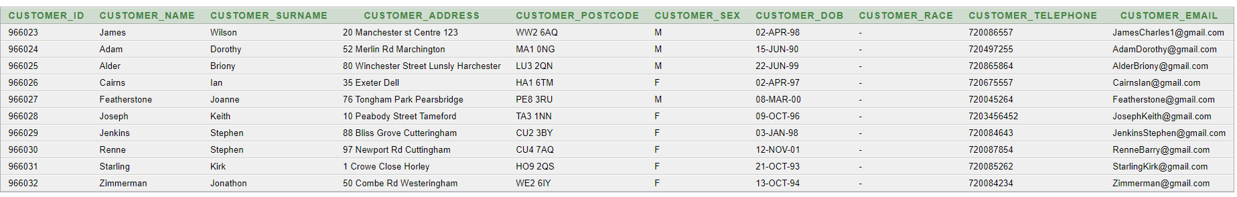

2)SANDWICH_TABLE

INSERT INTO SANDWICH(SANDWICH_ID ,SANDWICH_NAME ,SANDWICH_PRICE ,SANDWICH_TYPE,SANDWICH_DESCPITION )
VALUES(45020200,'Ham','$1.90','Han Sandwich','Made with focaccia bread, with lettuce and mustard');
VALUES(45020201,'Beef and horseradish','$4.99','beef stew','beef pieces salt and black pepper ,Heat vegetable oil in a large skillet over ,Pour beer and broth');
VALUES(45020202,'Salmon and cucumber','$2.50','Salmon cucumber','cup chopped peeled cucumber,mayonnaise,sour cream,lemon juice ');
VALUES(45020203,'Egg mayo','$1.50','Egg Sandwich',' eggs, vinegar, mustard, salt, and white pepper ');
VALUES(45020204,'Cheese and onion','$1.99','Cheese Sandwich','Made with toasted bread with soft,onion,melty cheese');
VALUES(45020205,'Tuna and mayo','$2.25','tuna mayo Sandwich','Made with toasted bread with soft,mayo,egg yolks');
VALUES(45020206,'Falafal wrap','$2.99','falafel sandwich rolled in bread','chickpea paste, add boiled chickpeas,chopped garlic,chopped parsley,Fry the falafel balls');
VALUES(45020207,'Plain salad','$2.20','Plain salad','Made plain potato salad');
VALUES(45020208,'Corned beef','$2.20','Salt Beef','Made Flat Cut of Brisket,salt-cured');
VALUES(45020209,'Turkey mayo','$2.10','Turkey Chicken','Made fresh turkey,cup mayonnaise,fresh parsley, chopped');
VALUES(45020210,'Prawn mayo','$2.19','Prawn','Made cup mayonnaise, ketchup,freshly squeezed lemon juice,worcestershire sauce');

OUTPUT OF PERFOMIED DML
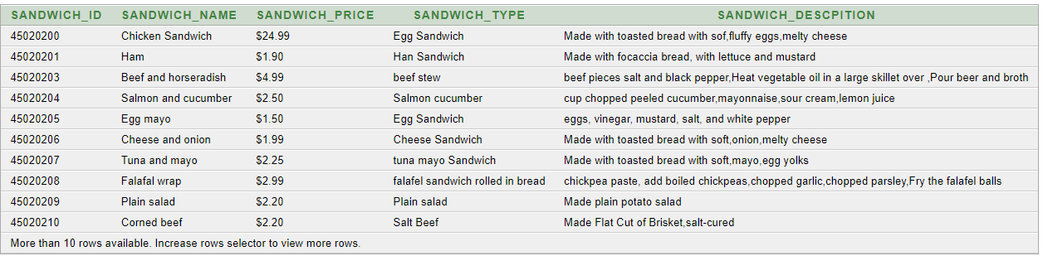

3)BRANCH_TABLE

INSERT INTO BRANCH(BRANCH_ID, BRANCH_NAME,BRANCH_ADDRESS,BRANCH_TELEPHONE_NUMBER,BRANCH_POSTCODE,BRANCH_LOCATION)
VALUES(15050,'SANDWICH HACKEY','10 CITYSTREET CENTRE 104',706020543,'POSTCODE OF CUSTOMER HOUSE HN1 5TH','HACKNEY HIGH STREET');
VALUES(15051,'SANDWICH HACKEY','22 CITYSTREET CENTRE 164',701231543,'POSTCODE OF CUSTOMER HOUSE HN5 1TH','HACKNEY HIGH STREET');
VALUES(15023,'SANDWICH HACKEY','1 CITYSTREET CENTRE 142',70242343,'POSTCODE OF CUSTOMER HOUSE HN2 1TH','HACKNEY HIGH STREET');
VALUES(15032,'SANDWICH HACKEY','20 CITYSTREET CENTRE 4',706432443,'POSTCODE OF CUSTOMER HOUSE HN4 1TH','HACKNEY HIGH STREET');
VALUES(15034,'SANDWICH HACKEY','35 CITYSTREET CENTRE 24',700205643,'POSTCODE OF CUSTOMER HOUSE HN3 1TH','HACKNEY HIGH STREET');
VALUES(15053,'SANDWICH HACKEY','43 CITYSTREET CENTRE 104',705430543,'POSTCODE OF CUSTOMER HOUSE HN2 1TH','HACKNEY HIGH STREET');
VALUES(15012,'SANDWICH HACKEY','54 CITYSTREET CENTRE 104',735020543,'POSTCODE OF CUSTOMER HOUSE HN4 1TH','HACKNEY HIGH STREET');
VALUES(14123,'SANDWICH HACKEY','34 CITYSTREET CENTRE 104',703532043,'POSTCODE OF CUSTOMER HOUSE HN2 5TH','HACKNEY HIGH STREET');
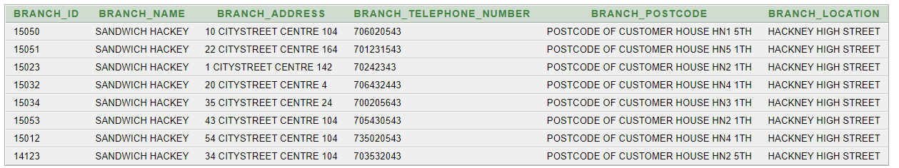
OUTPUT OF PERFOMIED DML

4) DELIVERY_TABLE

INSERT INTO DELIVERY(DELIVERY_ID ,CUSTOMER_ID ,ORDER_ID ,STAFF_ID ,DELIVERY_POSTCODE ,MODE_OF_DELIVERY ,DELIVERY_ADDRESS ,DELIVERY_DATE )
VALUES(1000,94123,6661,5006020543,'HN2 5TH','Car,Motorbike,Bike','5 Citystreet Centre 104',to_date('12/01/2017','dd/mm/yyyy'));
VALUES(1001,913223,6662,5006020543,'HN2 4TH','Car,Motorbike,Bike','6 Citystreet Centre 105',to_date('13/02/2017','dd/mm/yyyy'));
VALUES(1002,912023,6663,5006020543,'HN7 7TH','Car,Motorbike,Bike','7 Citystreet Centre 143',to_date('01/02/2017','dd/mm/yyyy'));
VALUES(1003,912267,6664,5006020543,'HN6 4TH','Car,Motorbike,Bike','11 Citystreet Centre 134',to_date('05/03/2017','dd/mm/yyyy'));
VALUES(1004,91298,6665,5006020543,'HN3 2TH','Car,Motorbike,Bike','14 Citystreet Centre 134',to_date('01/03/2017','dd/mm/yyyy'));
VALUES(1005,99623,6666,5006020543,'HN6 3TH','Car,Motorbike,Bike','12 Citystreet Centre 134',to_date('21/03/2017','dd/mm/yyyy'));
VALUES(1006,96943,6667,5006020543,'HN3 8TH','Car,Motorbike,Bike','11 Citystreet Centre 134',to_date('10/03/2017','dd/mm/yyyy'));
VALUES(1007,966024,6668,5006020543,'HN2 9TH','Car,Motorbike,Bike','4 Citystreet Centre 54',to_date('18/03/2017','dd/mm/yyyy'));
OUTPUT OF PERFOMIED DML
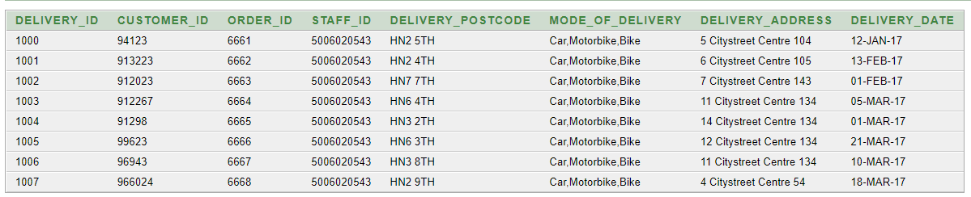

5)STAFF_TABLE

INSERT INTO STAFF (STAFF_ID , STAFF_NAME , STAFF_SURNAME ,STAFF_ADDRESS,STAFF_DOB,STAFF_POSITION ,STAFF_SEX ,STAFF_TELEPHONE_NUMBER ,STAFF_EMAIL , STAFF_QUALIFICATION,DATE_OF_EMPLOYMENT)
VALUES(6533325530,'Mike','Webster','10 Liverpool street 130',to_date('11/03/1994','dd/mm/yyyy'),'Manager','M',755521231,'Mick@gmail.com','BSC Degree',to_date('20/12/2013','dd/mm/yyyy'));
VALUES(6533325531,'Alder','Briony','7 Liverpool street 130',to_date('19/07/1990','dd/mm/yyyy'),'Employee','M',755521421,'Alder@gmail.com','Intermidate',to_date('23/04/2009','dd/mm/yyyy'));
VALUES(6533325532,'Cowan','Vernon','5 Liverpool street 130',to_date('22/05/1997','dd/mm/yyyy'),'Employee','M',755535453,'Cowan@gmail.com','Intermidate',to_date('15/09/2014','dd/mm/yyyy'));
VALUES(6533325533,'Davison','Colin','2 Liverpool street 130',to_date('18/01/1995','dd/mm/yyyy'),'Employee','M',755123121,'Davison@gmail.com','Intermidate',to_date('16/03/2012','dd/mm/yyyy'));
VALUES(6533325534,'Eccles','Rosamund','1 Liverpool street 130',to_date('17/04/1994','dd/mm/yyyy'),'Employee','F',75523422,'Eccles@gmail.com','Intermidate',to_date('21/07/2013','dd/mm/yyyy'));
VALUES(6533325535,'Featherstone','Joanne','11 Liverpool street 130',to_date('13/04/2003','dd/mm/yyyy'),'Manager','M',72131040,'Featherstone@gmail.com','BSC Degree',to_date('25/05/2009','dd/mm/yyyy'));
VALUES(6533325536,'Field','Hector','3 Liverpool street 130',to_date('12/09/1999','dd/mm/yyyy'),'Employee','M',713220040,'Field@gmail.com','Intermidate',to_date('21/01/2015','dd/mm/yyyy'));
VALUES(6533325537,'Morgan','Angela','9 Liverpool street 130',to_date('16/04/1998','dd/mm/yyyy'),'Manager','M',713430040,'Morgan@gmail.com','BSC Degree',to_date('10/03/2011','dd/mm/yyyy'));

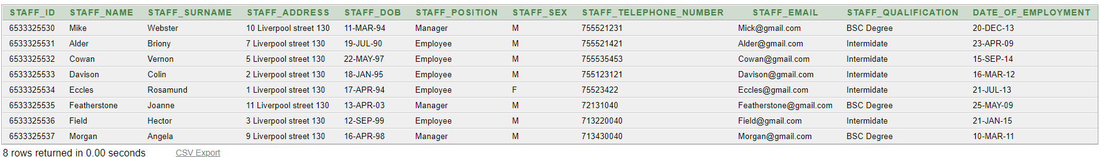
OUTPUT OF PERFOMIED DML

6)ORDER_TABLE
INSERT into ORDER_TABLE(ORDER_ID ,BRANCH_ID ,DELIVERY_ID ,CUSTOMER_ID ,STAFF_ID ,SANDWICH_ID ,DATE_ORDERED )
VALUES(6661,15050,1000,966023,6533325530,45020200,to_date('12/01/2017','dd/mm/yyyy'));
VALUES(6662,15051,1001,966024,6533325531,45020201,to_date('13/01/2017','dd/mm/yyyy'));
VALUES(6663,15052,1002,966025,6533325532,45020203,to_date('01/01/2017','dd/mm/yyyy'));
VALUES(6664,15053,1003,966026,6533325533,45020204,to_date('05/01/2017','dd/mm/yyyy'));
VALUES(6665,15054,1004,966027,6533325534,45020205,to_date('11/01/2017','dd/mm/yyyy'));
VALUES(6666,15055,1005,966028,6533325535,45020206,to_date('10/01/2017','dd/mm/yyyy'));
VALUES(6667,15056,1006,966029,6533325536,45020207,to_date('12/01/2017','dd/mm/yyyy'));
VALUES(6668,15057,1007,966030,6533325537,45020208,to_date('21/01/2017','dd/mm/yyyy'));
VALUES(6669,15058,1008,966031,6533325538,45020209,to_date('09/01/2017','dd/mm/yyyy'));
VALUES(6670,15069,1009,966032,6533325539,45020210,to_date('07/01/2017','dd/mm/yyyy'));

OUTPUT OF PERFOMIED DML
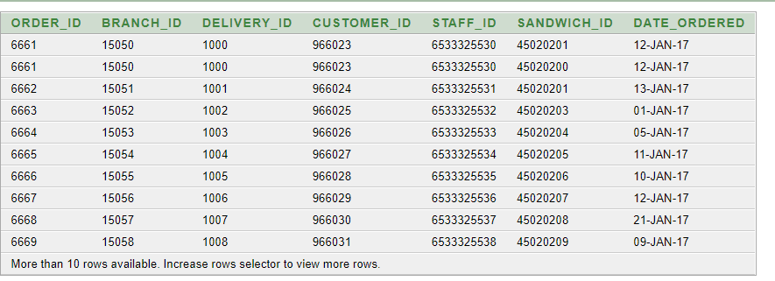

PERFORMING QUERIES
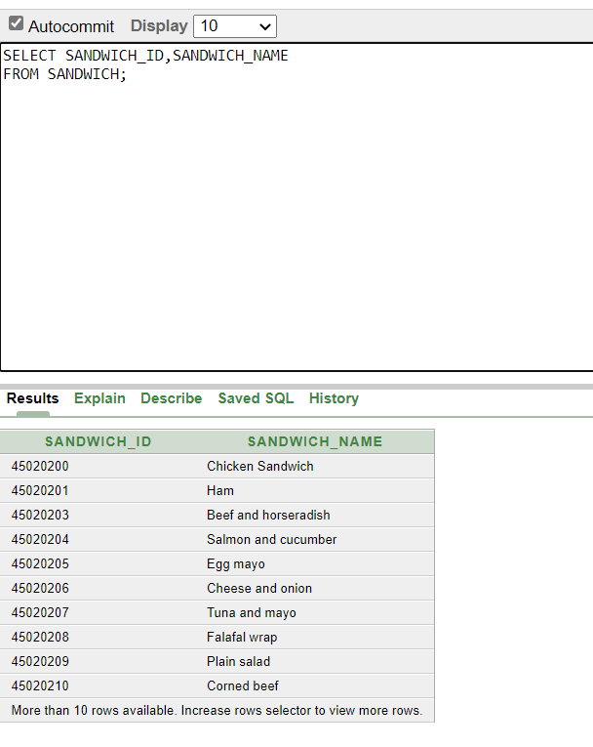

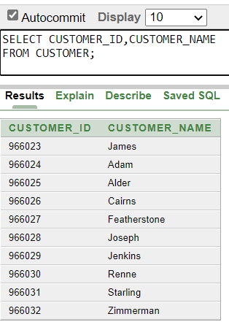

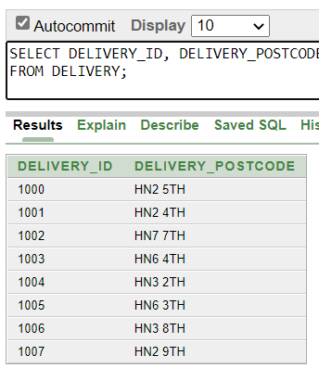

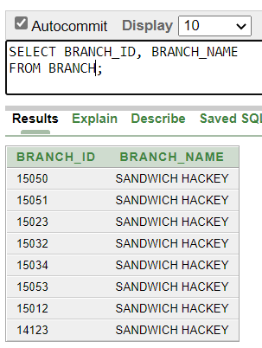

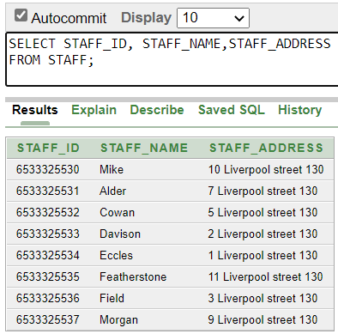

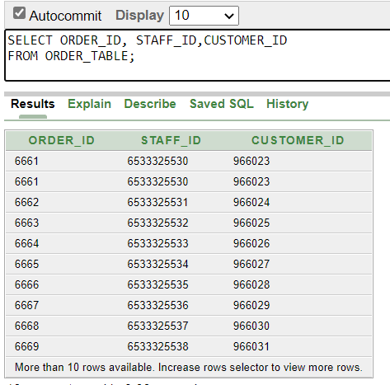

Task | Start Date | End date
Meeting | 10/12/2021 | 12/12/2021
Research | 15/1/2022 | 25/1/2022
Design proposal | 27/1/2022 | 27/1/2022
Implementation of design | 1/2/2022 | 7/2/2022
Creation of queries, forms and reports | 15/2/2022 | 28/2/2022
Final Designing | 1/2/2022 | 5/2/2022
Testing | 15/3/2022 | 21/3/2022

