The 4th Assignment:

Group Details:
No. | Student ID | Student Name
1 | 446001393 | Sami Maatouq Wali
2 | 446005881 | Ameen Alshangeeti
3 | 446007815 | Abdullah Bogari

Project Title (Maximum 10 words):
AI-Based Campus Illegal Waste Dumping Detection System

Project Description (Minimum 100 words):
The objective of this project is to create an AI-based system capable of detecting illegal activities that take place within a university campus by making use of videos from surveillance cameras. Unlike a basic garbage detection system which merely identifies waste objects in an image, the system being proposed will examine sequences of video frames in order to judge whether a person actually carries out a dumping action and leaves waste in an unauthorized spot. For this purpose, the system has to understand movements and the changes that happen over time rather than depending on a single image.
The project will make use of Computer Vision, Video Processing, Motion Analysis, and Machine Learning in order to obtain useful information from surveillance videos. Various machine learning algorithms will then be trained to classify the activities as either Dumping or No Dumping and the performance of these algorithms will be compared in order to find out which approach works best.
For the implementation and comparison stage, the main task will focus on recognizing the dumping action itself. A dumping action can involve dropping, throwing, tossing, or releasing an object. The object does not have to be identified as a particular type of garbage during this stage. The models will use the original Dumping and No Dumping labels supplied with MIVIA-IWDD-500. Activities such as walking, standing, reading, or temporarily placing an object will retain the labels provided by the dataset rather than being automatically changed into dumping events.
The surveillance videos will be converted into ordered sequences of frames so that the models can analyze how an action develops over time. Instead of treating every extracted image as an unrelated image, the frames belonging to one video will remain in chronological order and will represent one video sequence. Several video action recognition approaches will then be compared using the same training and testing data.
In addition to video action recognition, YOLOv8n will be used as a supporting object detection method. It has been trained using the Littering dataset from Roboflow Universe in order to locate regions associated with littering in individual images. This provides an additional source of visual information while the main video classification task remains focused on recognizing Dumping and No Dumping actions over time. The final interface allows the user to select a video, examine the action predictions, inspect the YOLO evidence, and view the saved evaluation results.

Define Dataset that will be used in your project with Samples? (Minimum 500 words):
For the aspect of the project concerned with detecting illegal dumping, the main dataset used is MIVIA-IWDD-500. This dataset was designed specifically with a view to detecting illegal waste dumping from surveillance video and is therefore more appropriate for this project than datasets which consist only of static images of garbage.
The MIVIA-IWDD-500 dataset includes 500 video sequences amounting to about three hours of recorded material and is evenly split between 250 positive videos which show illegal dumping and 250 negative videos which do not involve illegal dumping; the positive videos are further broken down into 125 examples of static dumping and 125 of dynamic dumping.
Static dumping refers to cases in which waste is intentionally left at a certain location; for instance, someone might put a garbage bag on the ground and then leave the area. Dynamic dumping on the other hand involves dumping waste while in motion, such as throwing an object while walking or getting rid of waste from a moving vehicle.
A key benefit of the dataset is that the negative videos do not just show empty scenes; instead, they contain activities which might look like dumping, for example people carrying objects, temporarily putting down objects, picking up items, carrying out sanitation activities, or moving around existing waste. This is advantageous since it decreases the chance that the system learns a wrong shortcut, such as believing that any visible bag indicates illegal dumping.
The dataset includes details concerning the time at which a dumping event starts in the case of positive videos. This event-onset timestamp could then enable the project to be extended in the future from simple video classification to temporal localization, with the system trying to determine when the illegal action actually begins. Furthermore, other metadata can be used to describe conditions such as daytime, nighttime, bright scenes, and dim scenes. In the current implementation, the event timestamps are recorded for inspection and are not used to select the training frames.
The benchmark that has been published includes 400 videos for training and 100 for testing. Of the videos used for training, 200 are positive and 200 are negative, and among those used for testing there are 50 positive and 50 negative videos. Within the official training division, 320 videos were used for fitting the models and 80 were reserved for validation. All four action-recognition approaches use these same video divisions.
For the implementation, 24 chronologically ordered frames are extracted from each video, resulting in 12,000 extracted frames from 500 original videos. These frames are treated as video sequences rather than as independent original images. All frames belonging to the same video remain in the same data split in order to prevent information from passing between the training and testing sets.
The second dataset used is Littering, version 8, named yolotiny, which is available through Roboflow Universe. This dataset contains still images with bounding-box annotations in COCO format. The annotations use the class name littering and identify the location of the labelled region within each image. The box can cover the person or region associated with the activity, so this is not a dataset with separate object categories such as bottles, bags, or pens.
The accompanying dataset description refers to approximately 17,400 exported images and includes augmented versions produced through horizontal flipping, cropping, and shearing. The actual preparation process used the image records referenced by the available COCO annotation files. These contained 11,882 training images and 1,168 validation images, giving 13,050 prepared image records and 13,051 bounding boxes. Three of these images have no target boxes and were retained as background examples. These image records should not be described as 13,050 independent original scenes because the export includes related and augmented images.
The supplied test directory contains 1,230 images but no COCO annotation file. Consequently, the current YOLO evaluation uses the labelled validation division. The supplied Roboflow split was preserved, although a complete audit of related source images and source videos across its divisions has not yet been carried out. MIVIA remains the main dataset for recognizing dumping actions over time, while the Littering dataset is used to train YOLOv8n to locate labelled littering regions.
Samples from the actual project files are shown below. The first example contains four selected frames from vid0001.mp4, which has the Dumping label, and four frames from vid0002.mp4, which has the No Dumping label. The second example shows a Littering validation image with its provided ground-truth box. These illustrate the supplied data and labels rather than model predictions.
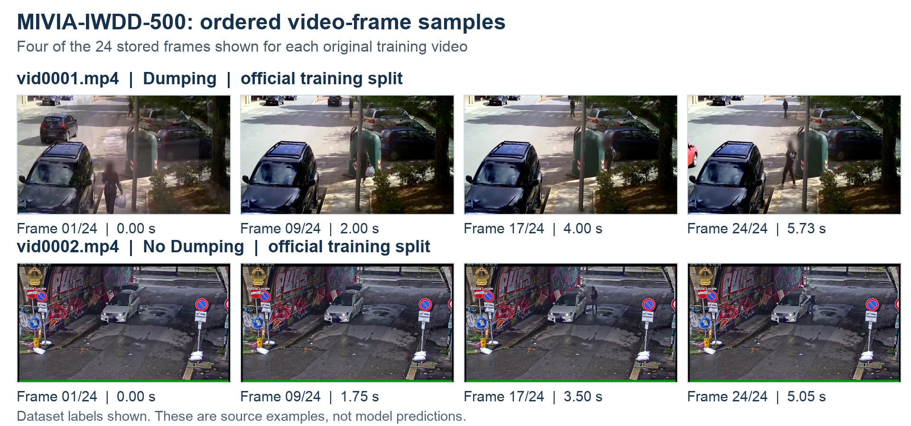
Figure 1. Four chronologically ordered samples from each of two MIVIA training videos: vid0001.mp4 (Dumping) and vid0002.mp4 (No Dumping). Each original sequence contains 24 stored frames. These are dataset examples, not predictions.
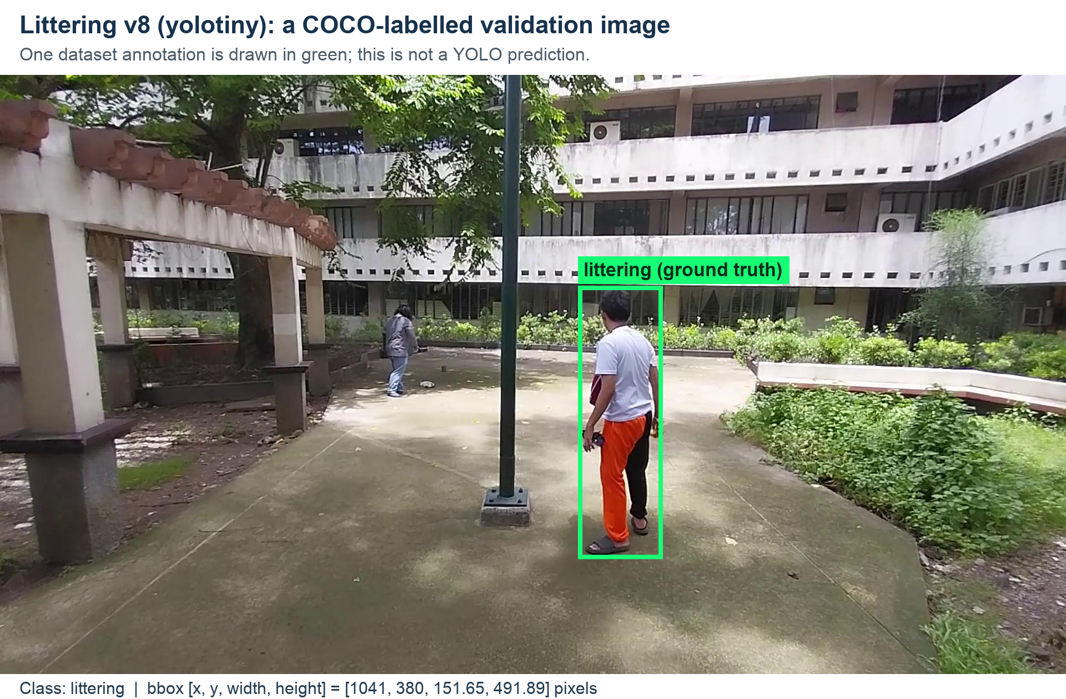
Figure 2. Actual Roboflow Littering v8 validation image with its supplied COCO ground-truth box. This sample marks the person region associated with littering; it is a dataset annotation rather than a model prediction or an object-type label.

Similar Projects with explaining the main differences between your project and these projects (Minimum 3 Projects):
1. CivicSense
CivicSense is an open-source AI-powered littering detection platform designed to monitor images, videos, cameras, and surveillance streams. The system combines object detection, human pose estimation, and multi-object tracking in order to determine whether an object is associated with a person and whether it is subsequently dropped or thrown. It also attempts to distinguish active littering from waste that was already present on the ground. The project is publicly available on GitHub and can be installed and tested using video files, making it useful as a practical reference for the proposed dumping action detection system.
The main difference is that our project compares four complete-video classification approaches using the same MIVIA video divisions and evaluation measures. The current implementation does not use a person-object tracking or pose-estimation pipeline. It provides a separate YOLOv8n littering-region detector as supporting visual information and allows the user to inspect both results through the interface.
https://github.com/muhammad-fiaz/civicsense
2. TRACE
TRACE, which stands for Trash Recognition and Automated Civic Enforcement, is an open-source surveillance system designed to detect littering events in public spaces. The system uses YOLOv8 for detecting people and waste objects and ByteTrack for tracking them across video frames. One particularly relevant part of TRACE is its event state machine, which follows a detected object through states such as CARRYING, SEPARATION, STATIONARY, and ALERTED. This allows the system to consider the relationship between a person and an object over time rather than relying only on a single image. The source code is publicly available on GitHub and the system can be tested using video or camera input.
The main difference is that TRACE uses explicit tracked states to form a littering alert, while our implemented action models classify an ordered sequence of 24 frames as Dumping or No Dumping. Our project records Accuracy, Precision, Recall, F1-score, and a Confusion Matrix for each of the four approaches. A tracked-object state machine has not been implemented in the current system.
https://github.com/Arnab500th/Hackathon-Automated-Littering-Detection-and-Alert-System-for-Public-Spaces
3. AI for Environmental Monitoring and Urban Planning
AI for Environmental Monitoring and Urban Planning is an open-source project that uses CCTV video to detect possible illegal dumping events. Its processing pipeline combines motion detection, object tracking, stationary-object analysis, and a MobileNetV3 classifier. The project includes source code, installation instructions, a video-based command-line demonstration, and an evaluation of the system using real test videos. The authors also report false-positive detections as an important challenge, which is relevant to the proposed project because ordinary movements and objects should not be incorrectly classified as dumping events.
The main difference is that our project compares Optical Flow and SVM, CNN and LSTM, a small 3D CNN, and MoViNet A0. The three video neural networks and the supporting YOLOv8n detector were trained from random initialization. Our project also reports false alarms and missed dumping events through the Confusion Matrix, so the comparison shows how each approach behaves on the same videos rather than relying only on the overall Accuracy.
https://github.com/syedahmadbokhari/AI-for-Environmental-Monitoring-and-Urban-Planning

References:
1. MIVIA-IWDD-500, MIVIA Lab, University of Salerno
https://github.com/MiviaLab/IllegalWasteDumping
2. Benchmarking Illegal Waste Dumping Detection: A Public Video Dataset and a Reference Baseline, Image and Vision Computing
https://www.sciencedirect.com/science/article/pii/S0262885626002325
3. Illegal Waste Dumping Detection, WACV 2026 WasteVision Workshop
https://openaccess.thecvf.com/content/WACV2026W/WasteVision/html/Bouwmans_Illegal_waste_dumping_detection_WACVW_2026_paper.html
4. Littering Dataset, Version 8 (yolotiny), Roboflow Universe
https://universe.roboflow.com/thesis-kztn8/littering-whlsk/dataset/8
5. OpenCV Documentation
https://docs.opencv.org/
6. OpenCV Optical Flow Documentation
https://docs.opencv.org/4.x/d4/dee/tutorial_optical_flow.html
7. Scikit-learn Support Vector Machines
https://scikit-learn.org/stable/modules/svm.html
8. Long Short-Term Memory, Hochreiter and Schmidhuber, Neural Computation, 1997
https://doi.org/10.1162/neco.1997.9.8.1735
9. Learning Spatiotemporal Features with 3D Convolutional Networks, Tran et al., ICCV, 2015
https://openaccess.thecvf.com/content_iccv_2015/html/Tran_Learning_Spatiotemporal_Features_ICCV_2015_paper.html
10. MoViNets: Mobile Video Networks for Efficient Video Recognition, Kondratyuk et al., CVPR, 2021
https://arxiv.org/abs/2103.11511
11. MoViNet-pytorch, Unofficial PyTorch Implementation
https://github.com/Atze00/MoViNet-pytorch
12. Ultralytics YOLOv8 Documentation
https://docs.ultralytics.com/
13. Real-Time Detection and Monitoring of Public Littering Behavior Using Deep Learning for a Sustainable Environment
https://www.nature.com/articles/s41598-024-77118-x
14. Vision-Based Garbage Dumping Action Detection for Real-World Surveillance Platform
https://onlinelibrary.wiley.com/doi/10.4218/etrij.2018-0520
15. CivicSense
https://github.com/muhammad-fiaz/civicsense
16. TRACE
https://github.com/Arnab500th/Hackathon-Automated-Littering-Detection-and-Alert-System-for-Public-Spaces
17. AI for Environmental Monitoring and Urban Planning
https://github.com/syedahmadbokhari/AI-for-Environmental-Monitoring-and-Urban-Planning

Define Dataset Manipulation that will be used in your project with Samples? (Minimum 500 words):
The dataset manipulation stage was carried out separately for the video action-recognition task and for the supporting object-detection task. This was necessary because MIVIA-IWDD-500 contains complete surveillance videos labelled as Dumping or No Dumping, while the Littering dataset contains still images with bounding-box annotations for a littering region. The two datasets therefore have different formats and different purposes within the project.
For the main dumping-action task, the original MIVIA-IWDD-500 dataset was preserved in its official division. The dataset contains 500 original surveillance videos in total. There are 400 videos in the official training division and 100 videos in the official testing division. Each division contains equal numbers of Dumping and No Dumping videos. The official testing videos were kept separate from the videos used for fitting the models.
The 400 official training videos were divided again into 320 fitting videos and 80 validation videos. This division was performed at video level with a fixed random seed of 42 so that the same video is always assigned to the same division. The split was stratified, which means that Dumping and No Dumping remained balanced in the fitting and validation groups. No frames from one source video were allowed to appear in different groups. This is important because frames from the same video are visually similar, and splitting them between training and testing could give an unrealistic result.
Each original MIVIA video was converted into 24 chronologically ordered frames. The frames were selected at evenly spaced positions from the beginning of the video until its end. This produced 9,600 extracted frames from the 400 official training videos and 2,400 extracted frames from the 100 official testing videos. Within the training division, 7,680 frames belong to the 320 fitting videos and 1,920 belong to the 80 validation videos. The total number of extracted frames was therefore 12,000. These frames were kept as 500 source-video sequences rather than being counted as independent original samples.
For example, vid0001.mp4 has the Dumping label and contains 173 source frames at 30 frames per second. Its 24 stored frames were selected from source positions 0 to 172. Stored frames 1, 9, 17, and 24 correspond to approximately 0.00, 2.00, 4.00, and 5.73 seconds. The same uniform sampling procedure was used for the No Dumping video vid0002.mp4. The event-onset label was not used to choose frames, so the extraction procedure was the same for both classes.
After extraction, each frame was converted from OpenCV BGR format into RGB format. The frames were resized to 112 by 112 pixels using letterbox resizing. This keeps the original aspect ratio and adds black borders where necessary, which prevents the person and the scene from being stretched. Pixel values were divided by 255 when preparing input tensors for the neural networks. All videos were decoded successfully. Two event timestamps were found outside their source video durations; they were recorded as diagnostic information and were not used for sampling or training.
For Optical Flow and SVM, the frames were converted into grayscale and movement was calculated between consecutive frames using Farneback Optical Flow. The motion was summarized using spatial regions, temporal groups, and motion statistics, producing 320 features for each video. A StandardScaler was fitted using the fitting videos and then applied to the validation and test features. For CNN and LSTM, the 3D CNN, and MoViNet A0, the same ordered RGB frames were retained as complete sequences.
The second manipulation process was carried out for the Littering version 8 dataset from Roboflow Universe. The original export uses COCO annotations, while YOLOv8n requires labels in YOLO format. The labelled train and validation divisions supplied by the dataset were preserved. The preparation processed 11,882 training image records with 11,884 boxes and 1,168 validation image records with 1,167 boxes. Three images had no target box and were retained with empty YOLO label files.
The COCO bounding boxes were converted into a class number, normalized centre position, normalized width, and normalized height. The target class was kept as one class named littering. For example, a box with its upper-left position at x = 1041 and y = 380, width 151.65 and height 491.89, in a 1920 by 1080 image becomes approximately 0.5817, 0.5796, 0.0790, and 0.4555 for the centre and size values. The original image and the associated box remain linked through the label file.
The input size used for YOLO training was 320 by 320 pixels. The 1,230 test images were excluded from detection metrics because their annotation file was absent. Existing augmented images were not counted as independent original scenes. The supplied Roboflow divisions were retained, but related source images and source videos across those divisions have not yet been fully audited. This limitation is kept separate from the MIVIA video-level split checks, which were completed.

Implementation with Screenshot of your Outcomes:
The implementation of the project was completed using Python, OpenCV, PyTorch, Scikit-learn, Ultralytics YOLO, and a Tkinter graphical user interface. The main implementation was divided into two connected parts. The first part was responsible for recognizing whether a dumping action happened in a surveillance video. The second part was responsible for finding visual regions related to littering in selected video frames. Both outputs are available through the same interface.
For the action-recognition part, an MP4 surveillance video is selected through the graphical user interface. The system extracts 24 ordered frames from the selected video using the same preprocessing method used during training. These frames are resized, converted into RGB format, and then passed to the trained action-recognition models. The user can select one model or compare all four trained models. The four implemented approaches are Optical Flow with SVM, CNN with LSTM, 3D CNN, and MoViNet A0.
The four action-recognition models were evaluated using the same 100 official MIVIA testing videos. The positive class used when calculating Precision, Recall, and F1-score is Dumping. The results saved by the completed evaluation are shown below.
Model | Accuracy | Precision | Recall | F1 score
Optical Flow + SVM | 64.00% | 62.96% | 68.00% | 65.38%
CNN + LSTM | 61.00% | 70.37% | 38.00% | 49.35%
3D CNN | 69.00% | 63.38% | 90.00% | 74.38%
MoViNet A0 | 72.00% | 71.15% | 74.00% | 72.55%

MoViNet A0 achieved the highest Accuracy of 72%, while the 3D CNN achieved the highest dumping Recall of 90% and the highest dumping F1-score of 74.38%. CNN and LSTM produced fewer false alarms but missed more genuine dumping events. The Confusion Matrices show that Optical Flow and SVM produced 20 false alarms and missed 16 dumping events. CNN and LSTM produced 8 false alarms and missed 31 events. The 3D CNN produced 26 false alarms and missed 5 events, while MoViNet A0 produced 15 false alarms and missed 13 events.
The current MIVIA results are exploratory because earlier results on the official testing set were examined before the model-selection criterion was changed to macro F1. The models were fitted using training videos only, but this previous inspection means that the reported test results should not be described as an evaluation on a completely untouched testing set.
A supporting YOLOv8n object-detection model was also implemented. YOLOv8n was trained from scratch using the Littering dataset for five epochs with an image size of 320 by 320 pixels and a batch size of 32. The model was evaluated using the 1,168 validation images because the supplied test images did not have annotation files. It achieved Precision of 51.08%, Recall of 72.24%, mAP at 50 of 54.29%, and mAP at 50 to 95 of 24.50%. These are validation results for detecting labelled littering regions.
The final graphical interface contains two main tabs. The first tab is Video Analysis. The user chooses one MP4 video, selects an action-recognition model, and can enable the YOLO scan. The MIVIA models analyze the video using 24 ordered frames. YOLO scans 12 evenly spaced frames from the same video and displays any detected littering regions at the selected detection threshold. Annotated frames are saved so that the user can inspect them. The second tab is Evaluation Results. It displays the four MIVIA model results and a selectable Confusion Matrix, followed by the YOLO object-detection results.
The output should be treated as supporting AI evidence. A human reviewer should examine the selected video, the action result, and the annotated YOLO frames before any action is taken. The current dataset has only one littering detection class and therefore does not provide a prediction such as bottle, bag, or pen.
A further comparison has been proposed in which YOLO detections would be converted into one Dumping or No Dumping result for each video. This would require scanning the same 24 MIVIA frames, choosing the aggregation rule and threshold using the 80 validation videos, and then evaluating the fixed rule on the same 100 test videos. This video-level YOLO baseline has not yet been implemented or evaluated, so no fifth classification result is reported here.
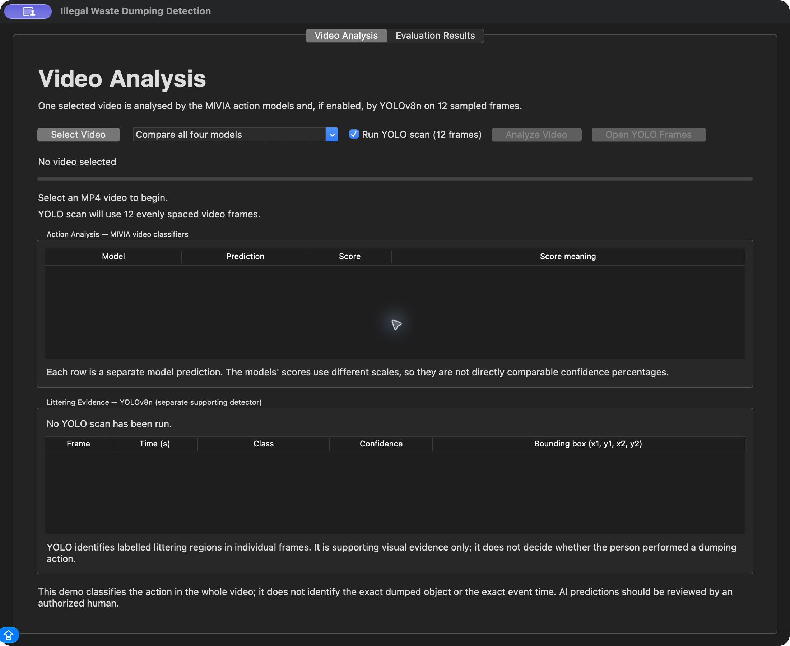
Figure 3. Actual Video Analysis screen before a video is selected. One selected video is passed to the action classifiers, and the optional YOLO scan uses 12 sampled frames.
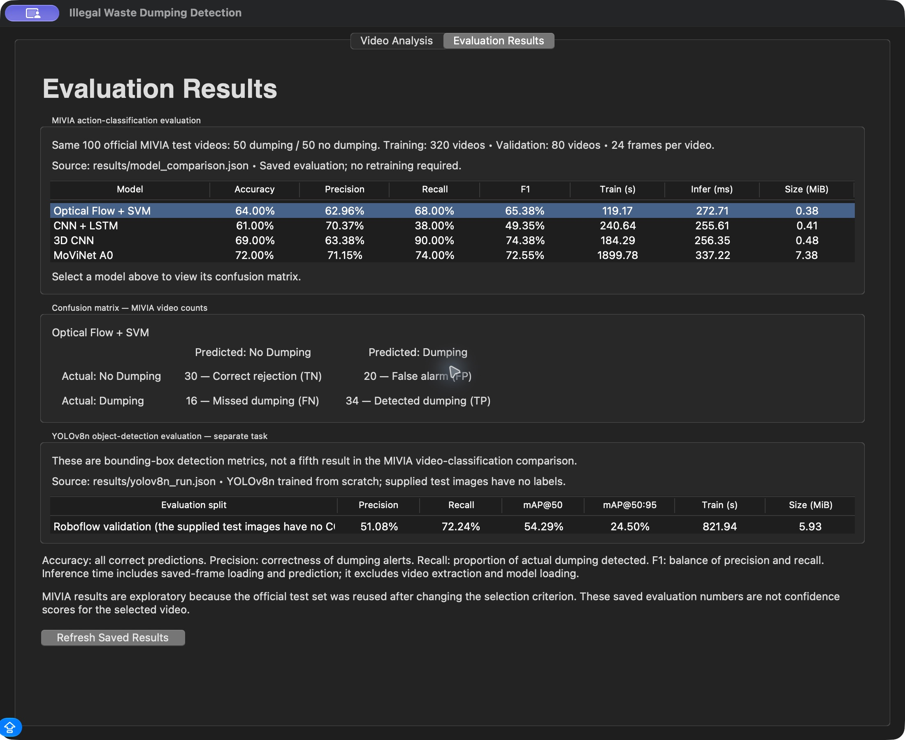
Figure 4. Actual Evaluation Results screen displaying the four MIVIA test results, the Optical Flow and SVM Confusion Matrix, and separate YOLO validation detection results.
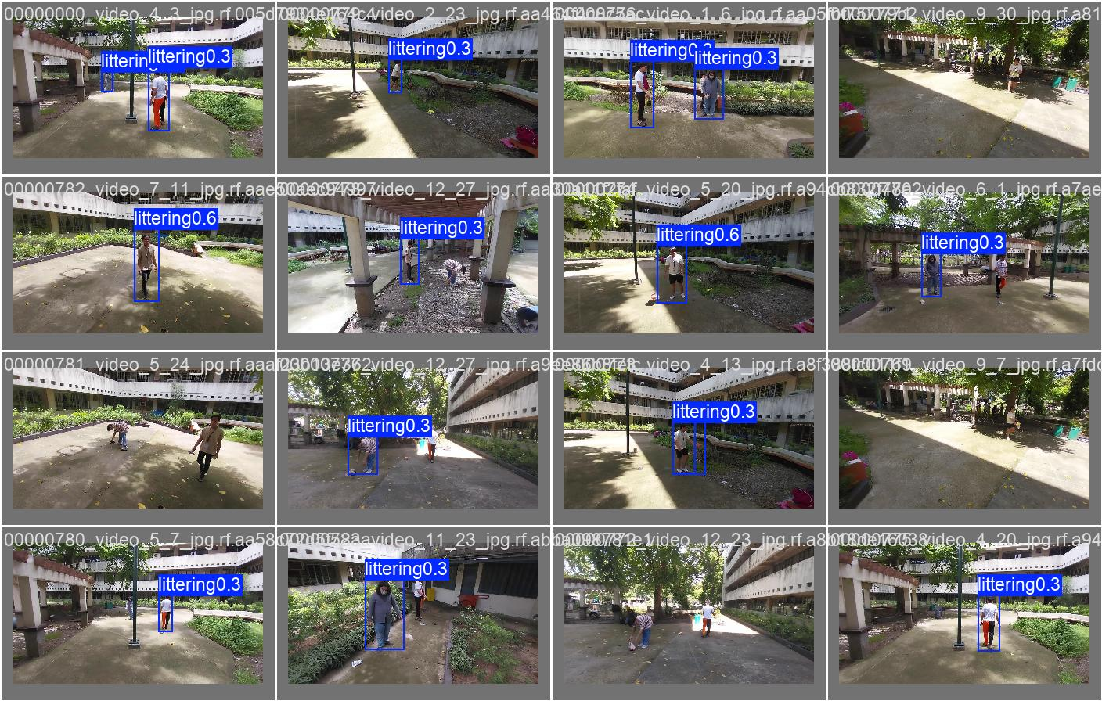
Figure 5. Saved YOLOv8n validation predictions showing detected littering regions and their model scores. These frame-level detections are separate from the MIVIA video-classification outcomes.

Define the AI technologies that will be applied in your project and why you select these technologies? (Minimum 1000 words):
The first classification algorithm that was proposed for the project is Optical Flow combined with a Support Vector Machine, or SVM. This is a classical machine learning approach which uses motion information extracted from ordered video frames. Optical Flow calculates the apparent movement of pixels between frames, and this information is then converted into numerical features. The SVM is a supervised machine learning algorithm which tries to identify a decision boundary that separates one class from another. In this project, the SVM was trained using motion features obtained from videos of dumping and videos of no dumping. Once it has been trained, it classifies the features of a new video and decides which class they are most similar to.
This approach was selected because movement is an important part of a dumping action. It provides a classical comparison method which can be trained using the available videos without needing a large neural network. The implementation uses Farneback Optical Flow between consecutive sampled frames. The movement is summarized across spatial regions and temporal groups, producing 320 numerical features for each video. A StandardScaler and SVM are used together so that the feature scaling is learned from the fitting videos. Six predefined SVM settings were compared using the validation set. The selected setting used an RBF kernel with C equal to 10 and gamma set to scale. The final output includes a decision score rather than a calibrated probability.
The second algorithm is a Convolutional Neural Network combined with a Long Short-Term Memory network, commonly referred to as CNN and LSTM. The CNN examines each frame and obtains visual features which describe its contents. These features are then passed to the LSTM in chronological order so that the model can learn how the visual information changes over time. This approach is useful since a dumping action cannot always be identified from a single image; instead, it is necessary to examine a sequence showing how a person and an object move. The final output classifies the complete video sequence as either Dumping or No Dumping.
CNN and LSTM were selected because they provide an understandable division between visual processing and temporal processing. The CNN handles information about the appearance of each frame, while the LSTM handles the order in which that information appears. This allows the project to compare a sequence-learning approach with the motion features used by Optical Flow and SVM. A relatively small network was used because the fitting set contains 320 videos and the training had to be completed using the available computer resources. The model was trained from random initialization using the project data.
The third algorithm is a Three-Dimensional Convolutional Neural Network, or 3D CNN. Unlike a CNN which examines each image separately, a 3D CNN processes the spatial and temporal information of a video sequence together. Its filters examine the height and width of the frames as well as changes across consecutive frames. This enables the model to learn visual and motion patterns at the same time. For this project, a relatively small 3D CNN was used so that training could be carried out using the available computer resources.
The 3D CNN was selected in order to examine whether learning movement and appearance jointly would provide a useful result on the MIVIA videos. The model receives the same 24-frame sequences as the other video approaches, which keeps the input data consistent. Its completed result was useful for identifying the difference between Recall and Precision. The model detected 45 of the 50 genuine dumping events in the test set but also produced 26 false alarms among the 50 No Dumping videos. This shows why a model with high Recall should still be examined using a Confusion Matrix and the other measures.
The fourth algorithm is MoViNet, which is a neural network architecture designed for video recognition. The project uses the A0 configuration through an unofficial PyTorch implementation. This model receives the same ordered frame sequences as the other approaches and was trained to classify them as Dumping or No Dumping. Its performance was then compared with Optical Flow and SVM, CNN and LSTM, and the 3D CNN in order to examine whether this architecture provides a useful balance between classification performance and computational requirements.
MoViNet A0 was selected because its design is intended for efficient video recognition and it provides another way of processing spatial and temporal information. Using the A0 configuration allowed the project to include a video-focused architecture while keeping the model practical for the available machine. Its architecture code was used without downloading pretrained weights. In the completed comparison, MoViNet A0 achieved the highest Accuracy, although its training time was longer than the smaller models. This allows the project to discuss both predictive performance and the resources required to obtain it.
In addition to the four video classification approaches, YOLOv8n, a lightweight version of the YOLO object detection architecture, was used as a supporting object detection algorithm. YOLOv8n analyzes individual images and identifies the location of regions associated with littering. It was trained using the Littering dataset from Roboflow Universe, which provides bounding-box annotations for the littering class. This gives the project an additional source of visual information alongside the temporal analysis performed using MIVIA-IWDD-500.
YOLOv8n was selected because it produces locations which the user can inspect directly in annotated frames. This is useful when reviewing the visual evidence behind a possible incident. The dataset has only one class, so the model does not identify a particular object type such as a bottle or a pen. The model was trained from the yolov8n architecture with random weights for five epochs. The current application scans 12 evenly spaced frames from a selected video and saves the annotated outputs. The detection score describes a frame-level region and should not be interpreted as the probability that a dumping action happened in the complete video.
The neural networks were trained from scratch using the project data. No pretrained weights were loaded for CNN and LSTM, the 3D CNN, MoViNet A0, or YOLOv8n. This allows the report to describe what was learned from the available project datasets. The four main video approaches use the same MIVIA videos, the same fitting and validation divisions, and the same 100 official testing videos. Each video is represented by 24 chronologically ordered frames, and all frames from a particular video remain in the same split.
Model selection was carried out using the validation set. The main selection measure was macro F1, which gives equal importance to the Dumping and No Dumping classes. For Optical Flow and SVM, the validation results were used to select the SVM settings. For the neural networks, they were used to select the best training epoch. The three video neural networks used AdamW, a maximum of 20 epochs, a batch size of 4, a learning rate of 0.001, weight decay of 0.0001, and an early-stopping patience of 5 epochs. Their loss function was BCEWithLogitsLoss, and their classification threshold was 0.5. The maximum training budget was shared, although the actual stopping epoch differed between models.
Evaluation was carried out using Accuracy, Precision, Recall, the F1-score, and a Confusion Matrix. Accuracy reflects the percentage of correct video predictions. Precision indicates how many of the videos deemed to be Dumping actually were dumping events. Recall shows how many of the genuine dumping events were successfully detected. The F1-score combines Precision and Recall into a single measure. The reported class-specific Precision, Recall, and F1 use Dumping as the positive class. The Confusion Matrix shows True Positives, True Negatives, False Positives, and False Negatives. Training time, inference time, and model size were also recorded. The saved inference measurements include frame loading and prediction, but exclude extracting frames from the original video and loading the model.
YOLOv8n was evaluated separately using Precision, Recall, mAP at 50, and mAP at 50 to 95. These evaluate whether its predicted boxes match the supplied labelled regions. A proposed extension would convert its detections across the same 24 video frames into one Dumping or No Dumping prediction. The conversion rule would be selected using the MIVIA validation videos before evaluating it on the test videos. This would allow a video-level baseline to be compared with the four action models using the same classification measures. That extension remains proposed, and the current report contains only the completed YOLO detection evaluation.
Python and OpenCV were selected for reading videos, extracting frames, resizing images, and calculating motion. Scikit-learn was used for the SVM pipeline and classification measures. PyTorch was used for the video neural networks, while Ultralytics was used for the YOLOv8n detector. Tkinter was used for the final interface because it provides a direct way to select a video and examine both the prediction results and saved evaluation tables. Together these technologies support the required implementation and comparison without needing an online language-model service.
The current MIVIA evaluation results are reported as exploratory because the official testing set was examined before the model-selection criterion was revised. The Roboflow results are validation detection results, and related-image leakage across its supplied splits has not yet been fully audited. These limitations are included so that the completed measurements are interpreted according to the data and procedure that were actually used.

