**ASSIGNMENT#4**

**HADOOP INSTALLATION**

**Namenode**

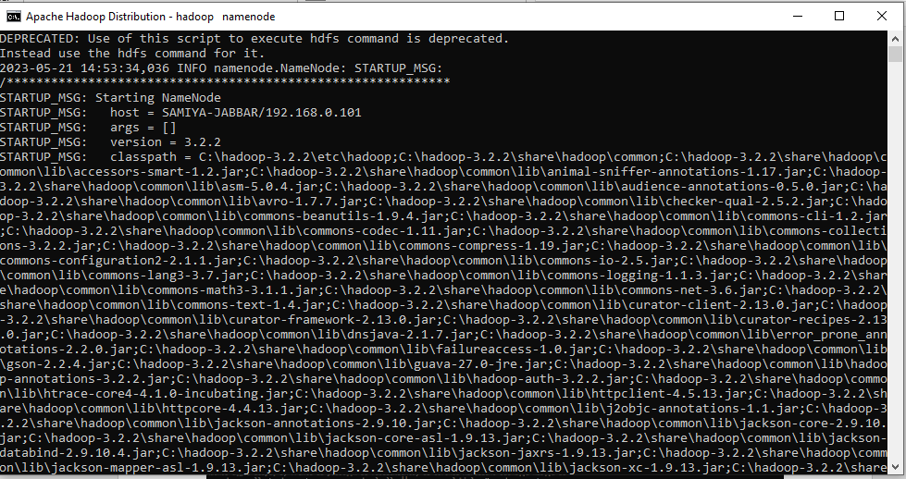

**Datanode**

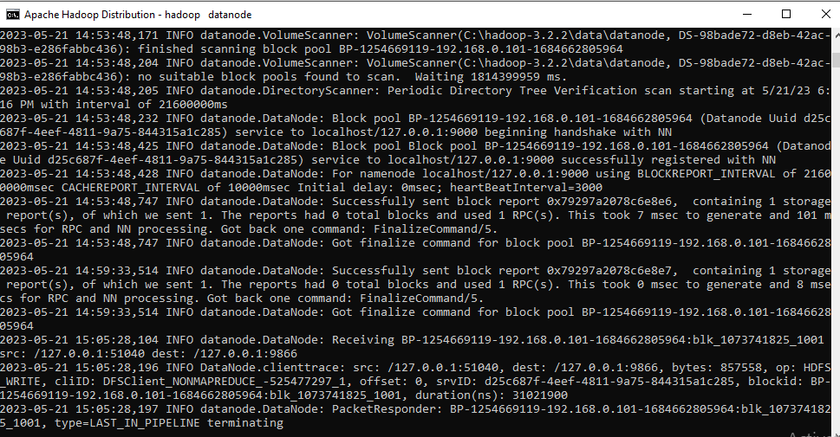

**Resource Manager**

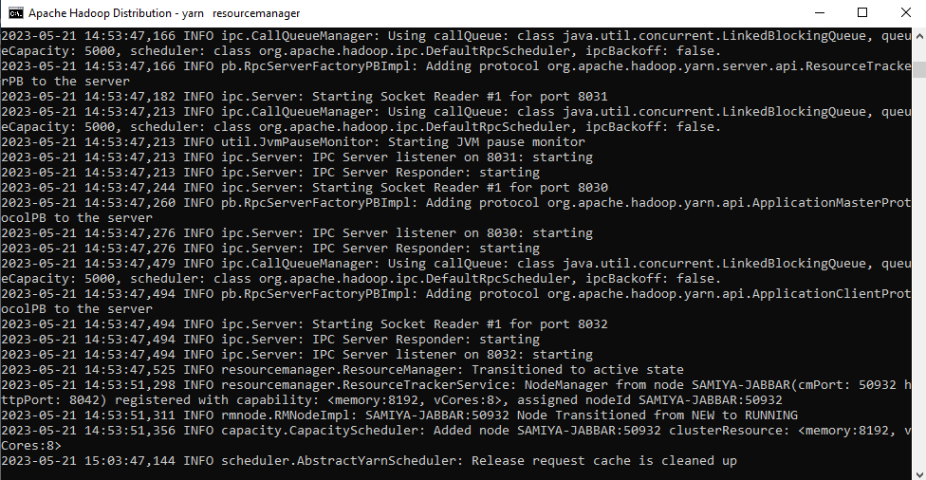

**Yarn Node Manager**

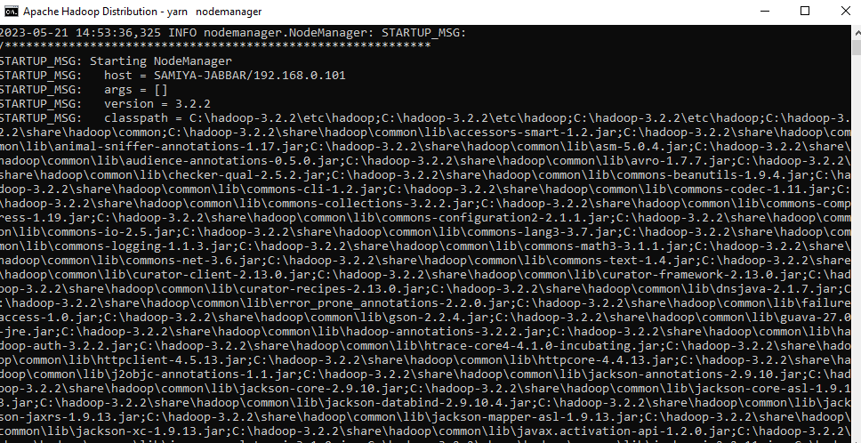

**Make a Folder to place input files, Check/verify input file content**

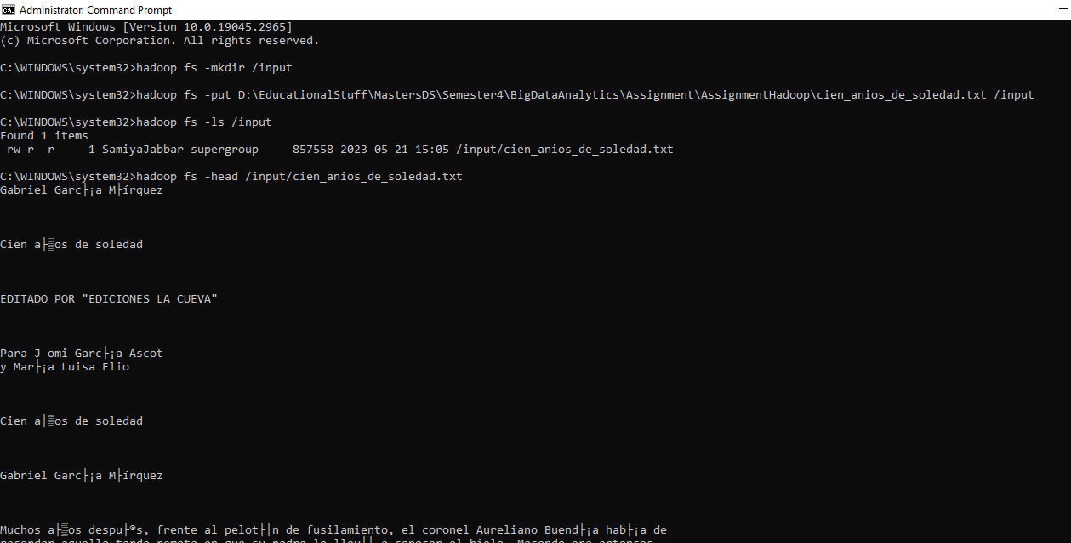

**Browse Directory - INPUT**

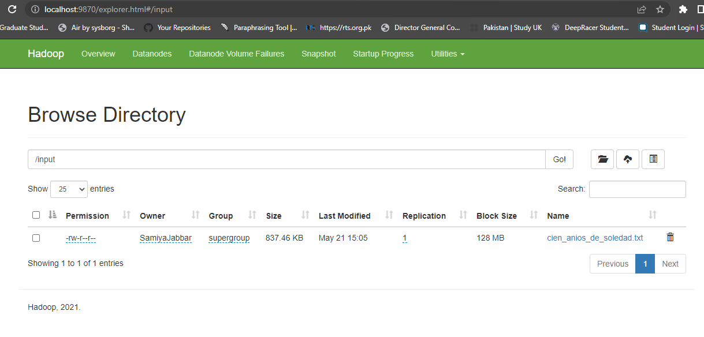

**Browse Directory - OUTPUT**

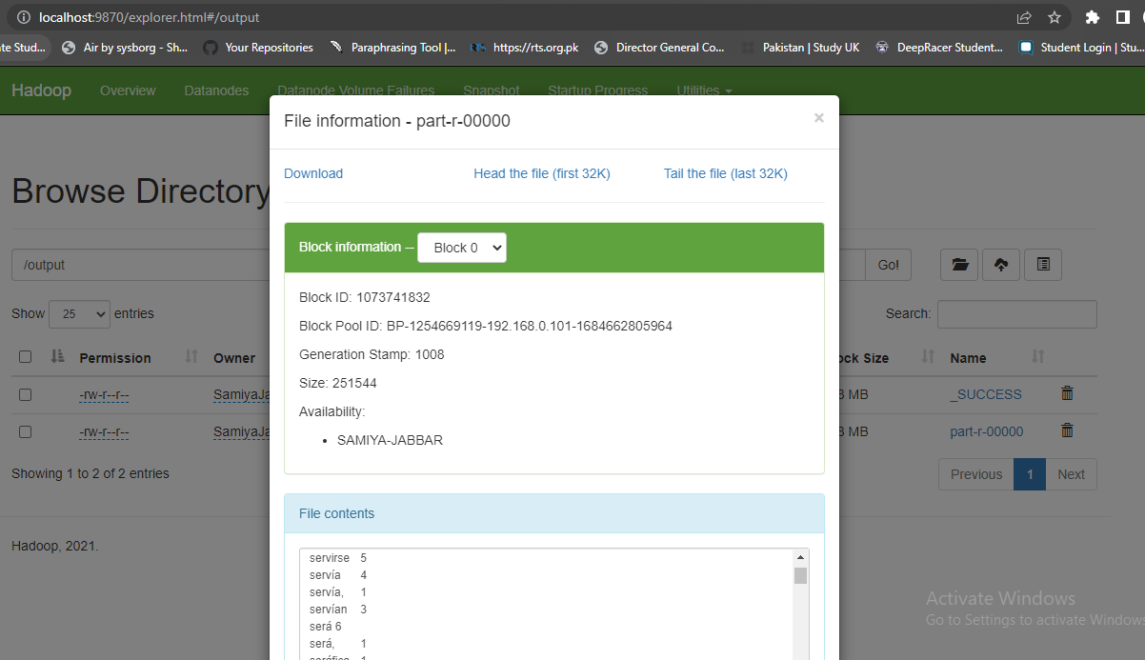

**CONCLUSION**

In Assignment#4, I installed Hadoop 3.2.2 on Windows 10 also tested the WordCount program considered as Hadoop and MapReduce HELLO WORLD problem.