**ASSIGNMENT#3**

**Objective:**

**Perform Rapid Miner Naïve Bayes Task 🡪 Apply Naïve Bayes Algorithm on Golf Sample Dataset and perform Classification**

**PROCESS**

Model: Naïve Bayes

Performance metrics: Classification

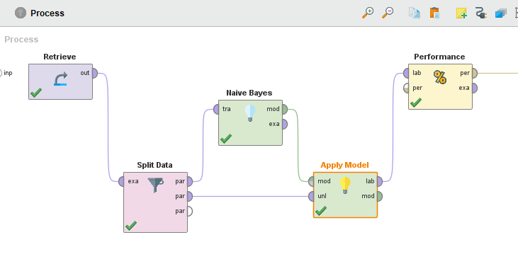

**DATASET**

We have used Unbalanced Golf Sample Dataset

No.of Attributes: 4

A1: Outlook

A2: Temperature

A3: Humidity

A4: Windy

Class Attribute: Play(Yes,no)

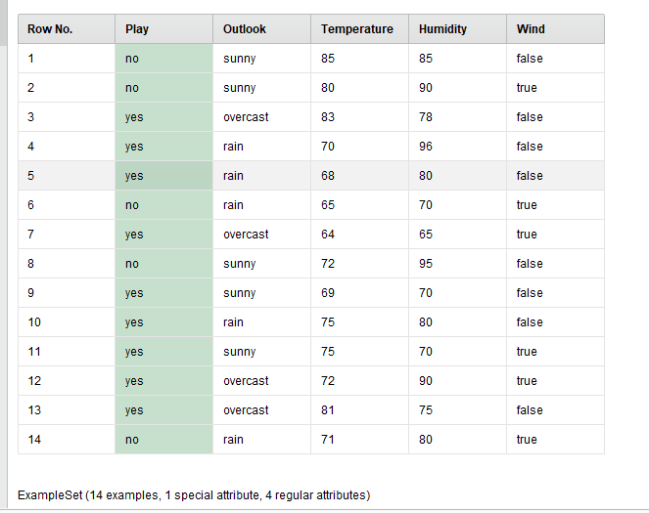

**PERFORMANCE METRICS**

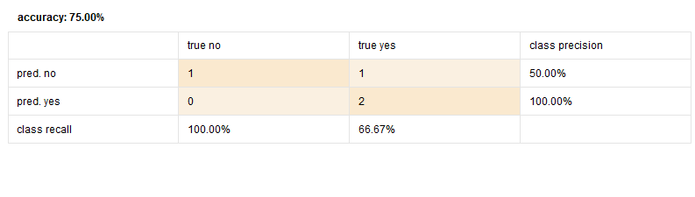

**CALCULATIONS:**

