**Objective:**

**Perform Rapid Miner NLP Task 🡪 Find the count(frequency) of words in a given document also find unique words after the removal of stop words**

**Input File**

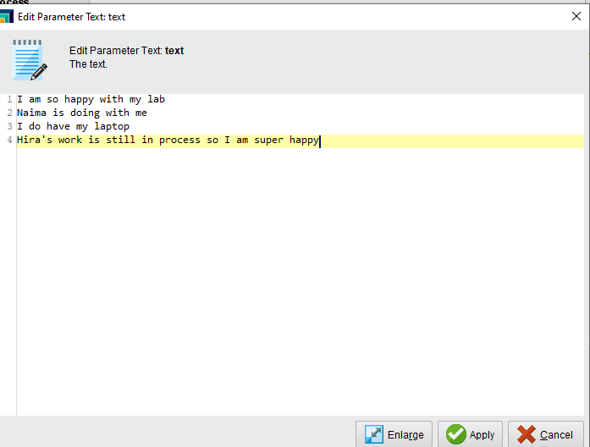

**The process to get the Frequency of each word in a document:**

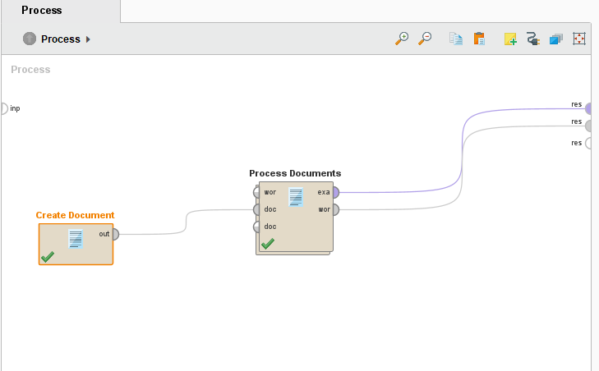

**Result: Count All Words (Frequency)**

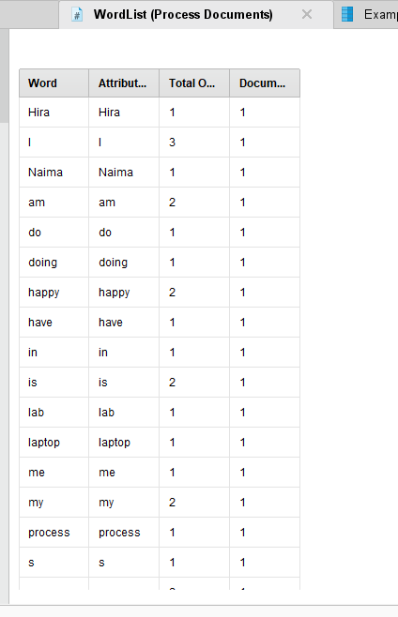

**The process to get the count of unique words after the removal of stop words**

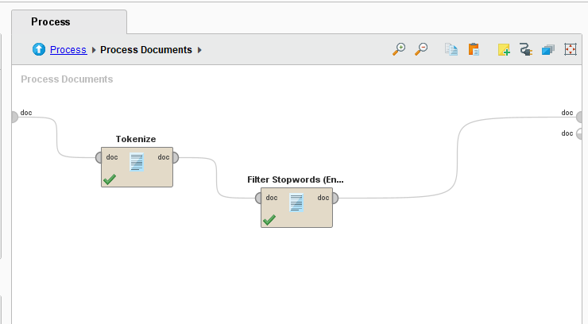

**Result: After Stop Words Removal**

