**Lab#4**

**Introduction to Matplotlib**

**Objective:** In this lab, you will learn how to use Matplotlib to visualize data and create different types of graphs.

**Prerequisites:** Basic knowledge of Python and data analysis.

**Tools:** Python 3.x , Jupyter Notebook, Matplotlib.

**Dataset:** The sales data of a store.

**Step 1: Importing Required Libraries**

Before we start plotting, we need to import the required libraries. We will be using Matplotlib for plotting and Pandas for reading the data.



**Step 2: Loading the Dataset**

Now, we will load the dataset into a Pandas DataFrame.



**Step 3: Exploring the Dataset**

Before we start plotting the data, let's explore the dataset to get an idea of what it contains.

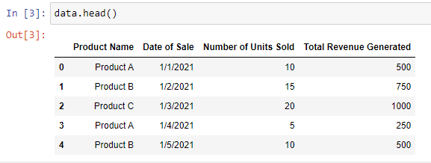

This will display the first few rows of the dataset.

**Step 4: Plotting Different Types of Graphs**

Now, we will use Matplotlib to plot different types of graphs to visualize the data.

1. **Line Plot**

A line plot is a type of graph that displays information as a series of data points connected by straight lines.

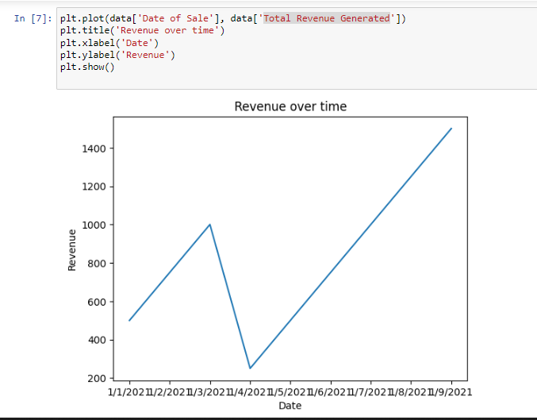

This will plot the revenue generated over time.

1. **Bar Plot**

A bar plot is a graph displaying information as rectangular bars. It is useful for comparing different categories.

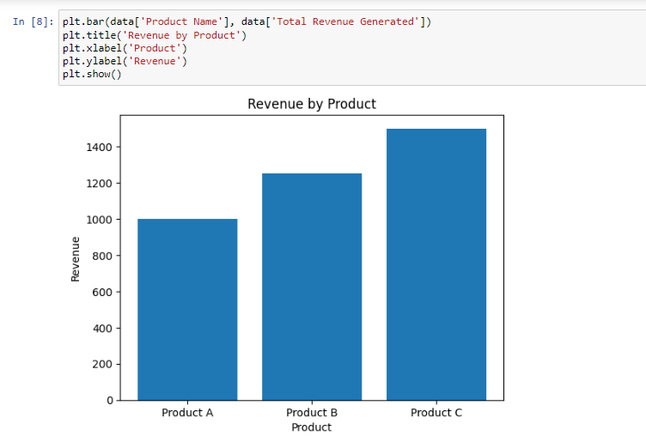

This will plot the revenue generated by each product.

1. **Scatter Plot**

A scatter plot is a type of graph that displays information as a collection of points.

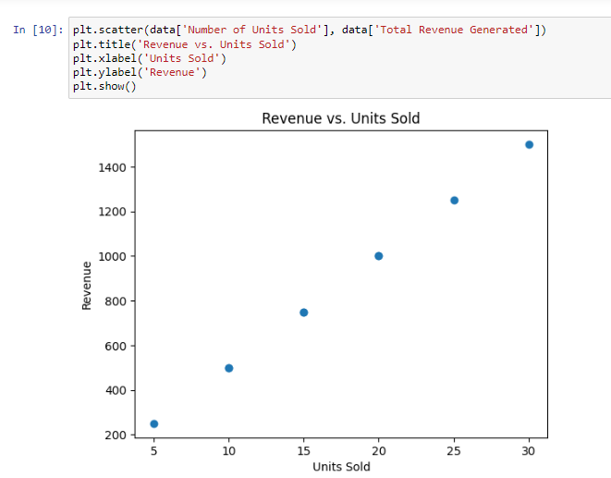

This will plot the relationship between units sold and revenue generated.

1. **Histogram**

A histogram is a type of graph that displays the distribution of a numerical variable.

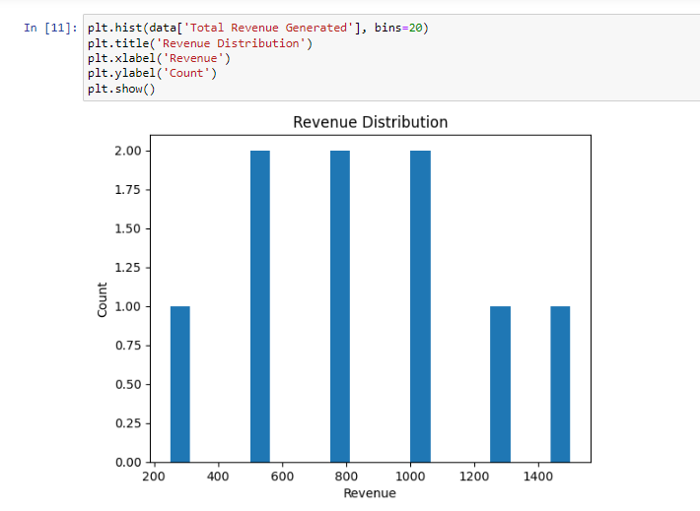

This will plot the distribution of revenue.

**Conclusion**

Matplotlib is a powerful tool for visualizing data and creating different types of graphs. In this lab, you learned how to use matplotlib to create line plots, bar plots, scatter plots, and histograms. You can use these techniques to analyze and visualize data in a variety of fields, from business to science.

**TASKS:**

**Task 1: Visualizing COVID-19 Data**

In this task, you will use Matplotlib to visualize COVID-19 data. You will use a CSV file containing information about the number of confirmed cases, deaths, and recoveries for different countries.

* Load the COVID-19 data from the CSV file into a Pandas DataFrame.
* Plot a line graph that shows the total number of confirmed cases over time for a specific country.
* Plot a bar graph that shows the total number of deaths and recoveries for a specific country.

**Task 2: Analyzing Stock Prices**

In this task, you will use Matplotlib to analyze stock prices. You will be using a JSON file that contains information about the daily stock prices of a company.

* Load the stock price data from the JSON file into a Pandas DataFrame.
* Plot a line graph that shows the daily closing price of the stock over time.
* Plot a scatter plot that shows the relationship between the daily trading volume and the daily closing price.

**Task 3: Visualizing Flight Data**

In this task, you will use Matplotlib to visualize flight data. You will be using a JSON file that contains information about the flights between different cities.

* Load the flight data from the JSON file into a Pandas DataFrame.
* Plot a bar graph that shows the total number of flights between different cities.
* Plot a pie chart that shows the percentage of flights that are delayed for more than 30 minutes.

Top of Form