**TABLE OF CONTENTS**

1. **Introduction**
2. **The WTA Tour at a Glance**
3. **The WTA Calendar Construction**
4. **Players’ Scheduling and Behavior**
5. **Review of Player Participation in 2018**

1. **Introduction:**

Tennis is unique from other sports with the fact that there are no “home games” for the players and all tournaments take place in different cities throughout the world. Players typically spend 10+ months of the year on the road and can easily accumulate fatigue that could negatively influence their performance. Medical professionals state that jet lag, sleep interruptions, and altitude changes, among other consequences, can resulting in mis-coordinated performance if there is no adequate time for adjustment. The magnitude of this effect is unknown and is the central topic of this paper.

The author analyzes the 2018 full tennis season by the Women’s Tennis Association and focuses on travel and performance data for the year-end top 30 women players. The paper employs multiple regression analysis to isolate and quantify that effect of travel, which is an input variable that has not been evaluated in any quantitative study before. In constructing the model, all data points are filtered for cases when players travel in consecutive weeks from one tournament to another in order to expose the effect of travel when there is no cushion time for recovery.

Overall, this research assesses the impact of travel on players’ results because casual fans oftentimes assume that tennis players have glamorous travel life when in fact travel actually works against them. The intention is to illustrate that even the big-name tennis stars are still human beings, subject to the laws of physics like all others.

1. **The WTA Tour at a Glance:**

The Women Tennis Association (WTA) tour comprises of 58 tournaments1 played around the world over 46 weeks during the calendar year2. All 58 tournaments award prize money and ranking points to the competitors under a positive linear relationship: the higher the prize money, the higher the points for progressing deeper into the tournament3. The rationale for that is that a higher prize pool will attract more players of higher caliber and the competition will be more intense with the tournament consisting of more rounds. This infers that the prestige of a given tournament is correlated with the prize pool, although other factors such as history, years of existence, and players’ facilities also have an important role in the classification of tournaments from the players’ perspective.

As a rule of thumb4, there are five tournament categories with asixth one for the Year-End Finals where only the top 20 from the year can compete divided in two tournaments. The exact categories are:

|  |  |  |
| --- | --- | --- |
| **Category** | **# of tournaments** | **Total Prize Pool for Each** |
| Grand Slam | 4 | $18.8M - $25.3M |
| Premier Mandatory | 4 | $6.7M - $8.7M |
| Premier 5 | 5 | $2.7M - $3.4M |
| Premier | 12 | $799K - $1M with Dubai as an exception offering $2.6M |
| International | 30 | $250K |
| Year-End Finals | 2 | $7.0M for players ranked #1-8 and $2.4M for players ranked #9-20 |
| **Total:** | **58** |  |

**Grand Slams:** These are the 4 most prestigious tennis tournaments that have legendary status: the Australian Open, the French Open (Roland Garros), Wimbledon, and the US Open. They have 128 participants in direct elimination, which requires a player to win 7 matches in order to win the tournament. The Grand Slams are played over 2 week periods.

**Premier Mandatory:** These are the next 4 most prestigious tournaments, which the WTA has made mandatory for the players in order to ensure the high-profile status of the tournaments. They are Indian Wells, Miami Open, Madrid Open, and China Open. Indian Wells and Miami feature 96 players and are both played over 10 days’ period. The top 32 players receive a “bye” in the first round and join the competition from the second round. This means that a top 32 player would need to win 6 matches in order to win the tournament, but a player outside the top 32 would need 7 victories. The Madrid Open and China Open have 64 players at the start and the winner needs to win 6 matches, regardless of rank. Both tournaments are played over a single week.

**Premier 5:** This is a group of 5 prestigious tournaments that offer half of the prize money of the Premier Mandatory ones. They are in Doha, Rome, Montreal, Cincinnati, and Wuhan. They are not mandatory and a player can decide to compete if she likes the facilities, the surface, or the location. This group of tournaments features 56 players and the top 8 are given a “bye” in the first round. This means that a top 8 player will need to win 5 matches in order to win the tournament, while a player outside of the top 8 needs to win 6. These tournaments are played during the course of a single week.

**Premier:** This is a group of smaller tournaments, which take place in Brisbane, Sydney, St. Petersburg (Russia), Dubai, Charleston, Stuttgart, Birmingham, Eastbourne, San Jose, New Haven, Tokyo, and Moscow. They can have different draw sizes ranging between 28, 32, or 56 players so this group has variations as to how many matches a player needs to win to become the champion. The minimum is 4, the maximum is 6. Yet, they award the same number of points. The differences in draw size are mostly due to the number of available tennis courts in the tournament’s complex and the requirement to finish play within a single week.

**International:** These are tournaments that happen around the world at places, which are trying to popularize tennis as a sport. They often change year after year due to sponsorship withdrawals, lack of leadership, or waning interest. They are organized at tennis club or university facilities and do not involve significant infrastructure investments. There are many instances when a new tournament will apply for a license and get approval after the country has seen a few successful star-like players in the recent 5 years (e.g. the Bucharest Open in Romania, starting in 2014, when Simona Halep finished as #2 having ascended in the rankings in the years prior to that). However, there are also a few tournaments in this category, which have existed for decades (e.g. Linz, Luxembourg), but keep its small format due to limitations (e.g. indoor courts). All these tournaments feature either 28 or 32 players and wining them requires 4 or 5 wins depending on player’s entry rank. They award the same amount of points and are played during a single week.

**Year-End Finals:** These are two tournaments reserved for players who finish in the top 20. The first one is only for the players ranked #1-8 and takes place in Singapore, while the second one is for players ranked #9-20 and takes place in Zhuhai. These tournaments have a round-robin format before semifinals and a final and have a generous prize pool (per number of players participating) as an incentive.

1. **The WTA Calendar Construction:**

In making its calendar, the WTA needs to **reconcile two dimensions: court surface and tournament location.**

Court Surface: There are 4 court surfaces - outdoor hard courts, clay courts, grass courts, and indoor hard courts5. The indoor hard courts are typically a carpet that is laid over arenas that host other sports (e.g. at Madison Square Garden in New York City). If a player needs to switch between court surfaces every week, she will lose the ability to play effectively on any of them as the body learns to adapt to a single surface over time. For example, sliding on clay courts is a skillful ability to retrieve balls and move around the court, while that is nearly impossible (and impractical) to replicate on the other court types. Attempting to do the same on grass may result in a fall and injury as the surface can be very slippery, while hard courts require plain running. Thus, for a player to remain healthy and competitive, it is necessary to play on a single-type court for at least several weeks at a time.

Tournament Location: Transitioning players gradually from one geography to another is another key element for keeping them focused and committed to the tour6. If a players needs to travel to different world regions every week, she will quickly build fatigue and exhaustion, which will lead to difficulties in realizing one’s potential and playing with a fresh mind7. In particular, the Hospital for Specialty Surgery (HSS)7 points that severe jet lag can affect a player’s performance quite negatively. Travel fatigue can disrupt a player’s normal routine, including sleeping and eating patterns and internal biorhythm. This can create a range of adverse effects ranging from decreased concentration to drowsiness to delayed reaction time to delayed cognition.  The disruption to the player’s bodies becomes more drastic with the number of time zones crossed - players can be slower at the start of the match and take longer to establish their rhythm. This can lead to more errors on the court and predispose the player to possible injury.

The first-hand experience of players also confirms that. CNN has reported how cross-country flights and travel delays affect players8. It is noteworthy to point that travel is seen as an adversary not only when it is international, but domestic as well. In the month of March, the players need to travel from Indian Wells, CA, to Miami, FL (two of the four Premier Mandatory tournaments), which are scheduled back-to-back. This coast-to-coast trip is described as “one of the worst ever”. Then, just 2 weeks after the Miami Open, there is an International-category tournament in Bogota, Colombia, for which many players have extensively remarked that it is a taxing change in altitude which leads them to experience dizziness on court. The 2018 champion in that tournament, Anna Karolina Schmiedlova, had offered the following comment in her interview: “I played in Bogota one time before, I lost in first round […] This time when I came here I prepared longer for the altitude…”9

Taking these precautions into consideration, the WTA has developed a calendar, which attempts to eliminate disruption, reduce stress (the “wear and tear”) and provide more structure for the players. Upon careful planning, the calendar could result in a very travel-friendly experience or provide breadth for the players in situations when they need extra matches (discussed later in the paper). In fact, it could be argued that the WTA has molded a few mini-tours moving from one geography to another, played on just one type of court surface at a time.

The approximate sequence is:

|  |  |  |  |  |  |  |  |  |  |  |  |  |
| --- | --- | --- | --- | --- | --- | --- | --- | --- | --- | --- | --- | --- |
|  | **January** | **February** | **March** | **April** | **May** | **June** | **July** | **August** | **September** | **October** | **November** | **December** |
| Court Type | Outdoor hard | Indoor hard | Outdoor hard | Clay | Clay | Grass | Grass | Outdoor hard | Outdoor hard | Outdoor hard + Indoor hard | **Off-season** | **Off-season** |
| World region | Australia | Middle East & Russia | USA | EU | EU | The U.K and EU | The U.K. | USA & Canada | USA 🡪 Asia | Asia & EU & Russia | **Off-season** | **Off-season** |

* **January:** The season starts in **Australia & New Zealand** with warm-up tournaments on **outdoor hard** courts for the Australian Open
* **February:** After the Australian Open, the tour moves to Doha & Dubai in the **Middle East** and St. Petersburg in **Russia**, which are played on **indoor courts**. However, there are also a few International category tournaments dispersed around the world during this month in Taipei, Budapest, and Acapulco. Thus, the month of February can differ a lot in terms of travel schedule for the players.
* **March:** The two Premier Mandatory tournaments of Indian Wells and Miami Open are played on **outdoor hard courts** in the **USA.**
* **April:** Thetour moves to **Europe** in preparation for the French Open (Roland Garros) where all tournaments are on **clay courts** (Lugano, Stuttgart, Madrid, Rome, Prague, Strasbourg). However, there are a few International category tournaments outside of Europe in Monterey, Bogota, and Rabat which are also on clay courts, but substantially far away from the main tour.
* **May:** The French Open (Roland Garros) takes place on **clay courts** after which the tour immediately moves to grass.
* **June:** There are warm-up **grass court** tournaments as preparation for Wimbledon that take place in **the U.K.** (Nottingham, Birmingham, Eastbourne), **the Netherlands**, and **Mallorca**.
* **July:** **Wimbledon** is played on grass in the **U.K.**
* **August:** The tour moves to **outdoor hard courts** in the **USA & Canada** (San Jose, Washington, D.C., Cincinnati, Montreal/Toronto, New Haven) as preparation for the US Open.
* **September:** The U.S. Open is played on **outdoor hard** in New York.
* **October:** The tour moves to **Asia** where all tournaments are on outdoor **hard courts** (Guangzhou, Seoul, Tokyo, Wuhan, Beijing, Hong Kong, Tianjin). However, these are followed by 3 tournaments in Europe (Luxembourg, Linz, and Moscow). The Year-end finals are played in Singapore and Zhuhai.

Additionally, the WTA is careful not to schedule any tournaments over the weeks when Grand Slams and Premium Mandatory events are played (8 such tournaments over 14 weeks). In all other weeks, the WTA also spreads the Premium 5 and Premium events as to avoid any overlaps. Typically, a Premium event of any type will overlap only with an International event.

As could be deduced from the options in this calendar, there are many different travel itineraries that a player can complete in a given year, which could have an impact on her performance if her chosen tournaments are away from each other and played over successive weeks. To summarize the number of options available, the following histogram bar chart* shows the number of tournaments on the schedule per week:

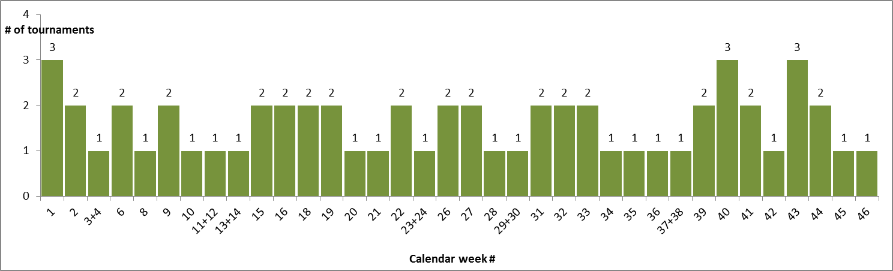

*\*Combined weeks 11+12, 13+14, etc show tournaments that are happening over 2-week periods*

This chart shows WTA’s attempt to “contain” the tournaments and create an equitable for the players and the tournaments schedule in which no week has more than 3 tournaments. Yet, this represents a vast sea of travel routes. In the theoretical case that a player goes to play every week in 1 tournament, there are exactly 1,769,472 combinations possible, which is quite staggering. Of course, a player will not be physically able to compete in all weeks of the year, so she needs to be smart about her schedule and weigh the tournaments according to her goals and abilities. However, the travel component can never be fully eliminated and remains a factor as the players change not only locations, but climates and altitudes, too, as described above.

1. **Players’ Scheduling and Behavior:**

The game of tennis has become more physical and draining10. The depth of the women’s field has improved and top players face serious competition even in the early rounds at every tournament11. In 2018, the year of research data for this paper, only 3 players from the top 10 reached the quarterfinals of French Open (Roland Garros) and even more strikingly, only 1 player from the top 10 reached the quarterfinals of Wimbledon. As a result, the points difference among the top 10 has shrunk and almost at every (Premier 5 or above) tournament, there could be a new world #1, keeping the suspense high. After the end of the 2018 season, on the eve of the Australian Open in January 2019, there were 11 different women who could become #1, which was unprecedented12.

This increased competition and sporting drama is excellent for the fans13, but has a physically exhausting effect on the players. It has become more imperative that a player makes a smart schedule and avoids excessive play. From a player’s perspective, her schedule needs to be the following: 4 Grand Slams, 4 Premium Mandatory Tournaments, and 9 other tournaments in order to bring her total number of tournaments played to 17. This is because the WTA uses the best 17 tournaments to calculate a player’s ranking4. If a player competes in less than 17 tournaments, there is a lost opportunity, while if she competes in more than 17, the WTA will pick the most advantageous ones to count for her ranking. Thus, an important conclusion is that every time a player loses in the first round of a tournament, it is only to her advantage to travel to another one and try to win points there. This replacement opportunity pushes some players to even compete at 25 tournaments per year, as will be shown below.

The choice how to fill the 9 other tournaments is left to the player. Typically, her choice will be dictated by any or a combination of the following factors:

* The tournament is in the player’s home country or town
* The tournament is offering her appearance money (which is legal under the WTA rules 4 )
* The player is coming back from injury and needs match play to get back in form
* The player suffered an unexpected early round loss and needs more match play, especially before a Grand Slam
* The player is chasing the Year-End WTA Finals (a phenomenon that only occurs in October when several players may be in contention for the coveted spots)
* The player is just curious about a place

As the season progresses, players often adjust their schedules to take into account unique developments described above - early round losses, injuries, or the need for more match play before Grand Slams. To ascertain these behavioral claims, we can examine the data for the year-end top 20 for 2018. We focus on the top 20 because they are in the best position to escape the travel fatigue due to three main factors:

* They are the highest earners on the tour and can afford first-class travel, physiologists/fitness instructors, and nutrition counselors
* They typically go deep into tournaments and are therefore less likely to sign-up for tournaments in consecutive weeks
* They can cherry-pick among tournaments on a grand level and construct a schedule, which they believe would produce the best results (suggesting that “smart travel” is already pre-built in their schedules)

We will examine 6 claims:

|  |  |
| --- | --- |
| Claim #1 | *All players,* whose ranking allows that, compete at the 4 Grand Slams and the 4 Premium Mandatory tournaments for a total of 8 required tournaments per year |
| Evidence | * 15 of the top 20 players in 2018 competed at all 8 events * 4 players competed at 7 events (all withdrew from the 8th because of injuries) * 1 player (Serena Williams) competed at just 5 (Serena Williams’ schedule is an exception as she started the year only in March with no rank due to return from maternity leave) |
| Conclusion | **Correct (factoring injuries and discounting the one outlier due to special circumstances)** |

|  |  |
| --- | --- |
| Claim #2 | *Most players* supplement that with at least 9 additional tournaments because the WTA takes the best 17 tournaments to compute a players’ ranking. |
| Evidence | * The top 20 played an average of 20.4 tournaments in 2018, with a maximum of 25. Removing Serena Williams, who played only 7, the average becomes 21.1. That is 13 in excess to the required 8. * To check for distribution, 17 of the top 20 played at least 18 tournaments in the year, which meets the claim’s threshold of 9 (over the required 8) |
| Conclusion | **Correct** |

|  |  |
| --- | --- |
| Claim #3 | *Most players* would travel to another tournament to try and gain points there, if they lost in the first round. |
| Evidence | * The average number of first-round losses for top 20 players is 5, distributed as follows:      * 2 players lost 2 times in their first round * 4 players lost 3 times in their first round * 2 players lost 4 times in their first round * 5 players lost 5 times in their first round * 2 players lost 6 times in their first round * 1 player lost 7 times in her first round * 4 players lost 8 times in their first round * If the top 20 players lose 5 times in their opening match, they should then play 17+5 = 22 tournaments. We saw from claim #2 that the average without Serena Williams is 21. Collectively, they fall 1 tournament short. * At individual level, 10 of the top 20 have at least one tournament that counts in their best 17 with a score of 0 14 (a wasted slot), even though they still play additional tournaments to try and make up for that. |
| Conclusion | **Partially correct – players seek to fill all 17 slots with points, but 50% still never reach that (too many first-round losses)** |

|  |  |
| --- | --- |
| Claim #4 | *Most players* do not play in the week prior to a Grand Slam to avoid burnout and stay fresh and acclimate to the Grand Slam’s location |
| Evidence | * 6 of the top 20 players played the week before the Australian Open * 4 of the top 20 players played the week before the French Open * 7 of the top 20 players played the week before Wimbledon * 4 of the top 20 players played the week before the U.S. Open * **Collectively**, only 11 of the top 20 ever played in the week before a Slam |
| Conclusion | **Correct** |

|  |  |
| --- | --- |
| Claim #5 | If #4 if correct, those who play only play 1-2 matches for practice and do not put their best effort in tournaments in the week before a Grand Slam |
| Evidence | * The top 20 players lost in the first round 8 times from 21 collective attempts (38%) in tournaments preceding the Grand Slams * The top 20 players collectively earned 123 points on average in the tournament before a Grand Slam, which translates to a finish between a quarter-final and a semi-final. Most would be expected to reach that stage at any regular tournament regardless of where it falls in the calendar. * 3 of the top 20 players won those Slam “warm-up” tournaments (Angelique Kerber in Sydney, Caroline Wozniacki in Eastbourne, and Aryna Sabalenka in New Haven). |
| Conclusion | **Incorrect – players reach later rounds and also win those tournaments** |

|  |  |
| --- | --- |
| Claim #6 | *Most players*avoid playing consecutive weeks |
| Evidence | * On average, 46% of the tournaments that the top 20 competed at were consecutive tournaments requiring the players to directly travel from one location to another * However, the chart presents evidence to postulate that the top 5 players avoid playing consecutive tournaments (as well as Serena Williams at #16, and Madison Keys at #17) |
| Conclusion | **Incorrect – playing in consecutive weeks is more common than thought, but probably scheduled “smartly”** |

Based on the last finding, we can conclude that travel is a factor in as many as half of the tournaments played by the top 20. As such, it would be an important variable to examine and quantify.

1. **Review of Player Participation in 2018:**

Playing mostly away from home is a fact of life for women’s tennis players. One study15 tried to isolate “home play” in professional tennis and found that on the men’s side, “home play” carries significant advantage (the best example is Roger Federer winning 8 times in Basel, his home town), but on the women’s side, it has no effect on results. This is an interesting finding that could perhaps be explained with the fact that women start their professional career earlier than men and the feeling of home is not as developed.

Thus, we could start with the basic assumption that no woman has any advantage anywhere. Data for the 2018 season was collected directly from the WTA Tour web-site and the scope includes all tournaments in which the year-end top 30 competed. The author drew a cut-off at 30 for three primary reasons: (1) this number would provide statistical power for the study, (2) the top 30 are in the best position to overcome side effects from travel (as discussed above) and already did well during the year, which would provide the toughest data to attribute performance to travel fatigue, and (3) nobody, except one single player (year-end rank #24), has played at a tournament from the ITF tour, which is the lower-level tour by the International Tennis Federation (ITF). For this latter point, mixing data from WTA and ITF tournaments could lead to distortions in the results because the ITF has different structure and runs many more tournaments around the globe, which could be in close proximity to one another, lessening the requirement for extensive travel17. Players from the top 30 are eligible to play in ITF events as well, but the incentives are very little as those tournaments pale in terms of prize money, ranking points, and facilities. Thus, having an WTA-only records in the data set would ensure consistent measurements and more reliable results.

Data will be examined for two cases: (1) unfiltered, inclusive of every tournament, and (2) filtered for consecutive tournaments only. The reason for this dual-inspection is because the ultimate multilinear regression will be done on the filtered case for records indicating that players traveled from one tournament to another in successive weeks, i.e. with no big cushion time or a break between. This will give us a more reliable measure of the effect of travel on performance. Thus, the unfiltered data review will be brief.

Unfiltered Data (all tournaments):

We have a total of 613 observations across 30 players. 21 players (70%) have competed in at least 20 tournaments.

*Figure 1: Number of tournaments and first-round losses by player’s year-end rank:*

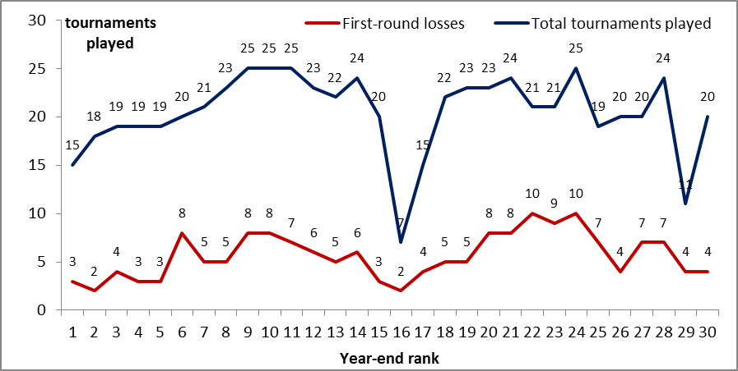

As described in the previous section, only the 17 best tournaments count in the WTA ranking, so any first-round losses can be replaced by any other tournaments. However, as presented in Claim #3 (and deducible from the graph above), only half of the players are able to fill all 17 tournaments spots with points – many fall one or two tournaments short because they experience greater number of losses than anticipated, as the tour has intensified in competition.

There are two outliers in the unfiltered case: the players finishing the year at #16 and #29, Serena Williams and Maria Sharapova, respectively. Both had different paths in 2018 with Serena Williams returning from pregnancy and playing just a few select tournaments and Maria Sharapova battling injuries.

Filtered Data (consecutive tournaments only):

We have a total of 287 observations across 30 players. 21 players (70%) have competed in at least 10 consecutive tournaments. It is telling to observe how low the distribution among the top 5 is: those players have avoided competing at successive tournaments. One explanation could be that they had a deep run into their current tournament and cancelled their participation in next week’s one based on the good results they posted. Another could be that they just don’t play week-in and week-out by original intent and construct. However, both explanations point to the fact that lesser number of consecutive tournaments may be one of the factors for their success and why they finished the year in the top 5. This indirectly supports the claim that lesser consecutive travel results in greater overall success.

*Figure 3: Number of consecutive tournaments and first-round losses by player’s year-end rank:*

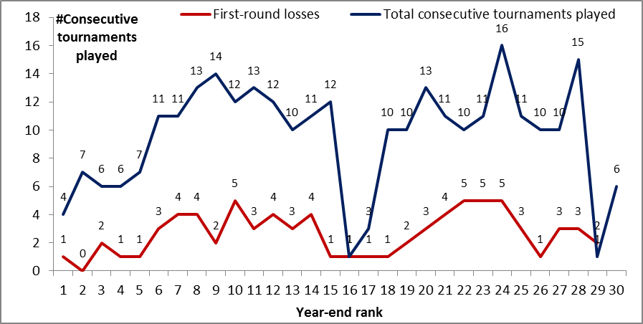

If we examine the quality of performance in consecutive tournaments, we can graph the average points earned per consecutive tournaments played:

*Figure 4: Average number of points earned when playing consecutive tournaments (with linear trendline):*

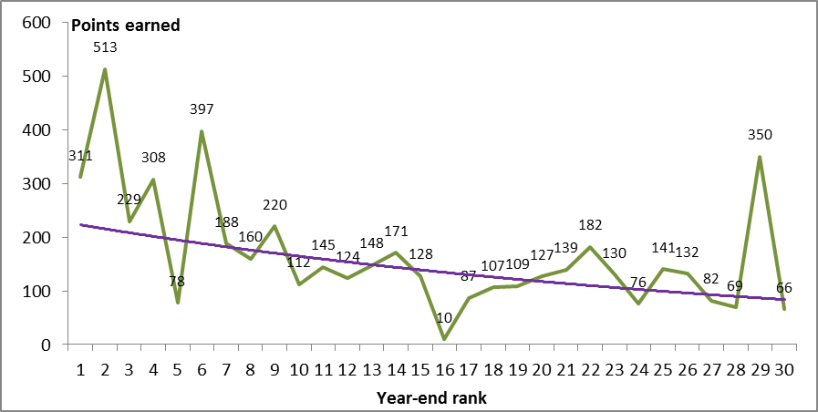

From this graph, we see that the majority of top 5 (except player ranked #5) achieve better results *per consecutive tournament played* than their lower-ranked peers (one exception at rank #29, which is Maria Sharapova, who has played only 1 consecutive tournament). However, it should be noted that the consecutive tournaments in which the top 5 have chosen to compete are calendar pairs of big and important tournaments that are either the Premium Mandatory or Premium 5 (e.g. Indian Wells-Miami, Madrid-Rome, Canadian Open-Cincinnati, Wuhan-Beijing), where more points are available.

The filtered data set points to 3 outliers, with 2 of them the same as in the unfiltered case: American players Serena Williams (returning from pregnancy and playing very select few tournaments) and Madison Keys, and Maria Sharapova (battling injuries throughout the season, cutting it short after the U.S. Open). This is a normal working number of outliers for the data set, which is not anticipated to produce any skews in the data.

Of special scrutiny are the outliers on the opposite end, the players who competed more than everybody else in consecutive tournaments. First, at year-end rank #24, we find Mihaela Buzarnescu, who competed in 16 consecutive tournaments. The return, as we see in Figure 4, has not been as good because she only earned 74 points per consecutive tournament, while the average for the top 30 stood at 158. Furthermore, just before the U.S. Open, Buzarnescu suffered an injury, which caused her to miss the next 2 months on the tour17. This could have come directly from physical exhaustion from competing in so many consecutive tournaments. Second, at year-end rank #28, we find Su-Wei Hsieh, who competed in 15 consecutive tournaments. She also did not have a great return for all that travel because she only earned 69 points per consecutive tournament. Unlike Buzarnescu, she did not get injured, but she started the year at rank #103 and managed to finish at #28, which suggests that she originally had planned to participate in more tournaments in order to improve her ranking.

Overall, based on these observations, it is interesting to do an “efficiency scatter plot” to examine the number of consecutive tournaments played to the average points earned for the entire top 30:

*Figure 6: Efficiency scatterplot of average points earned by number of consecutive tournaments played (with linear trendline). The red circles indicate the outliers discussed above.*

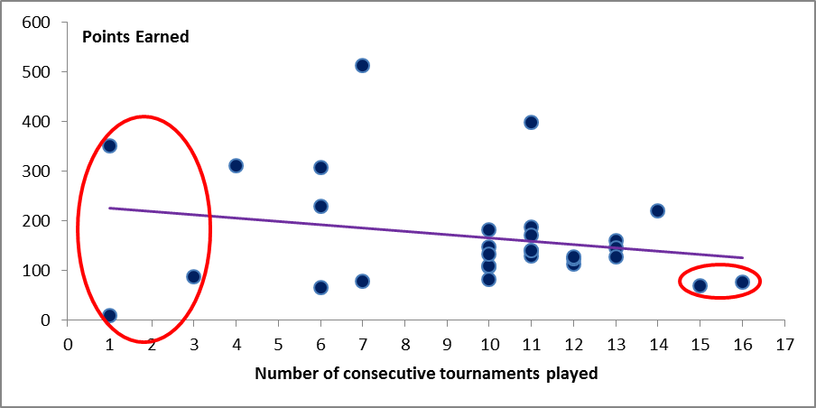

It is very interesting to observe how many players have earned similar points at 10, 11, 12, and 13 consecutive tournaments played. The trendline, however, suggests that there are diminishing returns to playing more consecutive tournaments.

From this graph, it is worthwhile to look into 2 more outliers: the players who earned 397 points (playing 11 consecutive tournaments) and 513 points (playing 7 consecutive tournaments), the highest return from the top 30. In the former case, Sloane Stephens, has such a high return because she won Miami Open (Premier Mandatory) after playing Indian Wells. In the latter case, Caroline Wozniacki won Beijing (another one of the four Premier Mandatory tournaments in the year) after playing Wuhan. In both of these cases, the players lost in their second match the week prior and then played next week in the same country (USA and China) winning the tournament. For Sloane Stephens, this was also her home country.

________________________________________________________________________

The most impressionable, well-researched, and cumulative visualization precedents focused on the evolution of women’s tennis are:

* Women’s equality in prize money compared to men16
* Women’s distribution of prize money across the top 200 and in comparison to golf17
* Women’s increasing average age among top players18 (the median age of a top-50 women player in 2017 has jumped up from 23 in 2008 to 27 in 2018, testifying to the change in fitness and recovery routines, described above)
* Women’s greatest players in history19

Another precedent offering 10 different ways to visualize the outcomes of a single tournament (Wimbledon in this case) is

Age is an important factor. One very recent study20 from 2018 found that men and women experience a peak of form at a very identical age: 26 for power and 28 for accuracy, after which performance starts decaying. Yet, one cannot escape noticing that tennis careers are becoming longer. This has been attributed to a change in gym routines emphasizing exercises that are preventive, restorative (such as stretching), and longevity-oriented21. Players hire physiotherapists and nutrition coaches to help them stay in competitive shape.

1 The $125K series are excluded, a category that is between ITF-level events (lower tour) and WTA Tour events. The Fed Cup is also excluded, as it is a special-format tournament, which may only apply to certain players if their country is playing and winning.

2 WTA Calendar for 2018 at <https://www.wtatennis.com/calendar/year/2018>

3  The WTA points system for 2018 at <https://wta-playerzone.com/common/pdf/Rankings.pdf>

4 The WTA Rule Book for 2018 at <http://wtafiles.wtatennis.com/pdf/publications/2018WTARulebook.pdf>

5 Faculty interview, Department of Physics at the University of Illinois at Urbana Champaign, October 2007, available at <https://van.physics.illinois.edu/qa/listing.php?id=948&t=tennis-courts>

6 Editorial, “The Quick and the Dead – how to adapt to different surfaces and conditions”, *The Guardian*, June 2009, available at <https://www.theguardian.com/lifeandstyle/2009/jun/28/tennis-adapt-surfaces-conditions>

# 7 Felix, Ioonna, “How Playing Tennis in Different Regions Impact Joints”, *official website for the Hospital for Specialty Surgery (HSS)*, January 2016, available at <https://www.hss.edu/playbook/how-playing-tennis-in-different-regions-impact-joints/>

8 Rossingh, Danielle, “Travel Like a Tennis Pro: Jet Lag, Delays, and private Jets (If You Are Lucky)”, *CNN online,* November 2016, available at <https://www.cnn.com/2016/11/22/tennis/tennis-travel-story/index.html>

9 Livaudais, Stephanie, “Schmiedlova overcomes ‘big pressure’ to reach Bogota final”, *WTA Online*, April 2018, aavailable at <https://www.wtatennis.com/news/schmiedlova-overcomes-big-pressure-reach-bogota-final>

10 Kimmelman, Dennis, “How Power Has Transformed Women’s Tennis”, *The New York Times,* August 2010, available at <https://www.nytimes.com/2010/08/29/magazine/29Tennis-t.html?mtrref=www.google.com&gwh=8618CDFB4D2D8DB9B895A133287AA6BE&gwt=pay>

11 Perrotta, Tom, “There Are No Easy Matches in Women’s Tennis Any More”, *FiveThirtyEight*, July 2017, available at <https://fivethirtyeight.com/features/there-are-no-easy-matches-in-womens-tennis-anymore/>

12 Nguyen, Courtney, “Australian Open 2019: Eleven Players Vying for No.1 Spot in Melbourne”, *WTA online,* January 2019, available at<https://www.wtatennis.com/news/australian-open-2019-eleven-players-vying-no1-spot-melbourne>

13Tignor, Steve, “The WTA in 2019: Are Fans Ready to Embrace Depth Rather Than Dominance”, *Tennis.com¸*December 2018, available at <http://www.tennis.com/pro-game/2018/12/depth-perception-are-fans-ready-embrace-variety-womens-game/78462/>

14 “0” is used here for stylistic purposes, in reality points are still given for first-round losses, but they are either 1 or 10 depending on the tournament category, which is negligibly small.

### 15 Koning, Ruud, Home advantage in professional tennis, *Journal of Sports Sciences*, 29:1, pp. 19-27, 2011

### 16 ITF schedules and tour information at <https://www.itftennis.com/procircuit/tournaments/tour-info.aspx>

### 17 Kane, David. “Buzarnescu out of US Open Series after Montreal ankle injury”, *WTA Tour online,* August 2018, available at <https://www.wtatennis.com/news/buzarnescu-out-us-open-series-after-montreal-ankle-injury>

### ____

# 16 Popovic, Nadja, “Battle of the sexes: charting how women in tennis achieved equal pay”, *The Guradian,* September 2015, available at <https://www.theguardian.com/sport/2015/sep/11/how-women-in-tennis-achieved-equal-pay-us-open>

17 Jericho, Greg, “Tennis Players Want More Money? It’s not as absurd as it sounds”, *The Guardian*, January 2018, available at <https://www.theguardian.com/business/grogonomics/2018/jan/18/tennis-players-want-more-money-its-not-as-absurd-as-it-sounds>

18 Foley, Katherine Ellen, Dan Kopf September 2018, “Tennis has evolved and the 30s are the new 20s”, *Quartz*, available at <https://qz.com/1379932/the-2018-us-open-makes-it-clear-tennis-has-evolved-and-the-30s-are-the-new-20s/>

19 Burn-Murdoch, John, “A visual history of women’s tennis”, *The Financial Times,* September 2016, available at <https://ig.ft.com/sites/visual-history-of-womens-tennis/>

20 Sutter, Andreas, Sam Barton, Manmohan Dev Sharma, Ugofilippo Basellini, David J Hosken, C Ruth Archer. “Senescent declines in elite tennis players are similar across the sexes”. *Behavioral Ecology*, 2018, reported by the Science Daily at <https://www.sciencedaily.com/releases/2018/08/180829115534.htm>

21 Soong, Kelyn, “Pro tennis players’ good habits are prolonging their careers. The average athlete can learn from them”. *The Washington Post*, August 2017, available at

<https://www.washingtonpost.com/lifestyle/wellness/pro-tennis-players-good-habits-are-prolonging-their-careers-the-average-athlete-can-learn-from-them/2017/08/02/8964c9a0-77ab-11e7-9eac-d56bd5568db8_story.html?utm_term=.e83f8f2c1b63>