**Sexism in Science:**

**Exploring its roots, pinpointing problematic trends, and engaging in systemic change from the ground up**

**Abstract**

[will compose later after all research/data collection is done]

*Though I am aware that sexual harassment effects male-identifying, gender non-binary, and transgender populations, in this paper I will be focusing predominantly on sexism & sexual harassment pertaining to women and women-identifying populations.

**Introduction**

**Surveying the Landscape**

Gender inequality, sexual harassment, sexual assault--in recent years, these terms have been so commonplace in the collective colloquial verbatim that it does not strike as odd to hear a casual conversation about street harassment, or get caught up in a wave of public outrage over the latest figure convicted of sexual assault. And yet, this is but a contemporary phenomenon. Such a visible approach to matters of sexual harassment would have been unthinkable in the past; far from being the potentially empowering and validating act that it is now, to participate in public allegation meant a near complete emotional, social, and career suicide. On one hand, if women had the courage to speak up, their voices were devalued and experiences swept under the rug; on the other, women often barred themselves from speaking out due to the societally enforced burden of self-blame and shame.[1] Shockingly, many women have had trouble even acknowledging their experiences as sexual violence--in a sweeping review conducted over 28 studies of women who were raped after the age of 14, it was found that 60.4% of the 5,917 women in the studies did not recognize their experiences as rape, even though it fit the standard definition.[2] How did these attitudes towards sexual harassment, so entrenched in the cultural manifold our society, begin to shift?

We can attribute one of the movers of our cultural manifold to the now famous #MeToo movement. A term originally coined in 2006 by civil rights activist Tarana Burke, it reemerged in October of 2017 in the Twittersphere, where actress Alyssa Milano used it as a hashtag to highlight sexual abuse by the Hollywood titan Harvey Weinstein, calling out for fellow survivors of sexual violation to step forward and join in on highlighting similar experiences. Though not a new idea by any means, a global phenomenon of viral proportions ensued--similar hashtags popped up in every region of the world, and produced very tangible recognition of the legitimacy of women’s voices. We saw Harvey Weinstein and Bill Cosby fall to an uprising of women with the audacity to speak up. We saw incredible media coverage, not in the conciliatory tone often adopted when defending the perpetrator, but in, at the very least, a neutral perspective. In the New York Times, the number of articles that mention sexual harassment has spiked in the wake of the #MeToo movement: the number has tripled from 2016 to 2017, and quadrupled from 2016 to 2018.[3] Indeed, sexual harassment is at last being portrayed by mainstream media as less epidemic than endemic, less isolated than pervasive.

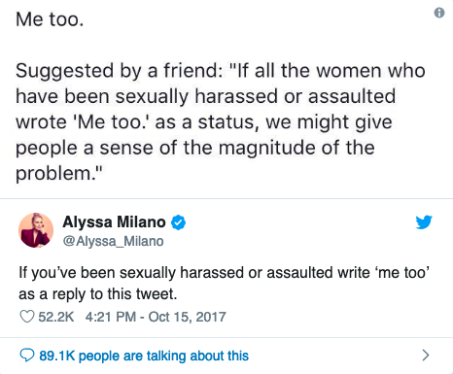

**Fig 1.** Alyssa Milano’s text that ignited the #MeToo movement in 2017 (Twitter)

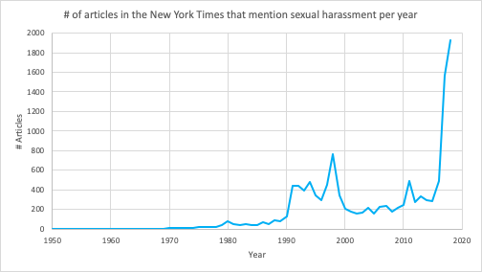

**Fig 2.** The number of articles in the New York times that mention sexual harassment per year. Interestingly, there is a slight increase in mentions between 1990 and 2000, but nothing comparable to what the numbers are in 2017 and 2018. At more than 300 articles already mentioning sexual harassment in 2019, this year is projected to have similar numbers as the last. (adapted from NYT API)

In addition to jumpstarting the conversation of sexual violation, and holding prominent Hollywood accountable for their actions, the #MeToo movement has had its impact felt in all sectors and all pressure points in the spectrum of gender inequality topics. HR Acuity, an employee relations technology company, conducted a survey of companies representing 4.4 million employees in the Fortune 100, 500, and 1000 lists, and found that since the movement started, 54% of companies state the number of harassment claims have gone up.[4] The number jumps to 84% when looking at large scale companies of more than 20,000 employees. There is a clear development of women feeling more comfortable about coming forward with incidents if they occur.

“Radiating out from sexual harassment to sex inequality as a whole, the movement has stimulated a wider public discussion of equal hiring, equal numbers of women on boards, equal pay, and more women in politics, as well as brought further focus to the role of white supremacy in misogyny. Anyone who doubts that sexual abuse is central to the second-class status of women might consider what taking it seriously on a systemic basis has set off. **Sexual harassment encompasses, parallels, evokes, or echoes many other abuses of women and children, from simple discrimination to other abuses of authority or trust or power.** Sexual harassment is like sexual abuse in childhood, in that the trust of victims is manipulated, dependency exploited, and institutions betray those who report. Sexual harassment often includes rape, and it raises similar issues of sex that is acquiesced to under conditions of unequal power. **Sexual harassment makes all forms of women’s work into a form of prostitution: forced trading of sexual access for economic survival.** Sexual harassment turns real work into an arm of the sex trade. The imperative to exchange sex for survival, or the dangled possibility of survival whether real or not, governs women’s inequality, hence women’s lives, worldwide.”

Writes Catharine MacKinnon, Professor of Law at Michigan Law and pioneer of the legal claim of sexual harassment, in an essay commenting on the global effects the #MeToo movement.[5] She makes several poignant points in this passage which are relevant to future considerations: 1) that sexual harassment, in its premise and outcome, parallels other forms of abuse, such as abuses of power (one could comfortably say these two pair enticingly well together), and 2) that sexual harassment inevitably make women’s work into a form of prostitution. These claims are worth pondering over, especially when assessing the impact of sexual harassment in environments that are male dominated.

**Sexism in STEM fields**

Let us consider STEM fields (fields pertaining to science, technology, engineering, or mathematics). Women make up half of the college-educated workforce in the US, but only 29% of the science and engineering workforce.[6] If we probe even further, we find that a mere 15% of engineers, and 25% of computer scientists are women. In STEM, there exists a unique condition where there is a staggering lack of female presence, let alone female empowerment . In the absence of such oversight, support network, and/or mentorship, sexism becomes normalized, and toxic environments are left to bloom. Consequently, women in STEM experience the highest rate of sexual harassment of any profession outside of the military.[7]

In order to understand the impact of sexual harassment in these environments, it is important to break down the different types of violations and how exactly it compromises women. Psychologists who study gender-related behavior have developed a three part classification system, which divides sexual harassment into: sexual coercion, unwanted sexual attention, and gender harassment.[8] **Sexual coercion** consists of sexual advances, in which the the conditions of employment or academic standing depend upon sexual cooperation. **Unwanted sexual attention** also consists of sexual advances, but does not include threats or rewards contingent upon cooperation. Examples of this are unwelcome touching, hugging, stroking, persistent requests for dates despite expressed decline, and can include assault. **Gender harassment** includes ‘‘a broad range of verbal and nonverbal behaviors not aimed at sexual cooperation but that convey insulting, hostile, and degrading attitudes about members of one gender”.[9] It can be further separated into two subcategories: **sexist hostility**, which includes demeaning jokes about women, indicating women are not suited for leadership positions, etc, and **crude harassment**, which entails the use of crude terms to reduce women to their gender (i.e. “pussy”, “slut”).

These categories work to disintegrate well being in distinct ways: the first two categories “suggest sexual advances (the goal being sexual exploitation of women) [while] the third category is expressing hostility toward women (the goal being insult, humiliation, or ostracism.)”[10] What is also alarming, as previously mentioned, is the rate at which the public consciousness normalizes gender harassment. If these behaviors are deemed acceptable, what hope do we have of countering malignant practices towards women? Especially in these sectors that are male dominated, there is a necessity to advocate for the equal opportunity and well-being of women. And so we must ask: has the global movement of female empowerment managed to liberate the STEM sectors?

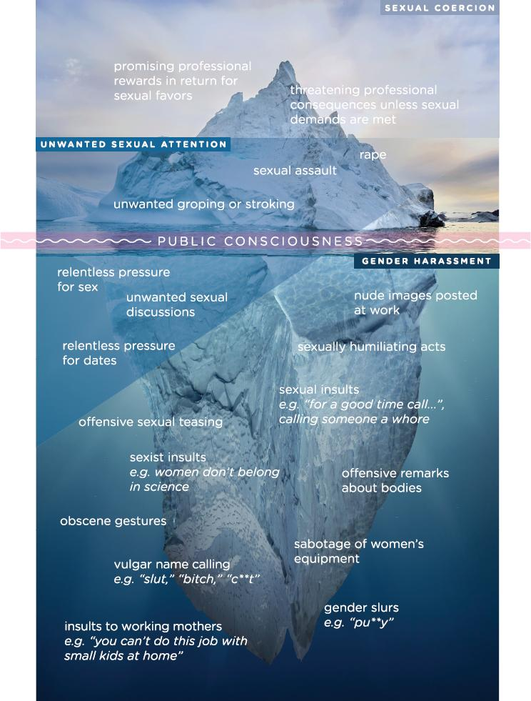

**Fig 3.** The public consciousness of sexual harassment and specific sexual harassment behaviors. Much of what we perceive as sexual harassment, namely acts in the realm of sexual coercion and unwanted sexual attention, is only a small portion of what encompasses sexual harassment. (adapted from National Academies Report, 2018)

**The Academic Environment**

The answer is not straightforward, though cautiously promising. Since the advent of the #MeToo movement, there has been a spike in activism within STEM fields as well. Several high-profile investigators have left their positions after sexual harassment investigations, including geneticist Francisco Ayala, cancer biologist Inder Verma, and astrophysicist Christina Ott. Over two years ago, Julie Libarkin, a professor at Michigan State University, started compiling a database of publicly available cases of sexual misconduct in academia.[11] Now, this report includes over 700 cases of misconduct throughout US institutions. Looking at the numbers of cases across the years, there is a definite uptrend in reported cases since 2017, in both STEM and non-STEM fields.

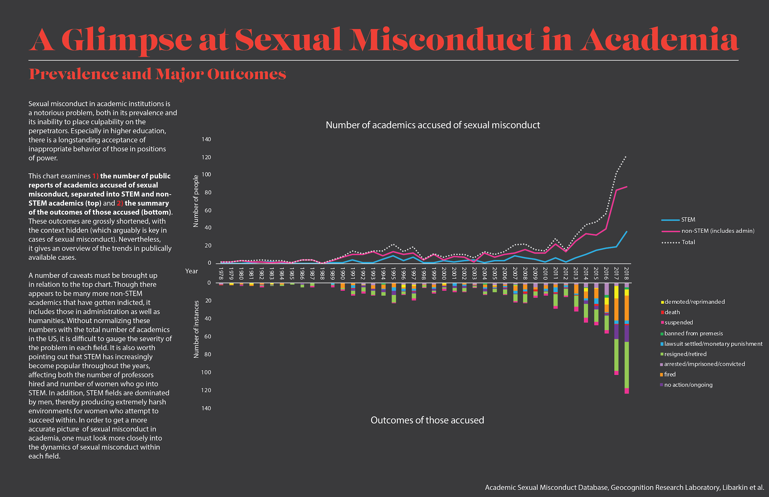

**Fig 4.** Quantifying public sexual misconduct cases. There is an overall increase in the number of cases in 2017 and 2018, which aligns with when the #MeToo movement began. (data from Libarkin, 2019)

BethAnn Franklin, a professor of neuroscience at Vanderbilt University, took to Twitter and the greater online community to start the #MeTooSTEM movement, in an effort to make stories of women in STEM visible, and hold organizations of power accountable for dealing with sexual harassment allegations. This movement has received so much support that it is now acting as a nonprofit organization.[12] She has started various petitions to remove confirmed sexual harassers from the National Academies of Sciences, Engineering, and Medicine, revoke honors from the American Association for the Advancement of Sciences from scientists who commit breaches of ethics, and deny NIH grants and other financial support to scientists who have committed sexual misconduct.

Yet, time and time again, we see that sexism has an undeniable, looming presence over STEM. None of the prominent scientists who left their positions due to sexual misconduct investigations have had their honors or memberships revoked from influential scientific organizations (i.e. the National Academies, the very organization that conducted a sweeping review of sexual harassment in STEM fields, and came up with suggestions on how to counter this). This means that they still have powerful leverage over who gets membership to these organizations, who gets grant approval, who gets recognition for their scientific work. Dr. Franklin herself has had her tenure bid revoked, after a four year application processing period while her Twitter account activity was being investigated, and now, she has almost run out of her NIH funding. Her tenure was approved by her department and the executive faculty committee, but was revoked when the medical dean asked them to reconsider. The review was due to a false complaint against her by Aurelio Galli, a former physiology professor, after she served as a witness in an investigation into his alleged misconduct against a female graduate student.

Jef McAllister, a part of Dr. Franklin’s legal team, states: "It is ironic, but unfortunately not surprising, that someone with a national reputation for promoting women in STEM at universities finds herself ground down in an opaque and irregular tenure review. It has been a long and demoralizing process of the sort that pushes many women out of academia."[13]

Though there seems to be a clear uprising of women speaking out, there is an equally strong force that seeks to keep what order was had up until now in place. More voices are offering their experiences and recommendations, yet the institutions that have the power to change the perspective of sexism in STEM have done very little.

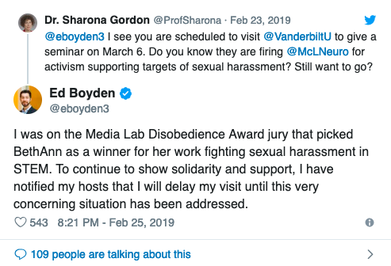 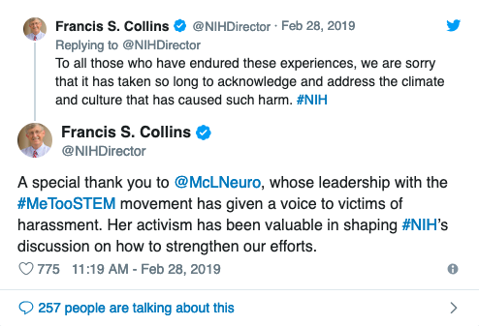

**Fig 5**. Examples of individuals showing support for Dr. Franklin, both men and women. Ed Boyden is a famous neuroscientist at MIT, Sharona Gordon is a physicist at UW, and Francis Collins is the director of the NIH. In parallel, this also exemplifies that a significant amount of activism and occurs online, and is worth looking into.

*Maybe include Title IX info and general info about sexual harassment across different levels of academia.

**Sexism in Industry & the Private Sector**

*Need to look into this more + find primary sources

**STEM in Development**

Another angle to look at the gender disparity, and subsequent sexism in STEM is to approach this from a development standpoint. What are the trends in STEM engagement and enrollment from elementary school to higher education, to industry or academic positions?

Jeanette Miranda, a female aerospace engineer who has immersed herself in engineering and computer science since middle school, has volunteered at robotics competitions at the middle and high school level for three years.

Of the gender makeup at the competitions, she states, “Middle school is usually pretty good, especially because the programs I work with are smaller teams and so it's easier to get together an all female team of eight students. By the time you get to the larger high school teams, in particular because these are kind of hands on projects...Yeah, it's usually pretty bad already. And so I think if you can change it at that point it's a start.”

*Need more numbers, make the point that perhaps what is more necessary is engagement at a young age and retention of that engagement, mentorship so that WHEN they get to the point where there is a gender disparity, young women are equipped to handle these situations.

**Purpose**

Despite the laundry list of undesirable statistics on the sexism problem in STEM, I find it curious that I personally have not, if limited to my experience in the academic and workplace environment, experienced sexism of any sort. After studying neuroscience at Brown for my undergraduate studies, I spent a few years at a computational neuroscience lab in Princeton, and now am working at the biotech startup Kallyope. I have experienced STEM in academic, nonprofit, and industry environments, and have been fortunate to have overall positive experiences from all. I suspect it is by no small margin due to luck and circumstance--of having the chance to be surrounded by women in science, and men who seek to uplift women pursuing science.

However, the numbers tell a different story. Though the are significant improvements in the treatment of women in STEM due to the global trend of empowerment, and the fortitude of women that have previously paved a path forward, the sexism in STEM is deep-rooted, its reach extensive and insidious. Extensive research has been done by the National Academies and other prominent organizations on the prevalence of sexual harassment in STEM, but these are only numbers. There are stories behind these numbers, nuances to the problem--perhaps best exemplified by the fact that the very organizations who have conducted the research into sexual harassment in STEM have turned a blind eye to the problem when it prompts them to take action.

The objective of this project is to take data from both official papers, and less conventional sources (i.e. Twitter, websites), and paint a more comprehensive picture of sexism in STEM fields--in doing so, it will be easier to pinpoint areas of concern within the whole that requires more focus. Subsequently, I would like to explore how we can increase the retention rate of STEM engagement from K-12 to higher education, to the workforce. Likely, there are two separate cases, one for retention in K-12, one for retention in the workforce.

*More clear thesis statement will come after data collection/research is complete

**References**

Brown, Sarah. "This Scientist Was the Architect of #MeTooSTEM. Now Others Are Fighting to Save Her Job." The Chronicle of Higher Education. March 01, 2019. Accessed March 26, 2019. https://www.chronicle.com/article/This-Scientist-Was-the/245806.

Elting, Liz. "A Hard Look At The Hard Numbers Of #MeToo." Forbes. October 15, 2018. Accessed March 26, 2019. https://www.forbes.com/sites/lizelting/2018/10/15/a-hard-look-at-the-hard-numbers-of-metoo/#20f14fde79f9.

Geocognition, |. "The Academic Sexual Misconduct and Violations of Relationship Policies Database." GEOCOGNITION RESEARCH LABORATORY. September 15, 2018. Accessed March 26, 2019. https://geocognitionresearchlaboratory.com/2018/08/20/the-academic-sexual-misconduct-database/.

Holland, Kathryn J., and Lilia M. Cortina. "Sexual Harassment: Undermining the Wellbeing of Working Women." *Handbook on Well-Being of Working Women*, 2016, 83-101. doi:10.1007/978-94-017-9897-6_6.

"Home." Me Too STEM. Accessed March 26, 2019. https://metoostem.com/.

MacKinnon, Catharine A. "Where #MeToo Came From, and Where It's Going." The Atlantic. March 24, 2019. Accessed March 26, 2019. https://www.theatlantic.com/ideas/archive/2019/03/catharine-mackinnon-what-metoo-has-changed/585313/.

*Science & Engineering Indicators 2016. National Science Board*. Place of Publication Not Identified: Distributed by ERIC Clearinghouse, 2016.

*Sexual Harassment of Women: Climate, Culture, and Consequences in Academic Sciences, Engineering, and Medicine*. Washington D.C.: National Academies Press, 2018.

Weiss, Karen G. "Too Ashamed to Report: Deconstructing the Shame of Sexual Victimization." *Feminist Criminology*5, no. 3 (2010): 286-310. doi:10.1177/1557085110376343.

Wilson, Laura C., and Katherine E. Miller. "Meta-Analysis of the Prevalence of Unacknowledged Rape." *Trauma, Violence, & Abuse*17, no. 2 (2015): 149-59. doi:10.1177/1524838015576391.

"Women in Science Take on Sexual Harassment." Feature | Women in Science Take on Sexual Harassment. Accessed March 26, 2019. http://www.asbmb.org/asbmbtoday/201809/Feature/Harassment/.

1. Karen G. Weiss, "Too Ashamed to Report: Deconstructing the Shame of Sexual Victimization," *Feminist Criminology* 5, no. 3 (2010): , doi:10.1177/1557085110376343.
2. Laura C. Wilson and Katherine E. Miller, "Meta-Analysis of the Prevalence of Unacknowledged Rape," *Trauma, Violence, & Abuse*17, no. 2 (2015): , doi:10.1177/1524838015576391.
3. New York Times API.
4. Liz Elting, "A Hard Look At The Hard Numbers Of #MeToo," Forbes, October 15, 2018, , accessed March 26, 2019, https://www.forbes.com/sites/lizelting/2018/10/15/a-hard-look-at-the-hard-numbers-of-metoo/#20f14fde79f9.
5. Catharine A. MacKinnon, "Where #MeToo Came From, and Where It's Going," The Atlantic, March 24, 2019, , accessed March 26, 2019, https://www.theatlantic.com/ideas/archive/2019/03/catharine-mackinnon-what-metoo-has-changed/585313/.
6. *Science & Engineering Indicators 2016. National Science Board*(Place of Publication Not Identified: Distributed by ERIC Clearinghouse, 2016).
7. *Sexual Harassment of Women: Climate, Culture, and Consequences in Academic Sciences, Engineering, and Medicine*(Washington D.C.: National Academies Press, 2018).
8. Louise F. Fitzgerald, Suzanne Swan, and Karla Fischer, "Why Didnt She Just Report Him? The Psychological and Legal Implications of Womens Responses to Sexual Harassment," *Journal of Social Issues* 51, no. 1 (1995): , doi:10.1111/j.1540-4560.1995.tb01312.x.
9. Louise F. Fitzgerald, Suzanne Swan, and Karla Fischer, "Why Didnt She Just Report Him? The Psychological and Legal Implications of Womens Responses to Sexual Harassment," *Journal of Social Issues* 51, no. 1 (1995): , doi:10.1111/j.1540-4560.1995.tb01312.x.
10. Kathryn J. Holland and Lilia M. Cortina, "Sexual Harassment: Undermining the Wellbeing of Working Women," *Handbook on Well-Being of Working Women*, 2016, , doi:10.1007/978-94-017-9897-6_6.
11. Geocognition, "The Academic Sexual Misconduct and Violations of Relationship Policies Database," GEOCOGNITION RESEARCH LABORATORY, September 15, 2018, , accessed March 26, 2019, https://geocognitionresearchlaboratory.com/2018/08/20/the-academic-sexual-misconduct-database/.
12. Sarah Brown, "This Scientist Was the Architect of #MeTooSTEM. Now Others Are Fighting to Save Her Job.," The Chronicle of Higher Education, March 01, 2019, , accessed March 26, 2019, https://www.chronicle.com/article/This-Scientist-Was-the/245806.
13. Sarah Brown, "This Scientist Was the Architect of #MeTooSTEM. Now Others Are Fighting to Save Her Job.," The Chronicle of Higher Education, March 01, 2019, , accessed March 26, 2019, https://www.chronicle.com/article/This-Scientist-Was-the/245806.