

MiddleMan: Design Document

Bernard Valentino and Samuel Hill

Application Definition Statement

MiddleMan is an android application that helps people that flip items from Craigslist to eBay to do so with increased efficiency and greater profitability. With useful price analysis tools, this helps those users do their jobs much more easily.

Sources and Snippets

**APIs**

Google Static Map

This was the easiest of our APIs to implement. WIth a simple URL call, we got the image of the map, complete with markers. However, this did not make it into the production version of our application due to time restrictions.

eBay

This was much easier to work with than the others; it had great documentation and solid responses.

Craigslist

Craigslist has no API. Instead, we parsed the data from its XML feed. The responses are inconsistent at best and leave much to be desired.

**Code**

StackOverflow was the source of many of our snippets and solutions. We found this site to be an invaluable asset in creating MiddleMan.

<http://stackoverflow.com/questions/13709362/passing-arraylist-of-objects-through-intent-java-android>

Solution posted Dec 4 '12 at 18:46 by [Sam](http://stackoverflow.com/users/1267661/sam)

<http://stackoverflow.com/questions/2002288/static-way-to-get-context-on-android>

Solution posted Feb 25 '11 at 6:37 by [Rohit Ghatol](http://stackoverflow.com/users/633674/rohit-ghatol)

<http://stackoverflow.com/questions/10786042/java-url-encoding>

Solution posted May 28 '12 at 14:15 [BalusC](http://stackoverflow.com/users/157882/balusc)

We also had great success in using the Android Developer tutorials. They also reference StackOverflow for several examples.

<http://developer.android.com/training/basics/network-ops/xml.html>

<http://developer.android.com/training/implementing-navigation/temporal.html>

Several other sites also aided us in our development efforts.

<http://androiddevelopement.blogspot.in/2011/06/android-xml-parsing-tutorial-using.html>

<http://www.sitepoint.com/learning-to-parse-xml-data-in-your-android-app/>

Market Research

Our target segment is currently successful eBay resellers (“flippers”), whose flipping process could be made more efficient by using a service. Although that is our main segment, we expect the service to spill over to other potential customers.

**For whom are we creating value?**

Current and emerging eBay resellers whose lives could become more profitable and well spent by using this service.

**Which customer needs are we satisfying?**

A flipper needs several things to be successful at his job.

1) Information about an item

a) market volume

b) availability

c) profitability

2) A seller

3) A buyer

Our service provides the 1) information about an item, as well as linking the customer to the 2) seller through craigslist, and allows them to have a reasonable level of confidence that they will find a 3) buyer using eBay.

**Who are our most important customers?**

Our most important customers are currently successful eBay flippers. Our service saves them time by cutting the time they spend searching for items and allowing them to spend more time selling.

We contacted some potential customers:

Customers contacted

* Sunita Rai, a successful eBay flipper, was sponsored by the eBay site as a success story. We contacted her to see about her sellers niche and she shared with us that she commonly went to thrift stores in order to find items which she could flip for more. We asked her how she felt about our application and explained how it works. She responded that she would be interested in utilizing it when her family obligations limit her from leaving the house to go thrifting.
* Robert Smith - a self titled “Flipping Coach,” Robert offers services as a mentor in establishing oneself in the flipping trade. Robert shared with us that his primary technique for finding flippable items is comparing the completed sales page of eBay with the local listings on Craigslist: just what we designed our application to do! We explained to him our idea and he said that he supported the idea that we had, but didn’t see it as being useful for beginners due to our small customer base. He explained that when first getting into flipping, the profits are not very high and that the cost benefit ratio for the service was not practical for them. If we wanted to monetize this service, we’d have to break the service out into multiple subscription levels.
* [reddit: [EdgyEvolution](http://www.reddit.com/user/EdgyEvolution)]... I think sticking with a niche is definitely the safest and most efficient way to sell on ebay, however, expanding this niche is necessary if you want to continue to grow as a seller IMO. If you resell, then it is very easy to spot deals within your market niche and flip the items for a profit, but I think selling strictly one type of item is very limiting. I've found profit in very random items by simply searching it on ebay or using an app on my iphone that scans the barcode and compares prices across the web. Selling on ebay is a great way to make extra cash and it's such a thrill to see what your listed item will go for in the last minutes of an auction.

**What value do we deliver to the customer?**

We provide increased efficiency, higher accuracy, and reduced time spent searching for items to flip.

**Which one of our customer’s problems are we helping to solve?**

Flippers spend a large amount of time researching and finding items to flip. Our service reduces that time.

**How would we monetize this product?**  
 Trial + Advertisements

Subscription

UI Design

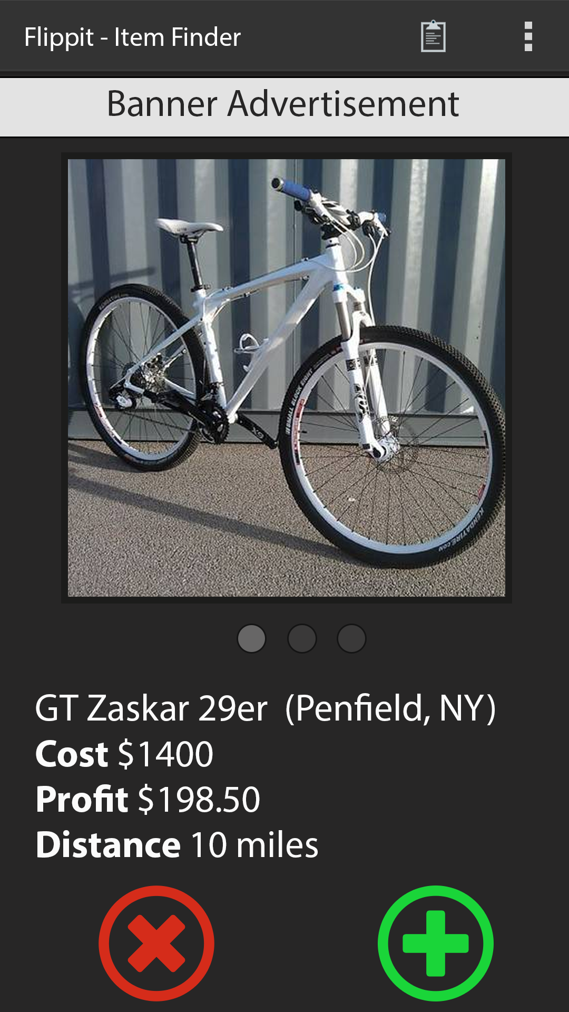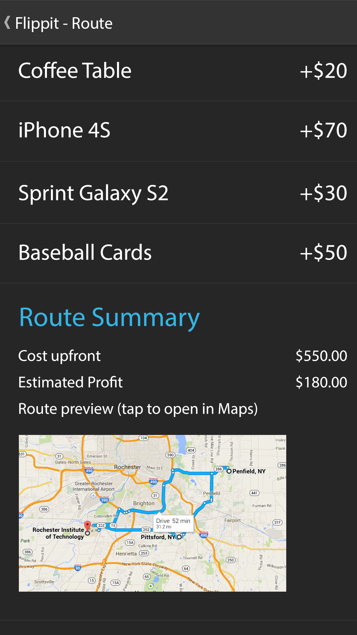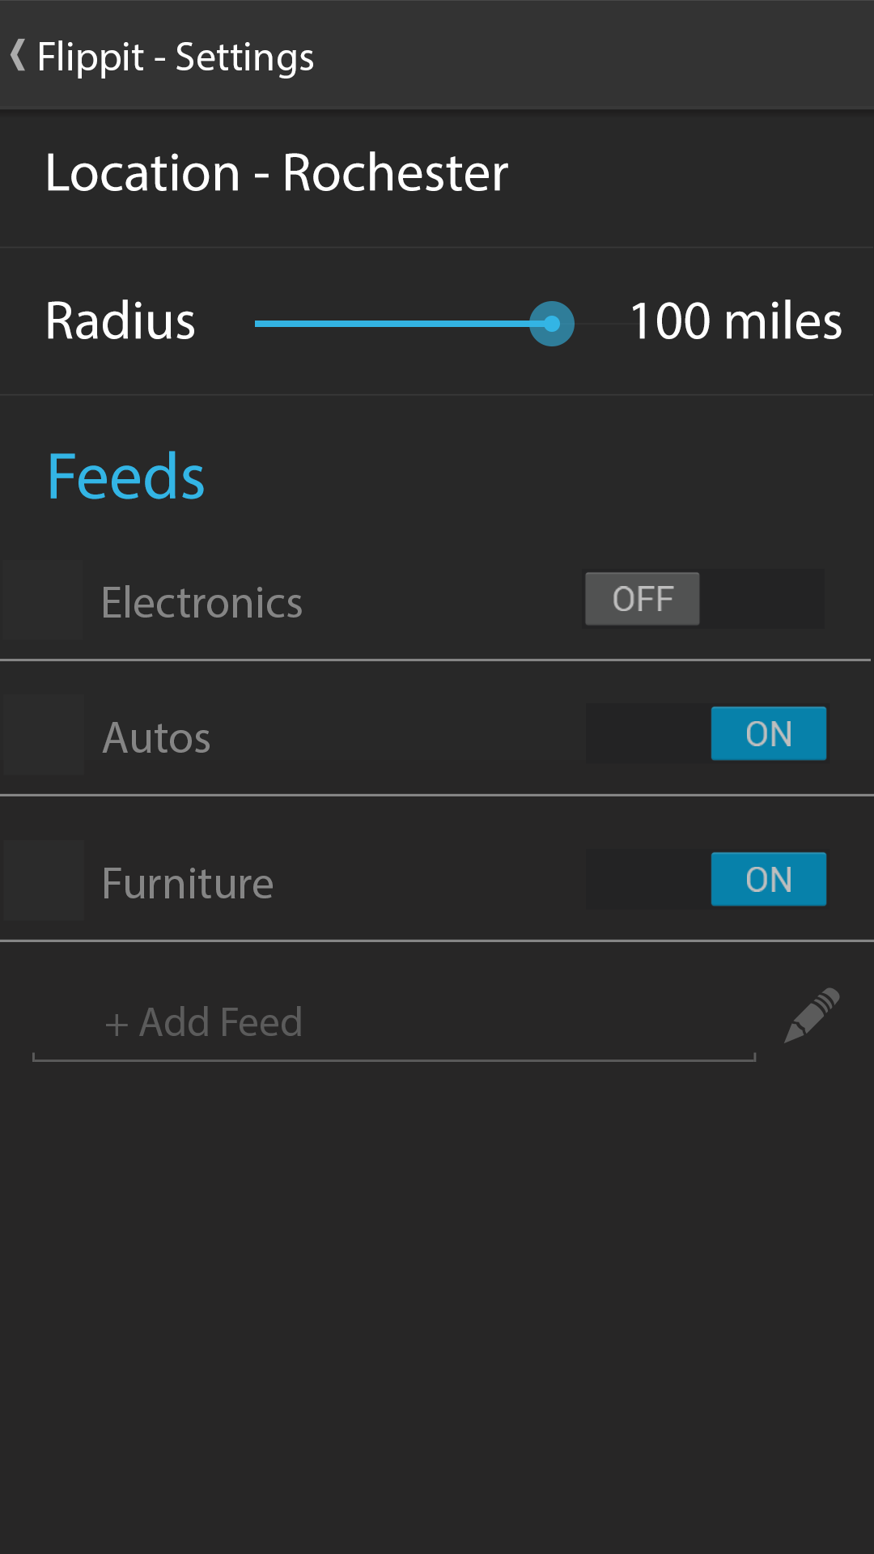

Home Shopping Cart Settings

This design was created with a free photoshop template for Android 4.0.

The goal was to make it as minimalist as possible. Here’s the typical workflow:

1) On startup, the app suggests a profitable item to the user for purchase.

2) Once an item is selected, it is added to the cart and the estimated total cost and profit, as well as total distance, are calculated.

3) These values are displayed in Route Summary, where the user can then set up his route and see his total expenses and expected profit.

The settings page is also designed with ease-of-use in mind, with only several options to select and modify.

Planned Features

**Plan a route based on locations parsed from Craigslist data.** The locations Craigslist provides are very rough. However, it would still be useful to the user to see approximately how long the route will take.

**Automatically search in different categories for viable products.** The Feeds section would allow the user to essentially subscribe to items that would be profitable. This way, he would not have to search for items at all; rather, they would just show up when they become available. This gives users of MiddleMan an advantage of time against others that might not use it.

**Contact the owner of the item from within the app.** We want our application to be a one-stop experience, so we’d like for the user to be able to send a form email to the owner of the item with the intent of stopping by to purchase it.

**Automatically get the user’s location.** It would be better if the location function of the phone could be used. Unfortunately, we did not get to implement it in this version of MiddleMan.

Self-Evaluation

**Shortcomings**

Because of our limited testing hardware, it is currently not possible to get the user’s location automatically. With dedicated testing devices, we are confident that we could implement a location-sensing feature that would eliminate the need for the user to input his location.

We also did not get to implement Feeds. Craigslist’s API presented an issue in which we can only search by keyword. In the time given, we were not able to find an adequate workaround for this issue.

**A-level work**

There is currently no other application in the Google Play market that allows as much market analysis as Middleman. We have a target audience, with features that meet those predicted in our original design document.

In the creation of MiddleMan, we went above and beyond in several areas. Particularly, we were able to leverage the Craigslist and eBay APIs to get useful information for the user. We also had reusable code in all classes. We were also able to successfully apply Google’s Android development guidelines to make sure our application was usable. For example, when the user has to wait for data to load, he is alerted by a loading spinner with a friendly message.

In addition, we had reusable classes: ItemView and its corresponding layout display items in both the cart and also the item detail screen with a simple method call.