**SSH keys setup for password less login to Linux servers and ability to SSH from JUMP**

1. **Generate SSH key pair:**  
   - Select SSH2-RSA and a minimum 2048 or 4096 bit key and click **Generate**

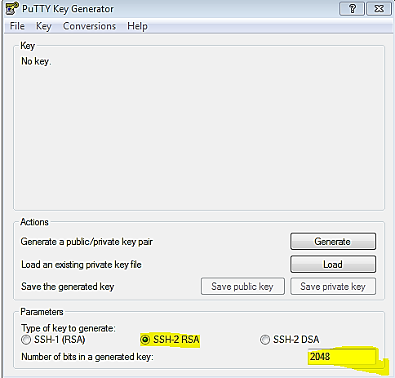

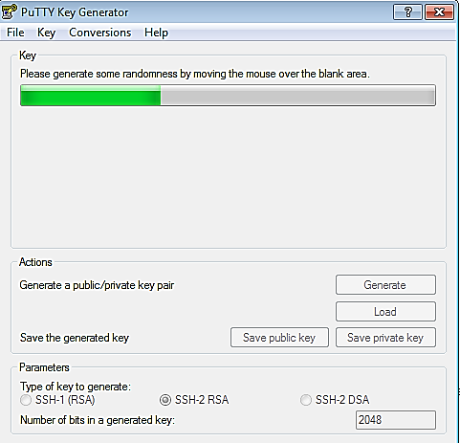

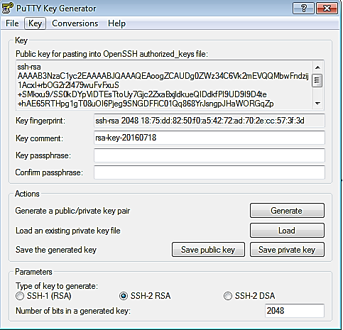

* Copy private key to a secure location on your local machine. **DO NOT share private key with any person or application.** If private key is shared by mistake, please generate a new key pair and delete old key pair.
* Click on “**Save private key”** without passphrase. If saved with a passphrase for more security, you will need to use this passphrase whenever key is used.
* **Save to your local laptop location. For example as below:**  
   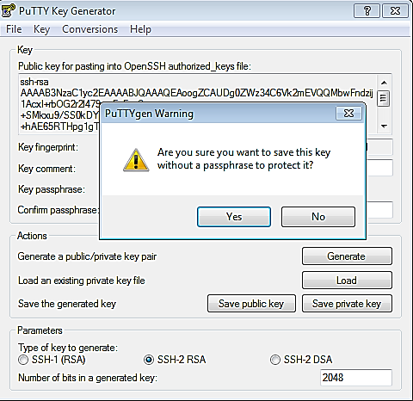

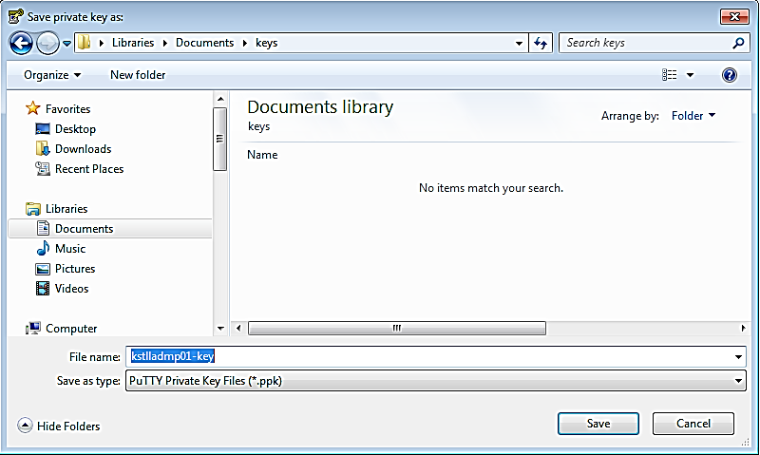

* **Copy public key and paste into your home: ~/.ssh/authorized_keys as below**

For example, copy public key:   
**ssh-rsa** AAAAB3NzaC1yc2EAAAABJQAAAQEAoogZCAUDg0ZWz34C6Vk2mEuS+*******something will be here************ZA 8jbL0T9Ax0aokXf6HnYFWytPs0L3KzLnXQ+zm7M9QvYa+wHiF3ae9q62JYw== **rsa-key**-20160718

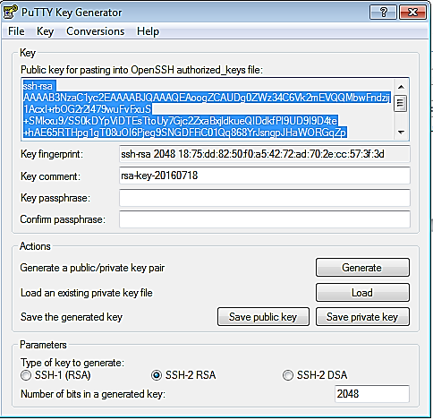

Login into host **(JUMP HOST** - where you want the password less login and password less SSH**)** to be setup and paste public key to below file:

* **vi ~/.ssh/authorized_keys:**

1. **Login using ssh keys from PUTTY:**   
   Open putty session. Expand -> **SSH** -> **Auth** -> click Browse and provide private key location

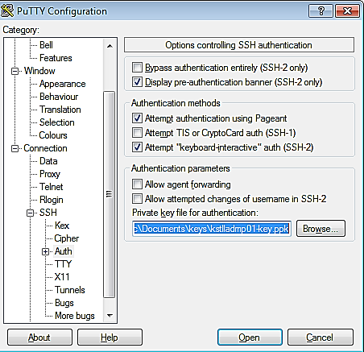

**Enter host details ((JUMP HOST** - where you want the password less login and password less SSH**)** - **(also select Default Settings and save for better results)**

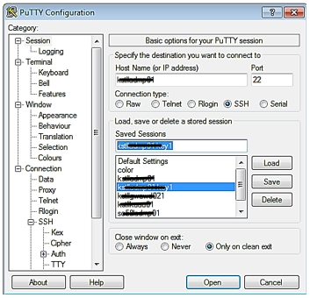

**Successful login without password will be successful now for that particular host where you did**

**vi ~/.ssh/authorized_keys and copied the keys..**

**For ALL/set of hosts this can be done by using below script…**

**Keys setup for password-less login for servers in DMZ – password-less login from jump/bastion servers to app servers:**Generate ssh key pair on jump server/bastion host, example below:

[usernameadm@**JUMPHOST** ~]$ **ssh-keygen -t rsa**

Generating public/private rsa key pair.

Enter file in which to save the key (/home/usernameADM/.ssh/id_rsa):

Enter passphrase (empty for no passphrase):  **- PRESS ENTER**

Enter same passphrase again: **- PRESS ENTER**

Your identification has been saved in /home/usernameADM/.ssh/id_rsa.

Your public key has been saved in **/home/usernameadm/.ssh/id_rsa.pub**.

The key fingerprint is:

ae:da:f8:0b:b3:78:f1:2b:70:c9:3b:47:a9:01:45:fd

The key's randomart image is:

+--[ RSA 2048]----+

| ... |

| . . |

| . . |

| . E |

| o . .S |

| . * o. |

| ooB . |

| .**o. |

| ..+**o |

+-----------------+

[usernameadm@**JUMPHOST** ~]$

* Copy public key generated above – **id_rsa.pub** to destination server in DMZ @ .ssh/authorized_keys. This will enable password-less authentication between jump server/bastion host to servers in DMZ. Example below:

[usernameadm@**JUMPHOST** ~]$ cat .ssh/id_rsa.pub | ssh usernameadm@hostname1 "mkdir .ssh && cat >>.ssh/authorized_keys"  
or if .ssh directory is already existing on destination server in your home directory, just copy the public key using:  
[usernameadm@ **JUMPHOST** ~]$ cat .ssh/id_rsa.pub | ssh usernameadm@hostname1 "cat >>.ssh/authorized_keys"

**Skip above manual steps by running below scripts:**

Login to appropriate Bastion/Jump host and following below:

* Change to **~/.ssh** dir
* Please run above steps in the document to create **authorized_keys** and **id_rsa.pub** files.
* cd ~/.ssh/
* “ls –lrt” must show below files:
  + id_rsa
  + id_rsa.pub
  + authorized_keys
* create a file **“vi ssh_keys_copy.sh”** and copy contents from URL:
* chmod 755 **./ssh_keys_copy.sh**
* **./ssh_keys_copy.sh**

**Note:**

>Provide the password when prompted

>list of servers are present under “**servers_list**” dir., pick a list based on requirement **or** create a new file

**Example:   
./ssh_keys_copy.sh “./servers_list/** **servers_list_nextgen” “Pxxxxxxxadm or Vxxxxxx”**

* Now we can able to login without password and able SSH from bastion/jump servers without asking for password…

**Note: In order to copy keys to all servers we should have “home dir.” on servers, in case you are missing it please raise a request for UNIX team to create one…**To check servers missing home dir., please run the following script as below **–** this doesn’t require a home dir. in bastion host.

* **./homecheck.sh** "**server_list**(or) **server**" "**uid**"

Above script will prints and also create a file under **/tmp_stage/”uid”/** with list of servers, which you can use for creating a request for UNIX team.