CHECKS:

* Check across all screen sizes
* Check across all browsers (Chrome, IE, Firefox)
* All images optimized
* SEO Wording added
* Google Analytics Tracking
* Google Webmaster Tools
* Robots.txt

SEO Phrases:

Page Title: Front-end / Wordpress Developer – Cape Town – Sam Koegelenberg

Description: I’m Samantha and I am based in Cape Town, South Africa. I started learning and doing on web development in 2019.

FIX:

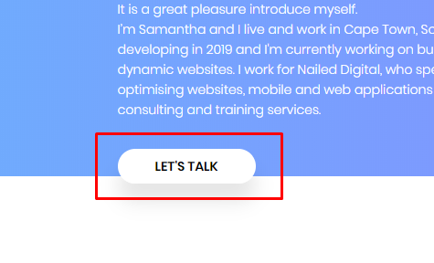

Let’s Talk and Hire Me needs to scroll to the Contact Us section when clicked

Wording update:



Change to Front-end/WordPress Developer

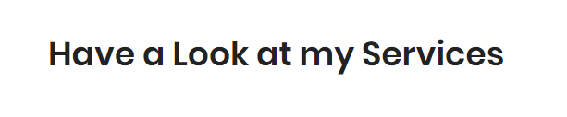

What I do

Add:  
E-commerce Websites

Wordpress Maintenance and Content Management

~~It is a great pleasure introduce myself.~~   
I’m Samantha and I am based in Cape Town, South Africa. I started learning and doing web development in 2019.   
I am currently working for Nailed Digital, who specialises in developing and optimising websites, web applications, web consulting and training services.