Standard Operating Procedure (SOP)

Process ID & Name: | [Example: SOP-RR2-001] PROVIDER Collection Communications & Escalation
Supporting Policies: | Invoice of Records, Bad Debt Allowance and Write-Offs, and Revenue Cycle Controls.
Control ID(s): | [Example: INV-001]
Department Owner: | Finance
Effective Date: | December 17, 2025
References:

- PURPOSE
This SOP establishes the standardized approach for collection communications, escalations, and related decision making, to ensure accounts receivable balances are valid, collectible and stated at net realizable value, in accordance with US GAAP, while complying with contractual terms, federal and state laws.
While the SOP provides operational guidance for engaging customers and members regarding overdue balances, its primary objective is to protect the integrity of the Accounts Receivable subledger and related financial reporting by ensuring that:
- Collection efforts are timely, documented and proportionate to risk;
- Credit risk is identified early and escalated appropriately;
- Outcomes of the collection process (e.g., payment plans, disputes, write-offs) are reflected accurately in the accounting records.
This SOP supports the financial statement assertions Accuracy, Completeness, Cutoff, Existence, Rights & Obligations, Valuation, Classification).

- SCOPE
Applies to all funded customers/payors and all invoice types under a Provider Member- standard, consolidated, VMS, international, with balances recorded in Accounts Receivable.
Specifically, this SOP governs the following:
- Customer-facing communications (email, phone, written notices);
- Timing, cadence, and escalation of collection efforts (ex. Internal coordination between Finance, Client Success, Sales, and Leadership regarding delinquent accounts)
- Documentation of collection activity and customer responses.
This SOP does not APPLY TO SELF-FUNDED, REVERSE ACH, OR CREDIT CARD ACCOUNTS.
Outputs from this SOP (ex. aging status, dispute outcomes, failed collection efforts) are key inputs into the applicable accounting policies.

- ROLES & RESPONSIBILITIES
This section defines clear ownership, authority boundaries and accountability for collection communications and escalation activities. Roles are structured so that operational actions reinforce, without replacing, formal accounting decisions.
Roles & Responsibilities:
Collection Analyst | Initiate and maintain customer-facing collection communications, document all activity, disputes, commitments, and responses, monitor aging; identify delinquent accounts, Escalate delinquent or at-risk accounts
Corporate Finance | Apply cash, assist with missing remittance research, perform complex reconciliations, record accounting entries related to credit memos, rebills, adjustments allowances, write-offs, reclasses, maintain accounting documentation and audit files
Billing Analyst | Research and resolve invoice disputes (rates, hours, variances), prepare/process credit memos, rebills, or adjustments when approved, maintain documentation in NetSuite, perform reconciliation.
Payroll | Support dispute resolution related to pay/hours, provide documentation needed to validate or correct billing
Contracts Specialist | Owns the maintenance of customer setup data in the BO platform, including creation and updates.
Client Success Partners | Engage Members and customer to remove blockers, assist with invoice dispute research and customer-relationship mediation
Account Manager (AM) or Business Development Manager (BDM) | Exert pressure and use relationship leverage when Client Success escalation does not resolve. Align on payment plan if needed (Finance approval required), escalate to Leadership for final action
Director of Payroll & Billing | Review outputs from collections to assess collectability, maintain financial controls and audit support, maintain accounting documentation and audit files, perform complex reconciliations.
Controller | Evaluate need for allowances or write-offs under CECL, ensure AR remains at Net Realizable Value (NRV), maintain financial controls and audit support. Approve accounting entries related to credit memos, rebills, adjustments allowances, write-offs, reclasses, maintain accounting documentation and audit files
CFO | Final approval for write-offs, settlements, material concessions, approve allowance methodologies and judgment areas, provide oversight ensuring GAAP and internal control compliance
Leadership | Approve credit holds, assignment suspensions, demand letters, chargebacks (>90 DPD), write-offs, referral to external collection agencies.

  - Segregation of Duties
To maintain strong internal controls:
- Personnel responsible for collection communications are separate from those responsible for accounting determinations
- No individual can execute collection actions and approve accounting treatment for the same receivable

This segregation supports the assertions of accuracy, valuation and existence and reduces the risk of bias and error.
- SUMMARY OF STAGES & SLA TIMELINES
Collection communications are different based on the payment terms and if the account is on automated communications. Summary of the stages are below:
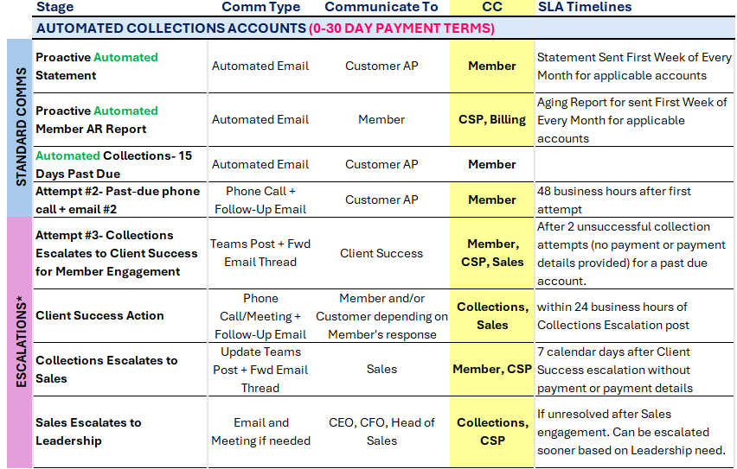
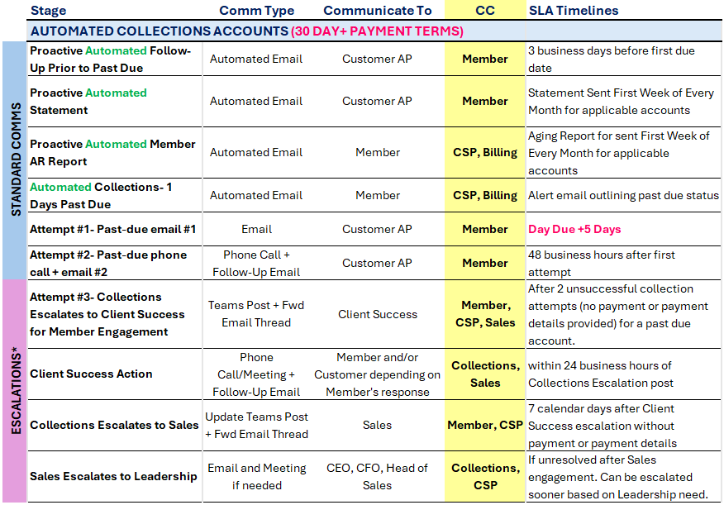

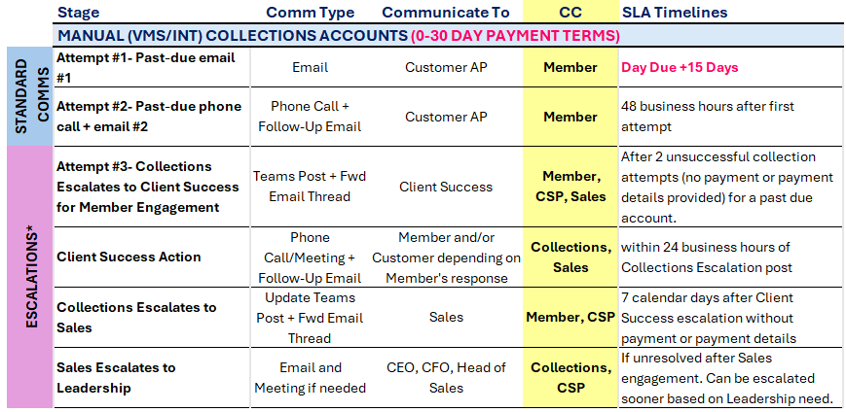
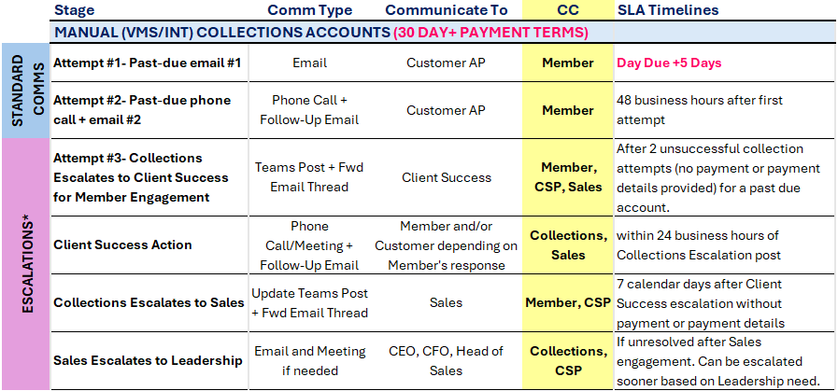
*Escalation timing may be accelerated based on dollar exposure, customer risk profile, or known payment history.

- STANDARD COLLECTION COMMUNICATIONS

  - Purpose of Standard Collection Communications
Standard collection communications are designed to ensure timely collection, maintain accurate and supportable Accounts Receivable aging, and create a complete audit trail of collection activity and customer responses. These procedures are foundation and support the assertions of existence, accuracy, completeness and accuracy.
  - Standard Communication Principles
Owner: Collections Analyst

- Communications should be centralized using the shared inbox, collections@mybasepay.com
- Collection communications should not be sent from an individual MBP email address.
- Be clear, factual and consistent; do not speculate on reasons for non-payment
- Always request payment details (check/ACH number, amount, remittance advice, and expected deposit/date)
- CC Member to ensure alignment and avoid surprises
- Escalate early when non-responsiveness or any blocker patterns emerge.

  - Standard Collection Checks Prior to Any Communications
Owner: Collections Analyst
Before contacting a customer, complete the following checks:
- Confirm payment status is current in NetSuite
  - Verify that no payments have been received – payment application should be updated in the AR aging by the end of every business day.
  - Determine if the outstanding invoice appears to be a skip payment, or a partial payment and adjust communication as needed.

- Confirm invoice validity and invoice-of-record alignment:
- Confirm the invoice(s) being chased are the legal invoice(s) of record for the customer billing model
- If invoice-of-record alignment is unclear escalate to Billing/Corporate Finance and pause outreach until confirmed

- Review account notes and open operational blockers
- Review NetSuite notes, prior collection history and any Billing activity.
- Identify whether the issue is likely a process delay versus a credit risk
- Confirm that the collections inbox has not received recent updates related to recent payments statuses

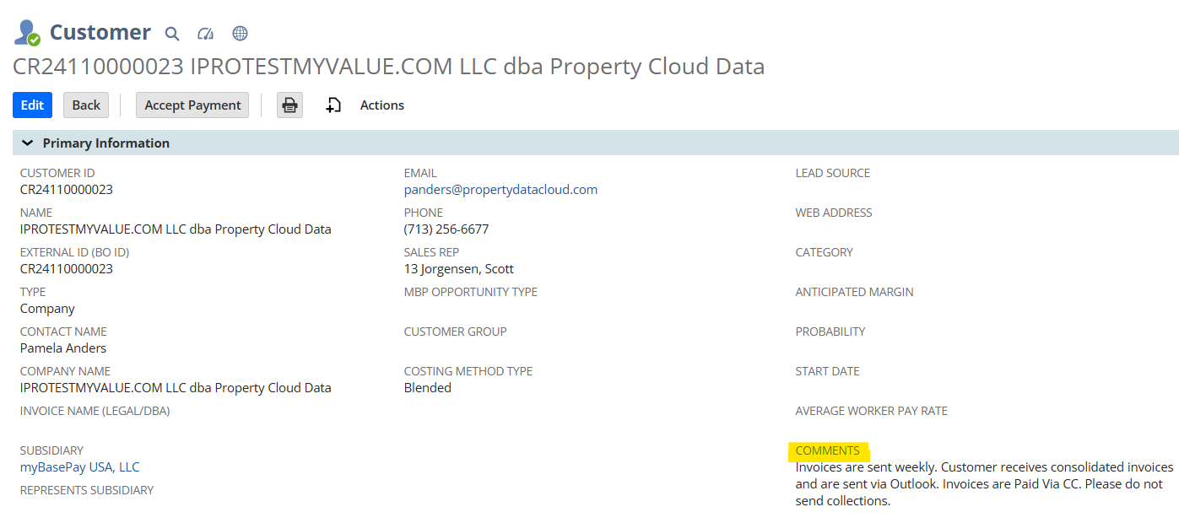
Figure 1 example of customer record comments

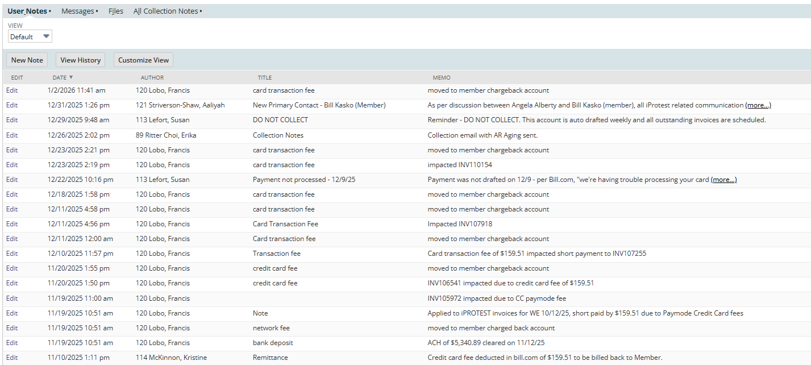
Figure 2 Example of customer record notes

  - Documenting Collection Attempts
Owner: Collections Analyst
All collection communications must be documented to create a reliable audit trail and support AR valuation decisions.
Each documented attempt should include:
- Date and time
- Channel (email / call / voicemail / text)
- Contact name and address/number used
- Invoices referenced and total amount
- Customer response summary (or “no response”)
- Next scheduled follow-up date
- Any commitments made (payment date, remittance promise, dispute raised)
- STATUS
NetSuite Documentation Standard: Use NetSuite activity/notes and attach relevant supporting items (email thread printed to PDF, statement, dispute evidence) where appropriate – all documentation should be attached as PDF, word or excel ONLY.

*Do Not enter collection notes in the Comment section of the NS Customer Record
Below the customer record in NetSuite:

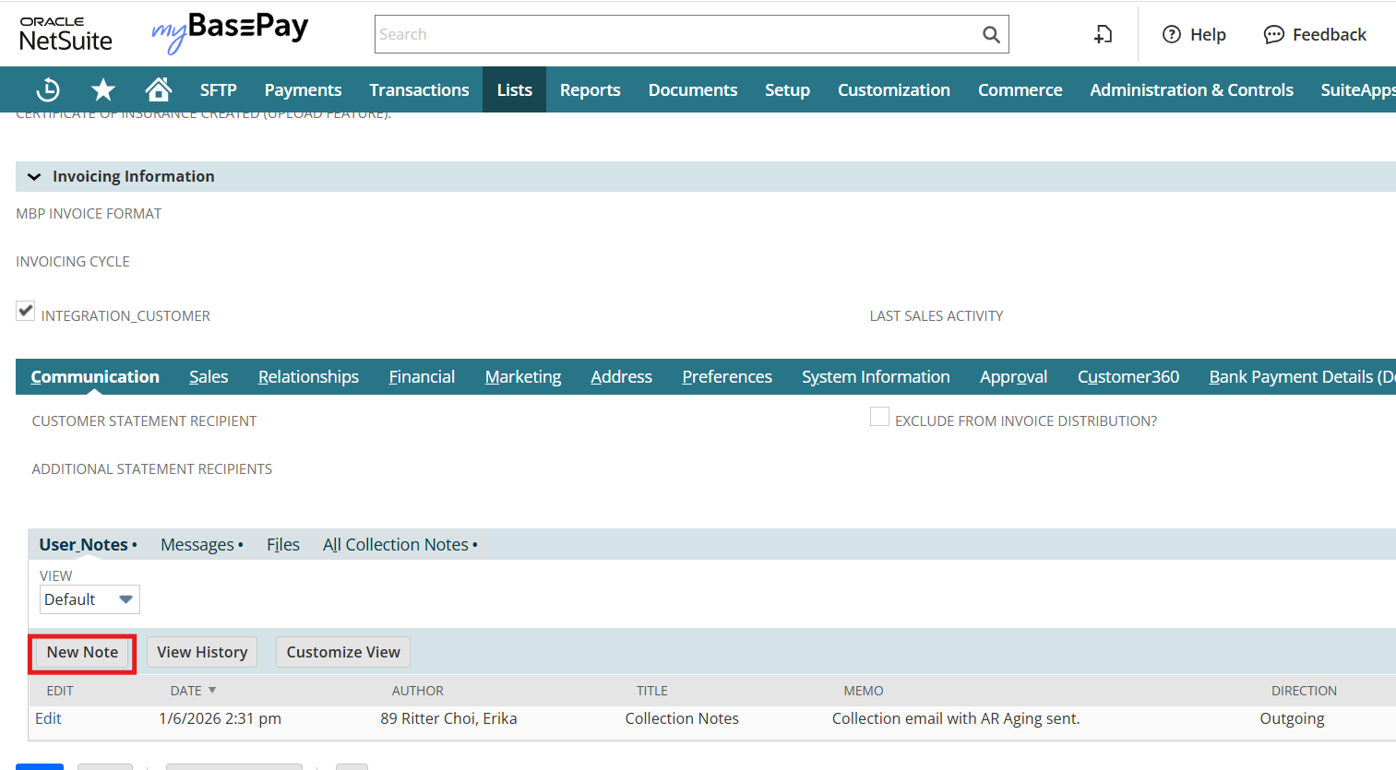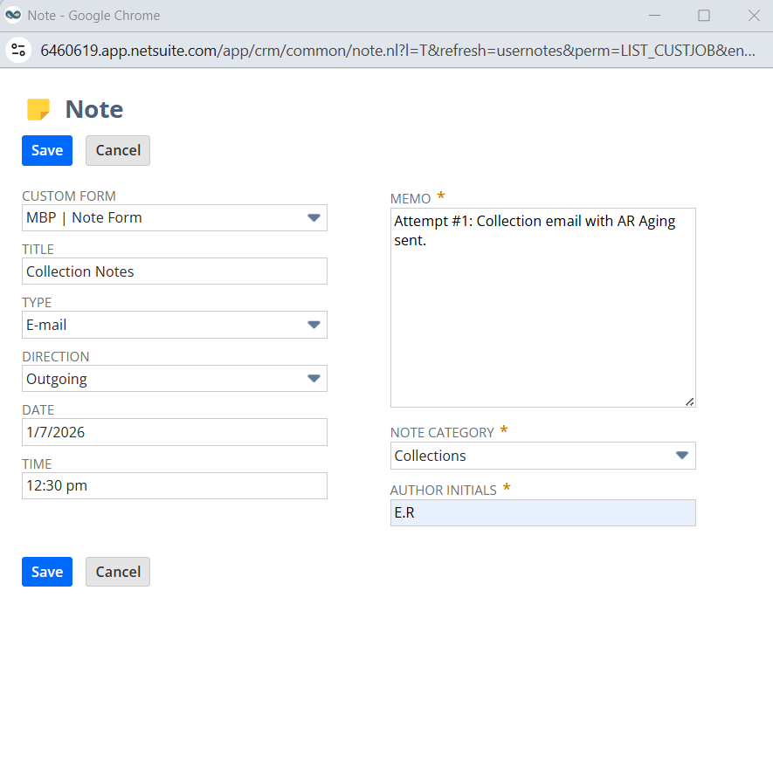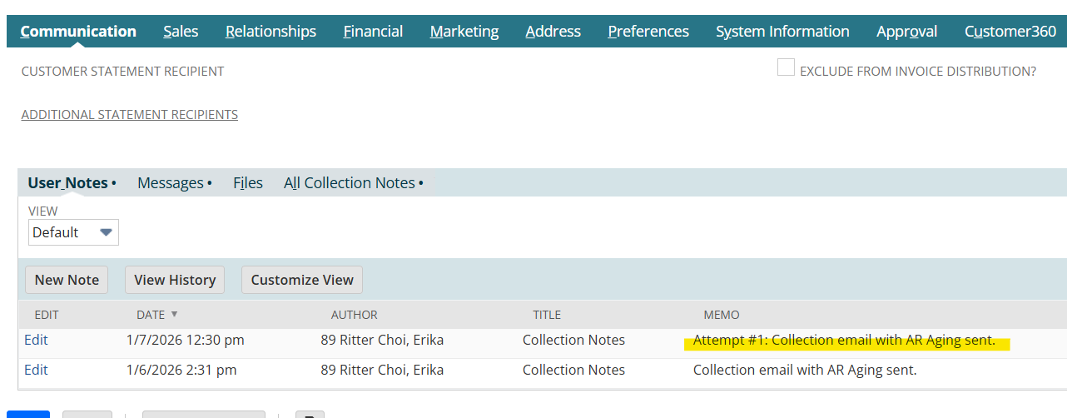

  - VMS/MSP Standard Collection Practices
Owner: Collection Analyst
Collections will know which accounts are invoiced in a VMS by looking at the

For VMS/MSP Accounts: Collections must reference the invoice number, dates and amounts in the clients VMS.

Logins for VMS accounts can be accessed here: VMS Portal Logins

  - Proactive Automated Follow-Up Prior to Past Due (T-5 Business Days before first invoice due) –
Owner: Collections Analyst
Purpose: Reduce preventable delinquencies by confirming the invoice is in the customers’ payment queue prior to due date.
Steps:
- Email AP contact(s) with invoice details
- Request confirmation the invoice is queued for payment
- CC the member
- Document the communication in NS notes under Customer record
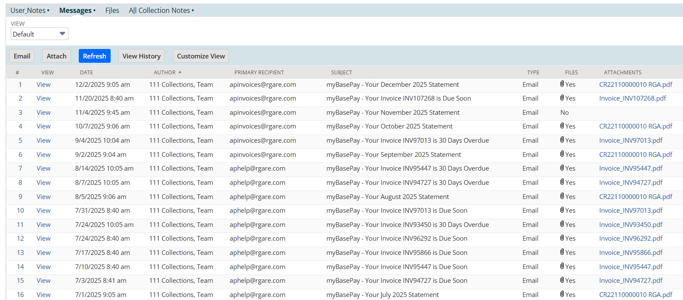
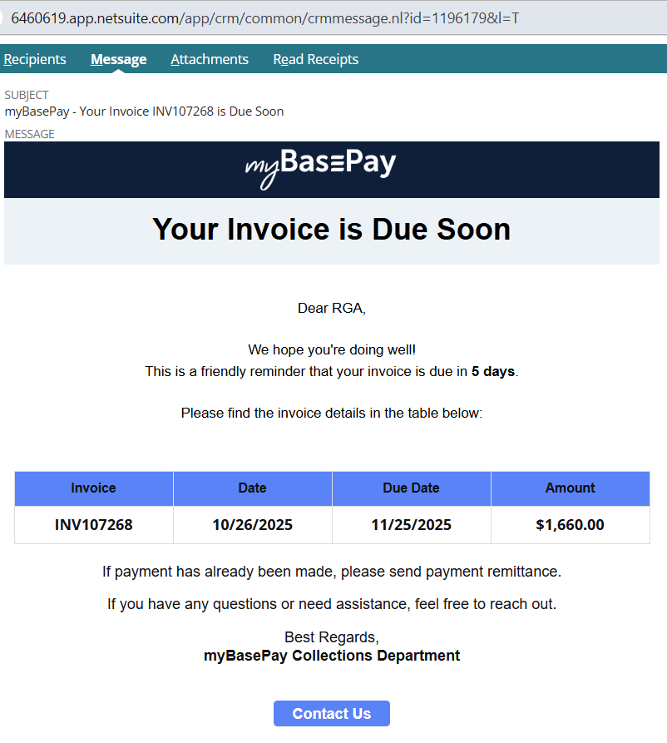

  - Proactive Automated Collection Notifications – Member Monthly AR Statement
Owner: Collections Analyst

  - Proactive Automated Collection Notifications
Owner: Collections Analyst
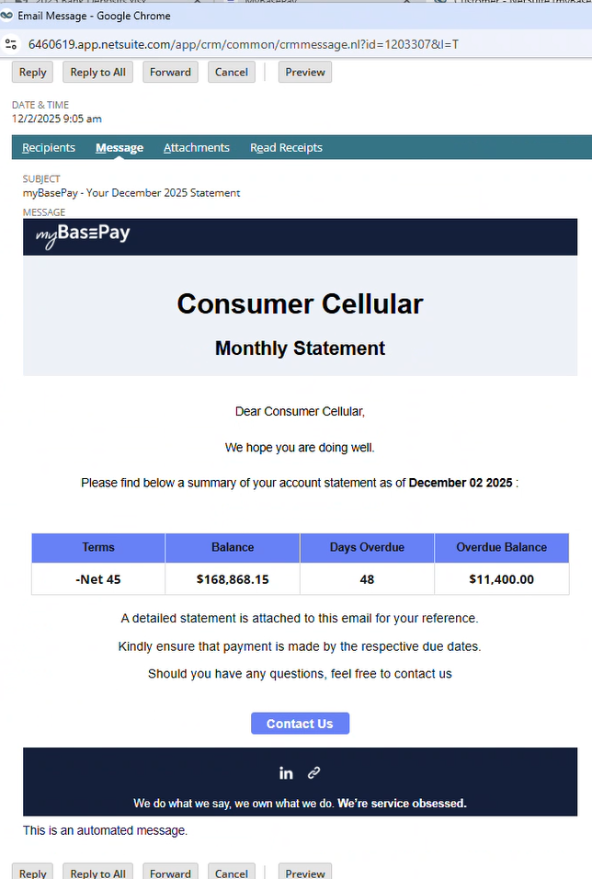
Automated statements being sent to accounts labelled ‘Yes’ for automated communications.
Automated communications must be monitored to ensure accuracy and prevent miscommunication on disputed or non-standard accounts.
Example of statement sent the first week of every month –

Example of mentioned attachment –

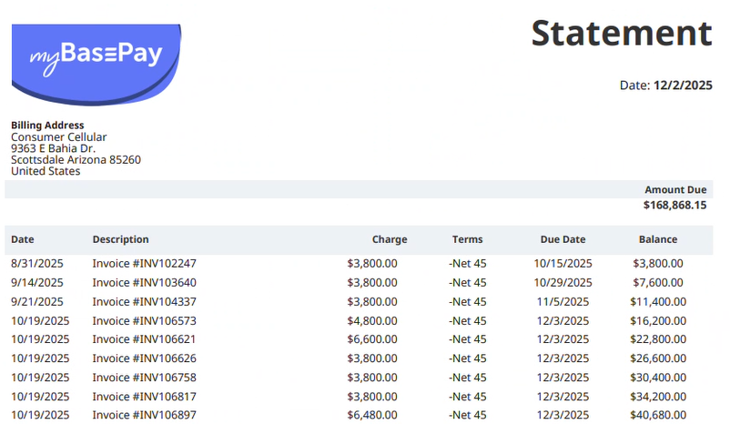
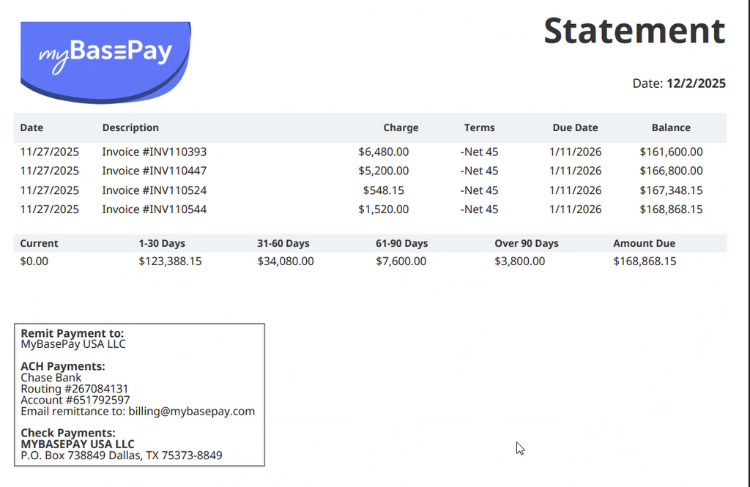

  - Preparing Standard Collection Documents-
Owner: Collections Analyst
Collections may provide customers with the following standard documents:
- Customer Statement (default client-facing document)
- NetSuite-generated PDF statement is the standard
- Do not send internal AR aging reports or modified spreadsheets
Tip: If a statement shows a forward balance with insufficient detail, adjust the date range to include all underlying transactions.

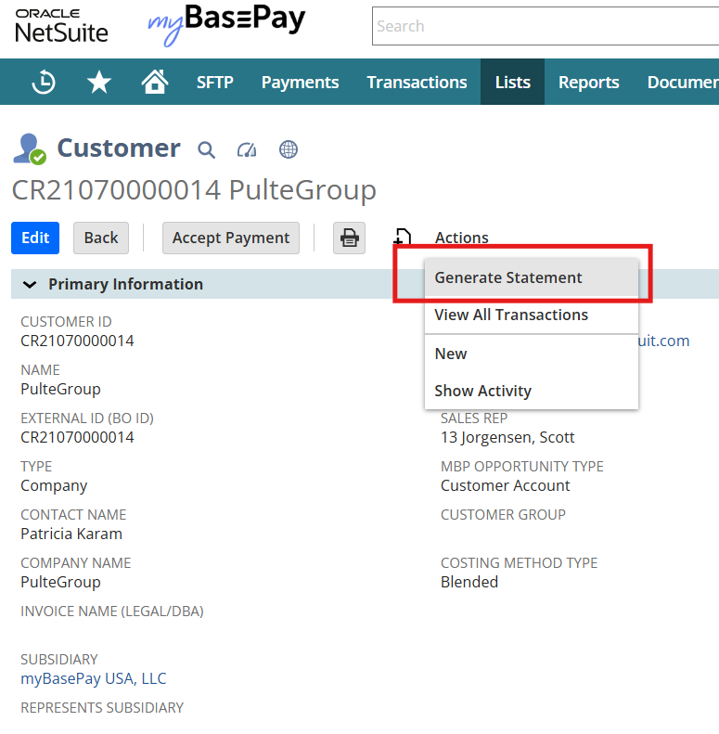
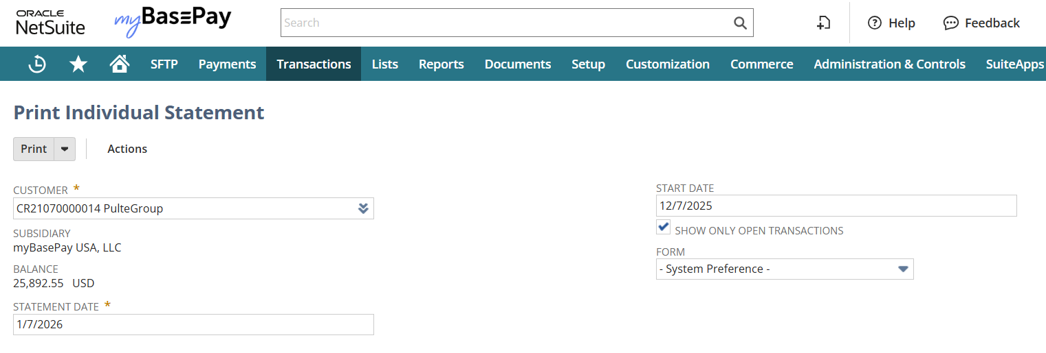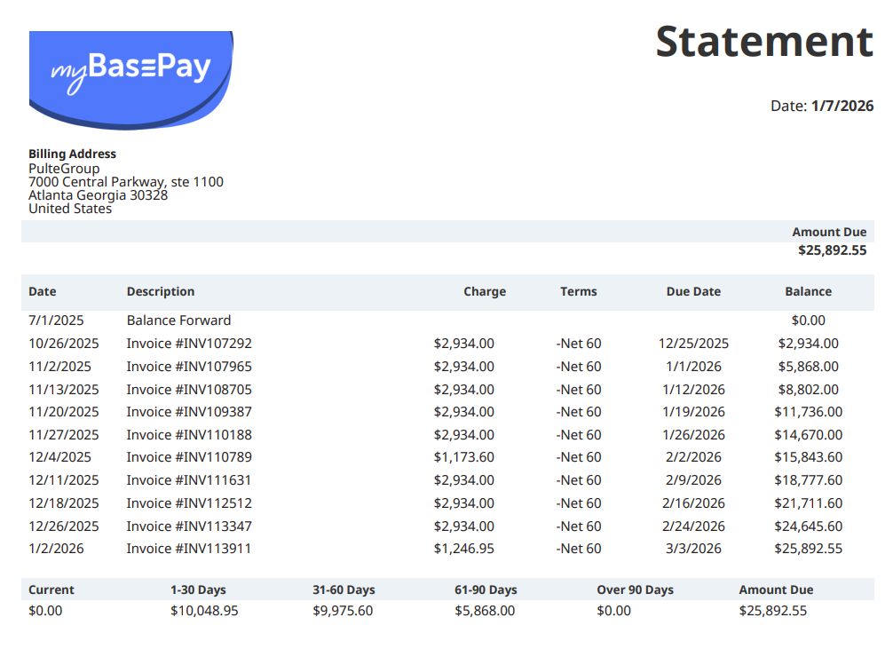

- Invoice Copies
- Provide NetSuite invoice PDFs (or approved customer-specific invoice format where required, in PDF)
- If the customer has custom invoice requirements or portal-specific formats, route to Billing for confirmation and re-issuance if necessary.

Invoice Copies-
How to pull multiple invoices from NS:
https://6460619.app.netsuite.com/app/site/hosting/scriptlet.nl?script=1445&deploy=1&compid=6460619&whence=
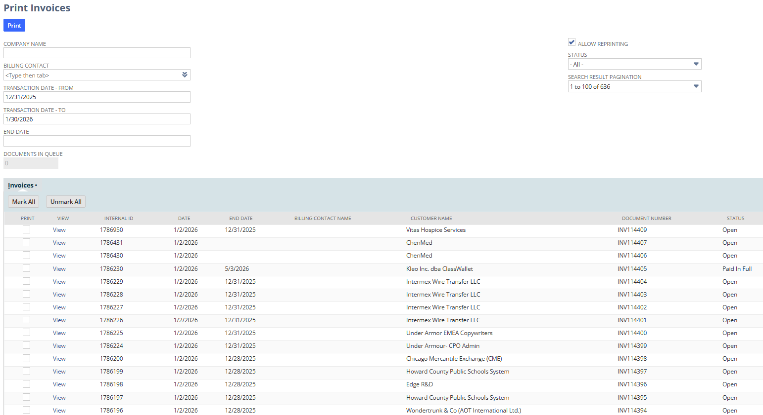

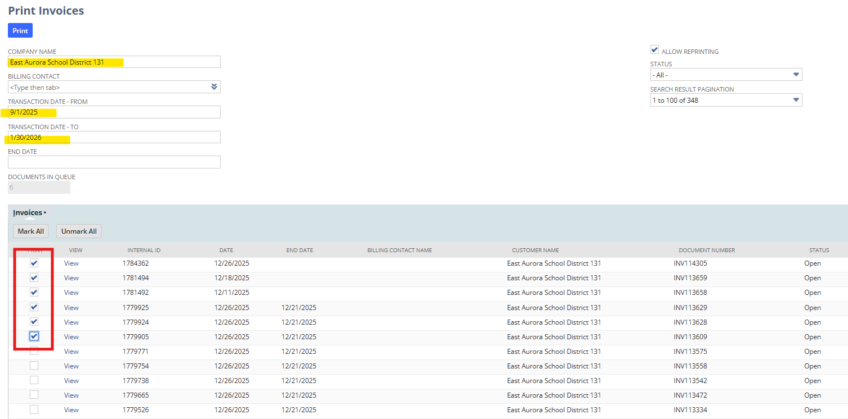
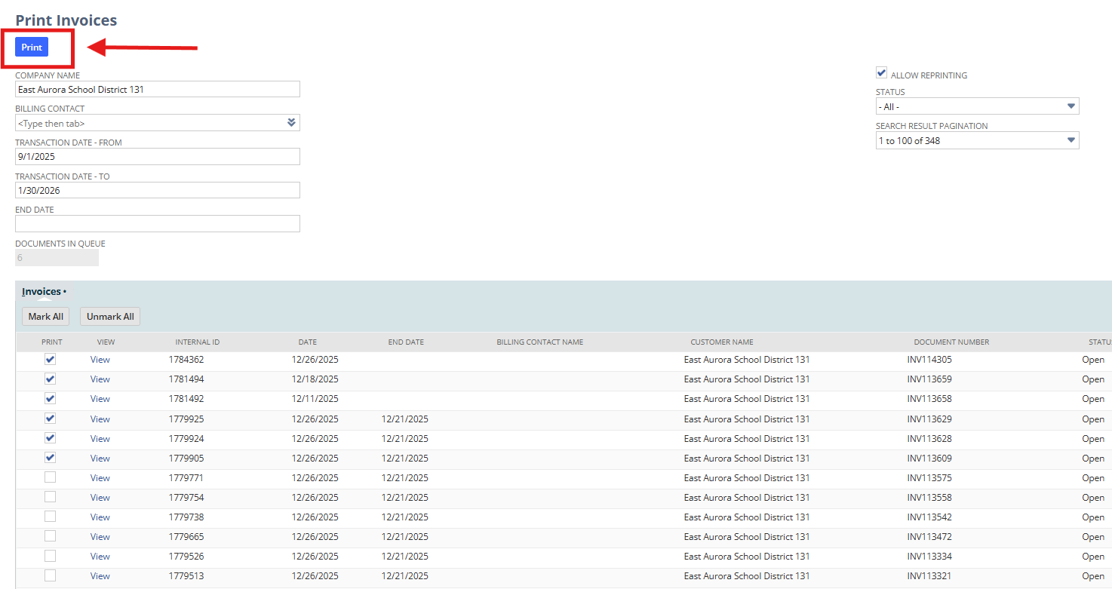

Group Invoices-
Group invoices will be displayed on the AR, that consolidated invoice needs to be collected on.
Collections will need to pull the grouped invoice to forward to the customer for collections.

- PAST DUE COLLECTION COMMUNICATIONS
  - Purpose
Past Due Collection Communications establishes a consistent, time-bound escalation cadence once an invoice becomes overdue. These procedures are designed to:
- Prompt timely payment or receipt of payment details
- Identify disputes or collection blockers early
- Support accurate AR aging and valuation
- Create documented evidence for escalation, allowance assessment, or write-off consideration.
This section supports the financial statement assertions of Existence, Accuracy, Completeness and Valuation.

  - Past Due Escalation Framework
Once an invoice reaches its due date with no payment or confirmed payment details, Collections will follow the escalation cadence laid out in 4. SUMMARY OF STAGES & SLA TIMELINES

  - Past Due Attempt #1- Past‑Due Email #1
Owner: Collections Analyst
Timing: Due Date +5
Purpose: Prompt confirmation of payment status and obtain remittance details

Steps:
- Email AP contact(s): request payment details (check/ACH #, amount, remittance, expected date).
- Attach invoice copy for reference
- CC the member
- Document outreach and any response in NetSuite
Example Email Template:
Subject: Friendly Reminder: Invoice Past Due — Past Due Invoices w/xxx
Hi [Name],
I hope you're doing well. I’m reaching out regarding Invoice [#] for [Amount], which became past due on [Due Date]. I’ve attached a copy for reference. Could you please provide the payment details (check/ACH number, amount, remittance, expected payment date)?
This will help us ensure everything is applied correctly on our end. Thank you in advance, we appreciate your help!
Best,
[Your Name]
CC: [Member Name]
  - Past Due Attempt #2- Past‑Due Phone Call + Email
Owner: Collections Analyst
Timing: Due Date +7
Trigger: No payment or payment details after Attempt #1, Provide final notice prior to escalation

Steps:
- Place a phone call to AP contact(s)
- If no answer, leave detailed voicemail
- Send follow-up email summarizing the outreach
- Attach invoice(s) and current statement
- CC the Member
- Document the call outcome and communications in NetSuite under Customer record
  - If payment details are provided: document the details and monitor for receipt and application of payment
  - If no payment details are provided: reinforce urgency and advice next-steps follow-up
Optional text (if consented)
Hi [Name], this is [Your Name] from [Company]. Following up on Invoice [#], now past due. Could you confirm the scheduled payment date? Happy to resend the invoice if needed. Thank you!

Example Phone Script:
Intro:
Hi [Name], this is [Your Name] calling from [Company] regarding Invoice [#] for [Amount], which is now 7 days past due.
Purpose:
I’m calling to confirm whether the invoice has been scheduled for payment and to collect any payment details (check/ACH number, amount, remittance timing).
If they provide details:
Great, thank you — I’ll document that and ensure proper posting on our end.
If they need the invoice again:
Happy to send it immediately. Which email should I send it to?
If no information:
No problem — we do need the payment details as soon as possible. When is a good time for us to expect an update?
Close:
Thanks so much for your time today. I’ll follow up with an email recap.
Phone- Example Voicemail Script-
Thank you, and I hope you have a great rest of your day!

Example Email Template If No Payment Details Gathered:
Subject: Follow-Up: [customer name] - Past Due Invoices w/[Member name] - Outstanding Balance as of [today’s date] – [$ amount]
Hi [Name],
I’m following up on my earlier message regarding Invoice [#] for [Amount], now [X] days past due. As we haven’t yet received payment details, I wanted to check in and make sure you have everything you need.
For convenience, I’ve attached the invoice and current statement.
Could you please share the payment details or scheduled payment date?
Your prompt attention is appreciated.
Best,
[Your Name]
CC: [Member Name]

Example Email Template If Payment Details were Gathered:
Subject: Recap of Today’s Call — Invoice [#]
Hi [Name],
Thank you for taking my call today. As discussed, we’re following up on Invoice [#] for [Amount], now 7 days past due.
Summary of call:
- [Insert what they shared — the payment details (check/ACH #, amount, remittance, expected date]
Thank you again, we appreciate your help!
Best,
[Your Name]
CC: [Member Name]

Example Phone Script with Escalation Language:
Hi [Name], this is [Your Name] calling from [Company].
I’m following up again on Invoice [#] for [Amount], which is now significantly past due. We still haven’t received any payment details or a scheduled payment date.
Because of the age of this balance, we do need to receive either payment or the payment details within the next 24 hours to avoid moving this into our internal escalation process.
I want to make sure we can resolve this directly with you before that happens.
Could you please provide an update today?
Thank you — I’m here if you need anything.

Phone- Example Voicemail Script with Escalation Language-
Hi [Name], this is [Your Name] from [Company].
I’m calling regarding Invoice [#] for [Amount], which is now well past due. We still have not received payment details, and at this stage, we do need that information within the next 24 hours to avoid escalation.
Please call me back at [Your Number] or email me at [Your Email] with the payment date and remittance details as soon as possible.
Thank you — I appreciate your prompt attention.

Example Email Template with Escalation Language:
Subject: Urgent: Payment Details Required Within 24 Hours — Invoice [#]
Hi [Name],
I’m reaching out again regarding Invoice [#] for [Amount], which remains past due. We still have not received the payment details or a confirmed payment date.
Due to the age of this balance, we do need to receive either the payment or the payment details within the next 24 hours to prevent this from moving into our internal escalation process.
If you need the invoice or statement resent, I’m happy to provide it.
Thank you in advance for your prompt attention — we appreciate it.
Best regards,
[Your Name]
CC: [Member]

Optional Text Message (if consented)- with escalation language-
Hi [Name], this is [Your Name] from [Company]. We still need payment details for Invoice [#], now past due. Please send the payment date/remittance info within 24 hours to avoid escalation. Thank you.

  - ACCOUNTING AWARENESS (COLLECTIONS BOUNDARY)
- Collections activity does not alter accounting treatment, however: Repeated non-response, broken payment promises or unresolved delays must be flagged to Corporate Finance
- These indicators may be considered in allowance or write-off evaluations under the applicable accounting policies.

- ESCALATION COLLECTION COMMUNICATIONS
  - Purpose
Escalation collection communications define the formal escalation path when standard collection efforts have not resulted in payment or confirmed payment details. The objective is to:
- Resolve delinquent balance efficiently
- Engage the appropriate internal stakeholders based on risk and exposure
- Maintain consistent documentation and accountability
- Protect customer relationships while safeguarding cash flow and financial reporting integrity
This section supports the financial statement assertions of completeness, valuation, existence and rights & obligations.
  - ESCALATION READINESS REQUIREMENTS
Owner: Collections Analyst
Before escalating beyond Collections, the following must be completed and documented:
- At least 2 documented outreach attempts
- Clear record of dates, channels, and responses (or lack thereof)
- Confirmation that no payment or remittance has been received
- Confirmation that no open billing revision or dispute is pending
This documentation ensures escalations are fact-based, consistent and auditable.

  - Escalation Trigger Criteria
An account must be escalated when any of the following conditions are met:
- Three documented collection attempts have occurred with no payment or payment arrangement
- The account remains unresolved after 10 days past due or greater
- Dollar exposure, customer risk profile, or payment history warrants accelerated escalation
- Non-responsiveness or recurring delays indicate heightened credit risk
Escalation timing may be accelerated at the discretion of Finance or Leadership.
  - Attempt #3- Collections Escalates to Client Success for Member Engagement
Owner: Collections Analyst & Client Success Partner
Trigger: Any combination of email/call/text totaling 3 attempts with no payment or payment details.
Purpose: Leverage the Member relationship to re-engage the customer and remove non-credit blockers (e.g. AP delays, missing information, portal issues)

Steps:
- Open and internal escalation ticket by posting in the Members Hub > Collections Support Channel
- Include a concise, standardized case summary (see below)
- Forward the full email thread, invoice copies, and current statement to CSP
- CSP engages the Member to assist in customer outreach and alignment
- CSP keeps Collections cc’d on all communications and posts updates in the escalation thread
Timeline Expectation:
- Payment or payment details are expected within 7 calendar days
- If no resolution is achieved, proceed to escalation to Sales

Example Teams Post:
Subject: Collections Escalation: [Customer Name]/ [Member Name]- [Amount Past Due]
Hi [@CSP Name],
I need your support in reaching out to the Member to help resolve a past due collections issue with [Customer Name]. We have not received payment or payment details despite multiple outreach attempts, which you have already been cc’d on for awareness. I’m forwarding the email thread, invoice copies, and current statement for reference shortly.
Below is the concise case summary:
Customer: [Customer Name]
Invoices & Amounts:
• Invoice [#] — [Amount] — [Days Past Due]
• Invoice [#] — [Amount] — [Days Past Due]
Total Past Due: [Total Amount]
Contact History:
Attempt #1- [Date] - Email sent (no response, response summary)
Attempt #2- [Date] - Phone Call (VM or summary of call), Follow-up email (no response, response summary), Text message (if applicable)
Attempt #3- [Date] - Phone Call (VM or summary of call), Follow-up email (no response, response summary), Text message (if applicable)
Known Blockers (if any): [AP contact turnover / missing PO / disputed rate / customer portal issue, known repeat delayed payor OR No blockers communicated- customer non-responsive]
Requested Assistance:
- Please contact the Member and request their help in engaging the customer.
We need either payment or payment details (check/ACH #, remittance, amount, expected date) as soon as possible.
- If no progress is made within 7 days, this may need to proceed to a Sales escalation per standard process.
- Please ensure Collections is cc’d on all related communications. Following any calls, please send a recap email and include Collections. Any additional updates should be posted here to ensure accurate recordkeeping.
- Please don’t hesitate to post any questions or requests for support in this post!
    - Forward the email thread to the Client Success Partner
Example Email Template:
Hi [CSP Name],
I’m forwarding the recent thread regarding Invoice [#] for [Amount], which is now past due. We haven’t received a response or any payment details from the customer, and we’d appreciate your help engaging [Member Name] (cc’d) to move this forward.
Please let us know if you need anything additional from Collections. Thank you for your support.
Best,
[Your Name]
CC: [Member]
Example Phone Script for Client Success to Members-
Hi [Member Name], it’s [CSP Name] from myBasePay. How are you?
(Pause for response)
I’m calling because our Collections team has been trying to get in touch with [Customer Name] about Invoice [#] for [Amount], which is now past due, and we still haven’t been able to obtain any payment details or a confirmed payment date from their AP team.
Since you have the closest relationship with the client, I wanted to reach out directly to see if you could help us engage them. Your involvement typically helps unlock a quicker response, and we really appreciate your partnership on these situations.
I want to share some transparency around our collections process. To best support you and preserve the client relationship, we follow a defined 7-day timeline once an item reaches Client Success to secure payment or payment details. If that timeline is not met, we escalate to Sales for additional support, though our preference is always to resolve matters before reaching that point.
Can we align on the best approach to reaching the customer? I want to make sure you’re fully supported and have everything you need before reaching out. The email from collections has copies of the invoices and a current statement.
(Pause for response)
Thanks so much for your partnership on this. We really appreciate you helping move this forward.

Example Client Success Email Template-
Subject: Support Needed on Past-Due Customer Invoice(s) - Can We Connect?
Hi [Member Name],
Please see below as our Collections team has been trying to connect with [Customer Name] regarding the past due Invoice [#] for [Amount], but unfortunately we haven’t yet received any payment details or confirmation of a scheduled payment. Given your close relationship with the client, we’d appreciate your support in engaging them so we can bring this to a smooth resolution.
If you’re available, could we hop on a quick call to align on the next best steps and how we can support you in reaching out to the customer? My goal is to make this as easy as possible for you and ensure you have everything you need to move forward.
To protect our members and support healthy customer relationships, we follow a structured collections timeline. Once an item reaches this stage, we have a 7-day window to secure payment or payment details before involving Sales for additional support. I’m confident we can work together to resolve this within that timeframe.
Thank you so much for your partnership. Let me know a time that works best for you, and I’ll make myself available!
Thanks,
[CSP Name]
CC: Collections, Sales

  - Second Escalation – Collections Escalates to Sales
Owner: Collection Analyst & Account Manager (AM) or Business Development Manager (BDM)
Trigger: no resolution one week after Client Success Engagement
Purpose: Apply commercial leverage and reinforce commercial obligations
Sales can support by:
- Exerting pressure and re-affirming contract obligations and consequences of nonpayment by discussing potential assignment suspension, price increase, funding changes, chargebacks, interest on past due amounts, etc.
- Align and set final deadlines for payment/commitments before a leadership escalation
- Align a payment plan if needed, including chargebacks under the DOA threshold. Coordinating with Corporate Finance for approval.
- Determine if and when a leadership escalation is required to take action on chargebacks over 10k, potential assignment suspension, price increase, funding changes, etc.
Steps:
- Escalate to the assigned AM/BDM via the existing escalation thread
- Provide an update case summary including:
  - Account status (active headcount, billing exposure)
  - Updated contact history
  - Known blockers or customer positions
- AM/BDM engages Member and customers directly
- Collections remains cc’d on all communications
- Outcomes and commitments are documented in escalation thread

Example Teams Post:
Hi @[Sales Rep Name],
We need to escalate a past due collections issue for [Customer Name]. Client Success has been working with the Member over the past 7 days, but we have not been able to obtain payment or payment details for the outstanding invoice(s), so this now requires Sales support per our standard escalation policy.
Here is the summary for quick context:
Account Status: [# of active headcount including onboarding headcount, total weekly billings, etc.]
Customer: [Customer Name]
Invoices & Amounts:
• Invoice [#] — [Amount] — [Days Past Due]
• Invoice [#] — [Amount] — [Days Past Due]
Total Past Due: [Total Amount]
Contact History:
Below the customer record on NetSuite:
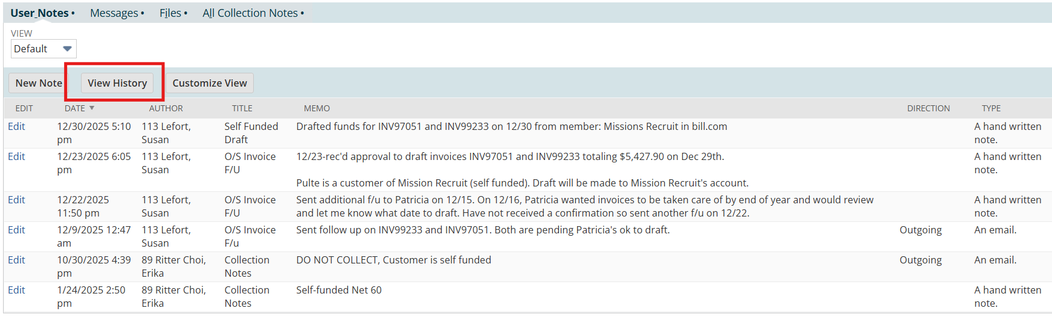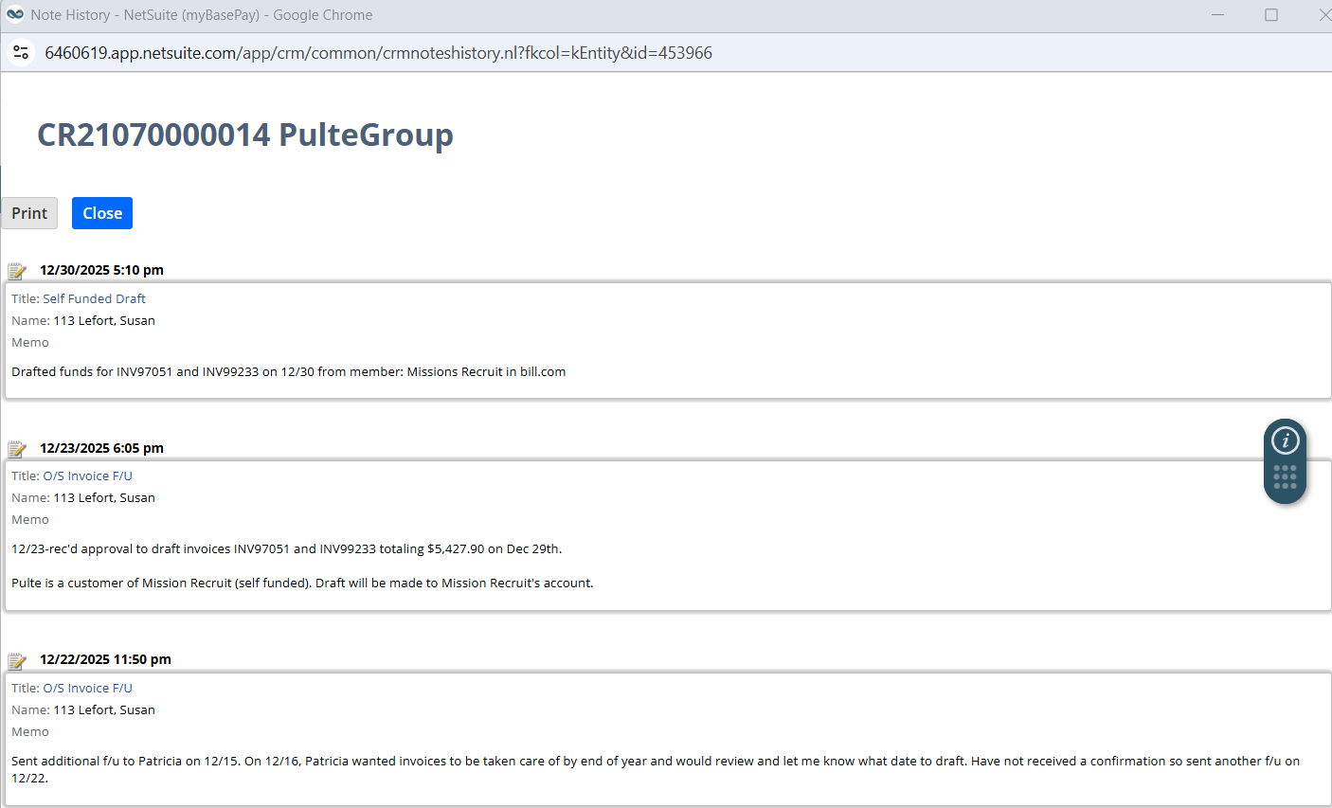

CS Attempts:
- Attempt #4- [Date] - Phone Call (VM or summary of call), Follow-up email (no response, response summary), Text message (if applicable)
Collection Attempts:
- Attempt #1- [Date] - Email sent (no response, response summary)
- Attempt #2- [Date] - Phone Call (VM or summary of call), Follow-up email (no response, response summary), Text message (if applicable)
- Attempt #3- [Date] - Phone Call (VM or summary of call), Follow-up email (no response, response summary), Text message (if applicable)
Known Blockers (if any): [AP contact turnover / missing PO / disputed rate / customer portal issue, known repeat delayed payor OR No blockers communicated- customer non-responsive]
Requested Assistance:
- Please contact the Member and align on an escalation resolution path. Re-affirm contract obligations and consequences of non-payment as needed by discussing potential assignment suspension, price increase, funding changes, chargebacks, etc. Any of these actions will require Leadership approval, we are only reminding the member of these actions at this point.
- We need either payment or payment details (check/ACH #, remittance, amount, expected date) as soon as possible.
- If the account is on Advanced Commissions and no progress is made within 14 days, then the member’s commissions will be switched to a Paid When Paid basis. Please inform the member accordingly.
- If no progress is made within 14 days, this account will be flagged for suspended corporate commissions as well until payment is received.

- Please proceed to a Leadership escalation when deemed necessary.
- Please keep Collections cc’d on any communications. Please follow-up on any calls with a recap email and cc collections. Please post any other updates here so we can maintain accurate records.
- Please don’t hesitate to post any questions or need for support in this post!

  - Third & Final Escalation – Sales Escalates to Leadership
Owner: Account Manager (AM) or Business Development Manager (BDM),CFO, CEO, Dept Head of Sales, Collections Analyst
Trigger: No resolution after sales escalation or earlier, if exposure or risk warrants immediate Leaderships visibility
Purpose: Determine and approve formal corrective or protective actions
Steps:
- AM/BDM escalates to leadership by forwarding the most recent email thread
- Include (see example below):
  - Total exposure and aging
  - Oldest Invoice date
  - Prior escalation steps taken
  - Recommended action(s)
  - Requested decisions timeline
Potential Leadership Actions:
- Assignment suspension
- Funding adjustments
- Price increase
- Demand letter issuance
- Chargeback approval
- External collections referral
- Contract termination
Documentation & Visibility Requirements:
- All escalation steps must be documented in the Collections Support Channel and NetSuite notes
- Leadership maintains visibility through:
  - Collections Support Channel
  - Weekly collections analysis report
- Escalations may be accelerated or redirected at Leadership discretion
**Leadership will maintain visibility on sales escalations per the Collections Support channel and the weekly collections analysis report and can decide to escalate sooner than sales rep escalation if necessary.
    - AM/BDM escalates to Leadership (CEO, CFO and Dept Head of Sales) via forwarding the latest email thread with these details:

Example Email Template:
Subject: Final Collections Escalation: Leadership Action Needed — [Customer Name]
Good Day,
I’m escalating [Customer Name] for final action per our collections policy. Despite coordinated outreach from Collections and Client Success, the customer has not provided payment or payment details for the outstanding balance of [Total Amount], with the oldest invoice now at [X] days past due.
To prevent further exposure and ensure adherence to contract obligations, my recommended course of action is:
→ [Select: Assignment suspension / Price Increase/ Funding Adjustments/ Demand letter / Chargeback over $10k (>90 DPD) / Write-off request / Referral to external collections/ Contract Termination]
Requested timeline:
I recommend that the action takes place according to this timeline – [detail dates for actions needed to resolve collections balance]
I’m available if you’d like a quick briefing call. Thank you for your guidance in helping us resolve this quickly.
Best regards,
[Sales Rep Name]
CC: Collections, CSP Rep

- ESCALATION ACTIONS

  - Purpose
Escalation Actions define the approved corrective measures available once collections and escalation efforts have not resulted in payment or confirmed payment details. These actions are intended to:
- Protect cash flow and limit credit exposure
- Enforce contractual rights
- Ensure Accounts Receivable remains stated at net realizable value
- Maintain consistent governance and approval controls
No escalation action may be taken with the appropriate approvals documented in accordance with this SOP.
  - Governance & Approval Principles
- All escalation actions require Leadership or Finance approval, depending on the nature of the action
- Collections and sales may recommend actions but not approve them
- Actions impacting revenue recognition, pricing, funding, allowances, write-offs must be approved by Corporate Finance and/or the CFO
- All approvals must be documented and retained with the collection record

  - Payment Plans Requested by Customer-
Owner: Collection Analyst & Account Manager or Business Development Manager & Corporate Finance
Approval Required: Corporate Finance (and CFO if material)
When Applicable:
- Customer requests extended or structured repayment plan
- Temporary liquidity constraints with continued intent to pay
Steps:
- Route all payment plans requests to Corporate Finance via the Collections Support Channel
- Pause standard collections cadence while approval is pending
- If approved:
  - Document full terms (amounts, dates, duration)
  - Monitor adherence to the agreed schedule
- If declined:
  - Sales communicates decision to Member
  - Collections resumes standard cadence immediately

Control Note:
Accounts on approved payment plans:
- Move to Paid When Paid member commissions
- Have corporate commissions suspended until resolved

Example Teams Post:
Subject: Collections Payment Plan Requested: [Customer Name]/ [Member Name]- [Amount Past Due]
@corporate finance @ sales rep – we received a customer payment plan request for [Customer Name].
• Collections is pausing the normal cadence while we await your decision.
If approved:
• We will document full terms (amounts, dates, duration).
• Collections will follow the monitoring cadence to ensure adherence.
• Please note: Accounts in an active repayment plan are placed on suspended corporate commissions and paid-when-paid member commissions immediately.
If declined:
• Collections will resume standard collections cadence right away.
Let me know if any additional details or documentation are needed — I can forward over the email thread and invoices upon request.

  - Assignment Suspension
Owner: Collection Analyst & Account Manager or Business Development Manager & Leadership & Client Success Rep
Approval Required: Leadership (CFO/CEO)

Purpose:
Limit additional exposure by suspending new assignments or onboarding until payment issues are resolved.

Steps:
- Sales escalates recommendation to Leadership
- Upon Approval
  - Client Success, Contracts, Payroll & Billing are notified via Teams Channel>Members Hub> Requests & Escalations channel
    - CSP needs to action the suspension
    - Contracts needs to mark the Customer status in BO as Suspended
    - Payroll needs to ensure that any hours processed are aligned with suspension timeline
    - Billing needs to be aware so they may redirect any customer or member communications to the Sales Rep by posting in the escalation thread.
  - Suspension is communicated to the Member
  - Collections continues pursuing outstanding AR

Once Leadership approves an assignment suspension due to collections:

  - Funding Adjustments
Owner: Sales, Contracts, Billing Analyst, Corporate Finance
Approval Required: Leadership and Corporate Finance

Purpose:
Modify funding agreements to mitigate risk (e.g., pre-funding, changed payment terms).

Steps:
- Contracts will need to issue an updated funding agreement
- Sales will need to communicate with the member on the change and facilitate execution of the new agreement
- Contracts will update the BO Customer record to the new funding type on the exact date that the new funding type is effective.
  - EX. Funding type change is effective 1/1/2026, the last payroll under the old funding type will be processed by Friday 1/9/2026. Contracts will wait until Monday 1/12/2026 to make the change in the system.
- Billing Analyst will confirm the funding change is in NS and will confirm that it is processed correctly during the first cycle.

  - Applying Interest to Invoices
Owner: Corporate Finance, Legal/Risk
Approval Required: CEO/CFO

Interest Application
Interest must not exceed the lower of contract terms or the applicable state cap. See Appendix for specific caps (e.g., CA 10%, TX 18%, NY 9%, MA 12%, CO 8%, AZ 10%, IL 9%, NV/UT: contract governs). Itemize interest on statements; cease accrual during documented disputes.

  - Demand letter
Owner: Corporate Finance, Legal/Risk
Approval Required: CEO/CFO

Purpose: Formally assert the Company’s right to payment prior to legal or external collection action.

Steps:
- Legal/Risk will draft an approved demand letter considering state and federal compliance laws applicable to the specific collection situation
- Collections ceases informal outreach once a demand letter is issued

FDCPA Compliance: Adhere to Fair Debt Collections Practices Act (FDCPA) where applicable for consumer debts for consumer debts and state-specific collection statutes
- If the debtor is an individual for personal purposes, FDCPA applies.
- If the debtor is a business entity or debt incurred for business purposes, FDCPA does not apply (but may impose similar requirements even for certain business contexts).

Demand Email Requirements
- State-specific consumer protection acts (e.g., Rosenthal Act in CA, TDCA in TX, FCCPA in FL, CFDCPA in CO, NY GBL in NY, MA disclosure laws) impose additional requirements. Ensure all demand letters and collection actions comply with these statutes.
- Demand letter must be sent at least 30 days before initiating legal action or referring to collections, per state law.
- Include contact details for dispute resolution and payment options.

Legal Compliance for Demand Letters: Demand letters must include all mandatory state disclosures and dispute instructions including Rosenthal Act (CA), TDCA (TX), FCCPA (FL), CFDCPA (CO), NY GBL, MA disclosure laws.

  - Chargeback over Sales Rep DOA Threshold (>90 DPD)
Owner: Sales, Billing Analyst
Approval Required: CFO

Steps:
- Sales informs the Member in writing of:
  - Chargeback amount
  - Impacted invoices
  - Timing
- Billing Analyst processes chargeback in the next billing cycle, including advanced commissions
- Documentation is retained with the collection record
Chargebacks must align with the Chargebacks to Members SOP

  - Contract Terminations- MBP Terminates
Owner: Leadership, Legal, Corporate Finance
- If MBP ends the contract,
  - Collections continues pursuing all open AR until paid in full.
  - Accounting evaluates allowance or write-off implications separately
  - Commission impacts are applied per policy

  - External Collections Agency Involvement
Owner: Corporate Finance, Leadership & Risk
Approval Required: Leadership
Steps:
- Collections prepares the account package, based on approvals.
- All internal outreach stops.
- Client Success and Sales are notified for visibility.
- Sales communicates with Member.
- Legal/Risk oversees engagement

ACCOUNTING BOUNDARY REMINDER
Escalation actions may indicate increased credit risk, but do not, by themselves, determine accounting treatment.

Inputs from this section are evaluated under:
- Bad debt Allowance & Write-Off Policy
- CECL framework
- Invoice of Record policy
Only Corporate finance may approve accounting entries
Collection Agencies: Risk ensures that MBP only engages licensed or registered collections agencies as required by state law; verifying bonding and registration requirements for each state.

- EXCEPTION HANDLING
  - Purpose:
Exception Handling defines how non-standard collection scenarios are identified, escalated, paused and resolved in a controlled, documented and auditable manner.

This section ensures that exceptions:
- Are resolved within defined timelines
- Are properly reflected in Accounts Receivable valuation and reporting
- Do not bypass approval or accounting controls

  - General Exception Principles:
Unless otherwise stated:
- Exceptions apply only to the impacted invoice(s), not the entire account
- Collections cadence continues on all non-impacted invoices
- All exceptions must be documented in the Collections Support Channel and NetSuite notes
- Accounting treatment is evaluated separately under the applicable policy

  - Payment Terms Correction or Change Request
Owner: Collection Analyst & Contracts Specialist & Corporate Finance & Account Manager/ Business Development Manager

Steps:
- Immediately route the request to the Contracts Specialist and Corporate Finance via the Collections Support channel.
- Contracts and Corporate Finance will need to rerun the credit approval to determine if we can accept the new proposed terms.
- If approved-
  - Contracts will engage sales to get a new contract signed
  - Sales will determine if there are any pricing impacts
  - Once new contract is signed, contracts will update the BO Customer record
- If declined- collections can loop in sales as an escalated service contact to discuss the payment terms with the client.

  - Disputed Invoices-
Owner: Collection Analyst & Client Success Partner & Billing Analyst
Pause Rule: Pause collections on disputed line(s)/invoice(s) only

Common Triggers:
- Incorrect rates
- Incorrect hours
- Anything that changes the revenue recorded and the total amount due

Steps:
- Immediately route the dispute to the assigned Billing Analyst & Client Success Partner via the Escalations Tracker.
- Document dispute details and initial findings
- Pause collections on the disputed line(s) until resolution.
- If the Member needs clarification → the CSP (Client Success Partner) steps in to own the explanation and communication. Collections will CC the CSP on any communications sent directly to the Member outside the standard templates.
- If the Customer needs clarification → Collections owns the communication and continues to CC the Member.
- Resolution expected within 24 hours unless complexity warrants escalation.

Accounting Impact:
Disputes may indicate valuation risk and are inputs to allowance assessments but do not trigger automatic write-offs

Example Escalations Comm:
Subject: Invoice Dispute: [Customer Name]/ [Member Name]- Invoice [#] for [Amount].
Hi [@Billing Analyst and @Client Success Partner]
We received an invoice dispute. My initial research confirms [details out our findings].
Please confirm this appears accurate and if so please provide the corrected invoice here so I may send over to the customer.
Please confirm within 24 hours as collections are paused on the disputed line(s) until resolved. Collections will continue normal cadence on all other non-disputed invoices.
Please post here if any questions or there is a need for further information- thanks!

  - Customer Requests Recipient of Invoices Changes or Clarification -
Owner: Collection Analyst & Billing Analyst & Contracts Specialist
Pause Rule: No pause unless invoice re-issuance is required
If the Customer needs clarification → Collections owns the communication and continues to CC the Member.

If the invoice recipient needs to be updated, Collections will ask the effective date of the change and get an email/written request for the change. If the request was made verbally then Collections will follow-up with an email to recap the change request. Each written change request should have:
1) name of person requesting the change,
2) first name, last name, email address and phone number of new recipient(s),
3) effective date of change,
4) current statement

Example Email Template:
Subject: Invoice Recipient Update Confirmation

Hi [Name],
Thanks again for speaking with me today. Per your request, we’ve updated the invoice recipient information effective [Effective Date]. The new recipient is cc’d here, and a current statement is attached for their reference.
Please let us know if any invoice copies need to be resent — we’re happy to provide them.
Best regards,
[Your Name]

Steps:

    - The Billing Analyst will complete an updated Vendor Setup Checklist form – confirming updated AP contact(s), invoice portal credentials, and remittance instructions, etc.
    - Billing Analyst will forward the written request and attach the updated Vendor Setup Checklist form a to contracts@mybasepay.com
    - Once contracts reviews for completion and accuracy, they will update the necessary information on the BO Customer record and file the updated form to the customer’s file.
    - Billing Analyst will then ensure the next invoices generated are sent to the new contact.

  - Customer Requests for Invoice Template Update-
Owner: Collection Analyst & Billing Analyst & Corporate Finance
Pause Rule: Pause collections on impacted invoice(s)

Common Triggers:
- Incorrect remit-details (names)
- Incorrect PO
- Formatting or portal resubmission requirements

Steps:
- Route request to Billing and Corporate Finance
- Corporate finance to issue a CM for existing invoice
- New invoice reflecting the corrections is created in NetSuite
- Invoice is re-sent to the customer, along with a copy of the CM for their AP department
- Collections resumes collection cadence on newly issued invoice

**Note: Billing will not make changes to invoices, all invoice corrections will be made by way of a credit memo and correctly issued invoice.
Example Teams Post:
Subject: Invoice Revision Request: [Customer Name]/ [Member Name]- Invoice [#] for [Amount].
Hi [@Billing Analyst and @CorpFinance]
We received an invoice revision request. [Detail out revision request].
Please provide the corrected invoice here so I may send over to the customer. [or confirm with a screenshot that the corrected invoice has been uploaded in the client’s AP portal]
Please complete within 24 hours as collections are paused on this invoice until resolved. Collections will continue normal cadence on all other invoices.
Please post here if any questions or there is a need for further information- thanks!

Example Email Template:
Subject: Revised Invoice Attached — Please Confirm Payment Queue Status
Hi [Name],
As requested, we’ve issued the revised invoice [#], which is attached here.[or we’ve uploaded the corrected invoice in the portal, screenshot below for confirmation.]
Could you please confirm that this updated invoice is now back in your payment queue for processing? This will help ensure there are no delays on our side.
If you need anything else or additional documents resent, we’re happy to help.
Thank you,
[Your Name]
CC: [Member]

  - Member Requested Delays-
Owner: Collection Analyst & Corporate Finance
Pause Rule: Maximum 48 hours without approval

Sometimes a Member asks Collections to “hold off” on contacting the customer.
- Collections may pause for 48 hours only unless approved by Finance Leadership.
Steps:
  - Member must provide a reason and anticipated timeline.
  - After 48 hours, cadence resumes unless explicit approval extends the hold.
  - If extended hold is approved, please save the approval and follow-up once the requested hold date has passed

ACCOUNTING IMPACT:
Extended holds may indicate increased credit risk and must be flagged to Finance

Example Email to Member:
Subject: Confirmation of Temporary Pause on Collections
Hi [Member Name],
Thanks for reaching out. We can pause collections activity for up to 48 hours as requested. To make sure we’re aligned, could you please share the reason for the pause and the timeline for when you’d like us to resume collections?
(If already provided, restate it here: “To confirm, you mentioned the pause is needed because [reason], and you expect to resume on [date].”)
Please note any pause beyond 48 hours requires internal escalation and approval, so having the clear timeline helps us stay compliant with our process.
Please confirm so we can stay partnered on our approach!
Thank you,
Best,
[Your Name]
Collections
CC CSP Rep

Example Email to Finance for Approval of Extended Hold:
Subject: Approval Request: Extended Collections Hold for [Customer Name]
Hi Finance Team,
I’m requesting approval for an extended hold on collections outreach for [Customer Name]. The Member has asked us to pause collections beyond the standard 48-hour limit, and per policy, any extension requires Finance approval.
Details:
- Customer: [Customer Name]
- Outstanding Amount: [Total Amount]
- Invoices Impacted: [List Invoice #s]
- Current Days Past Due: [X Days]
- Reason for Hold (from Member): [Member’s stated reason]
- Requested Hold Duration: Until [Date]
- Impact/Risk Considerations: [Optional: customer sensitivity, relationship risk, timing, etc.]
Please confirm whether we can approve this extended hold. Once we receive your decision, we will update the Member and adjust the collections cadence accordingly.
Thank you,
[Your Name]
Collections
CC CSP Rep, Sales Rep

  - Partial Payments
Owner: Collection Analyst & Corporate Finance
Pause Rule: No pause on remaining balance
Steps:
- Collections continues the cadence for all remaining unpaid balances until:
  - Full payment is received, or
  - The underpaid amount is not recurring and is under $20
    - If so, forward to corporate finance in the Collections Support Channel, for write off
  - Write-offs must be approved and processed before next weekly AR review

Example Teams Post:
Subject: Invoice Write- Off Request: [Customer Name]/ [Member Name]- Invoice [#] for [Amount].
Hi @Corporate Finance,
We received a partial payment for Invoice [#], and the remaining underpaid balance is under $20 and non-recurring. Per policy, we are requesting approval to write off the remaining amount.
Details:
• Customer: [Customer Name]
• Member: [Member Name]
• Invoice #: [#]
• Original Amount: [Amount]
• Amount Paid: [Amount]
• Underpaid Balance: [Amount under $20]
• Reason: Non-recurring small underpayment
Please complete the write-off prior to the next weekly AR aging analysis every Monday. Thank you!

  - Missing Remittance / Unapplied Cash
Owner: Collection Analyst & Corporate Finance
Pause Rule: No pause on collections

Steps:
- Corporate Finance sends the Missing Remittance Template (CC Collections).
- Collections follows up with the customer/AP contact to obtain the remittance details needed to apply the payment.
- Continue outreach until remittance details are provided.
- Once remittance details are provided, Corporate Finance will reply to the thread saying thanks

Accounting Impact:
Unapplied cash distorts AR aging and must be resolved promptly to maintain accuracy.
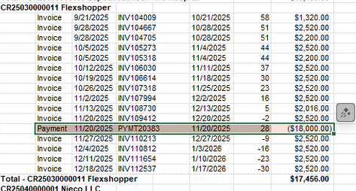

Example Email Template:
Subject: Request for Remittance Details - Missing Remittance on Recent Payment
Hi [Customer AP Contact Name],
We received a recent payment from [Customer Name], but we were unable to match it to the open invoices without the remittance details. Could you please provide the following so we can apply the payment correctly?
- Invoice number(s)
- Amount(s)
- Check/ACH number
- Payment date
- Any remittance or backup provided
This will ensure your account is updated accurately.
Collections is cc’d here for visibility and will assist with follow-up to ensure we can keep your account current without delay.
Thank you for your help,
billing@mybasepay.com
CC Collections
CC Member

  - Duplicate Payments or Overpayments
Owner: Collection Analyst & Corporate Finance
Pause Rule: No pause
Steps:
- Corporate Finance performs reconciliation.
- Collections will communicate with customer/AP on whether:
  - Refund is required, or
  - Overpayment will be applied to other open invoices.
- Collections documents resolution.

  - Bankruptcy Notices (Customer Insolvency)
Owner: Collection Analyst & Corporate Finance & Risk & Sales & Client Success
Pause Rule: Immediate full stop

Steps:
- Immediately stop all collections activity.
- Notify Finance Leadership, Legal/Risk, Client Success, and Sales via email.
- Await guidance on legal procedure and required claim filings.
- Note on the customer in NS for status of Allowance For Doubtful Account= AFDA

Accounting Impact:
Immediate CECL-specific reserve evaluation required.

Example of Email Template:
Subject: URGENT: Bankruptcy Notice Received — Immediate Collections Hold for [Customer Name]
Hi all,
We have received a bankruptcy notice for [Customer Name]. Per policy, we have immediately stopped all collections activity and placed the customer on “Bankruptcy – Collections Hold.”
Next Steps Needed:
1. Client Success please advise on active headcount or upcoming onboarding as we need to consider assignment suspensions.
2. Sales please reach out to the member to inform them of this notice. Corporate commissions and member commissions will be on hold.

3. Risk please advise on legal procedures, required claim filings, and any additional steps we need to take.
I will await your guidance before proceeding further.
Thank you,
[Your Name]
Collections

  - Contract Terminations- Provider Terminates
Owner: Corporate Finance, Leadership
Pause Rule: No pause unless directed

Steps:
- Prepare AR exposure report for Leadership to determine whether to:
  - Continue collections
  - Buy AR review to determine if buying the AR is required
- All advance commissions will move to Paid When Paid immediately.

  - Fraud Alerts or Suspicious Activity
Owner: Collections Analyst, Corporate Finance, Leadership, Legal/Risk
Pause Rule: Immediate Pause
Examples:
- Customer claims payment was made but cannot provide remittance
- Remittance details seem altered
- Bank account discrepancies in ACH requests

Steps:
- Pause outreach
- escalate to Finance, Leadership, Legal/Risk.
- Follow fraud investigation procedures

- REVISION HISTORY
Date | Description | Author | Approver
Dec 17, 2025 | Initial creation aligned to Revenue Cycle SOPs | Rachel Stonestreet (Sr. Director, HR Ops) | Chantal Schutz (CFO)

