DodgeBall Boxing Game User Manual
Team Members: Riordin Dupree, Sam Koenig, and Parker Smith
Course: CS 402 Mobile App Development
1. Introduction
DodgeBall Boxing Game is a mobile fighting game where the user selects an opponent, enters a fight, attacks the opponent, and defends against incoming attacks. The goal is to reduce the opponent’s health to 0 before the player’s health reaches 0.
The app is designed for quick mobile gameplay. A first time user can select a fight, enter the match, tap the opponent to attack, and hold defense buttons to avoid damage.
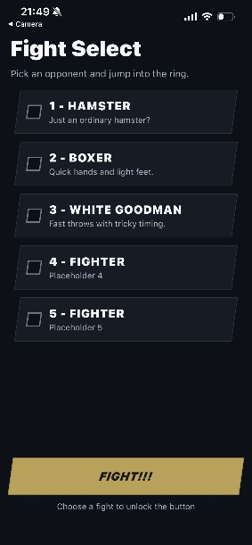
2. Installation and Setup
This app runs using Expo Go.
To run the app:
1. Install Expo Go on your phone.
- iPhone users can download Expo Go from the App Store.
- Android users can download Expo Go from the Google Play Store.
2. Open the project on the developer’s computer.
3. In the project folder, run:
npm install
4. Start the Expo development server:
npx expo start
5. A QR code will appear in the terminal or browser.
6. Open Expo Go on your phone.
7. Scan the QR code.
8. The app will load on your phone.
If the app does not load, make sure the phone and computer are on the same network. If that still does not work, run:
npx expo start --tunnel
3. Starting the App
After the app loads, the user will begin on the Fight Select screen. This screen lists the available fights. Each fight has a name and a short description.
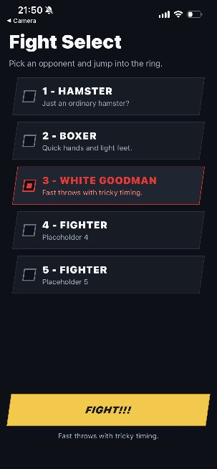
4. Fight Select Screen
The Fight Select screen is where the user chooses which opponent they want to fight.
To select a fight:
1. Look through the list of available fights.
2. Tap the fight you want to play.
3. The selected fight will become highlighted.
4. The selected fight description will appear near the bottom of the screen.
5. Tap the FIGHT!!! button to begin.
[Insert Screenshot: Fight 2 selected]
If no fight is selected, the user should tap one of the fight options before pressing the fight button.
5. Starting a Fight
After selecting a fight and pressing the FIGHT!!! button, the app opens the fight screen.
The fight screen includes:
- The opponent name
- Enemy health bar
- Enemy image
- Player health bar
- Guard button
- Duck button
- Exit button
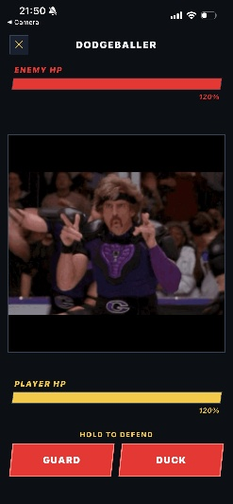
6. Fight Screen Overview
The fight screen is the main gameplay area.
The enemy health bar shows how much health the opponent has left. The player health bar shows how much health the player has left.
The player wins by lowering the enemy’s health to 0. The player loses if their own health reaches 0.
7. Attacking the Opponent
To attack the opponent:
1. Tap the enemy image.
2. The enemy health will decrease.
3. Continue attacking until the enemy health reaches 0.
The enemy image has attack zones, so tapping the opponent is how the player deals damage.
8. Defending Against Attacks
The enemy will attack during the fight. Before an attack happens, the game gives the user a warning. The warning tells the user what type of defense is needed.
Possible warnings include:
- INCOMING: GUARD
- INCOMING: DUCK
- INCOMING: BOTH
If the warning says INCOMING: GUARD, hold the Guard button.
If the warning says INCOMING: DUCK, hold the Duck button.
If the warning says INCOMING: BOTH, either Guard or Duck can defend against the attack.
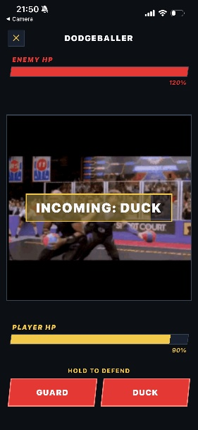
If the player defends correctly, the app displays feedback such as:
- BLOCKED!
- DODGED!
- DEFENDED!
If the player does not defend correctly, the player takes damage.
9. Guard Button
The Guard button blocks certain attacks.
To use Guard:
1. Watch for an incoming Guard attack.
2. Hold the Guard button before the attack lands.
3. If timed correctly, the attack will be blocked.
The Guard button uses a cooldown meter. After blocking, the Guard meter must refill before Guard can be used again.
10. Duck Button
The Duck button dodges certain attacks.
To use Duck:
1. Watch for an incoming Duck attack.
2. Hold the Duck button before the attack lands.
3. If timed correctly, the attack will be dodged.
The Duck button uses a meter that goes down while the player holds it. The meter refills when the player is not holding Duck.
11. Winning a Fight
The player wins when the enemy health reaches 0.
When the player wins, the app displays a victory screen. From there, the user can return to the main menu.
To return after winning:
1. Wait for the victory screen.
2. Tap RETURN TO MAIN MENU.
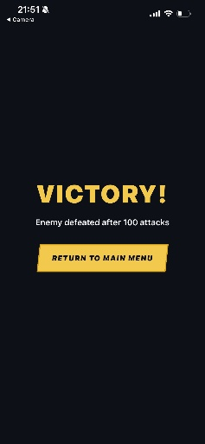

12. Losing a Fight
The player loses when the player health reaches 0.
When the player loses, the app displays a defeat screen. The user can either retry the fight or return to the main menu.
To retry:
1. Tap REMATCH.
To leave the fight:
1. Tap RETURN TO MAIN MENU.
13. Exiting a Fight
The user can exit a fight before it ends by pressing the X button at the top of the fight screen.
To exit:
1. Tap the X button.
2. The app returns to the Fight Select screen.
14. Error States and Troubleshooting
Problem: The app does not open in Expo Go.
Solution: Make sure Expo Go is installed. Make sure the phone and computer are on the same Wi-Fi network. If it still does not work, restart the Expo server using: npx expo start -c
Problem: The QR code does not work.
Solution: Try using tunnel mode: npx expo start --tunnel
Problem: The app shows an old version.
Solution: Clear the Expo cache by running: npx expo start -c
Problem: Images do not appear.
Solution: Restart the Expo server. If the issue continues, make sure the image files are included in the assets folder and that the project was pulled from the correct branch.
Problem: The app crashes during a fight.
Solution: Close Expo Go, restart the app, and try again. If the issue continues, return to the fight menu and choose a different fight.
15. Known Limitations
The current version of the app has some limitations:
- The app currently runs through Expo Go and is not published to the App Store or Google Play Store.
- The game is client side and does not currently save long-term progress.
- High scores may not be fully implemented yet.
16. Final Notes
DodgeBall Boxing Game is designed to be simple to start and easy to understand. The player selects a fight, enters the match, attacks the opponent, and responds to incoming attacks using Guard and Duck. The main goal is to defeat the opponent before the player’s health reaches 0.

