**Write a hive UDF that implements functionality of string concat_ws(string SEP, array). This UDF will accept two arguments, one string and one array of string. It will return a single string where all the elements of the array are separated by the SEP.**

**StEP1:created a clas Hiveconcat that extends UDF**

**Step2:Created a method evaluate to which arraylist and separator is used as argument**

**Step3:Used StringBuffer and used a for loop to Append the array with separator**

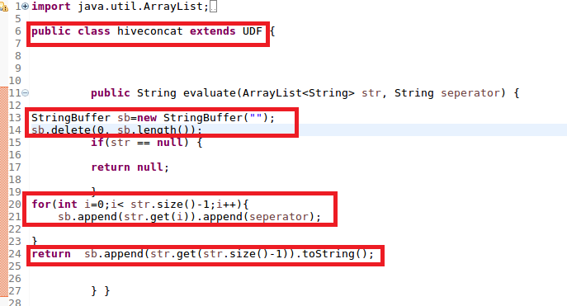

**Step4:created a table “arry_table” with array and separator**

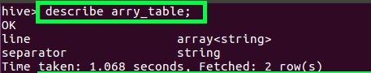

**Step5:added jar to hive and created a temporary function “concat_ws”**

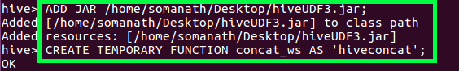

**Step6:Applied the temporary function on the arry_table**

