**Driver:**  
 In Driver putting the small file in distributed cache and put the input file and Output file

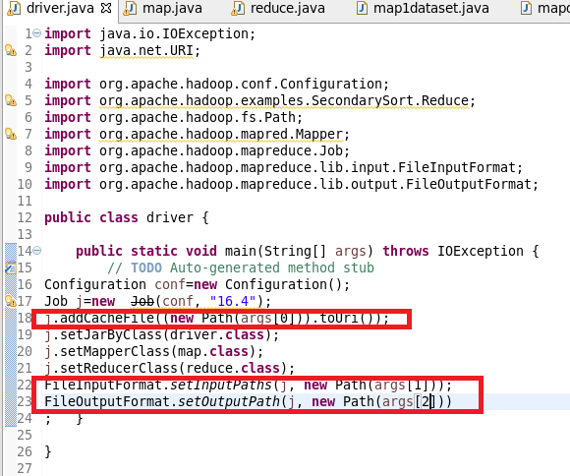

**Mapper**

**setup() Method:**

**In set up method getting the file from distributed cache and setting zipcode as key and state as value in hashmap() which colud be used in map method to join**

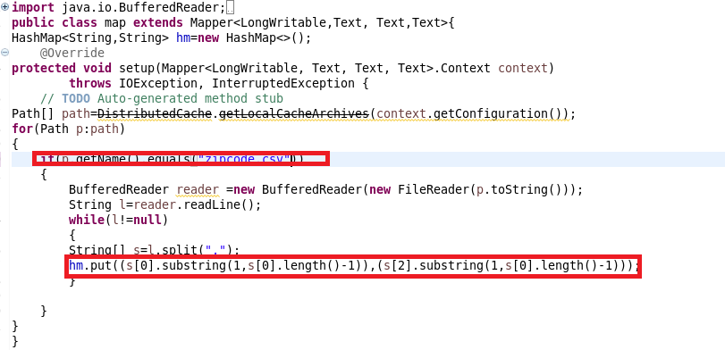

**Map() method**

**Here state is sent as key and problem is sent as value**

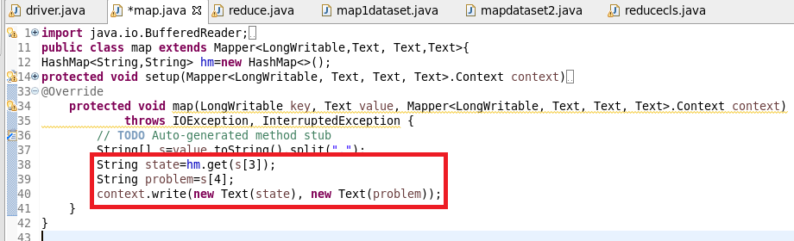

**Reducer**

**In reduce Method**

**I am getting state and corresponding problem and I am feeding it in a hashmap(hm) where I will provide this key and a count will be incremented as we want maximum problem .Now we have all the problems along with their count**

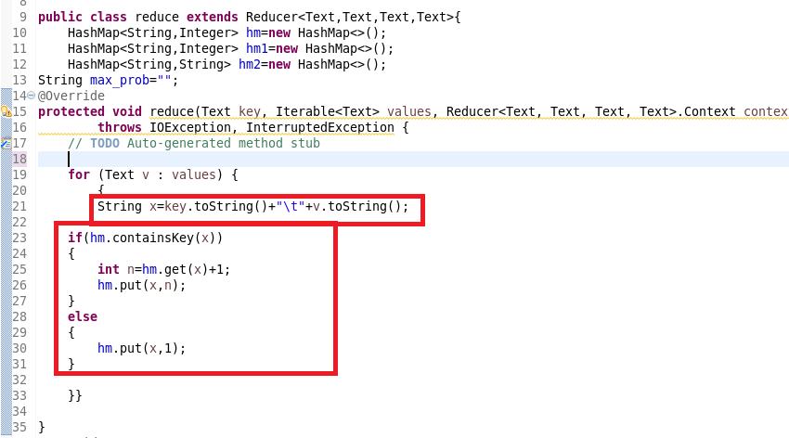

**Clean Up Method**

**Now since we want only max problem I am putting a new hashmap(hm2) on which I am sending the state as key so If value as hm ie count of problem I am using a maximum logic to get the maximum value(the problem which occurred max) and I am storing the problem with max value and In the third hashmap(hm2) I am putting State as key and maximum problem as value**

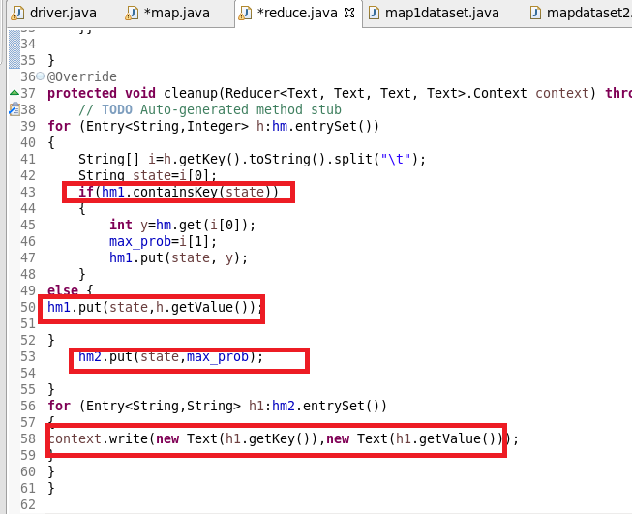

**Running jar**

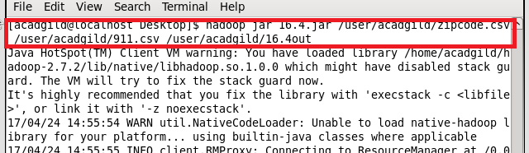

**Output**

