**ACID PROPERTIES IN HIVE**

ACID properties are important properties of any Transaction in database(ie).A transaction is said to be done in a proper manner only if it obeys the above properties.

As part of transaction in Hive supports these properties

1.**Atomicity**

This property states that a transaction must be treated as an atomic unit, that is, either all of its operations are executed or none. There must be no state in a database where a transaction is left partially completed. **(ie) data should be either fully written or nothing should be changed in case of failure of any transaction**

**2.Consistency**

The database must remain in a consistent state after any transaction. No transaction should have any adverse effect on the data residing in the database**(ie)If the database was in a consistent state before the execution of a transaction, it must remain consistent after the execution of the transaction as well**

3.**Isolation**

In a database system where more than one transaction are being executed simultaneously and in parallel, the property of isolation states that all the transactions will be carried out and executed as if it is the only transaction in the system. No transaction will affect the existence of any other transaction.(ie**)transaction should be independent of each other**

**4.Durability**

**it means the DATABASE should be durable if a transaction takes place and it is committed itit should be preserved in the database even if the machine state is lost or a system failure might occur.**

**Transactions in Hive only partially fulfill the ACID properties like atomicity, consistency, durability, at the partition level. Here, Isolation can be provided by turning on one of the locking mechanisms available with zookeeper or in memory.**

Now we will see what is transaction

A transaction is a single unit of work. If a transaction is successful, all of the data modifications made during the transaction are committed and become a permanent part of the database.

The unit of work may be deletion creation insertion updation etc

The different row-level transactions available in Hive 0.14 are as follows:

1. Insert
2. Delete
3. Update

Now we will perform some transaction

1.**Point to note is that Transaction in hive are supported only in ORC File format**

2.we should set some configuration propertion to enable transaction

now I am creating a table for college details and I am creating a table where file is stored as **ORC FILE AS SHOWN AND SETTING TRANSACTIONAL=TRUE and with bucketing as is required to maintain atomicity, consistency, durability**

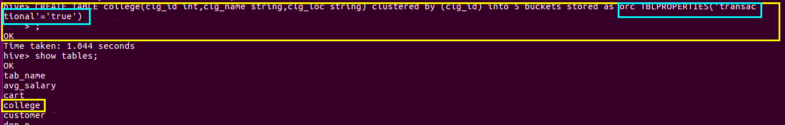**CREATING ORC TABLE**

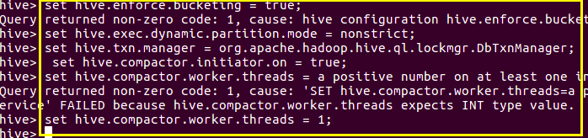**setting configuration for transaction**

**step2:Inserting data into table**

**The above command is used to insert row wise data into the Hive table. Here, each row is seperated by ‘*( )’ brackets.***

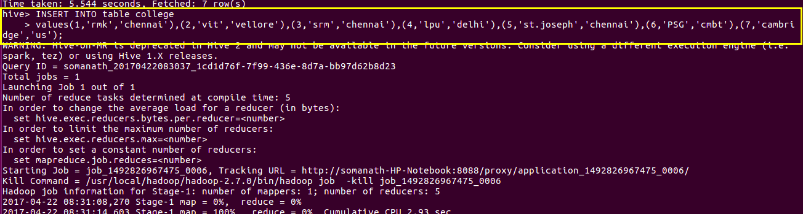

**Checking Data Inserted by using select \***



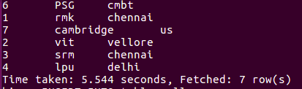**OUTPUT**

**we can also insert into existing as it will add with the existing data as shown I am adding the same data again as shown below**

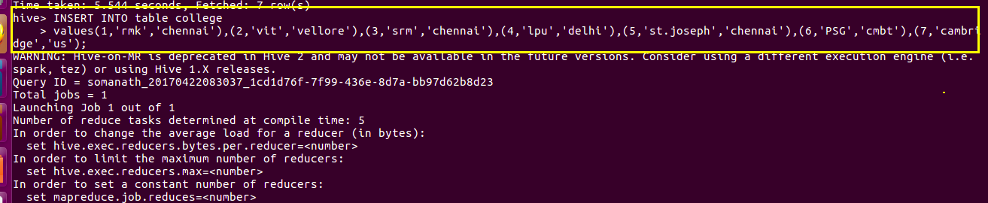

**CHECKING DATA AS WE CAN SEE THE DATA IS ADDED**

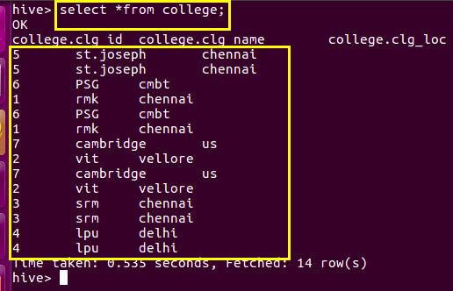

**let us update some data say we delete the data corresponding to id=5**

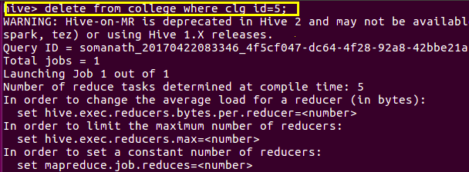

**now we can see that details corresponding to id 5 is deleted**

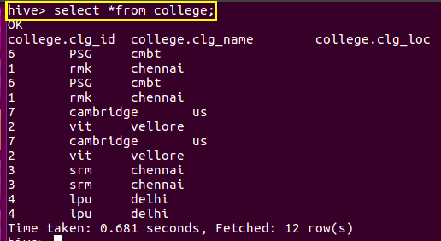

**at the same time update cannot be done on partitioned columns and it throws semantic error as shown**

**but update can be made on other non bucketed columns**

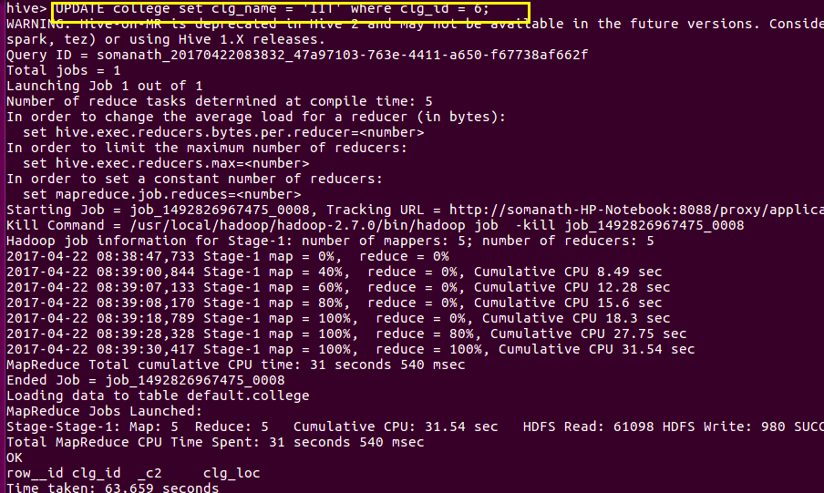

**Output**

**we can see that the college name is changed to IIT as highlighted**

