**IN order to convert avro to JSON type ,first we will create a table with avro format and load the data into the table**

**Step1:creating table with avro format**

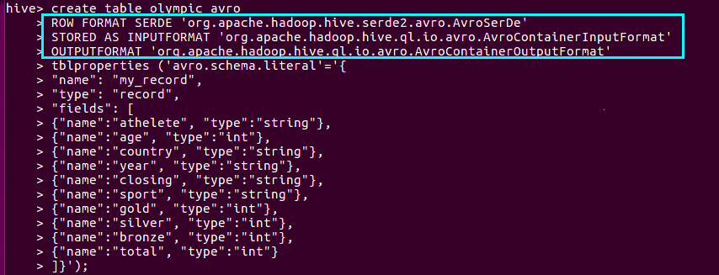**In the above code name means the column heading and type means the datatype**

**ROW FORMAT SERDE 'org.apache.hadoop.hive.serde2.avro.AvroSerDe'**

This means that the data providing is serialized and de-serialized as well.If we have our own serialized data, there is no need to use this line. Else, the above line should be present, which acts as the default serialize for the data.

**STORED AS INPUTFORMA org.apache.hadoop.hive.ql.io.avro.AvroContainerInputFormat'**

This line means we are storing the file as AvroContainerInputFormat which is present in the default hive package as specified above. When using this line, the file will be stored with extension .avro, which is an extension of Avro.

**OUTPUTFORMAT 'org.apache.hadoop.hive.ql.io.avro.AvroContainerOutputFormat'**

This line says that the output of the file is also in Avro format and will have the extension .avro

**Loading DATA**

**Since we have avro file we can directly inset data by using load command**

**as shown below**

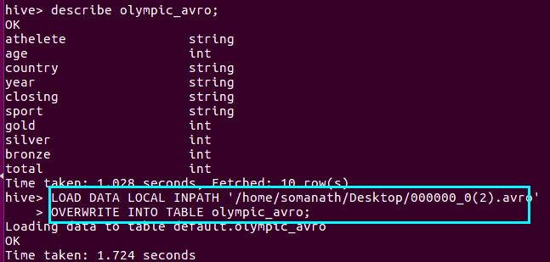

**Step3:Checking data insertion**

now we can check by using select staetment as shown

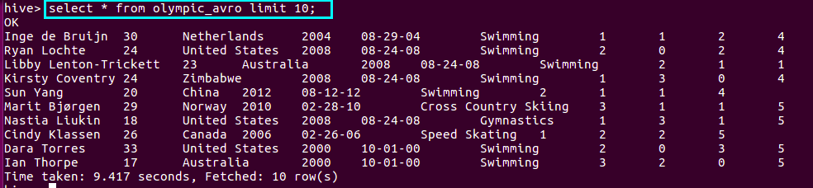**Step4:Converting AVRO TO JSON**

we have now successfully converted the avro file with the given schema

we will download the avrofile with the above schema from Hdfs as shown below

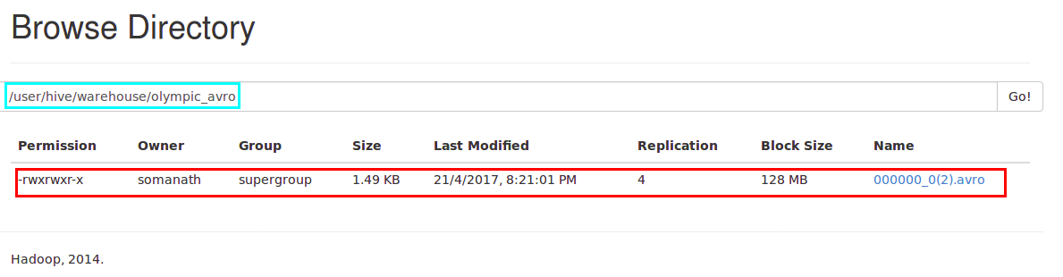

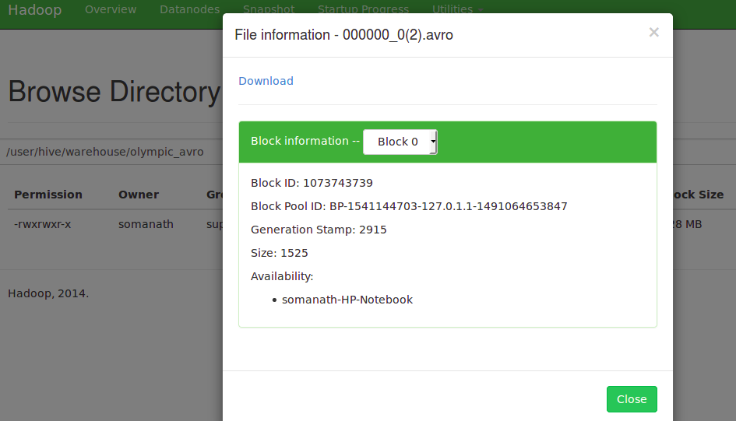

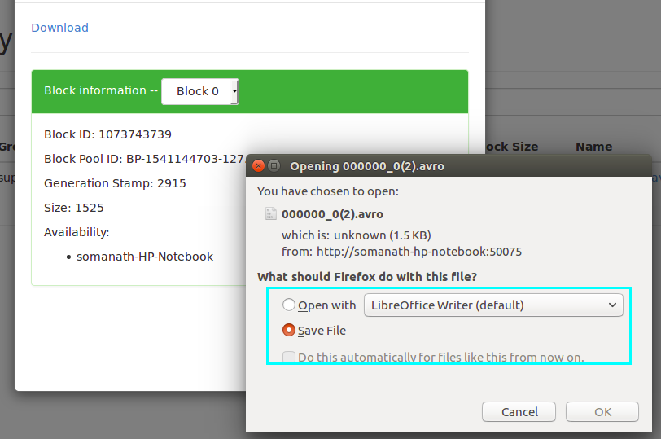

I am opening the file and opening by cat

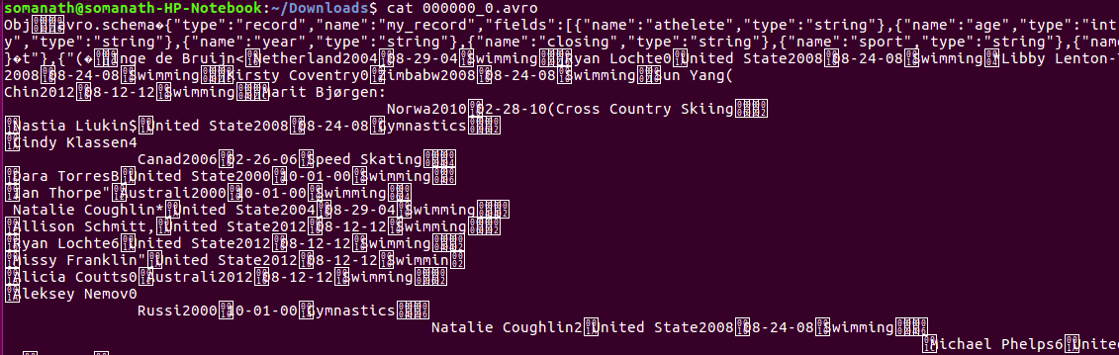

**In order to convert to avro to json we need a jar file called ‘avro-tools-1.7.5 jar’, which contains the option to convert the Avro file into JSON**

**and the command is java -jar avro-tools-1.7.5.jar tojson 'avro file name' >newfilename.json**

**In our case java -jar avro-tools-1.7.5.jar tojson 000000_0.avro >olympic.json as shown and the file is checked by using cat command as shown below**

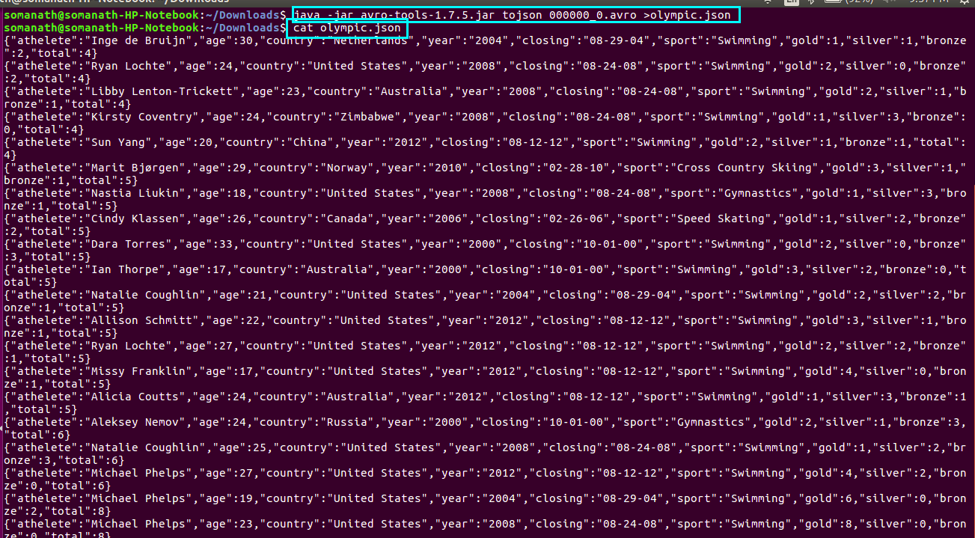

**Now, you can see the contents of your table with JSON format.  
As the Avro parser has converted the schema into an object and the object will contain the data .In the above image, you can see that inside the schema there are the contents which says that the created object is holding our content.**