Step1:Create a table customer with personal details and Order details and used list command to check the table created

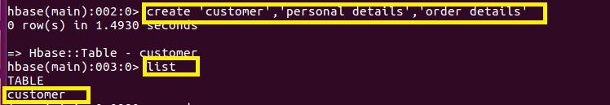

**Step2:Used Put command to Inset data column name,age,city,state for column family personal detais using aadhar card as rowkey**

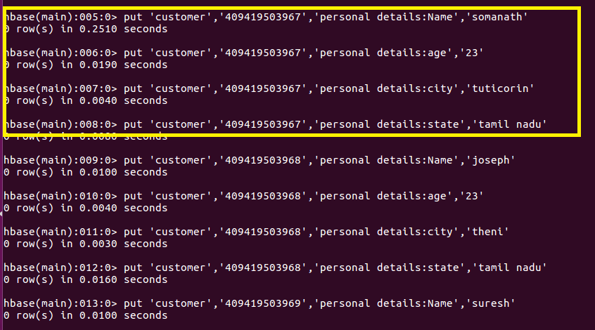

**Step3:Used Put command to Inset data column Order no, Order quantity,Order amount for column family Order details using aadhar card as rowkey**

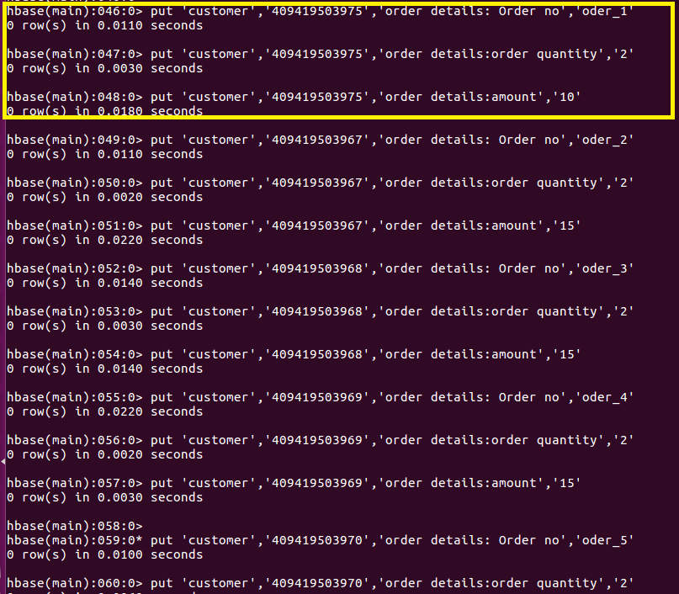

**Step4:Since It is asked to Insert 10 records ,I have inserted 10 records and checked it using count command which will give count of rows in Table**

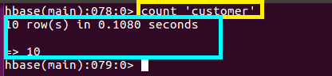

**Step5:Used get command to get a single record with row key ”409419503967” and got full details and got the Personal details and order details separately and got the name for “409419503967” and order details separately similarly we can get details of any record using rowkey**

