**Step1:Create a employee table in Mysql and columns as Emp_id, Emp_name, Dept_name(Hadoop Developer), Emp_sal and Inserting values into the Table Employee**

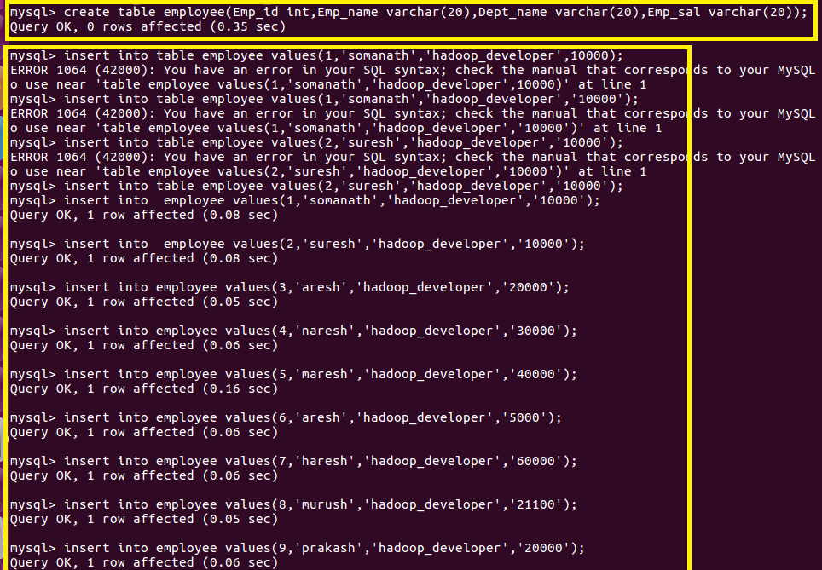

**Step2: Import the employee table contents into the HDFS directory using Sqoop.**

**Step2:Creating target directory in HDFS**

**But prior to that I want to store the table into a specified directory “sqoopout” so I am creating a directory In Hdfs or else by default it will be stored in a directory created by sqoop with username and table name**



**Step3:** **Import the employee table contents into the HDFS directory using Sqoop.**

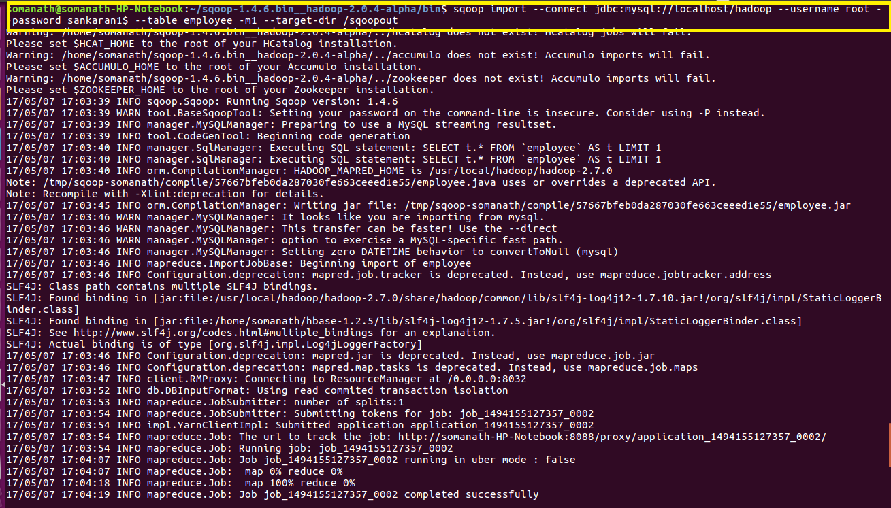

**COMMAND EXPLANATION**

**--connect -> It is used to give the JDBC Url of database**

**--Username🡪user name of database**

**--password🡪password of database**

**--table 🡪 give the table you want to copy from MySql**

**--target-dir🡪 directory used by Sqoop Under which the data will be stored in Hdfs**

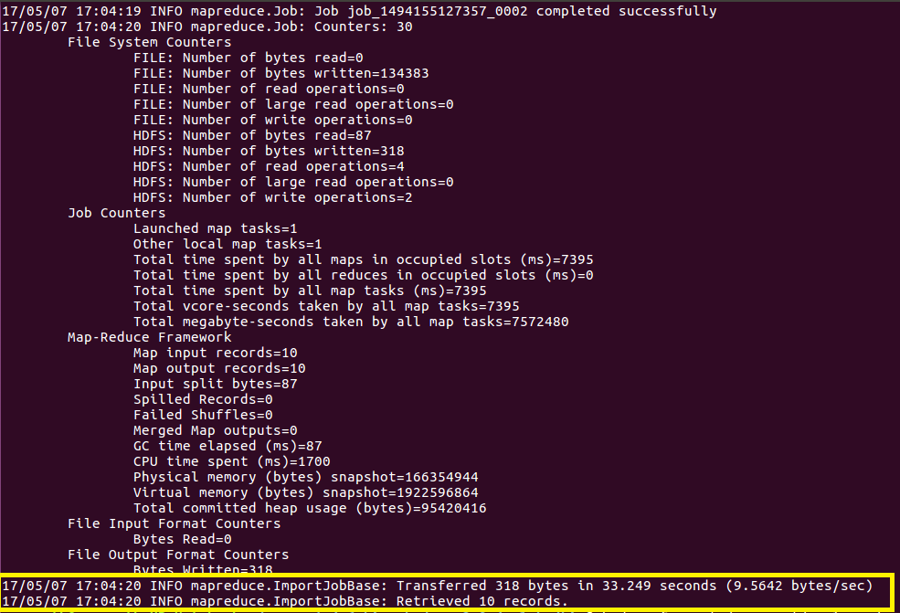

**The above image shows the import is successfully done**

**Output**

**THE output can be found in the sqoopout directory as shown**

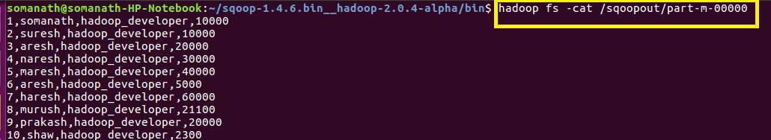

**Export employee details file from HDFS directory to Mysql table employee2 using Sqoop**

**Step4:Create a employee2 table in Mysql**

**In order to export data from HDFS I will create a Table “employee2” in MySql where the export will be done**



**Step5: Export employee details file from HDFS directory to Mysql table employee2 using Sqoop.**

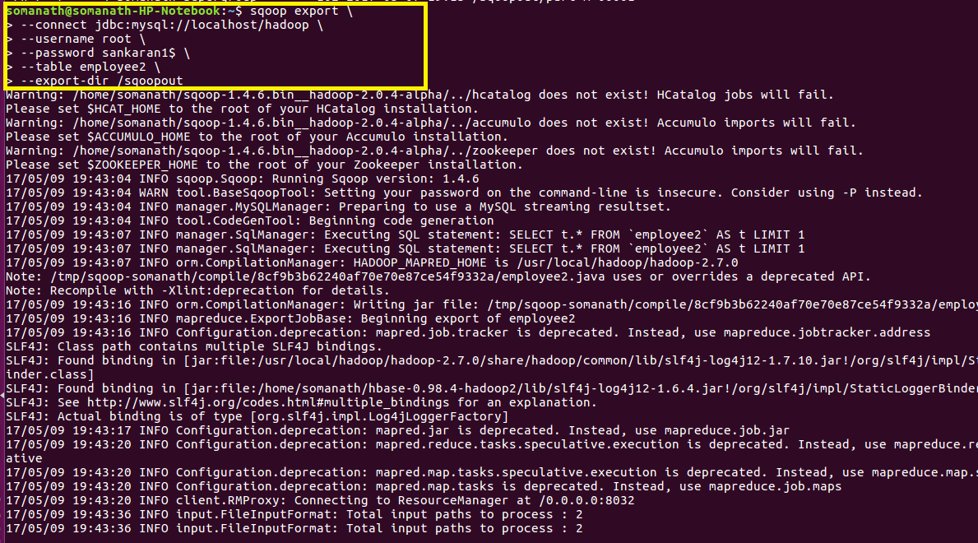

**COMMAND EXPLANATION**

**--connect -> It is used to give the JDBC Url of database**

**--Username🡪user name of database**

**--password🡪password of database**

**--table 🡪 give the table where the data will be copied in MySql from HDFS**

**--export-dir🡪 directory in Hdfs from where you want to copy to Mysql**

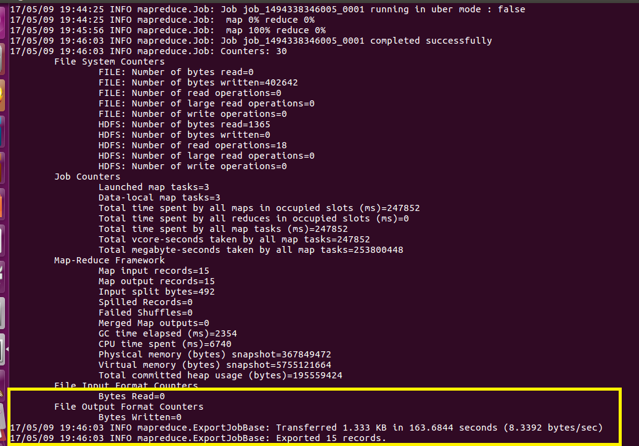

**The above image shows the emport is successfully done**

**Output**

**The data is successfully exported from HDFS to employee2 table in MySql**

