**Use HBaseAdmin class and create the table named company with one column family name details.**

Step1:Used configuration object and created a Hbase Configuration

Step2:Created a method “create” and passed table name and column family as parameters

Step3:In create method,As we want to create Table we need HbaseAdmin object using the given configuration

Step4:HTableDescriptor Object is used to create table With name”**Company**” and the Column families”**Details**”

Step5:used create table of HbaseAdmin Object to create table

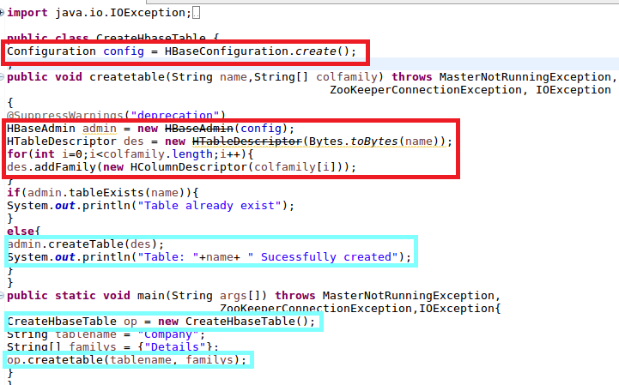

**OUTPUT**

**From console**

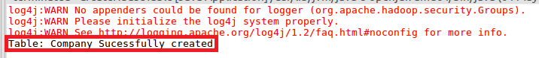

**It is verified by using LIST Command in HBase as shown**

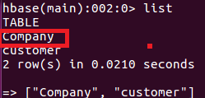

**Create the method name insert and use put class to insert records to company table.**

Step1: :Used configuration object and created a Hbase Configuration

Step2: Created a method “insert” and passed table name and column family as parameters

Step3:Created a object of put class with rowkey as parameter

Step4:Now we will add column and values for the table by using addcolumn method

Step5:Used hTable’s put method to add values

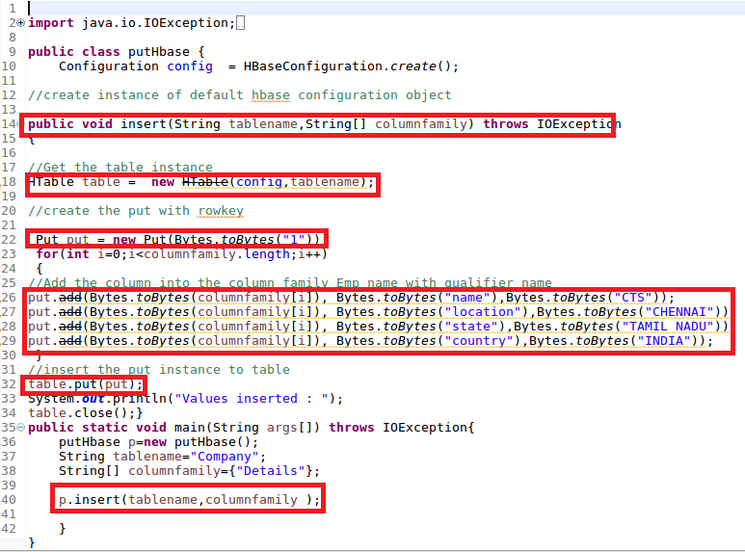

**Output**

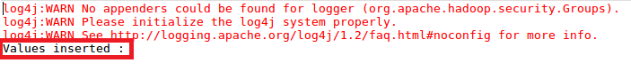

**Veified the data inserted using scan command**

