**Write a custom partitioner to divide the keys on the basis of range. Take minimum to be 0 and maximum to be 10. Divide them across 2 reducers.**

**Driver:**

Since input file is a sequence file it is mentioned by using j.setInputformat class

And mapoutput and Input key are set

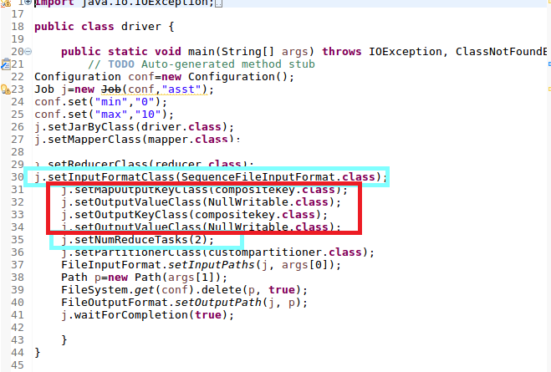

**Mapper**

**Since sorting needs to be done on total Units sold ,so I am using a composite key which takes the company and value as Input**

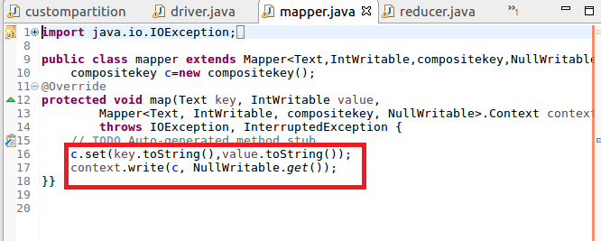

**Composite Key class**

**Since we want sorting needs to be done on total units sold ,we have to override compare method and sorting should be done on count in desc order.Remaining methods readFileds and**

**Writefields are used for sereialisation and deserialization**

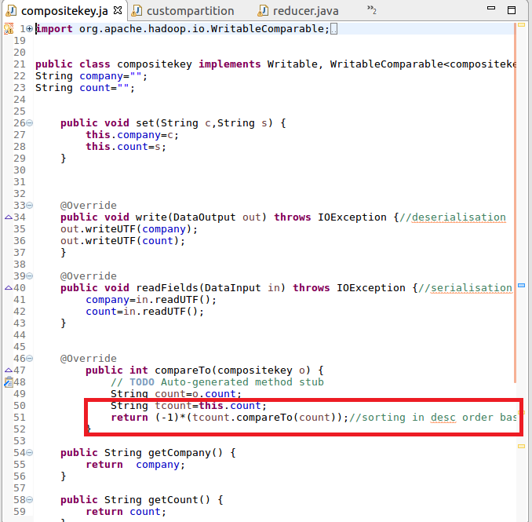

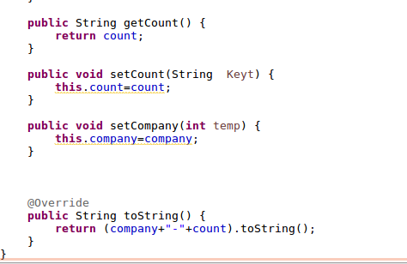

**Custom Patitioner:**

**As it is asked to divide across reducers,I am sending if sold units is in the range 0 to 5 it will be sent to first reducer or else it will sent to second reducer**

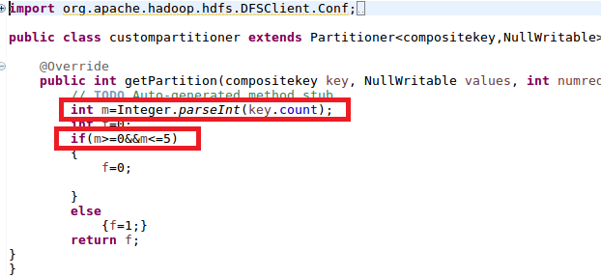

**Reducer**

**It is just used to write the sorted output on context**

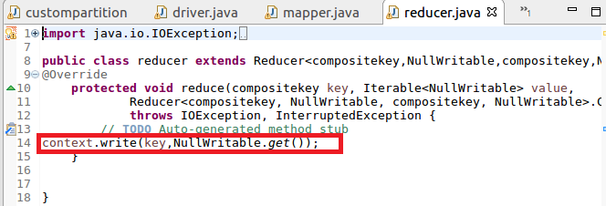

**Running jar**

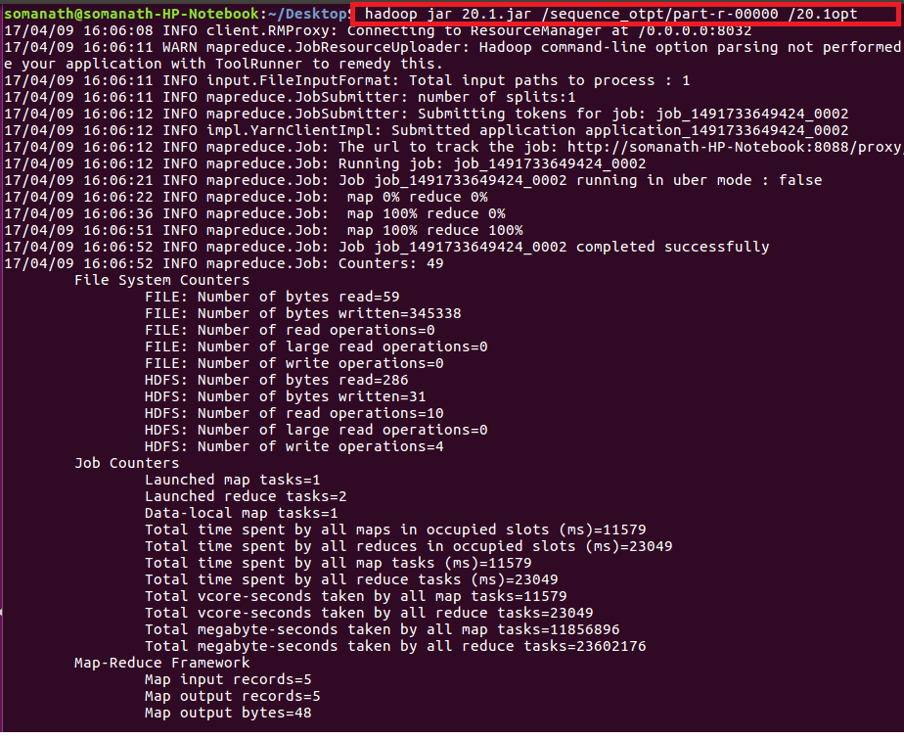

**OUTPUT**

**Since we have divide the data across reducers based on 5 as mid value ,companies with total units sold less than 5 went to 1 reducer and others with more than 5 went to second reducer as shown below**

