File formats in Hive :
A file format is a way in which information is stored or encoded in a computer file. In Hive it refers to how records are stored inside the file. As we are dealing with structured data, each record has to be its own structure. How records are encoded in a file defines a file format.
These file formats mainly vary between data encoding, compression rate, usage of space and disk I/O.
Following are some of the file formats in hive
1.Text file format
2.Sequence file format
3.RC File format
4.ORC file format
TextFile format:
It is the default file format in hive
In Hive if we define a table as TEXTFILE it can load data of from CSV (Comma Separated Values), delimited by Tabs, Spaces, and JSON data. This means fields in each record should be separated by comma or space or tab or it may be JSON(JavaScript Object Notation) data.
By default, if we use TEXTFILE format then each line is considered as a record.
IF a table is created as text file it takes the following hadoop class
But if we define the file as text file it is not compressed
org.apache.hadoop.mapred.TextInputFormat
org.apache.hadoop.mapred.TextOutputFormat

EXAMPLE
For all the fileformat let take the olympic data as Input
In order to define as a text file,the command stored as Textfile should be used
as the input is delimited by tab we are giving ‘\t’ and using load command data is loaded and checking the loaded data using select statement
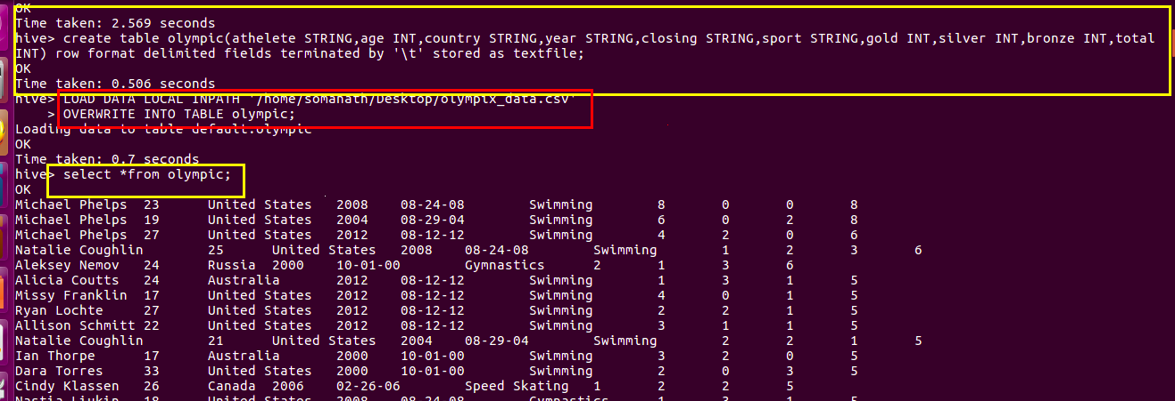

2.Sequence file format
The problem with hadoop is that it processes small no of large files conveniently than large no of small files. IF the files are small (smaller than block size) for each small file a block will be allocated which results in under utilisaton , a number of metadata increases which will become an overhead to the NameNode.Further more text file does not have any compression,So to provide some compression and to combine large no of small file a flat file system consists of binary key value pairs were introduced
Another thing with sequence file is that due to binary nature it enables faster transmission compared to text file
Infact this is the format used by hadoop for storing the results of intermediate key value pairs
RC File format
There are three types of sequence files:
• Uncompressed key/value records.
• Record compressed key/value records – only ‘values’ are compressed here
• Block compressed key/value records – both keys and values are collected in ‘blocks’ separately and compressed. The size of the ‘block’ is configurable.

Hive uses the SEQUENCEFILE input and output formats from the following package
org.apache.hadoop.mapred.SequenceFileInputFormat
org.apache.hadoop.hive.ql.io.HiveSequenceFileOutputFormat

In Hive we can create a sequence file by specifying STORED AS SEQUENCEFILE in the end of a CREATE TABLE statement as shown.
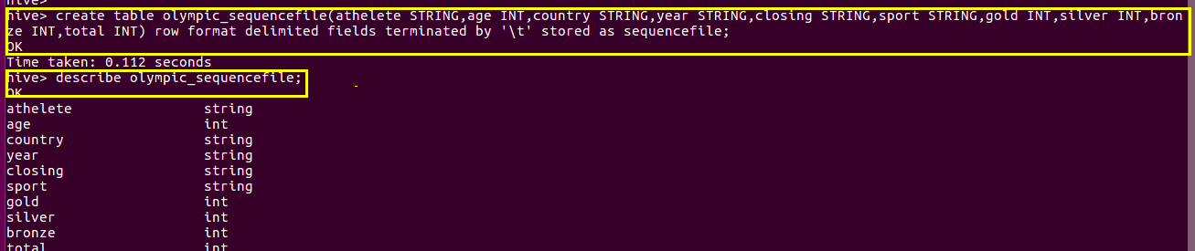
Loading data into sequence table
Now to load data into this table is somewhat different from loading into the table created using TEXTFILE format. You need to insert the data from another table because this SEQUENCEFILE format is binary format. It compresses the data and then stores it into the table. If you want to load directly as in TEXTFILE format that is not possible because we cannot insert the compressed files into tables.
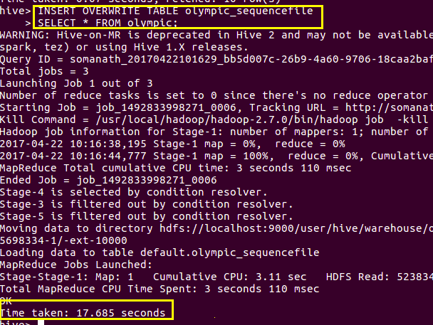

selecting data from the sequence file



In order to verify sequence file we can open the table from hive/warehouse using cat command and we can see the seq file as shown below (highlighted in blue colour)

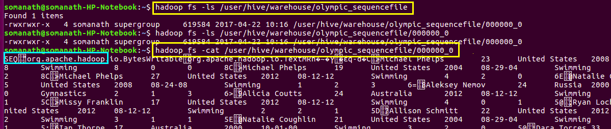

RC File format
Unfortunately, sequence files are not an optimal solution for Hive since it saves a complete
row as a single binary value.

Consequently, Hive has to read a full row and decompress it even if only one column is being
requested.so RC File format is Introduced
RCFILEs are also flat files consisting of binary key/value pairs, which shares much similarity with SEQUENCEFILE.
But the difference is that partitions the data not in horizontal manner but also in columnar manner(ie)It first partitions rows horizontally into row splits and then it vertically partitions each row split in a columnar way. RCFILE first stores the metadata of a row split, as the key part of a record, and all the data of a row split as the value part. This means that RCFILE encourages column oriented storage rather than row oriented storage.

Subsequently, each processing node reads only the columns relevant to a query from a file and skips irrelevant ones.

Additionally, compression on a column base is more efficient.

It can take advantage of similarity of the data in a colum
In Hive we can create a RC file by specifying STORED AS RCEFILE in the end of a CREATE TABLE statement as shown.
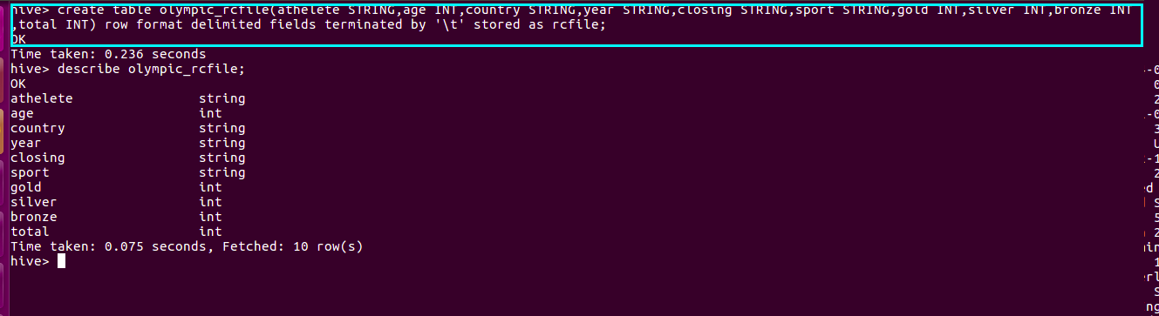

We cannot load data into RCFILE directly. First we need to load data into another table and then we need to overwrite it into our newly created RCFILE as shown below:
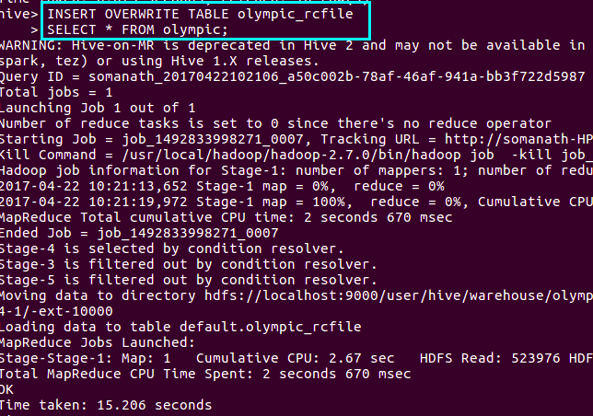
checking the schem using describe

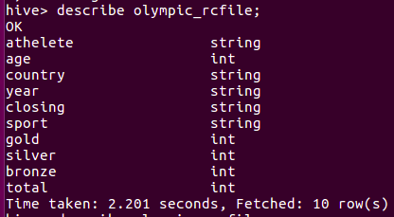

In order to verify rc file we can open the table from hive/warehouse using cat command and we can see the rc file as shown below (highlighted in blue colour)
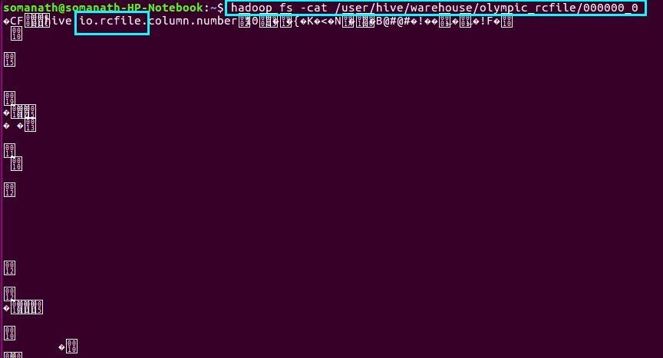

ORC File
ORC stands for Optimized Row Columnar which means it can store data in an optimized way than the other file formats. ORC reduces the size of the original data up to 75%. As a result the speed of data processing also increases. ORC shows better performance than Text, Sequence and RC file formats.
An ORC file contains rows data in groups called as Stripes along with a file footer. ORC format improves the performance when Hive is processing the data.

Hive has its own ORCFILE Input format and ORCFILE output format in its default package:
org.apache.hadoop.hive.ql.io.orc
creating ORC FILE
Here we are creating a table with name olympic_orcfile and the schema of the table is as specified above. The data inside the input file is delimited by tab space.
At the end the file format is specified as ORCFILE format.

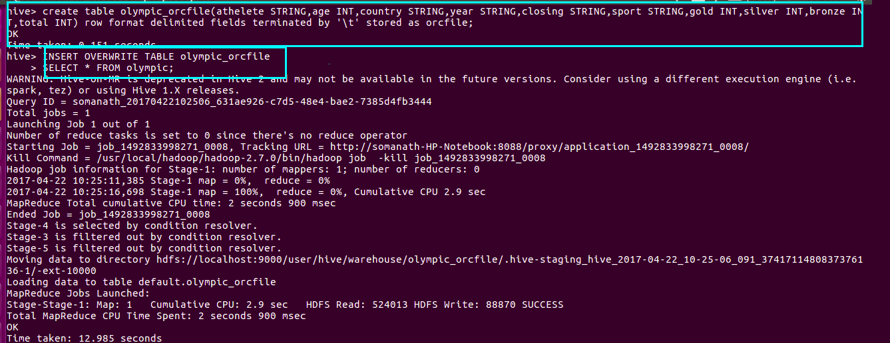
We can check the creation of orc file by

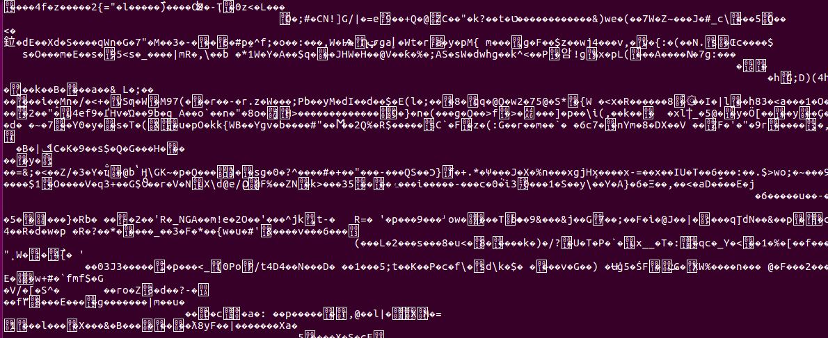
selecting from ORC FILE
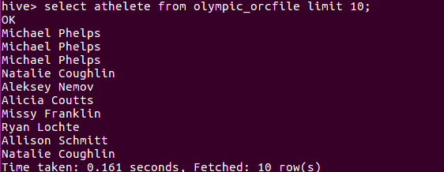

Compression ratio of the file formats can be seen from the size of the file as given below
We can see that orc file is 86 kb compared with text file of 505 kb

