calculate the top 3 state-wise sales for
each company. You may use multiple reducers for this activity
Driver:
Since we want statewise sales for each company,a composite key is used as mapoutput key class which consists of company ,state and count as argument and as it is asked to multiple reducers j.setnum reduce tasks is set to 2.
and group comporator class is defined which is used for group the data based on company name in reducer

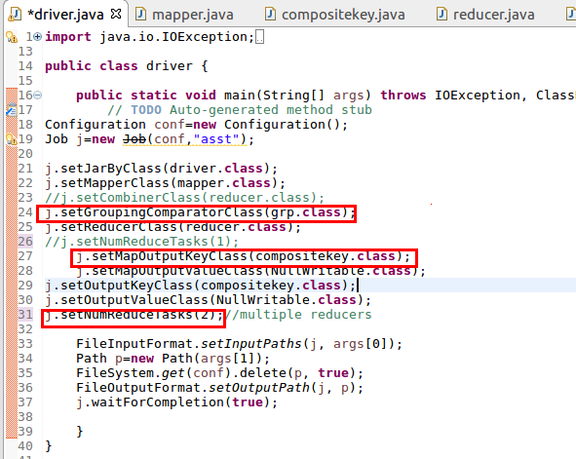
Mapper:
map method
In mapper in map method ,the input data is split by (|)and hashmap is used which takes the company and state as key and so if the key is already present the count will be increased or just a count of 1 is given as shown below
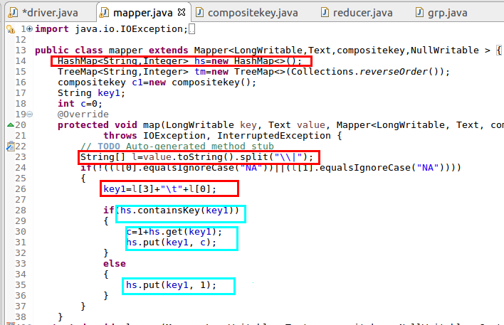
cleanup method
now we have the company and state as key and total unit sold as value in hashmap and we want top 3 state wise sales so the company,city,count is passed to composite key and is passed as key and nullwritable as value
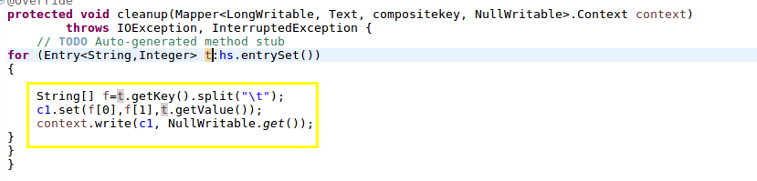
full mapper code

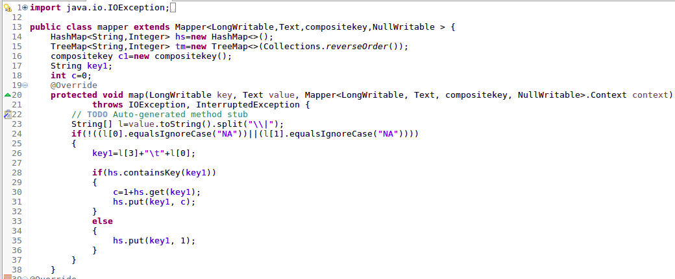

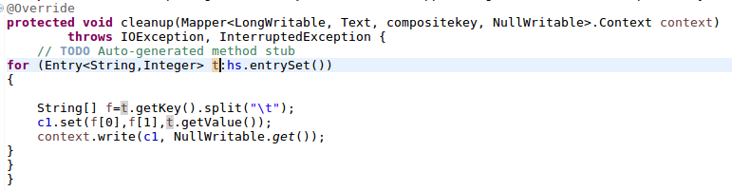
Compositekey class:
In composite key class company,state,count are passed and readfield() and writefields() are used to read and write from framework
Overriding hashcode()
Since multiple reducers are used it is necessary that a particular company should go to particular reducer.Since default hash modulo partititoner is used.In hash code method hashcode of company is sent
Overriding compareto methods:
Since we want top 3 state wise sales ,first company is compared if company is equal then we want to order it by descending based on sales count so multiplied by(-1)
Overriding ToSring()
It is used to display the company,state,sales count
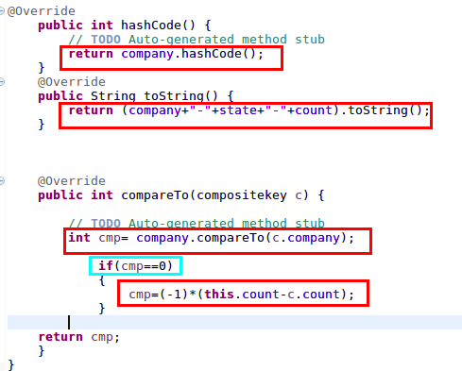

full composite key Code

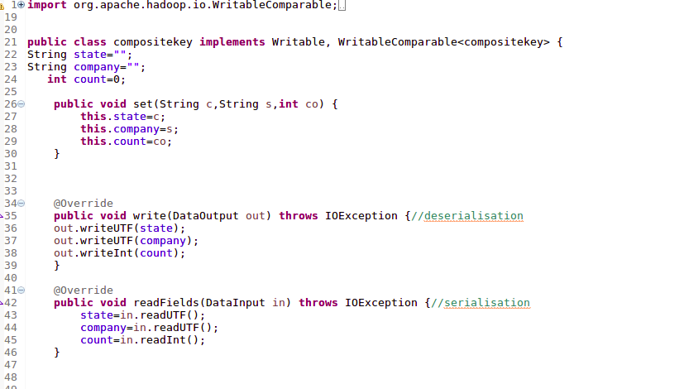

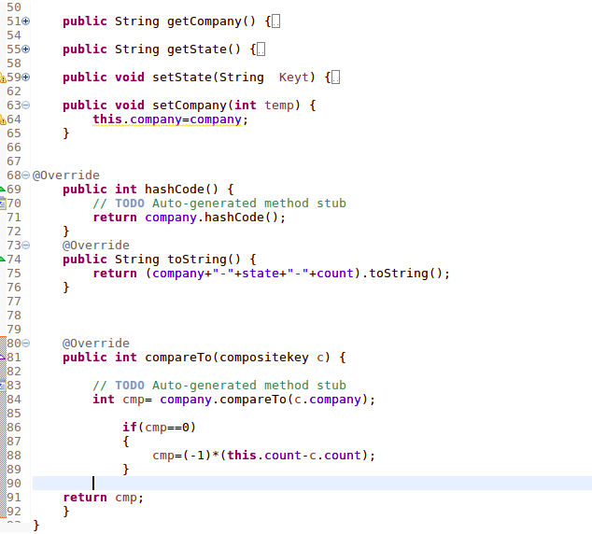
Group comparator class
since we want to grouping based on company rather than whole compositekey,it is explicitly defined by using customized group comparator class where compare to method is overriden and comparison is made based on company name
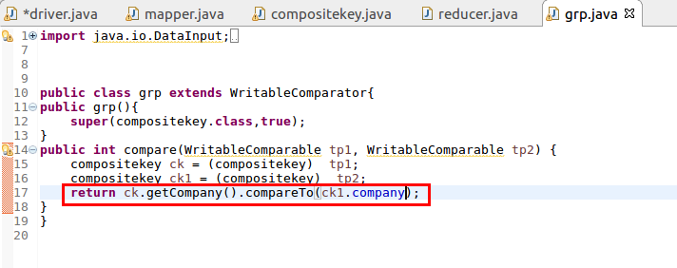
Reducer Class
Since we want top 3 statewise sales for each company an if condition is used which allows wirting of values only upto 3
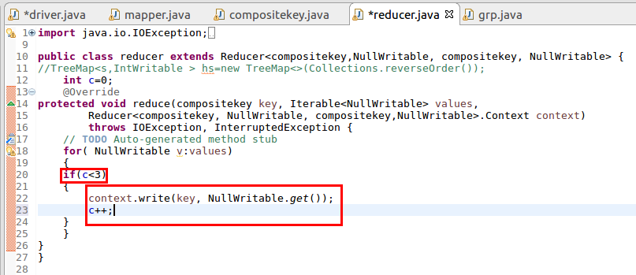
Running jar
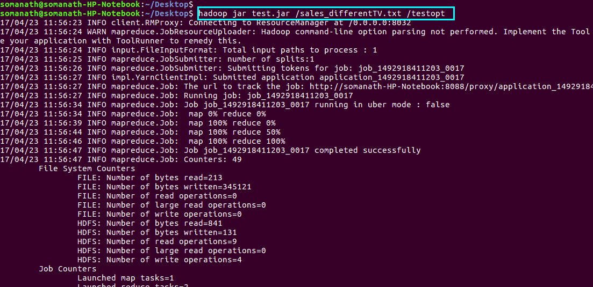
output
since we define 2 reducers output is distributed based on company and top 3 district for each company along with its sold units is displayed
