Creating employee table and Loading dataset of employee
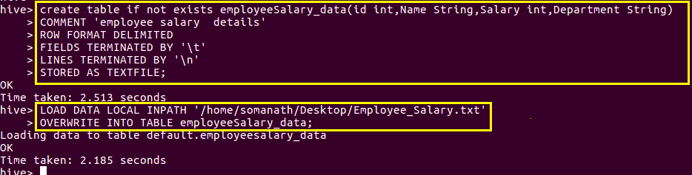
Qn1.Get a list of employees who receive a salary less than 100, compared to their immediate
employee with higher salary in
the same unit

since we want persons with salary less than 100 compare to immediate employee with higher salary
I am first creating a view where by using lag function and partioned by department and group by salary I am creating a column as previous as shown below

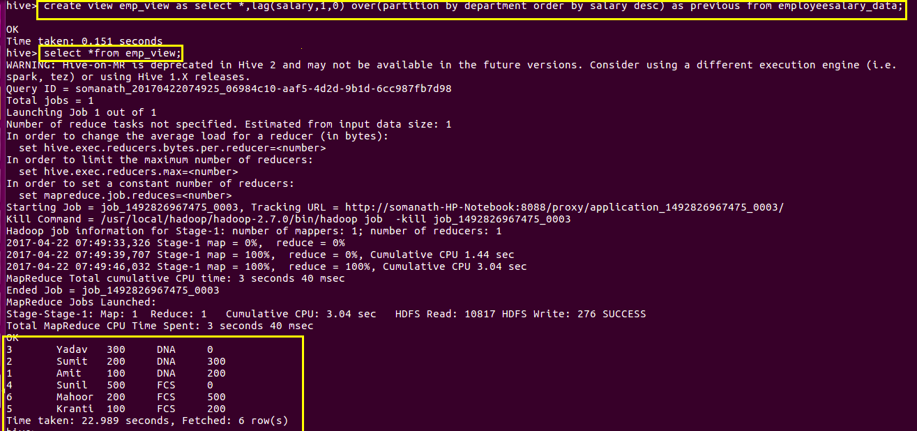

since we want the salary of employee less than immediate higher employee since the view is ordered in descending order I am just filtering in where clause as ( previous- salary)>100
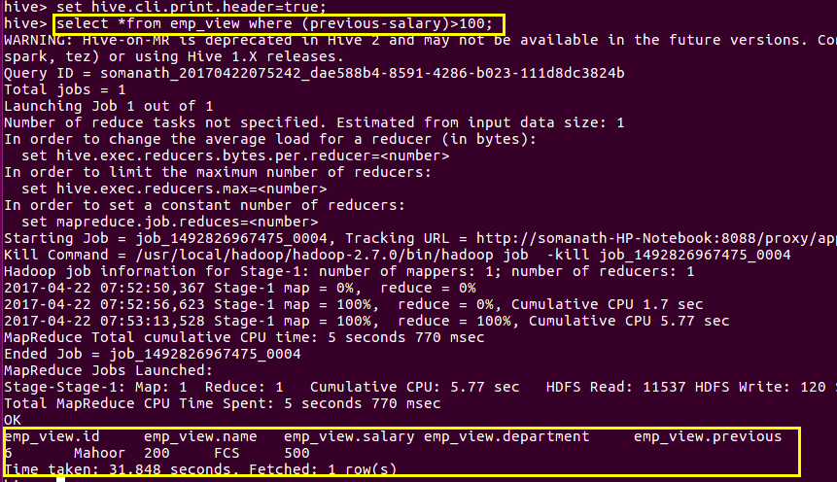
Qn2.List of all employees who draw higher salary than the average salary of that department
Step1:creating a view where avg salary is found department wise
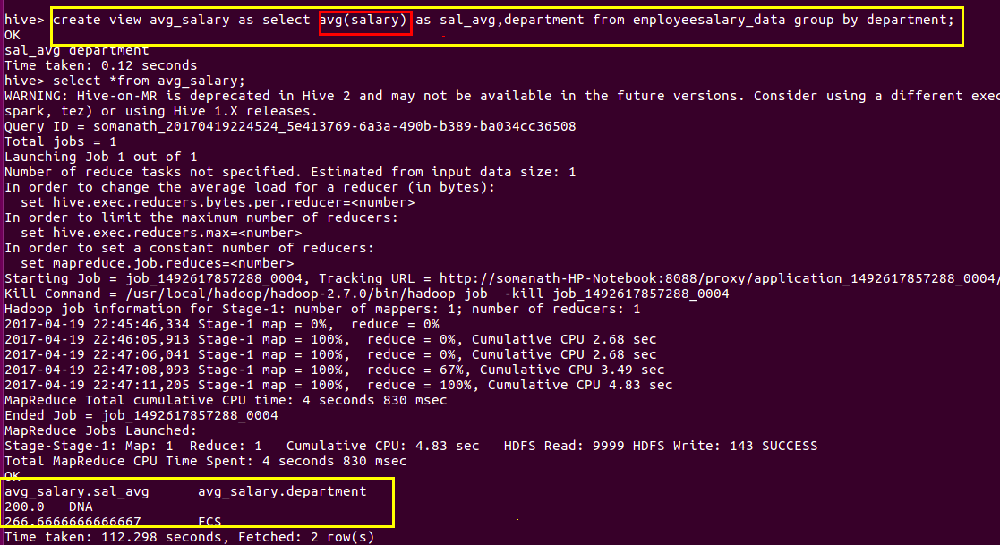

Step2:view table is joined with emp_table based on department and find the employees who are havin salary greater than avg salary

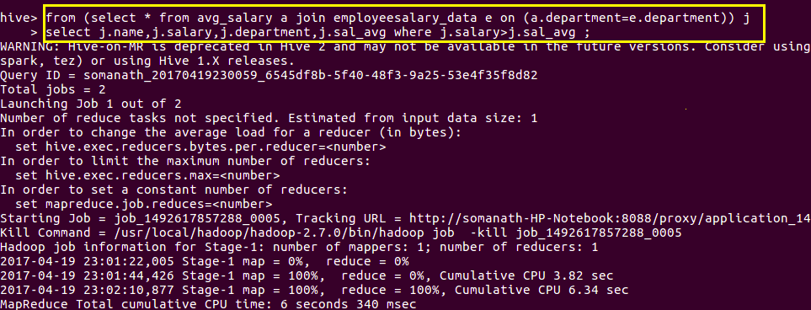
Output:
