Hive Script file
Hive scripts are used to execute a set of Hive commands collectively.
logic
The Hive script file should be saved with .sql extension to enable the execution.
Qn1.Get a list of employees who receive a salary less than 100, compared to their immediate
employee with higher salary in
the same unit

since we want persons with salary less than 100 compare to immediate employee with higher salary
I am first creating a view where by using lag function and partioned by department and group by salary I am creating a column as previous as shown below

since we want the salary of employee less than immediate higher employee since the view is ordered in descending order I am just filtering in where clause as ( previous- salary)>100

Qn2.List of all employees who draw higher salary than the average salary of that department

Step1:creating a view where avg salary is found department wise

Step2:view table is joined with emp_table based on department and find the employees who are havin salary greater than avg salary
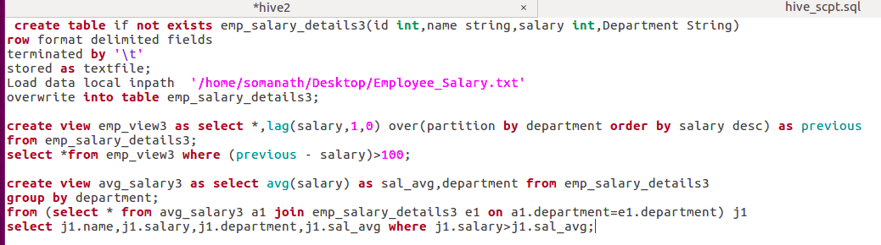
RUNNING HIVE SCRIPT FROM TERMINAL
Execute the hive script using the following command
hive -f /home/somanath/Desktop/hive_scpt.sql
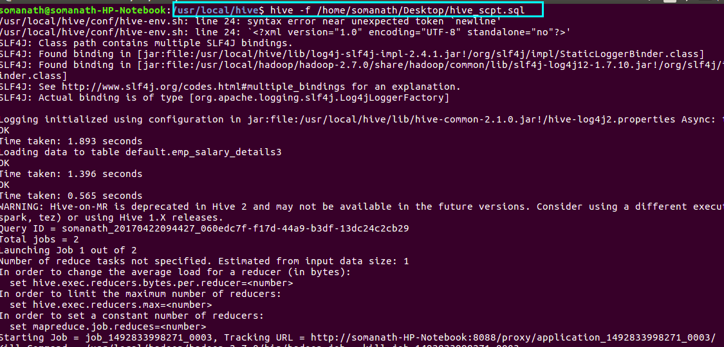
OUTPUT 1
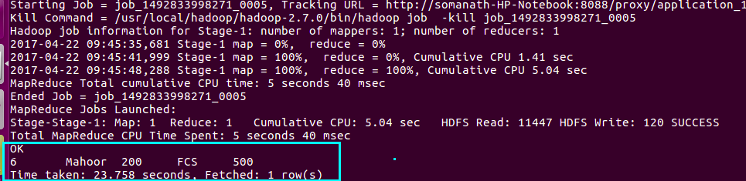
OUTPUT2
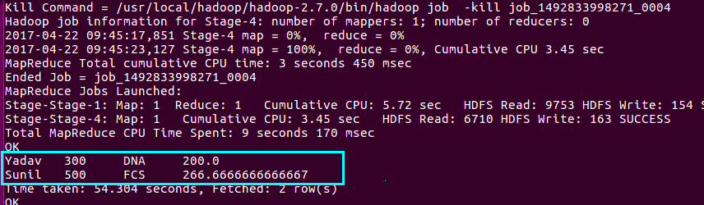

2.Sequence file format

In Hive we can create a sequence file by specifying STORED AS SEQUENCEFILE in the end of a CREATE TABLE statement as shown.
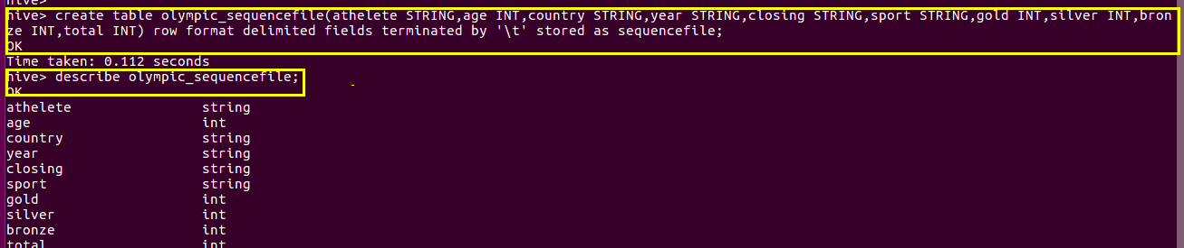
Loading data into sequence table
Now to load data into this table is somewhat different from loading into the table created using TEXTFILE format. You need to insert the data from another table because this SEQUENCEFILE format is binary format. It compresses the data and then stores it into the table. If you want to load directly as in TEXTFILE format that is not possible because we cannot insert the compressed files into tables.
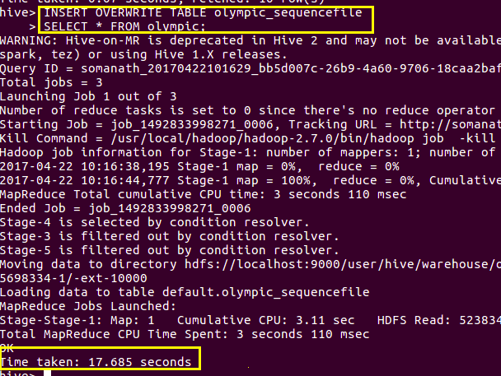

selecting data from the sequence file
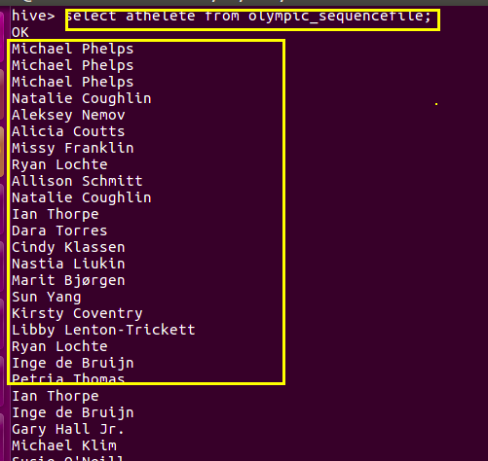
In order to verify sequence file we can open the table from hive/warehouse using cat command and we can see the seq file as shown below (highlighted in blue colour)

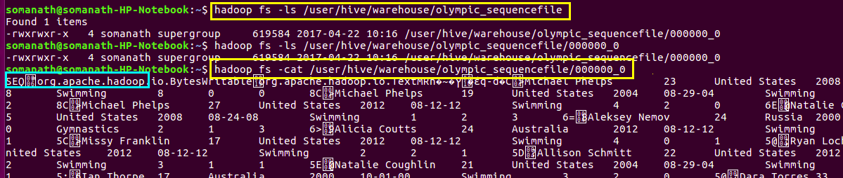

RC File format

In Hive we can create a RC file by specifying STORED AS RCEFILE in the end of a CREATE TABLE statement as shown.
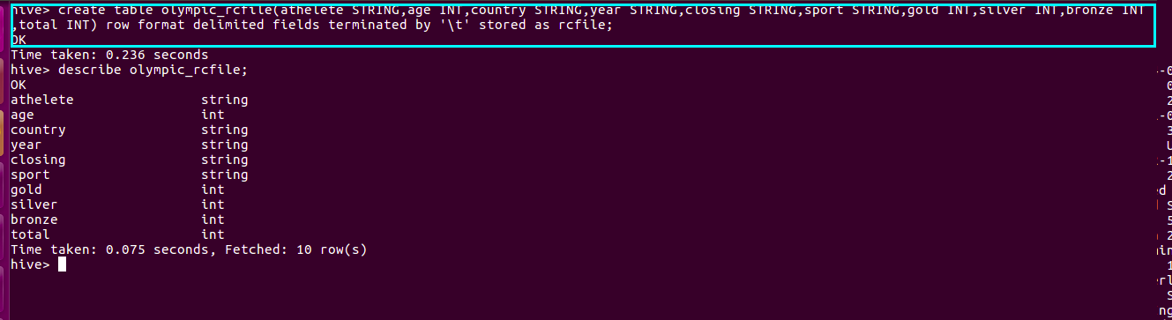

We cannot load data into RCFILE directly. First we need to load data into another table and then we need to overwrite it into our newly created RCFILE as shown below:
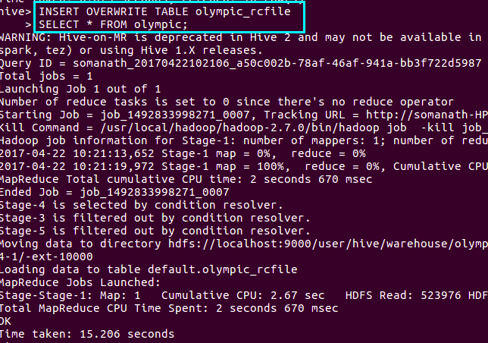
checking the schem using describe

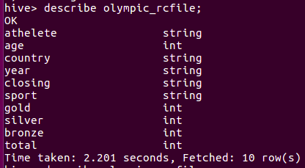

In order to verify rc file we can open the table from hive/warehouse using cat command and we can see the rc file as shown below (highlighted in blue colour)
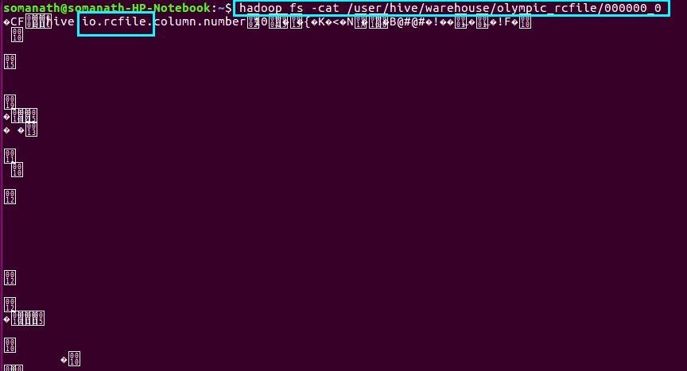
selecting from RC file
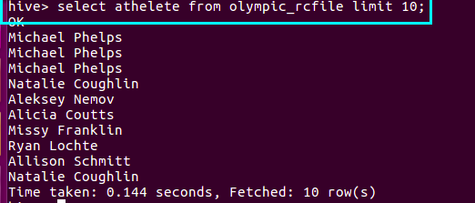

ORC File

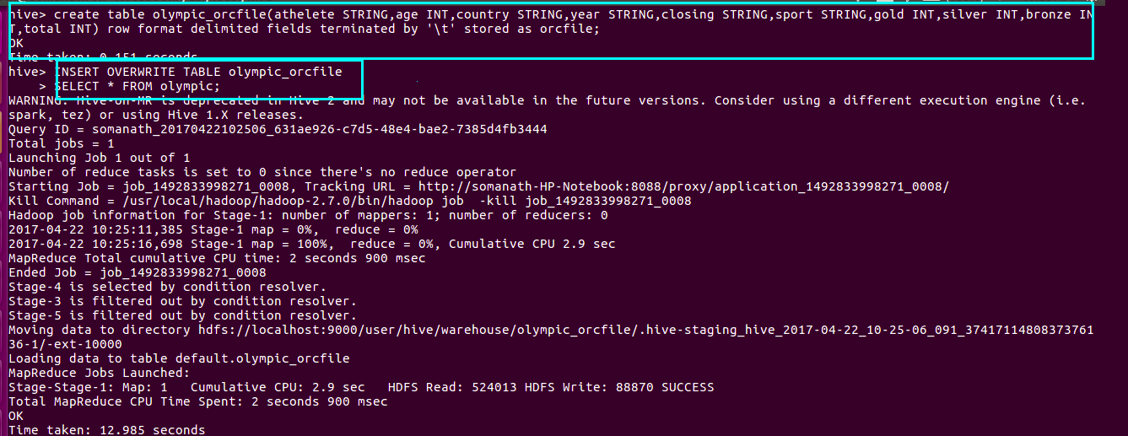
We can check the creation of orc file by

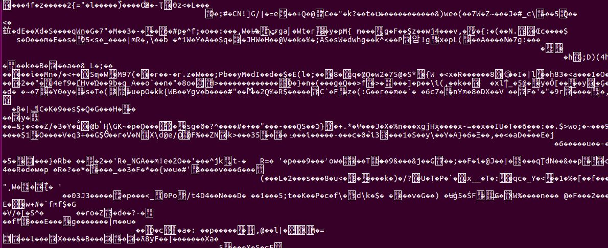
selecting from ORC FILE
