**View in Hive**

**Hive view is similar to view in other RDBMS.Suppose we have a very long querry that consists of multiple join ,It will be cumbersome to read and it will also result in a complex execution and will be difficult to understand the querry flow and execution**

**In order to address this Problem views are created.View is actually a virtual table formed as a result of a querry which can used like a table and can used in the subsequent querries**

**View can also be used if we want hide some information to common user**

**Since it is a virtual table whenever a view is created only the querry gets saved and whenever the view is used again in any other querry it just reruns the querry and no memory is allocated**

**Example scenario for view**

**We are creating 2 tables view and cart as shown**

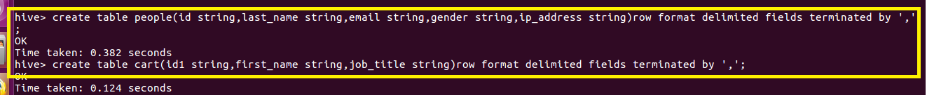

**Loading Table**

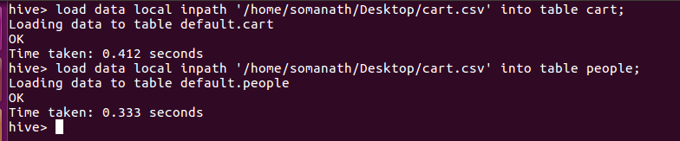

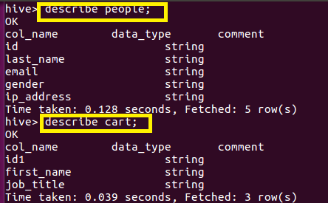

**Let us consider the below join statement**

**FROM (SELECT * FROM people JOIN cart**

**ON (cart.id1=people.id) WHERE last_name=’Henderson’) a**

**SELECT a.first_name WHERE a.id=’40-8340379′;**

The above querry is a nested querry where we are joining people and cart and giving a alias name as “a”.Then we are selecting firstname where id is 40-8340379

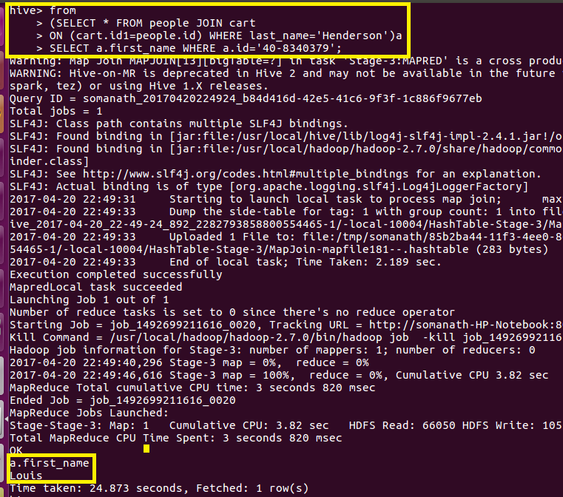

**Instead of using this complicated querry we are creating view where we are joining this table as shown**

**Creating view**

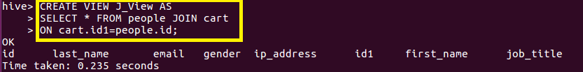

**View Output**

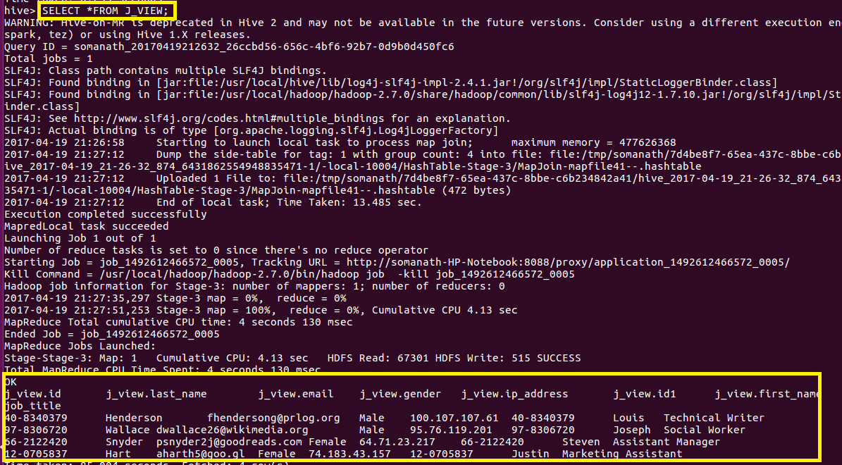

**In step2 ,we are accessing from this view and selecting the first_name where id=40-8340379**

**Output**

