Mobile robot

Requirements:

* A robot with at least two driving wheels
  + Simple differentially steered 2 wheel robot
  + Frame can be a commercially available simple robot frame with motors & wheels (additional budget ~30€)
* Should include at least 6-DoF IMU
* Some way for obstacle detection (sonars, IR sensors, ...)
* UI on the robot itself

Optional features:

* Navigation (plan how to get to target & avoid collisions)
* Onboard battery charger (charge from USB or AC-DC adapter)
* Mapping capabilities (at least in a 2D plane)

21.1.2022 Status

3- wheel self-driving robot with IR-mapping.

* As user I want robot to move in room without colliding to obstacles
* STM32 works as a CPU and DSP.
* 2 DC-motors move the vehicle through the H-bridge.
* 5 x IR-sensors work with collision avoidance. (3 in front, 2 on sides)
  + IR-sensor data is processed by the CPU and from data we get obstacle distance
* Sonar tower is on top of the car and is moved by step-servo
* Mapping is done from IR- and sonar-data
* System is powered by batteries, Micro-USB charges batteries. (2x 7.4V 2400 mAh Li-Ion)
* Mapped data is sent through micro-USB and also batteries are charged with micro-usb.
* PCB is printed to connect sensors, power, H-bridge and motors

To do:

* Order
* Info professor about plan and group info
* Requirements

28.1.2022 Status

Ready development kits from University? Frame, wheels and DC-motors ready. Frame material should be easily modified (wood, metal etc.) -> You can’t drill holes into cheap plastic, because it’ll crack easily.

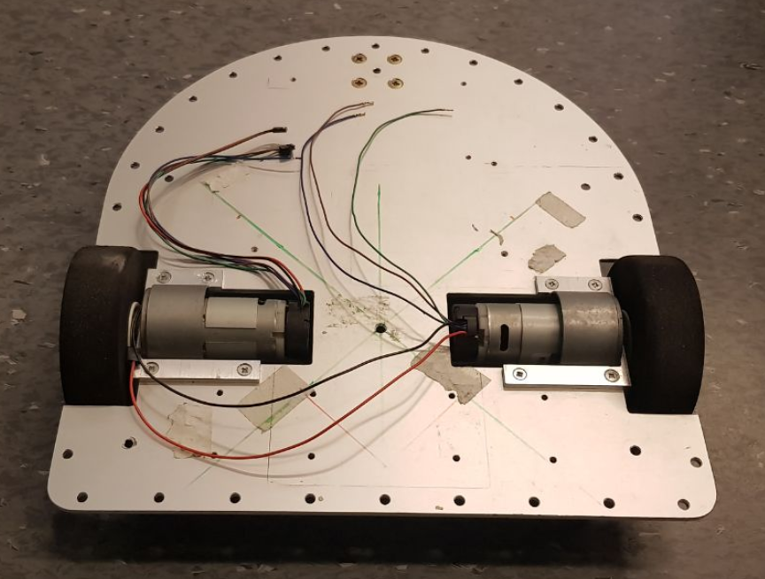

Should we use this one? Asked from

Inventory:

* STM32 Development kit
* Batteries
* IR-sensors

Should we order from West Taiwan or just march to Spelektroniikka?

4.2.2022

Trying to connect the professor, still no contact. Finishing documents.

11.2.2022

Finished feature, requirements, testing and Bill-of-materials documentation. Nikos will do schematic template. Ville will send docs to professors.