Table of Contents
List of Abbreviations 4
Abstract 6
1. Introduction 7
1.1 Context 7
1.2 Motivation 7
1.3 Remote sensing as a monitoring tool 8
1.4 Remote sensing of Case 2 waters 9
1.4.1 Optically active constituents 10
1.4.2 Inherent and apparent optical properties 10
1.5 Constituent retrievals: State of research 11
1.6 Objectives 13
2. Data and Methods 14
2.1 Study area 14
2.2 In situ data: sources and sampling stations 15
2.3 In situ validation data 16
2.3.1 AOPs 16
2.3.2 CHL 16
2.3.3 Phytoplankton 17
2.3.4 TSM and CDOM 17
2.3.5 IOPs 18
2.3.6 Auxiliary data 18
2.4 In situ data: additional quality control 18
2.5 Satellite data: acquisition and processing 19
2.6 Matchups 20
2.7 Methods: overview 21
2.8 Bio-optical model MiniWASI 22
2.8.1 Forward model 22
2.8.2 Inverse model 26
2.8.3 Model parametrization 26
2.9 Inversion of in situ $Rrsλ$ 29
2.10 Matchup validation 29
2.11 Operational processing chain 31
3. Results 32
3.1 AC performance 32
3.2 SHL2 35
3.2.1 CHL_{S} 35
3.2.2 Phytoplankton taxa 36
3.3 LéXPLORE 38
3.3.1 CHL_{F}, CHL_{A}, aLH₆₇₆, and CPHY_{R} 38
3.3.2 TSM and CDOM 41
3.3.3 Constituent time series and interrelationships 41
3.3.4 IOPs 45
3.4 eawag field campaigns 50
4. Discussion 54
4.1 AC: a limiting factor 54
4.2 General sources of matchup uncertainty 55
4.3 Phytoplankton taxa retrieval: limitations 55
4.4 Bulk phytoplankton retrieval: strengths and limitations 56
4.4.1 SHL2 validation and matchup representativeness 56
4.4.2 LéXPLORE: intercomparison of in situ CHL and CPHY references 57
4.4.3 Why LéXPLORE retrievals underperform relative to SHL2 57
4.4.4 Benchmarking against empirical algorithms and literature 59
4.4.5 Pigment composition and SIOP considerations 59
4.5 NAP: stable retrieval 60
4.6 CDOM: a retrieval failure and its causes 60
4.7 IOPs: implications for model configuration 61
4.8 Future study directions and general limitations 64
4.8.1 Uncertainty 64
4.8.2 AC and AE advancements 65
4.8.3 Bio-optical modelling: limitations and possible improvements 65
4.8.4 Hyperspectral missions: PACE 66
4.9 Conclusion 66
Appendices 67
Appendix 1: MiniWASI and WASI7 inversion performance 67
Appendix 2: Local relationship between aLH₆₇₆ and CHL_{F} 71
Appendix 3 : Relationship between modeled and measured in situ IOPs 72
Appendix 4: aLH₆₇₆ profile on 5.9.2021 74
Appendix 5: Drift of the ACS instrument 75
Bibliography 76

List of Abbreviations
Abbreviation | Full Term / Definition
AC | Atmospheric Correction
ACS | WET Labs ac-s spectrophotometer (absorption and attenuation sensor)
AE | Adjacency Effect
AI | Artificial Intelligence
AOP(s) | Apparent Optical Properties
BOMBER | Bio-Optical Model Based tool for Estimating water quality and bottom properties from Remote sensing images
CARRTEL | Centre Alpin de Recherche sur les Réseaux Trophiques et les Écosystèmes Limniques (INRAE research unit)
CCI | Climate Change Initiative (ESA)
CDOM | Colored Dissolved Organic Matter
CDOM_{R} | Modeled Colored Dissolved Organic Matter from hyperspectral in situ measurements
CDOM_{S3} | Modeled Colored Dissolved Organic Matter from Sentinel-3
CHL | Chlorophyll a
CHL_{A} | Absorption-corrected (fluorometric) Chlorophyll a
CHL_{F} | Fluorometric Chlorophyll a
CHL_{S} | Spectrophotometric (laboratory-measured) Chlorophyll a
CIPEL | Commission Internationale pour la Protection des Eaux du Léman (International Commission for the Protection of Lake Geneva)
CPHY | Phytoplankton concentration
CPHY_{R} | Modeled phytoplankton concentration from hyperspectral in situ measurements
CPHY_{S3} | Modeled phytoplankton concentration from Sentinel-3
DLR | German Aerospace Center (Deutsches Zentrum für Luft- und Raumfahrt)
EFR | Full Resolution (OLCI Level-1 product type)
EO | Earth Observation
EPFL | École Polytechnique Fédérale de Lausanne
ESA | European Space Agency
EUMETSAT | European Organisation for the Exploitation of Meteorological Satellites
HPLC | High-Performance Liquid Chromatography
INRAE | Institut National de Recherche pour l'Agriculture, l'Alimentation et l'Environnement
IOCCG | International Ocean Colour Coordinating Group
IOP(s) | Inherent Optical Properties
L1 | Level 1 (satellite data processing level)
L2 | Level 2 (satellite data processing level)
MdSA | Median Symmetric Accuracy
NAP | Non-Algal Particles from hyperspectral in situ measurements
NAP_{R} | Modeled Non-Algal Particles from hyperspectral in situ measurements
NAP_{S3} | Modeled Non-Algal Particles from Sentinel-3
NASA | National Aeronautics and Space Administration
NIR | Near-Infrared
NPQ | Non-Photochemical Quenching
OAC(s) | Optically Active Constituent(s)
OLA | Observatory on LAkes (database)
OLCI | Ocean and Land Colour Instrument
PACE | Plankton, Aerosol, Cloud, ocean Ecosystem (satellite mission)
PAR | Photosynthetically Active Radiation
POLYMER | POLYnomial-based algorithm applied to MERIS/OLCI (atmospheric correction algorithm)
PRISMA | PRecursore IperSpettrale della Missione Applicativa (hyperspectral satellite mission)
RAMSES | TriOS RAMSES hyperspectral radiometer
RGB | Red-Green-Blue
RMSE | Root Mean Square Error
RS | Remote Sensing
S2(A/B) | Sentinel-2 (A/B) satellites
S3(A/B) | Sentinel-3 (A/B) satellites
SA | Spectral Angle
SIOP(s) | Specific Inherent Optical Properties
SNR | Signal-to-Noise Ratio
TSM | Total Suspended Matter
UV | Ultraviolet
WASI | Water Colour Simulator

Abstract

1. Introduction

1.1 Context
Aquatic ecosystems provide essential services to both wildlife and people, including drinking water, food, and recreation. Monitoring their state, in particular by quantifying the substances suspended and dissolved in the water, is important to assess ecosystem health, understand biogeochemical processes, and protect human and animal welfare, for example by enabling the early detection of harmful algal blooms (IOCCG, 2000).
This is pressing for inland waters such as lakes which are increasingly threatened by overfishing, habitat loss, invasion of exotic species, micropollutants, and water quality degradation due to climate change and increased human activities (Jacquet et al., 2026; Moisset, 2017; Niroumand-Jadidi et al., 2021). Spaceborne remote sensing (RS) enables frequent, large-scale observations of water quality, which is valuable given its high spatial and temporal variability (Giardino et al., 2019).

1.2 Motivation
In Lake Geneva, degraded water quality is mainly associated with algal blooms. Since the 1950s, roughly 23 major algal blooms have been documented (Jacquet et al., 2026). Globally, algal blooms have increased due to climate change (see e.g. Hou et al., 2022) and despite decreased phosphorous levels, chlorophyll a (CHL) has largely remained constant in Lake Geneva since the 1980s. While this phenomenon is not fully understood, a link to climate change is suspected (Moisset, 2017). Frequent algal blooms may lead to a “decrease in water transparency and the formation of hypoxic and anoxic zones (Moisset, 2017, p. 35)”, disrupting the equilibrium of lakes, leading to an increase in toxic phytoplankton species, and reduced abundancy of fish and benthic species (Moisset, 2017).
Beyond serious impacts on ecosystem health, such blooms are directly relevant to Lake Geneva residents, negatively impacting ecosystem services. As an example, the bloom of R. minuta in 1990 made tap water undrinkable (Figure 1, A), with the front of a newspaper proclaiming “Genève crache!” (“Geneva spits!”) (Jacquet et al., 2026).
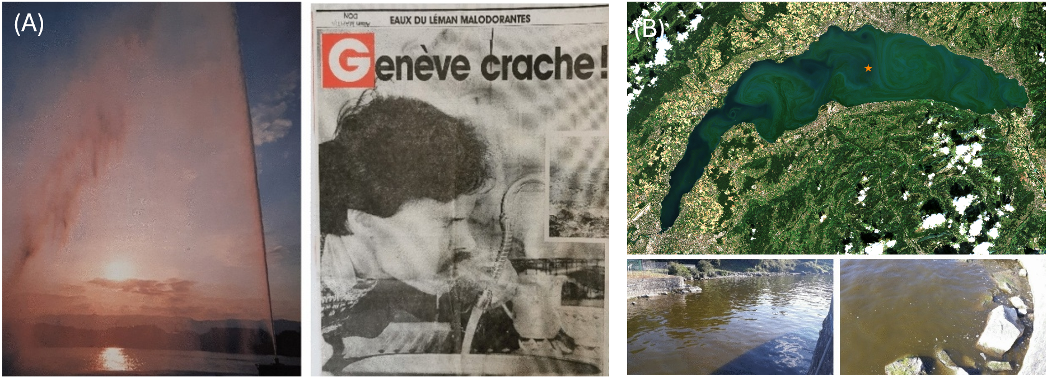
Figure 1: A) The bloom of Rhodomonas minuta and its impact include not only ecological disruptions but also a significant deterioration in water quality, resulting in a bad taste and odour in tap water. This affects the overall usability of water for consumption and other domestic purposes. On the left, the Geneva water jet colored by the presence of R. minuta. ©La Suisse. On the right, a news paper cover showing a person drinking tap water contaminated with R. minuta. ©Lémaniques (Jacquet et al., 2026, Figure 5) B) Bloom of Uroglena sp. in Lake Geneva visible across the entire lake and from space. At the top, true-color image with sampling station SHL2 (adapted), obtained from one of the Euro pean Space Agency’s Sentinel-2 Earth observation satellites developed under the Copernicus program, on September 6, 2021 (©Copernicus). At the bottom, photographs (©sjacquet) taken in Thonon-les-Bains, in front of INRAE CARRTEL, on the same day. Each milliliter of surface water contained several hundred to thousands of Uroglena sp. cells (Jacquet et al., 2026, Figure 6, adapted).
A bloom of Uroglena sp. in September 2021, while largely harmless, led to a bad odor and displeasing brown color of the water (Figure 1, B), impacting recreational activities around the lake (Irani Rahaghi et al., 2024; Jacquet et al., 2026). However, while its extent was evident from satellite imagery, the bloom could be hardly observed at the SHL2 monitoring station, which is situated in an area where there was relatively clear water (Jacquet et al., 2026).
While these constituents have wide-ranging ecological and biogeochemical significance, this thesis does not aim to assess impacts on ecosystem health, services, or the link of constituents to various bio-geochemical processes. Rather, it aims to contribute by providing novel insights on how spaceborne remote sensing (RS) can help quantify constituents in lakes.

1.3 Remote sensing as a monitoring tool
For the monitoring of water quality, spaceborne RS is a valuable tool complementary to in situ measurements: While in situ data can provide point-based, high-quality measurements, RS can provide a coarser estimates with broader spatial and temporal context (Giardino et al., 2019; Kiefer et al., 2015).
The Sentinel 3 (S3) Ocean and Land Color Instrument (OLCI) offers promising capabilities for aquatic remote sensing. It combines a near-daily revisit frequency with 21 spectral bands (400–1020 nm), a spatial resolution of 300 m, and a radiometric depth of 12 bits, as well as improved signal-to-noise performance (EUMETSAT, 2018).

1.4 Remote sensing of Case 2 waters
The RS of optically complex (“Case 2”) waters has gained increasing attention in recent years as sensors specifically designed for water applications such as S3 OLCI have become available (Giardino et al., 2019).
Compared to marine (“Case 1”) waters the RS of Case 2 waters, which includes inland water bodies and coastal areas, is more difficult since constituents are not closely correlated and highly diverse (IOCCG, 2000). This diversity is visually apparent across globally distributed Case 2 waters (Figure 2), from sediment-dominated deltas to phytoplankton-dominated lakes.
Giardino et al. (2019) list three major difficulties for multispectral spaceborne RS of (optically deep) Case 2 waters:
- Ill-posedness: The number of retrieved variables (implicitly also including atmospheric parameters) is often higher than the number of available bands. Further, constituent groups (see Section 1.4.1) can be highly divers in their optical properties.
- Water bodies are very dark, with the fraction of reflected light being in the order of 1%. Hence, instrument noise and AC errors disproportionally affect the retrieved spectra when compared to land applications.
- Masking effect: If one constituent dominates over the others, it is difficult to quantify the others.
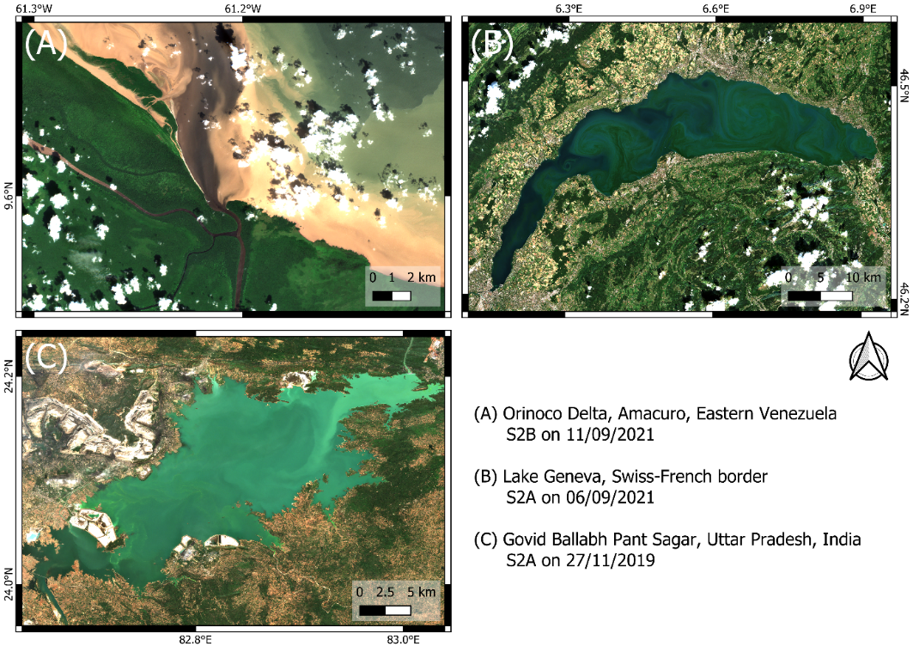
Figure 2: True-color Level 2 Sentinel 2 A/B (S2A/S2B) example images of OACs in Case-2 waters (©Copernicus). The same scaling of the 490, 560, and 665 nm bands was applied to all images. (A) Large quantities of suspended and dissolved matter in Orinoco Delta, Eastern Venezuela (B) Bloom of Uroglena sp. phytoplankton species in Lake Geneva (C) Suspended ash particles originating from coal plants in Govid Ballabh Pant Sagar (Rihand Dam), Uttar Pradesh, India.

1.4.1 Optically active constituents
RS can detect three general types of optically active constituents (OACs, constituents that absorb or scatter light), namely phytoplankton pigments, CDOM, and NAP (Bi et al., 2023; Gege, 2004; Giardino et al., 2012). While CDOM represents dissolved matter, NAP and phytoplankton are suspended and thus in their sum referred to as total suspended matter (TSM) or suspended particulate matter (IOCCG, 2000). Since the concentration of NAP is usually at least one order of magnitude higher than the concentration of phytoplankton pigments, NAP and TSM are sometimes used interchangeably.
The main phytoplankton pigment is CHL. It is used as a proxy for the detection of algal blooms and for the calculation of primary production (IOCCG, 2000). Optically, CHL is mainly distinguished by two absorption peaks in the blue and red respectively, which gives it its greenish color (Gege, 2004). Accessory pigments such as chlorophyll b or phycocyanin can help distinguish different phytoplankton taxa (Babin, Stramski, et al., 2003; Detoni et al., 2026; Maire et al., 2025).
NAP includes minerals, such as sediments and carbonate particles, but also organic particles such as dead and decaying phytoplankton cells or degraded organic matter from terrestrial inputs (Roesler, 2021). These particles scatter light back to the sensor, which at high concentrations results in relatively bright water color (Figure 2, C).
CDOM can be of diverse chemical composition, impacting its optical properties (Griffin et al., 2018). Allochthonous CDOM originates from outside the Lake, i.e. “from terrestrial vegetation and soil sources (Brandão et al., 2018, p. 2932)”, while autochthonous CDOM is produced in situ from phytoplankton. CDOM is usually associated with strong absorption in the ultraviolet and blue wavelengths (Brandão et al., 2018; Griffin et al., 2018), resulting in brownish water color (Figure 2, A).
Other constituents may also be of interest for the assessment of water quality. In Lake Geneva, spaceborne retrievals of TSM have been used to detect whiting events (see Nouchi, 2018). Such whiting events can occur due to calcite precipitation, which is suspected to be linked to the net CO₂ outgassing of many large lakes globally (Many et al., 2024). Further, TSM can originate from particulate pollution, such as ash from coal-fired power plants (see Figure 2, C). On a more global scale, decreased turbidity levels in typically turbid lakes during the COVID19 lockdown could be attributed to reduced anthropogenic inputs (D. Wu et al., 2026). High CDOM concentrations can lead to issues with water treatment and have been associated with the mobilization of metals (Griffin et al., 2018).

1.4.2 Inherent and apparent optical properties
Along with the signal of natural water, OACs determine the optical properties of a water body (Odermatt & Gege, 2022). These properties can be apparent (AOPs) or inherent (IOPs). AOPs are dependent on the ambient light field in a medium and thus influenced by the sun and observation geometry while IOPs are not (Ansari et al., 2025; Bi et al., 2023). AOPs include different radiance, irradiance and reflectance terms, and can be related to IOPs through physical modelling (see Albert & Mobley, 2003).
In the context of spaceborne RS of water bodies, $R_{rs}\left(λ\right)$ is the main AOP used for the retrieval of OACs. It is defined as the ratio of upwelling radiance to downwelling irradiance. IOPs include scattering, backscattering, absorption, and attenuation as well as terms derived from these quantities such as the single scattering albedo. IOPs are directly related to a waterbody’s optical properties, i.e. OAC concentrations (Albert & Mobley, 2003; Bi et al., 2023; Gege, 2004).
Bio-optical models relate OACs, IOPs, and AOPs based on physical modelling. To relate OACs to IOPs, bio optical models employ so-called specific inherent optical properties (SIOPs), which relate IOP spectra to constituent concentrations (Gege, 2004; Giardino et al., 2012). The most famous SIOP is the “Bricaud curve” (Bricaud et al., 1995) which relates CHL to phytoplankton absorption and is still widely used. Since the concentration-specific absorption of CDOM varies strongly, CDOM abundance is usually simply expressed as the CDOM absorption at 440 nm (Giardino et al., 2019). The conversion of IOPs to AOPs such as $R_{rs}\left(λ\right)$is largely based on the work of Albert & Mobley (2003).

1.5 Constituent retrievals: State of research
For constituent retrievals in Case 2 waters using spaceborne RS, mostly (semi-) empirical or semi-analytical models are applied, approximating bio-optical relationships between AOPs, IOPs, and OACs (Giardino et al., 2019). These models usually retrieve one constituent at a time (Odermatt et al., 2012). Often these models were originally developed for Case 1 waters. For CHL, the most notable such models are the Ocean Color (OCx) algorithms which quantify CHL based on blue-to-green reflectance ratios (O’Reilly et al., 1998). Similar empirical and semi-analytical algorithms exist for the retrieval of TSM (e.g. the commonly used “Nechad algorithm”, see Nechad et al., (2010)) and CDOM.
While such TSM and CHL algorithms have been successfully applied for a variety of water types, retrievals of CDOM have been less successful and are usually constrained to highly concentrated waters (Odermatt et al., 2012). Current research of OAC retrievals has increasingly focused on machine learning techniques (see e.g. Werther et al., 2022). As this thesis is not directly concerned with empirical and semi-analytical algorithms, the reader is directed to Giardino et al. (2019) and Odermatt et al. (2012) who have reviewed different kinds of retrieval algorithms extensively.
While empirical and semi-analytical models charm with their relative simplicity, in Case 2 waters they are constrained in their application due to the varying background signals of other constituents (Giardino et al., 2019). To provide good results, location-specific calibration is needed (Bonnier et al., 2024).
For constituent retrievals, bio-optical models invert AOPs, such as $R_{rs}\left(λ\right)$. The two main bio-optical models available for the inversion of OACs from satellite $R_{rs}\left(λ\right)$ are WASI and the Bio-Optical Model Based tool for Estimating water quality and bottom properties from Remote sensing images (BOMBER) (Gege, 2004; Giardino et al., 2012). Since BOMBER is an add-on to the subscription-based ENVI software (Giardino et al., 2012) and WASI is a free stand-alone software this thesis focuses on WASI, though it should be noted that both share the same core of bio-optical equations (see Gege, 2004). Bio-optical models promise more global applicability and the distinction of signals originating from different constituents. Recently, the inversion of spectrometric in situ $R_{rs}\left(λ\right)$ measurements has revealed promising capabilities for phytoplankton taxa retrievals, going beyond the simple retrieval of CHL, NAP, and CDOM (see Detoni et al., 2026; Maire et al., 2025).
Large-scale application of WASI and BOMBER to satellite data have been insufficiently explored, as such an exercise is computationally expensive. As an example, inverting a single Sentinel-2 image using WASI’s image module WASI-2D (see Gege (2014), thereafter referred to as WASI for brevity) takes over 24 hours for Lake Geneva (own assessment) an approximately 20 hours for Lake Garda (Niroumand-Jadidi & Gege, 2025).
Further, these models need reasonable input parameters for the convergence of the minimization algorithm, especially under ill-posed conditions (Gege, 2004; Giardino et al., 2019). The WASI-AI module (Niroumand-Jadidi & Gege, 2025) aims to overcome long processing times of WASI by training a small neural network on a sample of a few hundred pixels inverted using the “regular” WASI module. However, this study observed that the performance of WASI-AI is strongly dependent on proper convergence of the training pixels (Appendix 1).
Other limitations to bio-optical model retrievals are connected to SIOPs which can vary throughout space and time. Hence, studies may use approximations of SIOPs measured close to satellite overflights for retrievals or long term lake averages (see e.g. Giardino et al., 2014; Niroumand-Jadidi et al., 2022). While this provides a more accurate parametrization of the radiative transfer equations, measurements cannot be taken for every overflight, and long term averages may change. This poses further challenges to a more operational application of such retrievals.
Table 1: Literature review of studies that retrieved OACs using WASI or BOMBER. The literature review was conducted by a thorough keyword search of SCOPUS and the publication histories of major WASI and BOMBER contributors (i.e. Peter Gege, Milad Niroumand-Jadidi, Claudia Giardino, Mariano Bresciani). Listed studies do not include OAC retrievals in shallow water conditions.
Study | Satellite & # images | OACs, IOPs, AOPs | Optically deep Case 2 waters
BOMBER
Niroumand-Jadidi et al. (2022) | Sentinel-2, N=9  Landsat-9, N=9 | CHL, TSM | Trasimeno, Maggiore, Varese, Mantova, San Francisco Bay
Niroumand-Jadidi et al. (2020) | Sentinel-2, N=5 | CHL | Mantua Lakes
Giardino et al. (2014) | MODIS, N=1  Landsat-8, N=1 | CHL, TSM, CDOM, $R_{rs}\left(λ\right)$ | Garda
Fabbretto et al. (2023) | PRISMA, N=2 | CHL, TSM | Mulargia, Peipsi
Pinardi et al. (2018) | Sentinel-2, N=3 | CHL | Mantua Lakes
WASI
Dörnhöfer et al. (2016) | Sentinel-2, N=1 | TSM, b_{b},_{TSM}(550), CDOM, $R_{rs}\left(λ\right)$ | Starnberg
Hernando et al. (2024) | PRISMA, N=1  Sentinel-2, N=1 | CHL | Taal
Niroumand-Jadidi et al. (2021) | Sentinel-2, N=80 | CHL | Garda, Ledro, Idro, Trasimeno
Table 1 compiles past research of constituent retrievals using spaceborne sensors and bio-optical models WASI and BOMBER. The literature review revealed several research gaps:
- Most studies only considered a relatively small number of images (<10 images). They often constitute proof of concept, focusing on accurate parametrization for the day and location, sometimes employing sampling day SIOPs. The study by Niroumand-Jadidi et al. (2021) is an exception, validating CHL for 80 images.
- Past studies validate an incomplete set of OACs, IOPs, and AOPs with a clear focus on CHL. Notably, $R_{rs}\left(λ\right)$ is rarely validated, although one of the major sources of errors for such an exercise (Giardino et al., 2019).
- Multispectral studies are limited to Sentinel-2, Landsat-8/9, and MODIS and do so far not include S3. These missions were primarily designed for land applications (Giardino et al., 2019). S3 OLCI, specifically designed with water applications in mind, provides several advantages, such as higher spectral and temporal resolution as well as improved SNR (EUMETSAT, 2018).
- Past studies assume CHL as a single proxy for phytoplankton abundance. Retrievals of individual phytoplankton taxa, as e.g. demonstrated by Maire et al. (2025), have largely not been attempted from space using these models.
- Although it is the largest peri-alpine lake, no study has evaluated retrievals for Lake Geneva.

1.6 Objectives
Given the current state of research in spaceborne bio-optical constituent retrievals, this thesis aims to bridge the gap between custom singular image retrievals and automated, operational processing. It addresses the identified research gaps by validating WASI S3 OLCI retrievals from many valid matchup images (N = 374) against validation data including OACs (CHL, TSM, CDOM, phytoplankton taxa), IOPs (backscattering and absorption) and AOPs ($R_{rs}\left(λ\right)$) in Lake Geneva.
Given computational limitations of WASI (long processing times, limited inversion accuracy under ill-posed conditions), the first goal of this thesis was to develop an identical Python model that addresses these limitations. Further, this thesis answers the following research questions:
Using a default set of SIOPs, how does a WASI-based bio-optical inversion approach using S3 OLCI $R_{rs}\left(λ\right)$…
- …perform in retrieving the three basic water constituents (i.e., TSM, CDOM, CHL) in Lake Geneva?
- …help quantify information about the abundance and biovolume of different phytoplankton taxa in Lake Geneva?

2. Data and Methods

2.1 Study area
Lake Geneva is a clear, large, deep, oligotrophic, and monomictic lake on the northern outskirts of the alps (Kiefer et al., 2015; Moisset, 2017; Nouchi, 2018; see Figure 3). Spanning a total of 580 km², it is located at the border between France and Switzerland, providing drinking water for approximately one million people on both sides of the border. Major settlements on its shore include Geneva and Lausanne which are some of Switzerland’s biggest cities. Geographically, Lake Geneva is divided into the “small lake” (petit lac) and “large lake” (grand lac) with different morphometric characteristics (Moisset, 2017).
Table 2: Lake Geneva and its watershed morphometric characteristics. When available, information is given separately for the whole, large and small lake (Moisset, 2017, Table 1). Note that this study is mainly concerned with the large lake.
Lake characteristic

 | Whole lake | Large lake | Small lake
Superficies [km²] | 580.1 | 498.9 | 81.2
Volume [km³] | 89.0 | 86 | 3
Average depth [m] | 152.7 | 172 | 41
Main tributary [% of input] |  | Rhone river (86%) | La Versoix (1.6%)
Residence time [yr⁻¹] | 11.3
Watershed characteristic

Superficies [km²] | 7419
Main surface use | Agriculture 26%
Due to increased agricultural use of fertilizers and urbanization along with insufficient wastewater treatment, Lake Geneva experienced a period of eutrophication starting in the 1960s, strongly impacting the lake ecosystem. Average phosphorous (P) levels increased from 12.4 μg L⁻¹ in 1957 to 89.5 μg L⁻¹ in 1979. Among a variety of impacts, this led to algal blooms becoming more frequent, especially in summer. To reduce eutrophication the International Commission for the Protection of Lake Geneva (Commission internationale pour la Protection des Eaux du Léman; CIPEL) implemented a variety of P reduction policies. Despite resulting re-oligotrophication, phytoplankton biomass has recently remained stable in both the small and large lake (Jacquet et al., 2026; Moisset, 2017).

2.2 In situ data: sources and sampling stations
Lake Geneva is well adapted for the validation of spaceborne water quality and water constituent products because of its numerous in situ reference data. The reference data used in this study is exclusive to the large lake.
CIPEL regularly monitors a variety of parameters, including CHL and taxa-specific phytoplankton biovolume, at the SHL2 station (46.453N, 6.594E) located at the deepest point of the lake (310 m). This data can be accessed through the Observatory on LAkes (OLA) database (Rimet et al., 2020).
The LéXPLORE platform (46.500N, 6.661E) is a floating research laboratory moored at a depth of 110 m located 570 m from the northern shore (Gupana et al., 2025). Being a collaborative effort of 5 institutions (EPFL, eawag, unige, until, and CARRTEL INRAE-USMB), it provides data for a broad range of limnological research (Minaudo et al., 2021; Wüest et al., 2021).
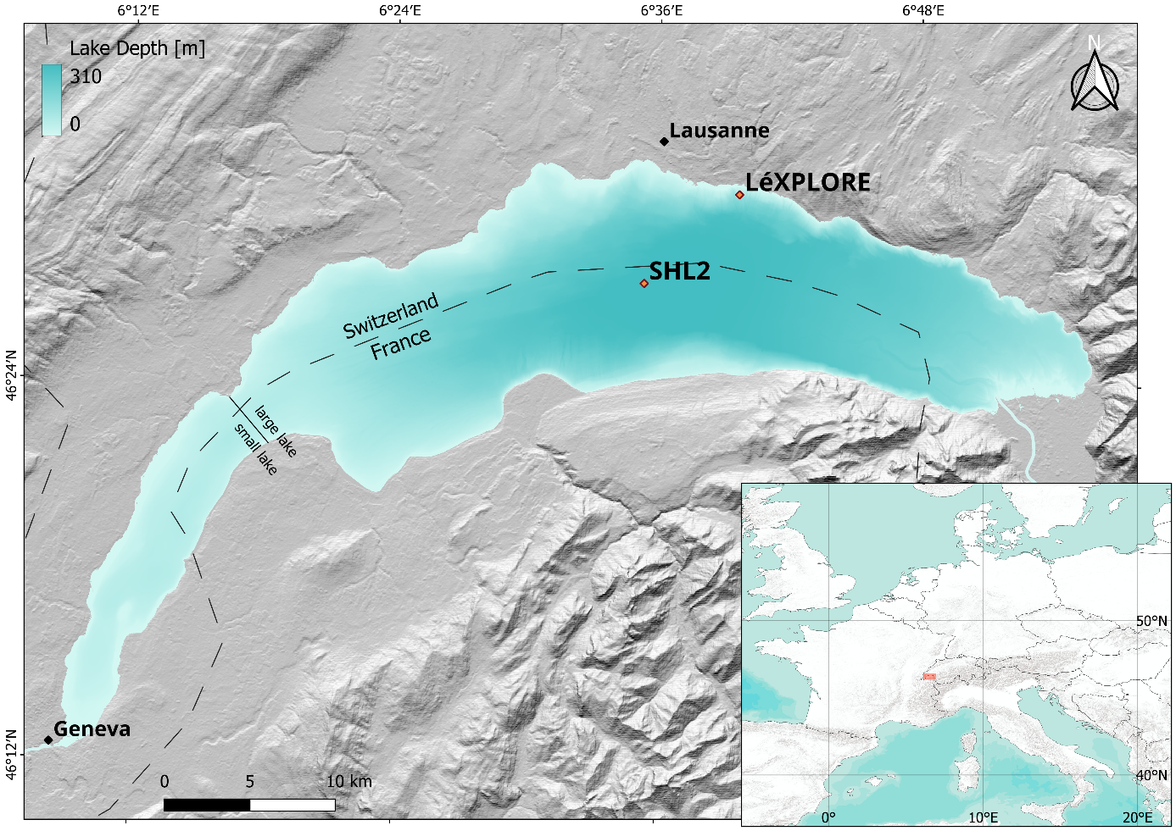
Figure 3: Overview map of Lake Geneva, including location of the sampling station SHL2 and the LéXPLORE platform.
It provides a variety of datasets in near real-time that can be downloaded from the datalakes website (www.datalakes-eawag.ch). The data used in this thesis originates from the autonomous Thetis profiler located 30 meters away from the platform which provides intradaily measurements of various variables such IOPs, fluorometric CHL, and radiometric quantities since 2018 (Minaudo et al., 2021; Wüest et al., 2021). Measurements from the top 50 m of the water column are taken every 3 hours at high vertical resolution (Gupana et al., 2022). The datalakes website provides Level 2 (L2, LéXPLORE Thetis Vertical Profiler Depth Time Grid) products that have been calibrated and quality controlled.
Additionally, three separate campaigns around LéXPLORE carried out by the Swiss Federal Institute of Aquatic Sciences (eawag) in June and May 2021 provide spatially distributed data of CHL and TSM.

2.3 In situ data: validation parameters

2.3.1 AOPs
The remote sensing reflectance $R_{rs}\left(λ\right)$ is the model input and not used for direct model evaluation. However, evaluating AC performance using in situ $R_{rs}\left(λ\right)$ is important to assess algorithm input quality and contextualize satellite retrievals (Giardino et al., 2019; Ogashawara et al., 2021). Thetis in situ $R_{rs}\left(λ\right)$ measurements are derived from in-water upwelling radiance and downwelling irradiance measurements (Table 3).
Table 3: Used measurements obtained from the Thetis profiler (after Gupana et al., 2022; Minaudo et al., 2021).
Measurements | Instrument | # Instrum. Channels | Wavelength Region
Fluorometric Chlorophyll-a | WetLabs ECO Triplet BBFL2W | 3 | 470 (excitation) and 695 (emission)
(Back)scattering | WetLabs ECO Triplet BBFL2W | 3 | 700
(Back)scattering | WetLabs ECO Triplet BB3W | 3 | 440, 532, 630
Absorption | WetLabs AC-S | 81 | 400–730
Upwelling radiance | Satlantic HOCR R08W | 180 | 300–1200
Downwelling irradiance | Satlantic HOCR ICSW | 180 | 300–1200

2.3.2 CHL
A variety of CHL data were acquired for validation (Table 5). This includes data from SHL2, the LéXPLORE platform Thetis profiler, and eawag field campaigns.
At SHL2, water samples collected at nine discrete depths (0, 1, 2.5, 3.5, 7.5, 10, 15, 20, 30 m) are analyzed using a state-of-the-art spectrophotometric approach (ISO10260:1992). Such measurements, denoted CHL_{S}, are taken approximately bi-weekly during summer while winter measurements are rarer.
The Thetis profiler’s WetLabs ECO Triplet BBFL2W instrument (Table 3) provides fluorometric CHL measurements, denoted CHL_{F}. However, fluorometric measurements are highly susceptible to errors due to non-photochemical quenching (NPQ), which has been demonstrated for the Thetis profiler (Gupana et al., 2022).
Gupana et al. (2022) applied a procedure to minimize the effect of different quenching states. Accordingly, CHL_{F} was corrected using a linear relationship with nighttime absorption line height at 676 nm (aLH₆₇₆) measurements, yielding absorption-corrected CHL_{F} (thereafter referred to as CHL_{A}). The original code can be found in the Thetis github repository (https://github.com/LeXPLORE-Platform/thetis-multi-instrument-profiler).
aLH₆₇₆ is a reliable proxy for CHL (Boss et al., 2013; Bricaud et al., 1995; Minaudo et al., 2021) and was thus also used for CHL validation. According to Figure S3 (Appendix 2) of the supplementary material of Minaudo et al. (2021), the local relationship between aLH676 and CHL_{F} not affected by NPQ can be approximately described as:
$$\begin{aligned}aLH_{676}≈0.0132×{CHL}_{F}+0.0033\#\left(1\right)\end{aligned}$$
When aLH₆₇₆ is converted to a CHL concentration (i.e. for the comparison of absolute values) it is thereafter referred to as $aLH_{676}→CHL$ to stress the uncertainties that may entail such a conversion. Solving Equation 1 for CHL_{F}, the conversion is as follows:
$$\begin{aligned}aLH_{676}→CHL&≈\frac{aLH_{676}-0.0033}{0.0132}\#\left(2\right)\end{aligned}$$
Phytoplankton concentration was also inverted from hyperspectral $R_{rs}\left(λ\right)$ (thereafter denoted CPHY_{R}, see Section 2.9).
A limited number of High-Performance Liquid Chromatography (HPLC) measurements, denoted CPHY_{HPLC} when including all pigments and CHL_{HPLC} when only including CHL, are available from three eawag field campaigns. These samples were collected around LéXPLORE at 0.5 m below the water surface as well as at the measured Secchi disk depth.

2.3.3 Phytoplankton
Phytoplankton abundance and biovolume are sampled concurrently with CHL_{S} from a water mixture sample of the first 18 m (Rimet et al., 2020). The dataset includes 225 genera which were classified into seven different groups (chrysophyceae, cryptophyta, cyanobacteria, diatoms, dinoflagellates, green algae, others) using phytoplankton databases (www.algaebase.org, https:/diatoms.org, www.ccap.ac.uk). “others” includes 6 genera part of a rare group (Choanoflagellates, Dictyochophyceae, Phaeothamniophyceae) and 13 genera that could not be classified. Note that these groups will thereafter be referred to as taxa, even though they do not necessarily refer to a taxonomic group.
While phytoplankton abundance and biovolume cannot be directly compared with phytoplankton pigment concentrations, they are expected to be correlated (Maire et al., 2025).

2.3.4 TSM and CDOM
A limited amount of TSM data was available from three eawag field campaigns around LéXPLORE (Table 5). TSM concentration was measured from water samples using a standard 1.5 µm glass fiber filter. Samples were taken 0.5 m below the water surface as well as at the measured Secchi disk depth.
Analogue to CPHY_{R}, TSM and CDOM were inverted from hyperspectral in situ $R_{rs}\left(λ\right)$, denoted TSM_{R} and CDOM_{R} respectively.

2.3.5 IOPs
For Thetis L2 products, absorption is limited to few wavelengths. However, for our validation study, the full spectrum measured by the WetLabs AC-S (Table 3) is of interest. Hence, the Thetis repository was cloned from GitHub and the full archive was re-processed to include hyperspectral constituent absorption $a_{wc}\left(λ\right)$. Note that Thetis processing removes pure water absorption.
For the same products, scattering at 440, 532, 630, and 700 nm measured at 117° is converted to backscattering and corrected for pure water contribution ($b_{b,\text{wc}}^{ }\left(440\right)$, $b_{b,\text{wc}}^{ }\left(532\right)$, $b_{b,\text{wc}}^{ }\left(630\right)$, and $b_{b,\text{wc}}^{ }\left(700\right)$) as described in the supplementary material of Minaudo et al., (2021). Although these wavelengths do not match S3 wavelengths, the values are expected to strongly correlate with adjacent S3 wavelengths since backscattering in WASI is spectrally smooth.

2.3.6 Auxiliary data
The Secchi depth, measured alongside CHL_{S} and Phytoplankton biovolume and abundance, was used to analyze matchup representativeness of CHL_{S} vertical distribution.

2.4 In situ data: additional quality control
Standard Thetis processing includes basic quality control, i.e. physically reasonable range checks and despiking (for depth-resolved measurements, unreasonable outliers along the depth dimension are removed).
Hyperspectral measurements, i.e. $R_{rs}\left(λ\right)$ and $a_{wc}\left(λ\right)$, were filtered for spikes in the spectral domain. To detect spikey spectra, “spectral roughness” was calculated as the normalized mean absolute second derivative according to Equation 3, taking $R_{rs}\left(λ\right)$ as an example,
$$\begin{aligned}spectral roughness=\frac{\sum_{i=1}^{N}{\left|\frac{d^{2}R_{rs}\left(λ_{i}\right)}{dλ^{2}}\right|}}{\sum_{i=1}^{N}{\left|R_{rs}\left(λ_{i}\right)\right|}}\#\left(3\right)\end{aligned}$$
where $N$ is the number of valid spectral bands after removing NaN values. Data with gaps (>10 nm), extremely low values (<0.001 at all wavelengths) and spikes (spectral roughness > 0.001 for $a_{wc}\left(λ\right)$ and spectral roughness > 0.002 for $R_{rs}\left(λ\right)$) were consequently removed. $a_{wc}\left(λ\right)$ that made previous checks were additionally smoothed using a Savitzky-Golay (Savitzky & Golay, 1964) filter (5-point window, 2nd-order polynomial).
Note that aLH₆₇₆ was not calculated based on re-processed and additionally filtered $a_{wc}\left(λ\right)$ but retained as the original Thetis product to ensure consistency with earlier studies (i.e. Gupana et al., 2025; Werther et al., 2022). Additional quality control constrained backscattering to the range [0.0001, 0.1 m⁻¹] and CHL proxies to the range [0, 50 mg m⁻³].
Data at SHL2 is extensively reviewed by CIPEL (Rimet et al., 2020). Relatively frequently, gaps in the vertical column were observed for CHL_{S} (e.g. due to earlier quality control or missing measurements). Such measurements were not removed to maintain a relatively large number of matchups. In-house campaign data was visually inspected: no removal of measurements was deemed necessary.

2.5 Satellite data: acquisition and processing
Sentinel 3A (S3A) and Sentinel 3B (S3B), collectively referred to as S3, are two EO satellites operated by ESA, launched in February 2016 and April 2018 respectively. On board, the imaging multispectral radiometer OLCI captures 21 bands at 300 m spatial resolution. Since the launch of S3B, the combined revisit time is less than a day for the study area. Of these 21 bands 11 are designed to support water constituent retrieval while the others are most useful for atmospheric correction (EUMETSAT, 2018; Table 4).
Table 4: Sentinel 3 OLCI Marine User Handbook band description. Wavelengths suited for phytoplankton or chlorophyll a retrievals (excluding fluorescence) are marked green. Oa9 is not available for POLYMER outputs. Table 1 adapted from EUMETSAT (2018), p. 20.
Band number | Central wavelength [nm] | Spectral width (FWHM) [nm] | Main function
Oa1 | 400 | 15 | AC, improved water constituent retrieval
Oa2 | 412.5 | 10 | CDOM and detrital pigments
Oa3 | 442.5 | 10 | CHL absorption maximum
Oa4 | 490 | 10 | High CHL and other photosynthetic pigments
Oa5 | 510 | 10 | CHL, TSM, turbidity and red tides
Oa6 | 560 | 10 | CHL reference (minimum)
Oa7 | 620 | 10 | TSM
Oa8 | 665 | 10 | CHL (2nd absorption maximum), TSM and CDOM
Oa9 | 673.75 | 7.5 | Improved fluorescence retrieval
Oa10 | 681.25 | 7.5 | CHL fluorescence peak
Oa11 | 708.75 | 10 | CHL fluorescence baseline
Oa12 | 753.75 | 7.5 | O₂ (oxygen) absorption and clouds
Oa13 | 761.25 | 2.5 | O₂ absorption band and AC aerosol estimation
Oa14 | 764.375 | 3.75 | AC
Oa15 | 767.5 | 2.5 | O₂ A-band absorption band used for cloud top pressure
Oa16 | 778.75 | 15 | AC aerosol estimation
Oa17 | 865 | 20 | AC aerosol estimation, clouds and pixel co-registration
Oa18 | 885 | 10 | Water vapour absorption reference band
Oa19 | 900 | 10 | Water vapour absorption
Oa20 | 940 | 20 | Water vapour absorption, linked to AC
Oa21 | 1020 | 40 | AC aerosol estimation
Level 1 images (L1 S3 OLCI EFR) were atmospherically corrected using the POLYMER radiative transfer model, which has been shown to perform best for Lake Geneva (Gupana et al., 2025). POLYMER performs AC by (1) applying corrections to the top-of-atmosphere reflectance $ρ_{TOA}$ that can be reliably quantified (i.e. Rayleigh scattering, gaseous absorption, main sun-glint component) and (2) fitting the remaining top-of-atmosphere signal with a spectral optimization. It decomposes the remaining $ρ_{TOA}$ into (a) an atmospheric and (residual) glint component modeled as a simple polynomial and (b) a bio-optical water reflectance model. It iteratively adjusts both so their combined spectrum best matches the measured reflectance across all wavelengths (Steinmetz et al., 2011). Bad pixels (such as invalid pixels, clouds, mountain shadows, and non-water body areas such as land, snow, and ice) were masked using the IdePix processor (Wevers et al., 2022), resulting in quality-controlled Level 2 (L2) POLYMER products. Images of less than 2000 (i.e. less than roughly 25% valid pixels) were discarded.
All image processing, including data acquisition and AC, was done using the Sencast toolbox developed at eawag (Odermatt et al., 2020).

2.6 Matchups
The number of valid matchups per reference dataset is shown in Table 5. In this thesis, a valid matchup is defined as a sample paired with an image >2000 pixels where the sampling station pixel is valid. A sample refers to a measurement (or multiple measurements at different depths) of a variable at a specific day and location. Note that for Thetis matchups the pixel south of the LéXPLORE platform is used to avoid contamination of image $R_{rs}\left(λ\right)$. If both S3A and S3B are valid matchups, two valid matchups are added to the count.
Table 5: In situ reference data for model validation: CPHY_{HPLC}: Total pigment concentration from HPLC analysis, CHL_{HPLC}: Chlorophyll a concentration from HPLC analysis, TSM: Gravimetrically determined total suspended matter concentration, CHL_{S}: Chlorophyll a concentration from spectrophotometry, CHL_{F}: Chlorophyll a concentration from fluorometry, CHL_{A}: Absorption-corrected CHL_{F}, aLH₆₇₆: Absorption line height at 676 nm, aLH₆₇₆→CHL: aLH₆₇₆ converted to CHL, CPHY_{S3}: Phytoplankton concentration inverted from in situ $R_{rs}\left(λ\right)$, NAP_{R}: Non-algal particle concentration inverted from in situ $R_{rs}\left(λ\right)$, CDOM_{R}: Colored dissolved organic matter absorption at 440 nm inverted from in situ $R_{rs}\left(λ\right)$. $a_{wc}\left(λ\right)$: Hyperspectral constituent absorption, $b_{b,wc}\left(wvl\right)$: Constituent backscattering (at wavelength “wvl”). In situ reference data for model input validation: $R_{rs}\left(λ\right)$: Hyperspectral remote sensing reflectance.
In-situ Reference Data | # In-situ Samples | # Valid Matchups  (S3A & B) | Time Range
eawag field campaigns
CPHY_{HPLC} & CHL_{HPLC} | 18 | 29 | 2021
TSM | 18 | 29 | 2021
SHL2
CHL_{S} | 159 | 42 | 2016 – 2023
Phytoplankton abundance | 156 | 40 | 2016 – 2023
Phytoplankton biovolume | 156 | 40 | 2016 – 2023
LéXPLORE Thetis profiler
CHL_{F} | 1125 | 326 | 2018 – 2025
aLH₆₇₆ & aLH₆₇₆→CHL | 1031 | 299 | 2018 – 2025
CHL_{A} | 1031 | 309 | 2018 – 2025
CPHY_{R} | 1035 | 215 | 2018 – 2025
NAP_{R} | 1035 | 215 | 2018 – 2025
CDOM_{R} | 1035 | 215 | 2018 – 2025
$$a_{wc}\left(λ\right)$$ | 1031 | 146 | 2018 – 2025
$$b_{b,wc}\left(700\right)$$ | 1042 | 326 | 2018 – 2025
$$b_{b,wc}\left(630\right)$$ | 1042 | 327 | 2018 – 2025
$$b_{b,wc}\left(532\right)$$ | 1042 | 325 | 2018 – 2025
$$b_{b,wc}\left(440\right)$$ | 1042 | 325 | 2018 – 2025
$R_{rs}\left(λ\right)$ | 1035 | 215 | 2018 – 2025

2.7 Methods: overview
Atmospherically corrected and quality-controlled S3 images are inverted using the Minimal WASI deep-water model (MiniWASI; Section 2.8). The inversion aims at retrieving seven unknown constituents using SIOPs of NAP and CDOM as well as five phytoplankton taxa-specific SIOPs (cryptophyta, cyanobacteria, diatoms, dinoflagellates, green algae).
To assess the retrieval of CHL the five retrieved taxa concentrations are summed, resulting in a total phytoplankton concentration CPHY_{S3} (Figure 4). The resulting WASI-derived maps are evaluated by comparison with matchup in situ measurements (Table 5) at corresponding sampling stations. Detailed descriptions of the bio-optical model configuration, the full processing chain, and the validation procedure are provided in Sections 2.8 – 2.10.
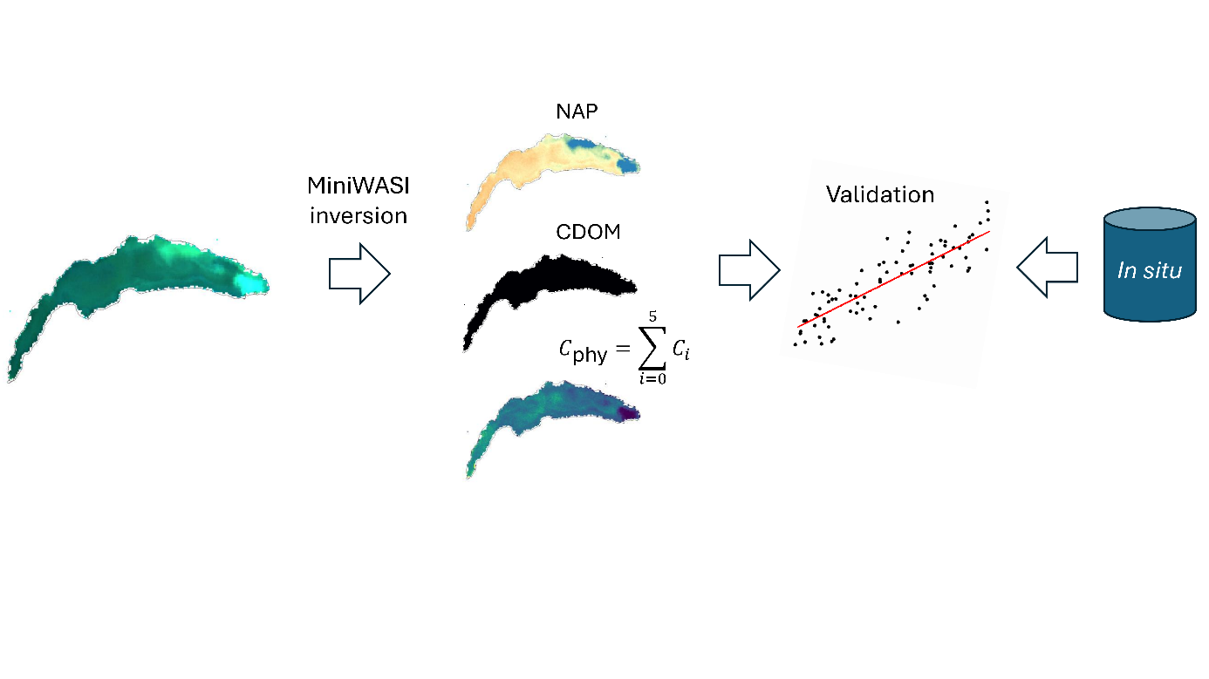
Figure 4: Schematic overview for the validation of the three basic constituents.

2.8 Bio-optical model MiniWASI
MiniWASI is a minimal Python clone of the WASI deepwater model developed by Peter Gege (Gege, 2004; Gege, 2014). MiniWASI was specifically designed for operational constituent retrieval from satellite images in optically deep Case 2 waters. It uses the lmfit (Non-Linear Least-Squares Minimization and Curve Fitting for Python) library for inversion (Newville et al., 2025) which allows it to be faster and more accurate in minimization (Appendix 1).
Radiative transfer model inversion relies on a forward model that simulates the observed signal as a function of constituent concentrations. In WASI, $R_{rs}\left(λ\right)$ is modeled as a function of constituent concentrations and associated SIOPs that convert these concentrations to IOP (backscattering and absorption) values. IOPs are related to AOPs such as $R_{rs}\left(λ\right)$ using established equations commonly used in water optics (Albert & Mobley, 2003). An initial estimate yields a forward-modeled $R_{rs}\left(λ\right)$ that is compared to the observed (e.g. satellite) $R_{rs}\left(λ\right)$. The residuals between modeled and observed $R_{rs}\left(λ\right)$ are minimized by iteratively adapting constituent concentrations in the forward model. This so-called inverse problem is solved using a minimization algorithm (see Section 2.8.2).

2.8.1 Forward model
The MiniWASI forward model is based on the WASI (Version 7) manual (Gege, 2024). It follows the WASI deepwater model for Case 2 waters, barring some limitations outlined in this Section. The reference Equations in the manual are given in Table 6. For a complete overview of WASI, this thesis refers to the most recent version of the WASI manual (e.g. Gege, 2024). While this section provides the general model formulation, the exact model parametrization is presented in Section 2.8.3. Reference wavelengths of SIOPs match WASI defaults and are fixed in MiniWASI.
To account for absorption by natural water, a pure water absorption coefficient spectrum at 20°C is read for file (original data from Kou et al., 1993; Lu, 2007; Pope & Fry, 1997; Wang, 2008; Warren, 1984).
$$\begin{aligned}{a_{w,T}\left(λ\right)=a}_{w}\left(λ\right)+\left(T-T_{0}\right)\frac{∂a_{w}\left(λ\right)}{∂T}, T_{0}=20°C\#\#\left(4\right)\end{aligned}$$
This spectrum $a_{w}\left(λ\right)$ [m⁻¹] is corrected using a gradient [m⁻¹ °C⁻¹] (also read from file) scaled by the temperature difference to the reference (Röttgers et al., 2013).
The CDOM absorption coefficient can be modeled as an exponential function (Bricaud et al., 1981; Carder et al., 1989),
$$\begin{aligned}a_{\text{CDOM}}\left(λ\right)=C_{y} a_{\text{CD}\text{OM}}^{n}\left(λ\right), a_{\text{CDOM}}^{n}\left(λ\right)=\exp\left[-S_{\text{CDOM}}\left(λ-440\right)\right]\#\left(5\right)\end{aligned}$$
where $C_{y}$ denotes the CDOM absorption coefficient at 440 nm [m⁻¹], which is assumed to be a proxy for CDOM abundance. The absorption coefficient equals the product of $C_{y}$ and a normalized absorption spectrum $a_{\text{CDOM}}^{n}\left(λ\right)$ dependent on the slope parameter $S_{\text{CDOM}}$ [nm⁻¹]. A gaussian approximation of the normalized absorption spectrum representative of Lake Constance can also be read from file.
The phytoplankton absorption coefficient [m⁻¹] and concentration [mg m³] is the sum of up to six classes ($C_{0}$ – $C_{5}$). For a class, the corresponding absorption coefficient is the product of concentration $C_{i}$ and its spectral absorption per unit pigment concentration [m² mg⁻¹]:
$$\begin{aligned}a_{\text{phy}}\left(λ\right)=\sum_{i=0}^{5}{C_{i}} ⋅a_{\text{phy},i}^{*}\left(λ\right), C_{\text{phy}}=\sum_{i=0}^{5}{C_{i}} \#\left(6\right)\end{aligned}$$
$C_{0}$ is connected to a mixture spectrum representative of the phytoplankton taxa present in Lake Constance during the 1990s (Heege, 2000). The other five classes represent a single (dominant) taxa, namely cryptophyta (original data from Soppa et al. 2020, unpublished), cyanobacteria (original data from Xi et al., 2017), diatoms, dinoflagellates, and green algae (Gege, 2012). The different taxa and their pigment-specific absorption spectra can be found in Figure 5.
The NAP absorption coefficient can be formulated as an exponential function (Babin, Stramski, et al., 2003):
$$\begin{aligned}a_{\text{NAP}}\left(λ\right)=C_{\text{NAP}}⋅a_{\text{NAP}}^{*}\left(λ\right), a_{\text{NAP}}^{*}\left(λ\right)=a_{\text{NAP}}^{*}\left(440\right)⋅\exp\left[-S_{\text{NAP}}⋅\left(λ-440\right)\right]\#\left(7\right)\end{aligned}$$
$$\begin{aligned}with: C_{\text{NAP}}=C_{\text{X}} + C_{\text{Mie}}\#\end{aligned}$$
It is the product of the concentration $C_{NAP}$ [g m⁻³] and a specific NAP absorption coefficient spectrum. $a_{\text{NAP}}^{*}\left(λ\right)$ is the product of the specific NAP absorption coefficient at 440 nm [m² g⁻¹], and a normalized absorption spectrum with slope $S_{\text{NAP}}$ [nm⁻¹]. In WASI $C_{NAP}$ is the sum of two sub-components with spectrally distinct backscattering (see Equation 11).
The total absorption coefficient is the sum of constituent absorption and the (temperature-corrected) absorption of natural water:
$$\begin{aligned}a\left(λ\right)=a_{w,T}\left(λ\right)+a_{\text{CDOM}}\left(λ\right)+a_{\text{phy}}\left(λ\right)+a_{\text{NAP}}\left(λ\right)\#\left(8\right)\end{aligned}$$
While the absorption coefficient of pure water is mainly temperature dependent, its backscattering coefficient is salinity dependent. The following empirical equation applies (after Morel, 1974):
$$\begin{aligned}b_{b,w}\left(λ\right)=b{\left(\frac{λ}{500}\right)}^{-4.32}\#\left(9\right)\end{aligned}$$
For freshwater the backscattering coefficient $b$ is set to 0.00111 [m⁻¹]. For oceanic water backscattering is higher; for a salinity between 35 and 38 ‰ $b$ is approximately 0.00144 [m⁻¹]. By default, the freshwater configuration is used.
The phytoplankton backscattering coefficient is assumed to be similar for all taxa.
$$\begin{aligned}b_{b,\text{phy}}\left(λ\right)=C_{\text{phy}}⋅b_{b,\text{phy}}^{*}\left(λ\right), b_{b,\text{phy}}^{*}\left(λ\right)=b_{b,\text{phy}}^{*}\left(550\right)⋅b_{\text{phy}}^{N}\left(λ\right)\#\left(10\right)\end{aligned}$$
Hence, it is the product of the total phytoplankton pigment concentration $C_{phy}$ [mg m³] and a specific phytoplankton backscattering spectrum. $b_{b,\text{phy}}^{*}\left(λ\right)$ is the product of the specific phytoplankton backscattering coefficient at 550 nm [m² mg⁻¹], and a normalized phytoplankton scattering spectrum that is read from file (original data from C. Giardino, personal communication with P. Gege).
The NAP backscattering coefficient is described by two spectrally distinct components with concentrations $C_{X}$ and $C_{Mie}$. For Case 2 waters, the backscattering coefficient of NAP is generally considered spectrally flat (Babin, Morel, et al., 2003).
$$\begin{aligned}b_{b,\text{NAP}}\left(λ\right)=C_{x}⋅b_{b,\text{X}}^{*}⋅b_{\text{X}}^{N}\left(λ\right) + C_{\text{Mie}}⋅b_{b,\text{Mie}}^{*}{\left(\frac{λ}{500}\right)}^{-n}\#\left(11\right)\end{aligned}$$
$$with: b_{b,\text{X}}^{*}\left(λ\right)= b_{b,\text{X}}^{*}⋅b_{\text{X}}^{N}\left(λ\right)$$
The backscattering coefficient of $C_{X}$ is the product of the concentration [g m⁻³], the specific backscattering coefficient [m² g⁻¹], and a normalized scattering coefficient spectrum which equals one for all wavelengths. This results in a spectrally flat specific backscattering spectrum $b_{b,\text{X}}^{*}\left(λ\right)$. $C_{Mie}$ is formulated in a similar manner, but its scattering coefficient follows Angström’s law instead, where $n$ is the Angström exponent related to the particle size distribution.
CDOM backscattering is assumed to be negligible and thus not parametrized. The bulk backscattering coefficient is the sum of the constituent and natural water backscattering coefficients:
$$\begin{aligned}b_{b}\left(λ\right)=b_{b,w}\left(λ\right)+b_{b,\text{phy}}\left(λ\right)+b_{b,\text{NAP}}\left(λ\right)\#\left(12\right)\end{aligned}$$
The conversion from IOPs to AOPs implemented in WASI is largely based on the work of Albert & Mobley (2003). The unitless single backscattering albedo can be purely expressed as a function of the calculated IOPs from Equations 8 and 12:
$$\begin{aligned}ω_{b}\left(λ\right)=\frac{b_{b}\left(λ\right)}{a\left(λ\right)+b_{b}\left(λ\right)}, 0≤ω_{b}≤1\#\left(13\right)\end{aligned}$$
It is related to the below-surface remote sensing reflectance $r_{rs}^{-}\left(λ\right)$through the subsurface radiance reflection factor [sr⁻¹],
$$f_{rs}\left(λ\right)=0.0512⋅\left(1+4.6659⋅ω_{b}-7.8387⋅ω_{b}^{2}+5.4571⋅ω_{b}^{3}\right)$$
$$\begin{aligned}⋅\left(1+\frac{0.1098}{\cos\left(θ_{s}^{'}\right)}\right)⋅\left(1+\frac{0.4021}{\cos\left(θ_{v}^{'}\right)}\right)\#\left(14\right)\end{aligned}$$
where $θ_{s}^{'}$ denotes the solar zenith angle in water, $θ_{v}^{'}$ the viewing zenith angle in water, and $θ_{v}$ the corresponding viewing zenith angle in air [rad]. The above water viewing and solar angles, input in degrees, are converted to radians. To compute below-water angles, Snell’s law is applied: $θ_{below}=\arcsin\left(\frac{\sin\left(θ_{above}\right)}{1.33}\right).$
Assuming no contribution by fluorescence, $r_{rs}^{-}\left(λ\right)$ [sr⁻¹] is the product $f_{rs}\left(λ\right)$ and $ω_{b}\left(λ\right)$:
$$\begin{aligned}r_{rs}^{-}\left(λ\right)=f_{rs}\left(λ\right) ω_{b}\left(λ\right)\#\left(15\right)\end{aligned}$$
The conversion from below- to above-water $r_{rs}\left(λ\right)$ requires the calculation of Fresnel reflectance at the air-water interface
$$\begin{aligned}ρ_{L}=\frac{1}{2}\left[\frac{\sin^{2}\left(θ_{v}-θ_{v}^{'}\right)}{\sin^{2}\left(θ_{v}+θ_{v}^{'}\right)}+\frac{\tan^{2}\left(θ_{v}-θ_{v}^{'}\right)}{\tan^{2}\left(θ_{v}+θ_{v}^{'}\right)}\right]\#\left(16\right)\end{aligned}$$
as well as the water-air transmission factor,
$$\begin{aligned}ξ=\frac{\left(1-σ\right)\left(1-ρ_{L}\right)}{{1.33}^{2}}, σ=0.03\#\left(17\right)\end{aligned}$$
where $ρ_{L}$ is the reflectance factor of upwelling radiance just below the water surface, which corresponds to the Fresnel reflectance, and $σ$ the reflection factor for downwelling irradiance with a typical value of 0.03 for cloud-free conditions and moderate solar zenith angles (<45°).
MiniWASI assumes no surface contribution (commonly referred to as sun-glint) to the remote sensing reflectance $r_{rs}\left(λ\right)$ since AC algorithms such as ACOLITE and POLYMER attempt to correct sun glint (Steinmetz et al., 2011; Vanhellemont & Ruddick, 2018). This conveniently eliminates the need for parametrization of the atmosphere. Assuming no sun glint, $r_{rs}\left(λ\right)$ [sr⁻¹] equals the radiance reflectance $R_{rs}\left(λ\right)$ contributed by water. Thereafter, the remote sensing reflectance is denoted as $R_{rs}\left(λ\right)$ and is calculated as follows:
$$\begin{aligned}r_{rs}\left(λ\right)=R_{rs}\left(λ\right)=ξ\frac{r_{rs}^{-}\left(λ\right)}{1-ρ_{u} Q r_{rs}^{-}\left(λ\right)}, ρ_{u}=0.54, Q=5\#\left(18\right)\end{aligned}$$
$ρ_{u}$ is the reflectance factor of upwelling irradiance just below the water surface with a typical value of 0.54. The ill-favored parameter $Q$ [sr] is fixed at 5. It corresponds to the fraction of upwelling irradiance compared to the upwelling radiance:
$$\begin{aligned}Q=\frac{E_{u}^{-}}{L_{u}^{-}}\#\left(19\right)\end{aligned}$$
Its value describes the angular distribution of the light field underwater. Unfortunately, no convenient parametrization of $Q$ exists. Assuming a single constant, wavelength-independent value is not physically accurate (Albert & Mobley, 2003).

2.8.2 Inverse model
MiniWASI uses the lmfit library for inversion. Given a vector of constituent concentrations $x$ lmfit minimizes the residual function:
$$\begin{aligned}\hat{x}=\arg{\min_{x}{\sum_{i}{{\left(f\left(x,λ_{i}\right)-R_{rs}^{\text{measured}}\left(λ_{i}\right)\right)}^{2}}}}\#\left(20\right)\end{aligned}$$
where $f\left(x,λ_{i}\right)$ is the forward model evaluated at wavelength $λ_{i}$, i.e. the modeled remote sensing reflectance $R_{rs}^{\text{modeled}}\left(λ_{i}\right)$, and $R_{rs}^{\text{measured}}\left(λ_{i}\right)$ is the measured (e.g. satellite) remote sensing reflectance. The inversion result $\hat{x}$ is the vector of parameters that best fits the observations in a least-squares sense. Note that $x$ is constrained by minimum and maximum constituent values which are not considered in the formulation of Equation 20 (see Table 7).
MiniWASI, like WASI, allows for the individual weighting of wavelengths. Accordingly, Equation 20 can be modified by adding a weight term:
$$\begin{aligned}\hat{x}=\arg{\min_{x}{\sum_{i}{w_{i}{\left(f\left(x,λ_{i}\right)-R_{rs}^{\text{measured}}\left(λ_{i}\right)\right)}^{2}}}}\#\left(21\right)\end{aligned}$$
where $w_{i}$ is the weight for wavelength $λ_{i}$. Conveniently, this also allows for an easy option to use or not use certain wavelengths (binary weights).
For solving the inverse problem. MiniWASI uses the Levenberg-Marquardt algorithm by default (Levenberg, 1944; Marquardt, 1963). However, any minimization method that is implemented in lmfit can be used, such as the Nelder-Mead algorithm implemented in WASI (Gege, 2004). lmfit also provides an estimate of the standard error for each inverted variable based on the covariance matrix, although such an estimate may not be possible under ill-posed conditions (see https://lmfit.github.io/lmfit-py/parameters.html#lmfit.parameter.Parameter.stderr).

2.8.3 Model parametrization
As outlined in Section 1, this thesis relies on a standard set of SIOPs representative of Lake Constance. Accordingly, for the SIOPs of CDOM, NAP, and bulk phytoplankton backscattering in Equations 4, 6, 9, and 10 the default values in Table 6 are used.
Equations 13 and 15 depend on the viewing zenith angle and the solar zenith angle. These values were input based on the average value of the image. Temperature $T$ is fixed at the default of 20°C since the temperature-dependence of pure water absorption is rather weak. The backscattering coefficient $b$ of pure water is set to 0.00111.
Table 6: References for the MiniWASI equations in the WASI (version 7) manual with lake- and condition-specific parametrization of the equations. For lake-specific parameters, default values for Lake Constance are used.
Equation | Equation(s) in Manual | Lake-specific Parameters | Default Value(s) | Comments
5 | 2.3, 2.4, 2.5 | $$S_{\text{CDOM}}$$ | 0.14
6 | 2.7, 2.8 | - | -
7 | 2.9, 2.10 | $S_{\text{NAP}}$, ${ a}_{\text{NAP}}^{*}\left(440\right)$ | 0.011, 0.041
8 | 2.1, 2.2 | - | -
10 | 2.15 | $$b_{\text{b,phy}}^{*}\left(550\right)$$ | 0.001
11 | 2.16 | $b_{b,\text{X}}^{*}, { b}_{b,\text{Mie}}^{*}$, $n$ | 0.0086, 0.0042. -1 | Case 1 parametrization is not implemented in MiniWASI
12 | 2.11 | - | -
13 | 2.20 | - | -
15 | 2.31 | - | - | MiniWASI does not parametrize fluorescence
17 | 2.36 | - | -
18 | 2.36, 2.34 | - | - | MiniWASI assumes sunglint-corrected data
19 | Not numerated, see manual Page 19 | - | -
 |  | Condition-dependent
4 | 2.1, 2.2 | $T$ | 20 | Since $T_{0}$ also equals 20°C there is no temperature-dependency in the default configuration
9 | 2.14 | $$b$$ | 0.00111 | Standard parametrization assumes fresh water
14 | 2.32 | $θ_{s}$, $θ_{v}$ | 40, 0.001 | Angles [°] are input based on the viewing and sun geometry.
16 | 2.24 | $θ_{s}$, $θ_{v}$ | 40, 0.001 | See comment above
Initial, minimum, and maximum values used for inversion are given in Table 7. For bulk CHL retrieval, the concentration of individual taxa ($C_{1}$ – $C_{5}$) was summed. This was preferred to varying the mixture class $C_{0}$ which is representative of 1990s conditions in Lake Constance and should only be used with care (personal communication with Peter Gege). Conveniently, this also results in a single model configuration for both individual taxon and bulk CHL retrievals. Such an approach has also been employed in a recent study where phytoplankton SIOPs were unknown (see Detoni et al., 2026). Note that the chrysophyceae taxa present in Lake Geneva is not parametrized in WASI and could accordingly not be retrieved.
For NAP retrievals, only $C_{X}$ was varied while $C_{Mie}$ was fixed at zero. To parametrize CDOM absorption, the exponential approximation was used. This is the common approach outlined in literature (Dörnhöfer et al., 2016; Maire et al., 2025; Niroumand-Jadidi & Gege, 2025).
Table 7: MiniWASI initial, minimum, and maximun values. $C_{x}$, $C_{i}$, and $C_{y}$ parametrization is based on the general distribution of in situ data. Since the pigment concentrations of $C_{1}$- $C_{5}$ are not well known, their initial value was set to 1 and their maximum value to that of in situ CHL.
Parameter | Model alias | Vary | Initial | Minimum | Maximum
NAP concentration (X) | $$C_{x}$$ | True | 1 | 0 | 10
NAP concentration (Mie) | $$C_{Mie}$$ | False | 0 | 0 | 0
CDOM absorption coefficient at 440 nm | $$C_{y}$$ | True | 0.1 | 0 | 0.5
Pigment concentration of mixture class | $$C_{0}$$ | False | 0 | 0 | 0
Pigment concentration of cryptophyta | $$C_{1}$$ | True | 1 | 0 | 15
Pigment concentration of cyanobacteria | $$C_{2}$$ | True | 1 | 0 | 15
Pigment concentration of diatoms | $$C_{3}$$ | True | 1 | 0 | 15
Pigment concentration of dinoflagellates | $$C_{4}$$ | True | 1 | 0 | 15
Pigment concentration of green algae | $$C_{5}$$ | True | 1 | 0 | 15
Initial values and bounds were set based on the distribution of the in situ data where available. Setting reasonable initial values is important: If the initial values are far off, the minimization algorithm may not converge. Further, to avoid unreasonable values, the range of constituent concentrations should be constrained (Gege, 2004). The effect of initial values and the general minimization accuracy of WASI and MiniWASI are further discussed in Appendix 1.
Since the inversion of phytoplankton pigment concentrations and CHL proved to be unstable, only the bands which are affiliated with CHL or other phytoplankton pigments were used in the inversion process (Oa3 – Oa6 and Oa8; see Table 4), barring fluorescence related ones.
Setting $C_{Mie}$ to zero and inserting the Lake Constance values for the lake-specific parameters in Table 6 of Equations 5, 6, 7, 10, and 11 yields a set of relevant SIOPs. Taking the condition-dependent pre-sets for Equations 4 and 10 fixes pure water IOPs. The resulting spectra are presented in Figure 5.
Note that thereafter, WASI model variable names (e.g. C_{x}) and respective OACs (e.g. NAP) are used interchangeably. In model-specific contexts the variable names are used while for the discussion of results the OAC names are used.
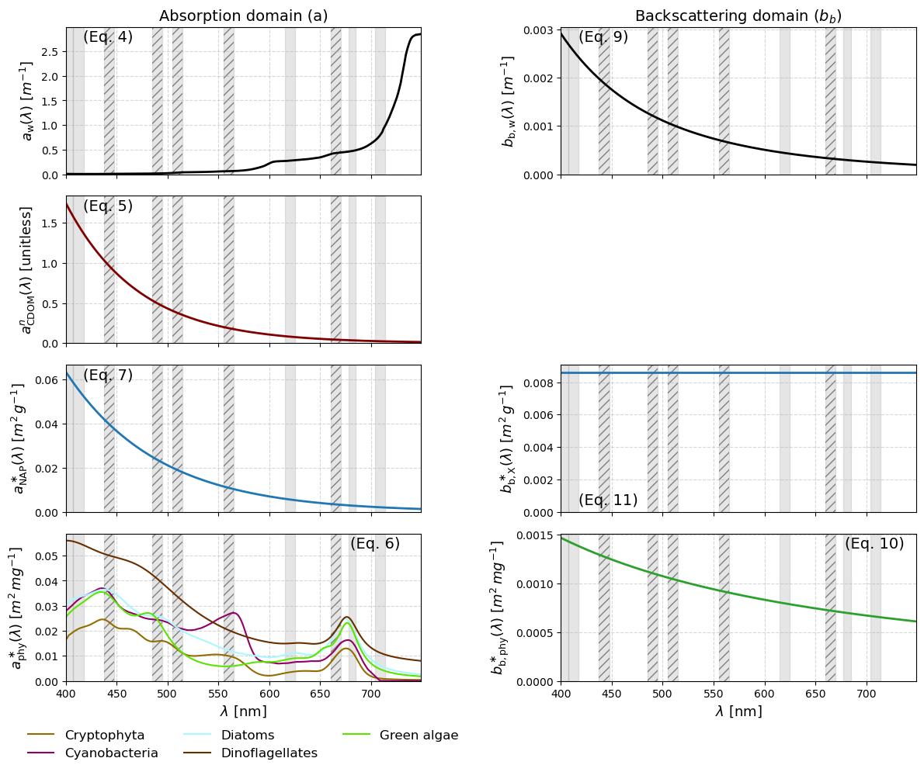
Figure 5: IOPs and SIOPs as configured with the Lake Constance pre-sets from Table 6. Reference to the Equations is given in brackets. Grey bars indicate S3 wavelengths at FWHM, hatched bars signify the used bands. From Equation 4: Absorption of pure water; note that ${a_{w,T}\left(λ\right)=a}_{w}\left(λ\right)$ given $T=20°C$. From Equation 10: Backscattering of pure water. From Equation 5: Normalized absorption coefficient of CDOM (exponential approximation). From Equation 7: Specific absorption coefficient of NAP. From Equation 11: Specific backscattering coefficient of NAP. From Equation 6: Normalized absorption coefficient of phytoplankton. From Equation 7: Normalized backscattering coefficient of phytoplankton.

2.9 Inversion of in situ $R_{rs}\left(λ\right)$
To obtain CDOM_{R}, TSM_{R} and CPHY_{R} the in situ $R_{rs}\left(λ\right)$ was inverted using the same model parametrization as outline in Section 2.8.3. Instead of only five wavelengths, the whole available range between 400 and 730 nm was used. $θ_{s}$ was input based on the matchup image and $θ_{v}$ was set to zero.

2.10 Matchup validation
For comparison with spaceborne retrievals, vertically distributed in situ data was averaged over the first 7.5 m at SHL2 (constituting approximately the average of auxiliary Secchi depth data) and, in accordance with previous research (e.g. Gupana et al., 2025; Werther et al., 2022), over 5 m at the LéXPLORE platform. Averaging was done through the median for the rather noisy absorption measurements and through the mean for other variables. eawag field campaign samples, taken 0.5 m below surface and at the Secchi disk depth, were also averaged.
For validation the metrics Pearson’s r, Bias, and Root Mean Square Error (RMSE), and Median Symmetric Accuracy (MdSA) were used. Pearson’s r [unitless] (Wilks, 2019) measures the strength and direction of the correlation of two variables, in this case between the in situ and retrieved values of a constituent:
$$\begin{aligned}r=\frac{\sum_{i=1}^{n}{\left(x_{i}-\overline{x}\right)\left(y_{i}-\overline{y}\right)}}{\sqrt{\sum_{i=1}^{n}{{\left(x_{i}-\overline{x}\right)}^{2}}\sqrt{\sum_{i=1}^{n}{{\left(y_{i}-\overline{y}\right)}^{2}}}}}\#\left(19\right)\end{aligned}$$
The relative Bias [%] (thereafter simply referred to as Bias) indicates if retrievals systematically underestimate or overestimate compared to in-situ data (Werther et al., 2022). A value close to zero percent indicates no or little Bias:
$$\begin{aligned}Bias=\left({10}^{\left|MR\right|}-1\right)\operatorname{sign}\left(MR\right)×100, MR=\operatorname{median}{​}\left(\log_{10}{​}\left(\frac{x_{i}}{y_{i}}\right)\right)\#\left(20\right)\end{aligned}$$
The RMSE [constituent units] (Wilks, 2019) indicates the average difference between in-situ measurements and retrievals:
$$\begin{aligned}\text{RMSE}=\sqrt{\frac{1}{n}\sum_{i=1}^{n}{{\left(y_{i}-x_{i}\right)}^{2}}}\#\left(21\right)\end{aligned}$$
The MdSA [%] (Werther et al., 2022) quantifies the typical relative difference between retrieved and in-situ values while treating overestimation and underestimation symmetrically. Unlike RMSE, MdSA is less sensitive to outliers:
$$\begin{aligned}\text{MdSA}=100\left(\exp\left(median\left(\left|\ln\left(\frac{y_{i}}{x_{i}}\right)\right|\right)\right)-1\right)\#\left(22\right)\end{aligned}$$
In the statistical metrics above, $n$ is the number of paired samples (i.e. valid matchups), $x_{i}$ represents the $i$-th reference (in-situ) measurement, $y_{i}$ the $i$ -th modeled (retrieved) value, $\overline{x}$ the in situ mean and $\overline{y}$ the modeled average.
To assess the similarity between reference and retrieved spectra, variables with hyperspectral in situ reference (i.e. $R_{rs}\left(λ\right)$ and
$a_{wc}\left(λ\right)$) are also evaluated in terms of spectral angle (SA):
$$\begin{aligned}\begin{aligned}\text{SA}=\cos^{-1}\left(\frac{\sum_{i=1}^{n}{a_{i}b_{i}}}{\sqrt{\sum_{i=1}^{n}{a_{i}^{2}}\sqrt{\sum_{i=1}^{n}{b_{i}^{2}}}}}\right)×\frac{180}{π}\# \#\#\end{aligned}\#\left(23\right)\end{aligned}$$
Where $a_{i}$ and $b_{i}$are the spectral values at band $i$ for the reference and retrieved spectra and n is the number of bands (Soppa et al., 2021).

2.11 Operational processing chain
The processing steps described in Section 2 were combined into a single processing chain, operationally linking image acquisition, AC, quality control, image inversion, and validation (https://github.com/samlan2000/msc_thesis). To summarize (Figure 6):
- Matchups (Section 2.6) between in situ data (Section 2.3) and L1 S3 OLCI EFR images (Section 2.5) were generated.
- These L1 images are downloaded, atmospherically corrected, and quality-filtered leveraging the Sencast toolbox (Section 2.5) yielding a L2 POLYMER product.
- The L2 products are inverted using MiniWASI, applying a single model parametrization (Section 2.8, parametrization in Section 2.8.3)
- The resulting constituent maps are compared to the in situ data using the validation metrics described in Section 2.10.
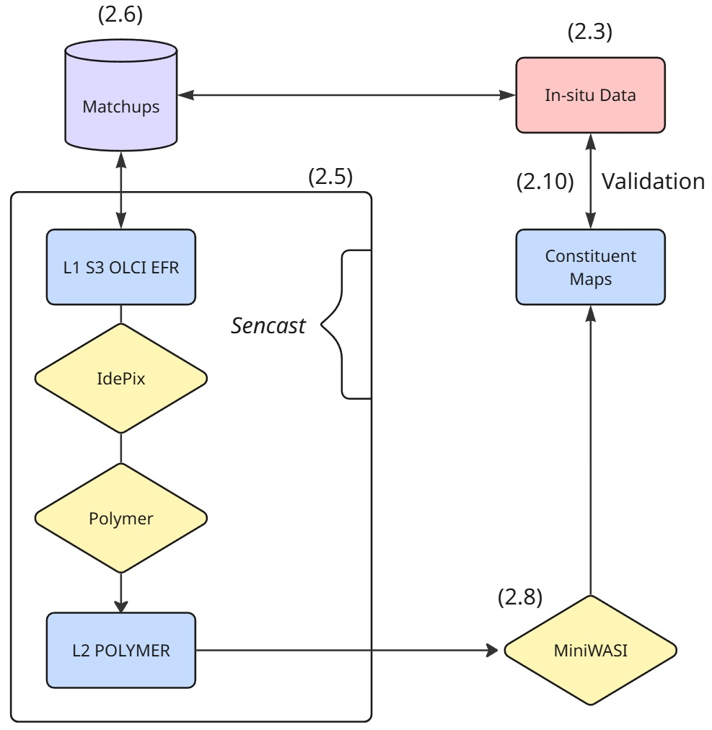
Figure 6: Schematic diagram of the processing chain presented in Section 2. References for the specific Section are given in brackets.

3. Results
This section starts out with AC validation as this is an overarching topic not directly concerned with model output validation. Thereafter, results are ordered regarding the sampling location since these offer distinct types of data that were sampled quasi-simultaneously, enabling valuable intercomparisons.
In accordance with the research questions, this section does not aim to rigorously assess results from in situ hyperspectral inversions; rather, results are combined with those of satellite retrievals where deemed suited. Furthermore, although validation is subdivided by S3A and S3B for completeness, differences in retrieval accuracy between the two are not discussed, as this falls outside the scope of this thesis.

3.1 AC performance
POLYMER AC showed varying performances across bands (Figure 7). The median SA over all bands was 8.7°, with the majority of SA (166 out of 215) being in the range of 5°-15°. AC performed best in the long blue and the green wavelengths (490, 510 and 560 nm). There, good agreement with in situ $R_{rs}\left(λ\right)$ was observed resulting in r values of 0.86, 0.87, and 0.89, RMSE around 0.0020 sr⁻¹, MdSA of 25.5, 23.5, and 21.4%, respectively with a small positive Bias (12.5 – 18.4%).
The shorter blue wavelengths (400, 412.5, and 442.5 nm) were biased towards overestimating satellite $R_{rs}\left(λ\right)$ (18.3, 41.6, and 41.2% respectively). This is especially the case for low to medium $R_{rs}\left(λ\right)$values (see Figure 7). Other quality metrics are very similar for the bands: r values vary around 0.85, RMSE around 0.0024 sr⁻¹ and MdSA around 42%.
In the red region of the spectrum, AC performance deteriorates towards longer wavelengths. While the performance is still quite good for 620 nm (r = 0.76, bias = -2.1%, RMSE = 0.0007 sr⁻¹, MdSA = 30.8%), in the longer red wavelengths (665, 681.25 708.75 nm) errors are in the magnitude of the in situ $R_{rs}\left(λ\right)$ (MdSA of 77.4% – 143.9%). Notably, satellite $R_{rs}\left(λ\right)$is clearly biased towards underestimating the in situ (-72.4% – -127.1%).
For inversion only 5 bands were used (see Section 2.8.3). Overall, the fitted $R_{rs}\left(λ\right)$ performed very similarly to the input Satellite $R_{rs}\left(λ\right)$ (Table 8; Figure 8). However, for the 665 nm band, located at the second CHL absorption peak, fitted $R_{rs}\left(λ\right)$showed better performance when compared against in situ measurements. This resulted in a reduced MdSA (99.0% to 37.7%), less Bias (-95.6% to 2.0%), smaller RMSE (0.0007 sr⁻¹ to 0.0006 sr⁻¹), and slightly higher correlation (0.60 to 0.65).
This improvement is also evident in the SA of the fitted bands: The input $R_{rs}\left(λ\right)$ showed a SA of 6.48°. After inversion, SA decreased to 5.45°.
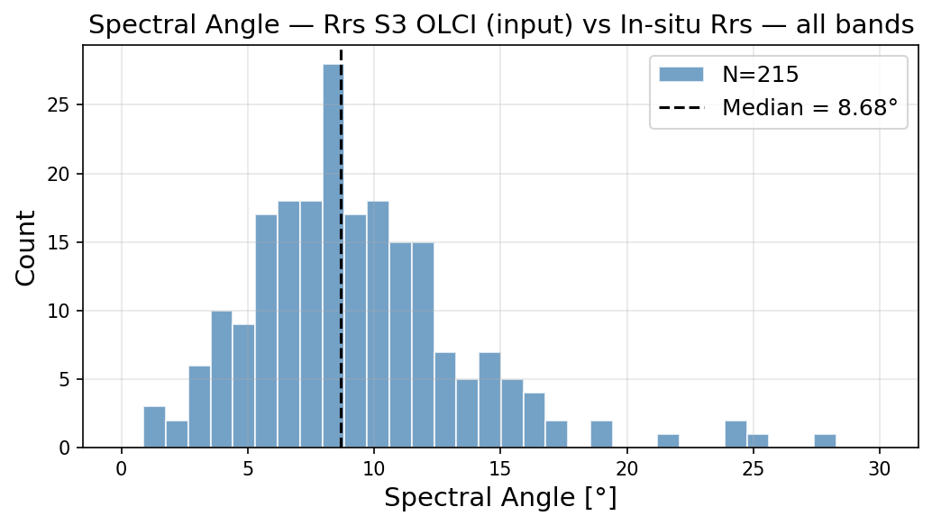
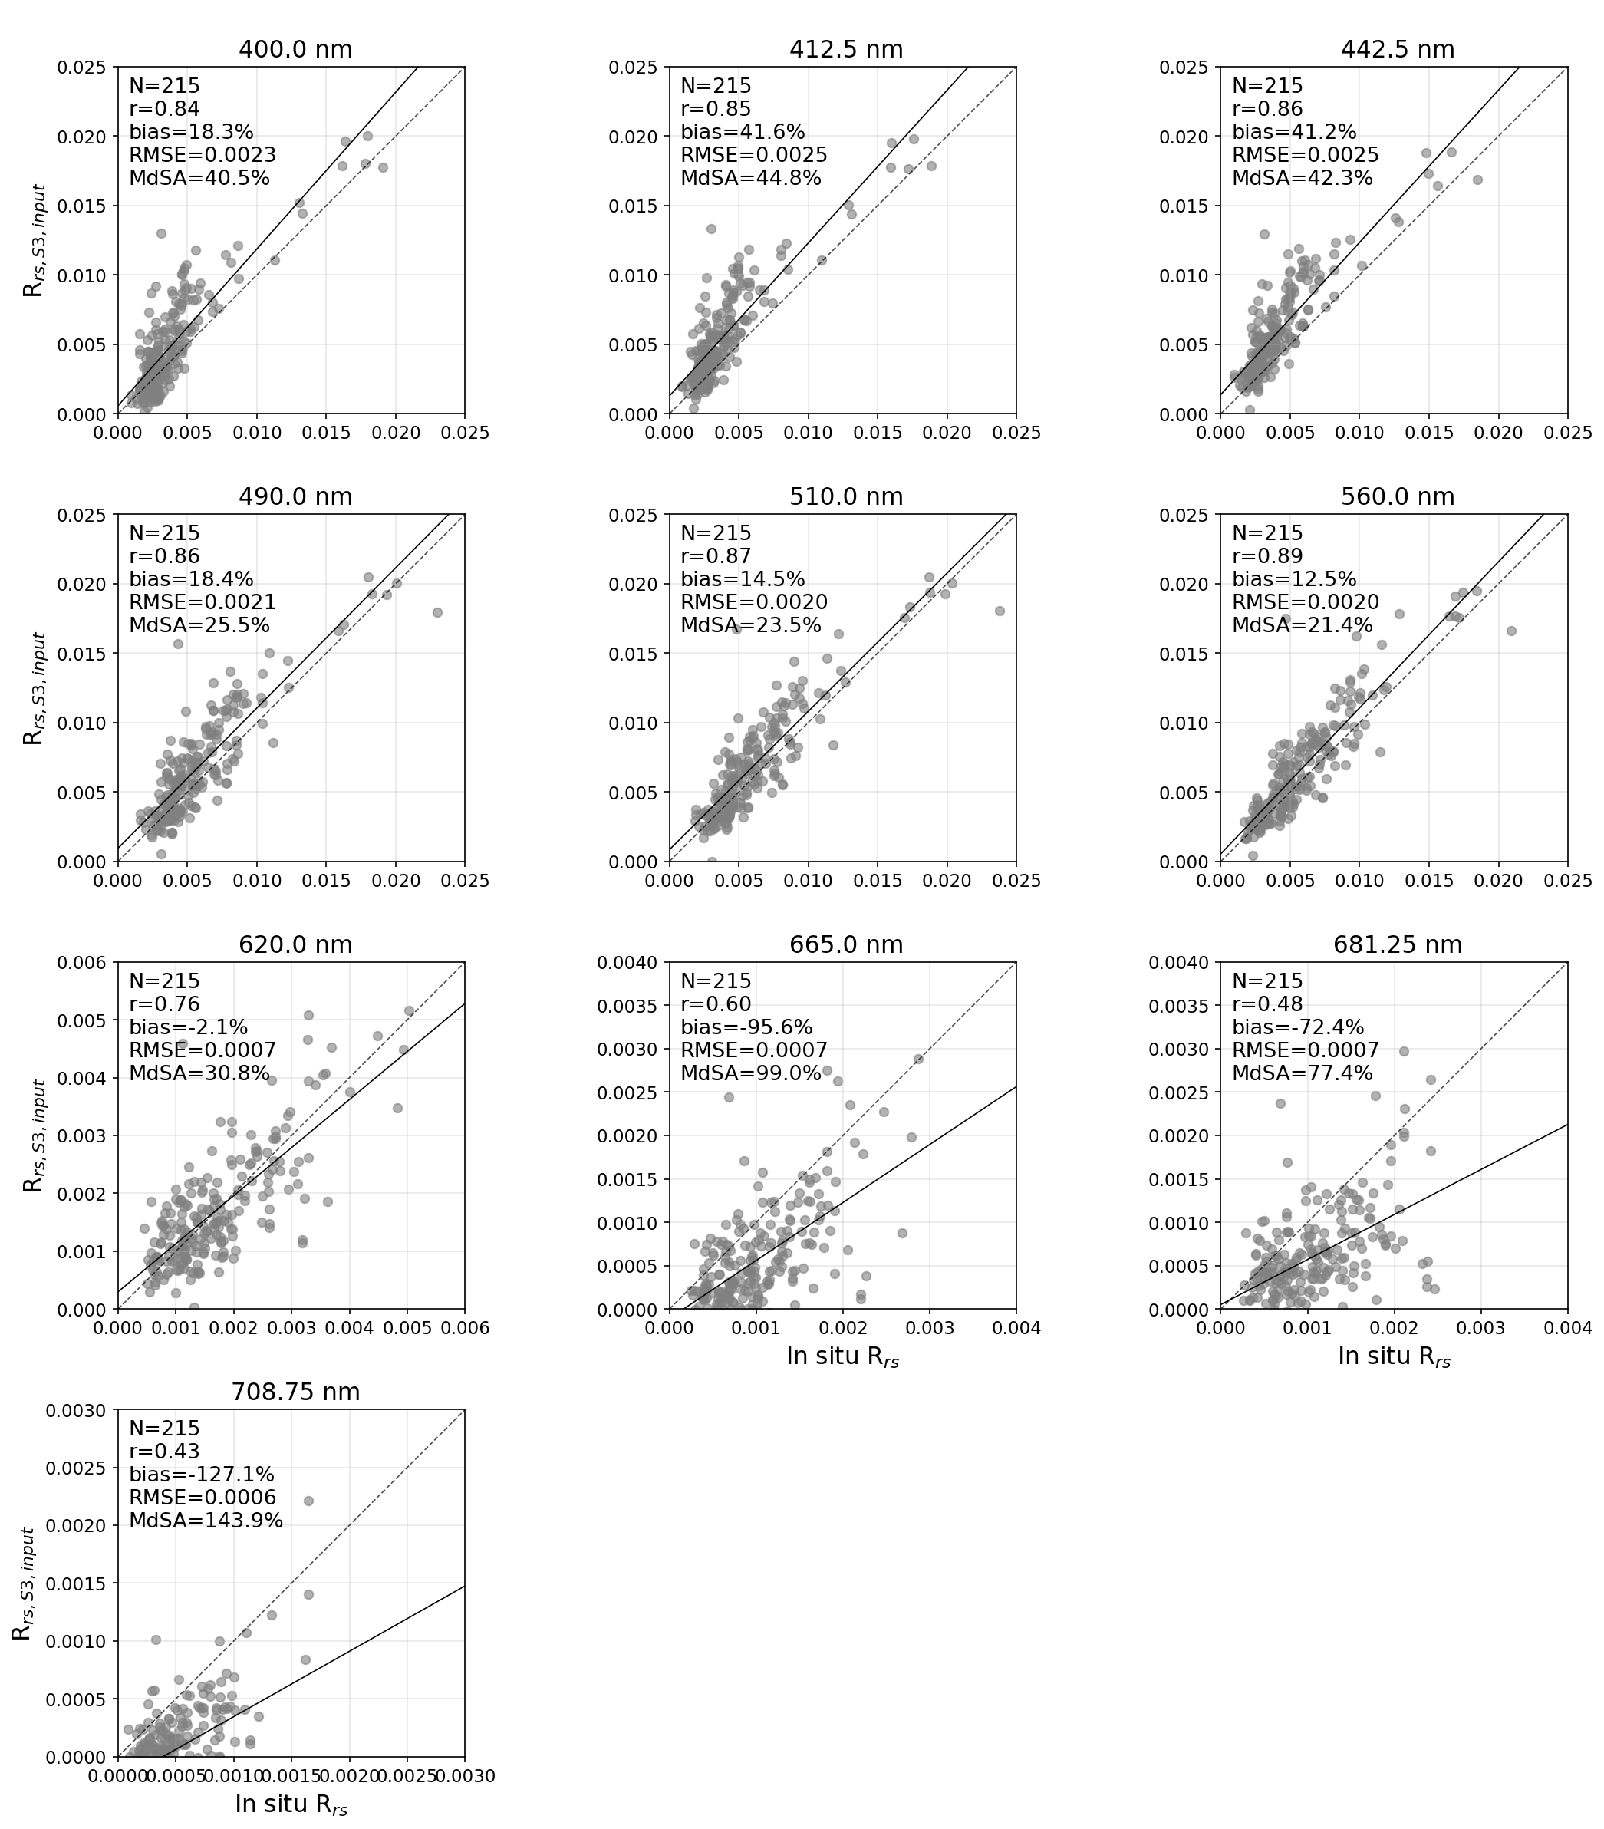
Figure 7: AC validation of Bands 1-10 including spectral angle. Note that plots may use different axis bounds. R_{rs}: (in situ) remote sensing reflectance at a specified wavelength, R_{rs,S3,input}: The input Sentinel 3 remote sensing reflectance at a specified wavelength.
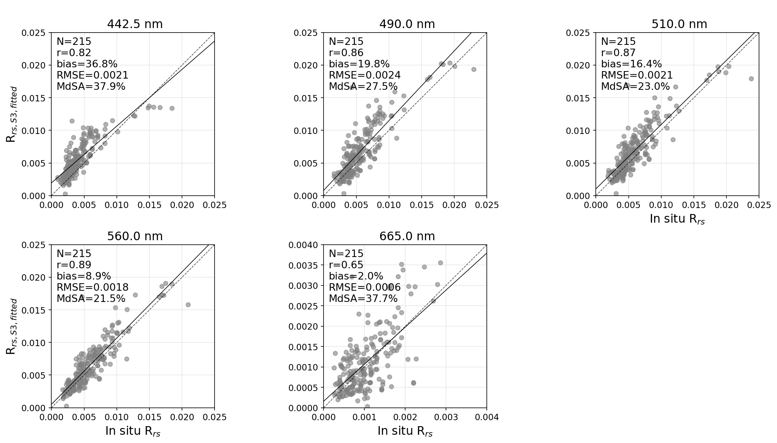
Figure 8: MiniWASI fitted Sentinel 3 remote sensing reflectance (R_{rs,S3,fitted}) validation of bands weighted during inversion (bands 3, 4, 5, 6, and 8). R_{rs}: (in situ) remote sensing reflectance at a specified wavelength.
Table 8: AC evaluation of both the input and fitted remote sensing reflectance ($R_{rs}\left(λ\right)$). Bands weighted during inversion are marked green. The Oa9 band, marked yellow, is not output by POLYMER. Quality metrics of the fitted but unweighted bands should be interpreted with care as they do not directly influence the inversion output.
Band number | Central wavelength [nm] | Pearson r | Bias [%] | RMSE [sr⁻¹] | MdSA [%] | N
Input satellite (SA all: 8.68°, SA weighted: 6.48°)$R_{rs}\left(λ\right)$

Oa1 | 400 | (0.84) | (18.3) | (0.0023) | (40.5) | (215)
Oa2 | 412.5 | (0.85) | (41.6) | (0.0025) | (44.8) | (215)
Oa3 | 442.5 | 0.86 | 41.2 | 0.0025 | 42.3 | 215
Oa4 | 490 | 0.86 | 18.4 | 0.0021 | 25.5 | 215
Oa5 | 510 | 0.87 | 14.5 | 0.0020 | 23.5 | 215
Oa6 | 560 | 0.89 | 12.5 | 0.0020 | 21.4 | 215
Oa7 | 620 | (0.76) | (-2.1) | (0.00066) | (30.8) | (215)
Oa8 | 665 | 0.60 | -95.6 | 0.00067 | 99.0 | 215
Oa9 | 673.75 | - | - | - | - | -
Oa10 | 681.25 | (0.48) | (-72.4) | (0.00071) | (77.4) | (215)
Oa11 | 708.75 | (0.43) | (-127.1) | (0.00059) | (143.9) | (215)
Fitted (SA all: 10.44°, SA weighted: 5.45°)$R_{rs}\left(λ\right)$

Oa1 | 400 | (0.65) | (62.5) | (0.0027) | (67.4) | (215)
Oa2 | 412.5 | (0.73) | (57.0) | (0.0024) | (59.3) | (215)
Oa3 | 442.5 | 0.82 | 36.8 | 0.0021 | 37.9 | 215
Oa4 | 490 | 0.86 | 19.8 | 0.0024 | 27.5 | 215
Oa5 | 510 | 0.87 | 16.4 | 0.0021 | 23.0 | 215
Oa6 | 560 | 0.89 | 8.9 | 0.0018 | 21.5 | 215
Oa7 | 620 | (0.73) | (0.1) | (0.00079) | (30.6) | (215)
Oa8 | 665 | 0.65 | 2.0 | 0.00056 | 37.7 | 215
Oa9 | 673.75 | - | - | - | - | -
Oa10 | 681.25 | (0.52) | (-11.8) | (0.00059) | (47.7) | (215)
Oa11 | 708.75 | (0.51) | (10.7) | (0.00036) | (51.0) | (215)

3.2 SHL2

3.2.1 CHL_{S}
Comparison of CPHY_{S3} against CHL_{S} showed good general agreement, resulting in high correlation (r = 0.80) at relatively low Bias (12.2%), MdSA below 30%, and an RMSE of 1.27 mg m⁻³ (Figure 9; Table 9). CPHY_{S3} reproduced the in situ CHL_{S} time series relatively well, capturing general trends and two phytoplankton blooms in in 2020 and 2021 respectively.
Three instances of (successive) underestimation of CHL_{S} exist in 2019, mid 2021, and fall 2023 respectively (Figure 10, top panel). The depth of the maximum CHL_{S} was below the measured Secchi disk depth on 19 dates while being within visibility on seven dates. On five dates the depth of the maximum CHL_{S} was within the top 7.5 m used as reference when it was simultaneously below the measured Secchi disk depth. These dates are part of aforementioned instances in mid-2021 and fall 2023 respectively (Figure 10, middle panel).
Retrieved NAP_{S3} varied up to 2 g m⁻³ and CDOM_{S3} up to 0.12 m⁻¹. On most dates CDOM_{S3} was zero, only once exceeding very low absorption values during the 2021 bloom (Figure 10, bottom panel).
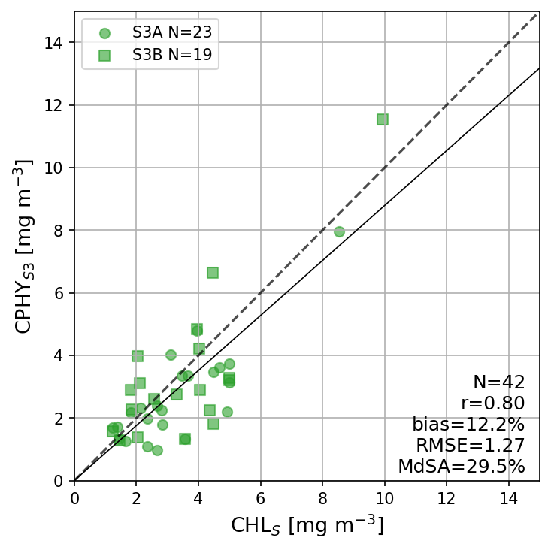
Figure 9: One-to-one comparison of phytoplankton concentration retrievals from Sentinel 3 (CPHY_{S3}) against in situ spectrophotometric Chlorophyll a (CHL_{S}) at SHL2.
Table 9: Obtained quality metrics for SHL2 spectrophotometric Chlorophyll a (CHL_{S}) validation.
 | Pearson r | Bias [%] | RMSE [mg m⁻³] | MdSA [%] | N
S3A | 0.83 | 14.5 | 0.98 | 25.2 | 23
S3B | 0.81 | -7.5 | 1.40 | 35.3 | 19
all | 0.80 | 12.2 | 1.27 | 29.5 | 42
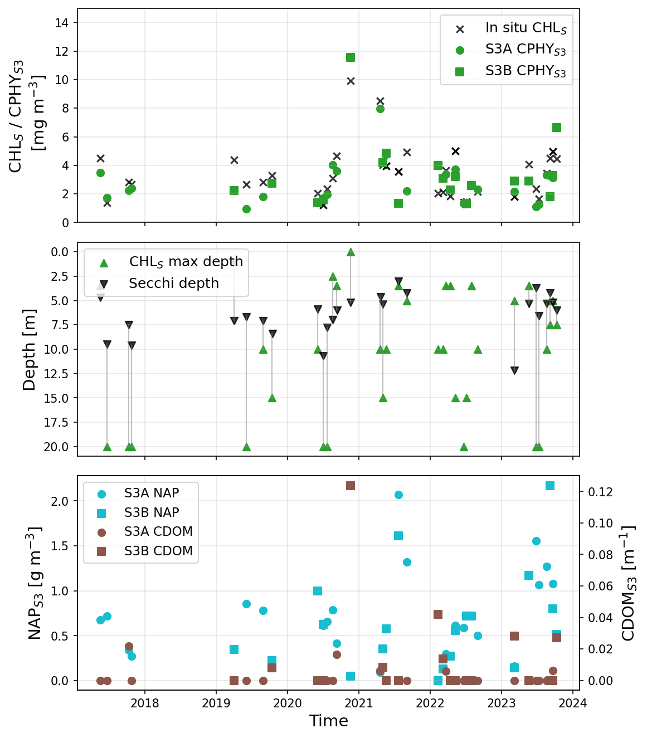
Figure 10: Top panel: Time series comparison of total phytoplankton pigment concentration retrievals from Sentinel 3 (CPHY_{S3}) against in situ spectrophotometric Chlorophyll a (CHL_{S}). Middle panel: Depth of the CHL_{S} maximum and Secchi depth. Bottom panel: Satellite-retrieved non-algal particle concentration (NAP_{S3}) and colored dissolved organic matter (CDOM_{S3}) time series.

3.2.2 Phytoplankton taxa
MiniWASI inversions retrieved mainly three taxa, namely diatoms, green algae, and dinoflagellates. Other taxa were rarely retrieved at all, with cyanobacteria and cryptophyta being present on only two and three dates respectively. Most taxa exhibited low or even negative correlation between modelled taxa pigment concentration and both biovolume and abundance. Only diatoms (r = 0.31 and r = 0.32 for biovolume and abundance respectively) were significantly correlated with the in situ counterparts (Table 10; Figure 12).
Table 10: Correlation between retrieved phytoplankton concentrations and in situ biovolumes and abundances respectively. Statistically significant correlation (p < 0.05) is marked bold.
 | Cryptophyta | Cyanobacteria | Diatoms | Dinoflagellates | Green algae
Biovolume (N=40)
r | -0.15 | -0.07 | 0.31 | -0.14 | 0.06
p | 0.370 | 0.672 | 0.049 | 0.378 | 0.696
Abundance (N=40)
r | -0.19 | -0.07 | 0.32 | -0.13 | -0.10
p | 0.235 | 0.652 | 0.043 | 0.420 | 0.556
When looking at the relative proportions of measured abundances and biovolumes compared to the proportions of the modelled concentrations (Figure 11) no clear relationships appear visible. In situ data shows that significant quantities of chrysophyceae are present in Lake Geneva (Figure 11) which are not parametrized in MiniWASI.
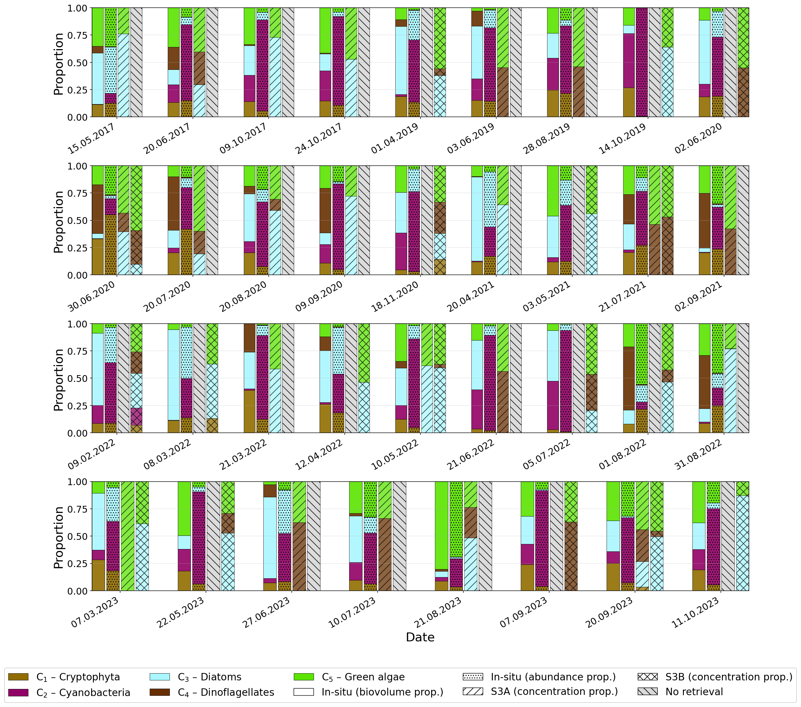
Figure 11: Relative phytoplankton taxa concentrations from Sentinel 3A and 3B (S3A and S3B) and biovolumes (in situ).
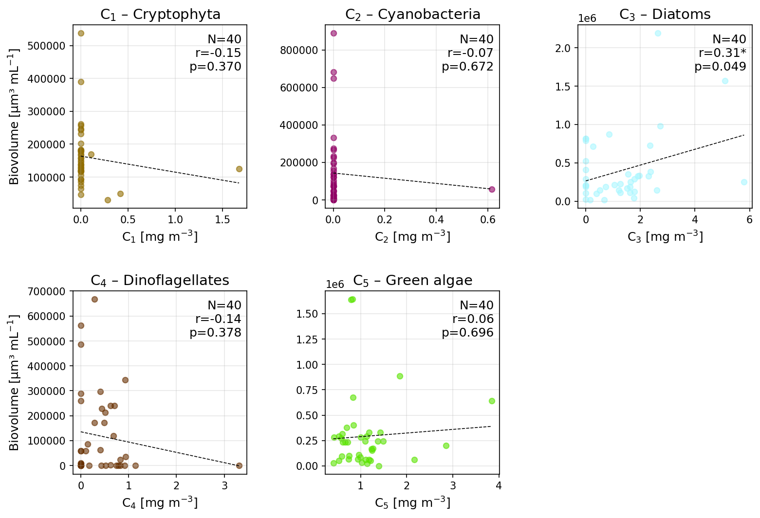
Figure 12: Correlation between retrieved phytoplankton concentrations and in situ biovolumes. Statistically significant correlation (p < 0.05) is marked with an asterisk.

3.3 LéXPLORE

3.3.1 CHL_{F}, CHL_{A}, aLH₆₇₆, and CPHY_{R}
Inter-comparisons of the bulk phytoplankton in situ data at LéXPLORE show high correlation (r = 0.76 – 0.87) across the board (Figure 13; Table 11). CHL_{F} is clearly biased in comparison to other methods (-29.7 – 74.2%), also resulting in high MdSA (44.8 – 75.8%) and RMSE (1.86 – 2.36 mg m⁻³). aLH₆₇₆→CHL and CHL_{A} agree best, with r = 0.87 and MdSA = 25.7%. Visual comparison of the two methods shows that CHL_{A} is lower at medium to high CHL while being higher at very low CHL (<2 mg m⁻³).
CPHY_{R} retrievals from hyperspectral in situ $R_{rs}\left(λ\right)$ showed satisfactory agreement with CHL (Figure 13). Correlation is highest with aLH₆₇₆ (r = 0.78). CPHY_{R} is generally higher than CHL_{F} (21.6%) but lower than aLH₆₇₆→CHL (-27.6%) and CHL_{A} (-21.6%). Correlation with other CHL proxies is relatively high (r = 0.76 – 0.81), with RMSE between 1.77 and 1.88 mg m⁻³ and MdSA between 32.3 and 44.8%.
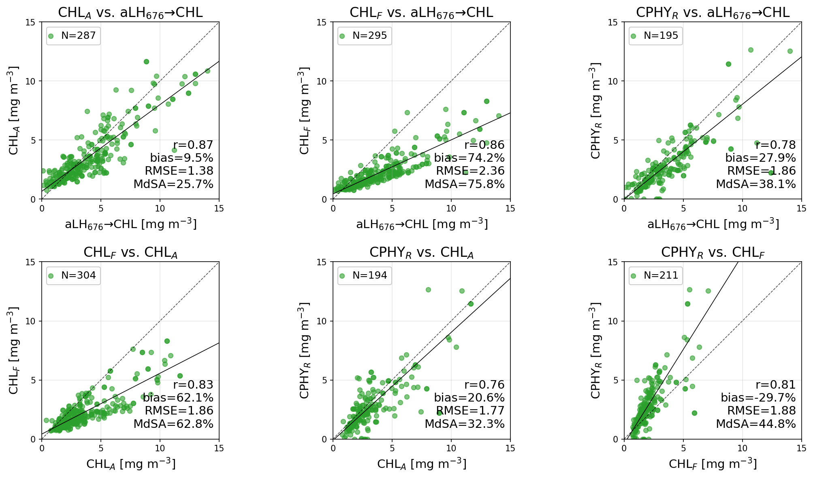
Figure 13: Pairwise relationships of CHL and CPHY references. CHL_{F}: Chlorophyll a concentration from fluorometry, CHL_{A}: Absorption-corrected CHL_{F}, aLH₆₇₆: Absorption line height at 676 nm, aLH₆₇₆→CHL: aLH₆₇₆ converted to CHL, CPHY_{S3}: Phytoplankton concentration inverted from in situ $R_{rs}\left(λ\right)$. Note that one CPHY_{R} datapoint is outside the visualized range.
Table 11: Pairwise relationships of CHL and CPHY references. CHL_{F}: Chlorophyll a concentration from fluorometry, CHL_{A}: Absorption-corrected CHL_{F}, aLH₆₇₆: Absorption line height at 676 nm, aLH₆₇₆→CHL: aLH₆₇₆ converted to CHL, CPHY_{S3}: Phytoplankton concentration inverted from in situ $R_{rs}\left(λ\right)$.
 | Pearson r | Bias [%] | RMSE [mg m⁻³] | MdSA [%] | N
aLH₆₇₆→CHL vs. CPHY_{R} | 0.78 | 27.9 | 1.86 | 38.1 | 195
CHL_{A} vs. CPHY_{R} | 0.76 | 20.6 | 1.77 | 32.3 | 194
CHL_{F} vs. CPHY_{R} | 0.81 | -29.7 | 1.88 | 44.8 | 211
CHL_{A} vs. aLH₆₇₆→CHL | 0.87 | 9.5 | 1.38 | 25.7 | 287
CHL_{F} vs. aLH₆₇₆→CHL | 0.86 | 74.2 | 2.36 | 75.8 | 295
CHL_{F} vs. CHL_{A} | 0.83 | 62.1 | 1.86 | 62.8 | 304
Satellite retrievals of CPHY_{S3} showed moderate to good agreement with in situ CHL and CPHY_{R} (Figure 14; Table 12). The best agreement was found between CPHY_{S3} and CHL_{A}, with r = 0.72, bias = -18.0%, RMSE = 1.71 mg m⁻³ and MdSA = 45.0%, being somewhat worse than the SHL2 agreement (where r = 0.80). Correlation was similar with aLH₆₇₆ (r = 0.73), with slightly higher bias (-28.3%), RMSE (2.03 mg m⁻³), and MdSA (51.8%) for aLH₆₇₆→CHL. At very low aLH₆₇₆→CHL values (<1 mg m⁻³) satellite retrievals were higher in comparison. CPHY_{S3} retrievals are positively biased when compared to CHL_{F} (30.1%), with r = 0.68, RMSE = 1.81 mg m⁻³, and MdSA = 54.3%. Visually, the agreement with CPHY_{R} is the worst, mainly due to consistent lower values of CPHY_{S3} at high CHPY_{R} (>8 mg m⁻³). However, overall quality metrics are in the range of the other comparisons (r = 0.68, bias = -15.8%, RMSE = 1.89 mg m⁻³, MdSA = 57.4%).
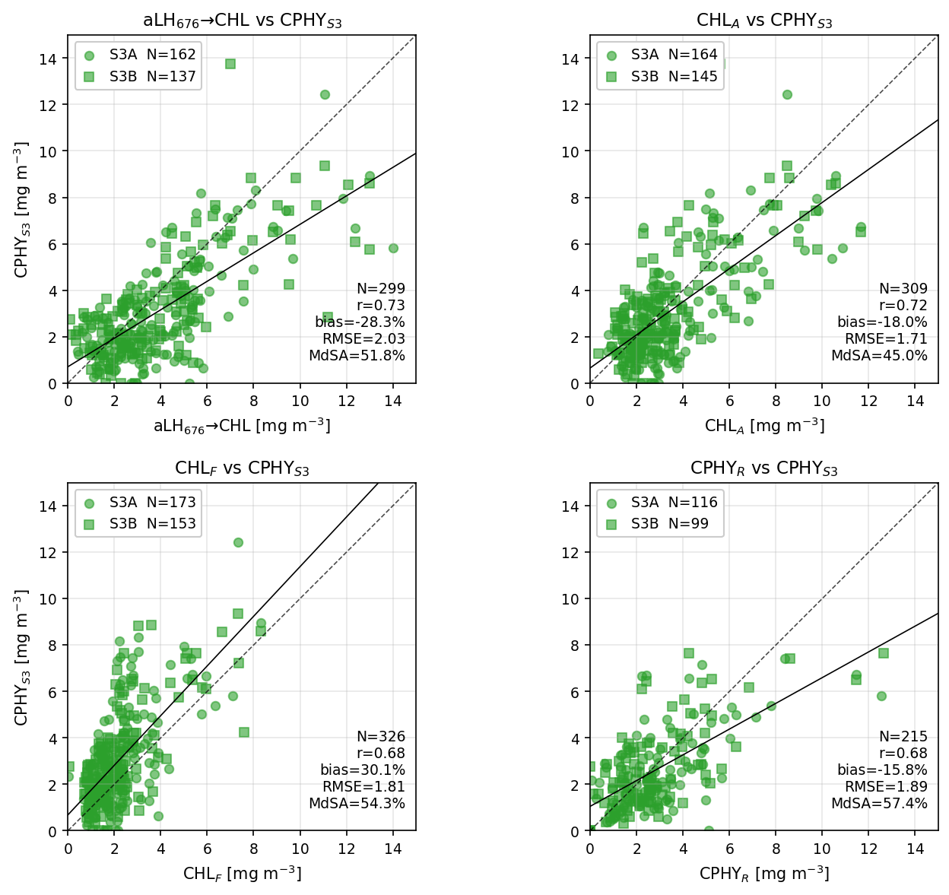
Figure 14: Validation of retrieved Sentinel 3A and B (S3A and S3B) phytoplankton concentration (CPHY_{S3}) against in situ references. CHL_{F}: Chlorophyll a concentration from fluorometry, CHL_{A}: Absorption-corrected CHL_{F}, aLH₆₇₆: Absorption line height at 676 nm, aLH₆₇₆→CHL: aLH₆₇₆ converted to CHL, CPHY_{S3}: Phytoplankton concentration inverted from in situ $R_{rs}\left(λ\right)$. Note that one CPHY_{R} matchup is outside the visualized range.
Table 12: Validation of retrieved Sentinel 3A and B (S3A and S3B) phytoplankton concentration (CPHY_{S3}) against in situ references. CHL_{F}: Chlorophyll a concentration from fluorometry, CHL_{A}: Absorption-corrected CHL_{F}, aLH₆₇₆: Absorption line height at 676 nm, aLH₆₇₆→CHL: aLH₆₇₆ converted to CHL, CPHY_{S3}: Phytoplankton concentration inverted from in situ $R_{rs}\left(λ\right)$.
 | Pearson r | Bias [%] | RMSE [m⁻¹] | MdSA [%] | N
aLH₆₇₆→ CHL vs. CPHY_{S3}
S3A | 0.72 | -31.6 | 2.01 | 52.2 | 162
S3B | 0.74 | -20.7 | 2.06 | 49.3 | 137
all | 0.73 | -28.3 | 2.03 | 51.8 | 299
CHL_{A} vs. CPHY_{S3}
S3A | 0.73 | -20.5 | 1.7 | 42.6 | 164
S3B | 0.72 | -5.8 | 1.71 | 46.1 | 145
all | 0.72 | -18.0 | 1.71 | 45.0 | 309
CHL_{F} vs. CPHY_{S3}
S3A | 0.64 | 28.3 | 1.81 | 61.6 | 173
S3B | 0.71 | 34.5 | 1.82 | 49.5 | 153
all | 0.68 | 30.1 | 1.81 | 54.3 | 326
CPHY_{R} vs. CPHY_{S3}
S3A | 0.72 | -23.9 | 1.79 | 53.9 | 116
S3B | 0.66 | -5.4 | 2.0 | 64.9 | 99
all | 0.68 | -15.8 | 1.89 | 57.4 | 215

3.3.2 TSM and CDOM
Satellite CDOM retrievals essentially failed, with CDOM_{S3} being extremely low for the most part well below CDOM_{R} values (Figure 15; Table 13). Agreement was accordingly not good with weak correlation (r = 0.2) and errors in the order of magnitude of CDOM_{R} (RMSE = 0.07 m⁻¹).
Satellite NAP_{S3} showed satisfactory agreement with in situ NAP_{R} hyperspectral retrievals (r = 0.77, bias = -5.3, RMSE = 0.51 g m⁻³, MdSA = 39.9%). For high NAP_{R} values (> 2 g m⁻³) NAP_{S3} retrievals were generally higher in comparison while for low NAP_{R} values (< 0.5 g m⁻³) retrievals were generally lower in comparison (Figure 15).
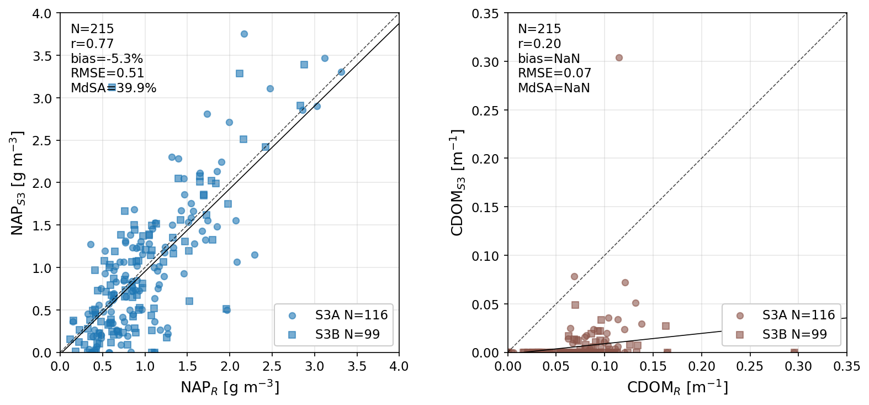
Figure 15: Validation of retrieved Sentinel 3A and B (S3A and S3B) non-algal particle (NAP_{S3}) and colored dissolved organic matter (CDOM_{S3}) against in situ hyperspectral retrievals (NAP_{R} and CDOM_{R} respectively). NaN values indicate numerical overflow.
Table 13: Validation of retrieved Sentinel 3A and B (S3A and S3B) non-algal particle (NAP_{S3}) and colored dissolved organic matter (CDOM_{S3}) against in situ hyperspectral retrievals (NAP_{R} and CDOM_{R} respectively).
 | Pearson r | Bias [%] | RMSE | MdSA [%] | N
NAP_{R} vs. NAP_{S3} |  |  | [g m⁻³]
S3A | 0.79 | -7.6 | 0.51 | 41.0 | 116
S3B | 0.75 | -0.0 | 0.51 | 37.8 | 99
all | 0.77 | -5.3 | 0.51 | 39.9 | 215
CDOM_{R} vs. CDOM_{S3} |  |  | [m⁻¹]
S3A | 0.24 | overflow | 0.071 | overflow | 116
S3B | 0.21 | overflow | 0.078 | overflow | 99
all | 0.20 | overflow | 0.074 | overflow | 215

3.3.3 Constituent time series and interrelationships
This section shows the time series of the three constituents both for satellite retrievals and in situ data. Instead of comparing the hyperspectral retrievals of all three constituents, which would be methodologically most consistent, it was decided to choose the CHL_{A} to represent CHL since it is assumed to be a more reliable proxy and can be compared against earlier studies (i.e. Gupana et al., 2025; Werther et al., 2022).
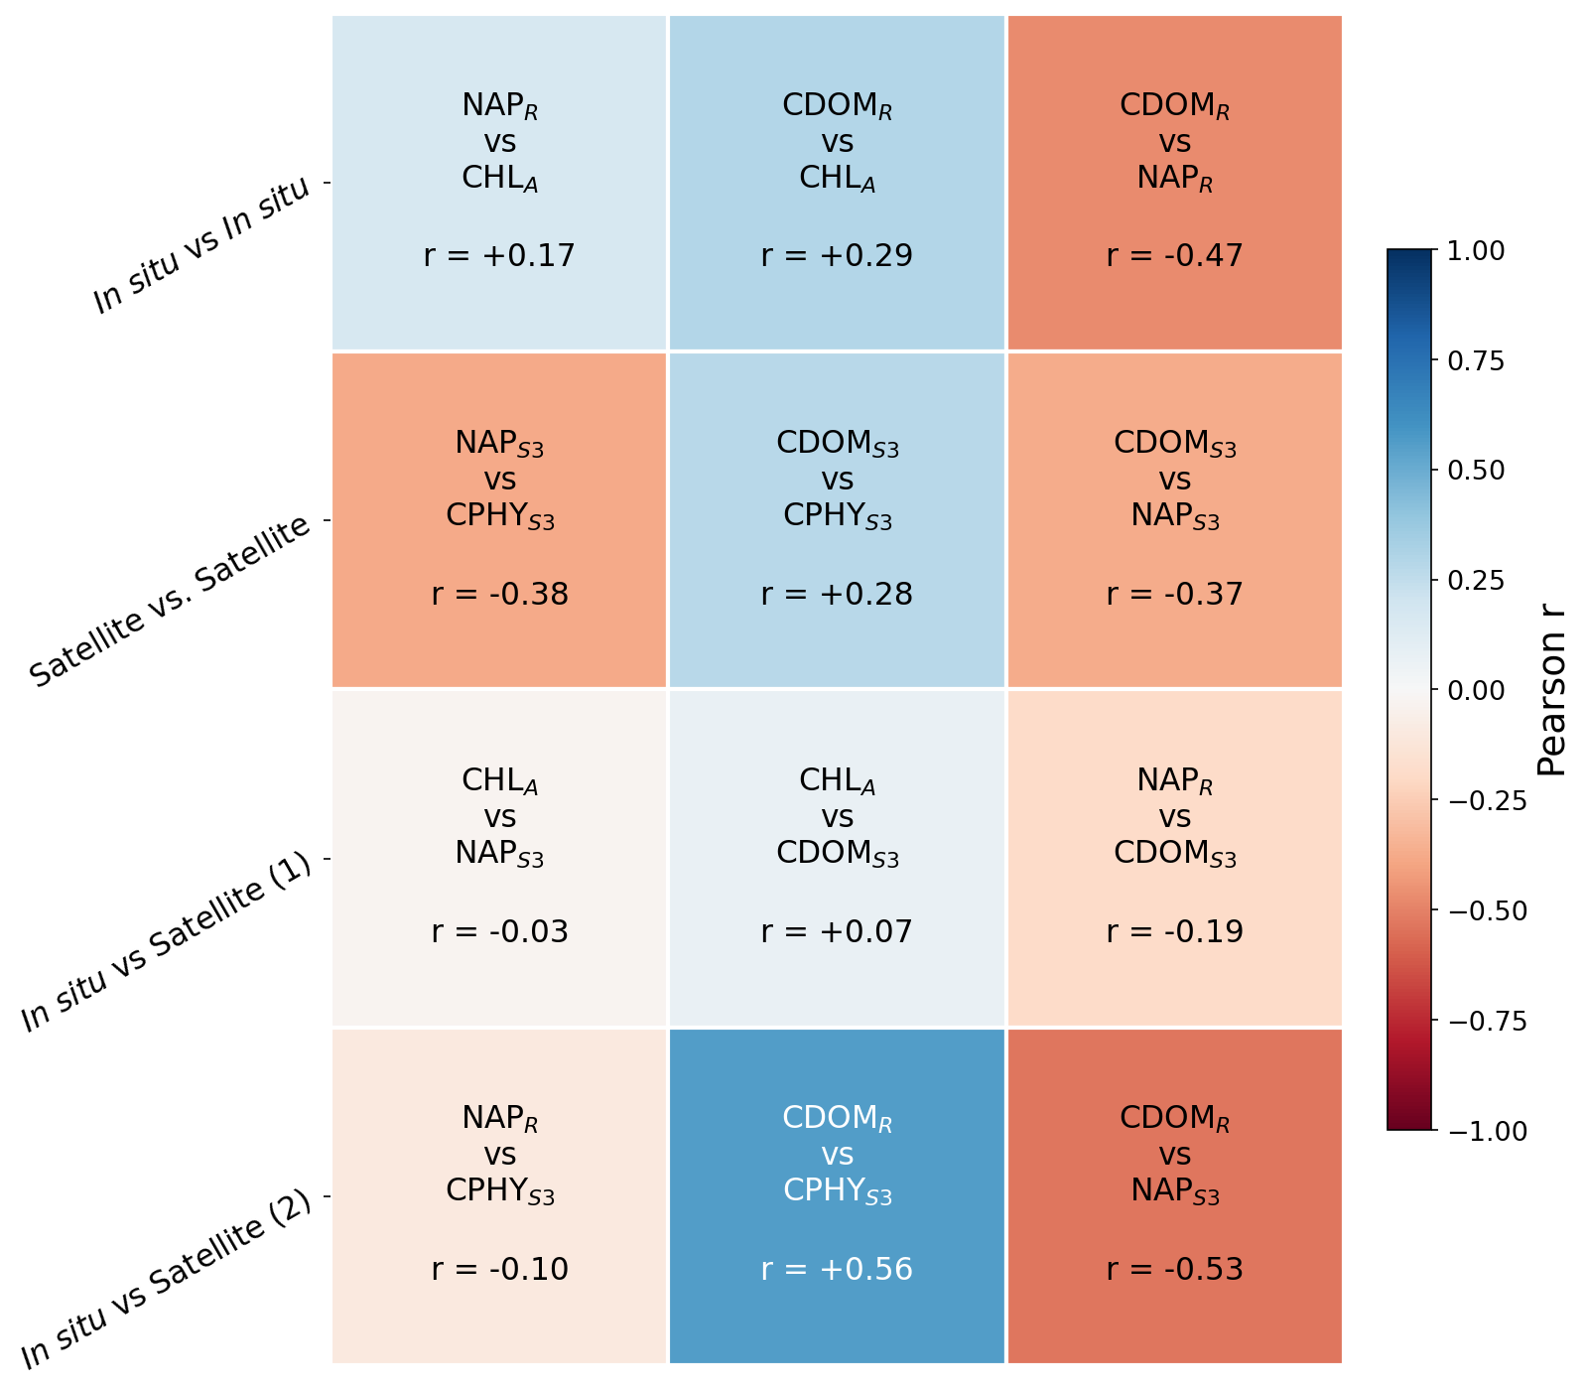
Figure 16: Water constituent intercomparison: pairwise correlation. In situ: CHL_{A}: Absorption-corrected fluorometric Chlorophyll a, NAP_{R}: Non-algal particle concentration inverted from in situ $R_{rs}\left(λ\right)$, CDOM_{R}: Colored dissolved organic matter absorption at 440 nm inverted from in situ $R_{rs}\left(λ\right)$. Satellite: CPHY_{S3}: Phytoplankton concentration inverted from Sentinel 3 $R_{rs}\left(λ\right)$, NAP_{S3}: Concentration of non-algal particles inverted from Sentinel 3 $R_{rs}\left(λ\right)$, CDOM_{S3}: Colored dissolved organic matter absorption at 440 nm inverted from Sentinel 3 $R_{rs}\left(λ\right)$.
Pairwise correlation of different constituents for all possible combinations of satellite and in situ data is shown in Figure 16. Note that any comparison including CDOM_{S3} should not be overinterpreted as these retrievals were extremely unreliable (see Section 3.3.2). Notably, the relationship between NAP and CHL is rather random (r = -0.38 – 0.17) regardless of the mode of comparison. Further, NAP and CDOM_{R} exhibit moderate negative relationships (r = -0.47 – -0.53). CDOM_{R} and CHL proxies are weakly to moderately positively correlated (r = 0.29 and 0.56 for CHL_{A} and CPHY_{S3} respectively).
The equivalent time series (Figure 17) shows that CPHY_{S3} and NAP_{S3} are mostly able to reproduce the temporal patterns of their in situ counterparts. CPHY_{S3} captured most algal blooms that show in CHL_{A}, although with some under- (e.g. spring 2020) and overestimations (e.g. September 2021). In 2024, where no major blooms appear in CHL_{A}, the visual agreement seems lacking. The time series reveals prolonged periods where CPHY_{S3} was well below CHL_{A} under high NAP conditions, most prominently in Summer 2024. The NAP_{R} time series consistently shows a summer peak between June and mid-September when data is available, which is mostly well matched by NAP_{S3}. In 2020 NAP_{S3} retrievals were successively below NAP_{R}.

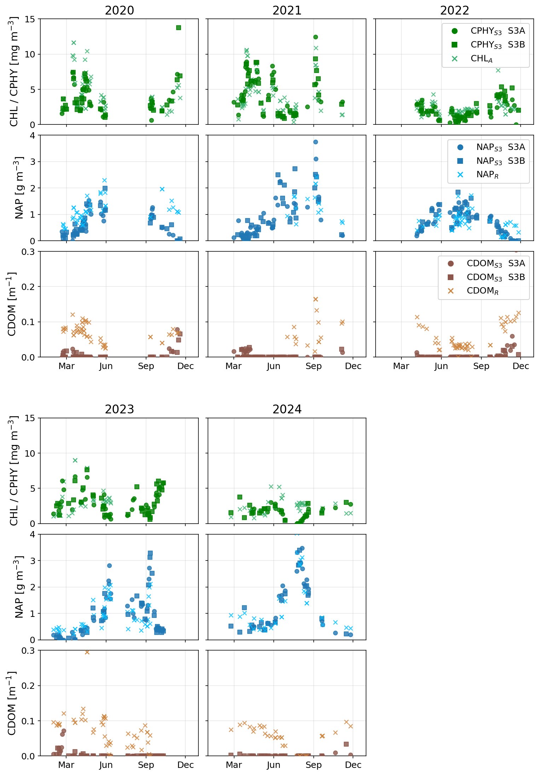
Figure 17: Time series of water constituent retrievals and in situ data. Absorption-corrected fluorometric Chlorophyll a (CHL_{A}) is used to represent in situ CHL, while in situ colored dissolved organic matter and non-algal particle concentration are represented by inverted in situ estimates (CDOM_{R} and NAP_{R}). Note that only years with more than 10 datapoints are shown. CPHY_{S3}, NAP_{S3}, and CDOM_{S3} are retrievals from Sentinel 3 of phytoplankton concentration, NAP concentration, and CDOM.

3.3.4 IOPs
Satellite $a_{wc,S3}\left(λ\right)$ underestimated in situ $a_{wc}\left(λ\right)$ across all bands used in the inversion (Table 14). Consistent with the failed CDOM retrieval reported in Section 3.3.2, Bias was strongest in the blue bands, decreasing towards the red (from -169.6% at 442.5 nm to -41.9% at 665 nm). A similar pattern is observed for MdSA (decrease from 169.6% to 52.6%) and RMSE (decrease from 0.28 m⁻¹ to 0.037 m⁻¹). Correlation is highest at 665 nm (r = 0.64) and lowest at 560 nm (r = 0.23). The median SA of $a_{wc,S3}\left(λ\right)$ is 8.90° (Table 14), signifying moderate matching of the $a_{wc}\left(λ\right)$ spectral shape.
Visually, $a_{wc,S3}\left(λ\right)$ is highly correlated with CPHY_{S3} at all wavelengths (see Figure 18, first column). This was confirmed statistically, with the correlation consistently increasing from 442.5 nm (r = 0.86) to 665 nm (r = 1). This pattern is also evident when comparing retrieved phytoplankton absorption (a_{phy}) against NAP absorption (a_{NAP}) and CDOM absorption (a_{CDOM}). a_{phy} generally dominates over a_{NAP} at high $a_{wc,S3}\left(λ\right)$, at medium to low values contributions are roughly equal for 442.5 nm; at 665 nm a_{phy} clearly dominates (Figure 18, second column). a_{phy} dominates over a_{CDOM} at all wavelengths (Figure 18, third column).
However, in situ $a_{wc}\left(λ\right)$ was not highly correlated with CPHY_{S3}, with r = 0.64 for 665 nm and consistently lower correlation coefficients for the other bands (r = 0.33 – 0.36).
Table 14: Validation of water constituent absorption at bands used during inversion. SA: spectral angle, S3A: Sentinel 3A, S3B: Sentinel 3B.
Band number | Central wavelength [nm] | Pearson r | Bias [%] | RMSE [m⁻¹] | MdSA [%] | N
S3A (median SA: 8.27°)

Oa3 | 442.5 | 0.49 | -159.8 | 0.27 | 159.8 | 81
Oa4 | 490 | 0.45 | -124.9 | 0.15 | 124.9 | 81
Oa5 | 510 | 0.41 | -111.2 | 0.11 | 111.2 | 81
Oa6 | 560 | 0.20 | -84.2 | 0.062 | 86.7 | 81
Oa8 | 665 | 0.59 | -42.0 | 0.039 | 54.9 | 81
S3B (median SA: 9.17°)

Oa3 | 442.5 | 0.53 | -177.7 | 0.29 | 177.7 | 65
Oa4 | 490 | 0.53 | -128.0 | 0.15 | 128.0 | 65
Oa5 | 510 | 0.50 | -121.6 | 0.11 | 121.6 | 65
Oa6 | 560 | 0.29 | -100.9 | 0.058 | 101.8 | 65
Oa8 | 665 | 0.71 | -41.7 | 0.035 | 50.7 | 65
All (median SA: 8.90°)

Oa3 | 442.5 | 0.50 | -169.6 | 0.28 | 169.6 | 146
Oa4 | 490 | 0.48 | -127.8 | 0.15 | 127.8 | 146
Oa5 | 510 | 0.44 | -120.1 | 0.11 | 120.1 | 146
Oa6 | 560 | 0.23 | -87.0 | 0.06 | 93.9 | 146
Oa8 | 665 | 0.64 | -41.9 | 0.037 | 52.6 | 146

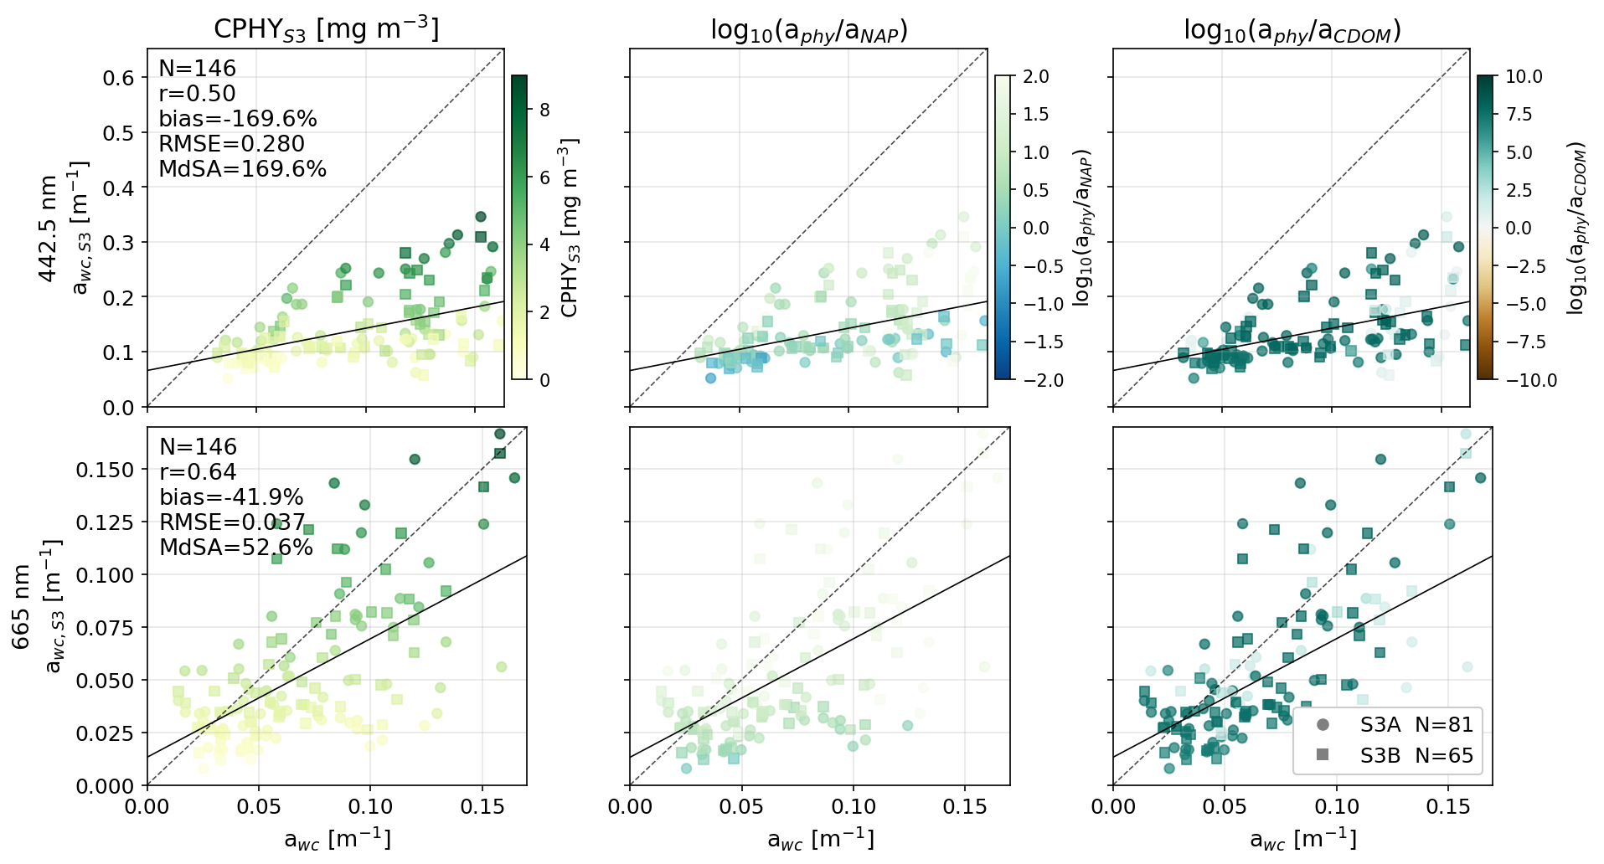
Figure 18: Validation of water constituent absorption at two select wavelengths corresponding to phytoplankton absorption peaks (442.5 and 665 nm). a_{wc}: absorption by water constituents measured in situ, a_{wc,S3}: absorption by water constituents as inverted from Sentinel 3A and B (S3A and S3B) $R_{rs}\left(λ\right)$. The first column is colored by retrieved phytoplankton concentration (CPHY_{S3}), the second by the proportion of retrieved phytoplankton absorption (a_{phy}) to retrieved non-algal particle absorption (a_{NAP}), the third by the proportion of a_{phy} to retrieved colored dissolved organic matter absorption (a_{CDOM}). Axes and colors are log-scaled.
Satellite constituent backscattering was correlated with in situ measurements at adjacent wavelengths, with r approximately equaling 0.84 for all comparisons (Table 15). The relationship between retrieved backscattering at 620 nm, $b_{b,\text{wc,S3}}^{ }\left(620\right)$, and in situ measurements at 630 nm, $b_{b,\text{wc}}^{ }\left(630\right)$, exemplifies their general relationship (see Figure 19). $b_{b,\text{wc,S3}}^{ }\left(620\right)$ was largely dominated by NAP backscattering $(b_{b,\text{NAP}}^{ }\left(λ\right)$), barring matchups with high CPHY_{S3} and low NAP_{S3}. Visually, $b_{b,\text{wc,S3}}^{ }\left(620\right)$ seems highly correlated with NAP_{S3} (Figure 19, bottom plot), which was confirmed statistically (r = 0.97).
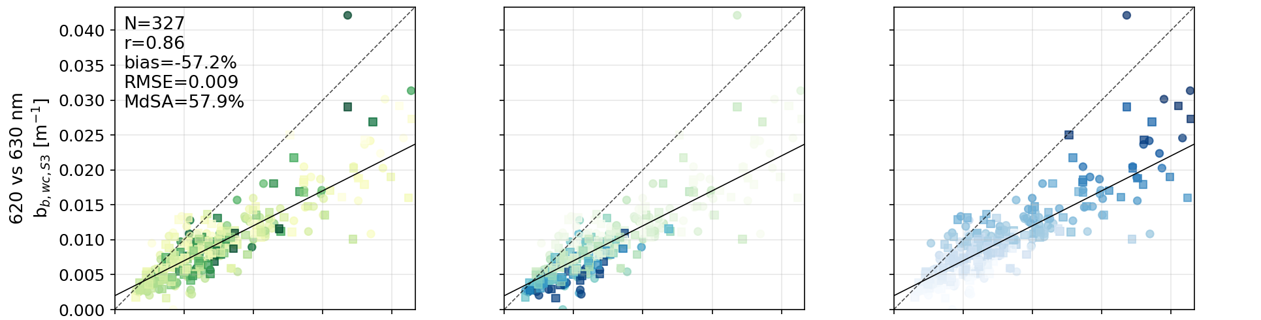
Figure 19: Validation of constituent backscattering: Retrieved constituent backscattering at 620 nm (b_{b,wc,S3}(620)) vs. in situ converted constituent backscattering at 630 nm (b_{b,wc}(630)). The top-left plot is colored by retrieved phytoplankton concentration (CPHY_{S3}), the top-right plot by the proportion of retrieved particulate non-algal backscattering (b_{b,NAP}) to retrieved phytoplankton backscattering (b_{b,phy}), and the bottom plot by retrieved non-algal particle (NAP_{S3}) concentration.
Satellite retrievals were significantly lower compared to the in situ, increasing from smaller to longer wavelengths (-37.6% to -70.4%) with MdSA from 40.0 to 70.4% and RMSE around 0.01 m⁻¹ (Table 15). This pattern is not exclusive to satellite retrievals; similar bias was also observed when checking hyperspectral in situ inversions (Appendix 3). Notably, Figure 19 shows a cluster of points with strong underestimations where backscattering is assumed to be dominated by phytoplankton.
The $b_{b,\text{wc,S3}}^{ }\left(442.5\right)$ vs. $b_{b,\text{wc}}^{ }\left(440\right)$ comparison showed significantly less bias than the others. (Figure 21; Table 15). In accordance with $b_{b,\text{phy}}^{*}\left(λ\right)$ (see Figure 5), $b_{b,\text{wc,S3}}^{ }\left(442.5\right)$ naturally has a stronger $b_{b,\text{phy}}^{ }\left(λ\right)$ component than the longer wavelengths. Matchups with small $b_{b,\text{wc}}^{ }\left(440\right)$ (<0.02 m⁻¹) were only weakly biased while for larger values the same strong negative bias as for the other comparisons can be observed.
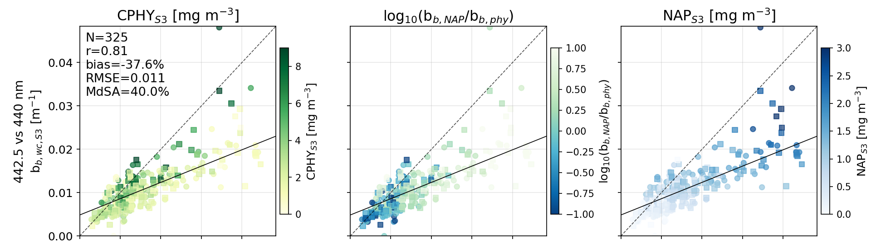
Figure 20: Validation of constituent backscattering: Retrieved constituent backscattering at 442.5 nm (b_{b,wc,S3}(442.5)) vs. in situ converted constituent backscattering at 440 nm (b_{b,wc}(440)). The top-left plot is colored by retrieved phytoplankton concentration (CPHY_{S3}), the top-right plot by the proportion of retrieved particulate non-algal backscattering (b_{b,NAP}) to retrieved phytoplankton backscattering (b_{b,phy}), and the bottom plot by retrieved non-algal particle (NAP_{S3}) concentration.
Table 15: Validation of constituent backscattering. b_{b,wc,S3}(wvl): constituent backscattering at wavelength “wvl” as inverted from Sentinel 3A and B (S3A and S3B) $R_{rs}\left(λ\right)$. b_{b,wc}(wvl): constituent backscattering from in situ scattering conversion at wavelength “wvl”.
 | Pearson r | Bias [%] | RMSE [m⁻¹] | MdSA [%] | N
b_{b,wc,S3}(708.75) vs. b_{b,wc}(700)
S3A | 0.86 | -68.6 | 0.0088 | 70.4 | 173
S3B | 0.87 | -67.1 | 0.0086 | 68.4 | 153
all | 0.86 | -68.4 | 0.0087 | 68.6 | 326
b_{b,wc,S3}(620) vs. b_{b,wc}(630)
S3A | 0.86 | -58.1 | 0.0083 | 58.3 | 174
S3B | 0.87 | -55.6 | 0.0088 | 55.6 | 153
all | 0.86 | -57.2 | 0.0085 | 57.9 | 327
b_{b,wc,S3}(510) vs. b_{b,wc}(532)
S3A | 0.84 | -70.8 | 0.01 | 70.8 | 173
S3B | 0.85 | -70.3 | 0.01 | 70.3 | 152
all | 0.84 | -70.4 | 0.01 | 70.4 | 325
b_{b,wc,S3}(442.5) vs. b_{b,wc}(440)
S3A | 0.79 | -36.9 | 0.011 | 41.5 | 173
S3B | 0.83 | -38.7 | 0.01 | 39.6 | 152
all | 0.81 | -37.6 | 0.011 | 40.0 | 325

Normalized in situ $b_{b,\text{wc}}^{ }\left(λ\right)$ shows significant spectral variation (Figure 20, A). While NAP_{S3} dominated spectra are on average relatively well matched in spectral shape (Figure 20, C), this is not the case for CPHY_{S3} dominated ones where a mismatch in the blue can be observed (Figure 20, A). While on average in situ NAP_{S3}-dominated spectra are more spectrally flat they show greater variability in spectral shapes. Figure 20, D, showing unnormalized spectra, further reinforces some of the observations from Figure 19 and Figure 21: a) backscattering is lower for CPHY_{S3}-dominated spectra (both in situ and satellite) and b) a general mismatch of magnitude (regardless of the dominating constituent) between in situ and satellite, stronger at larger wavelengths.
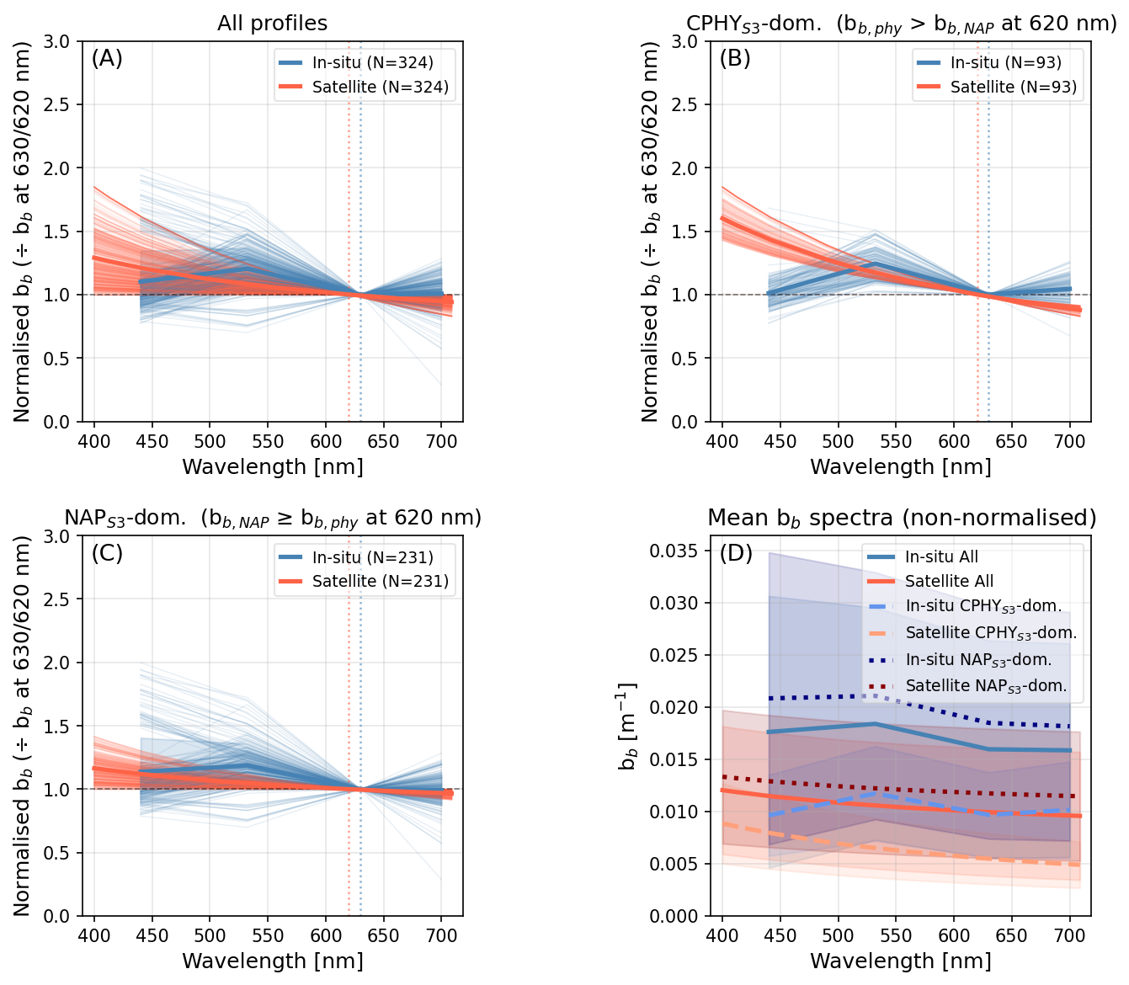
Figure 21: Comparison of retrieved and in situ backscattering (b_{b}) spectral shapes. b_{b,NAP}: retrieved backscattering by non-algal particles, b_{b,phy}: retrieved backscattering by phytoplankton, CPHY_{S3}: retrieved phytoplankton concentration, NAP_{S3}: retrieved particulate non-algal concentration. Spectra are normalized (applies to panels A, B, and C) at 630 nm for in situ data and at 620 nm for satellite retrievals. Thick lines indicate the average spectra. A) All normalized backscattering spectra. B) Backscattering spectra with higher b_{b,phy} than b_{b,NAP} (“CPHY_{S3} dominated”). C) Backscattering spectra with higher b_{b,NAP} than b_{b,phy} (“NAP_{S3} dominated”). D) Non-normalized spectra with thick lines representing the six average spectra from A, B, and C and polygons indicating the observed ranges among groupings.

3.4 eawag field campaigns
On 20.5.2021 both S3A (image acquired at 10:16) and S3B (image acquired at 9:37) covered Lake Geneva, matching a field campaign on the same date around noon. The true color RGB images reveal a gyre-like form with comparatively high $R_{rs}\left(λ\right)$ in the sampling zone (see Figure 22).
Four sampling points (P1, P2, P4, and P5) are located on the northern edges of the gyre. Accordingly, slightly higher NAP_{S3} values were retrieved (0.78, 0.99, 0.84, and 0.83 g m⁻³) than for P3 and P6 (0.71, and 0.5 g m⁻³) in the case of the S3A image. For CPHY_{S3}, values were generally lower in the main arm of the gyre; however, due to high noise this did not always translate to matchups.
The S3B image is very similar to the S3A one, but it is of a slightly darker color; accordingly, somewhat lower concentrations were obtained for NAP_{S3} and higher concentrations for CPHY_{S3} (maps not shown; see Table 16). Although the in situ samples do not necessarily follow the spatial distribution of the maps, the general range of values is in good agreement (Table 16).
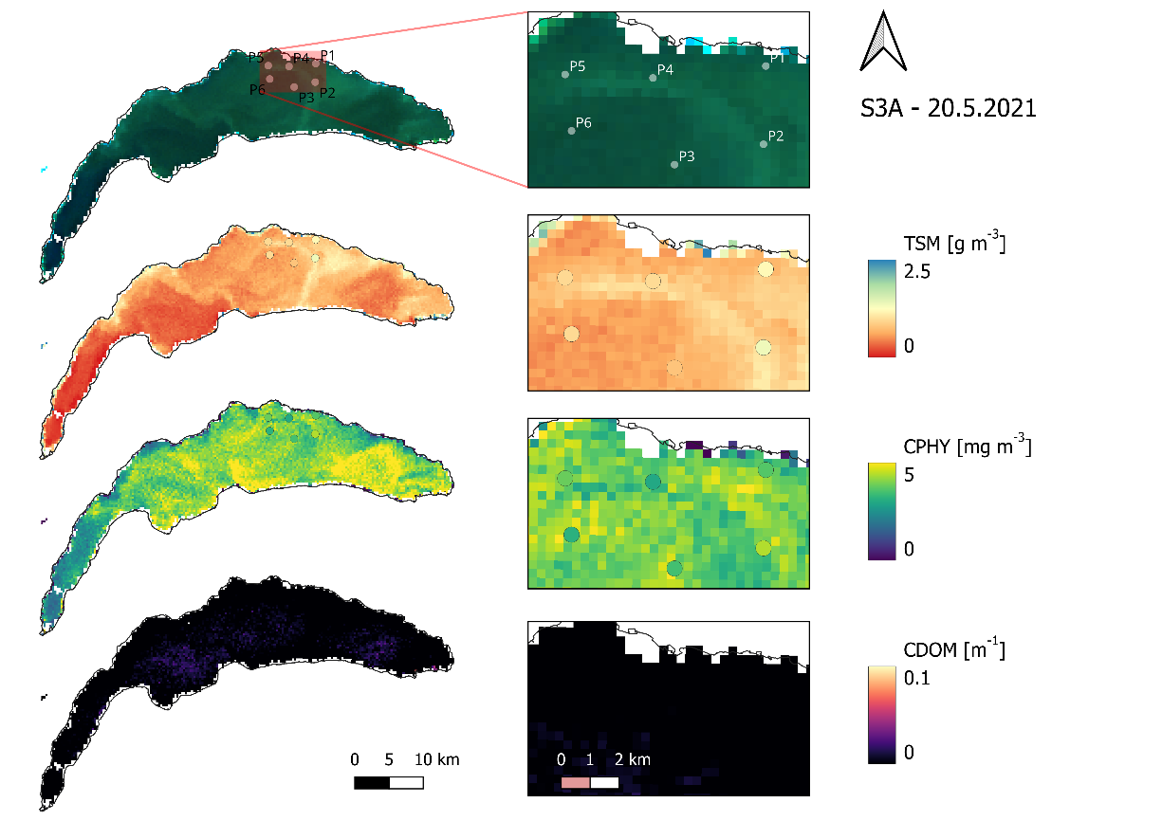
Figure 22: Retrievals for a S3A image paired with in situ data (points) from a spatially distributed campaign (20.5.2021). TSM: total suspended matter (considered equivalent to particulate non-algal concentration), CPHY: phytoplankton concentration (in situ samples: all pigments), CDOM: colored dissolved organic matter absorption at 440 nm (no in situ samples).
Table 16: Validation of two spatially distributed matchups with Sentinel 3A and B (S3A and S3B) on 20.5.2021. TSM: total suspended matter, NAP_{S3}: satellite non-algal particle concentration, CPHY_{HPLC}: total phytoplankton pigment concentration, CPHY_{S3}: satellite phytoplankton concentration
 | P1 | P2 | P3 | P4 | P5 | P6
TSM vs. NAP_{S3} [g m⁻³]
S3A | 0.78 | 0.99 | 0.71 | 0.84 | 0.83 | 0.50
S3B | 0.65 | 0.78 | 0.65 | 0.65 | 0.69 | 0.50
In situ | 1.2 | 1.37 | 0.80 | 0.97 | 0.96 | 0.97
CPHY_{HPLC} vs. CPHY_{S3} [mg m⁻³]
S3A | 3.66 | 3.28 | 4.31 | 3.61 | 4.15 | 4.44
S3B | 4.31 | 4.57 | 4.23 | 4.58 | 4.32 | 4.55
In situ | 3.67 | 4.43 | 3.50 | 3.00 | 3.86 | 3.19
A campaign on 11.6.2021 was covered only by S3B, revealing very bright areas with high $R_{rs}\left(λ\right)$ in the sampling zone towards the north-eastern shore, with NAP_{S3} retrievals exceeding 2.5 g m⁻³. CPHY_{S3} retrievals were relatively low in the area of interest, especially in areas of very high NAP_{S3} (Figure 23).
NAP_{S3} retrievals match the general spatial distribution of the in situ TSM samples: The two points within the bright area (P3 and P4) correspond to the highest retrievals (2.15 and 2.56 g m⁻³) and in situ (2.33 and 2.3 g m⁻³) samples. P2, located on the very edge of the beforementioned area, was characterized by similar NAP_{S3} (2 g m⁻³) but somewhat lower in situ (1.65 g m⁻³). P5 and P6 had lower NAP_{S3} (1.43 and 1.24 g m⁻³), with in situ TSM values of 1.45 and 1.75 g m⁻³ respectively.
Both CPHY_{S3} and CPHY_{HPLC} points towards P6 having highest CPHY concentrations. While CPHY_{S3} does not rigorously follow the spatial distribution of CPHY_{HPLC} and shows slightly lower concentrations, the absolute values are in a similar range Table 17.
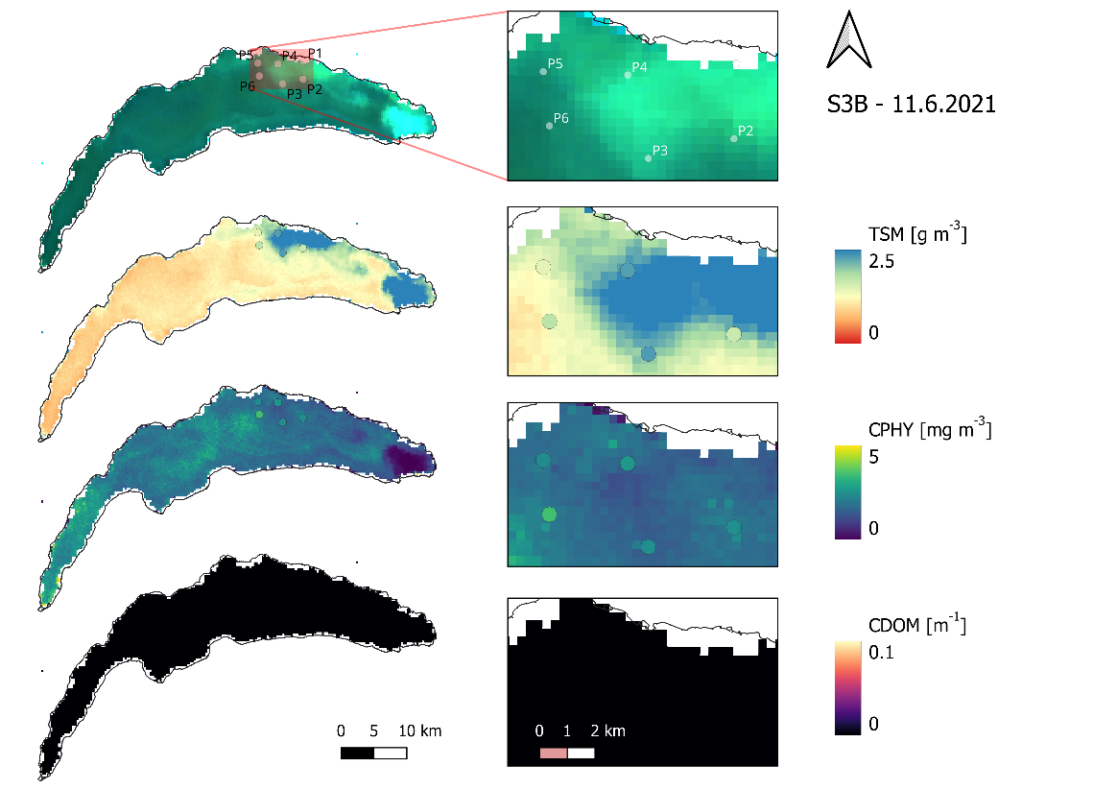
Figure 23: Retrievals for a S3A image paired with in situ data (points) from a spatially distributed campaign (11.6.2021). TSM: total suspended matter (considered equivalent to particulate non-algal concentration), CPHY: phytoplankton concentration (in situ samples: all pigments), CDOM: colored dissolved organic matter absorption at 440 nm (no in situ samples).
Table 17: Validation of one spatially distributed matchup with Sentinel 3B (S3B) on 11.6.2021. Note that P1 was outside the valid image area. TSM: total suspended matter, NAP_{S3}: satellite non-algal particle concentration, CPHY_{HPLC}: total phytoplankton pigment concentration, CPHY_{S3}: satellite phytoplankton concentration.
 | P1 | P2 | P3 | P4 | P5 | P6
TSM vs. NAP_{S3} [g m⁻³]
S3B | - | 2.0 | 2.15 | 2.56 | 1.43 | 1.24
In situ | - | 1.65 | 2.33 | 2.30 | 1.45 | 1.75
CPHY_{HPLC} vs. CPHY_{S3} [mg m⁻³]
S3B | - | 1.93 | 1.57 | 1.45 | 1.76 | 2.14
In situ | - | 2.47 | 2.49 | 2.67 | 2.40 | 3.48

S3A and S3B images on 16.6.2021 indicate that the abundance of suspended matter recorded five days prior had moved towards the western edges of the sampling zone. This was reflected by NAP_{S3} retrievals (Figure 24): Sampling points P4, P5, and P6 were in such bright areas, with retrievals of 2.27, 2.78, and 2.57 g m⁻³ for S3A, with P1 right on the edge (2.2 g m⁻³) and P2 and P3 to the south-east of it (1.55 and 1.5 g m⁻³). This pattern is only partly visible in the in situ data, with P2 having notably high concentrations and P6 notably low concentrations (Table 18).
CPHY_{S3} showed rather low concentrations (around 1.5 mg m⁻³) in the whole area of interest. A horseshoe-like form of very low (often below 1 mg m⁻³) CPHY_{S3} encompasses P4 and P5 where the RGB image is distinctly turquoise. CPHY_{HPLC} data matches the map very well, making the in situ sampling points nearly invisible in the CPHY map of Figure 24. Retrievals for the S3B image (not shown) are nearly identical to the S3A ones, barring slightly lower concentrations for both NAP_{S3} and CPHY_{S3} (Table 18).
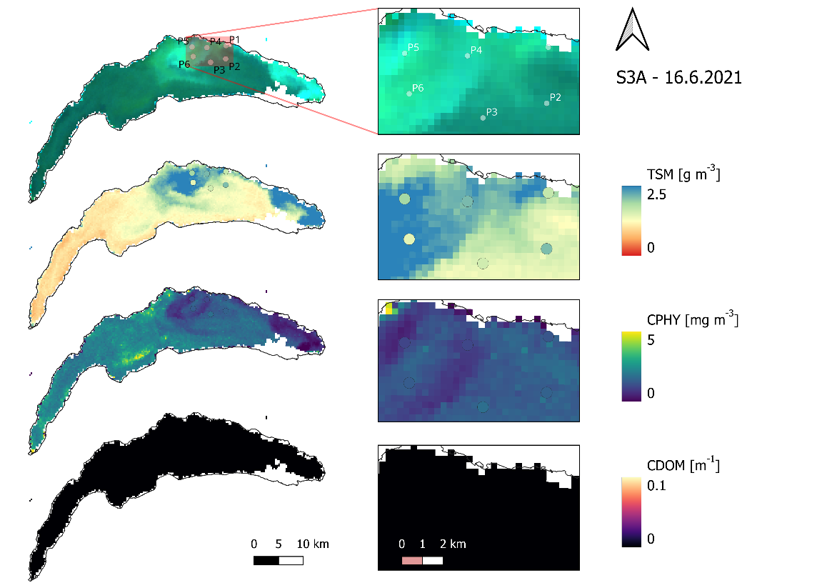
Figure 24: Retrievals for a S3A image paired with in situ data (points) from a spatially distributed campaign (16.6.2021). TSM: total suspended matter (considered equivalent to particulate non-algal concentration), CPHY: phytoplankton concentration (in situ samples: all pigments), CDOM: colored dissolved organic matter absorption at 440 nm (no in situ samples).
Table 18: Validation of two spatially distributed matchups with Sentinel 3A and B (S3A and S3B) on 16.6.2021. TSM: total suspended matter, NAP_{S3}: satellite non-algal particle concentration, CPHY_{HPLC}: total phytoplankton pigment concentration, CPHY_{S3}: satellite phytoplankton concentration
 | P1 | P2 | P3 | P4 | P5 | P6
TSM vs. NAP_{S3} [g m⁻³]
S3A | 2.20 | 1.55 | 1.50 | 2.27 | 2.78 | 2.57
S3B | 2.14 | 1.48 | 1.37 | 1.99 | 2.45 | 2.26
In situ | 1.70 | 2.10 | 1.60 | 2.12 | 1.9 | 1.45
CPHY_{HPLC} vs. CPHY_{S3} [mg m⁻³]
S3A | 1.42 | 1.49 | 1.49 | 0.91 | 1.11 | 1.43
S3B | 1.35 | 1.44 | 1.39 | 0.88 | 0.71 | 1.46
In situ | 1.32 | 1.55 | 1.82 | 1.07 | 1.02 | 1.44
Combining the results from all three campaigns (Figure 25), very good agreement was achieved between CPHY_{S3} and CPHY_{HPLC} (r = 0.87, bias = 0.3%, RMSE = 0.72 mg m⁻³, MdSA = 20.7%). Good results were also obtained when comparing NAP_{S3} and TSM (r = 0.78, bias = 15.1%, RMSE = 0.47 g m⁻³, MdSA = 29.6%).
When comparing CPHY_{S3} to CHL_{HPLC} (also excluding Chlorophyll a Chlorophyllide and other Chlorophylls) instead of the total pigment concentration CPHY_{HPLC}, correlation remains similar (r = 0.81) but significant Bias is introduced
(86.2%), resulting in apparent overestimates.
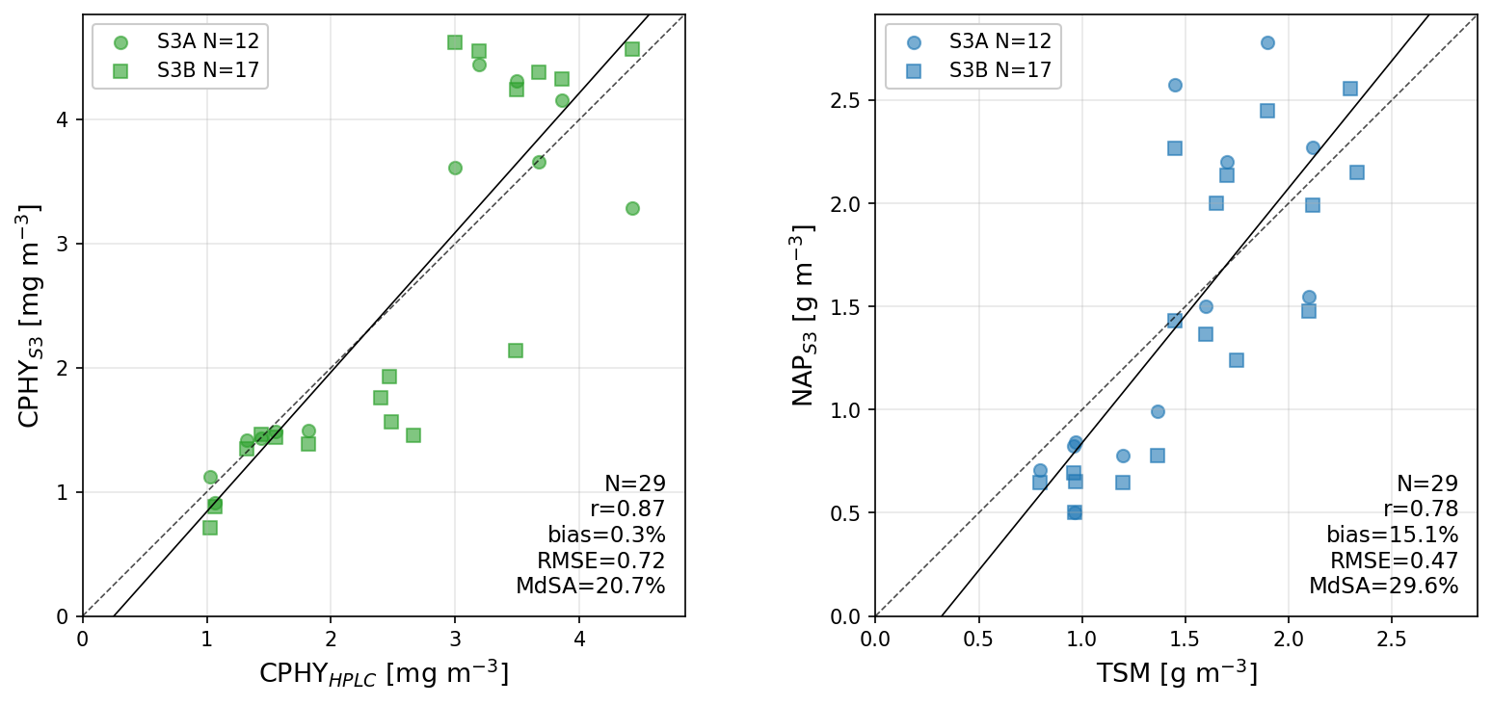
Figure 25: Validation of CPHY_{S3} and NAP_{S3} retrievals from five Sentinel 3A and 3B (S3A and S3B) images using in situ CPHY_{HPLC} and TSM from three spatially distributed campaigns. TSM: total suspended matter, NAP_{S3}: satellite non-algal particle concentration, CPHY_{HPLC}: total phytoplankton pigment concentration, CPHY_{S3}: satellite phytoplankton concentration.

4. Discussion

4.1 AC: a limiting factor
Water constituent retrievals should also include an assessment of AC accuracy (Ogashawara et al., 2021). AC accuracy is a limiting factor, as these errors strongly propagate downstream. This notion is not new; according to early estimates by Gordon and Clark (1981) errors <5% are needed in the blue wavelengths to achieve CHL ocean products with errors <30%. Although this early benchmark does not directly apply to this study and other more sophisticated retrieval algorithms, it clearly shows that even 45 years later AC errors (here 21.4 – 99.0% at relevant bands) are still far beyond what would be needed for high accuracy retrievals.
For the retrieval of CHL and phytoplankton information about the second absorption peak around 665 nm is crucial (Cael et al., 2020). However, evaluation of the 665 nm band revealed limited AC accuracies (MdSA = 99.0%). The underperformance of POLYMER at longer wavelengths has been observed in previous studies (Soppa et al., 2021; Werther et al., 2022). Since past studies using the Thetis dataset have shown that POLYMER is the best performing AC algorithm for Lake Geneva and that errors in the 665 band are high for all algorithms (Gupana et al., 2025; Werther et al., 2022), it is unlikely that switching AC algorithm would improve retrievals.
MiniWASI proved somewhat resistant to AC errors at 665 nm, with fitted $R_{rs}\left(λ\right)$ showing significantly better results (MdSA improvement from 99.0 to 37.7%), hence effectively extrapolating the band based on the more consistent bands.
The impact of the adjacency effect (AE) remains a big unknown. The validation of POLYMER $R_{rs}\left(λ\right)$ implicitly includes errors due to AE, which are technically not part of AC itself. AE is strongest close to the shore and in the NIR bands (Castagna & Vanhellemont, 2025). POLYMER can by design implicitly correct for (some of) the adjacency signal although not as well as explicit physical modelling (Castagna & Vanhellemont, 2025).
While adjacency effects generally add to the total $R_{rs}\left(λ\right)$, AE in the NIR may propagate to different errors in the visible wavelengths for POLYMER (Y. Wu et al., 2024). Y. Wu et al. (2024) found, that AE correction significantly improved near-shore performance of POLYMER for the whole spectrum. Visual interpretation suggests that AE have a significant impact on the visual spectrum for about 3 pixels from shore (~1 km). However, visual interpretation alone cannot confirm a strong impact on the pixel south of LéXPLORE, which served as reference.
Errors in the blue and red bands propagate directly into the CDOM (Section 4.6) and absorption IOP (Section 4.7) results discussed below.

4.2 General sources of matchup uncertainty
A variety of factors related to satellite matchups, which apply to all constituents, complicate the general assessment of errors. Hence, they are listed here to further contextualize the discussion of the validation exercise. What the satellite “sees” may not be representative of the in situ data, generally referred to as “(matchup) representativeness” (Bonnier et al., 2024). We subset these into three classes:
- Vertical (visibility) mismatch: As an example, for phytoplankton, samples include water along the first 18 m of the column while the visibility at SHL2 is on average only 7 m. An example of the effect of mismatches of visibility and CHL maximum can be found in Sections 3.2.1 and 4.4.1.
- Spatial mismatch: The pixel area may not be representative of the sampling location (e.g. small scale patterns at low spatial resolution).
- Temporal mismatch: Significant changes in constituent concentrations may have occurred between image acquisition and time of sampling. Temporal mismatch at LéXPLORE is usually less than an hour and unknown at SHL2 (no timestamps).
Closely related is the issue of non-uniformities: Bio-optical models such as WASI assume that constituents are uniformly distributed throughout the vertical column. Especially for phytoplankton, this is rarely the case. As a result, the impact of near-surface constituent concentrations is greatest on the $R_{rs}\left(λ\right)$ spectrum (for an example of a strongly non-uniform aLH₆₇₆ profile see Appendix 4). Further, such non-uniformities result in wavelength-dependent effects (different penetration depths) which are hard to account for. Radiative transfer simulations have shown this to be a significant source of errors (Nouchi, 2018).

4.3 Phytoplankton taxa retrieval: limitations
Retrievals of individual phytoplankton taxa were largely unsuccessful; significant correlation could only be achieved with one taxon (diatoms). Although it has been shown that such retrievals are possible for Case 2 waters using in situ hyperspectral data (Maire et al., 2025) the application to spaceborne multispectral data remains challenging. On the sensor side a variety of limitations exist, such as low spectral and spatial resolutions, AC errors, and instrument noise (i.e. low SNR) (Giardino et al., 2019).
In situ concentrations of individual taxa are not known exactly, but their biovolumes indicate they are generally low (Figure 12). This is consistent with Maire et al. (in preparation), who report a detection limit of 5 mg m⁻³ for retrieving individual phytoplankton taxa. Diatoms, the only taxon for which retrievals correlated with in situ data, also show the highest biovolumes, further supporting this explanation.
On the model side, the inclusion of different phytoplankton absorption SIOP spectra can lead to the inversion being strongly ill-posed, even for hyperspectral measurements (Cael et al., 2020). In turn, the introduction of errors can lead to degradation of hyperspectral spaceborne retrievals (Maire et al., in preparation). For multispectral sensors, the lower number of bands naturally increases the ill-posedness of the inverse problem. Hence, for this study the combination of significant errors in the input $R_{rs}\left(λ\right)$ (21.4 – 99.0% depending on the band) and low spectral resolution (five used bands) are likely the main reasons for the poor performance of taxa retrievals.
Another major modeling uncertainty is that the SIOPs used in this study were taken from Lake Constance. There is no guarantee that they are representative of Lake Geneva; this study effectively works with an uncalibrated model. In the case of phytoplankton, one taxon with significant abundance and biovolume, namely chrysophyceae, was not parametrized.
SIOPs of phytoplankton species, even among a single taxon, can vary strongly (Maire et al., 2025). Despite this, bulk phytoplankton absorption can generally be described by just a few spectral shapes (Cael et al., 2020). This may explain why individual phytoplankton taxa could not be retrieved, while the retrieved bulk concentration mostly aligned with in situ measurements across various methods and locations. How spaceborne retrievals of phytoplankton taxa could be improved is further discussed in Sections 4.8.3 and 4.8.4.

4.4 Bulk phytoplankton retrieval: strengths and limitations

4.4.1 SHL2 validation and matchup representativeness
While individual taxa retrievals were unsuccessful, bulk phytoplankton retrievals in the form of CHL largely achieved good results (see Sections 3.2.1, 3.3.1, and 3.4).
At SHL2 good results were achieved (r = 0.80) with good matching of the in situ time series. The underestimation CHL_{S} coincided with the CHL_{S} maximum being below the Secchi depth but still within the top 7.5 m of the water column for five matchups in mid-2021 and fall 2023. In such cases, the CHL_{S} maximum is not visible to the satellite but still shows up in the in situ reference.
For the same dataset, Bonnier et al. (2024) weighted the in situ data according to the optical visibility to improve matchup representativeness. This improved the agreement between the S3-derived ESA CCI product and CHL_{S} compared to when taking a simple depth average (r = 0.8 vs. r = 0.85). They also noted that the agreement was generally highest when looking at the first 2 or 5 m of the water column. This study observed no improvements when decreasing the averaging depth, hence it was kept at 7.5 m.
While optically weighing the in situ data may increase matchup representativeness, a simple depth-averaged CHL represents a physically defined and directly measurable quantity, whereas optically weighted CHL is a derived quantity whose value depends on the chosen weighting scheme.
This study achieved the same correlation as the ESA CCI product (r = 0.8). However, the uncorrected ESA CCI product was clearly biased (-2.7 mg m⁻³), while this was less of an issue for MiniWASI retrievals (see Section 3.2.1). This supports the general notion that physical models are more widely applicable (Giardino et al., 2019), while empirical models, such as the OC2 algorithm ESA CCI uses for Lake Geneva, require lake-specific calibration. Comparing different OC algorithms, Bonnier et al. (2024) found best results for re-calibrated OC4 (r = 0.9); however this comparison applied the abovementioned optical weighting strategy which makes it hard to directly compare results to this study.

4.4.2 LéXPLORE: intercomparison of in situ CHL and CPHY references
At LéXPLORE different in situ products of CHL and CPHY showed substantial differences. CHL_{F} was negatively biased compared to the other products, which is most likely due to systematic underestimations under NPQ conditions (see Section 2.3.2). CPHY_{R} showed some outliers negatively impacting the correlation with other products (r = 0.77 – 0.82). However, its general good agreement with CHL_{A} and aLH₆₇₆→CHL supports the chosen methodology as a means of phytoplankton retrieval.
While aLH₆₇₆ was highly correlated with other products, the linear conversion of aLH₆₇₆→CHL consistently showed overestimates at low concentrations and underestimates at high concentrations in cross-comparisons. Different equations have been proposed for the aLH₆₇₆→CHL conversion in Case 1 waters (see e.g. Boss et al., 2013; Cael et al., 2020). The conversion from phytoplankton absorption to CHL or CPHY is dependent on packaging effects (Bricaud et al., 1995; Ferreira et al., 2017) and thus also cell size and the phytoplankton community (Boss et al., 2013; Cael et al., 2020). Further, any bias in the absorption measurements will naturally propagate; hence, conversion was computed based on a local relationship for the Thetis profiler (Minaudo et al., 2021, supplementary material).
While such conversions are routinely used to assess CHL and CPHY in Case 1 waters, the used conversion has not been systematically evaluated for the Thetis profiler. Rather, past research at LéXPLORE used aLH₆₇₆ to correct CHL_{F} for NPQ effects (Gupana et al., 2025; Werther et al., 2022). While CHL_{A} was consistent with other products, uncertainties in the absorption measurements will propagate to aLH₆₇₆ and in turn CHL_{A}.
The quality control of hyperspectral absorption profiles revealed many profiles with spikes and gaps. Such profiles were filtered out for absorption matchups (N = 143) but not for aLH₆₇₆ matchups (N = 312). While using the standard L2 aLH₆₇₆ provided by the datalakes website ensures consistency with previous studies using the same dataset (e.g. Gupana et al., 2025; Werther et al., 2022) as well as general reproducibility, additional quality control may increase the products accuracy.

4.4.3 Why LéXPLORE retrievals underperform relative to SHL2
Correlations between CPHY_{S3} and in situ data at LéXPLORE were worse than at SHL2 (r = 0.72 vs. 0.80). Furthermore, CPHY_{S3} was significantly biased to underestimate CHL and CPHY, except for CHL_{F}, which is expected due to NPQ effects. Possible reasons for degraded performance may include:
- Lower quality of in situ data: CHL_{S} samples are collected using a state-of-the-art spectrophotometric approach (ISO10260:1992). CHL_{F}, CHL_{A}, aLH₆₇₆→CHL are not direct measurements of CHL but rather convert either fluorescence (CHL_{F}), absorption (aLH₆₇₆→CHL), or a mix of both (CHL_{A}) to CHL. CPHY_{R} is, like CPHY_{S3}, a result of $R_{rs}\left(λ\right)$ inversion and should thus be interpreted with additional caution.
- Positional uncertainty: To avoid undesired effects of the LéXPLORE platform on $R_{rs}\left(λ\right)$, the pixel south of the platform was taken as reference. The distance between the Thetis profiler and the center of the southern pixel is approximately 250 m.
- Lower quality of satellite data due to AE: Pixels located close to the shore are more strongly impacted, i.e. a significant part of the optical signal originates from adjacent land pixels through atmospheric scattering rather than the lake (Castagna & Vanhellemont, 2025).
- Higher optical complexity: While NAP_{S3} was at most moderate (2 g m⁻³) at SHL2 (see Figure 10) high concentrations (4 g m⁻³) were sometimes observed at LéXPLORE (see Figure 17). This mirrors large scale lake processes: At the northern shore, interflow dynamics may lead to the upwelling of suspended matter and the precipitation of calcite (Many et al., 2022; Many et al., 2024; Nouchi et al., 2019). Possible implications, include masking of the optical signal (Giardino et al., 2019) and degraded matchup representativeness, are discussed further.
- Timeframe mismatch: SHL2 data did not include 2024 data, where retrievals at LéXPLORE were in comparatively bad agreement with CHL_{A} (see Section 3.3.3).
Noticeable underestimations of CHL_{A} in summer 2024 may be caused by high NAP concentrations. On one hand, the accurate retrieval of low to intermediate CHL may be difficult given the large NAP contribution to the optical signal (“masking effect”). On the other hand, high NAP concentrations could impact matchup representativeness, as the CHL maximum may not be visible to the satellite while still showing up in the depth-average CHL_{A}, as has also been shown for the SHL2 station using auxiliary Secchi depth data. Although visibility is unknown, the inspection of corresponding in situ aLH₆₇₆ depth profiles showed non-surface CHL maxima, indicating that this assumption is reasonable.
The representativeness issue is illustrated by a single striking outlier: on 5.9.2021 CPHY_{S3} signaled a significant algal bloom (around 14 mg m⁻³) while CHL_{A} was more conservative in its estimate (8 mg m⁻³, see Figure 14). This instance corresponds to the aforementioned Uroglena sp. bloom (see Figure 1, B). For the same event Irani Rahaghi et al. (2024) estimate concentrations of up to 50 mg m⁻³. This mismatch may be due to strong non-uniformity, with CHL being strongly concentrated at the surface (thus strongly influencing $R_{rs}\left(λ\right)$) but quickly decreasing with depth as can be seen in the corresponding aLH₆₇₆ profile (see Appendix 4).

4.4.4 Benchmarking against empirical algorithms and literature
Comparison against CHL_{A} (MdSA = 45.0%) showed that MiniWASI retrievals outperformed various empirical algorithms not specifically calibrated for Lake Geneva which achieved MdSA ranging from 49.79% to 175.18% (Werther et al., 2022). However, re-calibrated OC3 (MdSA = 26.59%) outperformed retrievals presented in this study (Gupana et al., 2025). The study by Gupana et al. (2025) did only include data until August 2022. Note that MiniWASI performance was somewhat weaker thereafter, especially in 2024 (see Figure 17).

4.4.5 Pigment composition and SIOP considerations
The best results were obtained for matchups with CPHY_{HPLC} (see Section 3.4), resulting in high correlation (r = 0.87) and low absolute and relative errors (RMSE = 0.72 mg m⁻³, MdSA = 20.7%). The worse results when only looking at CHL_{HPLC} show that for such a validation exercise careful consideration is needed of what pigments are to be retrieved on the model side and which pigments are measured in situ.
The SIOPs used in this study encompass a variety of absorption features that do not originate from CHL. As an example, green algae exhibit Chlorophyll b features, while the used cyanobacteria spectrum has a strong phycoerythrin feature at 560 nm (Maire et al., 2025). Accessory pigments such as Chlorophyll b, Chlorophyll c, as well as various photosynthetic and photoprotective carotenoids can make up a significant proportion of total phytoplankton pigment concentration (Babin, Morel, et al., 2003; Ferreira et al., 2017). For the three field campaigns, HPLC analysis showed accessory pigment concentrations up to 50%, mainly made up of Chlorophyll b and Chlorophyllides.
However, for WASI phytoplankton absorption was normalized only by CHL (e.g. for cyanobacteria) or in some cases the sum of CHL and Phaeophytin (e.g. for diatoms). Hence, while accessory pigments impact the spectral shape of SIOPs, the retrieved “phytoplankton concentration” (as referred to in WASI) is mainly the phytoplankton CHL concentration. Hence, CPHY_{S3} should in theory be in better agreement with CHL_{HPLC} than CPHY_{HPLC}, which was not the case. No satisfactory explanation was found for this surprising result.
While HPLC is the gold standard for the analysis of phytoplankton pigment composition (A. Aminot; F. Rey, 2001), other methods this study used as reference are aimed at only retrieving CHL. However, the retrieved quantity may include contributions from other pigments: As an example, spectrophotometric procedures cannot distinguish Chlorophyllides and CHL, which naturally leads to slight overestimations (A. Aminot; F. Rey, 2001).
Similar validation studies of constituent retrievals often overlook the optical complexity of phytoplankton pigments. Since CHL and the concentration of accessory pigments is highly correlated (Babin, Stramski, et al., 2003), empirical models for CHL retrievals may implicitly correct for the signal of accessory pigments during calibration. For bio-optical models, careful consideration of both the used SIOPs and the in situ measurements is advised.

4.5 NAP: stable retrieval
NAP retrievals were in good overall agreement with TSM field samples from three spatially distributed campaigns (see Section 3.4). Notable outliers exist for the campaign on 16.6.2021: For P2 high TSM was sampled while dark water color resulted in low NAP_{S3} retrievals. For P6 the opposite occurred, where whiting of the water, along high NAP_{S3}, were observed but low TSM was sampled in situ. Given visual interpretation of the water color, it seems unlikely that P2 experienced higher TSM concentrations than P6. A possible explanation could be small scale variations that cannot be well resolved by S3 OLCI spatial resolution (300 m).
Relatively high correlation between NAP_{S3} and NAP_{R} has been found (r = 0.77). This result is supported by high correlation for the largely NAP-dominated backscattering IOPs (see Section 3.3.4). However, it must be highlighted that NAP_{R} is not a direct measurement but the result of in situ hyperspectral inversion, essentially using the same model configuration as NAP_{S3}. The general range of values agrees with past inter-annual averages (2002 – 2015) reported for Lake Geneva. They show low TSM concentrations < 0.5 g m⁻³ during winter and higher concentrations > 1 g m⁻³ during summer, coinciding with the hydrological cycle of the Rhone (Nouchi, 2018).
Although some studies have investigated whiting events in Lake Geneva using spaceborne RS (see e.g. Li et al., 2022; Many et al., 2022; Nouchi et al., 2019) to the authors knowledge no previous studies have directly validated retrievals of suspended matter concentrations. For the application of particle tracking Li et al. (2022) retrieved TSM using the S3 OLCI 665 nm band. Indirect validation using turbidity measurements at SHL2 revealed higher RMSE (0.76 g m⁻³, supplementary material) than achieved for this study (0.47 – 0.52 g m⁻³).

4.6 CDOM: a retrieval failure and its causes
CDOM retrievals were unsuccessful, with CDOM_{S3} retrievals being well below the CDOM_{R} references. Average CDOM values for Lake Geneva are 0.1 m⁻¹ (Nouchi, 2018); hence this mismatch is a retrieval failure and not related to CDOM_{R}. This failure is most likely the interplay of several factors:
- AC errors in the blue bands: For matchups with (presumably) significant CDOM (i.e. low to intermediate $R_{rs}\left(λ\right)$ in the 400-490 nm range) there is a clear overestimation of $R_{rs}\left(λ\right)$. Hence, the absence of CDOM, which strongly absorbs in these wavelengths, may be compensating for these AC errors.
- Limited weighting of the blue wavelengths: Since CDOM strongly absorbs in the blue, CDOM retrieval algorithms rely on blue wavelengths. This study did not use the first two (400 and 412.5 nm) OLCI bands in order to stabilize CPHY_{S3} retrievals. One intended use case of those two bands is to help improve CDOM retrievals (see Table 4).
- Low CDOM concentrations, averaging 0.1 m⁻¹ in Lake Geneva. Lake Geneva CDOM absorption is far below what most waters for RS studies exhibit. A review of constituent retrievals in Case 2 waters by Odermatt et al. (2012) shows that past studies considered ranges of CDOM absorption at 400 nm between 0.1 m⁻¹ and 10 m⁻¹. Griffin et al. (2018) define visibly colored CDOM waters as CDOM > 3 m⁻¹.
- Spectral ambiguity: As for the retrieval of individual phytoplankton taxa, the retrieval of CDOM is strongly ill-posed. It “competes” with 6 other unknown absorbers (C₁ – C₅ and C_{x}) whose absorption peak is largely superimposed (Odermatt et al., 2012; also see Figure 5). This study experimentally observed that retrieved CDOM decreased with increasing number of unknown C_{i}.
The configuration of CDOM absorption with $S_{\text{CDOM}}$ = 0.14 should be well representative of Lake Geneva as reported values of $S_{\text{CDOM}}$ range between 0.1 and 0.18 (Nouchi, 2018). Hence, retrieval failure is unlikely due to CDOM absorption configuration.
This retrieval failure propagates through the whole range of relevant AOP, IOP, and OAC comparisons: Too high input satellite $R_{rs}\left(λ\right)$ in the blue wavelengths (see Table 8), very strong underestimation of $a_{wc}\left(λ\right)$ in the blue wavelengths (see Figure 18), and consequently in CDOM absorption (see Figure 15).

4.7 IOPs: implications for model configuration
Retrieved $a_{\text{wc,S3}}^{ }\left(λ\right)$ strongly underestimated absorption, resulting in negative Biases and significant errors (see Section 3.3.4). This is to a significant part due to missing CDOM absorption as it was close to 0 at LéXPLORE for most of the time. Accordingly, Bias decreased with increasing wavelength as CDOM absorption becomes smaller. The resulting erroneous domination of CPHY_{S3} of the absorption spectrum is signified by high correlations with $a_{\text{wc,S3}}^{ }\left(λ\right)$ but low to moderate correlations with in situ $a_{wc}\left(λ\right)$. The same phenomenon is also reflected by the stronger correlation between CDOM_{R} and CPHY_{S3} (r = 0.56) than between CDOM_{R} and CHL_{A} (r = 0.29).
Significant negative Biases (>100% in the blue green) show that even though CDOM absorption is comparatively small for Lake Geneva, it still is a major absorber, even at low concentrations. For typical Lake Geneva concentrations (C_{x} = 1 g m⁻³, C_{y} = 0.1 m⁻¹, C₀ = 3 mg m⁻³) WASI forward modelling shows that C_{y} (i.e. CDOM) makes up approximately 50% of total $a_{wc}\left(λ\right)$ in the small blue wavelengths and significantly impacts $R_{rs}\left(λ\right)$ (Figure 26).
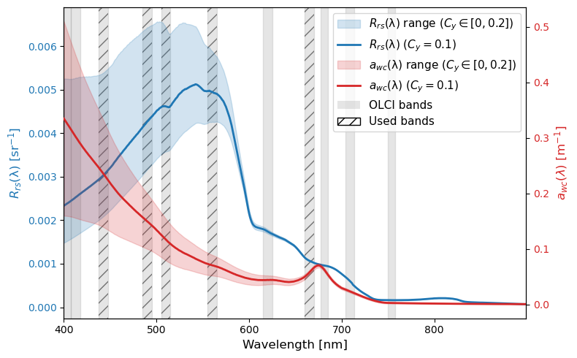
Figure 26: WASI forward-modelled remote sensing reflectance ($R_{rs}\left(λ\right)$) and constituent absorption (a_{wc}(λ)) for Lake Geneva “standard” concentrations of C₀ = 3 mg m⁻³, C_{X} = 1 g m⁻³, and varying C_{y} [0, 0.2 m⁻¹]. OLCI bands at full width half maximum are highlighted grey, with hatched lines indicting the used bands.
The absence of CDOM and the accompanying Bias renders any closer interpretation of the absorption bands used < 600 nm difficult. At 665 nm the contribution of CDOM absorption should be minimal. There, Bias was still present, although in much lower magnitude as for smaller wavelengths (-42.2%).
To rule out any effects of biases in the satellite images themselves, hyperspectral in situ retrievals of $a_{wc}\left(λ\right)$ were cross-checked, revealing high negative biases (-63.8 – -100.5% (Appendix 3).
This Bias prompted a thorough investigation of absorption data processing and calibration, which revealed ACS instrument drift (Appendix 5). This drift is sometimes up to one order of magnitude higher than the constituent absorption. While the processing of the L2 Thetis dataset tries to account for this drift by linearly interpolating in between calibration measurements, the relative magnitude of the drift and the relatively low frequency of such calibration measurements indicate limited data quality for $a_{wc}\left(λ\right)$. Since drift seems to not be strongly wavelength-dependent, the impact on aLH₆₇₆ is assumed to be comparatively small.
$b_{b,\text{wc,S3}}^{ }\left(λ\right)$ underestimated in situ $b_{b,\text{wc}}^{ }\left(λ\right)$, especially at high values. Since the same pattern was observed for hyperspectral in situ retrievals, the observed Bias cannot be attributed to errors in OLCI $R_{rs}\left(λ\right)$ or reduced spectral resolution. Backscattering was found to be largely dominated by NAP_{S3}.
Since no strong Bias was observed for retrieved NAP (see Figure 25) it is assumed that the general magnitude of the $b_{b,\text{X}}^{*}\left(λ\right)$ is appropriate. This notion is supported by similar $b_{b,\text{NAP}}^{*}\left(λ\right)$ magnitudes for other peri-alpine lakes such as Lake Garda (Giardino et al., 2014), Lake Maggiore and Lake Varese (Niroumand-Jadidi et al., 2022) based on exponential approximations of in situ measurements. Note that these studies generally assume $b_{b,\text{NAP}}^{*}\left(λ\right)$ higher as this study: To increase $b_{b,\text{wc}}^{ }\left(λ\right)$ even lower $b_{b,\text{X}}^{*}\left(λ\right)$ would be needed. Even when experimentally setting $b_{b,\text{X}}^{*}\left(λ\right)$ unreasonably low (e.g. to 0.003 m² g⁻¹ at all wavelengths), which sometimes resulted in very unlikely NAP_{S3} > 10 g m⁻³, the Bias in $b_{b,\text{wc,S3}}^{ }\left(λ\right)$ was still not fully removed.
A general indicator of SIOP mismatch could be the underestimation of $a_{wc}\left(665\right)$, which would enable an underestimation of $b_{b,\text{wc}}^{ }\left(665\right)$ while maintaining similar $R_{rs}\left(λ\right)$. However, observed issues with absorption profiles (see Appendix 2) question the accuracy of $a_{wc}\left(λ\right)$.
$b_{b,\text{wc}}^{ }\left(λ\right)$ is influenced by not only backscattering SIOPs such as $b_{b,\text{X}}^{*}\left(λ\right)$ but also indirectly by absorption SIOPs, especially $a_{\text{NAP}}^{*}\left(λ\right)$, and anisotropy modelling (e.g. the ill-favored Q factor). Removing the observed Bias would require parameter tuning of $b_{b,\text{NAP}}^{*}\left(λ\right)$ and $a_{\text{NAP}}^{*}\left(λ\right)$ leading to unreasonable constituent outputs. Hence, while uncertainties in SIOPs may contribute to the Bias, it is deemed unlikely that they fully explain it.
Backscattering is not measured directly, rather scattering at a single angle is converted to backscattering using the equations of Boss & Pegau (2001). Such a conversion may induce some uncertainties (see e.g. Vaillancourt (2004)), although hardly in the observed magnitude. Issues due to calibration (e.g. extrapolation to large $b_{b,\text{wc}}^{ }\left(λ\right)$) or air bubbles might also be present but cannot be assessed. Since no direct measurements of $b_{b,\text{wc}}^{ }\left(λ\right)$ and backscattering SIOPs have been published for Lake Geneva the exact nature of the observed Bias remains unknown.
Like the magnitude of backscattering, the spectral shapes do necessarily match in situ measurements (Figure 21). The observed spectra do usually not follow a spectrally flat or exponential function, as assumed by $b_{b,\text{X}}^{*}\left(λ\right)$ and $b_{b,\text{phy}}^{*}\left(λ\right)$ respectively.
Hence, these commonly used backscattering SIOP approximations may not properly capture wavelength dependency. However, the effect of these mismatches should not be overstated since the normalization (of still rather spectrally flat spectra) strongly highlights spectral features.
Studies examining real world (specific) backscattering (see e.g. Figure 27) have observed spectral shapes that do not strictly follow common exponential or spectrally flat approximations (Gallie & Murtha, 1992; Gordon et al., 2009; Vaillancourt, 2004; Whitmire et al., 2010). Still, especially the exponential approximation is widely used and generally aligns with in situ measurements to a satisfactory degree (see e.g. Reynolds et al., 2016).
However, based on the comparison between phytoplankton-dominated modelled and in situ measurements, for this study we suspect that modelled phytoplankton backscattering is assumed to be too steep. This may not be necessarily towards the blue wavelengths (as Figure 21, B might suggest) as such an interpretation would implicitly assume correct modelling at the normalization reference wavelength.
Overall variability of in situ backscattering shapes indicates that backscattering processes in Lake Geneva are more complex than modeled. The spectral shape and magnitude of (concentration-specific) backscattering varies depending on a variety of factors, such as cell size, chemical composition and taxonomy (Brewin et al., 2012; Gege, 2004; Reynolds et al., 2016; Vaillancourt, 2004) and is thus challenging to model.
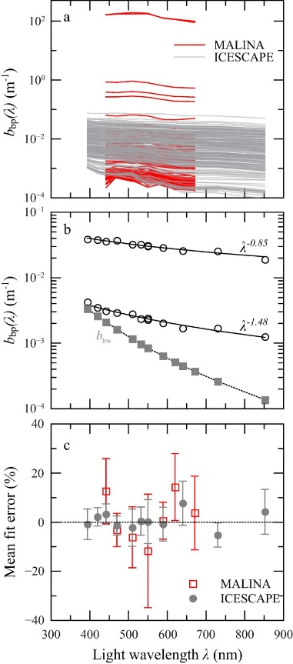
Figure 27: All measured spectra of the particle backscattering coefficient, b_{bp}(λ), obtained during the MALINA and ICESCAPE cruises (Reynolds et al., 2016, Figure 8a).

4.8 Future study directions and general limitations

4.8.1 Uncertainty
The assessment of uncertainties is rarely done for constituent retrievals, although crucial for end users (Giardino et al., 2019; IOCCG, 2019). While this need has been recognized (IOCCG, 2019) and some algorithms provide an estimate of uncertainty (see e.g. Werther et al., 2022), bio-optical models such as WASI and BOMBER do not directly report uncertainty. For WASI, an assesment of uncertainty is usually done through the comparison to WASI-AI outputs (Niroumand-Jadidi & Gege, 2025, see also Appendix 1). MiniWASI provides an estimate of the standard error (see Section 2.8.2), although the extreme ill-posedness due to the inversion of 7 unknown variables made this estimate impossbile.
Retrieval errors are relatively complex due to a chain of major uncertainties (e.g. sensor noise, AC errors, AE, different model uncertainties). For bio-optical models, the separation of these errors through an uncertainty budget would be optimal, although a challenging task given the complexity and diversity of OACs (IOCCG, 2019). It should also be noted that in situ data are not error free (as is clear by the disagreement of different CHL proxies): hence, validation studies like this should not be interpreted as a strict quantification of uncertainty in end products (IOCCG, 2019). Future studies should explore how uncertainties are best to be quantified for bio-optical modelling.

4.8.2 AC and AE advancements
Although it is hard to pinpoint the exact effect of AC errors in the uncertainty budget (IOCCG, 2019), it is clear that errors are susbtantial and that more accurate AC is needed for the improvement of constituent retrievals in Case 2 waters (Giardino et al., 2019). This study concludes, that higher accuracy in the 665 nm as well as the blue bands could help improve OLCI bio-optical CHL and CDOM retrievals.
The validation of near-shore $R_{rs}\left(λ\right)$ inherently includes errors that are due to the AE. To potentially improve constituent retrievals, especially near-shore, future research should explore newly developed AE correction algorithms such as RAdCor (Castagna & Vanhellemont, 2025). How the prior application of such algorithms impacts the performance of AC algorithms is part of ongoing research (Pühringer et al., in preparation).

4.8.3 Bio-optical modelling: limitations and possible improvements
Study-specific issues encountered with IOPs and SIOPs have already been discussed thoroughly: observed mismatches for absorption and backscattering, missing chrysophyceae taxon, and SIOP transfer from Lake Constance. This Section will rather focus on general limitations of bio-optical modelling which are hard to quantify but are nonetheless relevant for the bigger picture and future advancements.
A prominent issue with absorption-based estimates of phytoplankton concentrations that has already been raised in the 1990s by Bricaud et al. (1995) is the so-called “packaging effect:” Shape and magnitude of phytoplankton absorption SIOPs are not only dependent on accessory pigments but also the packaging effect where bundling pigments inside cells reduces their light-absorbing efficiency (Bricaud et al., 1995). Using a variety of different specific absorption spectra may partly account for packaging (taxa-dependent cell-sizes), however its effect on the results of this study remains unknown.
It should also be noted that, like phytoplankton, NAP and CDOM constitute rather broad classes with variable optical properties, even at a single location (Gege, 2024). SIOP measurements could help to identify the optical properties of different OACs and their variability in Lake Geneva. Such measurements would also help answer if the identified IOP mismatches (see Section 4.5) are due to the used SIOPs or some other reasons such as limited quality of the Thetis IOP data.
An approach for future research could constitute the modelling of absorption by different phytoplankton pigments rather than phytoplankton taxa. This would allow a less ill-posed configuration while covering phytoplankton optical variability. Further, regularization of the inverse problem (e.g. through the use of priors) may improve retrievals, especially under strongly ill-posed conditions (Cael et al., 2020).

4.8.4 Hyperspectral missions: PACE
This study supports the notion, that the accurate inversion of phytoplankton taxa from multispectral measurements is extremely challenging (or even mathematically impossible) when confronted with significant errors in the input data (Cael et al., 2020). Hyperspectral sensors provide novel opportunities for constituent retrievals, especially for the detection of different phytoplankton taxa (Giardino et al., 2019).
While past studies have relied on on-demand missions such as PRISMA (see Table 1) that may not be suited for operational monitoring, NASA's newly launched Plankton, Aerosol, Cloud, ocean Ecosystem (PACE) missions ocean color instrument provides 240 continuous bands between 340 and 890 nm at 2.5 nm spectral resolution at a revisit time of approximately two days (Xu et al., 2026). PACE’s spectral range (including parts of the UV spectrum) may further allow it to better disentangle NAP, CDOM and phytoplankton signals (Cael et al., 2020). How the PACE mission can be used to assess different phytoplankton taxa in Case 2 waters is part of ongoing research (Maire et al., in preparation).

4.9 Conclusion
This thesis developed a bio-optical model MiniWASI tailored to operational retrievals of OACs and IOPs in optically deep Case 2 waters. By validating retrievals from a large number (N = 374) of images using a default set of SIOPs and automated processing, this thesis made the jump to a more operational approach in WASI inversions.
Using a default set of SIOPs, a WASI-based bio-optical inversion approach using S3 OLCI $R_{rs}\left(λ\right)$performed well in retrieving CHL (r = 0.72 – 0.81; for datasets used in previous studies) and TSM (r = 0.76 – 0.78) in Lake Geneva, while being unable to retrieve CDOM and differentiate different phytoplankton taxa.
Validation showed similar accuracies as empirical, locally calibrated CHL retrieval algorithms. The retrieval of individual phytoplankton taxa from S3 OLCI was not possible due to the strong ill-posedness of the inverse problem at low concentrations, limited spectral resolution, and errors in input $R_{rs}\left(λ\right)$.
The spaceborne retrieval of CDOM was not possible, often defaulting to 0. This was mainly attributed to a) biases in the blue bands (overestimation of $R_{rs}\left(λ\right)$) and b) model configuration (selected bands, large number of other competing absorbers).
On the other hand, NAP showed robust agreement with a limited amount of field samples and estimates from hyperspectral in situ data. Consistency in NAP retrievals is further supported by relatively high correlation of modelled and measured $b_{b,\text{wc}}^{ }\left(λ\right)$.
Future research directions include the quantification of retrieval uncertainties, applying and improving AC and AE algorithms, explicit model calibration (e.g. through SIOP in situ measurements), as well as the application to hyperspectral missions such as PACE.

Appendices

Appendix 1: MiniWASI and WASI7 inversion performance
With WASI, a common issue that was encountered when varying three basic constituent classes (here C₀, C_{x}, and C_{y}) is that the phytoplankton proxy (here C₀) was prone to stay at the initial value under ill-posed conditions. Figure 28 shows an example where WASI version 7 (WASI7) and WASI-AI retrievals were stuck at the initial value of 3 mg m⁻³ while MiniWASI achieved lower residuals and less dependency on the initial value.
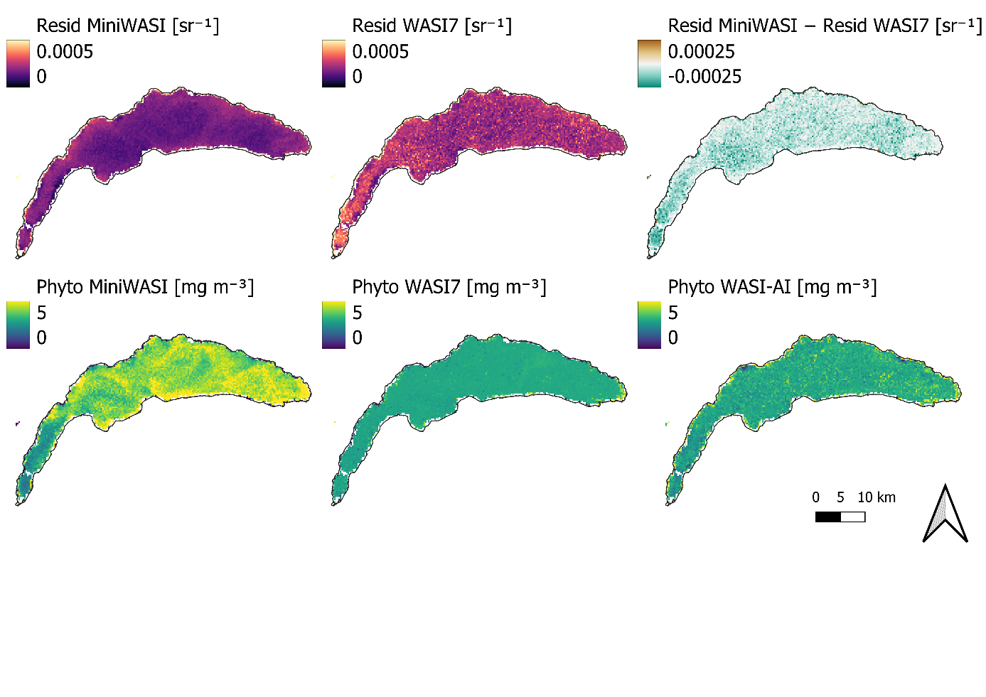
Figure 28: Example of inversion performance of MiniWASI and WASI7 under equal conditions. WASI7 shows higher residual values than MiniWASI. WASI7 and WASI-AI phytoplankton retrievals are “stuck” at the initial value of 3 mg m⁻³. Variables and initial values used for this test: C₀: 3, C_{x}: 1, C_{y}: 0.1. The number of iterations was doubled from the default 200 to 400 for WASI7.
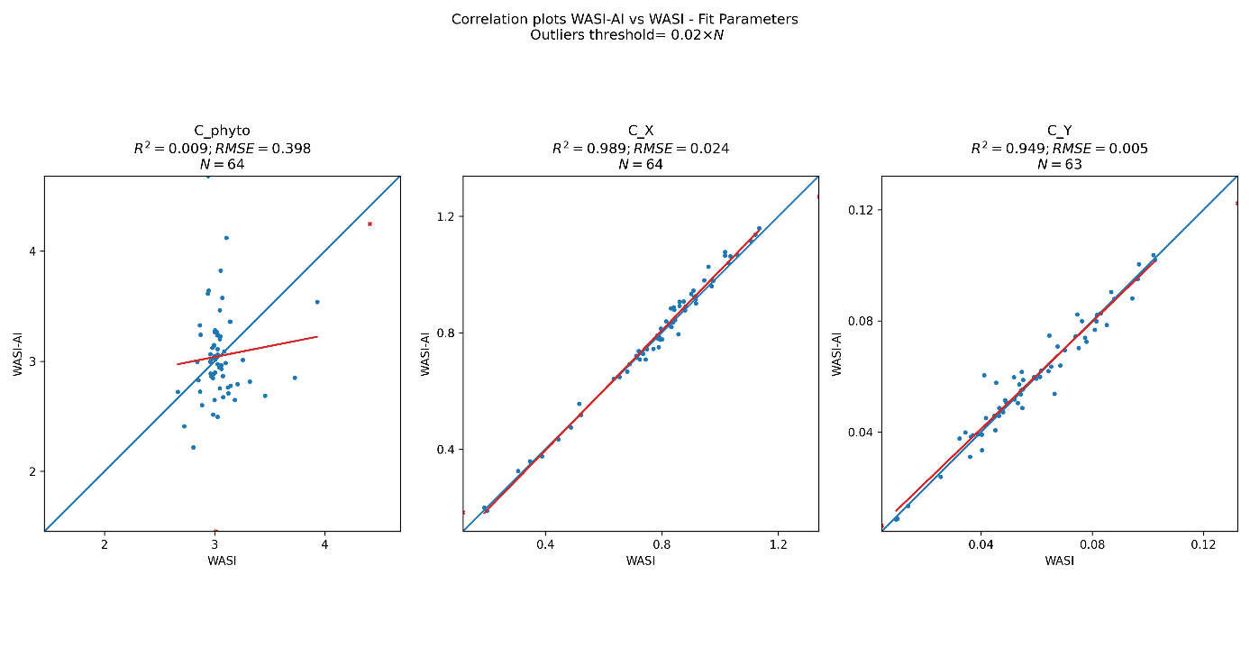
Figure 29: For the same image as in Figure 28: WASI vs. WASI-AI retrievals at 64 select pixels, as automatically generated by the WASI7 graphical user interface. The strong disagreement of phytoplankton retrievals of WASI-AI and WASI7 indicate extreme ill-posedness for this parameter.
Figure 29 shows that WASI7 and WASI-AI phytoplankton retrievals were around 3 mg m⁻³ with low agreement among the validation pixels (WASI7 vs. WASI-AI, r-squared = 0.009). Bad agreement between WASI7 and WASI-AI indicates high ill-posedness for a parameter (Niroumand-Jadidi & Gege, 2025).
This is not exclusive to the image presented in Figure 28. The campaign images from Section 3.4 were inverted using WASI7, WASI-AI, and MiniWASI (exact same model configuration). Figure 30 shows that for WASI7 retrievals were largely stuck around the initial value of 3 mg m⁻³ while MiniWASI retrieved a broader range of values. WASI-AI retrievals learn from WASI7 retrievals (image-based) and are thus impacted by any issue in WASI7 inversion accuracy (see Figure 28).
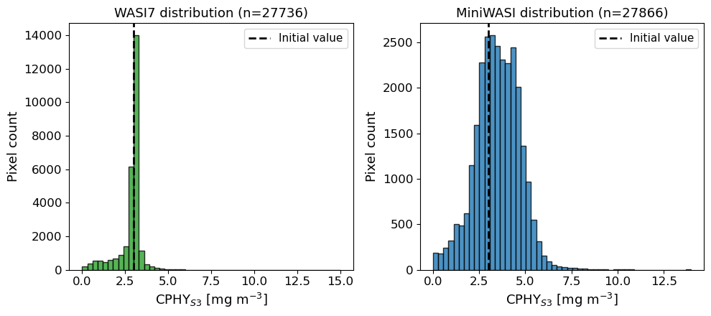
Figure 30: Histograms of phytoplankton concentration values of the five campaign images (see Section 3.4; Table 19). WASI7 retrievals of phytoplankton are strongly biased towards the initial value (3 mg m⁻³) while MiniWASI retrievals show greater variability at higher overall inversion accuracy (see Table 19). The number of pixels varies slightly due to the water masking procedure applied in WASI7.
Table 19 shows that MiniWASI was about two orders of magnitude faster than WASI7 and produced lower residuals for all campaign images.
Table 19: The mean residual and overall runtime for each campaign image of Section 3.4 when inverted with MiniWASI and WASI7 respectively. MiniWASI shows lower average residuals while being three orders of magnitude faster using parallel processing. Variables and initial values used for this test: C₀: 3, C_{x}: 1, C_{y}: 0.1. Since it was not possible to adjust the viewing angle in WASI7 in image inverse mode it was set to 0 for both WASI7 and MiniWASI.
Image | Mean Resid MiniWASI [sr⁻¹] | Runtime MiniWASI [sec] | Mean Resid WASI7 [sr⁻¹] | Runtime WASI7 [sec]
S3A_20210520T101659 | 0.0002655 | 8 | 0.0003578 | 857
S3A_20210616T101659 | 0.0004936 | 2 | 0.0006733 | 451
S3B_20210520T093729 | 0.0005574 | 1 | 0.0008048 | 450
S3B_20210611T100729 | 0.0004078 | 2 | 0.0005581 | 494
S3B_20210616T093735 | 0.0007878 | 2 | 0.001095 | 424
Hyperspectral RAMSES measurements provided as part of the WASI demo data were inverted using all available taxa-specific phytoplankton classes (C₁-C₅) using WASI7 and MiniWASI (Table 20). The goal of this was to check a) if residuals are calculated in the same manner in MiniWASI and WASI7 b) how they fare in inverting hyperspectral data using many phytoplankton classes (C_{i}).
Unlike reported in the manual (Gege, 2024), WASI7 residuals that are displayed in the user interface appear to be square-rooted. The following equation uses the same variable formulation as in the WASI7 user manual for the ease of comparison:
$$\text{Residuum}=\sqrt{\frac{1}{N}\sum_{i=1}^{N}{g_{i}}{\left(m_{i}-f_{i}\right)}^{2}}$$
where m = $R_{rs}^{\text{measured}}\left(λ_{i}\right)$, f = $R_{rs}^{\text{modeled}}\left(λ_{i}\right)$ (see Equation 21), g_{i} = per-band weight, N = number of nonzero-weight bands. MiniWASI residual reporting was adjusted for this exercise accordingly. While this formula does not exactly follow Equation 21, simple scaling does not impact the inversion result.
Spectra were inverted using both WASI7 (Table 20, column “Resid WASI7”) and MiniWASI (Table 20, column “Resid MiniWASI”), yielding a set of inverted parameters and a residual for both.
To check if a given WASI7 parameter set yields the same residual in MiniWASI the retrieved WASI7 parameter set was used to forward calculate a spectrum in MiniWASI and the resulting residual with the original RAMSES spectrum was manually re-calculated (Table 20, column “Resid WASI7 in MiniWASI”).
The same procedure cannot be applied vice versa since it is not possible to manually calculate a residual in WASI7. Hence, to check if a given MiniWASI parameter set yields the same residual in WASI7 the retrieved MiniWASI parameter set was used to invert the original RAMSES spectrum using a single iteration (Table 20, column “Resid MiniWASI in WASI7”). This single iteration hardly had an impact on the parameter set: Hence the residual could still be calculated without changing the parameters.
Residuals were largely the same in MiniWASI and WASI7 for the same parameter set (i.e. Resid MiniWASI vs. Resid MiniWASI in WASI7 and Resid WASI7 in MiniWASI Resid MiniWASI in WASI7 closely align). Slight differences may occur due to unknown differences in residual or forward calculation. It should be noted that forward calculations are visually indistinguishable when plotted on top of each other (not shown).
MiniWASI performed as good or better as WASI7 for all RAMSES measurements when judged by the MiniWASI replica of the WASI7 residual reporting. WASI7 was as good or better as MiniWASI in only two cases when judged by the WASI7 user interface residual reporting (Table 20).
Table 20: Inversion of hyperspectral RAMSES measurements distributed as part of the WASI7 demo data using MiniWASI and WASI7 respectively. Residual calculations in WASI7 and MiniWASI, while nearly identical, show small differences. Hence MiniWASI retrievals were also assessed in WASI7 and vice versa. MiniWASI retrieves a lower or the same residual when depending on the MiniWASI residual calculation. For WASI-type residuals MiniWASI outperforms WASI7 in 6 out of 8 cases. Variables and initial values used for this test: C₁: 1, C₂: 1, C₃: 1, C₄: 1, 5₁: 1, C_{x}: 1, C_{y}: 0.1. The number of iterations was set to 10000 for WASI7.
File | Resid MiniWASI [sr⁻¹] | Resid WASI7 in MiniWASI [sr⁻¹] | Resid WASI7 [sr⁻¹] | Resid MiniWASI in WASI7 [sr⁻¹]
Ramses_STA10_09.rrs | 3.41E-03 | 3.75E-03 | 3.75E-03 | 3.41E-03
Ramses_STA11_09.rrs | 1.06E-02 | 1.06E-02 | 1.05E-02 | 1.06E-02
Ramses_STA12_09.rrs | 7.44E-03 | 7.90E-03 | 7.82E-03 | 7.43E-03
Ramses_STA13_09.rrs | 6.05E-03 | 6.06E-03 | 5.9E-03 | 6.04E-03
Ramses_STA14_09.rrs | 4.84E-03 | 4.90E-03 | 4.89E-03 | 4.84E-03
Ramses_STA15_09.rrs | 1.26E-03 | 1.31E-03 | 1.28E-03 | 1.27E-03
Ramses_STA16_09.rrs | 1.18E-03 | 1.21E-03 | 1.21E-03 | 1.18E-03
Ramses_STA18_09.rrs | 5.00E-04 | 5.54E-04 | 5.55E-04 | 5.02E-04

Appendix 2: Local relationship between aLH₆₇₆ and CHL_{F}
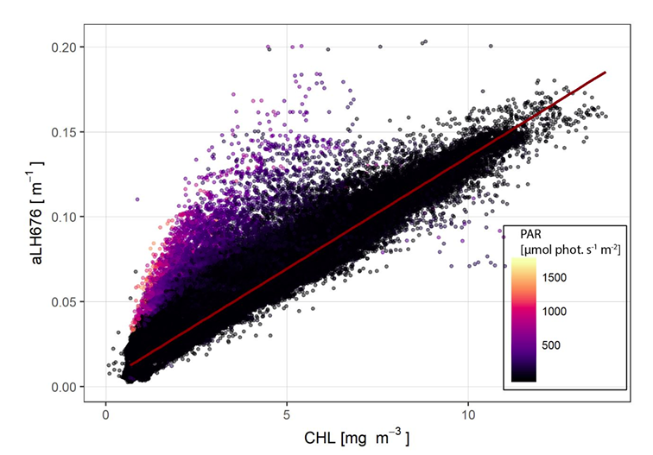
Figure 31: Relationship between fluorescence-based CHL and aLH676 over the entire database. Colorbar indicates the level of downwelling PAR irradiance received, evidencing non-photochemical quenching effect, which produces large biases in fluorescence-based CHL estimates (Minaudo et al., 2021, Figure S3). The red line, indicating the approximate relationship under low PAR conditions, was taken as reference for Equations 1 and 2.

Appendix 3 : Relationship between modeled and measured in situ IOPs
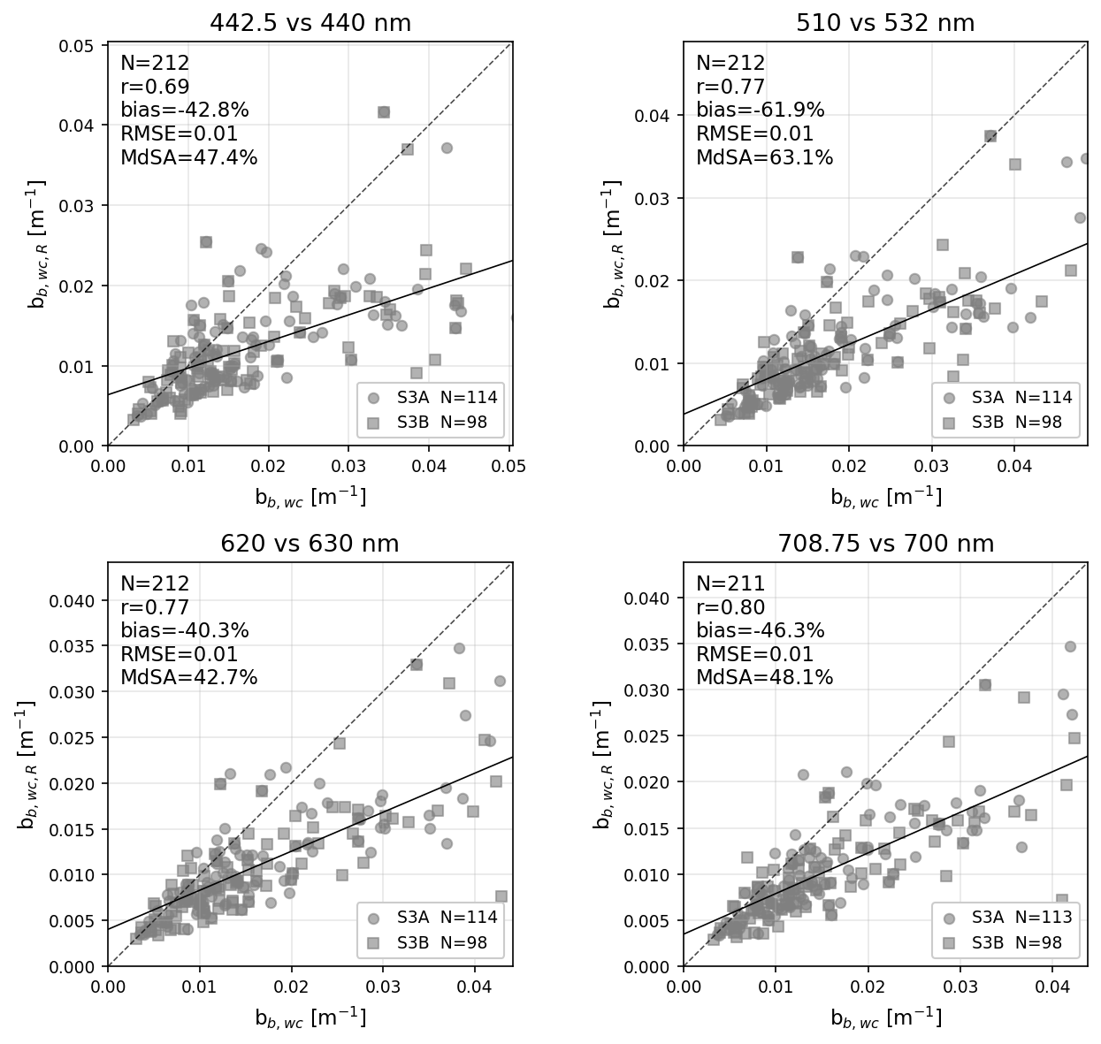
Figure 32:
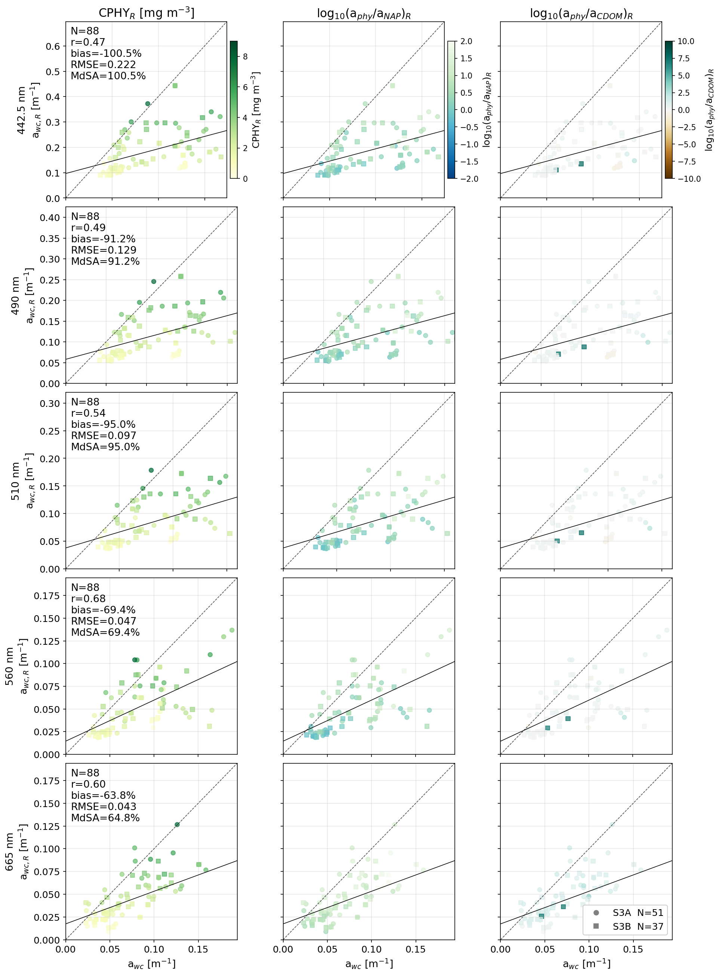
Figure 33:

Appendix 4: aLH₆₇₆ profile on 5.9.2021
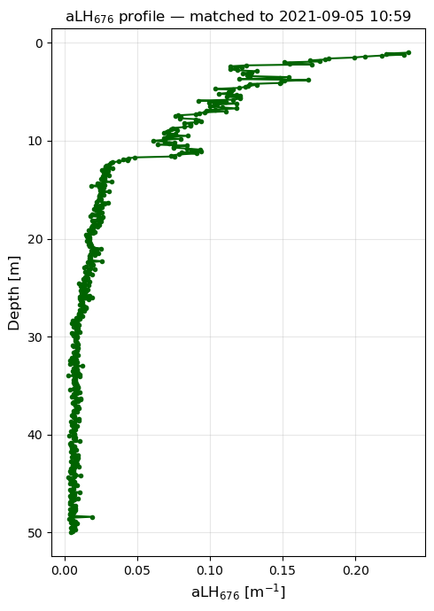
Figure 34: aLH₆₇₆ profile on 5.9.2021, corresponding to a bloom of Uroglena sp. Note the strong non-uniform vertical distribution, including in the range (0-5 m) used as average for in situ references. While near surface aLH₆₇₆ is approximately 0.2 m⁻¹ (corresponding to CHL ~ 15 mg m⁻³ when converted using Equation 2), it decreases to approximately 0.1 m⁻¹ at a depth of 5 m (CHL ~ 7.5 mg m⁻³).

Appendix 5: Drift of the ACS instrument
Figure 31 shows the observed ACS instrument drift at Thetis using a pure water MiliQ reference where absorption should equal 0. Note that drift is sometimes an order of magnitude higher than usual constituent absorption in Lake Geneva (e.g. when > 1 m⁻¹ at 676 nm). This is in contrast to the claim of drift <10% in the supplementary material of Minaudo et al. (2021). Cleaning seems to only partly correct the drift (e.g. by removing the effect of biofouling). Absorption measurements are corrected by linearly interpolating for drift between the MiliQ references.
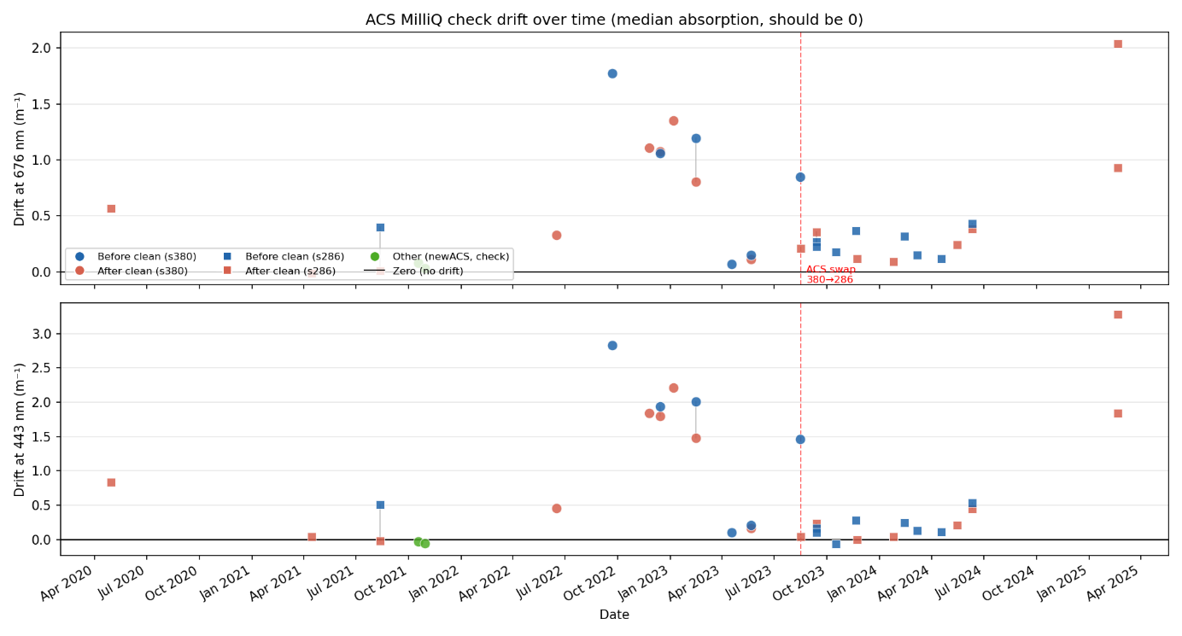
Figure 35: Drift of the ACS instrument absorption measurements at Thetis. An ACS instrument switch is indicated in fall 2023. Courtesy of Jonas Wydler.

Bibliography
A. Aminot; F. Rey. (2001). Chlorophyll a: Determination by spectroscopic methods. ICES. https://doi.org/10.17895/ICES.PUB.5080
Albert, A., & Mobley, C. (2003). An analytical model for subsurface irradiance and remote sensing reflectance in deep and shallow case-2 waters. Optics Express, 11(22), 2873. https://doi.org/10.1364/OE.11.002873
Ansari, M., Knudby, A., Amani, M., & Sawada, M. (2025). Retrieving Inland Water Quality Parameters via Satellite Remote Sensing: Sensor Evaluation, Atmospheric Correction, and Machine Learning Approaches. Remote Sensing, 17(10), 1734. https://doi.org/10.3390/rs17101734
Babin, M., Morel, A., Fournier-Sicre, V., Fell, F., & Stramski, D. (2003). Light scattering properties of marine particles in coastal and open ocean waters asrelated to the particle mass concentration. Limnology and Oceanography, 48(2), 843–859. https://doi.org/10.4319/lo.2003.48.2.0843
Babin, M., Stramski, D., Ferrari, G. M., Claustre, H., Bricaud, A., Obolensky, G., & Hoepffner, N. (2003). Variations in the light absorption coefficients of phytoplankton, nonalgal particles, and dissolved organic matter in coastal waters around Europe. Journal of Geophysical Research: Oceans, 108(C7), 2001JC000882. https://doi.org/10.1029/2001JC000882
Bi, S., Hieronymi, M., & Röttgers, R. (2023). Bio-geo-optical modelling of natural waters. Frontiers in Marine Science, 10, 1196352. https://doi.org/10.3389/fmars.2023.1196352
Bonnier, M., Anneville, O., Iestyn Woolway, R., Thackeray, S. J., Morin, G. P., Reynaud, N., Soulignac, F., Tormos, T., & Harmel, T. (2024). Assessing ESA Climate Change Initiative data for the monitoring of phytoplankton abundance and phenology in deep lakes: Investigation on Lake Geneva. Journal of Great Lakes Research, 50(4), 102372. https://doi.org/10.1016/j.jglr.2024.102372
Boss, E., & Pegau, W. S. (2001). Relationship of light scattering at an angle in the backward direction to the backscattering coefficient. Applied Optics, 40(30), 5503. https://doi.org/10.1364/AO.40.005503
Boss, E., Picheral, M., Leeuw, T., Chase, A., Karsenti, E., Gorsky, G., Taylor, L., Slade, W., Ras, J., & Claustre, H. (2013). The characteristics of particulate absorption, scattering and attenuation coefficients in the surface ocean; Contribution of the Tara Oceans expedition. Methods in Oceanography, 7, 52–62. https://doi.org/10.1016/j.mio.2013.11.002
Brandão, L. P. M., Brighenti, L. S., Staehr, P. A., Asmala, E., Massicotte, P., Tonetta, D., Barbosa, F. A. R., Pujoni, D., & Bezerra-Neto, J. F. (2018). Distinctive effects of allochthonous and autochthonous organic matter on CDOM spectra in a tropical lake. Biogeosciences, 15(9), 2931–2943. https://doi.org/10.5194/bg-15-2931-2018
Brewin, R. J. W., Dall’Olmo, G., Sathyendranath, S., & Hardman-Mountford, N. J. (2012). Particle backscattering as a function of chlorophyll and phytoplankton size structure in the open-ocean. Optics Express, 20(16), 17632. https://doi.org/10.1364/OE.20.017632
Bricaud, A., Babin, M., Morel, A., & Claustre, H. (1995). Variability in the chlorophyll‐specific absorption coefficients of natural phytoplankton: Analysis and parameterization. Journal of Geophysical Research: Oceans, 100(C7), 13321–13332. https://doi.org/10.1029/95JC00463
Bricaud, A., Morel, A., & Prieur, L. (1981). Absorption by dissolved organic matter of the sea (yellow substance) in the UV and visible domains1. Limnology and Oceanography, 26(1), 43–53. https://doi.org/10.4319/lo.1981.26.1.0043
Cael, B. B., Chase, A., & Boss, E. (2020). Information content of absorption spectra and implications for ocean color inversion. Applied Optics, 59(13), 3971. https://doi.org/10.1364/AO.389189
Carder, K. L., Steward, R. G., Harvey, G. R., & Ortner, P. B. (1989). Marine humic and fulvic acids: Their effects on remote sensing of ocean chlorophyll. Limnology and Oceanography, 34(1), 68–81. https://doi.org/10.4319/lo.1989.34.1.0068
Castagna, A., & Vanhellemont, Q. (2025). A generalized physics-based correction for adjacency effects. Applied Optics, 64(10), 2719. https://doi.org/10.1364/AO.546766
Detoni, A. M. S., Oliveira, N. R., Zoffoli, M. L., Gege, P., Caballero, I., Navarro, G., Fontela, M., Álvarez Fernandéz, M. J., Serrano, M. L., Moreno, L., Teixeira, I. G., Velo, A., & Padín, X. A. (2026). Unveiling optical and phytoplankton variability in the northwestern Iberian Peninsula using in-situ radiometry and the Water Colour Simulator – WASI. Estuarine, Coastal and Shelf Science, 340, 109976. https://doi.org/10.1016/j.ecss.2026.109976
Dörnhöfer, K., Göritz, A., Gege, P., Pflug, B., & Oppelt, N. (2016). Water Constituents and Water Depth Retrieval from Sentinel-2A—A First Evaluation in an Oligotrophic Lake. Remote Sensing, 8(11), 941. https://doi.org/10.3390/rs8110941
EUMETSAT. (2018). Sentinel-3 OLCI Marine User Handbook (EUM/OPS-SEN3/MAN/17/907205). EUMETSAT.
Fabbretto, A., Pellegrino, A., Giardino, C., Bresciani, M., Alikas, K., Braga, F., Vaičiūtė, D., Lima, T. M. A. D., Mangano, S., Ghirardi, N., Daraio, M. G., & Brando, V. E. (2023). Hyperspectral Prisma Data Processing For Water Quality Research And Applications. IGARSS 2023 - 2023 IEEE International Geoscience and Remote Sensing Symposium, 1744–1747. https://doi.org/10.1109/IGARSS52108.2023.10283366
Ferreira, A., Ciotti, Á. M., Mendes, C. R. B., Uitz, J., & Bricaud, A. (2017). Phytoplankton light absorption and the package effect in relation to photosynthetic and photoprotective pigments in the northern tip of A ntarctic P eninsula. Journal of Geophysical Research: Oceans, 122(9), 7344–7363. https://doi.org/10.1002/2017JC012964
Gallie, E. A., & Murtha, P. A. (1992). Specific absorption and backscattering spectra for suspended minerals and chlorophyll-a in chilko lake, British Columbia. Remote Sensing of Environment, 39(2), 103–118. https://doi.org/10.1016/0034-4257(92)90130-C
Gege, P. (2004). The water color simulator WASI: An integrating software tool for analysis and simulation of optical in situ spectra. Computers & Geosciences, 30(5), 523–532. https://doi.org/10.1016/j.cageo.2004.03.005
Gege, P. (2012). Estimation of phytoplankton concentration from downwelling irradiance measurements in water. Israel Journal of Plant Sciences, 60(1), 193–207. https://doi.org/10.1560/IJPS.60.1-2.193
Gege, P. (2014). WASI-2D: A software tool for regionally optimized analysis of imaging spectrometer data from deep and shallow waters. Computers & Geosciences, 62, 208–215. https://doi.org/10.1016/j.cageo.2013.07.022
Gege, P. (2024). The Water Colour Simulator WASI — User manual for WASI version 7 (WASI version 7). German Aerospace Center (DLR), Institut für Methodik der Fernerkundung. https://ioccg.org/resources/software/
Giardino, C., Brando, V. E., Gege, P., Pinnel, N., Hochberg, E., Knaeps, E., Reusen, I., Doerffer, R., Bresciani, M., Braga, F., Foerster, S., Champollion, N., & Dekker, A. (2019). Imaging Spectrometry of Inland and Coastal Waters: State of the Art, Achievements and Perspectives. Surveys in Geophysics, 40(3), 401–429. https://doi.org/10.1007/s10712-018-9476-0
Giardino, C., Bresciani, M., Cazzaniga, I., Schenk, K., Rieger, P., Braga, F., Matta, E., & Brando, V. (2014). Evaluation of Multi-Resolution Satellite Sensors for Assessing Water Quality and Bottom Depth of Lake Garda. Sensors, 14(12), 24116–24131. https://doi.org/10.3390/s141224116
Giardino, C., Candiani, G., Bresciani, M., Lee, Z., Gagliano, S., & Pepe, M. (2012). BOMBER: A tool for estimating water quality and bottom properties from remote sensing images. Computers & Geosciences, 45, 313–318. https://doi.org/10.1016/j.cageo.2011.11.022
Gordon, H. R., & Clark, D. K. (1981). Clear water radiances for atmospheric correction of coastal zone color scanner imagery. Applied Optics, 20(24), 4175. https://doi.org/10.1364/AO.20.004175
Gordon, H. R., Lewis, M. R., McLean, S. D., Twardowski, M. S., Freeman, S. A., Voss, K. J., & Boynton, G. C. (2009). Spectra of particulate backscattering in natural waters. Optics Express, 17(18), 16192. https://doi.org/10.1364/OE.17.016192
Griffin, C. G., Finlay, J. C., Brezonik, P. L., Olmanson, L., & Hozalski, R. M. (2018). Limitations on using CDOM as a proxy for DOC in temperate lakes. Water Research, 144, 719–727. https://doi.org/10.1016/j.watres.2018.08.007
Gupana, R. S., Damm, A., Rahaghi, A. I., Minaudo, C., & Odermatt, D. (2022). Non-photochemical quenching estimates from in situ spectroradiometer measurements: Implications on remote sensing of sun-induced chlorophyll fluorescence in lakes. Optics Express, 30(26), 46762. https://doi.org/10.1364/OE.469402
Gupana, R. S., Odermatt, D., Rahaghi, A. I., Minaudo, C., Werther, M., Giardino, C., & Damm, A. (2025). Remote Sensing of Sun-Induced Fluorescence in a Deep Lake: Disentangling Quenching Mechanisms Improves Relationship With Chlorophyll-a Concentration Estimates. IEEE Journal of Selected Topics in Applied Earth Observations and Remote Sensing, 18, 4410–4426. https://doi.org/10.1109/JSTARS.2025.3528911
Heege, T. (2000). Flugzeuggestützte Fernerkundung von Wasserinhaltsstoffen im Bodensee. DLR.
Hernando, A. M., Piano, A. M., Blanco, A. C., Medina, J. M., & Manuel, A. Y. (2024). COMPARATIVE ANALYSIS OF PRISMA HYPERSPECTRAL AND SENTINEL-2 MULTISPECTRAL IMAGES FOR CHLOROPHYLL-A AND TURBIDITY MAPPING OF TAAL LAKE. The International Archives of the Photogrammetry, Remote Sensing and Spatial Information Sciences, XLVIII-4/W8-2023, 293–299. https://doi.org/10.5194/isprs-archives-XLVIII-4-W8-2023-293-2024
Hou, X., Feng, L., Dai, Y., Hu, C., Gibson, L., Tang, J., Lee, Z., Wang, Y., Cai, X., Liu, J., Zheng, Y., & Zheng, C. (2022). Global mapping reveals increase in lacustrine algal blooms over the past decade. Nature Geoscience, 15(2), 130–134. https://doi.org/10.1038/s41561-021-00887-x
IOCCG. (2000). Remote Sensing of Ocean Colour in Coastal, and Other Optically-Complex, Waters (Nr. 3; Reports of the International Ocean-Colour Coordinating Group 3, S. 140). IOCCG.
IOCCG. (2019). Uncertainties in Ocean Colour Remote Sensing (F. Mélin, Hrsg.) [163]. International Ocean Colour Coordinating Group (IOCCG). https://doi.org/10.25607/OBP-696
Irani Rahaghi, A., Odermatt, D., Anneville, O., Sepúlveda Steiner, O., Reiss, R. S., Amadori, M., Toffolon, M., Jacquet, S., Harmel, T., Werther, M., Soulignac, F., Dambrine, E., Jézéquel, D., Hatté, C., Tran-Khac, V., Rasconi, S., Rimet, F., & Bouffard, D. (2024). Combined Earth observations reveal the sequence of conditions leading to a large algal bloom in Lake Geneva. Communications Earth & Environment, 5(1), 229. https://doi.org/10.1038/s43247-024-01351-5
Jacquet, S., Soulignac, F., & Anneville, O. (2026). A complete overview of algal blooms in Lake Geneva: Shall the past shed light on the future? Aquatic Sciences, 88(1), 3. https://doi.org/10.1007/s00027-025-01234-7
Kiefer, I., Odermatt, D., Anneville, O., Wüest, A., & Bouffard, D. (2015). Application of remote sensing for the optimization of in-situ sampling for monitoring of phytoplankton abundance in a large lake. Science of The Total Environment, 527–528, 493–506. https://doi.org/10.1016/j.scitotenv.2015.05.011
Kou, L., Labrie, D., & Chylek, P. (1993). Refractive indices of water and ice in the 065- to 25-μm spectral range. Applied Optics, 32(19), 3531. https://doi.org/10.1364/AO.32.003531
Levenberg, K. (1944). A method for the solution of certain non-linear problems in least squares. Quarterly of Applied Mathematics, 2(2), 164–168. https://doi.org/10.1090/qam/10666
Li, C., Odermatt, D., Bouffard, D., Wüest, A., & Kohn, T. (2022). Coupling remote sensing and particle tracking to estimate trajectories in large water bodies. International Journal of Applied Earth Observation and Geoinformation, 110, 102809. https://doi.org/10.1016/j.jag.2022.102809
Lu, Z. (2007). Optical absorption of pure water in the blue and ultraviolet. Texas A&M University.
Maire, L., Gege, P., Damm, A., & Odermatt, D. (2025). Differentiating phytoplankton taxa in lakes using hyperspectral in situ reflectance and imaging microscopy. Science of The Total Environment, 1003, 180718. https://doi.org/10.1016/j.scitotenv.2025.180718
Many, G., Escoffier, N., Ferrari, M., Jacquet, P., Odermatt, D., Mariethoz, G., Perolo, P., & Perga, M.-E. (2022). Long-Term Spatiotemporal Variability of Whitings in Lake Geneva from Multispectral Remote Sensing and Machine Learning. Remote Sensing, 14(23), 6175. https://doi.org/10.3390/rs14236175
Many, G., Escoffier, N., Perolo, P., Bärenbold, F., Bouffard, D., & Perga, M.-E. (2024). Calcite precipitation: The forgotten piece of lakes’ carbon cycle. Science Advances, 10(44), eado5924. https://doi.org/10.1126/sciadv.ado5924
Marquardt, D. W. (1963). An Algorithm for Least-Squares Estimation of Nonlinear Parameters. Journal of the Society for Industrial and Applied Mathematics, 11(2), 431–441. https://doi.org/10.1137/0111030
Minaudo, C., Odermatt, D., Bouffard, D., Rahaghi, A. I., Lavanchy, S., & Wüest, A. (2021). The Imprint of Primary Production on High-Frequency Profiles of Lake Optical Properties. Environmental Science & Technology, 55(20), 14234–14244. https://doi.org/10.1021/acs.est.1c02585
Moisset, S. (2017). Investigation of the link between phytoplankton and nutrients dynamic in Lake Geneva [Université de Genève]. https://doi.org/10.13097/ARCHIVE-OUVERTE/UNIGE:96830
Morel, A. (1974). Optical Properties of Pure Water and Pure Sea Water. Optical Aspects of Oceanography, 1–24.
Nechad, B., Ruddick, K. G., & Park, Y. (2010). Calibration and validation of a generic multisensor algorithm for mapping of total suspended matter in turbid waters. Remote Sensing of Environment, 114(4), 854–866. https://doi.org/10.1016/j.rse.2009.11.022
Newville, M., Otten, R., Nelson, A., Stensitzki, T., Ingargiola, A., Allan, D., Fox, A., Carter, F., & Rawlik, M. (2025). LMFIT: Non-Linear Least-Squares Minimization and Curve-Fitting for Python (Version 1.3.4) [Software]. Zenodo. https://doi.org/10.5281/ZENODO.598352
Niroumand-Jadidi, M., Bovolo, F., Bresciani, M., Gege, P., & Giardino, C. (2022). Water Quality Retrieval from Landsat-9 (OLI-2) Imagery and Comparison to Sentinel-2. Remote Sensing, 14(18), 4596. https://doi.org/10.3390/rs14184596
Niroumand-Jadidi, M., Bovolo, F., & Bruzzone, L. (2020). Water Quality Retrieval from PRISMA Hyperspectral Images: First Experience in a Turbid Lake and Comparison with Sentinel-2. Remote Sensing, 12(23), 3984. https://doi.org/10.3390/rs12233984
Niroumand-Jadidi, M., Bovolo, F., Bruzzone, L., & Gege, P. (2021). Inter-Comparison of Methods for Chlorophyll-a Retrieval: Sentinel-2 Time-Series Analysis in Italian Lakes. Remote Sensing, 13(12), 2381. https://doi.org/10.3390/rs13122381
Niroumand-Jadidi, M., & Gege, P. (2025). WASI-AI: Synergistic Integration of AI and Physics for Retrieving Water Quality and Benthic Parameters from Multi- and Hyperspectral Images. IEEE Journal of Selected Topics in Applied Earth Observations and Remote Sensing, 18, 22832–22846. https://doi.org/10.1109/JSTARS.2025.3605061
Nouchi, V. (2018). Toward a systematic integration of optical remote sensing for inland waters studies. EPFL.
Nouchi, V., Kutser, T., Wüest, A., Müller, B., Odermatt, D., Baracchini, T., & Bouffard, D. (2019). Resolving biogeochemical processes in lakes using remote sensing. Aquatic Sciences, 81(2), 27. https://doi.org/10.1007/s00027-019-0626-3
Odermatt, D., & Gege, P. (2022). Lake Colors: Interpreting Apparent Optical Properties. In Encyclopedia of Inland Waters (S. 474–489). Elsevier. https://doi.org/10.1016/B978-0-12-819166-8.00041-4
Odermatt, D., Gitelson, A., Brando, V. E., & Schaepman, M. (2012). Review of constituent retrieval in optically deep and complex waters from satellite imagery. Remote Sensing of Environment, 118, 116–126. https://doi.org/10.1016/j.rse.2011.11.013
Odermatt, D., Runnals, J., & Damm, A. (2020). SenCast: Copernicus Satellite Data on Demand [Software]. Eawag. https://github.com/eawag-surface-waters-research/sencast
Ogashawara, I., Kiel, C., Jechow, A., Kohnert, K., Ruhtz, T., Grossart, H.-P., Hölker, F., Nejstgaard, J. C., Berger, S. A., & Wollrab, S. (2021). The Use of Sentinel-2 for Chlorophyll-a Spatial Dynamics Assessment: A Comparative Study on Different Lakes in Northern Germany. Remote Sensing, 13(8), 1542. https://doi.org/10.3390/rs13081542
O’Reilly, J. E., Maritorena, S., Mitchell, B. G., Siegel, D. A., Carder, K. L., Garver, S. A., Kahru, M., & McClain, C. (1998). Ocean color chlorophyll algorithms for SeaWiFS. Journal of Geophysical Research: Oceans, 103(C11), 24937–24953. https://doi.org/10.1029/98JC02160
Pinardi, M., Bresciani, M., Villa, P., Cazzaniga, I., Laini, A., Tóth, V., Fadel, A., Austoni, M., Lami, A., & Giardino, C. (2018). Spatial and temporal dynamics of primary producers in shallow lakes as seen from space: Intra-annual observations from Sentinel-2A. Limnologica, 72, 32–43. https://doi.org/10.1016/j.limno.2018.08.002
Pope, R. M., & Fry, E. S. (1997). Absorption spectrum (380–700 nm) of pure water II Integrating cavity measurements. Applied Optics, 36(33), 8710. https://doi.org/10.1364/AO.36.008710
Reynolds, R. A., Stramski, D., & Neukermans, G. (2016). Optical backscattering by particles in Arctic seawater and relationships to particle mass concentration, size distribution, and bulk composition. Limnology and Oceanography, 61(5), 1869–1890. https://doi.org/10.1002/lno.10341
Rimet, F., Anneville, O., Barbet, D., Chardon, C., Crépin, L., Domaizon, I., Dorioz, J.-M., Espinat, L., Frossard, V., Guillard, J., Goulon, C., Hamelet, V., Hustache, J.-C., Jacquet, S., Lainé, L., Montuelle, B., Perney, P., Quetin, P., Rasconi, S., … Monet, G. (2020). The Observatory on LAkes (OLA) database: Sixty years of environmental data accessible to the public: The Observatory on LAkes (OLA) database. Journal of Limnology, 79(2). https://doi.org/10.4081/jlimnol.2020.1944
Roesler, C. (2021). Non-Algal Particles (NAP). In Ocean Optics Web Book. https://www.oceanopticsbook.info/view/optical-constituents-of-the-ocean/non-algal-particles-nap
Röttgers, R., Doerffer, R., McKee, D., & Schönfeld, W. (2013). Algorithm Theoretical Basis Document: The Water Optical Properties Processor (WOPP): Pure Water Spectral Absorption, Scattering, and Real Part of Refractive Index Model (Revision 7). ESA/ESRIN.
Savitzky, Abraham., & Golay, M. J. E. (1964). Smoothing and Differentiation of Data by Simplified Least Squares Procedures. Analytical Chemistry, 36(8), 1627–1639. https://doi.org/10.1021/ac60214a047
Soppa, M. A., Silva, B., Steinmetz, F., Keith, D., Scheffler, D., Bohn, N., & Bracher, A. (2021). Assessment of Polymer Atmospheric Correction Algorithm for Hyperspectral Remote Sensing Imagery over Coastal Waters. Sensors, 21(12), 4125. https://doi.org/10.3390/s21124125
Steinmetz, F., Deschamps, P.-Y., & Ramon, D. (2011). Atmospheric correction in presence of sun glint: Application to MERIS. Optics Express, 19(10), 9783. https://doi.org/10.1364/OE.19.009783
Vaillancourt, R. D. (2004). Light backscattering properties of marine phytoplankton: Relationships to cell size, chemical composition and taxonomy. Journal of Plankton Research, 26(2), 191–212. https://doi.org/10.1093/plankt/fbh012
Vanhellemont, Q., & Ruddick, K. (2018). Atmospheric correction of metre-scale optical satellite data for inland and coastal water applications. Remote Sensing of Environment, 216, 586–597. https://doi.org/10.1016/j.rse.2018.07.015
Wang, L. (2008). Measuring optical absorption coefficient of pure water in UV using the inte grating cavity absorption meter. Texas A&M University.
Warren, S. G. (1984). Optical constants of ice from the ultraviolet to the microwave. Applied Optics, 23(8), 1206. https://doi.org/10.1364/AO.23.001206
Werther, M., Odermatt, D., Simis, S. G. H., Gurlin, D., Lehmann, M. K., Kutser, T., Gupana, R., Varley, A., Hunter, P. D., Tyler, A. N., & Spyrakos, E. (2022a). A Bayesian approach for remote sensing of chlorophyll-a and associated retrieval uncertainty in oligotrophic and mesotrophic lakes. Remote Sensing of Environment, 283, 113295. https://doi.org/10.1016/j.rse.2022.113295
Werther, M., Odermatt, D., Simis, S. G. H., Gurlin, D., Lehmann, M. K., Kutser, T., Gupana, R., Varley, A., Hunter, P. D., Tyler, A. N., & Spyrakos, E. (2022b). A Bayesian approach for remote sensing of chlorophyll-a and associated retrieval uncertainty in oligotrophic and mesotrophic lakes. Remote Sensing of Environment, 283, 113295. https://doi.org/10.1016/j.rse.2022.113295
Wevers, J., Müller, D., Kirches, G., Quast, R., & Brockmann, C. (2022). IdePix for Sentinel-3 OLCI Algorithm Theoretical Basis Document. https://doi.org/10.5281/ZENODO.6517333
Whitmire, A. L., Pegau, W. S., Karp-Boss, L., Boss, E., & Cowles, T. J. (2010). Spectral backscattering properties of marine phytoplankton cultures. Optics Express, 18(14), 15073. https://doi.org/10.1364/OE.18.015073
Wilks, D. S. (2019). Statistical methods in the atmospheric sciences (Fourth edition). Elsevier.
Wu, D., Liu, W., Makowski, D., Tang, T., Greenwood, E. E., Huang, Y., Ciais, P., Zhang, H., Du, T., Xia, X., & Odermatt, D. (2026). COVID-19 containment and control reduced lake turbidity around the world. Communications Earth & Environment, 7(1), 201. https://doi.org/10.1038/s43247-026-03311-7
Wu, Y., Knudby, A., Pahlevan, N., Lapen, D., & Zeng, C. (2024). Sensor-generic adjacency-effect correction for remote sensing of coastal and inland waters. Remote Sensing of Environment, 315, 114433. https://doi.org/10.1016/j.rse.2024.114433
Wüest, A., Bouffard, D., Guillard, J., Ibelings, B. W., Lavanchy, S., Perga, M., & Pasche, N. (2021). LéXPLORE: A floating laboratory on Lake Geneva offering unique lake research opportunities. WIREs Water, 8(5), e1544. https://doi.org/10.1002/wat2.1544
Xi, H., Hieronymi, M., Krasemann, H., & Röttgers, R. (2017). Phytoplankton Group Identification Using Simulated and In situ Hyperspectral Remote Sensing Reflectance. Frontiers in Marine Science, 4, 272. https://doi.org/10.3389/fmars.2017.00272
Xu, J., Xue, K., Fang, C., Shen, M., Cao, Z., & Duan, H. (2026). Capabilities of PACE Ocean color Instrument (OCI) for phytoplankton pigments of inland lakes. International Journal of Applied Earth Observation and Geoinformation, 149, 105265. https://doi.org/10.1016/j.jag.2026.105265

