1) Create the **DEPT** table, based on the following table instance chart. Save the statement

in a script called lab_10_01.sql, and then execute the statement in the script to

create the table. Confirm that the table is created.

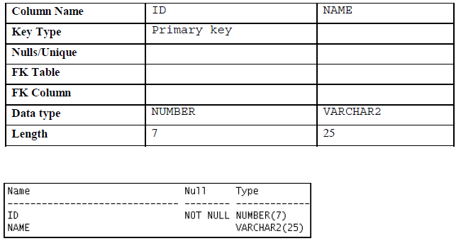

CREATE TABLE DEPT

( ID NUMBER(7) PRIMARY KEY NOT NULL,

NAME VARCHAR2(25));

2) Populate the DEPT table with data from the DEPARTMENTS table. Include only

columns that you need.

INSERT INTO DEPT(ID,NAME)

SELECT DEPARTMENT_ID, DEPARTMENT_NAME

FROM DEPARTMENTS;

3) Create the **EMP** **table** based on the following table instance chart. Save the statement

in a script called lab_10_03.sql, and then execute the statement in the script to

create the table. Confirm that the table is created.

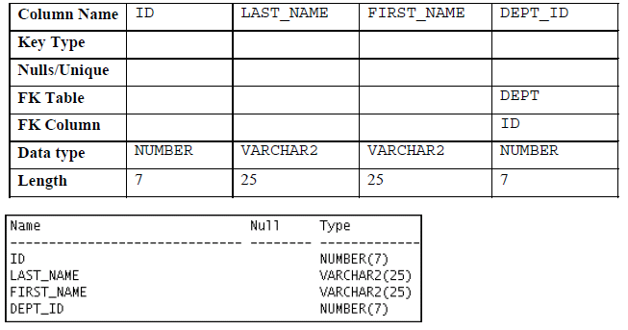

CREATE TABLE EMP

( ID NUMBER(7) primary key,

LAST_NAME VARCHAR(25),

FIRST_NAME VARCHAR(25),

DEPT_ID NUMBER(7) FOREIGN KEY REFERENCES DEPT(ID)

);

4) Create the EMPLOYEES2 table based on the structure of the EMPLOYEES table. Include only the EMPLOYEE_ID, FIRST_NAME, LAST_NAME, SALARY, and DEPARTMENT_ID columns. Name the columns in your new table ID, FIRST_NAME, LAST_NAME, SALARY, and DEPT_ID, respectively.

INSERT INTO EMPLOYEE2(FIRST_NAME,LAST_NAME,SALARY,DEPT_ID)

SELECT FIRST_NAME,LAST_NAME,SALARY,DEPARTMENT_ID

FROM EMPLOYEES;

5) Alter the EMPLOYEES2 table status to read-only.

ALTER TABLE EMPLOYEE2 READ ONLY;

6) Try to insert the following row in the EMPLOYEES2 table:

You get the following error message:

SQL Error: ORA-12081: update operation not allowed on table "HR"."EMPLOYEE2"

12081. 00000 - "update operation not allowed on table \"%s\".\"%s\""

7) Revert the EMPLOYEES2 table to the read/write status. Now, try to insert the same

row again. You should get the following messages:

Table EMPLOYEE2 altered.

1 row inserted.

8) Drop the EMPLOYEES2 table.

DROP TABLE EMPLOYEE2;

-------------------------------------------------------------------------------------------------------------------------------

1) The staff in the HR department wants to hide some of the data in the EMPLOYEES

table. Create a view called EMPLOYEES_VU based on the employee numbers,

employee last names, and department numbers from the EMPLOYEES table. The

heading for the employee name should be EMPLOYEE.

CREATE VIEW EMPLOYEE_VU AS

SELECT EMPLOYEE_ID, LAST_NAME AS EMPLOYEE, DEPARTMENT_ID

FROM EMPLOYEES;

2) Confirm that the view works. Display the contents of the EMPLOYEES_VU view.

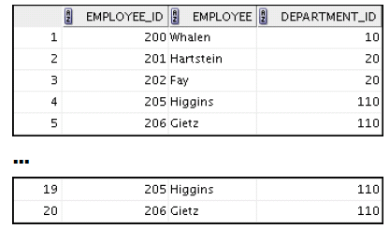

SELECT EMPLOYEE_ID, EMPLOYEE, DEPARTMENT_ID

FROM EMPLOYEE_VU;

3) Using your EMPLOYEES_VU view, write a query for the HR department to display all

employee names and department numbers.

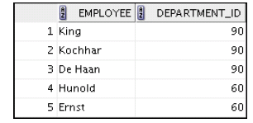

SELECT EMPLOYEE, DEPARTMENT_ID

FROM EMPLOYEE_VU;

4) Department 50 needs access to its employee data. Create a view named DEPT50 that

contains the employee numbers, employee last names, and department numbers for

all employees in department 50. You have been asked to label the view columns

EMPNO, EMPLOYEE, and DEPTNO. For security purposes, do not allow an employee to

be reassigned to another department through the view.

CREATE OR REPLACE VIEW DEPT_50 AS

SELECT EMPLOYEE_ID AS ENO, LAST_NAME AS EMPLOYEE, DEPARTMENT_ID AS DEPTNO

FROM EMPLOYEES

WHERE DEPARTMENT_ID=50

WITH READ ONLY;

5) Display the structure and contents of the DEPT50 view.

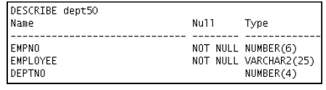

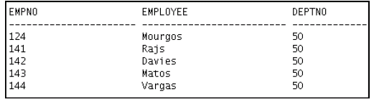

DESCRIBE DEPT_50;

SELECT *

FROM DEPT_50;