1) Run the statement in the lab_09_01.sql script to build the MY_EMPLOYEE table

used in this practice.

CREATE TABLE MY_EMPLOYEE

( ID NUMBER(4) NOT NULL PRIMARY KEY,

LAST_NAME VARCHAR2(25),

FIRST_NAME VARCHAR2(25),

USER_ID VARCHAR2(8),

SALARY NUMBER(9,2));

2) Describe the structure of the MY_EMPLOYEE table to identify the column names.

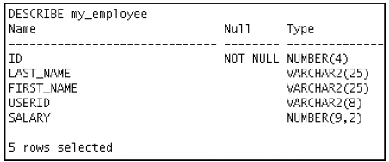

DESC my_employee;

3) Create an INSERT statement to add the *first row* of data to the MY_EMPLOYEE table

from the following sample data. Do not list the columns in the INSERT clause. *Do not*

*enter all rows yet.*

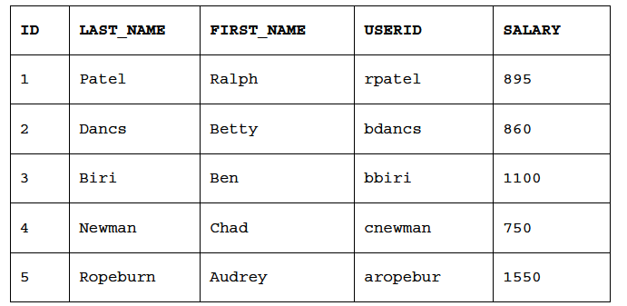

INSERT INTO MY_EMPLOYEE

VALUES(1,'PATEL','RALPH','rpatel',895)

4) Populate the MY_EMPLOYEE table with the second row of the sample data from the

preceding list. This time, list the columns explicitly in the INSERT clause.

INSERT INTO MY_EMPLOYEE

VALUES( &ID , '&LAST_NAME', '&FIRST_NAME', '&USER_ID', &SALARY);

5) Confirm your addition to the table.



SELECT*

FROM MY_EMPLOYEE;

6) Write an INSERT statement in a dynamic reusable script file to load the remaining

rows into the MY_EMPLOYEE table. The script should prompt for all the columns (ID,

LAST_NAME, FIRST_NAME, USERID, and SALARY). Save this script to a

lab_09_06.sql file.

7) Populate the table with the next two rows of the sample data listed in step 3 by

running the INSERT statement in the script that you created.

INSERT INTO MY_EMPLOYEE

VALUES( &ID , '&LAST_NAME', '&FIRST_NAME', '&USER_ID', &SALARY);

INSERT INTO MY_EMPLOYEE

VALUES( &ID , '&LAST_NAME', '&FIRST_NAME', '&USER_ID', &SALARY);

8) Confirm your additions to the table.



SELECT*

FROM MY_EMPLOYEE;

9) Make the data additions permanent

COMMIT;

10) Change the last name of employee 3 to Drexler.

UPDATE MY_EMPLOYEE

SET LAST_NAME='DREXLER'

WHERE ID=3;

11) Change the salary to $1,000 for all employees who have a salary less than $900.

UPDATE MY_EMPLOYEE

SET SALARY=1000

WHERE SALARY<900;

12) Verify your changes to the table.



SELECT*

FROM MY_EMPLOYEE;

13) Delete Betty Dancs from the MY_EMPLOYEE table.

DELETE FROM MY_EMPLOYEE

WHERE LAST_NAME='DANCS'

OR LAST_NAME='BETTY';

14) Confirm your changes to the table.



SELECT*

FROM MY_EMPLOYEE;

15) Commit all pending changes.

COMMIT;

16) Populate the table with the last row of the sample data listed in step 3 by using the

statements in the script that you created in step 6. Run the statements in the script.

INSERT INTO MY_EMPLOYEE

VALUES( &ID , '&LAST_NAME', '&FIRST_NAME', '&USER_ID', &SALARY);

17) Confirm your addition to the table.



SELECT*

FROM MY_EMPLOYEE;

18) Mark an intermediate point in the processing of the transaction.

SAVEPOINT A;

19) Delete all the rows from the MY_EMPLOYEE table.

DELETE FROM MY_EMPLOYEE;

20) Confirm that the table is empty.

SELECT*

FROM MY_EMPLOYEE

21) Discard the most recent DELETE operation without discarding the earlier INSERT

operation.

ROLLBACK A;

22) Confirm that the new row is still intact.



SELECT*

FROM MY_EMPLOYEE;

23) Make the data addition permanent.

COMMIT;

24) Modify the lab_09_06.sql script such that the USERID is generated automatically

by concatenating the first letter of the first name and the first seven characters of the

last name. The generated USERID must be in lowercase. Therefore, the script should

not prompt for the USERID. Save this script to a file named lab_09_24.sql.

INSERT INTO MY_EMPLOYEE

VALUES( &ID , '&LAST_NAME', '&FIRST_NAME', LOWER(SUBSTR('&FIRST_NAME',1,1)||SUBSTR('&LAST_NAME',1,7)), &SALARY);

25) Run the lab_09_24.sql script to insert the following record:

26) Confirm that the new row was added with correct USERID.



SELECT *

FROM MY_EMPLOYEE;