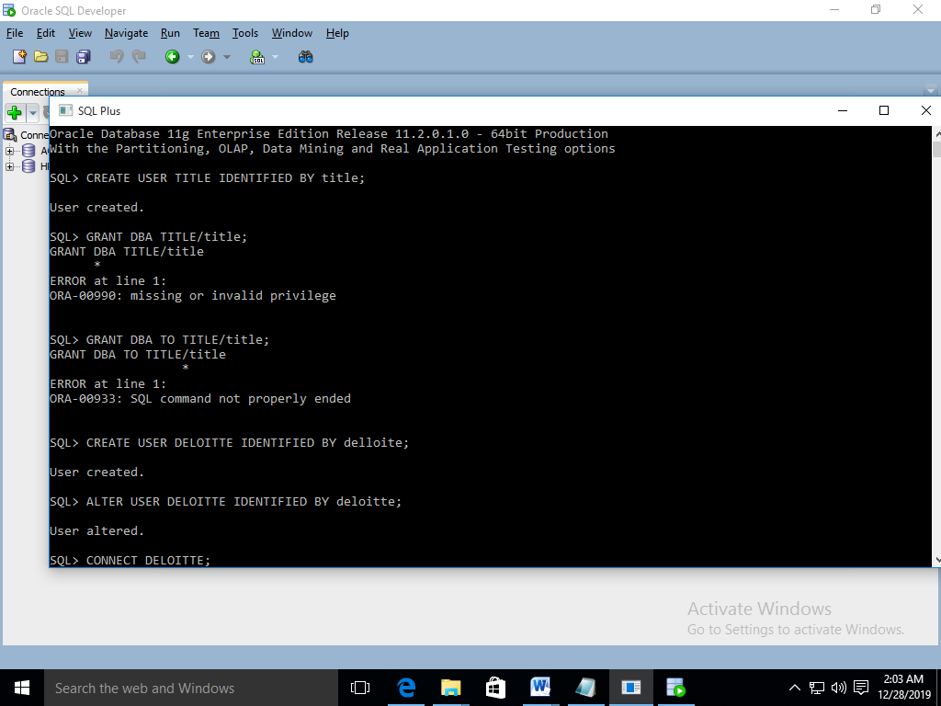

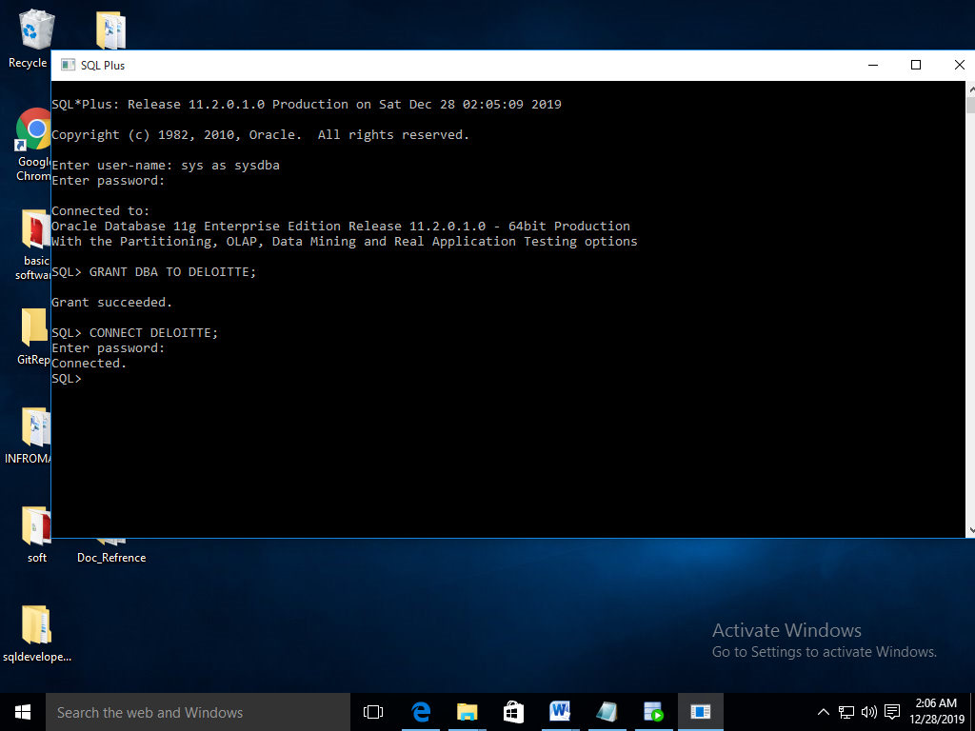

4. SELECT FIRST_NAME AS WORKER_NAME

FROM WORKER;

5. SELECT UPPER(FIRST_NAME)

FROM WORKER;

6.

SELECT UNIQUE(DEPARTMENT)

FROM WORKER;

7. SELECT INSTR(FIRST_NAME,'A')

FROM WORKER

WHERE FIRST_NAME='Amitabh';

8. SELECT SUBSTR(FIRST_NAME,1,3)

FROM WORKER;

9. SELECT RTRIM(FIRST_NAME)

FROM WORKER;

10.

SELECT LTRIM(DEPARTMENT)

FROM WORKER;

11.

SELECT UNIQUE(DEPARTMENT), LENGTH(DEPARTMENT)

FROM WORKER;

12.

SELECT REPLACE(FIRST_NAME,'A','a')

FROM WORKER;

13.

SELECT FIRST_NAME||' '||LAST_NAME AS COMPLETE_NAME

FROM WORKER;

14.

SELECT *

FROM WORKER

ORDER BY FIRST_NAME ASC;

15. SELECT *

FROM WORKER

ORDER BY FIRST_NAME ASC, DEPARTMENT DESC;

16.

SELECT *

FROM WORKER

WHERE FIRST_NAME='Vipul'

OR first_name='Satish';

17.

SELECT *

FROM WORKER

WHERE FIRST_NAME NOT LIKE 'Vipul'

AND first_name NOT LIKE 'Satish';

18.

SELECT *

FROM WORKER

WHERE DEPARTMENT='Admin';

19.

SELECT FIRST_NAME

FROM WORKER

WHERE FIRST_NAME LIKE '%%a%%';

20.

SELECT FIRST_NAME

FROM WORKER

WHERE FIRST_NAME LIKE '%%a';

21.

SELECT FIRST_NAME

FROM WORKER

WHERE FIRST_NAME LIKE '%%h'

AND LENGTH(FIRST_NAME)=6;

22. SET SERVEROUTPUT ON;

DECLARE

V_MAX_DEPT NUMBER(10);

BEGIN

SELECT MAX(DEPARTMENT_ID) INTO V_MAX_DEPT

FROM tbldepartments;

DBMS_OUTPUT.PUT_LINE(V_MAX_DEPT);

END;

/

23. SET SERVEROUTPUT ON;

DECLARE

V_NAME VARCHAR2(25);

BEGIN

SELECT REVERSE('FIRST_NAME') INTO V_NAME

FROM tblemployees;

DBMS_OUTPUT.PUT_LINE(V_NAME);

END;

24. DECLARE

V_FIRST_NAME VARCHAR2(20):=20;

BEGIN

BEGIN

V_FIRST VARCHAR(21):=10;

DBMS_OUTPUT.PUT_LINE(V_FIRST);

END;

DBMS_OUTPUT.PUT_LINE(V_FIRST_NAME);

END;

;

25. DECLARE

V_SAL NUMBER;

BEGIN

SELECT SALARY INTO V_SAL

FROM TBLEMPLOYEES

WHERE EMPLOYEE_ID=122;

DBMS_OUTPUT.PUT_LINE(V_SAL);

END;

/