Crepes Your Way
Inspired by


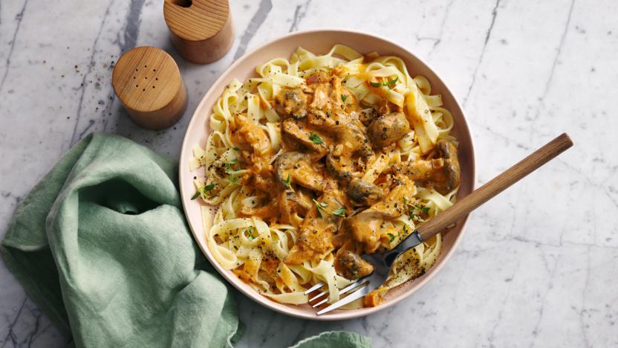
DID YOU KNOW?
“HJAHSJAHSJAHSJAHS!”

Nutrition – Total / Per Serving
Calories: 455kcal / 227.5kcal
Carbohydrates: 91g / 45.5g
Protein: 12g / 6g
Fat: 3g / 1.5g
Fibre: 0g / 0g
Sugar: 8g / 4g
Ingredients
120g plain flour (GF if preferred)
200ml almond milk
½ tsp salt
1 tsp granulated sugar
1 tsp butter (for the pan)






Good for:

Star Rating:



Method

Step 1 – Mix it Up!
Mix the plain flour, sugar, and salt together.
Slowly add the almond milk.
Mix until well combined.

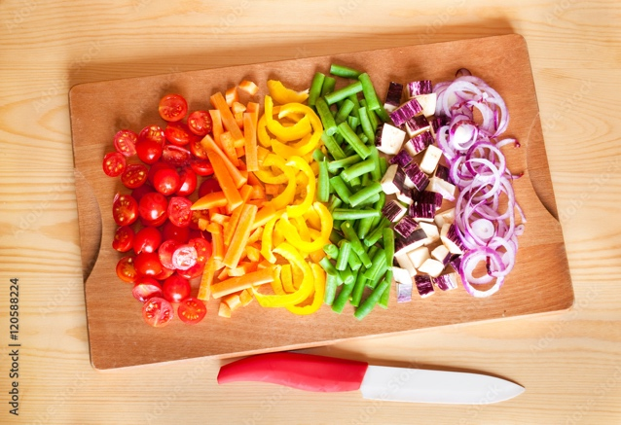

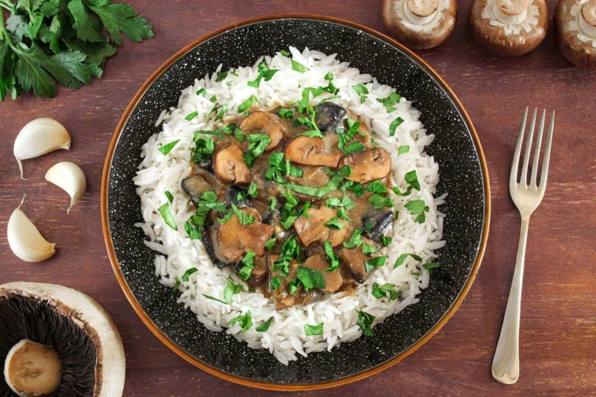
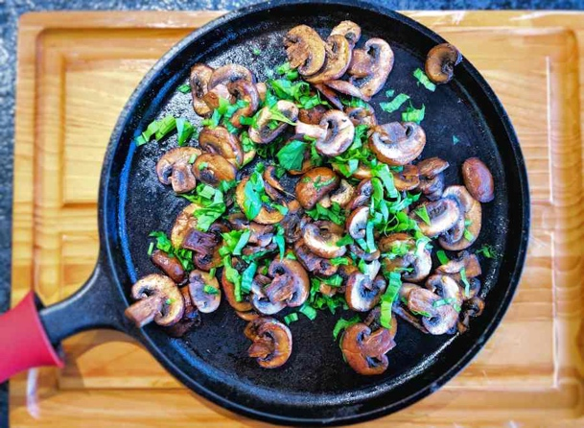
Make it Yours – Alternative Spices
Try these alternatives to spice up your crepes, add your ideas below:
- Add 1 tsp cinnamon and change the sugar to light brown sugar
- Add 1tbsp instead of maple syrup
- Add 1 banana and

Step 2 – Cook Your Crepe
Heat up your frying pan with butter.
Spoon in the batter (roughly 1/3) and tilt your pan to cover the flat surface.
When the crepe moves freely on the pan it is ready to be flipped.
Flip the crepe and fry until golden (~30 seconds).
Step 3 – Repeat
Repeat step 2 until the batter is finished (~3 crepes).
Top your crepes with toppings if desired.

