In mysql two tables are created campaign_details and numbers.

* campaign_details with columns mobile_number, id, campaign_id, sms_text, sent_date_time, sendStatus, delivery_datetime, delivery_response
* numbers with columns mobile_number, id, campaign_id, sms_text, sent_date_time, sendstatus, delivery_datetime, delivery_response

a one to many realtionship is established between those tables where campaign_id of numbers table references id of campaign_details.

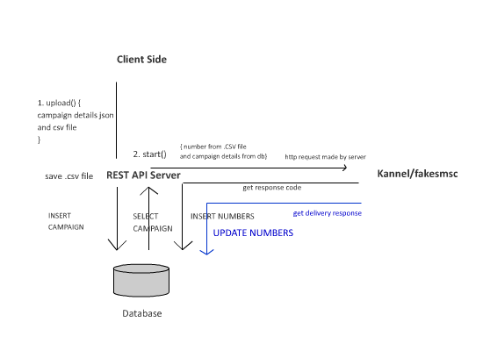

Brief Overview

1. After the user has logged in the user can create a new campaign by providing campaign information like id, name, smstext and csv file that contains the numbers. After submitted button is pressed the csv file is saved in a server and other campaign info are stored in the database along with the file path of the csv file.   
     
   As campaign info are inserted the javascript ajax code automatically shows the campaign info that are inserted in the table. And the user can now start processing the campaign.

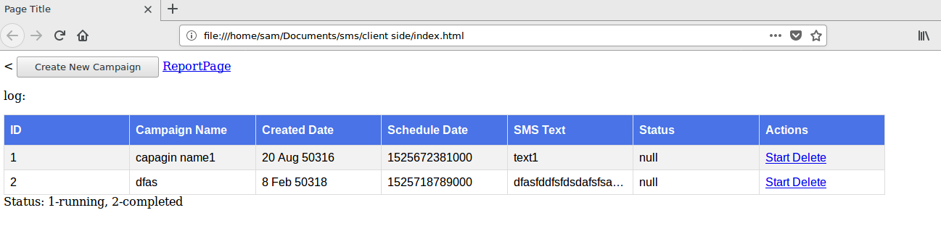

1. As user clicks start, the corresponding campaign info is fetched from database and combined with corresponding file numbers from csv file to prepare parameters for sending request to fakesmsc. After the request is sent to kannel/fakesmsc, the response code given by kannel is extracted. This code is than combined with other numbers information and inserted into numbers table.   
     
   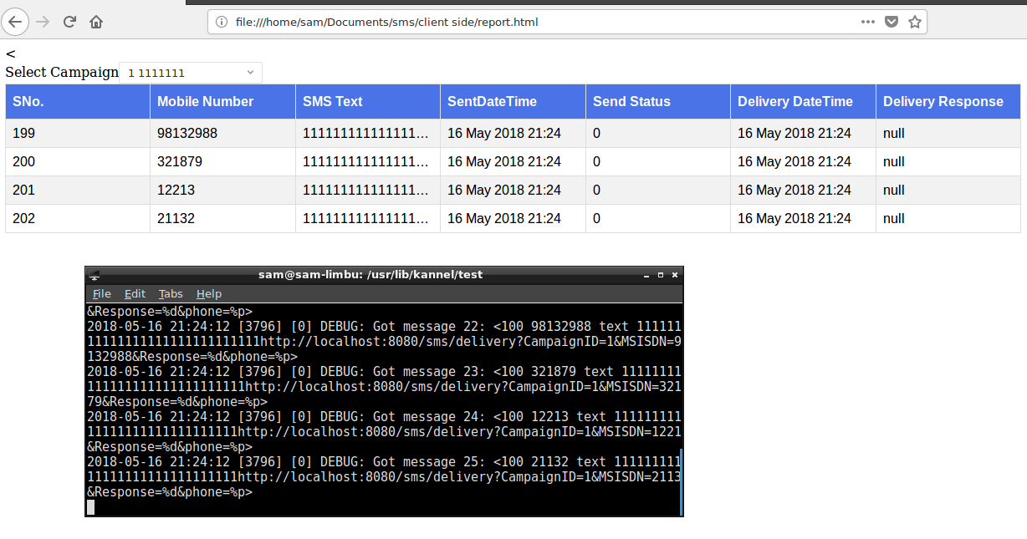
2. A delivery URL is prepared to listen for delivery reponse that would be given by kannel. The encoded URL is decoded and delivery response code is extracted and updated into the numbers database along with the current timestamp As campaign info are inserted the javascript ajax code automatically shows the campaign info that are inserted in the table. And the user can now start processing the campaign.

***Simulating drl response from fakesmsc***



***Number 21132 is delivered***

