Tactical Planing Framework Documentation
  - Structured Guide to Personal Planning Optimization
Umay ŞAMLI – samliumay965@gmail.com

Version: 1.0

Table of Contents
Objectives 3
How to Implement? 3
PF - UML Activity Diagram System 4
PF System – General 5
PF System – Explanation 6
Pre-Preparation-1/4 6
Diamond System 7
Pre-Preparation-2/3 9
PHA-1 9
Preparation-1-1/1-2 10
Preparation-1/2/3 and Plan-DP-1/2 10
Realism Point (RP) Calculation 14
Day Management 14
Last Words Error! Bookmark not defined.
Abbreviations 17

Objectives
The primary objective of this documentation is to outline an approach for organizing personal life through a structured planning system. The methodology adapts daily planning into an engineering framework, with the main aim of optimizing the challenges associated with ADHD.
While this approach may not be ideal for everyone, it is particularly suited for individuals who seek greater control and are capable of adapting to complex frameworks. This documentation is intended for those who desire a systematic method for managing their tasks and routines.

How to Implement?
To implement this planning framework, you can choose between software-based or tools-based strategies. The software-based approach involves adapting a TO-DO list application to fit the system’s needs. However, not all TO-DO list software covers every aspect of this methodology.
While a dedicated TO-DO application is planned for open-source or SaaS release, for now, you can utilize any existing TO-DO list software, such as TickTick or ASANA.
The tools-based approach primarily relies on Microsoft Word and Excel. Planning conducted in Word can be easily converted to PDF format. Excel is best suited for observations and analysis, though it is less effective in PDF or hard copy formats.
This framework uses a customized version of the UML Activity Diagram, which will be explained in the following sections.

PF - UML Activity Diagram System
The logic of the custom UML Activity Diagram closely resembles that of the classic UML Activity Diagram. However, some distinctions are present, and the following table explains the unique elements used in this framework:

Shape | Explanation of the Shapes
 | Starting point: Indicates that the movement starts at the diagram must start from the stated point.
 | Ending point: Indicates that the movement starts at the diagram must end at the specified point. (Note: At Figure 1, Diagram does not have an ending point. The reason is, framework aims to optimize your all life continuously. So in theory it should not end.)
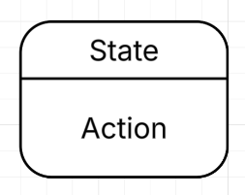 | Composite state (State / Action): State part indicates which action group (AG) the state belongs. Action states is a state grouping system. Gives user to easily identify which state are them based on names. Action part specifies what action should be taken to move next state.
 | Merge state: Works like an if/else method of the diagram. Shows the direction based on the answer of the question stated inside the shape.

PF System – General
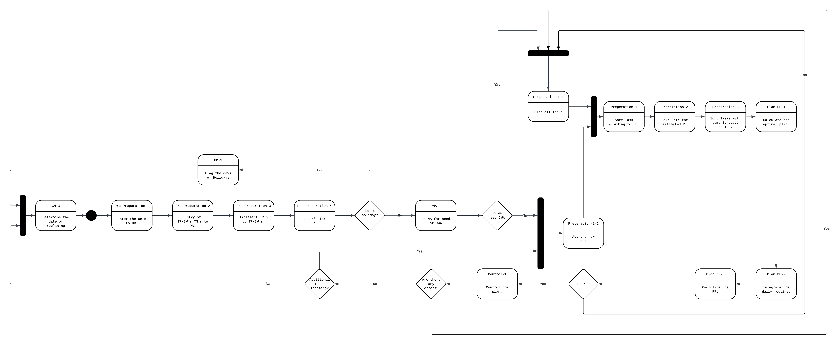
Figure 1

PF System – Explanation
The overall logic of the PF system is straightforward, especially when considering the abbreviations explained in the dedicated section.
While the diagram and terminology are simple, there are critical action steps that require further definition. These include how to undertake observations (OB), how to analyze them (AN), how to implement tactical notes (TN) into templates (TP) or software (SW), and how to calculate metrics such as Importance Level (IL) and Realism Point (RP). Additionally, concepts such as optimal planning, routine integration, and the process for handling incoming additional tasks will be detailed throughout the explanation of composite states in the main diagram.

Pre-Preparation-1/4
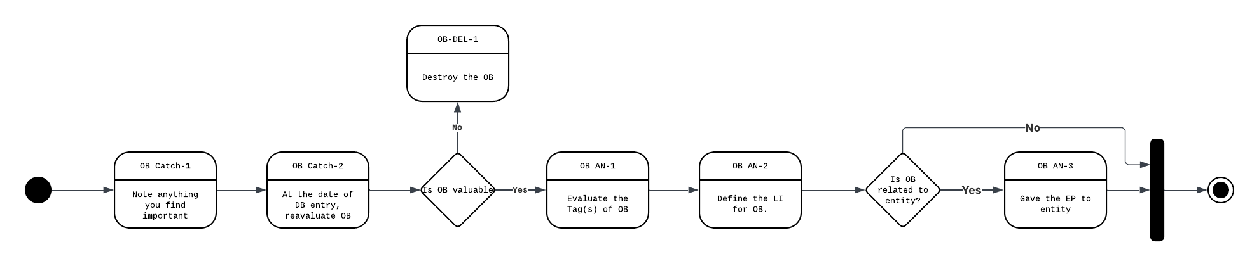
Figure 2

The objective of this stage is to solidify lessons learned from daily life. When an important event is observed, it should be promptly recorded. After two days, these observations are reviewed, and unnecessary entries are deleted—this process is referred to as Pre-Selection-1, encompassing OB Catch-1, OB Catch-2, and OB-DEL-1.

If an observation remains after Pre-Selection-1, it proceeds to the Pre-Selection-4 phase, which incorporates planning features. Each observation must be associated with specific combinators after analysis, as outlined below:
Name of Combinator | Explanation of Combinator
Tag(s) | Tags enable efficient querying and provide metadata for each observation. Multiple tags can be assigned to a single observation.
LI (Lessons Identified) | Not every observation results in a direct life lesson, but even entity-specific insights can guide decision-making about that entity.
EP | EP is part of the Diamond System, used to define the status of a specific entity. Observations with an EP point also include a list of related entities.

Diamond System
The Diamond System is designed to evaluate and track the status of entities relevant to the user. Each entity is assigned a base EP score, which adjusts over time based on events recorded as observations (OB).
Entities can encompass a wide range of subjects but are typically humans. Precision is encouraged, especially for human entities, and the tag system is used to document observations about other types of entities.
Entities enter the system at a level that reflects their importance. The following table details the base EP levels:
Level | Description
Level 1 | Reserved for the most crucial entities, such as close family, country of origin, guardians, or lifesavers. In most cases, Level 1 does not drop below 90 except for life-changing events.
Level 2 | For very important entities, such as close friends, spouses, or extended family. These may drop to Level 3, but not rise to Level 1.
Level 3 | Assigned to generally positive entities, such as helpful acquaintances or colleagues.
Level 4 | Entities that are neither liked nor hated, such as indifferent nations or co-workers with minor conflicts.
Level 5 | Entities associated with significant negative experiences, including divorced partners or those responsible for severe harm.

When a new entity is entered, a specific value within the relevant level is assigned, tailored to the user's judgment. The system is termed "Diamond" because, when functioning properly, the distribution of entities across levels forms a diamond shape.
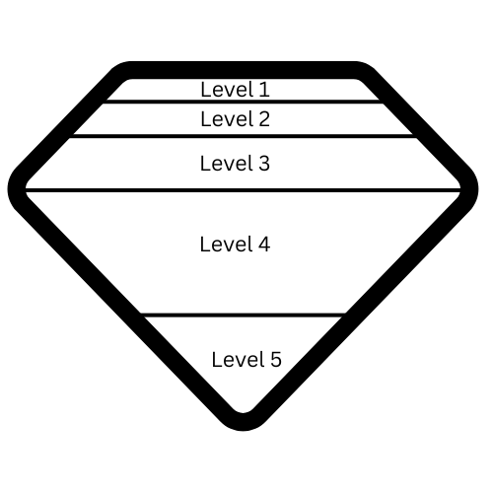
Figure 2

Pre-Preparation-2/3
Tactical Notes (TN) refer to any bugs, problems, or potential features that can be added to Templates (TP) or Software (SW). TNs are treated as observations (OB) but specifically pertain to SW and TP.
The Pre-Preparation-3 phase, depicted in the main diagram, adds an extra step for analyzing TNs. As with all observations, TNs are subject to the combinators outlined previously.

PHA-1
PHA-1 serves as an alarm or reset button. If task management becomes overcrowded, this function allows you to wipe all recorded tasks and re-evaluate the task list.
CWA stands for "Catastrophic Wipe Out," which is the abbreviation for this reset feature. Manual Analysis (MA) involves assessing whether a CWA is necessary, and sometimes starting over from scratch is preferred, hence its inclusion in the framework.

Preparation-1-1/1-2
These composite states facilitate dynamic task management within the framework. Both approaches are valid under different circumstances, as specified in Figure 1 of the documentation.

Preparation-1/2/3 and Plan-DP-1/2
The initial stage involves listing tasks according to their assigned importance levels. Next, deadlines are entered for each task. When two tasks share the same importance level, planning is prioritized based on deadlines.
In the software (SW) version, the system will automatically generate an optimal plan based on the properties of each task. The following properties are key:
Property | Definition
RT (Required Time) | The estimated time needed to complete the task.
IDL (Ideal Deadlines) | The target deadlines for each task.
IL (Importance Level) | The subjective importance assigned to each task by the user.

A reference table for Importance Level (IL) values and their meanings is provided below. Note that the value and the task's importance are inversely related.
IL-Level | Definition
1 | Tasks that must be completed without exception, whether long or short term. Examples include finals, emergency hospital visits, interviews, and application deadlines.
2 | Important tasks that are not as urgent as Level 1, often including long-term objectives with subtasks, such as preparing for finals, working on a startup, or updating a CV.
3 | Side missions or optional tasks, like purchasing a new computer, finishing books, or watching something for leisure.
4 | Tasks that are purely optional and depend on your mood, such as attending a social event or making general updates to the planning framework.

Task Managment Logic

Advanced Task Properties
In addition to basic properties (RT, IDL, IL), tasks possess structural attributes to support auto-scheduling:
- Is_Divisible (Boolean):
  - True (Default): The task can be split into smaller chunks across multiple days (e.g., Study Project). Minimum chunk size can be as low as 5 minutes based on load calculation.
  - False (Atomic): The task requires a continuous time block and cannot be split (e.g., Final Exam, Interview).
- Dependency List (N-to-N): A task can have multiple prerequisites (Pre-reqs) and can be a prerequisite for multiple other tasks. This creates a dependency graph rather than a simple list.

Auto-Distribution Algorithm (The "Smoothing" Logic)
The system automatically allocates tasks to daily slots using a "Time Smoothing" approach to minimize daily peaks.
Logic Flow:
- Filter: Select tasks based on Importance Level (IL) (Level 1 has highest priority).
- Calculate Window: Determine Available Days = (Ideal Deadline - Current Date).
- Check Atomicity:
  - If Atomic (Non-dividable): Find the nearest available slot matching the Required Time (RT) fully and book it.
  - If Divisible: Apply the Distribution Formula:
$$Daily Allocation=\frac{Required Time (RT)}{Available Days}$$
- Placement: Distribute the Daily Allocation to each day in the window.
  - Note: The system allows micro-allocations (e.g., 5-minute slots) if the deadline is far and RT is low, ensuring steady progress.

Task Dependency System (N-to-N)
PF-D utilizes a graph-based dependency model, not a linear hierarchy.
- Rule: Task X can be a prerequisite for Task Y and Task Z. Simultaneously, Task X might depend on Task A and Task B.
- Level Agnostic: A dependency relationship is independent of Importance Levels (IL). A Level 3 task (e.g., "Buy Calculator") can be a prerequisite for a Level 1 task (e.g., "Physics Exam").
- Visualization: This feature is primarily for planning visualization, ensuring the user understands the critical path and "what blocks what" in the grand scheme.

Realism Point (RP) Calculation
The Realism Point (RP) is a crucial metric for evaluating the feasibility of your plan. Rather than functioning as a simple success or failure indicator, RP is calculated as a "Load Factor" ratio, which assesses how full your schedule is:
$$RP = \frac{Total Required Time}{Available Free Time}$$
- RP < 0.8 (Safe Zone): The plan is realistic and includes sufficient buffer time.
- 0.8 < RP < 1.0 (Risky Zone): The schedule is tight and demands strict adherence.
- RP > 1.0 (Overload): The plan is not feasible; required time surpasses available time (equivalent to RP < 0 in the previous system).
When additional tasks are added, the system (in the SW version) will recalculate the RP value, allowing you to assess the updated plan's realism. During routine integration, you can configure the time allocated to daily routines and how much of your work time is consumed.

Day Management
Day management is inherently subjective and requires personal adjustment. Configuring your daily schedule is essential, as it defines available free time for dividing tasks. The following critical points should be considered:
- Medicine: If you take medications, including vitamins, optimize intake times for best results. This is especially important for conventional medicines. Incorporating these times into your routine enhances planning efficiency.
- Sports: Schedule training sessions to optimize your sleep pattern, aiming for at least 8 hours of sleep if you train intensively. Also, record the duration of each training session.
- Free Time: While challenging to optimize, you can define your daily free time by specifying the number of hours you wish to reserve.
- Holidays: Block out holidays in the system and recalculate the RP value. Always review the generated plan when using the software version.
- Others: Any additional routines outside of those listed above should be incorporated into your plan.
In the specilized software version, you will able to directly add routines to your task list and manually define the dates and times for specific activities.
This will help us to identify how much time you have in a day to do your tasks. So system will able to plan your tasks for you.

Feature Improvments
Software Based tool is under construction. I need 5 months (23.11.2025 is starting) to finish it. Then I will relase the code for free. I will gave the instructions for how to deploy at your home server. You can check the tech stack I will use.
Any Improvment sugestion is valualbe. You can reach to me via mail as you wish.

Abbreviations
IL | Importance Level
DB | Database
TP | Template
AN | Analysis
IDL | Ideal Deadlines
DP | Deployment
RP | Realism Point
CM | Change Management
GM | Gap Management
TC | Tactical Notes
PMA | Plan Movement Analysis
CWA | Catastrophic Wipe Out
MA | Manual Analysis
AG | Action Group
RT | Required Time
DEL | Deletion
LI | Lessons Identified
EP | Evaluation Point

