309551101郭育麟

ML_HW05

1 . Gaussian Process

1-1:

Kernel function : Rational quadratic kernel

$${(1+\frac{{(x_{i}-x_{j})}^{2}}{2*alpha*{Length_scale}^{2}})}^{-alpha}$$

Alpha : 1 , Length_scale = 1

In this homework , first using cal_kernel() to calculate data points’ similarity and return a kernel matrix . Then use predict() function to evaluate the new points (-60,60) each mean and variance . Finally use plot_gaussian() function to draw the result .

Data points (raw data) are sample from

$$y_{n}=f\left(x_{n}\right)+ϵ_{n}$$

$$where ε_{n} \sim N\left(0,B^{-1}\right)$$

$$B=5$$

Cal_kernel():

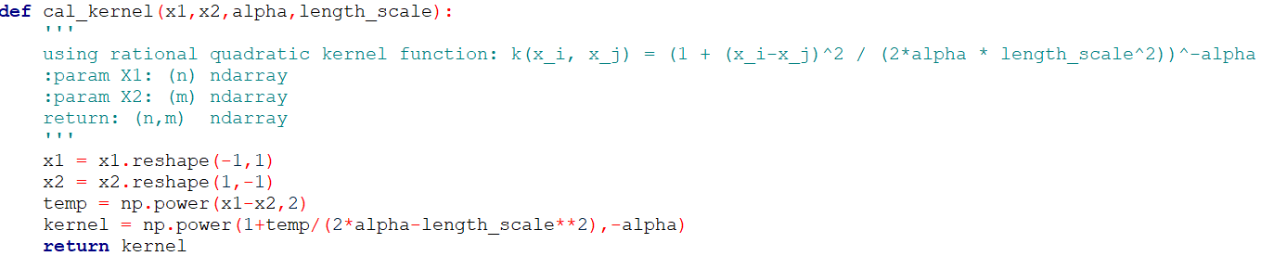

$${(1+\frac{{(x_{i}-x_{j})}^{2}}{2*alpha*{Length_scale}^{2}})}^{-alpha}$$

Predict():

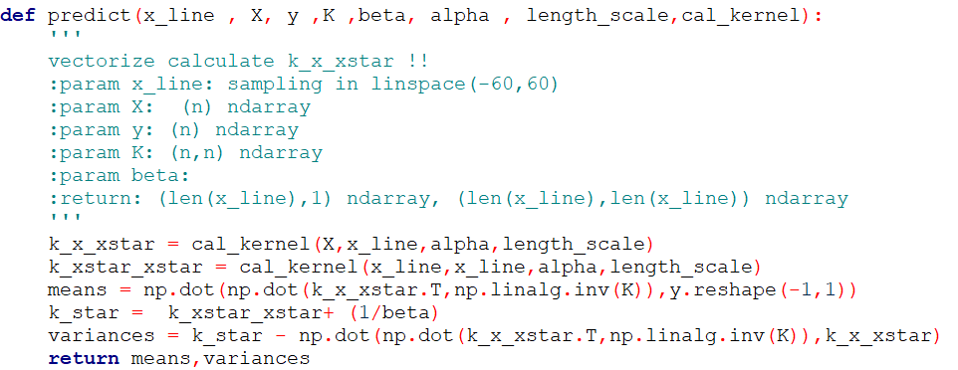

$$C=k+B^{-1}*I$$

$$k^{*}=k\left(x^{*},x^{*}\right)+B^{-1}$$

$$means\left(x^{*}\right)={k\left(x,x^{*}\right)}^{T}*C^{-1}*y$$

$${variance}^{2}=k^{*}-{k\left(x,x^{*}\right)}^{T}*C^{-1}*k(x,x^{*})$$

plot_gaussian():

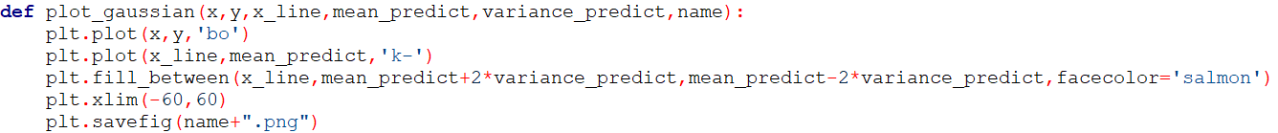

Given raw data ,mean and variance can plot the graph , 95% confidence interval means that $mean±2*standard deviation$.

Main():

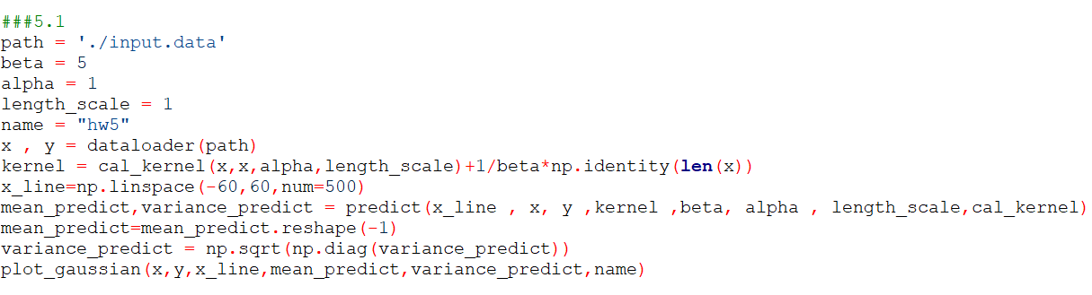

Result:

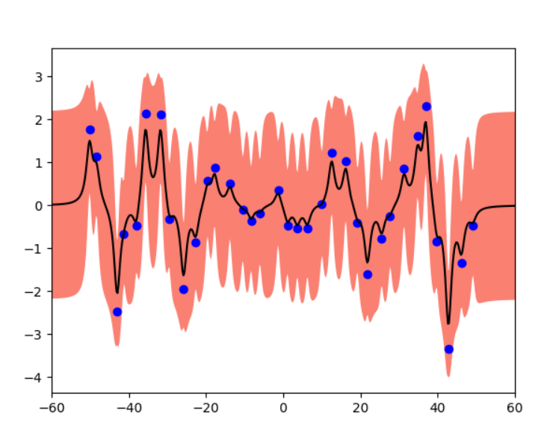

In the blue dots (raw data) interval , the variance would smaller than new points (-60~60) . Raw data has more specific range than new points .

1-2:

In this exercise , we need to optimize our parameter(alpha and lengh_scale) first . I use scipy.optimize minimize the negative likelihood function . After minimize I can get the better parameters so it can predict result same as 1-1 .

Initially function:

$$\frac{1}{{(2π)}^{\frac{n}{2}}{|Σ|}^{\frac{1}{2}}}e^{\frac{-1}{2}{\left(x-μ\right)}^{T}Σ(x-μ)}$$

After differential could get objective function .

Objective function :

$$lnP\left(y | θ\right)=\frac{-1}{2}\ln\left|C_{θ}\right|-\frac{-1}{2}y^{T}C_{θ}^{-1}y-\frac{N}{2}ln⁡(2π)$$

Objective_function():

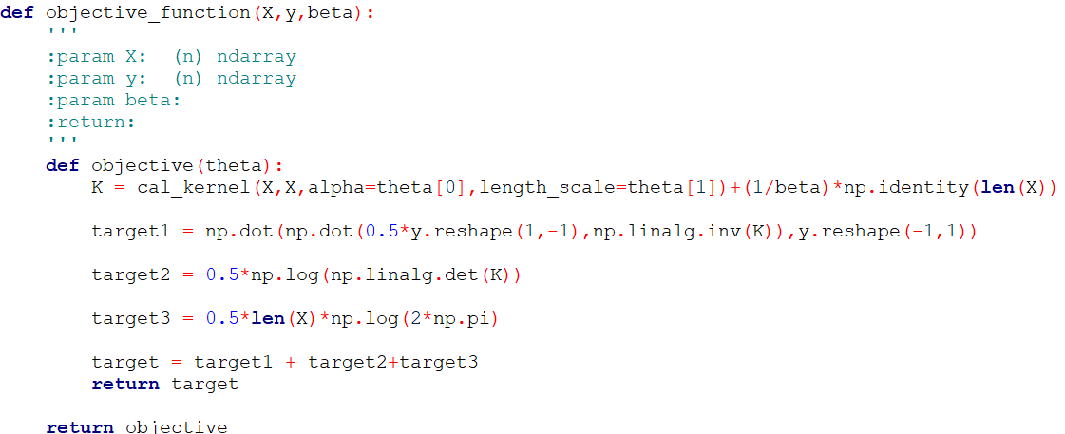

In this function , calculate the objective function value .

Minimize_negative_marginal():

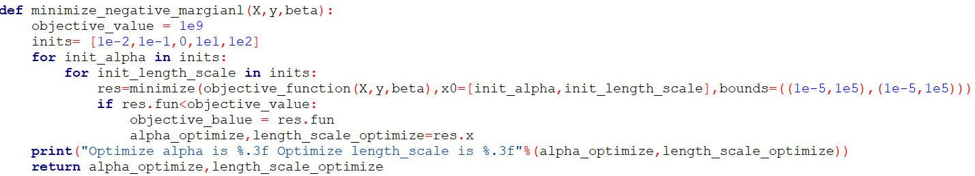

In this function , initial sets parameters from [1e-2,1e-1,1e1,1e2] and want to minimize the objective function . The reason why choose [1e-2 , 1e-1, 1e1 , 1e2] is avoid the minimize value is local minimum not global minimum . Finally , return alpha and length_scale .

Result:

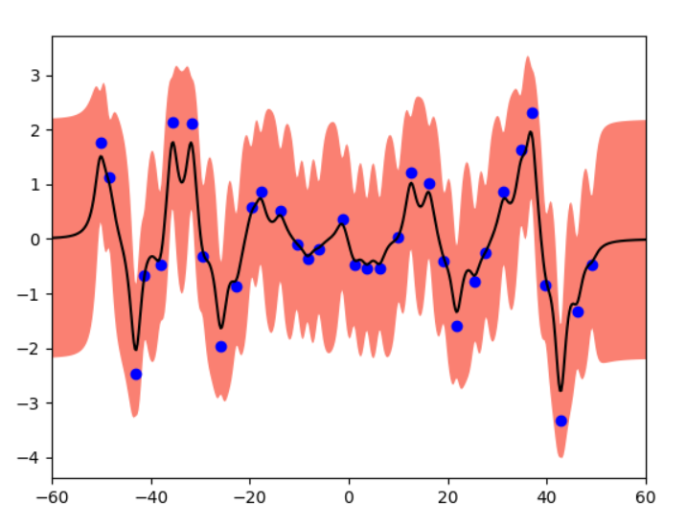

Compare:

In result 1-2 , the variance in blue dot (raw data) becomes smaller . The parameters which has been optimized would let the likelihood be maximum . So it can has better performance than 1-1