309551101 郭育麟

圖形識別 Pattern Recognition HW2

**Part 1 Coding**

**1.1 Compute the mean vectors mi (i=1, 2) of each 2 classes on**

**training data**

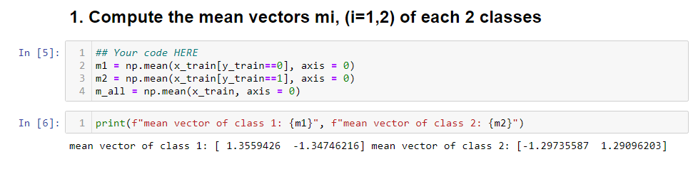

Use np.mean to calculate each mean .

**1.2 Compute the within-class scatter matrix $S_{W}$ training data**

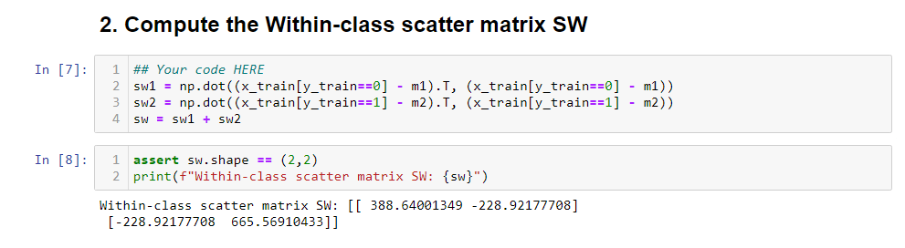

$S_{W}$ represent the degree of separation of same class projection data points

$$S_{W}=\sum_{i=1}^{K}{S_{k}}$$

$$where S_{k}=\sum_{n∈C_{k}}{\left(x_{n}-m_{C_{k}}\right){\left(x_{n}-m_{C_{k}}\right)}^{T}}$$

$$S_{k} can seen as k-class divergence matrix$$

**1.3 Compute the between-class scatter matrix $S_{B}$ on training data**

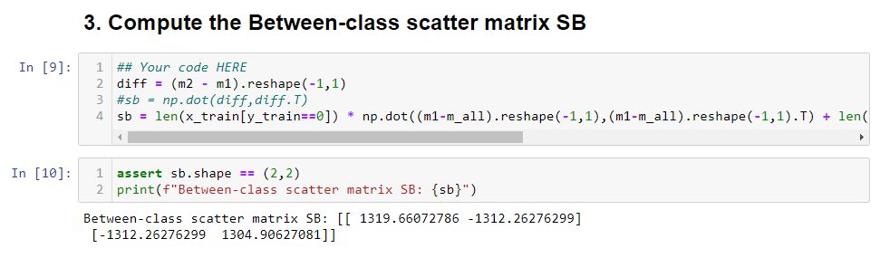

$S_{B}$ represent the degree of separation of different class projection data points

$$S_{B}=\sum_{i=1}^{K}{Number_{C_{k}}\left(m_{C_{k}}-m\right){\left(m_{C_{k}}-m\right)}^{T}}$$

$$where {Number}_{C_{k}} is the number of k-class data points$$

$$m_{C_{k} }is the k-class mean vector$$

$$m is the all data points mean vector$$

**1.4 Compute the Fisher’s linear discriminant $W$ training data**

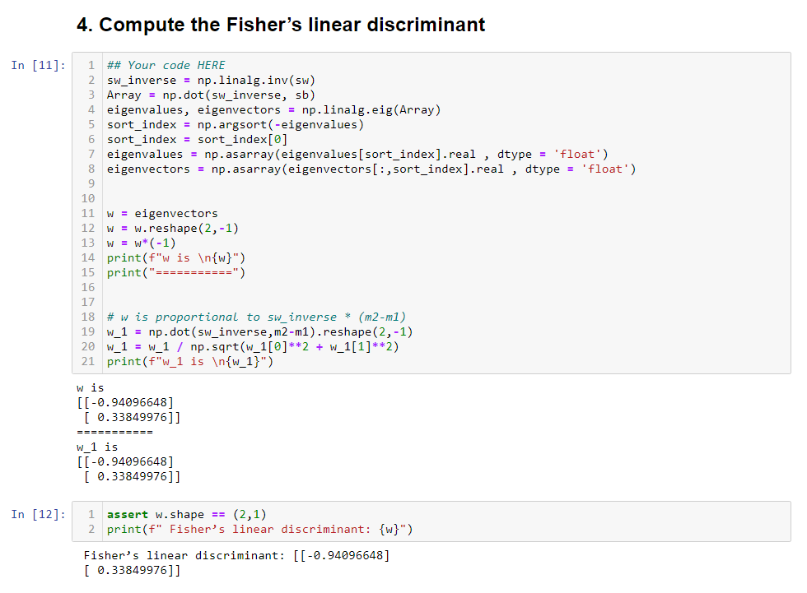

We want $S_{B}$ the bigger the better and want $S_{W}$ the smaller the better . So

the objective function will be $J\left(w\right)=\frac{w^{T}S_{B}W}{w^{T}S_{W}w} , w$ represent the projection

matrix . And by Rayleigh quotient and differential with respect to w

$$\frac{∂J\left(w\right)}{∂w}=0 →S_{B}w\left(w^{T}S_{W}w\right)=\left(w^{T}S_{B}w\right)S_{W}w$$

$$S_{B}w=\frac{w^{T}S_{B}w}{w^{T}S_{W}w}S_{W}w=J\left(w\right)S_{W}w$$

$$S_{W}^{-1}S_{B}w=J\left(w\right)w$$

$$where S_{W}^{-1}S_{B} is an array , J\left(w\right) is scalar$$

$$it can seen as the defiction of eigenvalue and eigenvectors$$

The equation $S_{W}^{-1}S_{B}W=λW$, compute $S_{W}^{-1}S_{B}$ eigenvalue and

eigenvectors , the optimal w is the eigenvalue of that corresponds to the

largest eigenvalue .

I also try $w α S_{w}^{-1}*{(m}_{2}-m_{1})$, and the answer is “w_1”

**1.5 Project the testing data by fisher’s linear discriminant to get the class prediction by nearest-neighbor rule and calculate your accuracy score on testing data**

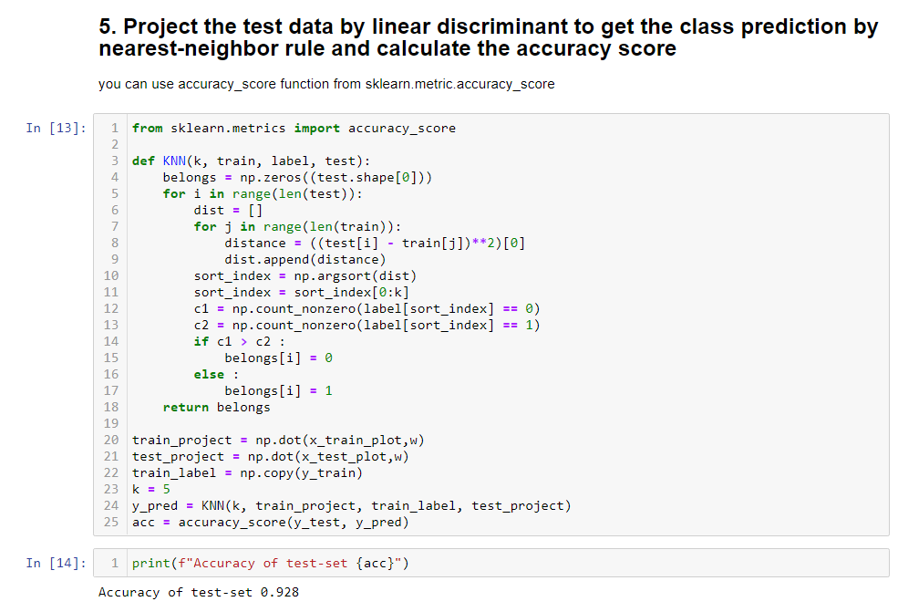

First , project testing data and training data by using previous eigenvector ,

and I use KNN algorithm(k = 5) to classification and get 92.8% accuracy .

**1.6 Plot the 1) best projection line on the training data and show**

**the slope and intercept on the title (you can choose and value of intercept for better visualization) 2) colorize the data with each class 3) project all data points on your projection line .**

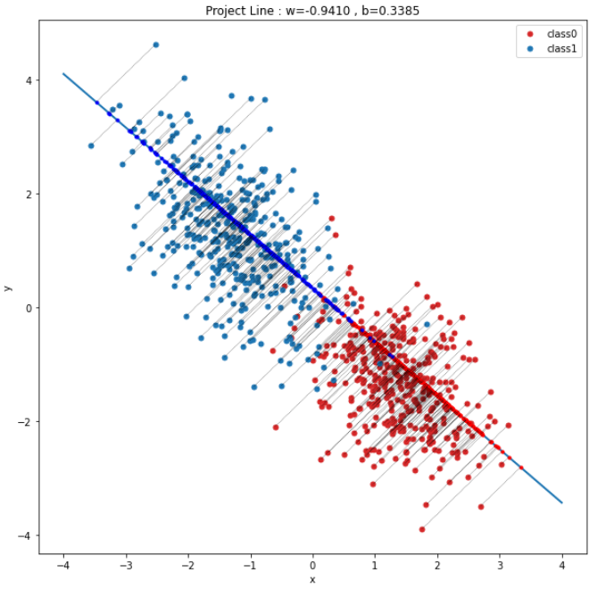

**Part2 Questions**

**2.1 Show that maximization of the class separation criterion**

**given by $L\left(λ,w\right)=w^{T}\left(m2-m1\right)+λ(w^{T}w-1)$ with**

**respect to w , using a Lagrange multiplier to enforce the**

**constraint $w^{T}w=1$, leads to the result that**

$w α (m2-m1)$

$$\frac{∂L}{∂w}=\left(m_{2}-m_{1}\right)+2*λ*w$$

$$w= -\frac{1}{2*λ}(m_{2}-m_{1})$$

$$∴w α (m_{2}-m_{1})$$

**2.2 Show that the logistic sigmoid function satisfies the property**

$σ\left(-a\right)=1-σ(a)$ and its inverse is given by $σ^{-1}\left(y\right)=ln⁡\{\frac{y}{1-y}\}$

(a)

$$σ\left(x\right)=\frac{1}{1+e^{-x}}$$

$$σ\left(-x\right)=\frac{1}{1+e^{x}}$$

$$1- σ\left(x\right)=\frac{1+e^{-x}}{1+e^{-x}}-\frac{1}{1+e^{-x}}=\frac{e^{-x}}{1+e^{-x}}=\frac{1}{1+e^{x}}$$

(b)

$$y=\frac{1}{1+e^{-x}}$$

$$→y\left(1+e^{-x}\right)=1$$

$$→y+y*e^{-x}=1$$

$${→e}^{-x}=\frac{1-y}{y}$$

$$→-x*\ln{e=}\ln{\frac{1-y}{y}}$$

$$→x=\ln\left(\frac{y}{1-y}\right)=σ^{-1}(y)$$