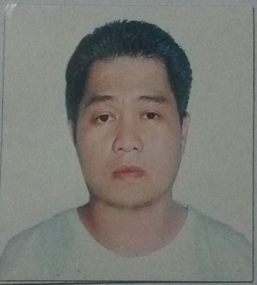

**PAULO G. MACALAGUIM**

[paulogmacalaguim@gmail.com](mailto:paulogmacalaguim@gmail.com)

24 Lising St., Rema Vill. Tandang Sora, Quezon City

09227305134/(02)9622078

Objectives:

To obtain a job where I can utilize my knowledge and skills as a career person in order to gain experience in the field of Business Industry as well as for the implementation of the company’s organizational goals

Education

* Polytechnic University of the Philippines

College of Office Administration and Business Teacher Education

Bachelor in Office Administration

Experience

* Customer Service Representative – October 23, 2017 – December 22, 2017

Convergys San Lazaro, Manila

* + CSR for retail account (seasonal)
* Account Specialist – Aug. 5, 2015 – October 7, 2017

Altair Global Solutions – 9th floor JELP Building, 409 Shaw Blvd, Mandaluyong City.

* + Call Transfer Agent to Collection Specialist
* Verifier - March 7, 2000 – July 2002

National Statistics Office – Sta. Mesa, Manila

* + To verify and release document of a particular person upon request such as birth certificate, death certificate and marriage certificate.

Reference

* Mr. Allan Absara

Convergys SLZ

09266691501

* Mr. Rhodel Magat

Country Manager – Altair Global Solutions

09053073937

* Ms. Hershy Viray

Collection Analyst - Altair Global Solutions

09431452533

PAULO G. MACALAGUIM