Brand Catalogue
READY_FOR_REVIEW — unexecuted review copy

Working positioning
Positioning: Proposed: considered workflow tools for small design teams. Audience: Independent design studios and their project leads. Attributes: Precise, calm, useful. Proposed statements remain proposals until the owner adopts them.

Brand name and legal name
Use Aster Works for product identification. Use Aster Works Ltd where the issuing legal party matters. Do not abbreviate legal names in execution or invoice fields.

Voice examples
Prefer specific evidence: "Your request is recorded; here is the next step." Avoid unproved absolutes such as "fully compliant" or "guaranteed secure". Owner-selected tone: Clear, measured and direct.

Clear space
Derive clear space from the actual mark: One height of the central square module on each side. Keep unrelated text outside this zone. The diagram illustrates the chosen rule rather than a universal logo formula.

Release sizes
Minimum sizes require review of the supplied artwork at intended use sizes. Compare 16, 24, 32 and 64 px and the 12, 20 and 30 mm ladder; record the smallest legible use after inspection.

Print and contrast
HEX values are screen specifications. Proposed process-print conversions need a printer proof; no exact Pantone match or certified CMYK conversion is claimed. Text contrast is calculated separately from logo aesthetics.

Office and email type
Use the available document font with Arial, Helvetica or Liberation Sans fallbacks. Email uses conservative system sans fonts. No font files are bundled; substitutions are recorded in build information.

Typesetting rules
Body text is 11 pt with measured spacing; footer text is 9 pt. Headings stay with the following paragraph. Avoid ornamental watermarks and crowded signature areas.

Editorial details
Use consistent dates, references and sentence case. Keep currency and entity names explicit. Use descriptive links, alt text and neutral language for disputes.

Keep the page useful
Page anatomy uses 22 mm margins, a reserved header and footer and restrained logo size. Long addresses wrap. Tables repeat header rows; continuation branding remains quiet.

Recommended production choice
Prefer native editable Word on blank A4 or Letter stock. Paper choice is independent of jurisdiction. Physical output and printer scaling require a separate proof.

Email letterhead
Email is a separate medium: a fluid presentation table, inline styles and live text branding. The print reference is not the sending template.

Image strategy
The image-free version remains readable. CID artwork requires an actual matching MIME attachment. No invented hosted asset URLs, tracking pixels or base64/SVG reliance in sending HTML.

Signature
A signature identifies the selected sender, role and approved contacts. It is not a handwritten signature or evidence of signing authority.

Imagery and iconography
Use source-provenance artwork with informative captions. Product icons do not imply a marketing logo master. Do not borrow third-party trademark specimens.

Motion and sub-brands
No motion or sub-brand system is invented for stationery. Where a real sub-brand exists, document its hierarchy and keep independent entities distinct.

Production rules
Stamp dimensions are configurable starting points. Outlined lettering and positive orientation are supplied. Supplier minimum lines/gaps, material and ink suitability remain proof gates.

Custody and approval
Assign a custodian, record purpose and version, and restrict stamp access. Common-seal requirements require constitution and local-law review.

Asset structure
Originals are hashed and retained separately from derivatives. Each recolour, crop or rasterization is labelled; reconstructed artwork never becomes an approved original by rendering.

Quality checks
Check small size, one-colour, reversed, grayscale and intended print use. Review every Word-derived page and browser print; structural checks alone are insufficient.

Source and ownership notes
Input asset rights stay with their owners. This package grants no trademark clearance, press approval or legal certification. Keep approval evidence separate from technical QA.

Logo family and clear-space specimen
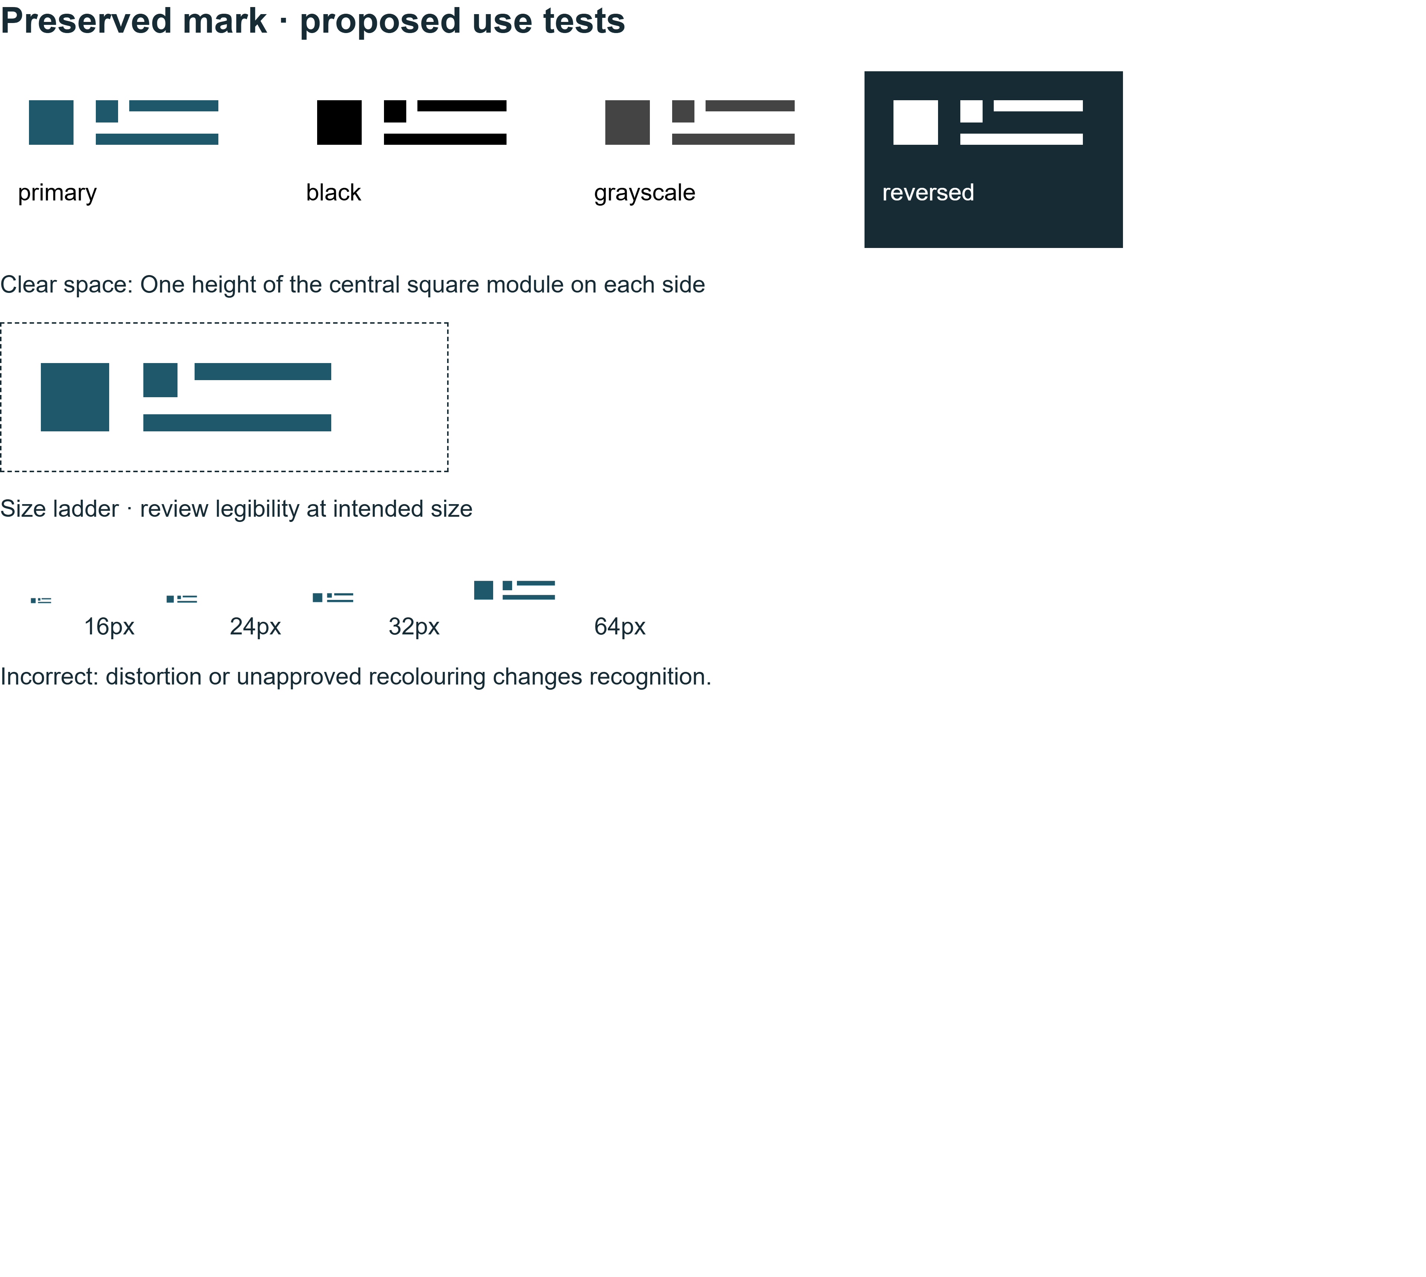
Logo family and clear-space specimen

Palette and type specimen
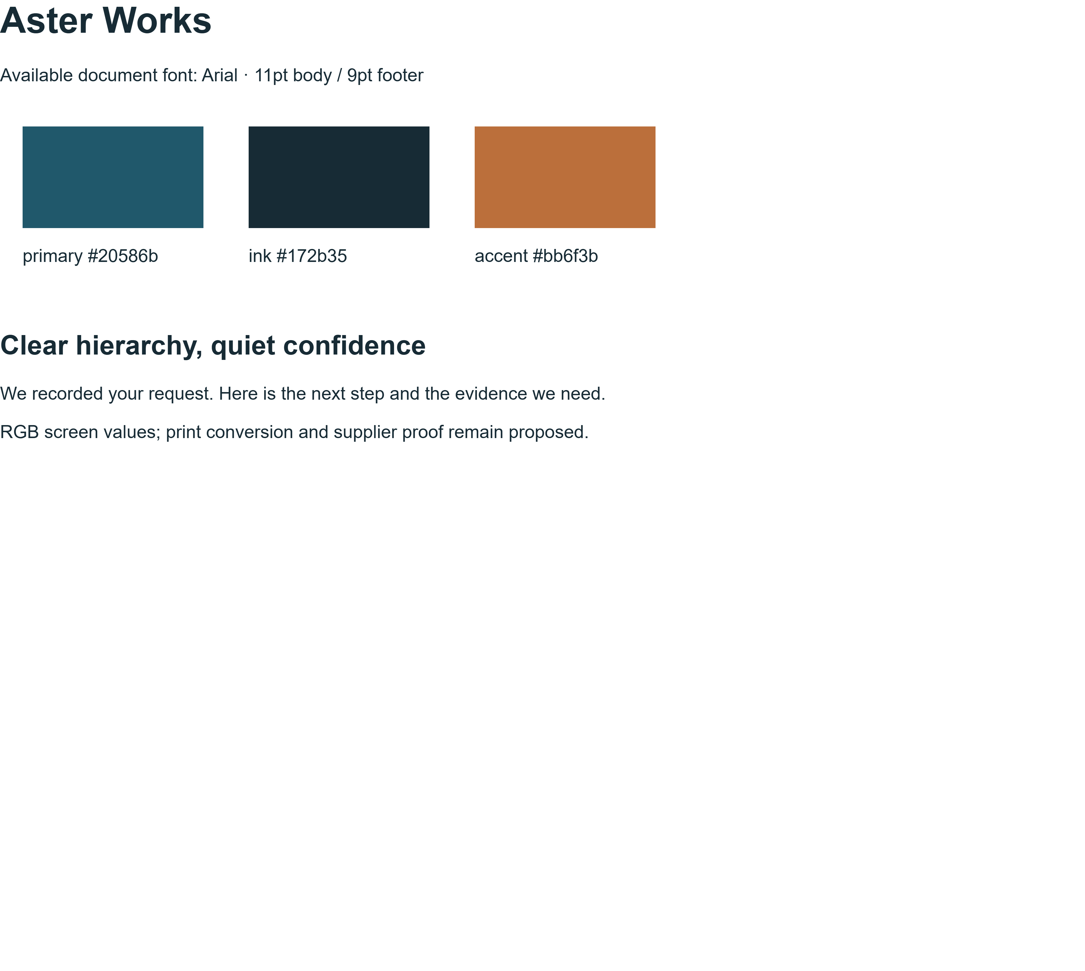
Palette and type specimen

Page anatomy
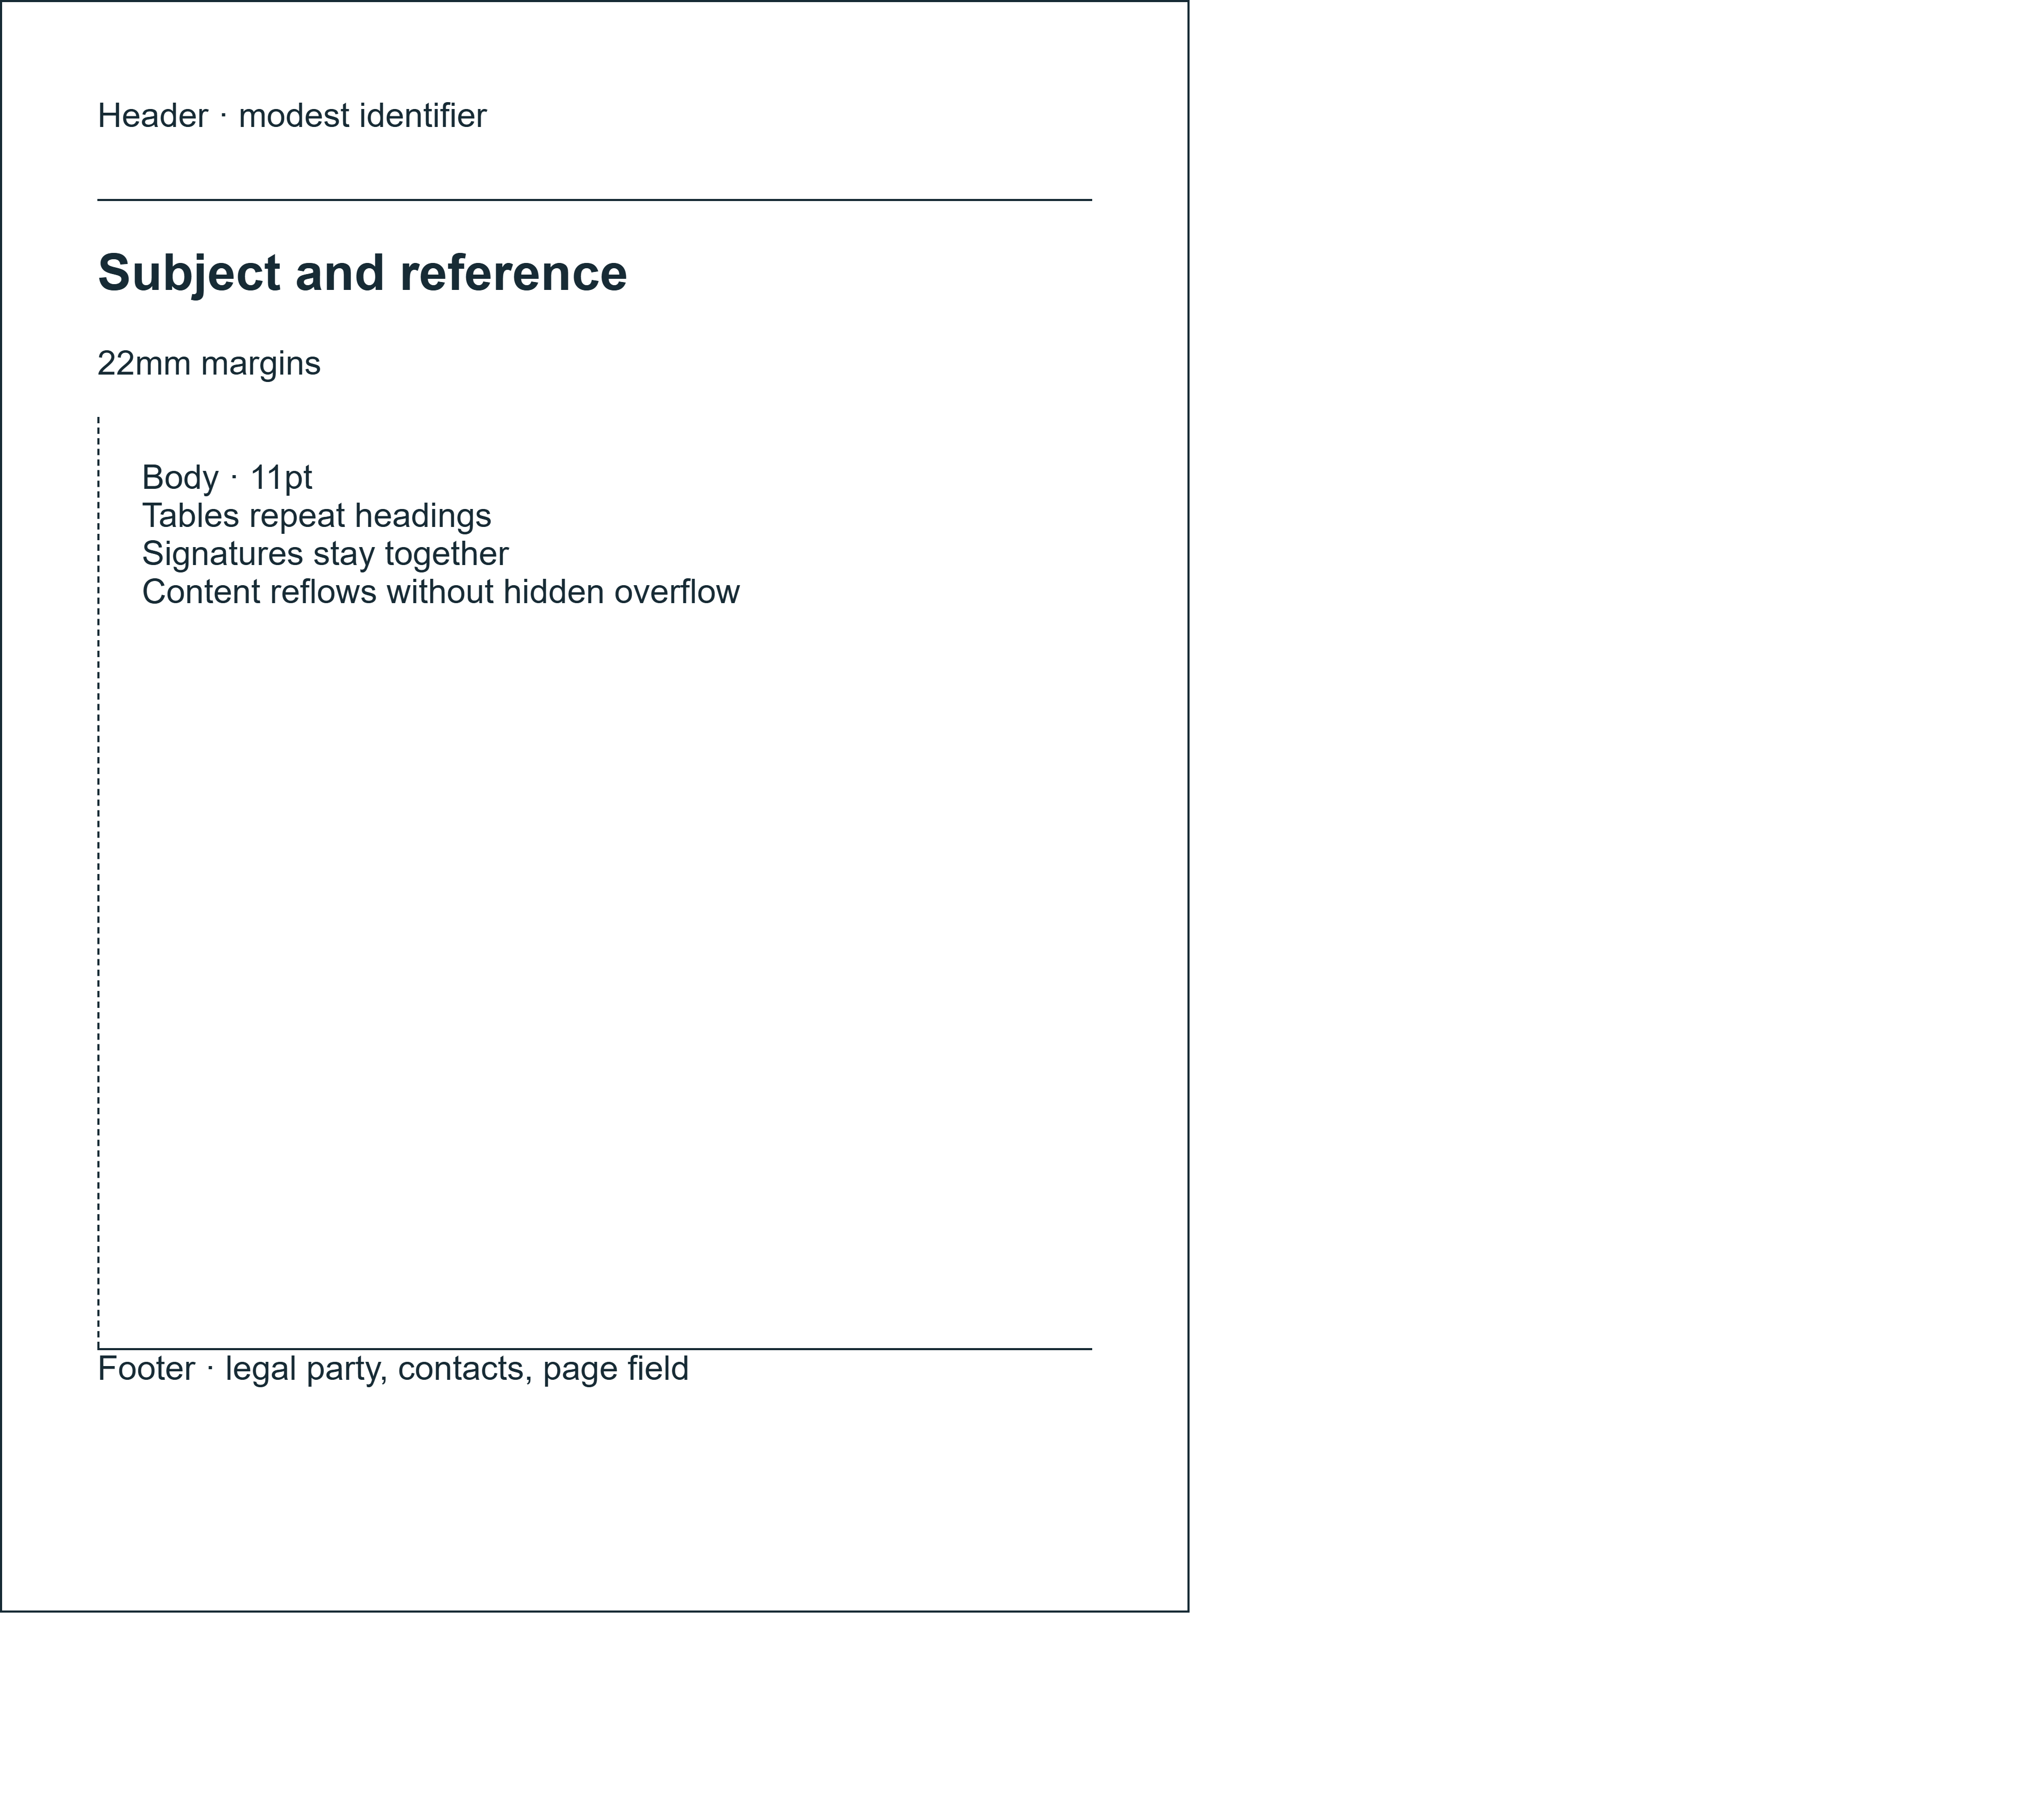
Page anatomy

