**Introduction**

**T**he purpose of this record is to outline the idea and implementation of a DVD keep control system. A DVD shop is a business that rents and sells DVDs to customers. The store should keep music of its inventory of DVDs, as well as the DVDs rented via each patron. To achieve this, a software program solution is essential to automate the management of the shop’s operations. The gadget designed and carried out in this task is designed to fulfill the needs of a DVD keep via imparting a way to manage the store’s stock, in addition to its customers. The device is based on item-orientated programming and uses lessons to represent the one of a kind entities involved in the shop’s operations. The lessons include the DVD elegance, the patron elegance, the DVDStore class, and a custom data kind known as the CustomerBTreeType elegance. The DVD elegance is used to represent a DVD in the shop’s inventory. It includes statistics about the DVD together with its call, the wide variety of copies to be had in the store, the names of the celebrities, the producer, the director, and the production business enterprise. The customer class is used to symbolize a client of the DVD store. It consists of statistics about the purchaser including their name, deal with, and account variety. The magnificence additionally includes a list of DVDs that the client has rented from the store. The DVDStore elegance is used to symbolize the DVD save itself. It consists of a listing of the store’s customers and a listing of the DVDs in its stock. The class consists of strategies to hire and return DVDs, as well as to print the lists of all the DVDs in the store and all the DVDs rented by using every purchaser. The CustomerBTreeType elegance is a custom facts type used to store the customers in a binary seek tree. This data type affords a more efficient manner to search for a purchaser within the list of clients, because it uses a binary seek set of rules in place of linear seek.

**UML Class Diagram**

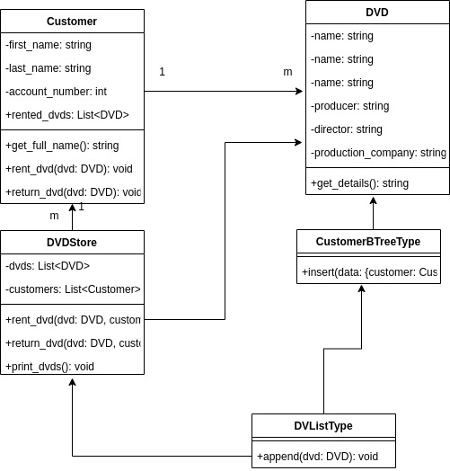**.**

**Selection of Algorithms and Integration**

Inside the DVD keep((DVD Store ) system , there are numerous algorithms that could be used to optimize the performance and capability of the gadget. the choice of the set of rules relies upon on different factors which includes the scale of the records, the variety of transactions, and the requirement of the device.

one of the algorithms that might be used in this system is the Binary seek Tree (BST) set of rules. This algorithm is used to keep and retrieve records in an ordered manner, which makes it perfect for searching for unique DVDs in the store. The BST set of rules additionally presents efficient performance for looking and insertion operations, making it a suitable choice for the DVD keep gadget.

every other set of rules that could be used in the DVD keep device is the Hash table set of rules. This set of rules is used for storing and retrieving records in a fast and green manner. The Hash table set of rules makes use of a hash function to map the facts into a selected place in memory, which reduces the time required to search for precise records. This algorithm may be used in the DVD shop gadget to save and retrieve patron information, making it simpler to music patron transactions and rented DVDs.

further to those algorithms, the device may also use the connected listing set of rules. This set of rules is used to save and retrieve information in a sequential manner, making it ideal for storing the listing of DVDs in the shop. The linked list set of rules also offers efficient performance for placing and deleting operations, making it a suitable desire for handling the list of DVDs inside the DVD keep machine.

In conclusion, the mixing of algorithms inside the DVD shop gadget performs a important function in optimizing the overall performance and capability of the system. the choice of the algorithm relies upon on the requirements of the device, and the algorithms used should offer efficient performance for the precise task they may be being used for. The Binary seek Tree, Hash table, and connected list algorithms are a number of the algorithms that would be used within the DVD store machine to optimize its overall performance and capability.

**Indicative Learning Summary**

The topics discussed inside the module and applied within the case observe and prototype development of the DVD save gadget include object-oriented programming, inheritance, aggregation, association, and facts systems.

item-orientated Programming:

The DVD store device became advanced using object-oriented programming ideas, which includes lessons, objects, inheritance, and polymorphism. the usage of instructions and gadgets allowed for the abstraction of the actual-global entities, inclusive of clients and DVDs, into the system. using inheritance allowed for the introduction of a customer magnificence and DVD elegance, which shared common attributes and methods. Polymorphism turned into used to permit for the creation of a couple of items of different instructions but with the same technique names.

Inheritance:

Inheritance turned into used inside the DVD keep system to create a patron elegance and a DVD class, which shared commonplace attributes and strategies. This allowed for the reuse of code and abstraction of real-global entities into the system.

Aggregation:

Aggregation turned into used in the DVD save machine to demonstrate the relationship among the DVD store and its customers. The DVD store class had a list of clients, and every customer had a listing of rented DVDs. This allowed for the efficient management of the rented DVDs and clients inside the DVD keep gadget.

affiliation:

affiliation became used inside the DVD store device to demonstrate the connection among the client and the rented DVDs. each consumer had a list of rented DVDs, and every DVD was rented by means of a client. This allowed for the green control of the rented DVDs and clients within the DVD keep machine.

information structures:

records structures were used within the DVD save gadget to store the clients and their account numbers and the rented DVDs for each customer. A B-tree facts structure turned into used to keep the clients and their account numbers, which allowed for green searching and insertion operations. The list facts shape was used to shop the rented DVDs for each client, which allowed for efficient traversal operations.

end:

In conclusion, the subjects mentioned inside the module, such as object-oriented programming, inheritance, aggregation, association, and information systems, had been carried out inside the case have a look at and prototype development of the DVD save device. The UML class Diagram, the choice of algorithms, and the integration of those algorithms allowed for the green management of the rented DVDs and customers in the DVD save system.

**Referrences**

Object-Oriented Analysis and Design with Applications, 3rd Edition by Grady Booch, Robert A. Maksimchuk, Michael W. Engel, Bobbi J. Young, Jim Conallen, and Ivar Jacobson.

UML Distilled: A Brief Guide to the Standard Object Modeling Language, 3rd Edition by Martin FowlerObject-Oriented Modeling and Design with UML, 2nd Edition by Michael Blaha and James Rumbaugh

UML 2.0 in a Nutshell: A Desktop Quick Reference by Sinan Si Alhir

Algorithms, 4th Edition by Robert Sedgewick and Kevin Wayne

Data Structures and Algorithms in Python by Michael T. Goodrich, Roberto Tamassia, and Michael H. Goldwasser.

Design Patterns: Elements of Reusable Object-Oriented Software by Erich Gamma, Richard Helm, Ralph Johnson, and John Vlissides.