

**MIDDLE EAST TECHNICAL UNIVERSITY**

**DEPARTMENT OF ELECTRICAL AND ELECTRONICS ENGINEERING**

***EE463 – Hardware Project***

***AC-DC Motor Drive Simulation Report***

*Nevzat S. Şenyayla*

*2263796*

*Sam Malek*

*2126845*

*Muhammed Barış*

*2030278*

*Asya Bal*

*2093417*

**TABLE OF CONTENTS**

I. ABSTRACT 3

II. INTRODUCTION 3

III. POSSIBLE SOLUTION APPROACHES 4

1) Three-Phase Full-Bridge Diode Rectifier and Buck Converter (Selected) 5

2) Three-Phase Fully Controlled Thyristor Rectifier 7

3) Single-Phase Fully Controlled Thyristor Rectifier 9

4) Dimmer 11

IV. DESIGN CONSIDERATIONS 13

V. SIMULATION RESULTS 14

1) 5% Duty cycle Results of the Circuit 15

2) 25% Duty Cycle Results of the Circuit 17

3) 50% Duty Cycle Results of the Circuit 19

4) 75% Duty Cycle Results for the Circuit 21

5) 95% Duty Cycle Results for the Circuit 23

VI. COMPONENT SELECTION 25

1) Three-Phase Full-Bridge Diode Rectifier 25

2) DC-Link Capacitor 25

3) IGBT 26

4) DIODE 26

VII. CONCLUSION 27

# ABSTRACT

This report is written in order to present the details of the considered preliminary design for EE463: Static Power Conversion course hardware project. The scope of this project is to design an AC to DC converter for the purpose of driving a DC motor. Design considerations that were followed during the selection of solution approach are indicated extensively in the report. Furthermore, simulation results of the considered solution approaches are given. The simulations seen throughout this report were obtained by utilizing Simulink Simscape Electrical workspace.

# INTRODUCTION

The main objective of power electronics branch is to process and control the flow of electric energy by supplying voltages and currents in a form that is optimally suited for user loads. In order to substantiate this objective, a hardware project that requires a design of an AC to DC converter to be used for driving purposes of a DC motor was assigned as a part of EE463: Static Power Conversion course.

The mentioned AC to DC converter is required to convert the 3 phase AC input coming from an autotransformer (i.e. Variac) to a adjustable DC output that can drive a specified DC motor. With this in mind, the design should include a rectifier and a control circuit complying with the requirements of the project. The rectifier unit basically converts the AC voltage to a DC voltage by means of power semiconductor devices. In the meantime, the control circuit is expected to manage the operation of the rectifier unit and provide adjustable DC output.

Several possible solution approaches, particularly converter topologies, were chosen to be examined carefully and were simulated in computer environment for the purpose of finding the best approach that meets the objectives considered for the project. Simulations were carried on in order to provide the performance characteristics of topologies and give insight about any potential problems that can be encountered in future. After this process, 3 phase diode rectifiers with a buck converter was selected to be utilized as the solution approach for the project.

The components to be used at the design will be determined with respect to analytical calculations and simulation results. A prototype will be built in the next step.

# POSSIBLE SOLUTION APPROACHES

Before diving into the implementation processes of the main solution approach, one should compare the advantages and the disadvantages of different possible solution methodologies in order to make a better decision on both the economical aspect and the efficiency, complexity, etc. In the case of this pre-defined project, there are many possible topologies that can be used as a solution approach, but when it is thought by means of the components’ availabilities, circuits’ complexities, additional costs, sub-systems, etc. the total number of the possible solution approaches decrease to four which are listed as,

1. Three-Phase Full-Bridge Diode Rectifier
2. Three-Phase Fully Controlled Thyristor Rectifier
3. Single-Phase Fully Controlled Thyristor Rectifier
4. Dimmer

Those four topologies listed above are the most widely used designs in power conversion applications and their selection carries vital importance in the design procedure of the defined project’s solution. In order to give a slight insight to the reader, the operational principles of the given four topologies are going to be briefly explained in this part.

In the topology of “Three-Phase Full-Bridge Diode Rectifier” there should be six diodes or one three phase diode rectifier IC at the input stage of the circuit which are used in the rectification process of the AC input signal. By the gate drive of a switch with a generated PWM, this input signal is transmitted to the output stage as ripple-free as possible by the virtue of L-C filter connected at the output stage of the circuit. If one changes the duty cycle of the generated PWM, the switching is changed accordingly and therefore the output voltage is controlled.

The solution approach of “Three-Phase Fully Controlled Thyristor Rectifier”, needs six thyristors which should be implemented and the drive operation of the gates of each thyristor by impulse gate currents supplied from a generated PWM with 120 degrees phase difference between each of the gate currents of each phase. The output signal can be changed according to the firing angle of the thyristor which can supply a user the necessary output voltage.

When “Single-Phase Fully Controlled Thyristor Rectifier” is taken into consideration, the same principles of Three-Phase Fully Controlled Thyristor Rectifier shall be applied. The only difference is the thyristor numbers which is four and the gate drives of the thyristors which should have 180 degrees phase difference between each phase.

“Dimmer Circuit” is a topology which has diac, triac, capacitor and two resistors where one of the resistors are a POT to change the time constant of the capacitor to supply the desired output voltage to the load.

### Three-Phase Full-Bridge Diode Rectifier and Buck Converter (Selected)

This topology is composed of a “Three-Phase Full-Bridge Diode Rectifier” integrated circuit in order to take a DC kind of output at the output stage while a three-phase AC signal is applied to its input, a DC-Link capacitor to decrease the ripple at the output stage of the rectifier as much as possible and a buck converter topology which is used in order to decrease the input DC signal to lower levels by an internal switching components like IGBT or MOSFET, a freewheeling diode and an L-C configuration at the output stage of the converter.

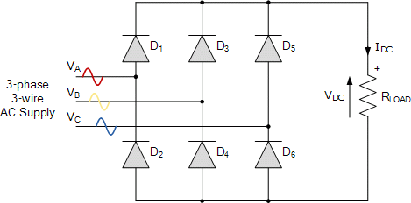

*Figure 1: Circuit schematic of 3-Phase full-bridge diode rectifier*

In order to control the switching frequency and switching period (conduct and cut-off period) of the switching component (an IGBT or a MOSFET) a PWM signal should be applied to the switching component’s gate from an analog controller or a microcontroller at the desired frequency. Besides, since the generated PWM is a very small voltage -like 5 Volts- and this small voltage circuitry should be isolated from the high voltage side from where the main power flows. In order to isolate the low-voltage circuit from the high-voltage side, an optocoupler or an isolation component shall be used in the design. As it can be clearly observed, there are several components that should be included in the designed solution.

From the point of view of the above information, the advantages and the disadvantages of the “Three-Phase Full-Bridge Diode Rectifier and Buck Converter” topology can be listed as,

1. **Advantages**
   1. *Easy controllable switching frequency to control the output ripples*
   2. *Simple speed control with only one switching device and an analog PWM generator or a controller*
   3. *The freedom of the design of output L-C filter by which the output ripples are controlled*
   4. *Relatively higher efficiency up to 94% according to the desired output voltage*
2. **Disadvantages**
   1. *The number of the components are relatively higher when compared to other design alternatives*
   2. *Due to higher components number, it results in relatively higher costs*
   3. *Any mistake in the design procedure or the operation may blow all the components of DC-DC converter which might yield to a higher cost and longer implementation processes*
   4. *It has high switching losses if a high kHz switching frequency is used*
   5. *If the inductance value of the converter is chosen as a large value to decrease the output ripples, the converter gets into discontinuous conduction mode easier which yields to higher output voltages which may harm the DC motor being driven.*

### Three-Phase Fully Controlled Thyristor Rectifier

The circuit schematic of three-phase fully controlled thyristor rectifier can be seen in Figure 3. This topology is composed of six thyristors utilized for 3 phase rectification purposes. A control circuit is required to feed current pulses to the gates of each thyristor with specified firing angle. Average output voltage can be controlled by means of firing angle of current pulse to the thyristors.

Thus, this topology provides a simple controllable operation without the need of a buck or boost converter to regulate the output. Also compared to other topologies, a larger output voltage with a small voltage ripple can be achieved even without DC side capacitor thanks to the controllable operation. Two quadrant operation is possible in this topology thanks to the inverter mode of thyristors. For achieving four quadrant operation, two parallel three phase thyristor rectifier can be used.

The biggest drawback of this topology is the synchronization problem. Basically, the control circuit that generates current pulses should be in synch with the 50 Hz 3 phase AC input in order to provide desired operation. This results in a relatively complicated control circuit design. Furthermore, in terms of power considerations, the delay caused by firing angle results in lower power factor (PF) and discrete power factor (DPF) for smaller output voltage levels compared to diode rectifiers. Thus, reactive power effects should be considered carefully for this topology.

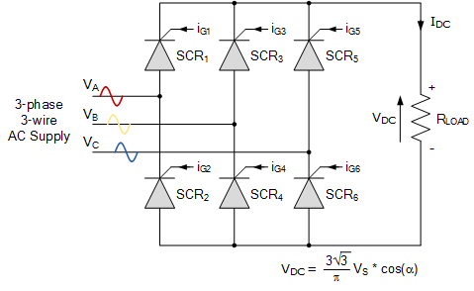

*Figure 2: Circuit Schematic of 3-phase full-bridge thyristor rectifier*

From the point of view of the above information the advantages and the disadvantages of the “Three-Phase Fully Controlled Thyristor Rectifier” topology can be listed as,

1. **Advantages**
2. *Higher output voltage thanks to three phase input*
3. *Lower output voltage ripple is achieved so that filtering is not necessary at the output*
4. *The efficiency is higher compared to the other rectifiers*
5. *Two quadrant operation, inverter mode, is already possible without the need of a parallel circuit.*
6. **Disadvantages**
7. *A relatively complicated control circuit is required to achieve synchronization with AC input*
8. *Lower power factor (PF) and discrete power factor (DPF) for smaller output voltage levels*

### Single-Phase Fully Controlled Thyristor Rectifier

The circuit schematic of single-phase fully controlled thyristor rectifier can be seen in Figure 3. This topology is composed of 4 thyristors utilized for single phase full wave rectification purposes. A control circuit is required to feed current pulses to the gates of each thyristor with specified firing angle. Similar to three phase fully controlled thyristor rectifier, average output voltage can be controlled by means of firing angle of current pulse to the thyristors.

However, for this topology output voltage level is lower than the three-phase case, therefore a boost converter might be needed in order to drive the DC motor properly in preferable levels. Also output voltage ripple is higher due to single phase source in this topology. Thus, three phase fully controlled thyristor rectifier is more preferable over single phase fully controlled thyristor rectifier.

The major drawback of this topology is that the gate signals of thyristors used in the circuit need to be controlled properly as it was the case with three phase fully controlled thyristors rectifier topology. However, control circuit is relatively simpler than the control circuit in three phase fully controlled thyristor rectifier topology due to the fact that less pulses are needed in a cycle. Furthermore, it should be noted that large harmonics are present in the input current in this topology type.

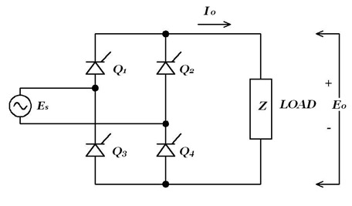

*Figure 3: Circuit schematic of single-phase full-bridge thyristor rectifier*

1. **Advantages**
   1. *Simpler control circuit compared to three phase fully controlled thyristor rectifier*
   2. *A cheaper solution relative to others*
   3. *Two quadrant operation, inverter mode, is already possible without the need of a parallel circuit.*
2. **Disadvantages**
   1. *Still a complicated control circuit is required to achieve synchronization with AC input*
   2. *Lower power factor (PF) and discrete power factor (DPF) for smaller output voltage levels*

### Dimmer

One of the options that is taken into consideration is the Dimmer topology. It is not an option provided in the project definition, but due to its simplicity, that topology is selected as a possible solution approach. After conducted researches, it is understood that the dimmer circuit comes with some benefits when compared to its alternatives. As it was explained in Chapter-I, the circuitry has diac, triac, capacitor and two resistors where one of the resistors are a POT to change the time constant of the capacitor to supply the desired output voltage to the load. In order to provide clearer information to the reader, the operational principle of the circuit will be analyzed. “Figure1” shows the circuit diagram of the Dimmer circuit. In the application, light bulb will be implemented as the load which is the DC motor in the project. BTB12 represents the TRIAC and DB3 is represents the DIAC. As it can be interpreted from the graph, it is a compact design with fewer components. In this part, TRIAC and DIAC will be explained briefly. Then; the roles of resistor, capacitor and potentiometer will be explained.

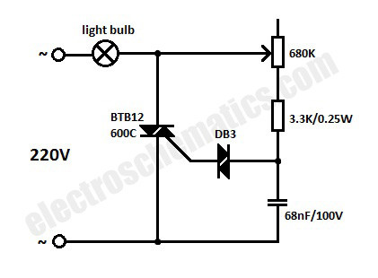

*Figure 4: The Schematic of the Dimmer*

“Figure 4” shows the I-V characteristics of TRIAC. It is as if an I-V graph of a thyristor where 1st quadrant is reflected to 3rd quadrant symmetrically. Indeed, it is true. A TRIAC is composed of simply two thyristors connected back to back and they are fed from the same gate connection. As the graph suggests, TRIAC is a 1st and 3rd quadrant device. This means that it can be opened with a negative current as well in which case it will conduct in reverse direction due to symmetry. Hence, there is no anode or cathode in TRIAC.

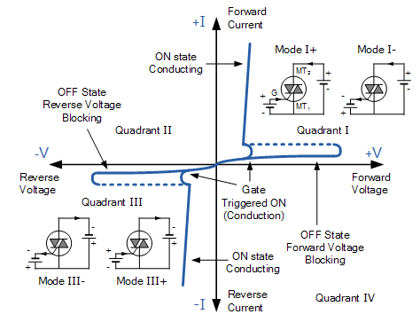

*Figure 5: The I-V Graph of the TRIAC*

“Figure 3X” shows I-V graph of a DIAC. As in previous case where TRIAC has been likened to a symmetrical thyristor, DIAC looks quite like a symmetrical diode. Actually, it is a double diode connected back to back. This gives an I-V graph symmetric with respect to origin. Only difference is there is a pulse in IBO-VBO point unlike a diode. Advantage of this characteristic is that it opens up at a relatively high voltage whereas a diode opens up at 0.7V. This can help with stability as the component does not open and close in an unstable way. Break-over voltage (VBO) is usually in an amount of 30V. Since both TRIAC and DIAC are 2-quadrant components, they are used together in this topology to exploit the advantages of 2-quadrant operation.

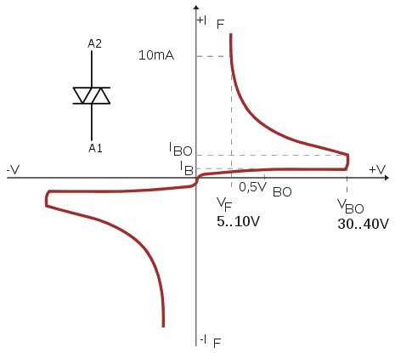

*Figure 6: The I-V Graph of the DIAC*

Apart from TRIAC and DIAC, there is also an R-C branch in dimmer. Main role of this branch is to adjust time constant. Capacitor is placed between one end of DIAC and the ground to facilitate voltage variation to be continuous and smooth. The embedded resistance plays a role to prevent time constant to go to “0”. If that resistor wasn’t placed, time constant would be varying in the range of zero to maximum value of RP*C. With this resistor, it will vary in the range of to . Eventually, TRIAC will not open at “0” degree as there is always a time constant bigger than “0”. The advantages and the disadvantages of the Dimmer can be listed as,

1. Advantages
   1. Relatively small number of components
   2. Lower cost
   3. Compact design availability
   4. Lower Frequency drive availability
2. Disadvantages
   1. Higher Output Ripples

# DESIGN CONSIDERATIONS

While coming up with a decision to make, N.A.M.-I Power decided on 3-phase full-bridge rectifier with buck converter. Underneath that decision lies a couple reasons.

* Buck converter offers a wide range of switching frequency choice. This gives more precision on controlling as well as adjusting output ripple.
* 3-phase full-bridge rectifier with buck converter provides a wide range of component selection. After determining the power demand, one can decide on components to use.
* While designing a buck converter, one has the ability to adjust the ripple of output. This offers a trade-off between performance and cost. While designing this converter, it is possible to decide on a low ripple to care for performance and buy more expensive components or decide on a higher ripple to save from component expenses, or a middle point somewhere in-between. Buck converter provides this flexibility.
* Buck converter is more efficient than its alternatives for higher duty cycle values.

# SIMULATION RESULTS

As a prospective Power Electronics Engineer, all of the design procedures should be implemented through the simulation software programs in order to observe whether the theoretical analyses are correct or not. Since there are many interpretations to the designed circuitry like the in-rush currents, peak reverse voltages, start-up conditions, etc. one should implement the design with a complete understanding to check the calculated results so that the pre-decided components can be ordered without any doubt about the operational limits. In order to observe those possible discrepancies, the whole circuit is designed on Simulink to conduct the simulation analyses. After the implementation of the design, the constructed circuit is given below in the figure.

*Figure 7: Three Phase Diode Bridge Rectifier and Buck Converter Schematic*

As one can clearly observe from the figure, there is a Three-Phase AC voltage source which represents the voltage of the Variac to feed our circuitry. A Three-Phase Full Bridge Diode Rectifier is connected to that input voltage in order to rectify it into a DC one so that the DC-DC Buck Converter can be operated accordingly. A DC link capacitor is connected at the output side of the Three-Phase Full Bridge Diode Rectifier as a smoothing capacitor i.e. the rectified signal converted to a more ripple-free one to increase the efficiency of the operation. That DC signal is given to the collector of an IGBT which is used as a switching component in the circuitry. The gate of the IGBT is fed with a PWM signal which is generated from the analog controller or microcontroller. The IGBT conducts and cuts-off according to the PWM signal’s period (which is chosen as 1kHz) to make the operator able to supply the desired voltage at the output. The diode connected to the emitter of the IGBT is used as a freewheeling diode to complete the current path being conducted because of the internal inductance of the DC motor when the IGBT is off.

By the usage of the same operational principle at each cycle, the input voltage is converted to the necessary output voltage through the Buck Converter.

### 5% Duty cycle Results of the Circuit

The start-up of the operation carries vital importance since there would be very high starting currents and voltages for each of the component used in the circuit. In order to analyze the starting process, 5% duty cycle is selected in order to observe the results. According to the simulation results of the circuit the current and voltage of the IGBT is given in the figure.

*Figure 8: The IGBT Current (up) and Voltage (down) for 5% Duty Cycle*

As it is seen from the figure above, the IGBT is drawing 3A during the steady state operation and the voltage across it is 550V. During the start-up, those values are increase to 35A and 685Volts. The maximum ratings are so important to conduct the component selection. After the analysis of IGBT voltage and current, the DC-Link capacitor and output voltage waveforms are given in the following figure. The mean output voltage is 25V for 5% duty cycle.

*Figure 9: The DC-Link Capacitor (up) and Output (down) Voltage for 5% Duty Cycle*

After the observations are made on the rectifier output and converter output voltages, the armature current, field current electrical torque and RPM of the DC motor is observed as follows. The RPM of the motor is 200 in this case.

*Figure 10: The Ia, If, Te and RPM Values of the DC Motor for 5% Duty Cycle*

The output voltage waveforms are like a square wave shaped since there is no inductance and capacitance connected at the output stage of the converter since the corner frequency synchronization of the L-C filter needs a deep analysis.

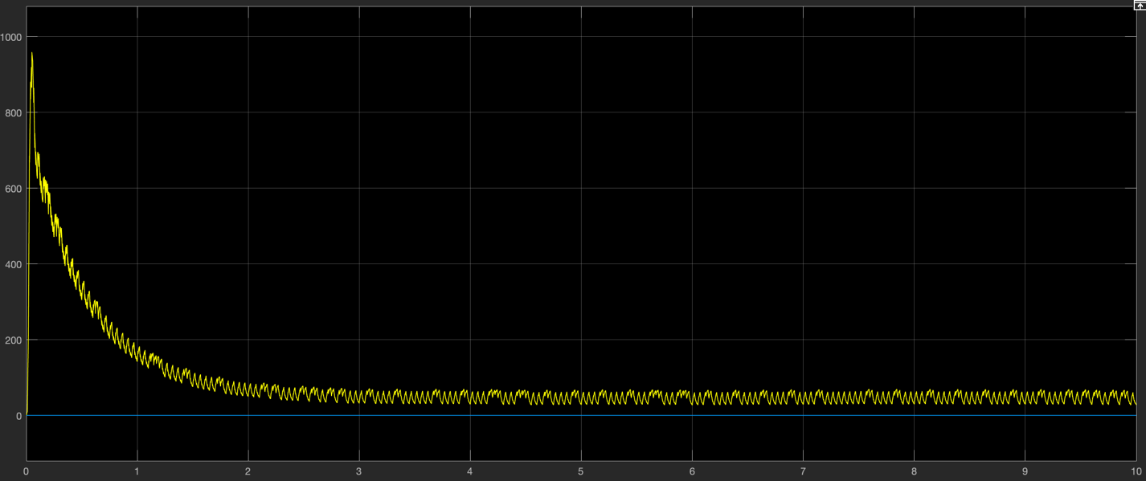

*Figure 11: The Power Output of the DC-DC Converter for 5% Duty Cycle*

### 25% Duty Cycle Results of the Circuit

Since the circuit will reach up to steady state when the duty cycle is increased incrementally to 25%, the simulation results give the results for IGBT voltage and current as in the figure.

*Figure 12: The IGBT Current (up) and Voltage (down) for 25% Duty Cycle*

As it is seen from the figure above, the IGBT is drawing 18A during the steady state operation and the voltage across it is 520V. The result is a meaningful one since the conduction period is increased. The DC-Link capacitor and output voltage waveforms are given in the following figure. The mean output voltage is 128V for 25% duty cycle.

*Figure 13: The DC-Link Capacitor (up) and Output (down) Voltage for 25% Duty Cycle*

After the observations are made on the rectifier output and converter output voltages, the armature current, field current electrical torque and RPM of the DC motor is observed as follows for 25% Duty Cycle. The RPM of the motor is 880 in this case.

*Figure 14: The Ia, If, Te and RPM Values of the DC Motor for 25% Duty Cycle*

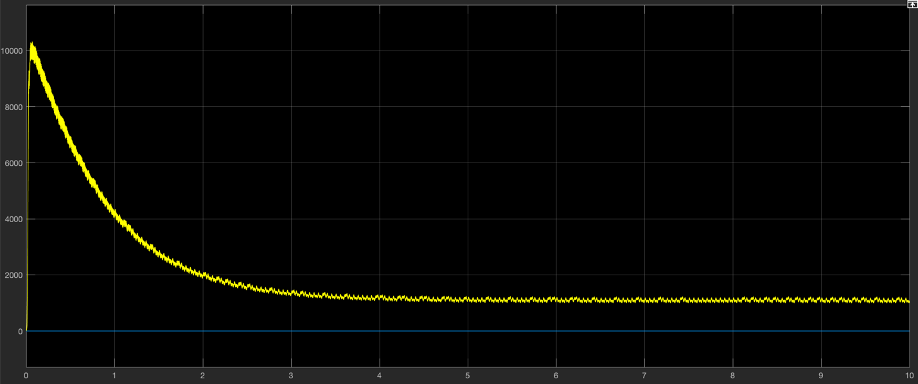

*Figure 15: The Power Output of the DC-DC Converter for 25% Duty Cycle*

### 50% Duty Cycle Results of the Circuit

During the operation at 50% Duty cycle, the IGBT voltage and current is represented in the figure.

*Figure 16: The IGBT Current (up) and Voltage (down) for 50% Duty Cycle*

During the operation the voltage across the IGBT is 486V and the current is 22A. Since the on period of the Duty Cycle is increased, the current flowing through the IGBT has increased and the mean output voltage is increased accordingly to 243V at 50% Duty Cycle.

*Figure 17: The DC-Link Capacitor (up) and Output (down) Voltage for 50% Duty Cycle*

After the observations are made on the rectifier output and converter output voltages, the armature current, field current electrical torque and RPM of the DC motor is observed as follows for 50% Duty Cycle. The RPM of the motor is 1750 in this case.

*Figure 18: The Ia, If, Te and RPM Values of the DC Motor for 50% Duty Cycle*

*Figure 19: The Power Output of the DC-DC Converter for 50% Duty Cycle*

### 75% Duty Cycle Results for the Circuit

The IGBT voltage and current is observed from the simulation as in the figure below. The IGBT carries 26A at 440V during the operation of 75% Duty Cycle.

*Figure 20: The IGBT Current (up) and Voltage (down) for 75% Duty Cycle*

During the operation the voltage across the IGBT is 486V and the current is 22A. Since the on period of the Duty Cycle is increased, the current flowing through the IGBT has increased and the mean output voltage is increased accordingly to 325V at 75% Duty Cycle.

*Figure 21: The DC-Link Capacitor (up) and Output (down) Voltage for 75% Duty Cycle*

After the observations are made on the rectifier output and converter output voltages, the armature current, field current electrical torque and RPM of the DC motor is observed as follows for 75% Duty Cycle and are given in the figure below. The RPM of the motor is 2400 in this case.

*Figure 22: The Ia, If, Te and RPM Values of the DC Motor for 75% Duty Cycle*

*Figure 23: The Power Output of the DC-DC Converter for 75% Duty Cycle*

### 95% Duty Cycle Results for the Circuit

The IGBT voltage and current is observed from the simulation as in the figure below.

*Figure 24: The IGBT Current (up) and Voltage (down) for 95% Duty Cycle*

During the operation the voltage across the IGBT is 375V and the current is 30A. Since the on period of the Duty Cycle is increased, the current flowing through the IGBT has increased and the mean output voltage is increased accordingly to 375V at 95% Duty Cycle.

*Figure 25: The DC-Link Capacitor (up) and Output (down) Voltage for 95% Duty Cycle*

After the observations are made on the rectifier output and converter output voltages, the armature current, field current electrical torque and RPM of the DC motor is observed as follows for 95% Duty Cycle and are given in the figure below. The RPM of the motor is 2700 in this case.

*Figure 26: The Ia, If, Te and RPM Values of the DC Motor for 95% Duty Cycle*

*Figure 27: The Power Output of the DC-DC Converter for 95% Duty Cycle*

# COMPONENT SELECTION

After the analyses of the circuit is completed through the simulations, next step was the component selection process according to the results.

### Three-Phase Full-Bridge Diode Rectifier

The first necessary component of the circuit is a three-phase full-bridge diode rectifier which will be used as a rectifier component to get a DC from the supplied AC signals. According to the simulation results, the important parameters are listed in Table 1.

*TABLE 1: Three-Phase Full-Bridge Diode Rectifier Parameters*

|  |  |
| --- | --- |
| ***MODEL NAME*** | *MDA 1505-2 7346* |
| ***PEAK REVERSE VOLTAGE*** | *1200V* |
| ***DC OUTPUT VOLTAGE*** | *570V* |
| ***DC OUTPUT CURRENT*** | *8A @ 55°* |
| ***PEAK FULL WAVE ONE CYCLE SURGE CURRENT*** | *200A* |
| ***PEAK FULL WAVE RECURRENT FORWARD CURRENT*** | *45A* |

### DC-Link Capacitor

There is a three-phase full-bridge diode rectifier at the input stage of the circuit, but still there is a need for a smoothing capacitor. In order to do so, the capacitance value of the DC-Link capacitor is decided to be 470uF at a voltage rating of 630V.

### IGBT

Since the IGBTs can carry more currents, the selected switching component in the design procedure is decided to be an IGBT instead of MOSFET. The technical specification of the IGBT is given below in table 2.

*TABLE 2: The Technical Specification of the IGBT*

|  |  |
| --- | --- |
| ***COLLECTOR-EMITTER VOLTAGE*** | *1200V* |
| ***GATE-EMITTER VOLTAGE*** | *+/- 20V* |
| ***COLLECTOR CURRENT*** | *50A @ 25°* |
| ***PULSED COLLECTOR CURRENT*** | *75A* |
| ***DIODE CONTINIOUS FORWARD CURRENT*** | *25A @ 100°* |
| ***DIODE MAXIMUM FORWARD CURRENT*** | *150A* |
| ***OPERATING TEMPERATURE*** | *-55° / +150°* |

### DIODE

In the design, the diode should have an ability of fast recovery and high current carrying capacity in order to withstand high currents during both the start-up and steady state. The technical specifications are given in table 3.

*TABLE 2: The Technical Specification of the Diode*

|  |  |
| --- | --- |
| ***PEAK REPETITIVE REVERSE VOLTAGE*** | *1200V* |
| ***AVERAGE RECTIFIED FORWARD CURRENT*** | *30A* |
| ***REPETITIVE PEAK SURGE CURRENT*** | *60A* |
| ***NON-REPETITIVE PEAK SURGE CURRENT*** | *300A* |
| ***FORWARD VOLTAGE*** | *2.6V* |
| ***REVERSE RECOVERY*** | *250us* |
| ***REVERSE RECOVERY TIME*** | *85ns* |

# CONCLUSION

In this stage of the project, the aim was to clarify the solution approach to be utilized throughout the project and to support it with the simulation results of the selected topology. Now that the path is determined and solution approach is decided on, next step will be component selection. This will be an important step for course learning outcomes. A proper planning will make the subsequent phases a lot easier and make the process smooth as far as success is concerned.