- Importing Libraries and Downloading Dataset using API
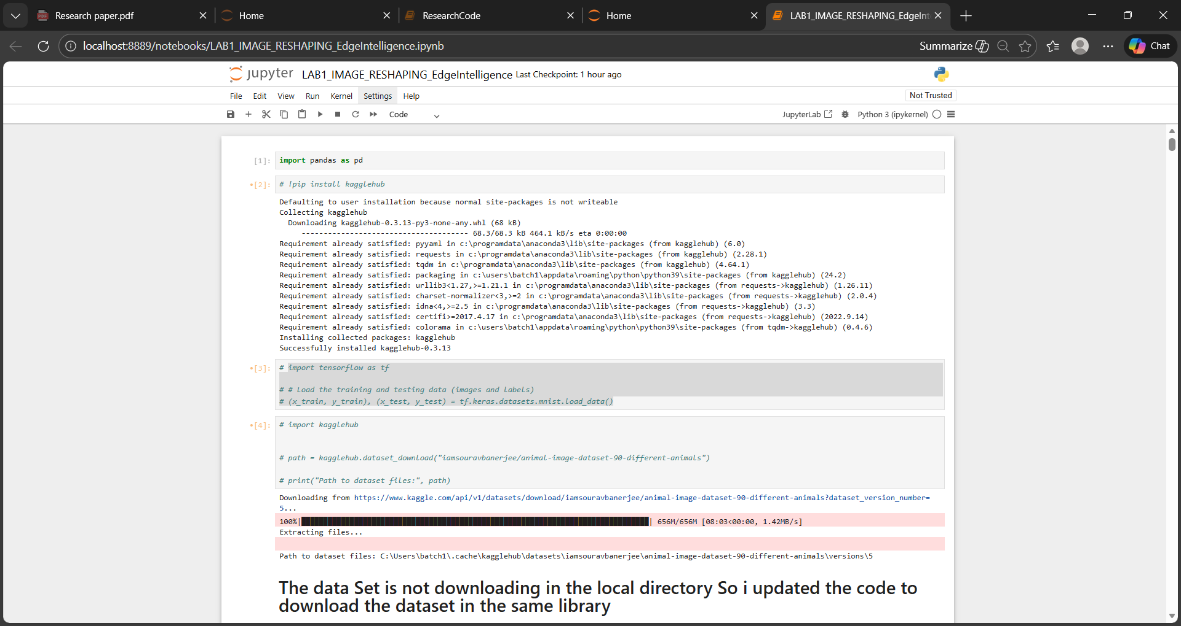
- The data Set is not downloading in the local directory So i updated the code to download the dataset in the same directory
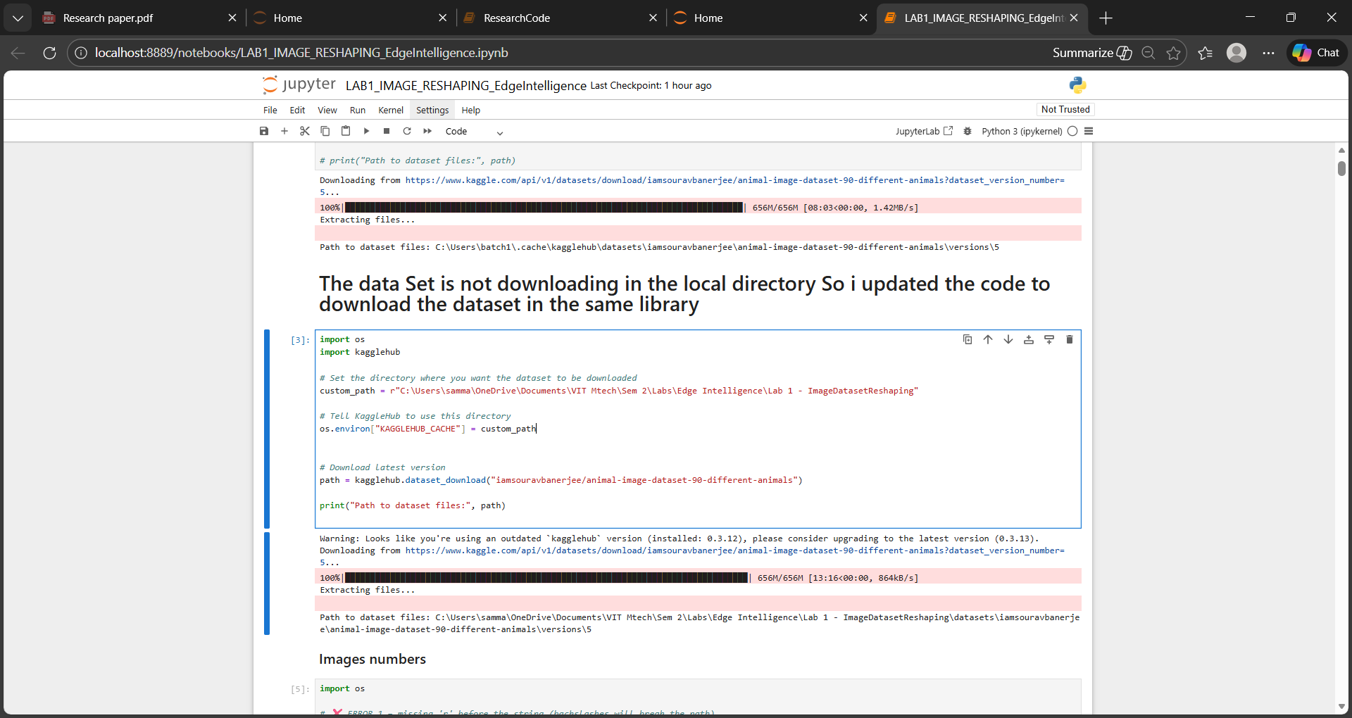

- Got Error because missing 'r' before the string (backslashes will break the path)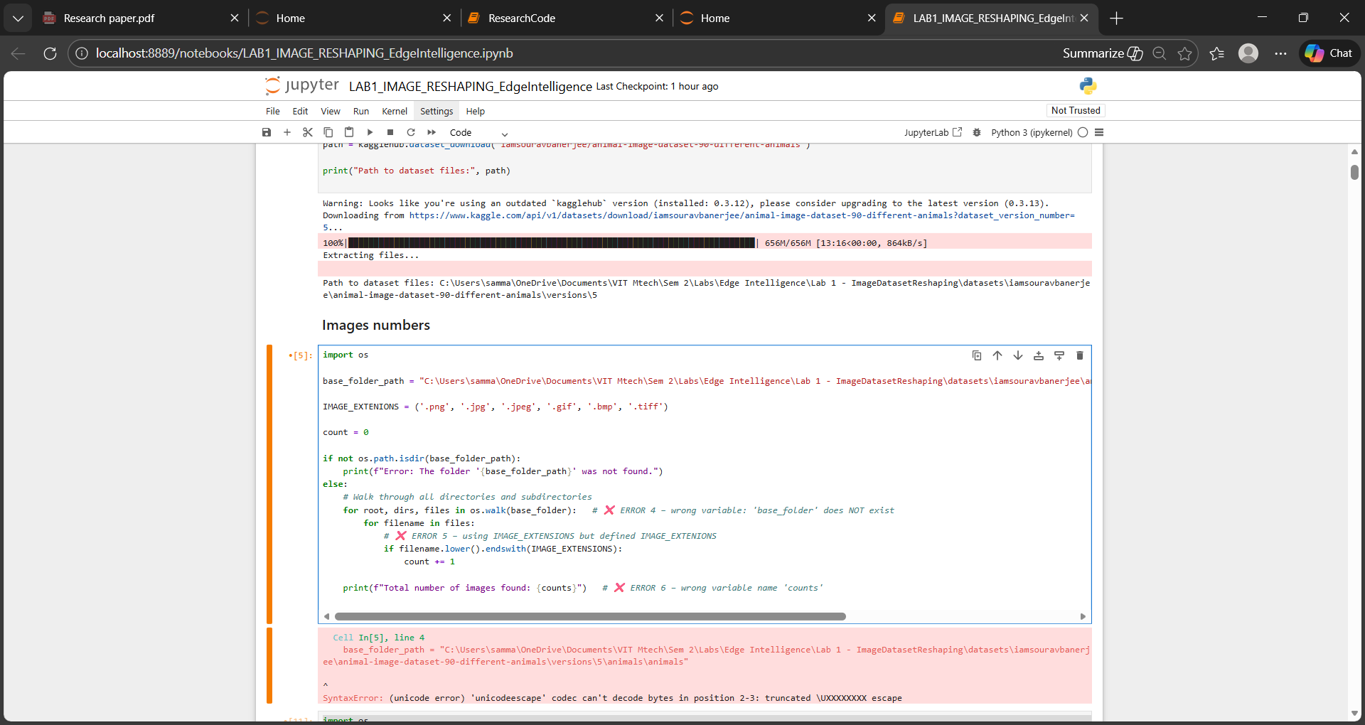
So included r in front of the path to format

- Because of typo included wrong variable and solved

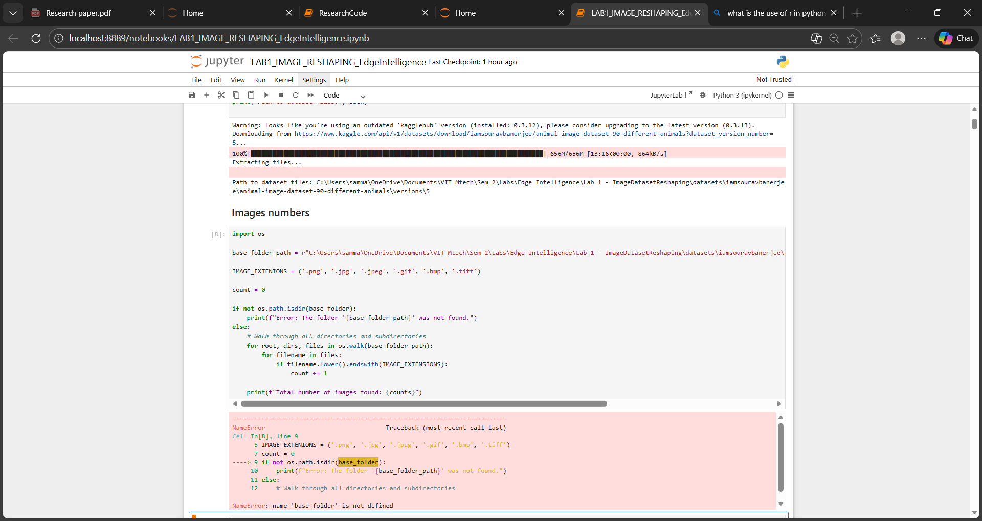

- Wrong extensions given in the code
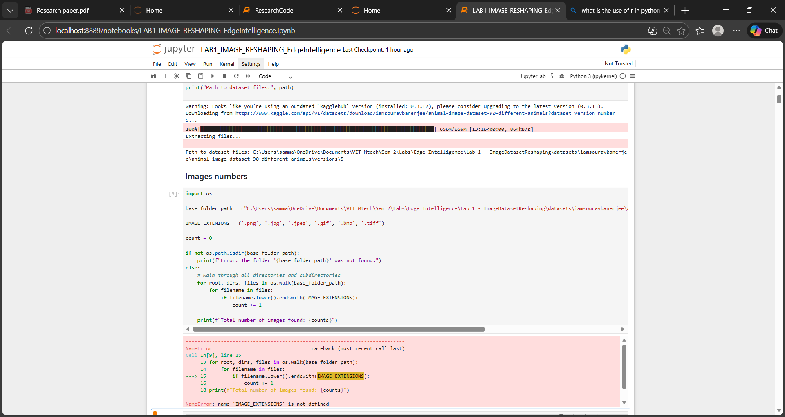
- Checking for Different shapes of images are present or not
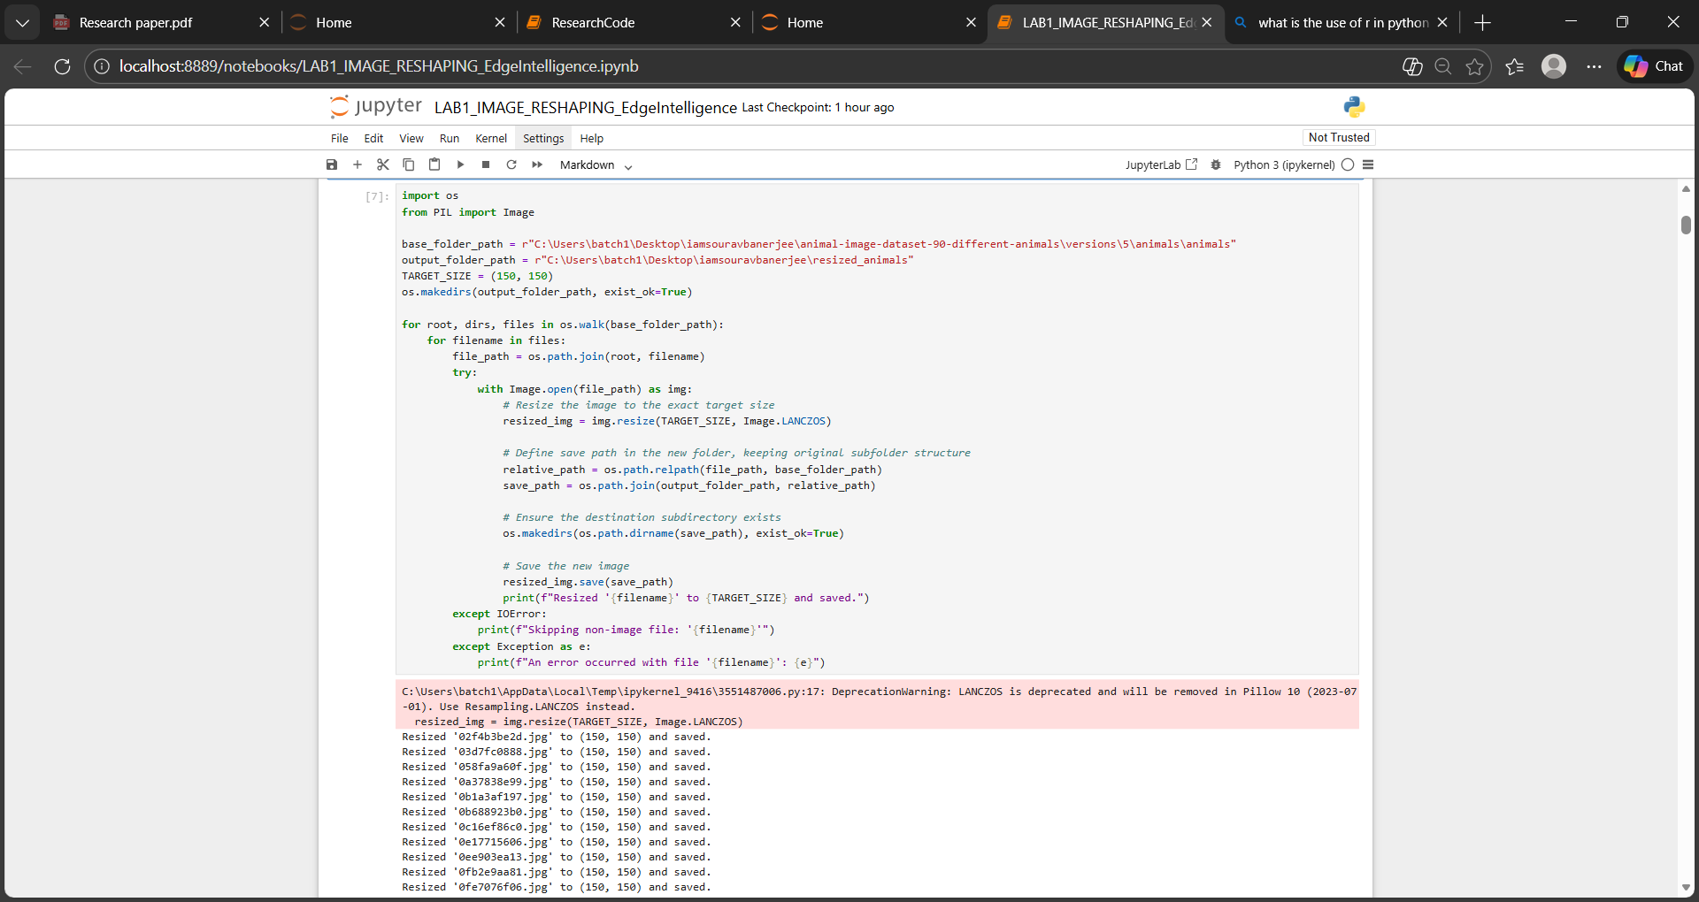

Had different shapes so need to reshape the images for to pass into neural network
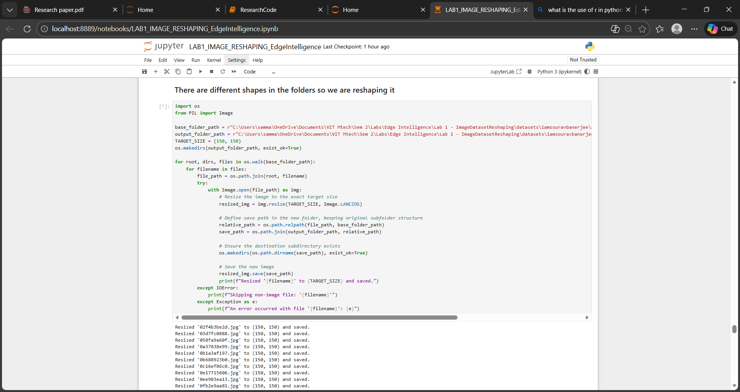
- Visualization of the Image dataset
