Object detection in videos using yolo Ultralytics

Gopi chand Sammangi
25MML0017

- Design and implement the pipeline for object detection in Videos using Yolov8
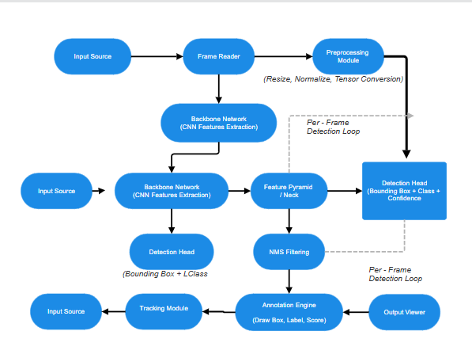
- Your design should capture Object Detection in frames (yolov8) and tracking the objects across frames (tracking algorithm). Implementation - yolov8 model from Ultralytics
Code:
import cv2
from ultralytics import YOLO
model = YOLO("yolov8n.pt") # you can change model
video_path = "video.mp4"
cap = cv2.VideoCapture("Yolovid.mp4")
if not cap.isOpened():
print("Error opening video")
exit()
while True:
success, frame = cap.read()
if not success:
break
results = model.track(
frame,
persist=True,
tracker="botsort.yaml"
)
annotated_frame = results[0].plot()
cv2.imshow("YOLOv8 Tracking", annotated_frame)
# Press ESC to stop
if cv2.waitKey(1) & 0xFF == 27:
break
cap.release()
cv2.destroyAllWindows()

Output
